SKEENA SUSTAINABILITY ASSESSMENT FORUM
Forestry Working Group – Roads Subcommittee

“SSAF SC Road App”
- General Access and Usage Notes
- App Walkthrough

Date: July 14, 2023
Draft 1.0

- GENERAL ACCESS AND USAGE NOTES
To access the new App, either paste this link to your web browser: https://arcg.is/1OuHrS0
or use the QR Code here:

If you select the weblink - you are asked if you want to open the new App in your web browser, or in the Survey123 field app. A Microsoft App Store link to the free downloadable ArcGIS Survey123 app is provided, for folks that still need to load it onto their mobile devices.
- Using within the mobile Survey123 field app is suggested, to enable working offline.
- Make sure your field crews have both the SSAF-RA and Survey123 field app properly loaded onto their mobile devices before heading out

To collect data:
- Open the Survey123 mobile app and select the “SSAF Roads SC Road App” survey form.
- On the bottom of your screen, tap the “Collect” button.
- Fill in the boxes (with reference to this Walkthrough Document). Use the left and right arrows on the bottom of your screen to navigate through survey pages.
- On the last page, tap the “check” icon to submit. If connected to the internet, you can choose to “Send Now” and it should automatically update the results table. If offline, choose “Save in Outbox”. This will save the entries into the Outbox. The field crew can/ will need to submit all entries from the Outbox once they have internet connection again.

To submit entries from the Outbox:
- Once you have internet connection, send all entries by opening your Survey123 app and tap the “Outbox” button on the bottom of your screen.
- The Outbox will show all the entries that you’ve saved. You can either send them individually (usually a good option if you want to verify the data that was collected) or send all of them all at once.
- To send them individually, tap on the entry that you want to send. It should ask you if you want to edit the survey, choose “Yes”. Go through the steps and then choose “Send Now” at the end.
- To send all at once, from the Outbox page, tap the “Send” button at the bottom-right of your screen. This should automatically send all entries and update the results table.

- APP WALKTHROUGH

**Refer to 1. GENERAL ACCESS AND USAGE NOTES for the procedure to begin data collection**

Page 1 of 6
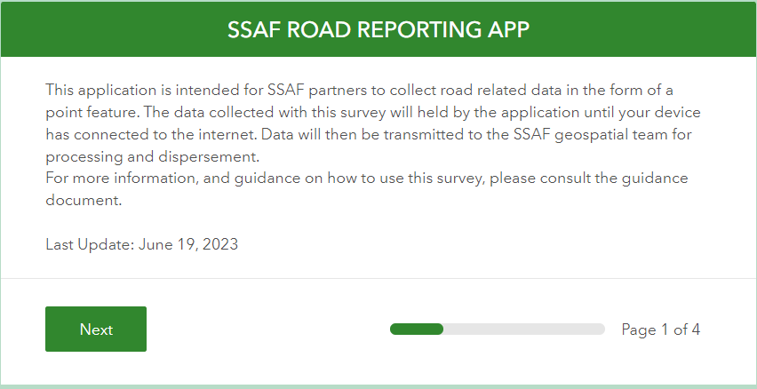

Walkthrough Notes:
Opening page. Tap “Next” to move on.

Page 2 of 6
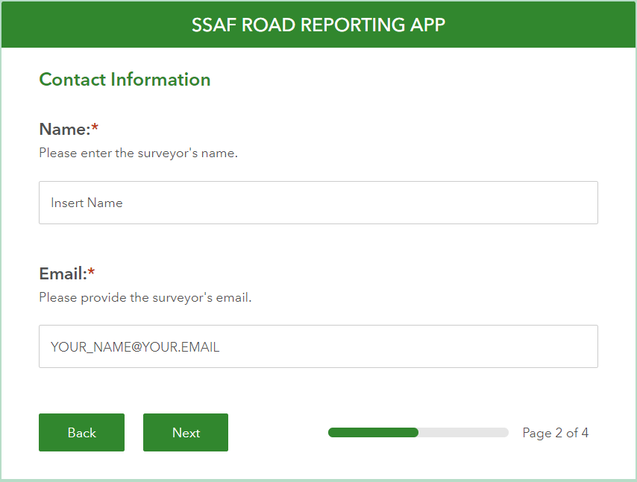

Walkthrough Notes:
Enter your Name and Email address. This will help identify your data in the App database for subsequent data extraction as needed.

Page 3 (Section A) of 6
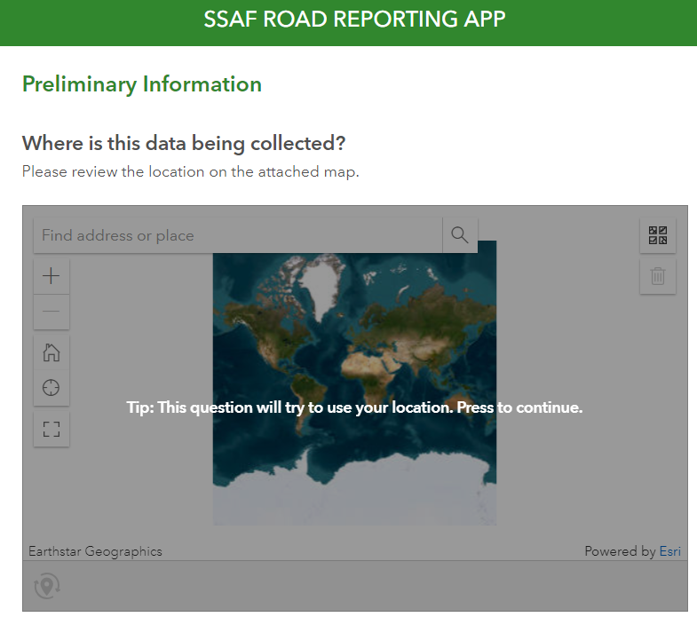

Walkthrough Notes:
Tap the image to allow the App to use your current location as a geo-reference for the data collection point.
When using this App within Survey123, this function will work offline.
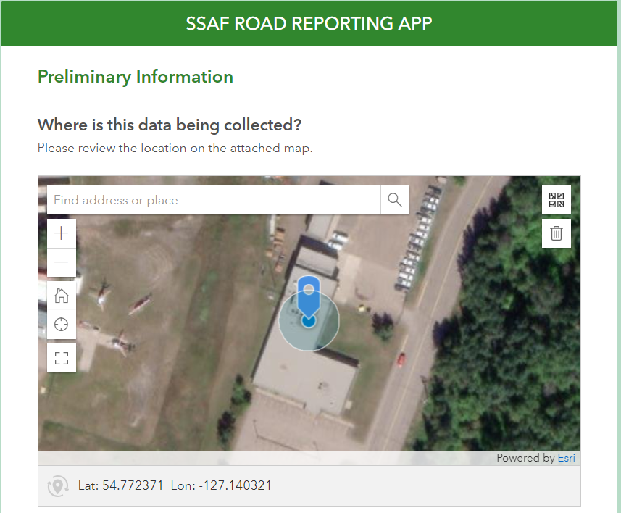
Here’s an example outcome of tapping the image. Note that Lat/ Long has been automatically generated.
The App also auto-generates an Observation Date and a Unique ID for each data point collected.

Page 3 (Section B) of 6
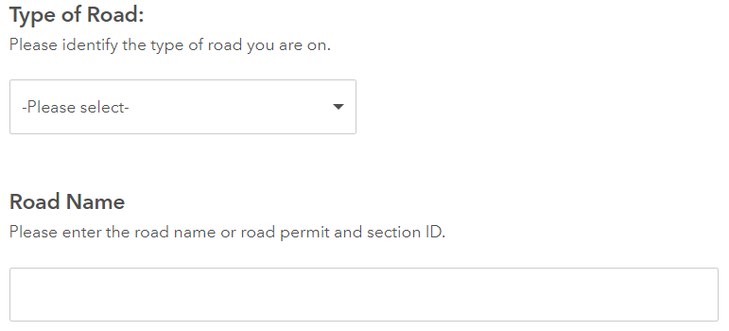

Walkthrough Notes:
Select “Type of Road” from the pull-down list. The options provided are:
- Highway
- MOT-Road
- Resource Road -Main
- Resource Road -Branch
- Resource Road -In-Block
- Resource Road -Trail/Other
- Recreation -Trail
- Private -Trail/Other

The Road Survey Guidance Document provides descriptions and typically example pictures for each option, to aid your selection.

For “Road Name”, please enter the road name as it shows on signage at the start of the road system you are working on.
- If there is no signage, or signage is unclear, or you are uncertain, you can leave this field blank.

Page 3 (Section C) of 6
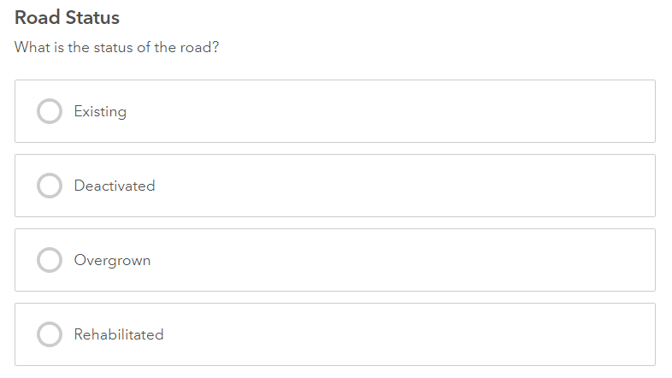

Walkthrough Notes:
Select the Road Status option that’s most appropriate for your data collection point, as observed in the field.
The Road Survey Guidance Document provides descriptions and typically example pictures for each option, to aid your selection.

Page 3 (Section D) of 6
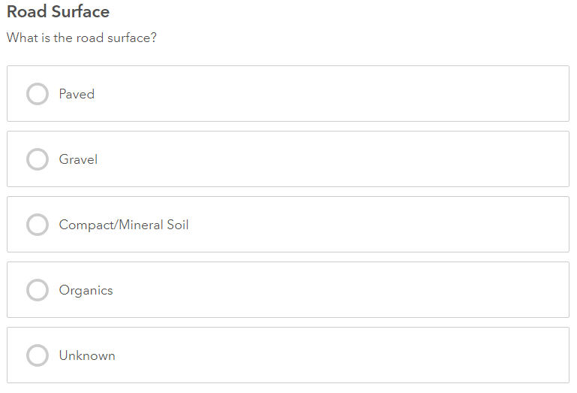

Walkthrough Notes:
Select the Road Surface option that’s most appropriate for your data collection point, as observed in the field.
- Typically don’t select “Unknown” unless you find it impossible to make a call. This option may be revisited in future iterations of the App.
The Road Survey Guidance Document provides descriptions and typically example pictures for each option, to aid your selection.

Page 3 (Section E) of 6
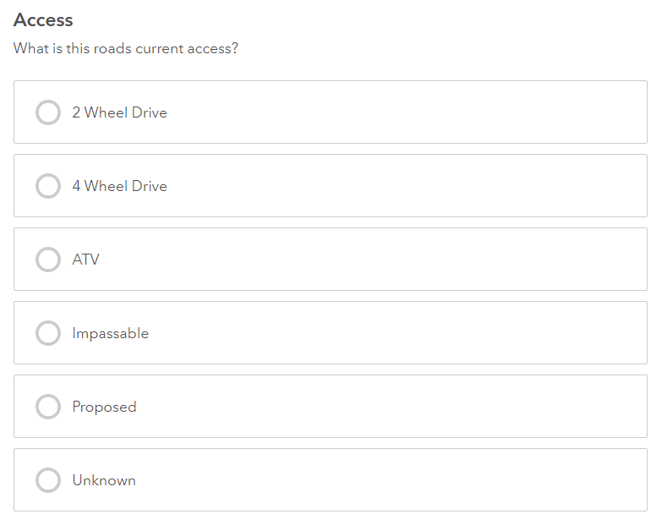

Walkthrough Notes:
Select the Access option that’s most appropriate for your data collection point, as observed in the field.
- “Proposed” option should never be selected. Also, typically don’t select “Unknown”, unless you find it impossible to make a call. These options may be revisited in future updates to the App.
The Road Survey Guidance Document provides descriptions and typically example pictures for each option, to aid your selection.

Page 3 (Section F) of 6
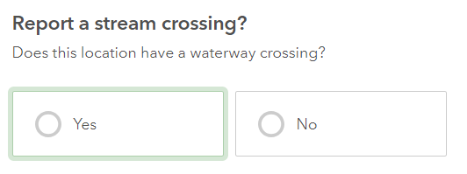

Walkthrough Notes:
Select “Yes” if you’re collecting data at a point where a “waterway” crosses the road, “No” otherwise.
- “Waterways” include:
- active or dry stream channels
- gullies
- cross-drains

If you select “Yes”, a new page entitled “Stream Crossing Report” is added to the survey.
A walkthrough of the “Stream Crossing Report” page is provided in the Page 4 of 6 section of this document.

Page 3 (Section G) of 6
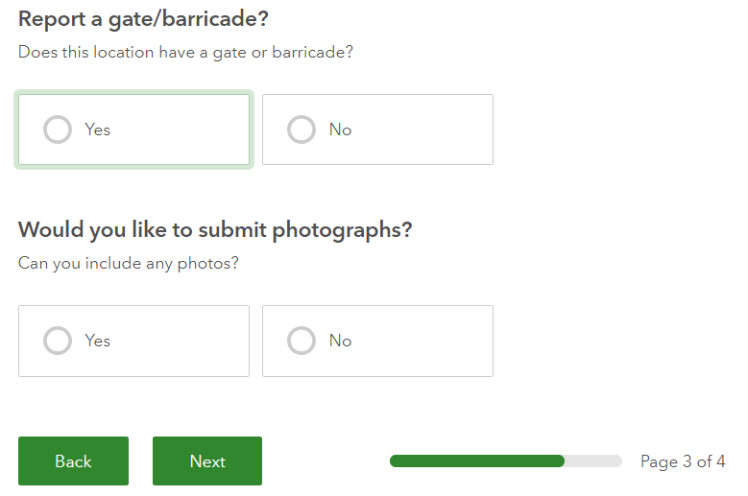

Re: Report a gate/ barricade? – select “Yes” if present at your data collection point.
The Road Survey Guidance Document provides a description and an example picture of a gate/ barricade, to aid your selection.

Re: Would you like to submit photographs? – if you select “Yes”, a new page entitled “Photograph Submission” is added to the survey.
A walkthrough of this page is provided in the Page 5 of 6 section of this document.

Page 4 (Section A) of 6
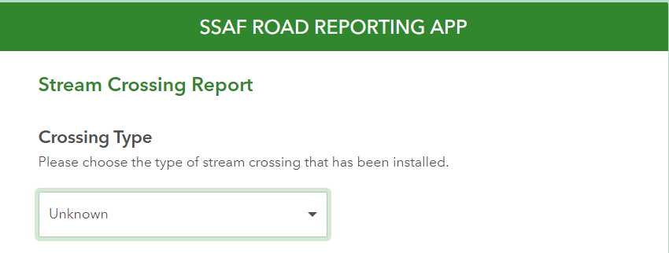

Select “Crossing Type” from the pull-down list. The options provided are:
- Unknown
- Bridge
- Open Bottom Culvert
- Wood Box Culvert
- Metal Culvert
- Ford
- Pulled

The Road Survey Guidance Document provides descriptions and typically example pictures for each option, to aid your selection.

The App assigns a default value of “Unknown”. You can retain as “Unknown” in situations where it would take unreasonable effort to field-confirm what the actual structure is – e.g. a more than 1 minute hike-in off the road running surface.
Common crossing structure types are provided. If you encounter a crossing type that is not on the pull-down list, please make note of the fact in the “Comments” field (see Page 6 of 6 later in this document) and take pictures.

Page 4 (Section B) of 6
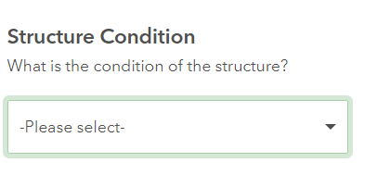

Select “Structure Condition” from the pull-down list. The options provided are:
- Functioning
- Partially Functioning
- Non-Functional

The Road Survey Guidance Document provides descriptions for each option, to aid your selection.

If you do select “Partially Functioning” or “Non-Functional”, provide a brief issue description and pictures. See the Page 6 of 6 section for instructions.

Page 4 (Section C) of 6
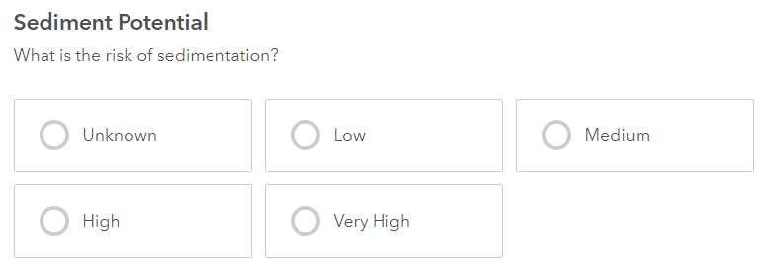

The Road Survey Guidance Document provides descriptions and typically example pictures for each option, that could aid your selection.

HOWEVER –please select “Unknown”, unless you are conducting a sediment transport potential assessment (e.g. FREP Water Quality Effectiveness Evaluation – WQEE), or have access to results from one that was recently conducted.

- It is anticipated that this App will be employed in support of Routine Watershed Assessments (RWA). Sediment transport potential assessments (e.g. WQEE) are a typical RWA element.

Page 4 (Section D) of 6
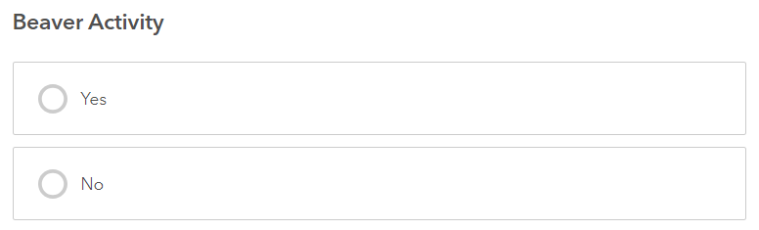
Upstream beaver dams can create natural water impoundments. If the dam fails, e.g. as the result of a peak flow event, the resulting water and debris torrent can cause damage to downstream road crossing structures.
Select “Yes” if there’s visible beaver activity in the vicinity of your data collection point, or if you’re specifically aware of upstream beaver activity e.g. as a result of assessments being conducted for your Indigenous Guardian Programs. Select “No” otherwise.

If you select “Yes”, the page expands to provide the following options. Select the option that’s most appropriate for your data collection point.
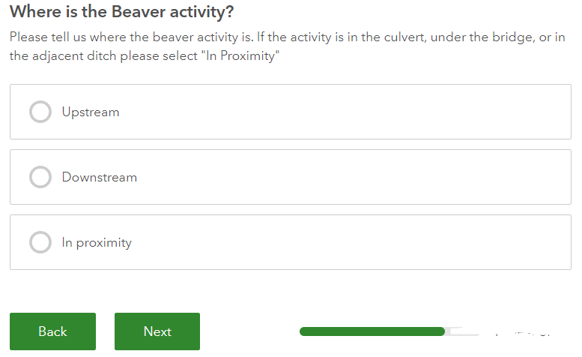

Page 5 of 6
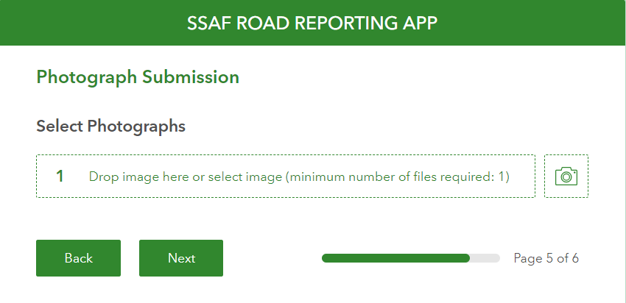

Pictures (e.g. of issues encountered) taken using the camera icon provided on this survey page will be associated with your data collection point. Pictures can also be dropped in from another App’s photo library (e.g. Avenza).
Page 6 (Section A) of 6
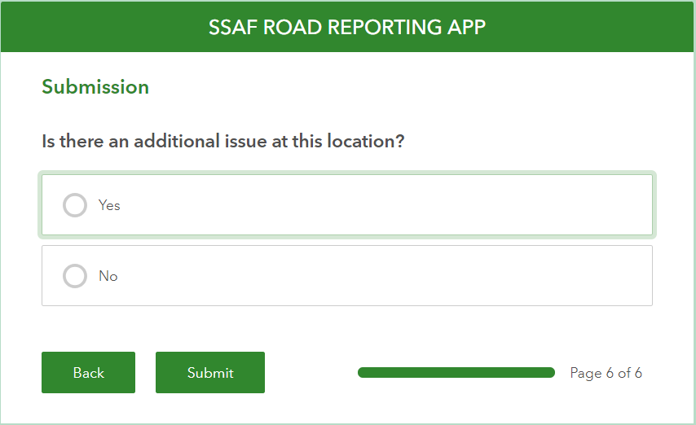

Select “Yes” if a road-related issue is occurring at the data collection point. Issues flagged in this manner will be forwarded to road obligation owners to support their actioning efforts.
The Road Survey Guidance Document (“Issues Descriptions” section) provides descriptions and typically example pictures for road-related issues that are frequently encountered during road inspections.
If you select “Yes”, the page expands to provide an “Issues Description” box. Describe the issue briefly. Take and submit pictures.

Page 6 (Section A) of 6
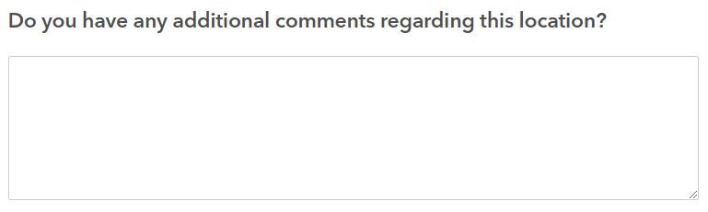

Additional Comments box.
Can be used as a tool for reporting roads-related data and or observations that are not presently accommodated by fields/ domains in this App, but that are important for (e.g.) implementation of your Indigenous Guardian Projects.
Examples: wildlife encounters; snow-related accessibility observations, etc.

END OF SURVEY

** Refer to 1. GENERAL ACCESS AND USAGE NOTES for the procedure to submit your collected data points to the App’s database **

