4.2 Forest Health Agent Writeups
4.2.1 Mountain Pine Beetle (IBM) Dendroctonus ponderosae (Hopk.)
Description
See Appendices 1.1 and 1.2 for descriptions of IBM Life Cycle, Host Susceptibility, Signs & Symptoms, and Damage.
IBM is one of the most destructive insect pests of mature pine in BC. It is a priority forest health agent for Skeena Stikine District because there are large areas of contiguous susceptible forest in each of the TSA’s (pine comprises 20%, 8% and 30%, respectively, of Bulkley, Kispiox, and Cassiar TSA’s forested landbases), and because of recent high incidence levels in Bulkley TSA.
Extent
There has been a history of IBM infestation in Bulkley TSA. In the 1970’s and 1980’s, IBM infestation caused extensive pine mortality in the Chapman and Coffin Lake areas. From 2003-2012, portions of both Kispiox and Bulkley TSA were included in the provincial Emergency Bark Beetle Management Area (EBBMA) established via the Forest Practices Code Bark Beetle Regulation to address the recent epidemic. Strong westerly prevailing winds and geographic barriers slowed IBM spread from the epicentre, but waves of attack occurring between 2003 and 2008 resulted in significant infestation and mortality in south and east central Bulkley landscape units.
It is widely understood that the epidemic has subsided, with pine mortality in Bulkley TSA peaking in 2011.
Map 2 shows areas and points of known current incidence, against a background of forest classified as high to very high IBM hazard (i.e. highly susceptible types). Table/Figure XX show current incidence trends by TSA, from 2011 to 2015, highlighting general declines since 2011 and relatively low current incidence levels.
Table/Figure XX: Provincial Annual Overview Survey (PAOS) Summary, 2011-2015
 | IBM - Affected/Killed Area (ha), by Year
Timber Supply Area | 2011 | 2012 | 2013 | 2014 | 2015
Bulkley | 10690 | 7091 | 3797 | 623 | 765
Kispiox | 1033 | 845 | 342 | 456 | 4
Cassiar | 5 | 73 | 44 | 18 | 0
Totals: | 11727 | 8010 | 4183 | 1096 | 769

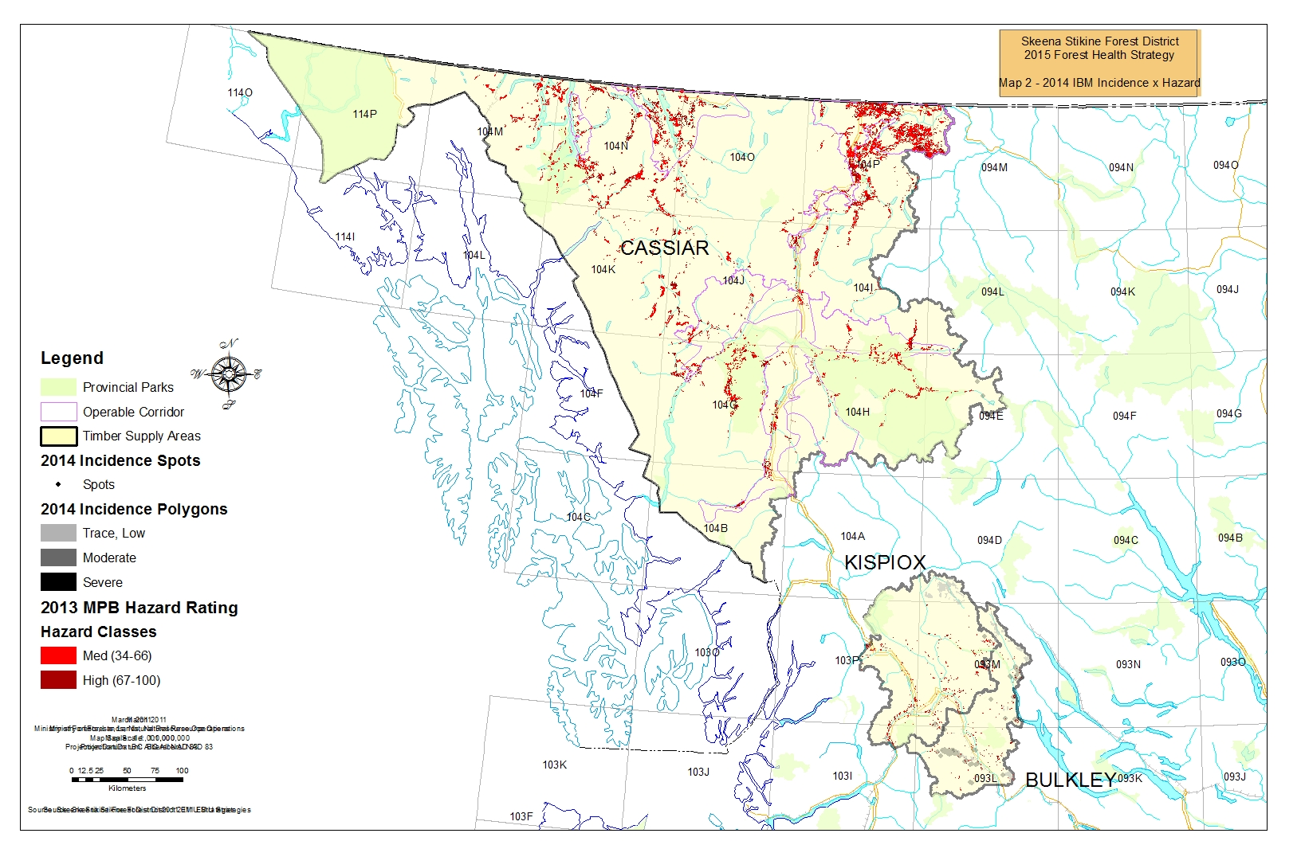
Non-Recoverable Loss (NRL) Assumptions and Estimation from Timber Supply Reviews (TSR)
Bulkley TSR3 (2011 currency)
- 2010 Provincial Aerial Overview Survey (PAOS) polygons define the extent of the current infestation.
PAOS polygons were used to group pine-leading types; the PAOS call on degree of infestation was then applied to pine volume component of the grouped types, per Table XX, to estimate volumes of infested/killed pine.
Table XX: % Pli Volume Mortality Assumed by PAOS Severity Class
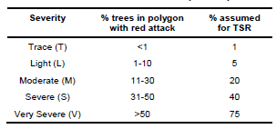
- current infestation levels will stay static – i.e. Bulkley will not experience future waves of attack from the MPB epicentre.
- licensees will target all currently infested, red or dead sawlog potential Pli-leading stands for harvest over the next 2 decades to maximum levels permitted by land base constraints.
- sawlog potential of the pine component of pine-leading stands will persist for 5 years (with the year of analysis set as year 0), after which if not already harvested by the model it will revert to pulp.
- dead pine will persist as standing inventory for 15 years, after which if not already harvested by the model it will fall down. Thus after 15 years this volume will be removed from the inventory to be counted as NRL (pro-rated over a 5-year period).
- after 20 years, NRL’s will revert to their previous historic levels as defined for TSR2 (3,000 m3/year). After prorating, 2,850 m3/year is attributed to timber harvesting land base (THLB) outside of the Wetzink’wa Community Forest.

Kispiox TSR3 (2006 currency)
- IBM NRL’s were determined to be unnecessary. VDYP yield curves already account for volume losses due to mortality caused by natural, endemic levels of insect infestation, and IBM incidence in Kispiox TSA was historically low to nil at that time.

Cassiar TSR3 (2013 currency)
- No IBM NRL’s were calculated, as IBM attack constituted a few isolated patches, most of which were outside the THLB.

Objectives, Strategies, Tactics & Best Management Practices
Overarching objectives from the 2013-2016 Provincial Forest Health Strategy are as follows:
Objective 1: Pest impacts are monitored and assessed
Objective 2: Practices are adapted to accommodate known forest health risks
Objective 3: Resources are protected through appropriately applied direct management actions

Strategy:
Maintain current infestation levels at or below thresholds suggested by provincial guidance for designated Beetle Management Units (BMU’s):
- Suppression/Prevention BMU’s: <= 20% current infestation
- Holding BMU’s: < 50% current infestation

Table XX provides tactics aimed at achievement of objectives and strategies, and recommended timing and delivery agents. Tactics are not independent, i.e. they should be delivered as a suite and in the order and timing provided in Table XX. Tactic context is provided below the table.

Table XX: IBM Tactics
Objective No. | Tactic (BMP) | Timing | Responsibility
1 | Complete and maintain Hazard/ Susceptibility mapping | Ongoing | MOF Branch
2 | Update Beetle Management Unit (BMU) designations and identify “aggressive” management areas | By March, year 0 | MOF District (Licensee input)
1 | Conduct aerial and ground surveys to capture spots and patches of current incidence; compile information | Mid-Aug to mid-Sept, year 0 | : Provincial AOS - MOF Branch & Region;  : Detailed Waypoint-Based AOS - MOF District to coordinate;  : Ground surveys/probing – MOF District, Licensees  : Compilation – MOF District
1, 2 | Assign risk-based Actioning Strategy to incidence points or areas; update Beetle Tactical Plans; consult with First Nations | Sept-Nov, year 0 | Tactics assignment: MOF District and Licensees; via the Skeena Region Bark Beetle Portal  https://experience.arcgis.com/experience/b6f7b90d68c04d1b84abbf252d07871d  username: PX_OSBP  password: guest123  Consultation: MOF District
2, 3 | Implement the Beetle Tactical Plan | Fall/ Winter year 0/1 | MOF District, Licensees
2 | Evaluate effectiveness of practices and tactics at achieving BMU strategy; modify as necessary | Mar-Apr year 1, then cycle begins again | MOF District & Region, Licensees

Tactic: Complete and maintain Hazard/ Susceptibility mapping
Susceptibility (hazard) mapping is an essential tool for assessing the relative risk a forest health agent poses to forest resource. Risk = Susceptibility (or Hazard) x Likelihood (or Consequence) of Damage, where a statement on Likelihood is advised by the intensity of current incidence in contiguous areas of susceptible forest. Relative risk helps advise Beetle Management Unit designation discussed later.

In 2014, FLNRO Branch Forest Health staff released mountain pine beetle, spruce beetle, and Douglas-fir beetle susceptibility mapping for each TSA in the Province. Vegetation Resources Inventory (VRI) and other overlay data current to fall 2013 was used. Their intent is to keep this mapping current.

Appendix 1.3 provides documentation for FLNRO Branch Forest Health staff’s IBM Hazard/Susceptibility mapping methodology. The following link provides access to spatial susceptibility data and supporting documentation for download: ftp://ftp.for.gov.bc.ca/HFP/external/!publish/barkbeetles/New%20Susceptibility%20Ratings/

Tactic: Update Beetle Management Unit (BMU) designations and identify “aggressive” management areas

2002/2003 saw the establishment of provincial Orders for Emergency Bark Beetle Management Area and Units (EBBMA and EMU’s).

Under s. 2 of the Forest Practices Code Bark Beetle Regulation (BBR), EBBMA’s can be established in provincial areas where an emergency situation exists due to severity of bark beetle infestation.
- Under BBR s. 3, the provincial bark beetle coordinator can designate EMU’s that comprise the EBBMA. To be considered for inclusion EMU’s must meet criteria for one of two categories:
- Aggressive, in which all forest health treatments including harvesting may be used – with access to provincial funding - for controlling the infestation, including detailed aerial overview surveys, ground survey, grid/stand baiting, STT (single-tree treatment, F&B/MSMA, heli-logging, tree extraction), and planning/research;
- Sanitation, in which harvesting is the primary forest health treatment used.
The historical EMU designation business flow for DSS included the following steps:
- Beetle Management Units (BMU’s) corresponding to Landscape Units were initially created for both Bulkley and Kispiox TSA’s. The same BMU’s are used for both Mountain Pine Beetle and Spruce Beetle.
- The Bulkley Bark Beetle Committee (BBBC), comprised of District, licensee, Regional Forest Health, and consultant staff under contract, conducted annual review of BMU’s against criteria specified by the spring 2003 “Guidance for Provincial Bark Beetle Management Technical Implementation Guidelines” https://www.for.gov.bc.ca/hfp/health/fhdata/ProvBBStrategy.pdf (PBBMTIG), and assigned an appropriate Management Strategy to each BMU: Suppression/Prevention, Holding, Salvage, or No Action/ Monitor.
- The BBBC then submitted an annual recommendation on which BMU’s to designate as “aggressive” or “sanitation” EMU’s for consideration by the provincial bark beetle coordinator.
  - Consistent with PBBMTIG guidance, the submission for EBBMA “aggressive” EMU’s was typically 80% Suppression/Prevention strategy BMU’s and 20% Holding strategy BMU’s. “Sanitation” EMU’s were comprised of BMU’s assigned a strategy of Holding or Salvage.
- the BBBC additionally submitted annual updates to Bark Beetle Tactical Plans for recommended “aggressive” EMU’s, identifying treatment types, areas, amounts, and required budgets.
The provincial bark beetle coordinator accepted Bulkley and Kispiox EMU’s into the EBBMA from 2003-2011, although provincial forest health funding for control actions was cut off by 2010.
In addition to enabling access to funding, EBBMA inclusion enabled access to administrative and policy tools for expedited harvest:
- Section 1.5.1.1 of the Interior Appraisal Manual (IAM), identified EBBMA as areas where a comparative cruise may be utilized. https://www.for.gov.bc.ca/ftp/hva/external/!publish/web/manuals/interior/2014/Interior2014NovMaster_1.pdf
- Section 2.11.2 of the Cutting Permit and Road Tenure Administration Manual (CPRT) identified EBBMA as operational guidance for a Delegated Decision Maker to consider in reaching decision on applications for blanket salvage permits. https://www.for.gov.bc.ca/dkm/ESF_Info/CPRT_Admin_Manual_ver3.pdf
The July 2014 “Order for Disestablishment of Emergency Bark Beetle Management Area and Units” repealed provincial Orders establishing Emergency Bark Beetle Management Areas (EBBMA) and Emergency Management Units (EMU) for Mountain Pine, Spruce and Douglas-fir beetle.
http://www.for.gov.bc.ca/ftp/hth/external/!publish/web/timber-tenures/BSP/EBBMA-Background.pdf
- EBBMA references in IAM section 1.5.1.1 have been dropped, although they remain in CPRT section 2.11.2.
In the absence of EBBMA, the DDM has authority to identify which BMU’s will comprise localized “aggressive” management areas, within which the DDM will be generally supportive of client applications for blanket salvage permits and/or for the use of the comparative cruise option for beetle control.
Consistent with the July 2014 FLNRO Deputy Minister memorandum regarding Blanket Salvage Cutting Permits https://www.for.gov.bc.ca/ftp/HTH/external/!publish/web/timber-tenures/BSP/Memo-july-3-2014.pdf, the DDM will consider case by case approval of major licensee application for blanket salvage permits to harvest dead or damaged timber in BMU’s outside the “aggressive” management area, where it can be established that the timber cannot logically be added to an approved or potentially planned harvesting opportunity.
The District Forest Health Strategy as annually updated will be the vehicle used by the DDM to communicate the extent of “aggressive” management areas.
District Stewardship will coordinate an annual revisit to BMU strategies with Regional Forest Health Specialist and licensee input, to support the DSS District Manager’s identification of DSS’ “aggressive” management area. The PBBMTIG shall continue to be employed as key guidance advising assignment of BMU strategy. In summary,
A strategy of Suppression/Prevention will be assigned for BMU’s with:
- abundant host trees with potential to perpetuate beetle population expansion are present, AND
- light to low outbreak status. High chance of controlling beetles, AND
- anticipate that can treat >= 80% of current infestation within one year, and 100% in 2 years, AND
- resources for direct control, harvest or milling capacity >= amount of infestation, AND
- road access exists, AND
- low patch/spot ratio

Holding for BMU’s with:
- abundant host trees, AND
- low to moderate outbreak status. Moderate chance of controlling beetle, AND
- anticipate that can treat 50-70% of current infestation, AND
- if access is presently poor, can be developed over short term, AND
- moderate to high patch/spot ratio
Salvage for BMU’s that have:
- abundant host trees but extensive current outbreaks cover a large proportion of susceptible stands, OR small volumes of pine, OR pine is marginally economic, AND
- anticipate that can treat <50% of current infestation

Monitor for BMU’s where there is no short term (<5 years) possibility of salvaging dead timber. Includes Parks, Ecological Reserves, no-harvest zones (e.g. SMZ1’s), and certain Sensitive Areas.

Table XX and Map 3 shows which BMU’s are assigned a strategy of “suppression/prevention” or “holding” (as summarized from the detailed BMU analysis included in Appendix 1.4), and included in the District Manager’s 2015 “aggressive” management area.
Table XX: Beetle Management Units (BMU) in “Aggressive” Management Area
TSA | BMU | Strategy
Bulkley | Babine East | Suppression/Prevention
Bulkley | Babine West | Holding
Bulkley | Chapman | Suppression/Prevention
Bulkley | Deep Creek | Holding
Bulkley | MacDonnel | Suppression/Prevention
Bulkley | Nilkitkwa | Holding
Bulkley | Reiseter | Suppression/Prevention
Bulkley | Telkwa | Holding
Bulkley | Torkelson | Suppression/Prevention
Bulkley | Valley | Suppression/Prevention
Kispiox | Cranberry River | Suppression/Prevention
Kispiox | Hanawald | Holding
Kispiox | Hazelton | Suppression/Prevention
Kispiox | Juniper | Suppression/Prevention
Kispiox | Kitwanga | Suppression/Prevention
Kispiox | Seven Sisters | Holding
Cassiar | Middle Iskut River | Holding
Cassiar | Upper Iskut River | Holding

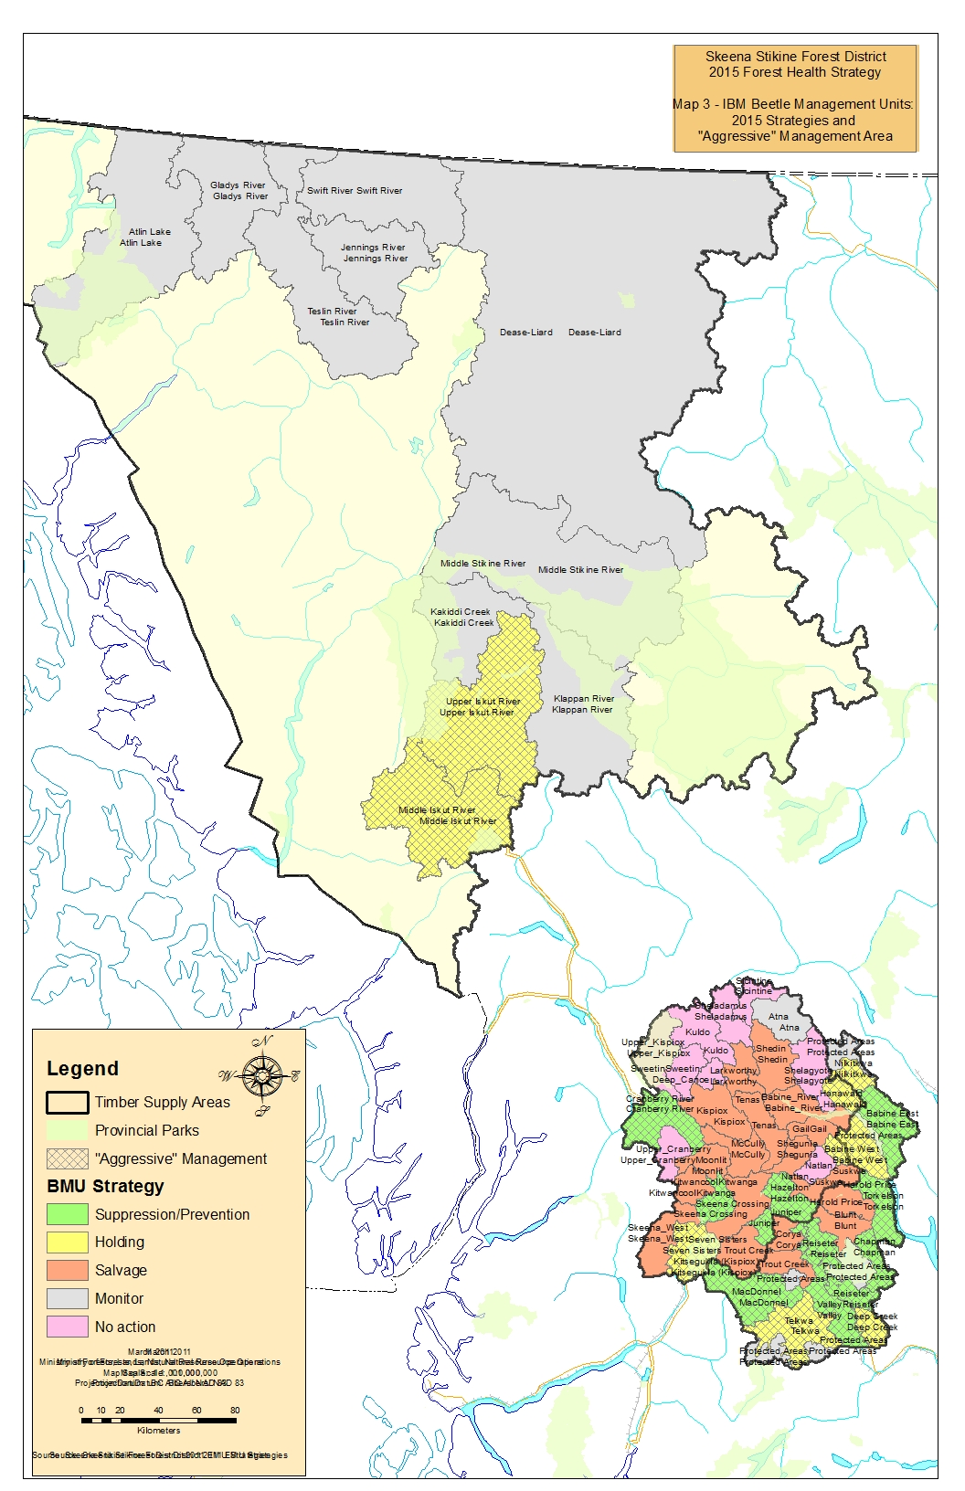
Tactic: Conduct aerial and ground surveys to capture spots or patches of current incidence; compile information
Data on spatial location and characteristics of current infestation spots and patches is required, to advise selection of BMU strategy and as the basis for Tactical Plans.
Provincial Forest Health Aerial Overview Survey (PAOS) mapping results will be employed as the main data source for selection of BMU strategy. PAOS provides general capture of broad polygons of infestation and spots, typically to <1:50,000 scale accuracy, which are suitable for this strategic use.
Beetle Tactical Plans require more detailed mapping and to a much higher standard of accuracy. A credible source for information is results from Detailed Waypoint-Based Aerial Overview Surveys (Detailed AOS), with follow-up ground probing. Survey contract standards for Detailed AOS and ground probing are provided in Appendices 1.5 and 1.6.
The District will pursue Provincial Land-Based Investment (LBI) forest health funding to support annual completion of Detailed AOS across the “aggressive” management area. Since access to this funding is not assured, as an interim measure licensees are encouraged to continue to employ standard operational approaches that yield comparable information, e.g.:
- conduct annual helicopter reconnaissance (recce) of susceptible forest within operating areas;
- obtain oblique photos of red/grey attack areas; delineate potential harvest areas and transfer to ground recce/ ground survey plan;
- ensure recce captures intensity and extent of currents associated with red/grey attack;

The District will undertake an annual compilation of any such data submitted by licensees.

Tactic: Assign risk-based Treatment Tactic to Waypoints or incidence areas; update Beetle Tactical Plans
The District will collaborate with Regional Forest Health staff and licensees in assigning a preliminary Treatment Tactic to any points and areas collected by more detailed mapping, annually by end of September. Table XX provides several concepts that advise Treatment Tactic selection; another key influence is the distance of the point or area from active roads.
Preliminary Treatment Tactics are revisited when ground probing results are available. Ground probing is typically conducted September-November. Sites determined to be likely candidates for Harvest or Fall & Burn are visited by probing crews. A split of responsibility is proposed, with major licensees responsible for ground probing of candidate Harvest sites, and District for candidate Fall&Burn sites.
The collection of points/ areas and their preliminary Treatment Tactic are the basis of Beetle Tactical Plans (section 5), which guide treatment activities. Intent is to complete a revisit of Tactical Plans by November 30 of each year.

Table XX: Mountain Pine Beetle Actioning Strategy
LRMP Zonation | Susceptibility  of Surrounding Forest | # Currents per Point or Area
 |  | 0-10 | 10-20 | 20+
 |  | Treatment Tactic
“Protected”: | Low to Mod | A | A | A, B
PR, SMZ1, CE, OGMA, SA, | High | A | B | B, D
NCO. PVQ | Extreme | A | B, D | B, D
"Special Consideration": | Low to Mod | A | A, B | B
SMZ2, RRZ, WTRA, CW, | High | A | B, C | B, C, D
WLD | Extreme | A, B | D, E | B, D, E
"Conventional": | Low – Mod | A | B, C, D | B to D
ETD, IRM, RMZ, LRC | High | A, B, D | B to E | C, D, E
 | Extreme | A, B, D | B to E | C, D, E

Zonation
PR Protected (Park, EcoReserve)
SMZ 1 Special Mgt Zone (no harvest)
CE Forest Ecosystem Network - Core area
OGMA Old Growth Management Area
SA Sensitive Area
NCO Non-Crown (e.g. Private Land, Indian Reserve)
PVQ “Preservation” Visual Quality Objective
SMZ2 Special Mgt Zone (resource value emphasis)
RRZ On-block Riparian Reserve Zone
WLD Wildlife Habitat (legal objective) – e.g Telkwa Caribou
WTRA Wildlife Tree Retention areas
CW Community Watersheds
ETD Enhanced Timber Development
IRM Integrated Resource Management
RMZ On-block Riparian Management Zone
LRC Forest Ecosystem Network – Hydroriparian corridor

Treatment Tactic
A No Treatment
B Fall and Burn
C Baiting/ Hold to Harvest
D Fall and Remove (single-tree extraction)
E Harvest (differentiate small-scale salvage (SSS) from clearcut with reserve (CCR) opportunities)

Tactic: Implement the Beetle Tactical Plan
Fall and Burn – this tactic is typically selected for isolated sites that cannot be accessed for harvest. Crews fall MPB infested trees, buck and stack the tree onto the stump, and then burn the pile to kill all beetles. Activities start in November and continue through to March. Contract standards are captured to Appendix 1.7.
Baiting/ Hold to Harvest – this tactic is selected for areas where harvesting cannot be completed before the next beetle flight. Pheromone baits are hung to attract mountain pine beetles and keep them contained to a general area prior to sanitation harvesting. Baits may also be placed to attract and hold residual beetles after an area has been logged (mop-up baiting). Baits should be hung in April-May (before ambient temperature reaches 20º C) on large, healthy, uninfested pine trees.
Regarding use of Lethal Trap Trees/MSMA (monosodium methane arsenate): historically Lethal Trap trees were used as a treatment tactic. Candidate trees were first baited to attract beetles, then within 2 weeks of beetle flight attacked trees were injected with MSMA: a systemic chemical that translocates through the stem to kill beetle larvae. Lethal trap trees were typically used in areas where lack of access precluded harvest, including Protected Areas and Parks.
The use of MSMA ceased in Skeena Stikine District prior to 2004 due to possible human health concerns. A FLNRO policy developed in the aftermath of a Forest Practices Board Audit now provides best management practices for legacy MSMA-treated trees, including reporting expectations where legacy trees are encountered (to a provincial database that details tree locations), and practice expectations including ensuring that legacy trees are left standing and conspicuously marked. A legacy tree management brochure is in Appendix 1X.
Independent scientific investigations were conducted in 2008 and 2009 to assess the degree to which residual arsenic in MSMA-treated trees poses a risk to human health. Final reports found that residual arsenic is largely confined to treated trees, and is not migrating into surrounding soil or vegetation.
Fall and Remove (single tree extraction) – this tactic is typically employed following mop-up baiting.

Harvest – primary focus should be on “sanitation logging”, i.e. harvesting of infested trees with the objective of destroying localized insect populations. The best timing for sanitation logging is after the beetle flight period (usually late August; later if weather is cool and wet) to late March, when beetles are still present in infested stems.
Also consider pre-emptive harvesting of high-risk stands, but not at the expense of sanitation harvesting.
Mountain Pine Beetle prefers large-diameter standing stems over downed stems, smaller-diameter trees, stumps, or slash. However, material originating from infested trees (cull logs, long butts, etc.) can be a source of beetles. And as beetles frequently over-winter in the lower bole of infested trees, high stumps left in winter-harvested areas may also be a source. In high to extreme hazard areas, mop-up baiting should be employed in order to attract and hold residual beetles.
Although the flight period usually occurs May to June, atypical weather conditions may lead to insect flight occurring outside this window. Harvest and haul activities can promote beetle spread. Hot milling (milling within 24 hours after transport) is recommended in such situations. Holding insect infested trees in log yard inventory or in bush decks during the flight period is not recommended: beetles may emerge and infest new areas.
It is vital to protect existing non-pine over- and understorey, both to protect stand integrity and to contribute to mid-term timber supply. Where existing spruce and balsam composition exceeds 5m²/ha basal area, consider employing an overstorey-removal harvest strategy.

Tactic: Monitor past areas; evaluate effectiveness of past practices
An essential element of any strategy is maintenance of a continuous improvement feedback loop, where practices are routinely examined for their effectiveness in delivering overarching strategies and objectives.
District staff will schedule a meeting with Regional Forest Health and major licensee staff, once annually by end of February, to review efficacy of tactics and practices. Results will be captured to future iterations of the Forest Health Strategy.

Appendix 1.1: IBM Life Cycle, Host Susceptibility, Signs & Symptoms, and Damage
Life Cycle
Per Figure 1, the Mountain Pine Beetle normally has a one-year life cycle, laying its eggs in mid summer, over-wintering as larvae, pupating in the spring and emerging as adults early in the following summer.

In what is called a 2-year cycle–but should more properly be called a 2-summer cycle– all life stages are delayed (usually because of cool weather) by 4 to 6 weeks. In these cases, the main beetle flight does not take place until much later than normal.

Occasionally, it is possible to have staggered two-year populations in the same area, and also possible to have one-year cycle beetles mixed in with two year.

Figure 1: IBM Life Cycle
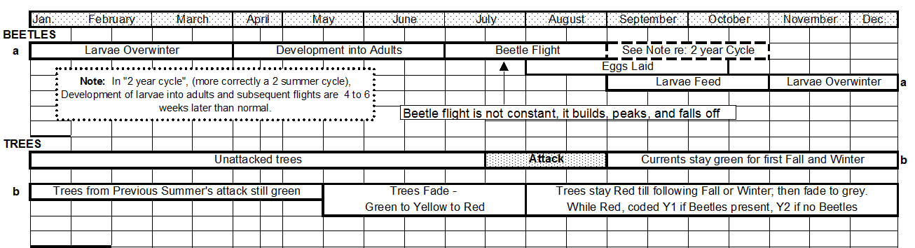

Appendix 1.2: Host Susceptibility, Signs & Symptoms, and Damage

( a scan of the IBM page from “Field Guide to Forest Damage in British Columbia” will be placed here. Also available at:
G:\!Workgrp\Stewardship\Operations\Forest Health\DSS Forest Health\2014-2015\2015 Forest Health Strategy\4_Forest Health Agents_Descr-etc\1 Mtn Pine Beetle\Appendix Items\ 2_IBM_FieldGuideScan.pdf )

Appendix 1.3: Mountain Pine Beetle Hazard Rating Documentation

(Double-click within box to expand)

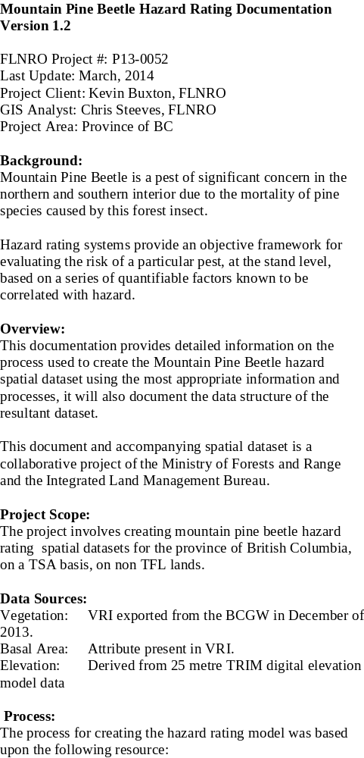

Appendix 1.4: 2015 IBM Beetle Management Unit Strategy Analysis

( a copy of the Excel –based BMU Strategy Analysis will be placed here. Also available at:
G:\!Workgrp\Stewardship\Operations\Forest Health\DSS Forest Health\2014-2015\2015 Forest Health Strategy\4_Forest Health Agents_Descr-etc\1 Mtn Pine Beetle\Appendix Items\2015_BMU_Strategy_Analysis.xlsx )

Appendix 1.5: Contract Specifications for Detailed Overview Pine Beetle Detection Surveys

(Double-click within box to expand)

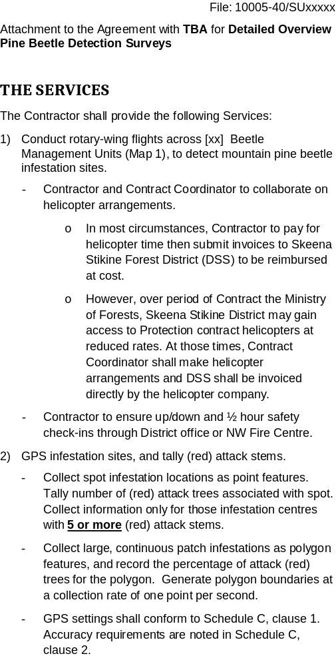

Appendix 1.6: Contract Specifications for IBM Ground Probing

(Double-click within box to expand)

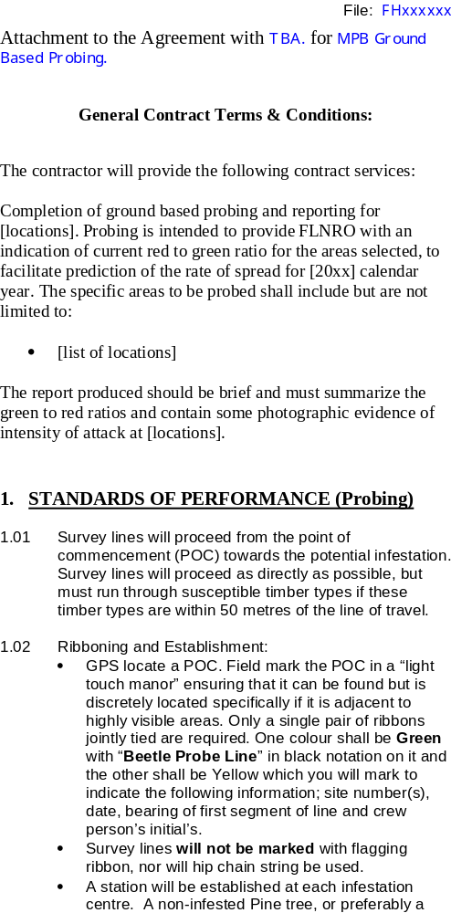

Appendix 1.7: Fall & Burn Contract Specifications (Double-click within box to expand)
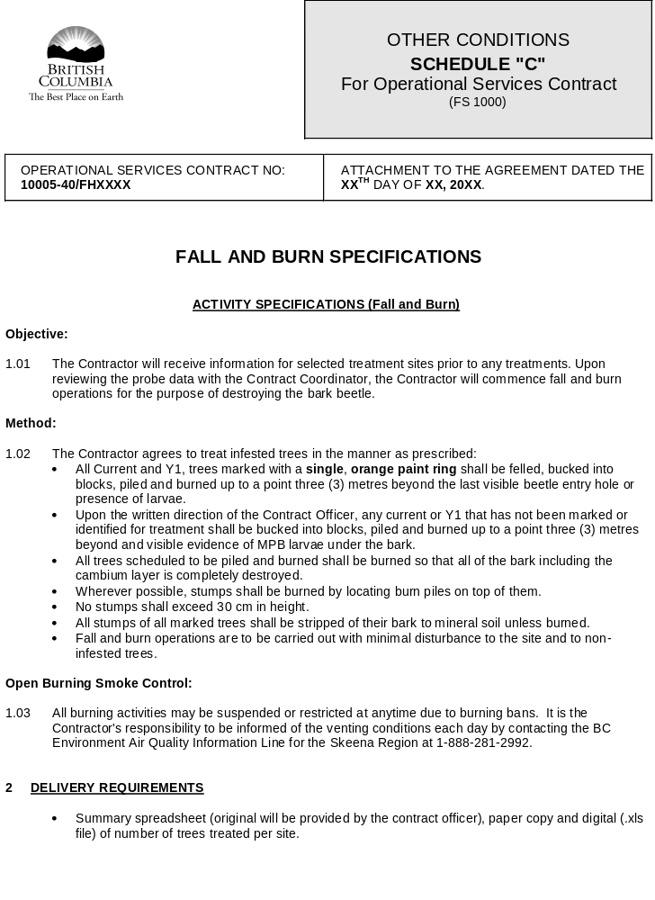
Appendix 1.8: MSMA Legacy Trees Brochure

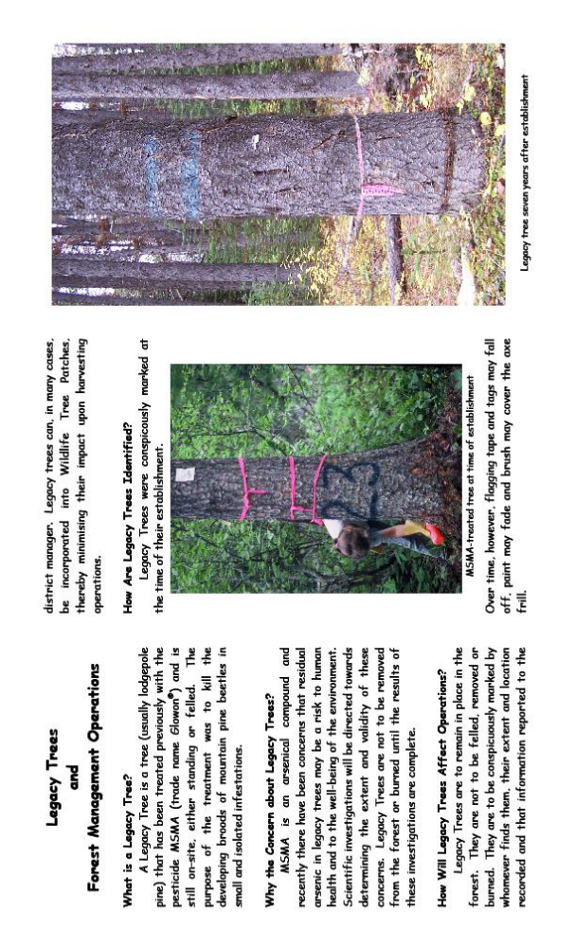
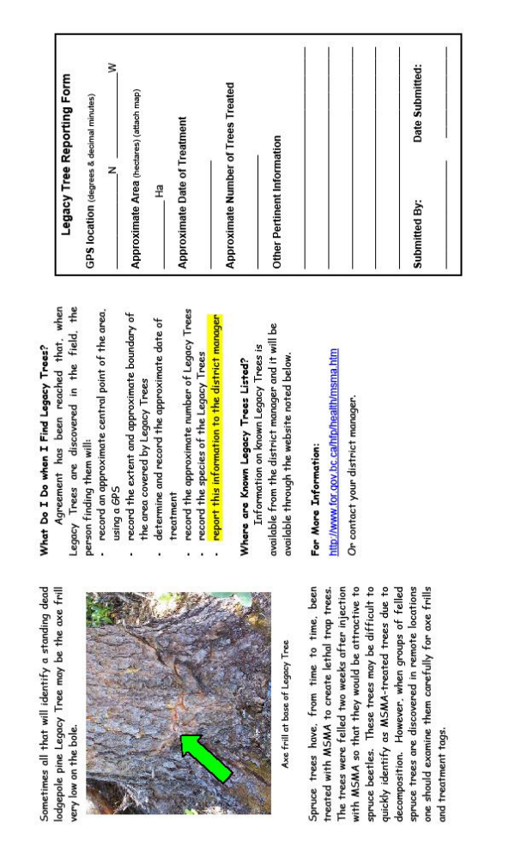

Per 2013 BC Provincial-Scale Mountain Pine Beetle (BCMPB) Model predictions
Appendix 1X provides modelling logic and geoprocessing steps used to derive hazard mapping.
PAOS yields mapped polygons that are assigned a Severity Rating of Trace (<1% recently killed), Light (1-10%), Moderate (11-29%), Severe (30-49%), and Very Severe (50% +). To produce Table XX, a single mortality figure was first selected to represent each Severity class (1% for Trace, 5% for Light, 20% fir Moderate, 40% for Severe, and 75% for Very Severe). The figures provided represent the sum of [(selected mortality figure for a Severity class) x (PAOS Severity class area)].
Guidance for Provincial Bark Beetle Management Technical Implementation Guidelines (PBBMTIG), Spring 2003

