4.2.2 Spruce Beetle (IBS) Dendroctonus rufipennis (Kirby)
Description
See Appendix 1X for descriptions of IBS Host Susceptibility, Signs & Symptoms, and Damage.
IBS is known to cause widespread damage in mature spruce forests in BC. It has significant potential to adversely affect most species of spruce that are present within DSS, including white, hybrid, Engelmann, Sitka, and black.
IBS generally has a two-year life cycle, laying eggs in mid summer, over-wintering once as larvae and again as immature adults to emerge and fly in early summer of the 2nd year. Abnormally warm weather can trigger a one-year life cycle, and there have been rare reports of a three-year cycle in higher elevation sites. It is possible to have staggered two-year populations in the same area, and one-year cycle beetles mixed in with two-year cycle beetles.
IBS is similar to other native bark beetles (IBM, IBB) in that larvae feeding in the phloem of the tree introduce a fungus, which together with the larval mining can halt translocation leading to mortality. A key difference is that spruce foliage does not turn red as rapidly as lodgepole pine and subalpine fir. Spruce crown symptoms typically do not occur until 18 to 24 months after successful attack. Transition from red to grey can occur rapidly, often over the course of a few weeks.
IBS is a priority forest health agent for Skeena Stikine District because there are large areas of contiguous susceptible forest in each of the TSA’s (spruce comprises 20%, 8% and 32%, respectively, of Bulkley, Kispiox, and Cassiar TSA’s forested landbases).

Extent
There has been a history of IBS infestation in Bulkley TSA. IBS outbreaks the 1970’s and 80’s infested relatively large areas in the Chapman and Coffin Lake areas of Bulkley TSA, resulting in spruce mortality and subsequent salvage logging.
Map 4 shows areas and points of known current incidence, against a background of forest classified as moderate to high IBS hazard. Table/Figure XX show current incidence trends by TSA from 2011 to 2015, highlighting a recent increase in IBS-related mortality in Bulkley TSA and generally low current incidence levels across remaining TSA’s.
Table/Figure XX: Provincial Annual Overview Survey (PAOS) Summary, 2011-2015
 | IBS - Affected/Killed Area (ha), by Year
Timber Supply Area | 2011 | 2012 | 2013 | 2014 | 2015
Bulkley | 0.0 | 0.1 | 0.0 | 13.1 | 128.3
Kispiox | 0.2 | 0.2 | 1.0 | 0.1 | 3.0
Cassiar | 0.0 | 0.1 | 1.1 | 20.3 | 3.2
Totals: | 0 | 0 | 2 | 33 | 169

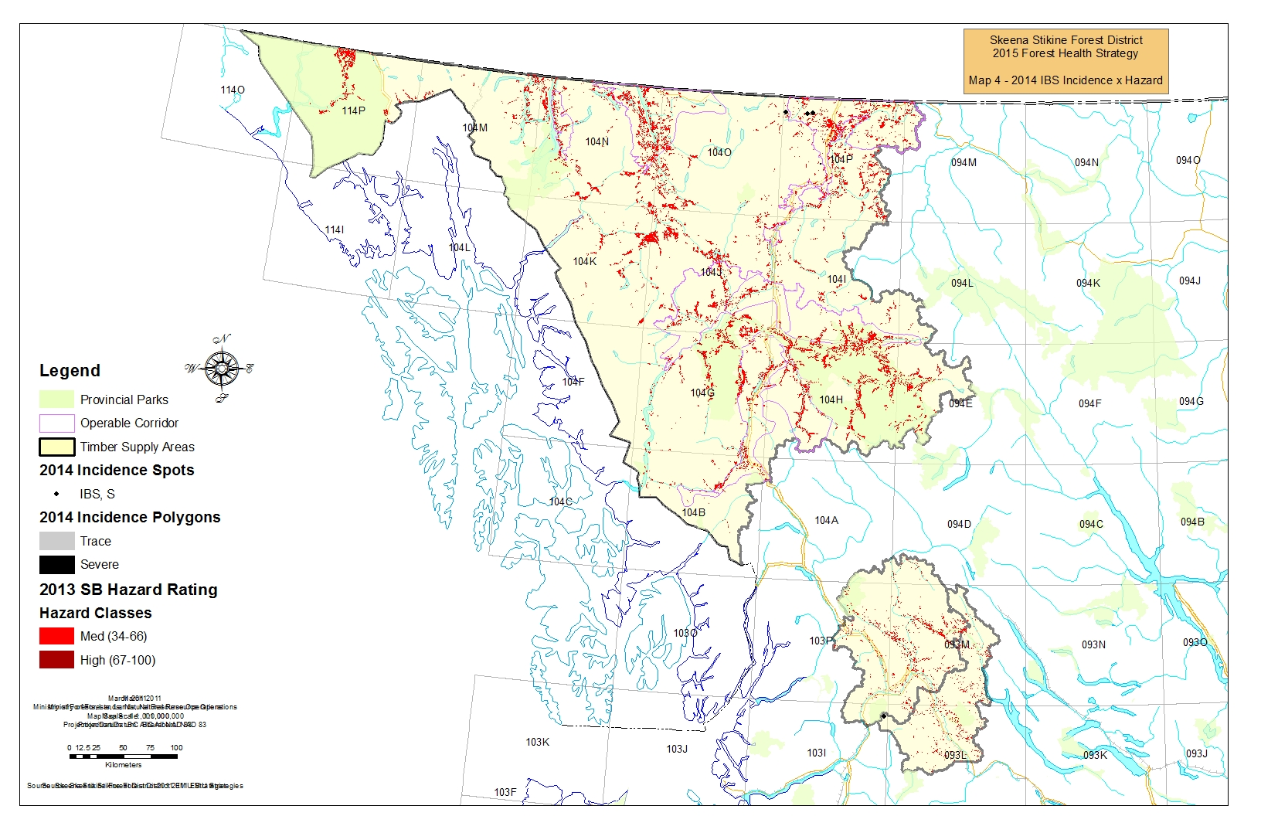
Non-Recoverable Loss (NRL) Assumptions and Estimation from Timber Supply Reviews (TSR)
Bulkley TSR3 (2011 currency); Kispiox TSR3 (2006 currency); Cassiar TSR3 (2013 currency)
- IBS NRL’s were determined to be unnecessary in all cases. VDYP yield curves already account for volume losses due to mortality caused by natural, endemic levels of insect infestation, and during the previous 10 year period IBS incidence in each TSA was low to nil.
Objectives, Strategies, Tactics & Best Management Practices
Overarching objectives from the 2013-2016 Provincial Forest Health Strategy are as follows:
Objective 1: Pest impacts are monitored and assessed
Objective 2: Practices are adapted to accommodate known forest health risks
Objective 3: Resources are protected through appropriately applied direct management actions

Strategy:
Maintain current infestation levels at or below thresholds suggested by provincial guidance for designated Beetle Management Units (BMU’s):
- Suppression/Prevention BMU’s: <= 20% current infestation
- Holding BMU’s: < 50% current infestation

Table XX provides tactics aimed at achievement of objectives and strategies, and recommended timing and delivery agents. Tactics are not independent, i.e. they should be delivered as a suite and in the order and timing provided in Table XX. Tactic context is provided below the table.

Table XX: IBS Tactics
Objective No. | Tactic (BMP) | Timing | Responsibility
1 | Complete and maintain Hazard/ Susceptibility mapping | Ongoing | MOF Branch
2 | Update Beetle Management Unit (BMU) designations and identify “aggressive” management areas | By April, year 0 | MOF District (Licensee input)
1 | Conduct aerial and ground surveys to capture spots and patches of current incidence; compile information | Aug-Sept, year 0 | : Provincial AOS - MOF Branch & Region;  : Detailed Waypoint-Based AOS - MOF District to coordinate
1, 2 | Assign risk-based Actioning Strategy to incidence points or areas; update Beetle Tactical Plans; Consult | Oct-Dec, year 0 | : Ground surveys/probing – MOF District, Licensees  : Compilation – MOF District
2, 3 | Implement the Beetle Tactical Plan | Fall/ Winter year 0/1 | : Ground surveys/probing - MOF District, Licensees
2 | Evaluate effectiveness of practices and tactics at achieving BMU strategy; modify as necessary | Mar-Apr, year 1, then cycle begins again | FLNRO District & Region, Licensees

Tactic: Complete and maintain Hazard/ Susceptibility mapping
Susceptibility (hazard) mapping is an essential tool for assessing the relative risk a forest health agent poses to forest resource. In 2014, FLNRO Branch Forest Health staff released mountain pine beetle, spruce beetle, and Douglas-fir beetle susceptibility mapping for each TSA in the Province. Vegetation Resources Inventory (VRI) and other overlay data current to fall 2013 was used. Their intent is to keep this mapping current.

The following link provides access to spatial susceptibility data and supporting documentation for download: ftp://ftp.for.gov.bc.ca/HFP/external/!publish/barkbeetles/New%20Susceptibility%20Ratings/

Tactic: Update Beetle Management Unit (BMU) designations and identify “aggressive” management areas

2002/2003 saw the establishment of provincial Orders for Emergency Bark Beetle Management Area and Units (EBBMA and EMU’s) for IBM, IBS, and Douglas-fir Beetle.
The provincial bark beetle coordinator accepted Bulkley and Kispiox IBS EMU’s into the EBBMA from 2003-2011, although as a result of nil to low infestation levels during that time, provincial forest health funding for control actions was neither sought nor provided.
In addition to enabling access to funding, EBBMA inclusion enabled access to administrative and policy tools for expedited harvest:
- Section 1.5.1.1 of the Interior Appraisal Manual (IAM), identified EBBMA as areas where a comparative cruise may be utilized. https://www.for.gov.bc.ca/ftp/hva/external/!publish/web/manuals/interior/2014/Interior2014NovMaster_1.pdf
- Section 2.11.2 of the Cutting Permit and Road Tenure Administration Manual (CPRT) identified EBBMA as operational guidance for a Delegated Decision Maker to consider in reaching decision on applications for blanket salvage permits. https://www.for.gov.bc.ca/dkm/ESF_Info/CPRT_Admin_Manual_ver3.pdf
The July 2014 “Order for Disestablishment of Emergency Bark Beetle Management Area and Units” repealed provincial Orders establishing EBBMA’s.
In the absence of EBBMA, the DDM has authority to identify which IBS BMU’s can comprise localized “aggressive” management areas, within which the DDM will be generally supportive of client applications for blanket salvage permits and/or for the use of the comparative cruise option for harvest of dead and damaged spruce.
Consistent with the July 2014 FLNRO Deputy Minister memorandum regarding Blanket Salvage Cutting Permits https://www.for.gov.bc.ca/ftp/HTH/external/!publish/web/timber-tenures/BSP/Memo-july-3-2014.pdf, the DDM will also consider case by case approval of major licensee application for blanket salvage permits to harvest dead or damaged timber in BMU’s outside the “aggressive” management area, where it can be established that the timber cannot logically be added to an approved or potentially planned harvesting opportunity.
The District Forest Health Strategy as annually updated will be the vehicle used by the DDM to communicate the extent of the “aggressive” management area. For 2015, the extent of the “aggressive” management area for IBS shall correspond to that for IBM. Table XX and Map 3 shows which IBM BMU’s are included in the “aggressive” management area.
Table XX: Beetle Management Units (BMU) in “Aggressive” Management Area
TSA | BMU | Strategy
Bulkley | Babine East | Suppression/Prevention
Bulkley | Babine West | Holding
Bulkley | Chapman | Suppression/Prevention
Bulkley | Deep Creek | Holding
Bulkley | MacDonnel | Suppression/Prevention
Bulkley | Nilkitkwa | Holding
Bulkley | Reiseter | Suppression/Prevention
Bulkley | Telkwa | Holding
Bulkley | Torkelson | Suppression/Prevention
Bulkley | Valley | Suppression/Prevention
Kispiox | Cranberry River | Suppression/Prevention
Kispiox | Hanawald | Holding
Kispiox | Hazelton | Suppression/Prevention
Kispiox | Juniper | Suppression/Prevention
Kispiox | Kitwanga | Suppression/Prevention
Kispiox | Seven Sisters | Holding
Cassiar | Middle Iskut River | Holding
Cassiar | Upper Iskut River | Holding

Tactic: Conduct aerial and ground surveys to capture spots or patches of current incidence; compile information
Data on spatial location and characteristics of current infestation spots and patches is required, to advise selection of BMU strategy and as the basis for Tactical Plans.
In future years Provincial Forest Health Aerial Overview Survey (PAOS) mapping results will be employed as the main data source for selection of BMU strategy. PAOS provides general capture of broad polygons of infestation and spots, typically to <1:50,000 scale accuracy, which are suitable for this strategic use.
Beetle Tactical Plans require more detailed mapping and to a much higher standard of accuracy. A credible source for information is results from Detailed Waypoint-Based Aerial Overview Surveys (Detailed AOS), with follow-up ground probing.
Survey contract standards for Detailed AOS and ground probing are provided in Appendix 1X.
- Recent IBS infestations can be difficult to locate from the air because infested trees may stay green up to 24 months following initial attack. Surveyors must be on the lookout for spots and areas of older attack, and areas of recent spruce blowdown which are favoured IBS breeding material.
Contract specifications for IBM ground probing are captured to Appendix 1X. Comparable procedures apply to IBS, except attack and marking codes are as per Table XX.
Table XX: Spruce Beetle (IBS) Attack and Marking Codes
Code | Attack Description | Tree Marking Code
SY1 | Year 1 – green-attacked trees, no exit holes, live IBS present | “SY1” and one paint ring
SY2 | Year 2 – trees starting to red-flag, IBS typically has moved down into lower bole and roots | “SY2” and two paint rings
G | Year 3+ - Dead – no needles, no live beetles present | “G”, no other marking required
S | Strip attack – live IBS on <50% of bole circumference | “S” and one paint ring
PO | Pitch Out – unsuccessful current attack: large gooey pitch tubes, resinous red frass, and pitch-filled egg galleries | “PO”, no other marking required
X | Dead – tree killed by another forest health agent | “X”, no other marking required

The District will pursue Provincial Land-Based Investment (LBI) forest health funding to support annual completion of Detailed AOS across the “aggressive” management area for both IBM and IBS. Since access to this funding is not assured, as an interim measure licensees are encouraged to continue to employ standard operational approaches that yield comparable information, e.g.:
- conduct annual helicopter reconnaissance (recce) of susceptible forest within operating areas;
- obtain oblique photos of red/grey attack areas; delineate potential harvest areas and transfer to ground recce/ ground survey plan;
- ensure recce captures intensity and extent of currents associated with red/grey attack;

The District will undertake an annual compilation of any such data submitted by licensees.

Tactic: Assign risk-based Treatment Tactic to Waypoints or incidence areas; update Beetle Tactical Plans
The District will collaborate with Regional Forest Health staff and licensees in assigning a preliminary Treatment Tactic to any IBS points and areas collected by more detailed mapping, annually by end of September. Tactic assignment concepts shall mirror those used for IBM.
Preliminary Treatment Tactics are revisited when ground probing results are available. Ground probing is typically conducted September-November. Sites determined to be likely candidates for Harvest or Fall & Burn are visited by probing crews. A split of responsibility is proposed, with major licensees responsible for ground probing of candidate Harvest sites, and District for candidate Fall&Burn sites.
Contract specifications for IBM ground probing are captured to Appendix 1X. Comparable procedures apply to IBS, except see Appendix XX for IBS Attack Codes.
The collection of points/ areas and their preliminary Treatment Tactic are the basis of Beetle Tactical Plans (section 5), which guide treatment activities. Intent is to complete a revisit of Tactical Plans by November 30 of each year.

Tactic: Implement the Beetle Tactical Plan
Harvest – primary focus should be on “sanitation logging”, i.e. harvesting of infested trees with the objective of destroying localized insect populations. The best timing for sanitation logging is between mid-summer and autumn for 1-year cycle beetles, or in autumn of the second year for 2 year cycle beetle.
As beetles frequently over-winter in the lower bole of infested trees, high stumps left in winter-harvested areas may also be a source. In high to extreme hazard areas, trap trees or mop-up baiting should be employed to attract and hold residual beetles.
Windthrown spruce trees and large pieces of slash are prime IBS breeding material. Large-scale blowdown of spruce trees should be prioritized for ground assessment and salvage logging. Employ clean logging practices when harvesting in high hazard spruce beetle stands.
Spruce trees felled and decked during harvest are also likely breeding material. Rights of Way and decked wood should be promptly removed from the site for milling.

Conventional Trap Trees
IBS prefer downed spruce logs as breeding material. Large healthy spruce trap trees felled and left on site will draw beetles from living, standing trees. Trap trees can also be used to attract residual beetles emerging from stumps or slash (I.e. mop-up).
- Trap trees should be large healthy, uninfested spruce, felled inside or within a 400 metres radius of spruce beetle infestation areas – although trap trees may attract beetles from up to 800 meters away,
- Trees should be felled into shade, and not bucked or limbed, to keep them cool and to slow the drying-out process. Trees should not be resting on the ground but be close allowing attack to occur on the underside of the bole of the tree.
- The trap trees should be felled in small patches of 15 to 25 trees (truckload) spaced roughly 400 m along a roadway, on alternating sides of the road if possible, close to known beetle infestations (~800 m, preferably less). This level of distribution should be sufficient for light to moderate populations. For heavier populations, spacing of a higher frequency is required such as every 200 m on alternating sides of the road. Freshly blown down spruce must be worked into the trap configuration as these provide the most ideal habitat and may already have populations building in them.
- Trap trees should be felled in late spring prior to the flight and after large snowfalls. Felling trees in the fall or winter is marginally acceptable but not preferred. Trees should be well marked so that the logs may be easily found again, even under a covering of snow. It is recommended that trap trees be removed from site and debarked and/or milled to destroy IBS.
- Under no circumstances should trap trees be left over two flight windows, else they may release the insects collected the year before.
Normal harvesting practices can be modified to take the place of trap trees. Rights-of-way or pre-felled uninfested spruce trees may be left on site over the flight window to act as trap trees. Any such wood should be examined for beetles and treated (milled or debarked) prior to the next winter if infested.
Regarding use of Lethal Trap Trees/ MSMA – see IBM writeup.
Baiting/ Hold to Harvest – this tactic is selected for areas where harvesting cannot be completed before the next beetle flight, and for smaller, distinct blocks having a light scattered attack with no heavily infested patches. Baiting costs are recognized as a “Forest Management Administration” cost to the Interior Appraisal Manual.
Synthetic pheromones (baits) mimic the chemical signals beetles emanate when initially attacking a susceptible spruce tree, and can be effective at drawing large numbers of beetles. It is not necessary to bait in conjunction with felling of trap trees, as trap trees alone are sufficient to draw beetles. Downed trap trees typically attract and hold many more beetles than baited trees.
Place baits in a 50 m x 50 m grid pattern (4 baits per hectare) on large healthy, uninfested spruce trees in infested stands, as a temporary holding tactic until sanitation harvesting can be completed. Ensure grid baiting is installed in spring no later than mid-May (i.e. before the beetle flight), on cutting permits scheduled for harvesting in the following fall/winter.
Pheromone suppliers typically do not keep large quantities on hand because shelf life is limited. As such suppliers require notification to manufacture the products. Recommended suppliers:
Synergy Semiochemicals Corp.
Email: synergy@semiochemical.com
Phone: 604-454-1122 or 604-568-8501
Contact: Dave Wakarchuk

WestGreen Global Technologies
Email: net2officebthomson@shaw.ca
Phone (778) 298-8798
Contact: Bruce Thomson

Scotts Canada Ltd.
Email: lawrence.vanderark@scotts.com
Phone: 604-940-9944, ext 312
Contact: Lawrence Vanderark

Fall and burn/ fall and peel
Handfalling, bucking, or debarking and burning of actively infested spruce trees are effective control strategies for small inoperable or isolated infestations. This option is the only one currently available for treating infestations in inoperable areas., and is unlikely to be implemented frequently due to the expense and worker safety concerns.
Crews fall IBS-infested trees, buck and stack the tree onto the stump, and then burn the pile to kill all beetles. Activities start in November and continue through to March. Contract standards are captured to Appendix 1X.

Tactic: Monitor past areas; evaluate effectiveness of past practices
An essential element of any strategy is maintenance of a continuous improvement feedback loop, where practices are routinely examined for their effectiveness in delivering overarching strategies and objectives.
District staff will schedule a meeting with Regional Forest Health and major licensee staff, once annually by end of February, to review efficacy of tactics and practices. Results will be captured to future iterations of the Forest Health Strategy.

Appendix 1X provides modelling logic and geoprocessing steps used to derive hazard mapping.
PAOS yields mapped polygons that are assigned a Severity Rating of Trace (<1% recently killed), Light (1-10%), Moderate (11-29%), Severe (30-49%), and Very Severe (50% +). To produce Table XX, a single mortality figure was first selected to represent each Severity class (1% for Trace, 5% for Light, 20% fir Moderate, 40% for Severe, and 75% for Very Severe). The figures provided represent the sum of [(selected mortality figure for a Severity class) x (PAOS Severity class area)].
Guidance for Provincial Bark Beetle Management Technical Implementation Guidelines (PBBMTIG), Spring 2003

