4.2.3 Western balsam bark beetle (IBB) Dryocoetes confusus (Swaine)
Description
See Appendix 1X for descriptions of IBB Host Susceptibility, Signs & Symptoms, and Damage.
Western balsam bark beetle (IBB) is the most destructive pest of mature subalpine and amabilis fir (“balsam”) in Skeena Stikine District. It is a high risk forest health agent for Skeena Stikine District because its presence is widespread, and because there are significant areas of contiguous susceptible forest in each of the TSA’s. Balsam comprises 60%, 40% and 24%, respectively, of Bulkley, Kispiox, and Cassiar TSA’s forested landbases.
IBB typically has a 2-year life cycle, during which the adult may lay up to 3 sets of eggs – one in the first summer, and two in the second – resulting in multiple and overlapping broods. Adult beetles initially fly in early to mid-summer and lay their first set of eggs, then overwinter under bark with the developing 1st brood. In the second summer adults elongate their galleries and lay another brood, then emerge to fly again and potentially lay a third set of eggs in the same or neighbouring trees.
The IBB 1st brood overwinters as larvae in year 1, then as callow adults in year 2. The 2nd and 3rd brood develop into larvae then over-winter with the 1st year brood, which have now developed into callow adults. In the third summer the 1st brood emerges as adults. The 2nd and 3rd brood over-winter as callow adults, then emerge and fly as adults in the middle of the 4th summer. Thus a total of 4 summers and 3 winters pass from the initial flight to the flight of the last set of brood.
Similar to other bark beetles larval mining introduces a fungus, lesions from which can girdle a tree, causing translocation through the phloem to cease and resulting in mortality.
Extent
IBB is widespread throughout balsam-leading stands at higher elevations in all TSA’s at primarily trace to low intensity levels. It is a chronic endemic pest, considered responsible for approximately 5% stand-level balsam mortality each year. Over time, significant mortality has occurred. Typically, the largest and highest volume trees are killed, leaving canopy gaps that fill with younger cohorts and a forest matrix where merchantable stand volumes stabilize at <70% of potential.
Map 6 shows areas and points of known current incidence, against a background of forest classified as moderate to high IBB hazard. Table/Figure XX show current incidence trends by TSA from 2011 to 2014, highlighting recent strong increases in IBB spread.
Table/Figure XX: Provincial Annual Overview Survey (PAOS) Summary, 2011-2014
 | IBB - Affected/Killed Area (ha), by Year
Timber Supply Area | 2011 | 2012 | 2013 | 2014
Bulkley | 127 | 604 | 2014 | 2544
Kispiox | 245 | 711 | 1736 | 2585
Cassiar | 0 | 472 | 1557 | 1987
Totals: | 373 | 1787 | 5308 | 7116

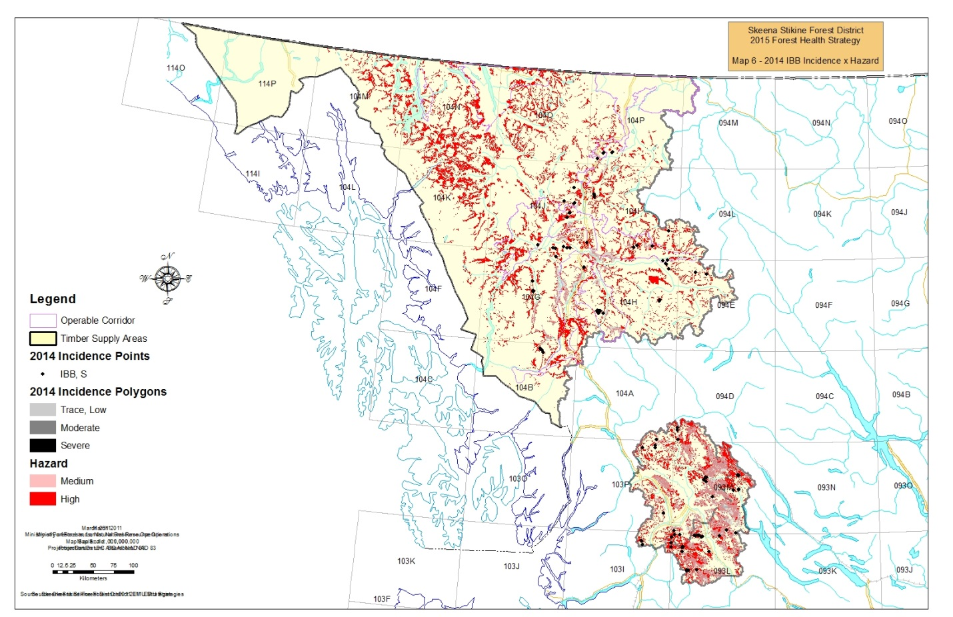
Non-Recoverable Loss (NRL) Assumptions and Estimation from Timber Supply Reviews (TSR)
Bulkley TSR3 (2011 currency); Kispiox TSR3 (2006 currency); Cassiar TSR3 (2013 currency)
A study by the Regional Entomologist comparing ground survey mortality to estimated losses concluded that IBB mortality is adequately accounted for in VDYP yield estimates as natural endemic losses. Therefore, no IBB NRL’s were calculated. A resurvey of these same balsam-leading stands has been undertaken by the Regional Entomologist to look at further mortality, but the remeasurement data is still awaiting analysis. This analysis should give a clearer indication of actual losses to IBB.
Tactics & Best Management Practices
Tactic (BMP) | Timing | Responsibility
Facilitate modified fire response | By March, year 0 | FLNRO District, WMB
Identify “aggressive” management area | By March, year 0 | FLNRO District (Licensee input)
Spatially capture spots and patches of significant historic and current incidence ; compile information | June-August, year 0 | : Provincial AOS - FLNRO Branch & Region;  : Compilation – FLNRO District
Assign Actioning Strategy to patches; update Beetle Tactical Plan | Sept-Nov, year 0 | FLNRO District & Region, Licensees
Implement the Beetle Tactical Plan | Fall/ Winter year 0/1 | FLNRO District, Licensees
Evaluate effectiveness of practices and tactics; modify as necessary | Jan-Feb, year 1, then cycle begins again | FLNRO District & Region, Licensees

Tactic: Facilitate modified fire response
In Bulkley TSA, high-elevation balsam-leading forest is concentrated in ESSF subzones (ESSF mc, wv). Diligent fire suppression efforts have resulted in few and small ESSF wildfires in the past 2 decades, despite an expectation that ESSFmc (comprising 28% of the THLB) will see 20-1000 ha wildfires naturally recurring on a 200 year interval. Large-scale wildfires can significantly aid efforts to suppress or slow the spread of landscape-wide pests such as IBB, as fires “sanitize” stands of their pests, and permit the establishment of young vigorous forest.
The District and local Wildfire Management Branch (WMB) staff undertake an annual update to the DSS Fire Management Plan, which advises WMB’s initial fire response. Response can range from full suppression, to modified approaches where fires are monitored but permitted to burn. District intent is to ensure inclusion of low-risk Bulkley ESSF balsam-leading forests in the Modified Response zone.
Tactic: Identify “aggressive” management area
In the absence of a designated Emergency Bark Beetle Management Area (EBBMA), the DDM has new authority to identify “aggressive” management areas for control of bark beetles, typically for mountain pine beetle, spruce beetle and Douglas-fir beetle but not specifically excluding IBB.
Within an “aggressive” management area for IBB, the DDM will be generally supportive of client applications for blanket salvage permits for harvest of dead and damaged subalpine and amabilis fir (including access to Interior Appraisal Manual Table 6-4 sawlog stumpage rates for salvage of damaged timber) and/or for the use of the comparative cruise option.
Consistent with the July 2014 FLNRO Deputy Minister memorandum regarding Blanket Salvage Cutting Permits https://www.for.gov.bc.ca/ftp/HTH/external/!publish/web/timber-tenures/BSP/Memo-july-3-2014.pdf, the DDM will also consider case by case approval of client application for blanket salvage permits to harvest dead or damaged timber outside the “aggressive” management area, where it can be established that the timber cannot logically be added to an approved or potentially planned harvesting opportunity.
The District Forest Health Strategy as annually updated will be the vehicle used by the DDM to communicate the extent of an IBB “aggressive” management area. The 2015/16 extent is set to [Timber Harvesting Landbase (THLB) within the ESSF biogeoclimatic zone of Bulkley TSA], for the following reasons:
- The largest concentration of forest susceptible to IBB is present in the ESSF;
- Historic and current IBB incidence is strongly associated with the ESSF;
- Bulkley TSA is unique amongst the TSA’s managed by DSS in that its Allowable Annual Cut (AAC) includes a quality-based partition: the 852 000 m3/year overall AAC has a partition of 502,700 m3/year attributable to sawlog stand types. Remaining AAC harvest must be from stand types characterized as “marginal sawlog” or “pulp” quality.
  - There is a concentration of these types in the ESSF, including stands that have been subject to recurrent IBB infestation.
  - Harvest performance in the marginal sawlog/pulp profile has been poor, e.g. averaging less than 25% of available AAC between 2006-2010.
  - The stability of the mid- to long-term sawlog timber supply forecast is reliant on full harvest of the AAC for the marginal sawlog/pulp quality profile and conversion to thrifty second growth stands. Licensees advise that current market conditions do not permit economical harvest of these stands. Access to the administrative tools made available within a defined IBB “aggressive” management area could improve economic viability of these more marginal types that are affected by IBB.
Tactic: Spatially capture spots and patches of significant historic and current incidence; compile information
To advise creation of an initial IBB Tactical Plan for 2015, the District has spatially compiled IBB patches and spots from sources including the 2011 Bulkley Vegetation Resources Inventory (VRI), and Provincial Aerial Overview Survey (PAOS) spatials.
- The 2011 Bulkley VRI was queried to compile an inventory of balsam-leading ESSF VRI polygons within the THLB, photo-interpreted as having trace to very severe levels of IBB incidence occurring between 2001 and 2011.
  - Affected balsam are now grey-attack, but from operational experience dead balsam has been known to retain merchantability characteristics (i.e. stay sound) for 20 or more years following mortality. VRI polygons with severe to very severe IBB incidence (>30%) are a potential focus for salvage operations, and there is strong likelihood that IBB will be present in the residual stand or surrounding balsam-leading stands.
- PAOS provides spatial capture of infestation patches and spots - to <1:50,000 scale accuracy – and a statement of relative attack intensity. The District has compiled 2009-2014 patches (severe to very severe IBB incidence) and spots (severe incidence only) associated with ESSF balsam-leading stands in the THLB as best available information on locations for recent and current IBB attack.
  - PAOS “spots” average 10-25 red-attack trees, and by convention are considered to represent 0.25-0.5 ha of severely (>30%) infested forest.
PAOS mapping is relatively low accuracy. Ideally an IBB Tactical Plan would be supported by an annual program of Detailed Aerial Overview Surveys (AOS), but IBB infestation is widespread throughout Bulkley TSA and the Forest Health LBIS budget for DSS (typically $3000) is insufficient.
- District will continue to compile new PAOS spatials for future IBB Tactical Plans.
- The Regional Entomologist has also committed to present a case to have the PAOS survey approach modified
– specifically for Bulkley TSA - to permit more accurate mapping of >5ha patches of combined red/grey IBB attack.
Licensees are also encouraged to continue to employ approaches that may yield comparable information, e.g.:
- helicopter reconnaissance (recce) of susceptible forest within operating areas;
- obtain oblique photos of red/grey attack areas; delineate potential harvest areas and transfer to ground recce/ ground survey plan;
- ensure recce captures intensity and extent of currents associated with red/grey attack.

The District will commit to compile any such spatial data submitted by licensees.

Tactic: Assign Actioning Strategy; update Beetle Tactical Plan
The District will collaborate with Regional Forest Health staff and licensees in assigning a preliminary Treatment Tactic to IBB spots and patches, annually by end of September. The collection of spots/ patches and their preliminary Treatment Tactic are the basis of the IBB Tactical Plan (section 5), which guides treatment activities. Intent is to complete a revisit of Tactical Plans by November 30 of each year.
Table XX lists considerations that can be used to guide Treatment Tactic selection.
Table XX: IBB Actioning Strategy (Assumes High Hazard Forest)
LRMP Zonation | Distance from active road | Spot versus Patch
 |  | Spot | Patch <5ha |  | Patch >=5 ha
 |  | Treatment Tactic
“Protected” | > 500m | A |  | A |  | A
PR, SMZ1, NCO. PVQ, | <= 500m | B |  | A |  | A
WTRA, RRZ
"Special Consideration" | > 500m | A |  | A |  | A
CE, WHA | <= 500m | B |  | C, D |  | C, D
"Conventional" | > 1000m | A |  | A |  | A
SMZ2, ETD, IRM, RMZ | <= 1000m | B |  | C, D |  | C, D, E

Zonation
PR Protected (Park, EcoReserve)
SMZ 1 Special Mgt Zone (no harvest)
CE Forest Ecosystem Network - Core area
NCO Non-Crown Ownership (e.g. Private Land, Indian Reserve)
PVQ “Preservation” Visual Quality Objective
WHA Wildlife Habitat Area, legal Order

SMZ2 Special Mgt Zone (resource value emphasis)
RRZ On-block Riparian Reserve Zone
WLD Wildlife Habitat (legal objective) – e.g Telkwa Caribou
WTRA Wildlife Tree Retention areas
CW Community Watersheds
ETD Enhanced Timber Development
IRM Integrated Resource Management
RMZ On-block Riparian Management Zone
LRC Forest Ecosystem Network – Hydroriparian corridor

Treatment Tactic
A No Treatment
B Fall & Burn
C Baiting/ Hold to Harvest
D Harvest – Small-Scale Salvage (SSS)
E Harvest – Clearcut with Reserves (CCR)

Preliminary Treatment Tactics are revisited when ground probing results are available. Ground probing is typically conducted September-November. Sites determined to be likely candidates for Harvest are visited by probing crews. A split of responsibility is proposed, with major licensees responsible for ground probing of candidate Harvest sites, and District for candidate Fall&Burn sites.
Contract specifications for IBM ground probing are captured to Appendix 1X. Comparable procedures apply to IBB, except Table XX attack codes should be substituted.
Table XX: Balsam Bark Beetle (IBB) Attack Codes
Tree Code | Phase of Attack | Year and Type of Attack
1 | Green Attack,  Unconfirmed | Resin and pitch visible above 2m on bole, but no symptoms at breast height.
2 | Green Attack,  Confirmed | Frass and resin visible on bole or beetles verified under bark in larval stages, at breast height on bole.
3 | Red Attack | Frass and/or resin, some beetles in brood adult phase ready to fly the following season.
4 | Red Tree | Red foliage, still fairly full crown, but beetles gone. Evidence of beetle activity may or may not be present under bark at breast height.
5 | Grey Trees | Old beetle-killed tree, Needles mostly gone (>50% of crown), Most fine branches retained, bark still intact. Barely merchantable.
6 | Grey Trees | Old beetle-killed tree, bark cracked/sloughing off, fine branches mostly gone. Non-Merchantable.
Bo | Grey Trees | Dead Balsam with no evidence of bark beetle attack. Killed by some other unidentified agent (insect or pathogen).

Tactic: Implement the Beetle Tactical Plan
Fall and Burn – this tactic is typically selected for isolated sites that cannot be accessed for harvest. Crews fall infested trees, buck and stack onto the stump, and then burn the pile to kill all beetles. Activities start in November and continue through to March. Contract standards are captured to Appendix 1.7.
Baiting/ Hold to Harvest – this tactic is selected for areas where harvesting cannot be completed before the next beetle flight. Pheromone baits are hung to attract beetles and keep them contained to a general area prior to harvest. Baits may also be placed to attract and hold residual beetles after an area has been logged (mop-up baiting). Baits should be hung in April-May (before ambient temperature reaches 20º C) or as per manufacturer’s instructions, on large, healthy, uninfested balsam.
Harvest – similar to IBS, IBB breed in downed logs and large slash. IBB usually infests the bole at a height over 1 m., so infested stumps are not of major concern.
- Employ clean logging practices;
- Protect developing understorey;
- Design cutblocks and wildlife tree retention areas so as to minimize windthrow potential;
- Monitor existing patches of windthrow for IBB presence; consider salvage, or baiting to attract IBB into designed cutblocks and holding for sanitation harvest.

Relative harvest priority is as follows:
- Priority 1 – stands with Red & Green incidence > 35% - represent areas of relatively current infestation, where there is potential both to recover sawlog volume and destroy IBB brood.
- Priority 2 - Red & Green incidence >20% and <= 35%.
- Priority 3 - Red & Green incidence <=20% in extensive areas of high IBB hazard (e.g. >100 ha contiguous).
- Priority 4 – accessible, extensive areas of grey-attack with some sawlog salvage potential; higher priority to stands of higher site productivity.
A recent study (Maclauchlan, 2014) concluded that as extreme weather events become more common, particularly in wetter subalpine fir ecosystems, mortality from western balsam bark beetle will be amplified. To minimize future losses, subalpine fir stands should be managed for a rotation age less than 100 years and mixed species stands promoted where ecologically feasible.
Tactic: Evaluate effectiveness of past practices
District staff will schedule a meeting with Regional Forest Health and major licensee staff, once annually by end of February, to review efficacy of tactics and practices. Results will be captured to future iterations of the Forest Health Strategy.

Appendix 1X provides modelling logic and geoprocessing steps used to derive hazard mapping.
PAOS yields mapped polygons that are assigned a Severity Rating of Trace (<1% recently killed), Light (1-10%), Moderate (11-29%), Severe (30-49%), and Very Severe (50% +). To produce Table XX, a single mortality figure was first selected to represent each Severity class (1% for Trace, 5% for Light, 20% fir Moderate, 40% for Severe, and 75% for Very Severe). The figures provided represent the sum of [(selected mortality figure for a Severity class) x (PAOS Severity class area)].

