    - Abiotic
High to Low priority
- Wildfire | - Suncscald
- Frost injury | - Wind
- Snow, ice, hail | - Flooding
- Winter Kill (Red belt) | - Wounds: Fire, Mechanical, Sunscald
- Drought | - Cedar flagging
- Road salt

Description
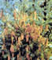
Frost injury results when unusually cold temperatures freeze sensitive new growth or older tissues not yet sufficiently hardened-off for winter. Late spring frost affects buds just breaking dormancy and succulent new growth. Late spring frosts are usually more injurious than early fall frosts. Reduced lateral and leader growth or tip dieback are common. Frost heaving is also caused by late spring frosts, and can result in significant seedling mortality on newly planted sites. Frost lesions or frost cracks act as entry points for canker and decay fungi or can lead to stem breakage.

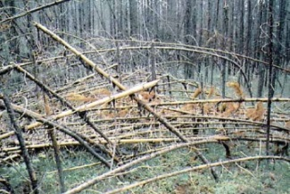
Snow damage consists of temporarily or permanently bent main stems, branch stripping or breakage, stem breakage, or uprooting. Symptoms are concentrated in small groups or are seen on scattered individual trees in affected stands. Older trees can suffer top breakage. Hail damage symptoms consist of tattered, ragged crowns with missing foliage and buds. Heavy snowfall or hail can cause significant mortality in young plantations.

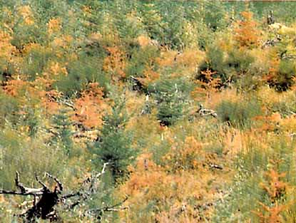
Drought symptoms are most apparent in late summer to early fall and can occur over extensive areas. Trees growing on shallow, gravelly, or sandy soils will show symptoms early in drought conditions. Younger trees become affected earlier than older trees, since the former have a smaller root system. Trees undergoing only moderate moisture stress will shed older needles prematurely, usually on the lower crown. Seedlings show wilting, yellowing, and necrosis of the foliage. Older trees exhibit symptoms from the top down and from the outside inward. Affected foliage eventually discolours brown in all species except larch. Drought can cause extensive mortality for four or five years after planting. The growth of surviving trees is often retarded. Damage is a result of growth reduction, dead tops, and defoliation.

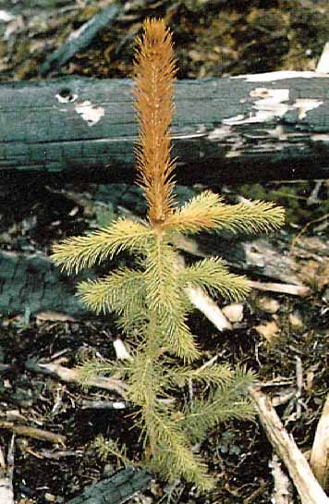
Winter Kill symptoms usually appear in spring as reddish-brown discolouration of foliage, which when viewed from a distance, appears as a well-defined horizontal band across a slope. Red belt is the result of a combination of climatic conditions. The unseasonable occurrence of warm, dry winds by day, followed by cold air drainage at night, leads to desiccation injury. Frozen soils do not allow lost moisture to be replaced quickly enough, and affected needles discolour and are eventually shed. Symptoms are often more pronounced in the upper crown and on the sides of trees facing the prevailing wind. Unopened buds are usually not harmed. Foliage and occasionally open buds are killed. Trees often recover from extensive defoliation but mortality may result from repeated red belt damage or destruction of all buds. Affected trees have a reduction in growth rate. Trees weakened by red belt are more susceptible to insect attack or disease. Large areas of red belt increase the fire hazard for the summer following the event.

Extent
Wildfire ranks as a high priority forest health factor in the Cassiar TSA. In 2010, 33,579 ha were burnt in the Cassiar. Other abiotic forest health factors in the district are sporadic and affect very small areas. These forest health agents are snow damage, windthrow, flooding, slides, drought and yellow cedar decline.

Abiotic forest health factors, other than wildfire, tend to cause localised damage. Climate Change is expected to increase the risk of abiotic forest health factors. Go to the “Climate Change “section of this Forest Health Strategy for Best Management Practices.

Non Recoverable Losses

Bulkley | TSR3 2011 | Mountain Pine Beetle | MPB projection model
Bulkley | TSR3 2011 | Windthrow | 5,500 m³/year
Bulkley | TSR3 2011 | Wildfire | 2,600 m³/year
Kispiox | TSR3 2007 | Windthrow | 1,132 m³/year
Kispiox | TSR3 2007 | Wildfire | 12,105 m³/year
Cassiar | TSR2 1999 | Western Balsam Bark Beetle | 1, 412 m³/year
Cassiar | TSR2 1999 | Fire | 47,200 m³/year

Windthrow:
Bulkley Windthrow losses were approximated using results of a study conducted by SYMBIOS Research in the 1990’s. SYMBIOS assessed data from 51 transects associated with logged blocks, and 56 transects associated with undisturbed forest. They calculated an average background windthrow level of 0.718 m³/ha in the undisturbed forest, and determined that windthrow associated with cutblock edges accounts for 4.14 m³/ha of harvested area. The net increase in windthrow due to harvesting is thus 4.14 - 0.718 = 3.422 m³/ha. At the 2001 analysis long-term annual harvest area rate (2000 hectares/year) this equates to a net annual loss of about 6,800 m³ that is not accounted for by the inventory. It is estimated that 20% of cutblock edge-induced windthrow is salvaged, leaving an annual unsalvaged loss of about 5,500 m³. Windthrow associated with catastrophic wind events is likely to be salvaged so was not included in this analysis. TSR 3 2011
Kispiox Windthrow data was extracted from the inventory, and the total activity period covers 1971 to 1991 (21 years). No records related to windthrow are available in the inventory for periods prior to 1971 or after 1991. Data selection was limited to the timber harvesting land base of the Kispiox TSA. Cutblock-edge blowdown was not quantified, as no reliable data source exists. TSR3 2007

Wildfire:
Bulkley Wildfire NRL’s have been taken from the Bulkley TSR 3 document. Annual wildfire losses were determined from 1977-1996 Northwest Fire Centre wildfire records. Records indicated a total lost volume of 56,818 m3, which corresponds to an annual loss of about 2,800 m3. It is estimated that approximately 10% of this volume is salvaged, which leaves an annual unsalvaged loss of about 2,600 m3. TSR 3 2011
Kispiox Wildfire data was obtained from the inventory file for fires from 1978 to 1988, and from the Northwest Fire Centre for the period 1989 to 1998. The total activity period for this analysis covers the years 1978 to 1998 (21 years). The inventory file contains records of wildfire and salvage activity beginning in 1958. Wildfire/salvage activity for 1958 to 1977 was not used in data compilation due to the extraordinarily high fire activity during 1958 to 1961 period and the absence of reliable data covering the period 1962 to1977 (i.e. large number of fires and area burned and no records available respectively). Data selection was limited to the timber harvesting land base of the Kispiox TSA. To estimate the volume losses, the total area burned or blown down was calculated. For the same areas, the size of the area salvaged was calculated. The difference represents the unsalvaged area. Volume losses were estimated by using the average volume per hectare for all merchantable stands in the TSA from the draft Kispiox TSA Inventory Audit (387 m3/ha). TSR3 2007
Cassiar Wildfire suppression began in the 1950s, and at that time the level of response to wildfire depended on the number of other fires burning elsewhere in the province. By the 1970s, suppression efforts aimed to extinguish all fires. By 1980, the selective suppression period began, in which suppression efforts were focused around communities, highways, other infrastructure, and valuable timber. Selective suppression has continued from 1980 to the present and was used to estimate NRLs due to wildfire in the Cassiar TSR 2. Data from TSR2 1999

Data
- see maps at the end of this section
Tactics
- Wildfires are managed by Protection Branch.
- Plant a mix of species to reduce long term risks.

