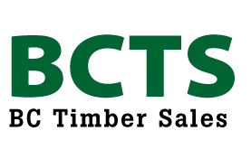
BC Timber Sales
Provincial Sustainable Forest Management Plan
SUSTAINABLE FORESTRY INITIATIVE® (SFI®)
2015-2019 Forest Management Standard

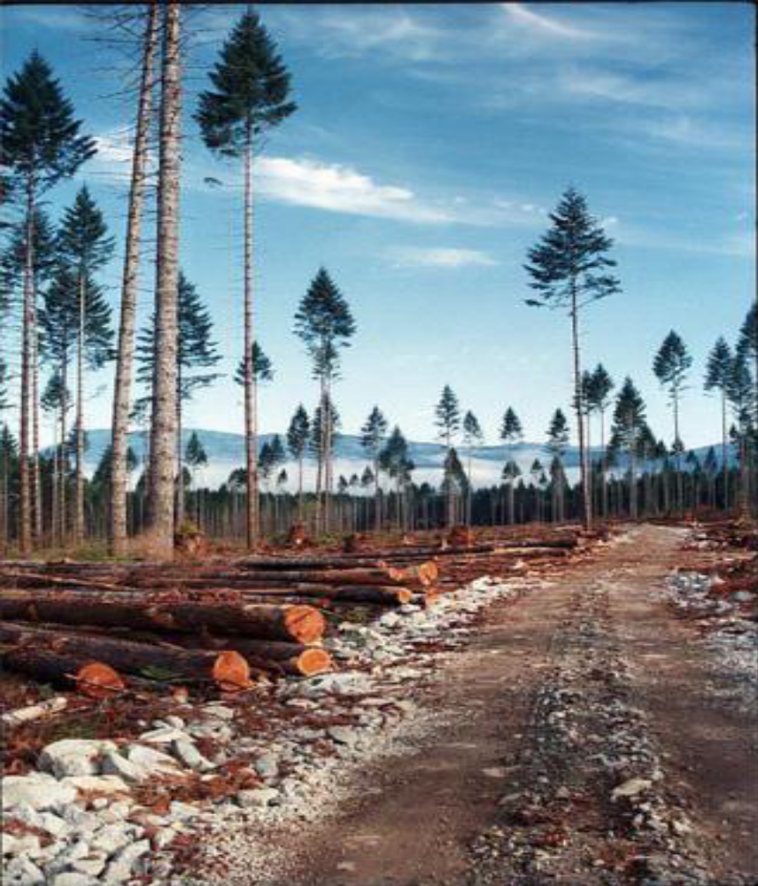

Updated: August 1, 2015

Table of Contents
1 INTRODUCTION 1
1.1 Background 2
1.2 Scope 2
2 FOREST MANAGEMENT STANDARD REQUIREMENTS 3
2.1 OBJECTIVE 1: Forest Management Planning 3
2.2 OBJECTIVE 2: Forest Health and Productivity 3
2.3 OBJECTIVE 3: Protection and Maintenance of Water Resources 5
2.4 OBJECTIVE 4: Conservation of Biological Diversity 6
2.5 OBJECTIVE 5: Management of Visual Quality and Recreational Benefits 7
2.6 OBJECTIVE 6: Protection of Special Sites 8
2.7 OBJECTIVE 7: Efficient Use of Fiber Resources 9
2.8 OBJECTIVES 8: Recognize and Respect Indigenous Peoples’ Rights 10
2.9 OBJECTIVE 9: Legal and Regulatory Compliance 11
2.10 OBJECTIVE 10: Forestry Research, Science, and Technology 12
2.11 OBJECTIVE 11: Training and Education 13
2.12 OBJECTIVE 12: Community Involvement and Landowner Outreach 13
2.13 OBJECTIVE 13: Public Land Management Responsibilities 14
2.14 OBJECTIVE 14: Communications and Public Reporting 15
2.15 OBJECTIVE 15: Management Review and Continual Improvement 16
APPENDIX A 17
APPENDIX B 18
APPENDIX C 20

INTRODUCTION

BC Timber Sales (BCTS) is fully committed to responsible and sustainable forest management of the lands where it conducts its operations. This Sustainable Forest Management Plan (SFMP) document describes how BCTS will meet the objectives of the 2015-2019 SUSTAINABLE FORESTRY INITIATIVE® (SFI®) Forest Management Standard on those management units certified to the SFI standard. BCTS is committed to meeting the performance measures and indicators contained within these objectives and upholding the following principles of the SFI standard, as applicable:

- Sustainable Forestry
- Forest Productivity and Health
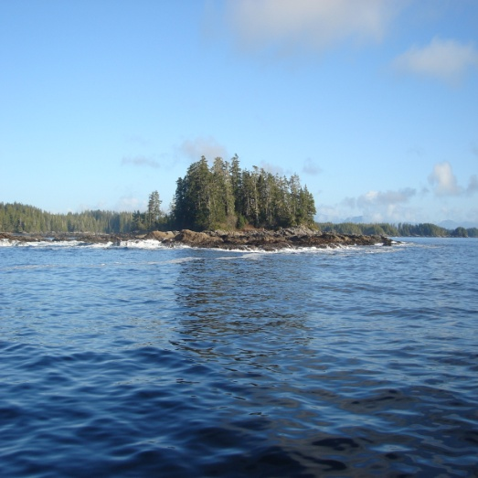
- Protection of Water Resources
- Protection of Biological Diversity
- Aesthetics and Recreation
- Protection of Special Sites
- Responsible Fiber Sourcing Practices in North America
- Legal Compliance
- Research
- Training and Education
- Community Involvement and Social Responsibility
- Transparency
- Continual Improvement

BCTS is currently certified to the ISO 14001: 2004 Environmental Management System (EMS) Standard. The EMS will act as the primary mechanism used to ensure this SFMP will be successfully implemented, monitored and measured.

This SFMP is designed to assist BCTS in maintaining SFI certification on management units certified to the SFI standard as outlined in Appendix B. BCTS Business Areas (BAs) have Roles and Responsibilities Matrices that provide the specifics on how each indicator is met and lists the parties responsible for meeting obligations related to the SFI performance measures and indicators.

Background

BCTS was originally established in 2003 as part of the BC Ministry of Forests and Range. The mandate of BCTS is to sell crown timber competitively and establish a benchmark for timber pricing on Crown lands within the Province of British Columbia (BC). Through 12 Business Areas and an operational presence in 33 locations, BCTS manages some 20 percent of the provincial Crown allowable annual cut. Approximately 92% of the commercial timber produced in BC comes from public lands, also known as Crown lands. Forest management of these lands involves interacting with both the government and the public. Processes involving land and resource management plans and local land use plans bring interest groups together to identify forest values and management objectives for a particular area of land. Subsequently, operational plans describe those forest values and guide implementation of related management objectives.

The Sustainable Forestry Initiative Program provides parameters (objectives, performance measures, and indicators) that are described within the SFI 2015-2019 Forest Management Standard. They are used to measure success in determining achievement in meeting the SFI standard. The BCTS SFMP addresses the parameters contained within the SFI standard and identifies the programs, plans and activities that support them. The SFI Program is overseen by the Sustainable Forestry Board (SFB), which is an independent board responsible for maintaining and enhancing the SFI standard certification procedures. The SFB contains members from conservation and environmental organizations, regulatory agencies, professional forestry organizations, logging professionals and landowners. For more information on the Sustainable Forestry Initiative, visit the SFI website at: http://www.sfiprogram.org/

Scope

This SFMP applies to sustainable forest management planning and practices (roads, harvesting and silviculture) conducted by BCTS corporate and business area staff and through agreements with BCTS timber sale licensees, permittees and contractors within management units areas certified to the SFI standard.

A map showing the location of BCTS Business Areas can be found in Appendix A. A table listing the applicable BCTS Business Areas and management units certified to the SFI standard can be found in Appendix B.

FOREST MANAGEMENT STANDARD REQUIREMENTS

OBJECTIVE 1: Forest Management Planning

To ensure forest management plans include long-term sustainable harvest levels and measures to avoid forest conversion.

Long term harvest levels are calculated through the Timber Supply Review process. The BCTS apportionment of the allowable annual cut (AAC) is assigned by the Minister for each management unit. Timber Supply Reviews are carried out periodically by the Province using the most up to date inventory information and considering current management practices.

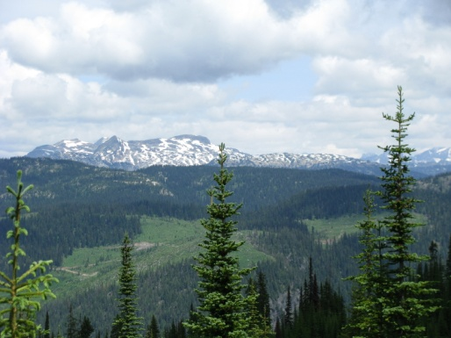
The AAC is determined as a result of extensive analyses, including growth and yield modeling, socio-economic factors, forest health factors, biodiversity at landscape scales and sustainable long term harvest levels. Assumptions are also made considering activities such as planting, stand tending and other activities that enhance the long term sustainability of the forest. These activities are tracked after entering them into the Cengea Forest - Resources and RESULTS databases. BCTS contributes to the timber supply analysis by participating in both industry and government led timber supply review processes.

BCTS Business Areas track apportionments and volume sold, harvested and billed (stumpage). This information is tracked to ensure trends are monitored and actual harvest levels are consistent with apportionments assigned by the Minister.

BCTS does not generally convert from one forest cover type to another unless that conversion is in compliance with relevant policy and does not impact any rare or ecologically significant native forest types. Reforestation is carried out with species that are designated in approved stocking standards.

OBJECTIVE 2: Forest Health and Productivity

To ensure long-term forest productivity, carbon storage and conservation of forest resources through prompt reforestation, afforestation, minimized chemical use, soil conservation, and protecting forests from damaging agents.

BCTS commits to reforesting/regenerating all harvested areas. Related to this performance measure, BCTS must comply with the legal standards that are in place for regeneration timeframes as specified by the Chief Forester of BC. This standard is consistent with the SFI Objective 2. The maximum regeneration delay specified by the applicable legal standards may exceed 5 years, based on the site factors that apply and if natural regeneration methods are suitable. Generally, all sites that are prescribed for artificial regeneration are planted within 2 years after harvest and prior to the establishment of competing brush. Sites for which natural regeneration is relied upon are assessed for regeneration success prior to the expiry of the regeneration delay period and stocking is supplemented through planting as necessary.

A reforestation prescription is written based on approved stocking standards which are based on the Biogeoclimatic Ecosystem Classification system and are included in the Forest Stewardship Plans for each Business Area. The reforestation prescription forms part of the Silviculture Plan that is contained within the Site Plan. Site Plans are prepared by professional foresters for every planned harvest block. The approved stocking standards specify the preferred and acceptable species for the site and the time period required to achieve adequate reforestation. This period, known as the regeneration delay period, must be consistent with the applicable legal standard and is measured from when harvesting commences, not the completion of harvest as in the SFI standard.
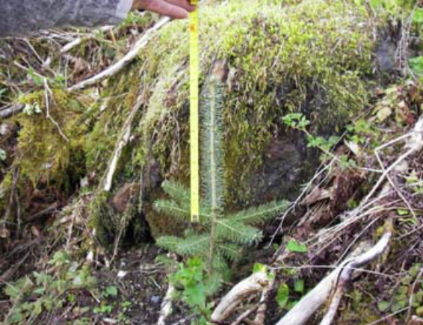
BCTS is committed to reforest blocks as soon as possible following harvest and to maintain a consistent level of stocking in order to ensure long term forest productivity. Successful regeneration is maintained by undertaking scheduled surveys to assess treatment needs. Treatment needs may include brushing and weeding, conifer release, and/or forest health treatments.

These types of treatment activities generally use manual brushing methods. The use of chemical herbicides by BCTS is limited; however, where they are used applications are conducted according to approved Pest Management Plans. BCTS does not use World Health Organization (WHO) type 1A and 1B pesticides or pesticides banned under the Stockholm Convention on Persistent Organic Pollutants (2001).

The Site Plan contains the limits for allowable soil disturbance and for permanent and temporary access on harvest blocks. Temporary access also contributes to allowable soil disturbance. The soil disturbance limits are monitored through the Environmental Management System and are established to avoid detrimental soil disturbance and to maintain soil productivity. If operational or final inspections identify that these limits are exceeded, rehabilitation efforts are undertaken by licensees to comply with maximum disturbance levels. At the landscape level, soil conservation is managed by minimizing the total amount of road required to enable safe and efficient forest harvesting activities. This is done through the development of total chance plans, operating plans, access management plans and/or through road deactivation and rehabilitation planning, as applicable. It is through these activities that BCTS seeks to minimize the amount of road required for successful operations.

Forest health information is obtained through forest health surveys, silviculture, surveys, pest mapping and District-level annual forest health plans (where available). This information is incorporated into Site Plans and used to schedule harvesting, determine block layout, and plan post-harvest site treatments (e.g. stumping). Where timber harvesting is not feasible, the application of other measures to reduce the risk of spread is considered. Fire preparedness is addressed through the environmental Emergency Response Plan (eERP) that is prepared by licensees and contractors.

OBJECTIVE 3: Protection and Maintenance of Water Resources

To protect the water quality of rivers, streams, lakes, wetlands and other water bodies through meeting or exceeding best management practices.

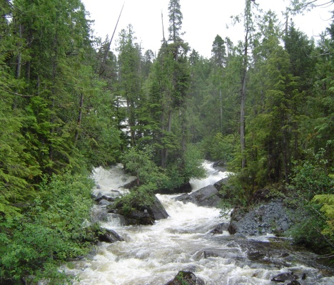
BCTS is committed to maintaining water quality through following the results and strategies stated within each Business Area’s FSP(s) and by following the Environmental Management System (EMS). These FSPs are consistent with current provincial legislation and applicable higher level plans. Criteria for carrying out activities around streams, wetlands and riparian areas are addressed within FSPs and the EMS. Wet Weather Shutdown Procedures have been developed by some BAs where they are needed for local operating conditions. The procedures are provided to timber sale licensees, road and bridge contractors, and silviculture contractors and reviewed at pre-work meetings.

Protection requirements for community watersheds, riparian areas, streams, lakes and other significant water bodies are identified and evaluated by professionals during operational planning. This is documented in Site Plans, Project Plans and associated maps. Riparian Reserve Zones and other areas to protect significant water bodies are marked in the field using BA Marking Standards. The timber sale contract package includes Project Plans and maps as well as the pre-work checklists and templates provided through the EMS. All of this information is reviewed during the pre-work meeting, monitored and inspected on-site as precautionary measures to avoid accidental encroachment on significant water bodies.

OBJECTIVE 4: Conservation of Biological Diversity

To manage the quality and distribution of wildlife habitats and contribute to the conservation of biological diversity by developing and implementing stand- and landscape-level measures that promote a diversity of types of habitat and successional stages, and the conservation of forest plants and animals, including aquatic species, as well as threatened and endangered species, Forests with Exceptional Conservation Value, old-growth forests and ecologically important sites.

BCTS operations are consistent with legislation, regulations, government orders, and higher level plans regarding wildlife habitats and biodiversity. This consistency is focussed at both the landscape and stand levels. At the landscape level, habitats that are significant for biodiversity objectives or to conserve sites with viable occurrences of significant species of concern are identified, e.g. Old Growth Management Areas (OGMA), Aspatial Old Growth Biodiversity Orders, Ungulate Winter Ranges (UWR), and Wildlife Habitat Areas (WHAs). Landscape level targets are established for various attributes and BCTS collaborates with other land managers to ensure consistency with these targets across the landscape. The Province collects forest inventory data that includes forest cover type, age, height, and habitat information. Current Vegetation Resource Inventories (VRIs) are maintained across all timber supply areas and Terrestrial Ecosystem Mapping (TEM) and Predictive Ecosystem Mapping (PEM) are conducted where ecosystem mapping is required to enable ecosystem based management or for other purposes as determined by provincial agencies.

At the stand level, field reconnaissance is completed to determine the forest cover types to be managed and to identify wildlife habitats that may be of concern or require special management. For each block harvested, a percentage of the area must be retained as Wildlife Trees as specified in the FSP. Wildlife Tree Retention Areas (WTRAs) must be identified and mapped to ensure their integrity over the long term. Some Business Areas also utilize the Retention silviculture system which results in the identification of Retention Patches, individual or groups of trees, to provide for biodiversity values at the stand level.

Business Area FSPs contain specific measures to mitigate the introduction, spread and impact of invasive plants. Vegetation seeding to limit or prevent soil erosion utilizes only seed mixes that are certified and do not contain invasive or damaging species.

Non-forested wetlands including bogs, fens and marshes, and vernal pools of ecological significance are classified according to the current Forest Planning and Practices Regulations. Wetlands too small to meet the legal classification requirements may still be identified as ecologically significant and any specific management requirements will be included in the site plan documents.


To ensure the protection of threatened and endangered species, Business Areas have provided information to staff, licensees, and contractors on Species at Risk in and around their operating areas, including lists of species that may be encountered and how these species can be identified. In April of 2013, the BCTS Provincial Planning Working Group produced the Species and Ecosystems of Management Concern Management Guide as a suggested resource for Business Areas to utilize as well. The FSPs prepared by each Business Area include results and strategies to address species identified in government orders applicable to their operating areas and may also address species that have been identified by the Ministry of Environment as requiring special management pending future designation.

OBJECTIVE 5: Management of Visual Quality and Recreational Benefits

To manage the visual impact of forest operations and provide recreational opportunities for the public.

The operating areas for some Business Areas have known scenic areas with established Visual Quality Objectives in Timber Supply Areas and Visual Quality Classes in Tree Farm Licence areas. BAs address these designations through the commitments described in the FSPs for their operating areas and by completing Visual Impact Assessments or Visual Assessment Packages to achieve these commitments.

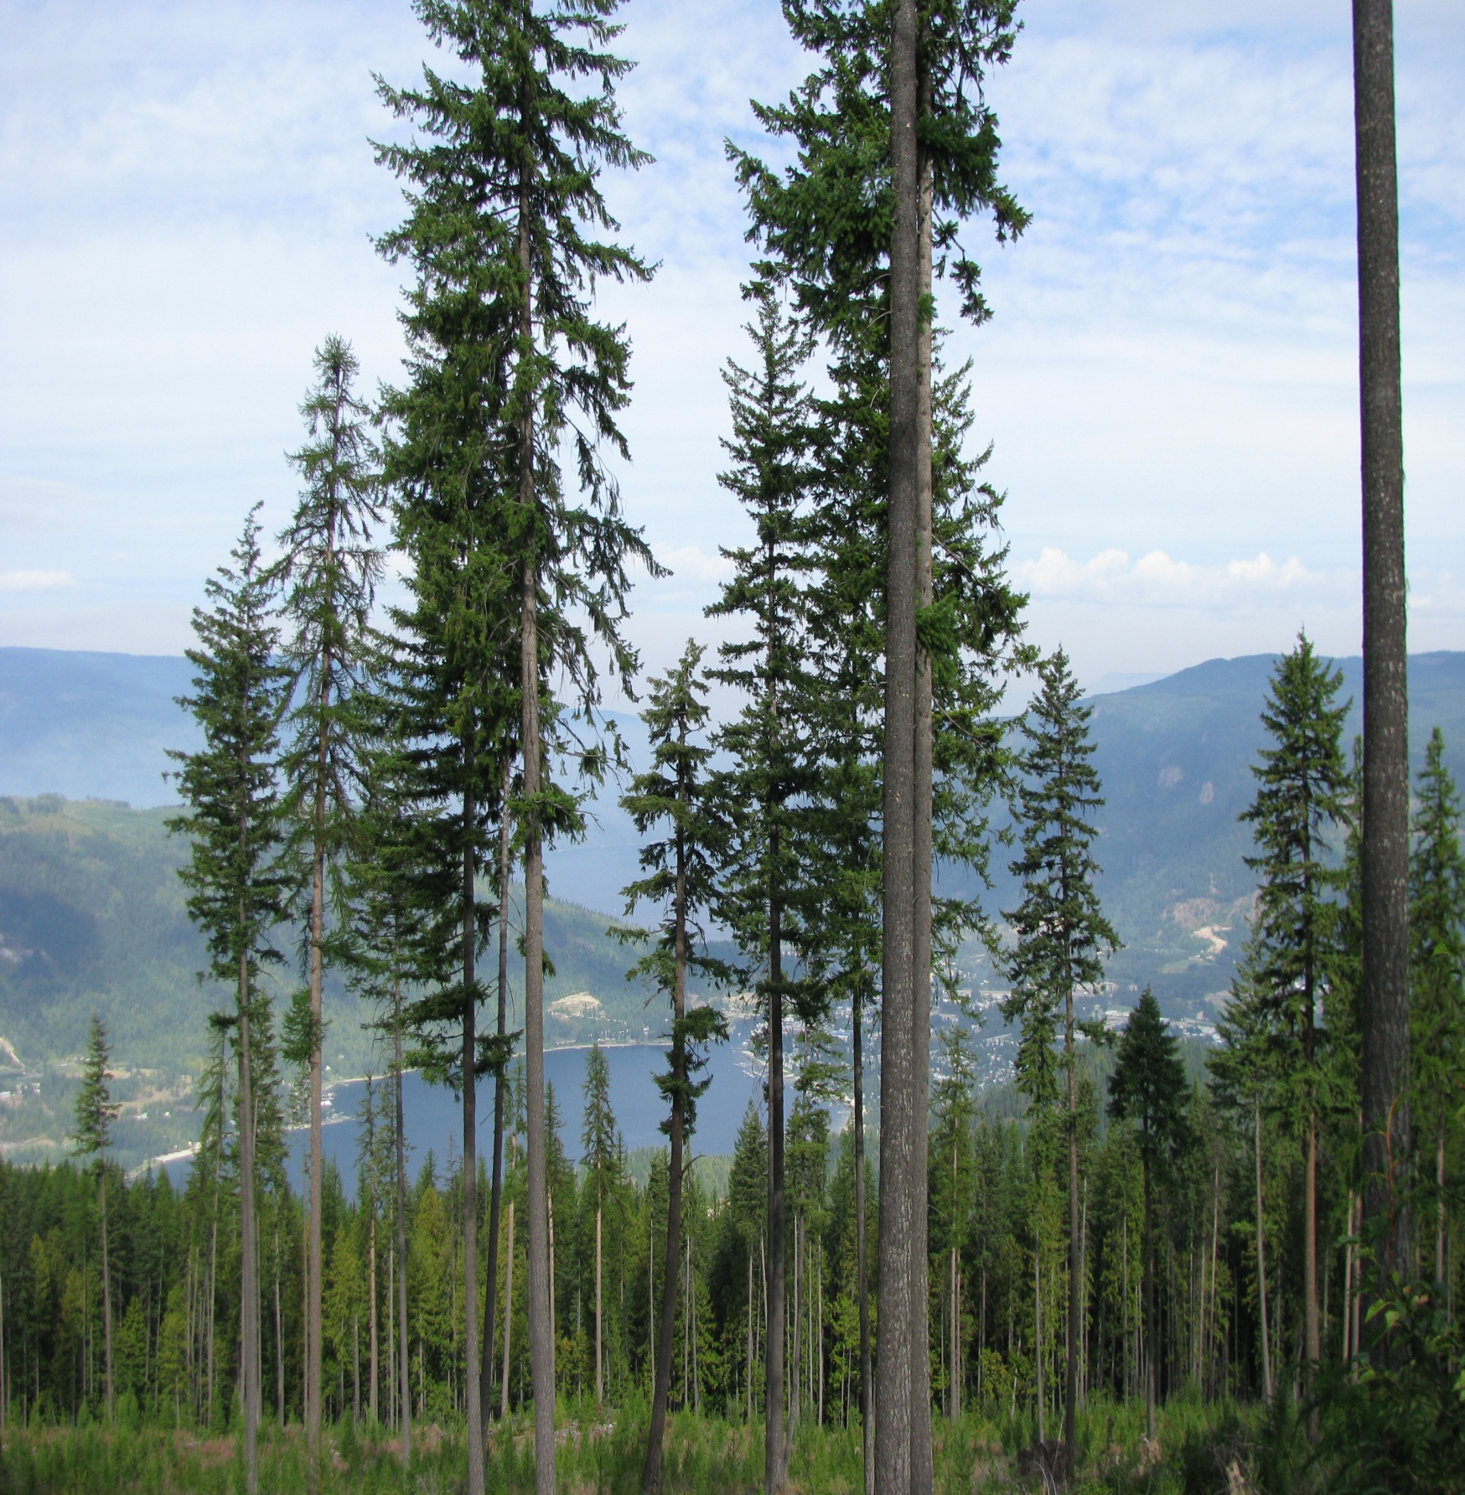
Maximum block sizes have been established in the Forest Planning and Practices Regulation of the Forest and Range Practices Act. This acts to minimize the visual impact of cut blocks over the landscape. Where applicable, Biodiversity Orders, higher level plans and Natural Disturbance Unit guidelines also contain patch size distribution targets that may allow some blocks to exceed the maximum limit, based on the current size and distribution of blocks in a particular landscape unit. When a cut block is planned to exceed the maximum size limit, the Forest Planning and Practices Regulation stipulates the conditions under which this can be done and a rationale will be written as part of the Site Plan. Average cut block size is tracked and monitored through the Cengea Forest - Resources database.

Green-up requirements outlined in the Forest Planning and Practices Regulation are used to determine the availability of adjacent blocks for harvest and whether to allow further harvesting in visually sensitive landscape units.

BCTS must identify established recreation sites and trails (managed by the Province) in their FSPs and must follow established objectives for those sites where they exist. BCTS provides recreation opportunities for the public within Business Area operating areas as part of the Forest Stewardship Plan commitments to the established legal objectives set for recreation sites and trails. Business Areas may also provide or improve access to recreation sites and may work with recreation stakeholders to prevent or mitigate any impacts on recreation opportunities by BCTS activities.

OBJECTIVE 6: Protection of Special Sites

To manage lands that are geologically or culturally important in a manner that takes into account their unique qualities.

Sites of historical significance are protected by federal and provincial legislation. These sites include parks and protected areas and various provincial and national historic sites. The areas are shown on map databases maintained by the Province. BCTS has online access to the databases and they are utilized in stand and landscape level planning. Outside of these existing protected sites, BCTS conforms to operational strategies involving protecting sites geological significance. For example, sites containing karst limestone topography are assessed and any development in the area will be conducted so as not to impact the karst features.

Sites of cultural significance, that are known to have existed prior to 1846, are protected by the Heritage Conservation Act (HCA); post 1846 sites are also protected if they are designated under the HCA. BCTS makes use of Archaeological Overview Mapping completed by the Province and other proponents and may also conduct their own Archaeological Impact Assessments and Archaeological Overview Assessments to determine the possibility of locating culturally significant sites during field reconnaissance. Site-specific cultural information can also be found within reports produced from Traditional Use Studies carried out by individual First Nations for the Province, from provincial websites, and from consultation with First Nations. Business Areas have developed detailed processes to be followed if sites of potential significance are identified during operational planning or field reconnaissance and processes for the exchange of cultural heritage information.

The EMS Environmental Field Procedures (EFPs) require that operators stop work and contact their project supervisor and the BCTS representative if a previously unidentified resource feature, resource value or sensitive area is found.

OBJECTIVE 7: Efficient Use of Fiber Resources

To minimize waste and ensure the efficient use of fiber resources.

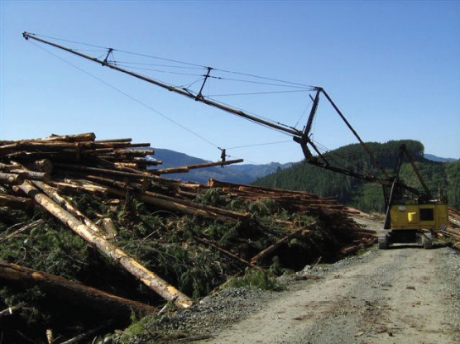
Timber Sale License (TSL) documents describe requirements for waste assessment. Timber merchantability specifications are provided in the Provincial Logging Residue and Waste Measurement Procedures Manual and, where required under the TSL document, blocks are waste surveyed at the completion of harvest. Any waste in excess of the maximum allowable is billed to the license holder. Innovative Timber Sale Licences (ITSLs) encourage higher levels of utilization by requiring that bidders pay for all volume from the cruise and do not have requirements for waste surveys. TSL holders are also required to comply with coarse woody debris retention requirements specified in Forest Planning and Practices Regulation Section 68 and applicable FSP results and strategies, as well as Wildfire Act responsibilities in relation to management of harvest residue. EMS harvest inspections ensure conformance with all requirements. BAs communicate periodically with licensees and other clients to gather market information for the development of Timber Sale Schedules.

OBJECTIVES 8: Recognize and Respect Indigenous Peoples’ Rights

To recognize and Respect Indigenous Peoples’ rights and traditional knowledge

The BC Timber Sales Sustainable Forest Management Policy includes a commitment to respect and recognize Aboriginal title and rights, and treaty rights. Business Areas must adequately share information and consult with local First Nations, consistent with the Crown’s obligations, current case law, and government policy and procedures.

BAs are responsible for information sharing and consultation with local First Nations, consistent with the Crown’s obligations, current case law, and informed by government policy and procedures. Records of First Nations information sharing and consultation undertaken by BCTS are maintained by BAs for each First Nation.
BAs work with others in government to communicate and become aware of aboriginal interests and concerns. Proposed BCTS forest operations are referred to applicable First Nations in keeping with the Crown’s duty to consult and as committed to in the FSP. A request for additional information on aboriginal interests which BCTS operations have the potential to impact is made upon referral.

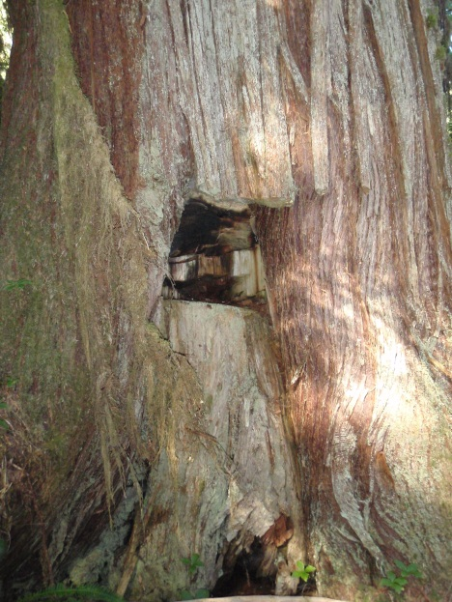
The FSPs provide results and strategies to “conserve or, if necessary, protect cultural heritage resources that are a) the focus of a traditional use by an aboriginal people that is of continuing importance to that people and b) not regulated under the Heritage Conservation Act (HCA)”. Where BCTS is made aware of cultural heritage resources that are of interest to a local First Nation, efforts will be made to ensure BCTS activities do not diminish the opportunity for First Nations to access and utilize those resources.
Archaeological features are managed as regulated under the Heritage Conservation Act. BCTS employs qualified archaeologists when required to identify archaeological features and develop strategies to avoid or mitigate potential impacts of forestry activities on those features.

OBJECTIVE 9: Legal and Regulatory Compliance

To comply with all applicable federal, provincial, state, and local laws and regulations.

For all areas in which it operates, BCTS has approved Forest Stewardship Plans (FSPs) prepared within the framework of the Forest and Range Practices Act. FSPs are consistent with all laws and regulations applicable to forestry and the environment. The BCTS Environmental Policy and provincial SFM Policy demonstrate BCTS’ ongoing commitment to all relevant legislation and other requirements to which it subscribes. BCTS is part of the BC provincial government and must adhere to all federal and provincial social legislation and policies.

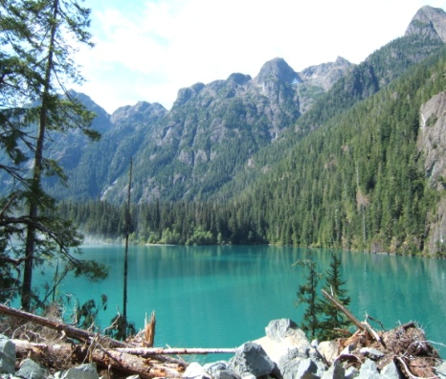
All non-conformances and potential non-compliances by licensees, permittees and contractors are documented during BCTS inspections. All significant non-conformances and potential non-compliances are tracked through the Cengea Issue Tracking Systems (ITS). BCTS staff are responsible for creating action plans to address issues and tracking the progress of licensees, permittees and contractors in rectifying the issues. BCTS is committed to reporting all potential non-compliances to the appropriate enforcement agency.

All forest activities are also monitored and tracked by outside agencies such as the Compliance & Enforcement Branch, the Forest Practices Board, and Fisheries and Oceans Canada.

BCTS staff is aware of all legal and other requirements that apply to their roles and responsibilities. The primary online source of this information is the “Quickscribe” (EnviroFor) service that the Ministry subscribes to and, in addition, staff are provided with a list of web links to sites where acts and regulations may be found. Information on legal and other requirements is contained in various operational checklists that staff provide to licensees, permittees and contractors.

OBJECTIVE 10: Forestry Research, Science, and Technology

To invest in forestry research, science and technology, upon which sustainable forest management decisions are based and broaden the awareness of climate change impacts on forests, wildlife and biological diversity.
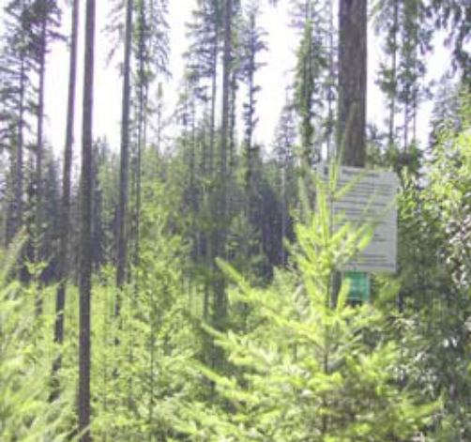
BCTS supports the activities of provincial forest research programs and assists in the implementation of operational research trials if requested. At the provincial and regional level, BCTS participates in programs to promote expertise in forest health, the geosciences and silviculture. In addition, BCTS accesses effectiveness evaluation results and extension materials from the provincial Forest and Range Evaluation Program (FREP). FREP conducts effectiveness monitoring of the Forest and Range Practices Act and related regulations and the implementation of FSP commitments to address the legislation.

Initiatives that BCTS participates in that directly support ongoing forest research include the provincial Research, Innovation and Knowledge Management Division (RIKMD) Forest Science Services, the Western Canada Sustainable Forestry Initiative Implementation Committee (WCSIC), FP Innovations, BCTS Seedling Services and the development and support of Cengea Forest - Resources- the BCTS forest management information system.

BCTS monitors information generated from regional climate change models as provided by the Future Forest Ecosystem Initiative and the Pacific Climate Impacts Consortium. BCTS also participates in Climate Change Adaptation and Forest Carbon Initiatives at the Provincial and Business Area level. In addition, BCTS has developed a Provincial Climate Change Action Plan that identifies actions that will be taken to build BCTS adaptive capacity to address climate change, including the communication of climate change related impact information to BCTS staff.

OBJECTIVE 11: Training and Education

To improve the implementation of sustainable forestry practices through appropriate training and education programs.

BCTS has EMS Training Matrices, which specify the training requirements for staff, licensees, permittees and contractors (LPCs). Awareness training for new staff takes place through on-line and other training resources during the new employee orientation period and ongoing awareness training is scheduled when required.

Under the terms of the Timber Sale Licence (TSL) Schedule D, TSL holders are required to ensure that all persons working on the cutting authority area or related permit areas for the benefit of the Licensee achieve and maintain training in the BCTS EMS. An on-line EMS/SFM awareness training course targeted towards LPC supervisors is available free of charge to LPCs through the following website: http://publish.myudutu.com/published/launch/41627/Course98256/Launch.html. LPCs are provided additional training materials consistent with the Western Canada SFI Implementation Committee (WCSIC) Training Policy during pre-work meetings. LPCs are required to train their crews and maintain training records. Training is also delivered to staff and information provided to LPCs when there are new legislation requirements and/or changes to checklists, Environmental Operating Procedures, Environmental Field Procedures or other BCTS EMS program documents.

BCTS is a member of WCSIC and is represented by the BCTS Certification Officer. The Business Area Certification Standards Officers provide information to their Business Areas on important issues from the WCSIC through communication from the BCTS Certification Officer.

OBJECTIVE 12: Community Involvement and Landowner Outreach

To broaden the practice of sustainable forestry through public outreach, education, and involvement, and to support the efforts of SFI Implementation Committees.

BCTS is motivated to ensure that the public is knowledgeable about sustainable forest management. BCTS encourages this by initiating and participating in various forestry related events in the communities where it operates. These events include National Forest Week, local trade shows, field tours and other extension efforts.

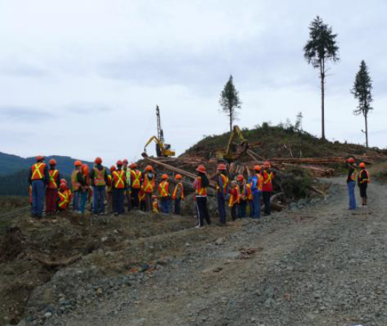
Forestry related literature is available to the public at each District / BA office front counter. Educational and informative material is also available on the main BCTS website at: http://www.for.gov.bc.ca/bcts/. Information on wildlife habitat, species at risk or endangered species may be found on the Ministry of Environment website at: http://www.gov.bc.ca/env/ .

The BCTS Certification Officer is a member of the Western Canada Sustainable Forestry Initiative Implementation Committee (WCSIC). The committee’s responsibilities are to perform local outreach and education activities that promote sustainable forestry, the SFI program, and SFI standard compliance. Further information is available at http://wcsic.ca/. The Certification Standards Officers in each Business Area maintain contact with the BCTS representative on the WCSIC to stay informed of concerns and issues involving SFI.

BCTS welcomes inquiries from the public regarding its sustainable forest management activities. The main BCTS SFM certification web page and the certification web pages for each Business Area contain a Certification Public Comment Form. Any inquiry from the public can be entered on this form and sent to the BA and to the BCTS Certification Officer. Prompt responses to these inquiries ensure consistency with the SFI standard.

In addition, BCTS supports SFI Inconsistent Practices reporting. More information on SFI Inconsistent Practices reporting is available through links provided on BCTS SFI-certified Business Area websites.

OBJECTIVE 13: Public Land Management Responsibilities
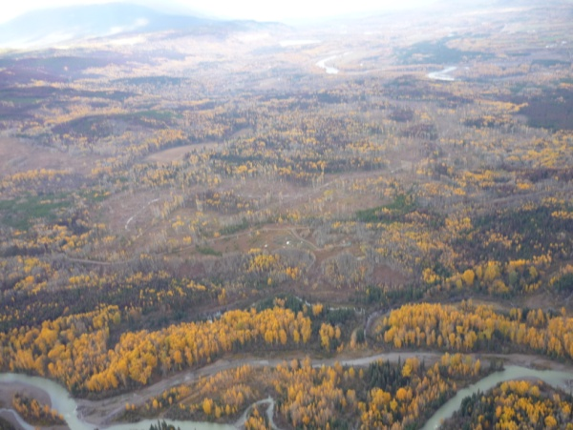
To participate and implement sustainable forest management on public lands.

BCTS has a mandate to sell timber in a competitive marketplace. All timber is sold through an open bid process. All planning, harvesting and road construction is consistent with legal requirements in applicable Land and Resource Management Plans, Strategic Land and Resource Plans (SLRPs) and other pertinent higher level plans. These plans are prepared with input from the public.

BCTS staff endeavour to participate in Strategic Land and Resource Planning processes, Timber Supply Area Steering Committees, EBM working groups, etc., where active.

OBJECTIVE 14: Communications and Public Reporting

To increase transparency and to annually report progress on conformance with the SFI Forest Management Standard.

BCTS is committed to providing a public report prepared by a certification body to SFI Inc. after the successful completion of certification, recertification or a surveillance audit to the 2015-2019 SFI Forest Management Standard. The public report shall include as a minimum, the following:
  - description of the audit process, objectives, and scope;
  - description of substitute indicators, if any, used in the audit and a rationale for each;
  - the name of Program Participant that was audited, including its SFI representative;
  - a general description of the Program Participant’s forestland included in the audit;
  - the name of the certification body and lead auditor (names of the audit team members, including technical experts may be included at the discretion of the audit team and Program Participant);
  - the dates the audit was conducted and completed;
  - a summary of the findings, including general descriptions of evidence of conformity and nonconformities and corrective action plans to address them, opportunities for improvement, and exceptional practices; and
  - the certification decision.

The public report will be posted on the SFI Inc. website and be available for public review.

As part of SFI certification, BCTS shall report annually on progress and accomplishments to SFI Inc. through the BCTS Certification Officer. The system for record keeping for the purposes of annual reporting will be maintained by the BCTS Certification Officer and copies of past reports will be retained to be used in demonstrating progress and improvement in meeting the objectives of the SFI standard.

OBJECTIVE 15: Management Review and Continual Improvement

To promote continual improvement in the practice of sustainable forestry by conducting a management review and monitoring performance.

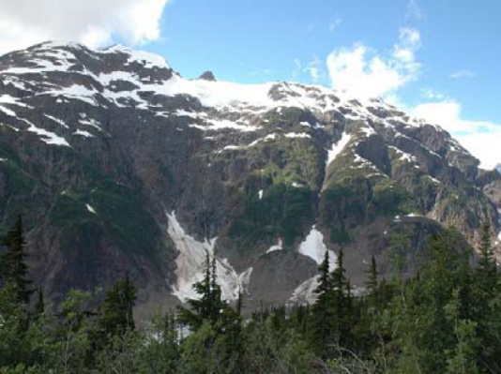
BCTS will demonstrate its commitment to continual improvement in the practice of sustainable forestry by following the continual improvement principles contained in its EMS and SFI programs. An effectiveness evaluation program forms part of the EMS process. This involves tracking the effectiveness of corrective actions and operational controls with the aim of continuously improving our environmental performance. In addition, some BAs have a local continuous improvement process with various teams that are responsible for continuous improvement of business processes.

BCTS conducts internal audits through the ISO 14001 certified EMS system. An SFI audit protocol has been developed to ensure adherence to the SFI standard.

Progress in achieving the SFI standard objectives and performance measures is conveyed to management during the annual Management Review Process. Following this review, changes and improvements necessary to continually improve SFI conformance are identified and passed on to appropriate staff members for incorporation into the BCTS SFI procedures. Any changes to these procedures are then communicated to staff, licensees, permittees and contractors to ensure all parties concerned are kept current with the most up-to-date information.

APPENDIX A
Map of BCTS Business Areas

http://www.for.gov.bc.ca/bcts/maps/

APPENDIX B

BCTS Business Area Management Units
(Register of SFI Sites)

Business Area | Management Unit | Prorated Forest Area under Management (ha)
Babine | Morice TSA 20 (Houston) | 225,483
Babine | Lakes TSA 14 | 138,953
Babine | Bulkley TSA 3 | 118,475
Cariboo-Chilcotin | Quesnel TSA 26 | 305,436
Cariboo-Chilcotin | Williams L. TSA 29 | 736,269
Cariboo-Chilcotin | Cascadia TSA (Blk 5-8) | 31,723
Chinook | Fraser TSA 30 | 172,845
Chinook | TFL 26 Mission | 376
Chinook | Soo TSA 31 | 121,746
Chinook | TFL 38 | 31,906
Chinook | QCI | 228,403
Kamloops | 100 Mile H. TSA 23 | 236,277
Kootenay | Arrow TSA 01 | 173,529
Kootenay | Boundary TSA 02 | 211,565
Kootenay | Kootenay L. TSA 13 | 265,664
Kootenay | TFL 03 - Springer Ck | 5,885
Kootenay | Cascadia TSA 45 Blocks 1, 2, 3 | 93,165
Kootenay | Cranbrook TSA 05 | 249,011
Kootenay | Invermere TSA 09 | 159,955
Okanagan-Columbia | Golden TSA 07 | 233,160
Okanagan-Columbia | Revelstoke TSA 27 | 92,746
Okanagan-Columbia | Cascadia TSA | 41,637
Okanagan-Columbia | TFL 55 | 18,205
Okanagan-Columbia | TFL 56 | 15,284
Peace-Liard | Dawson Creek TSA | 468,761
Prince George | P. George TSA | 362,724
Prince George | TFL 30 | 9,318
Prince George | Mackenzie TSA | 1,053,154
Prince George | TFL 53 | 11,460
Prince George | Robson Valley TSA | 363,628

Business Area | Management Unit | Prorated Forest Area under Management (ha)
Seaward-tlasta | Pacific TSA | 121,399
Seaward-tlasta | Kingcome TSA | 276,557
Seaward-tlasta | Mid Coast TSA | 328,000
Skeena | Cascadia TSA | 113,735
Skeena | Cassiar TSA | 100,077
Skeena | Kalum TSA | 100,818
Skeena | Kispiox TSA | 244,594
Skeena | Nass TSA | 437,608
Skeena | North Coast TSA | 346,199
Skeena | Pacific TSA (Block 28 A-H) | 380,984
Strait of Georgia | Arrowsmith TSA | 44,433
Strait of Georgia | Sunshine C. TSA | 183,033
Strait of Georgia | Strathcona TSA | 119,091
Strait of Georgia | Pacific TSA | 110,661
Strait of Georgia | TFL 54 - Interfor | 7,296
Strait of Georgia | TFL 57 - Iisaak | 2,912
Stuart-Nechako | PG TSA Vanderhoof | 291,147
Stuart-Nechako | PG TSA Fort S James | 583,808
Stuart-Nechako | CFA K4B - Tanizul | 1,807

APPENDIX C

BCTS PROVINCIAL SFI SUSTAINABLE FOREST MANAGEMENT PLAN
GLOSSARY OF TERMS

BA | Business Area
AAC | Allowable Annual Cut
WCSIC | Western Canada SFI Implementation Committee
BCTS | BC Timber Sales
BMP | Best Management Practices
C&E | Compliance & Enforcement
EBM | Ecosystem Based Management
EFP | Environmental Field Procedure
EMS | Environmental Management System
EOP | Environmental Operating Procedure
FSP | Forest Stewardship Plan
G&Y | Growth & Yield
Cengea Forest - Resources | Forest Management Information System
GIS | Geographic Information System
ISO | International Organization for Standardization
LBIP | Land Based Investment Program
LRMP | Land & Resource Management Plan
FLNR | Ministry of Forests, Lands and Natural Resource Operations
OGMA | Old Growth Management Area
RESULTS | Reporting Silviculture Updates and Land Status Tracking System
SFB | Sustainable Forestry Board
SFI | Sustainable Forestry Initiative
SFMP | Sustainable Forest Management Plan
TSA | Timber Supply Area
TSL | Timber Sale License
TSR | Timber Supply Review
UWR | Ungulate Winter Range
WTRA | Wildlife Tree Retention Area

