Forest Management System (FMS)
User Guide and Training Document

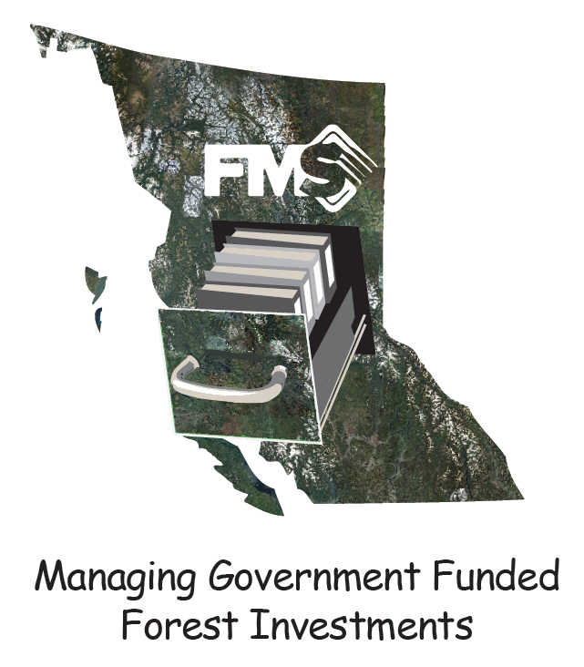

Version 2.2

Foreword

This document is the first edition of Forest Management System (FMS) User Guide and Training Document. This is not an exhaustive user guide and only covers workflows required to plan and manage government funded activities. For a complete user guide, please go to FMS help.

First Time Users to FMS

If you are new to using FMS, you MUST work through sections 1-21 of this User Guide / Training Document on the test server before onsite training and access to the production server is provided. You will be given an examination on the training material. (See section 22.0 Taking the FMS skills test (and getting a coffee mug!))

Pronouns

Throughout this document the pronouns they, them and their will be used for both the singular and plural of binary and non-binary people.

Disclaimer

While the Information contained in this document has been presented with all due care, the Information may not be free from errors or omission.

The author(s) are not liable for the accuracy of any information contained within this document nor by the way it is interpreted and used.

Acknowledgments

This edition has been developed by Nigel Fletcher with assistance following individuals in first name alphabetical order that have either written documents, provided input through emails, or provided direct editing.

Andrew Greschner  Brent Ziegler  Brian Saunders  David Majcher | George Jennings  Victoria London  Zach Cole

Table of Contents
Foreword 2
First Time Users to FMS 2
Pronouns 2
Disclaimer 2
Acknowledgments 2
1.0 Signing in 7
1.1 Forgot Password 7
2.0 Getting to know the FMS Interface 8
2.1 Results vs. RESULTS 9
2.2 Mouse/scroll wheel 9
2.3 Pinning tables to the sides 9
2.4 Using two monitors 9
3.0 Getting Help 10
4.0 Screen Freeze / Mouse Shift / Projections / Truncated results grid 10
Screen Freeze 10
Clearing cached data in Chrome 11
Mouse Shift 11
Projections 11
Results grid not showing attributes 11
5.0 Showing the right map layers 12
6.0 Setting your view 14
7.0 Setting how you want FMS to look (layout) 16
8.0 Pan and zoom 16
9.0 Selecting objects 17
10.0 Results table 18
11.0 Being consistent with RESULTS 18
12.0 Creating a block 19
12.1 Creating a block using existing geometry from the Opening SVW layer 19
12.2 Creating a block by creating geometry on the fly 23
12.21 Creating a spatial file from the GF Block 24
12.22 Deleting the GF Block 24
12.3 Creating a block by uploading a spatial file 25
12.4 Removing overlap of an adjacent SVW opening from a GF block 26
13.0 Buffering Roads 28
13.0 Creating Standards Units (which include Ecological Units (BEC)) 30
13.1 Create a standards unit for the Non-Productive Roads. 31
13.2 Create a standards unit for the Non-Productive Natural (swamp, NP, WTP, Rock). 33
13.3 Add the Productive Standards Unit 34
13.4 Split the Productive Standard Unit into two Standard Units 35
13.4 Checking your standards units 36
13.5 Combining two standards units together 37
14.0 Adding Activities to a GF Block 38
14.1 Adding a disturbance type to a GF block 38
14.2 Adding a silviculture activity to a GF block 40
14.3 Adding a block activity 41
14.4 Deleting an Activity 42
15.0 Adding the same activity to multiple blocks 42
16.0 Making batch changes to multiple activities 44
17.0 Getting a new Opening ID from RESULTS 46
18.0 Downloading a georeferenced pdf map 48
19.0 Using the search tool 49
20.0 Making a submission to RESULTS 51
21.0 Reporting out with PowerBI 51
21.1 Install Power BI 51
21.2 Open Odata feed 52
21.3 Open Power BI Report ODataReport.pbix 53
22.0 Taking the FMS skills test (and getting a coffee mug!) 56
23.0 Using the Silviculture Import/Export Tool (SIET) to add GF Blocks and Activities 57
23.1 Block template 57
23.2 Activity template 57
23.21 Download a blank template 57
23.22 Download a template that contains current data in FMS 58
23.22 Filling in the Excel workbook 60
23.23 Adding spatial to the SIET geodatabase file 61
Using ArcMap 61
23.231 Scenario 1 each activity has a separate spatial component (ArcMap) 61
23.232 Scenario 2 several activities has the same spatial component (ArcMap) 66
23.233 Scenario 3 each activity has several spatial components (ArcMap) 66
Using QGIS 66
23.234 Scenario 1 each activity has a separate spatial component (QGIS) 66
23.235 Scenario 2 several activities has the same spatial component (QGIS) 66
23.236 Scenario 3 each activity has several spatial components (QGIS) 66
ArcMap or QGIS not required 67
23.237 Scenario 4 block activities that do not require a spatial component 67
23.24 Importing zipped folder into FMS 67
24.0 Submitting data using SNAP and Plant Wizard 68
24.1 Data from SNAP (survey wizard) 68
24.2 Data from Plant Wizard 76
25.0 Hiding, Unhiding and Changing the order of Attributes 76
26.0 Getting into an ArcMap instance using citrix workspace 77
26.1 Loading Citrix workspace onto ministry computer 77
26.2 Logging into the Kamloops remote desktop and getting into ArcMap 77
27.0 The QGIS platform 78
27.1 Loading QGIS onto your computer 78
28.0 Importing GPX files into FMS 79
28.1 Using Arc Map to transfer GPX files into GDB format. 79
28.1 Using QGIS to transfer GPX files into GDB format. 84
28.3 Importing zipped shapefile 86
29.0 Using the sketch tool 87
25.1 Putting an annotation 88
25.2 Deleting the sketch 89
30.0 Collecting Spatial Data in the field 89
30.1 Using Trimble Data collector to collect spatial for FMS 89
30.2 Using a tablet/ipad to collect spatial for FMS 89
30.21 Collecting data with Avenza Maps 90
30.22 Collecting data with ArcGIS collector 90
30.3 Using a handheld GPS unit (Garmin GPSMAP 60CSx) to collect spatial for FMS 91
Appendix 1 – Two to Three Day Training Agenda 95
Appendix 2 – FMS Data Model 97
Appendix 2 – Layer definition 98
Appendix 3 – Data Dictionary by Block, Standards Unit, and activity 100
Categories 100
Block 100
Block Activity 100
Disturbance 101
General Tab 101
Disturbances Tab 102
Planting 102
General Tab 102
Plantings Tab 104

1.0 Signing in

FMS does work in other web browsers, but its best performance is using Chrome.
Open Chrome web browser and go to https://online.silvacom.com

Enter your username and password. You may wish to check remember me and let Chrome remember your password (if you are on your own ministry computer).
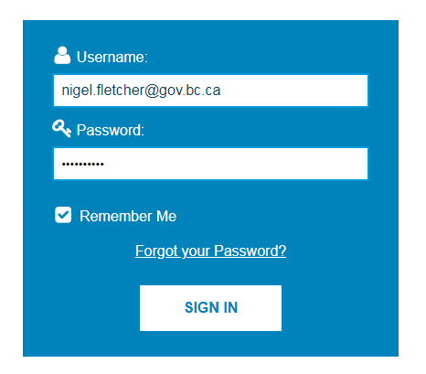
Now click on Harvest Planner – for training use the UAT (test) site
Need to talk about production site when it shows up
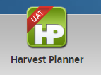

1.1 Forgot Password

If you have forgotten your password you can reset it yourself. Go to https://online.silvacom.com and click on . This will bring up a dialog box. Enter your Username which is your government email address, and click (it will go orange when you hover over the button).

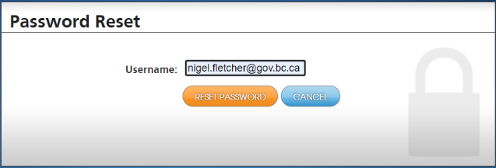

You will get a notification that an email has been sent to you.

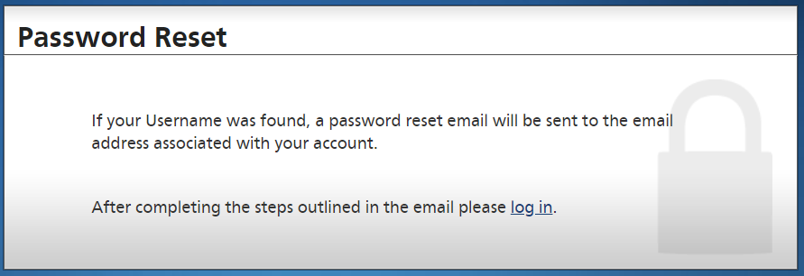

The email will provide a link to change your password:

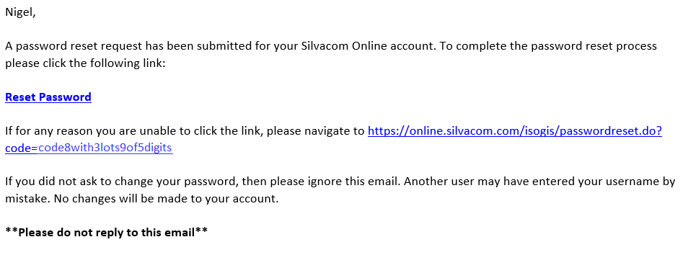
The link will take you to a webpage where you can reset your password.

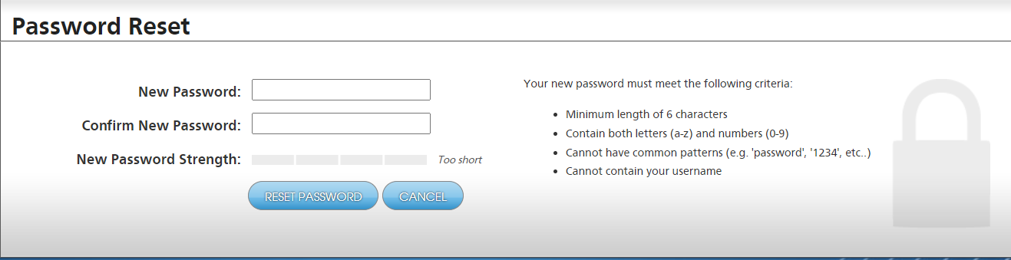

2.0 Getting to know the FMS Interface

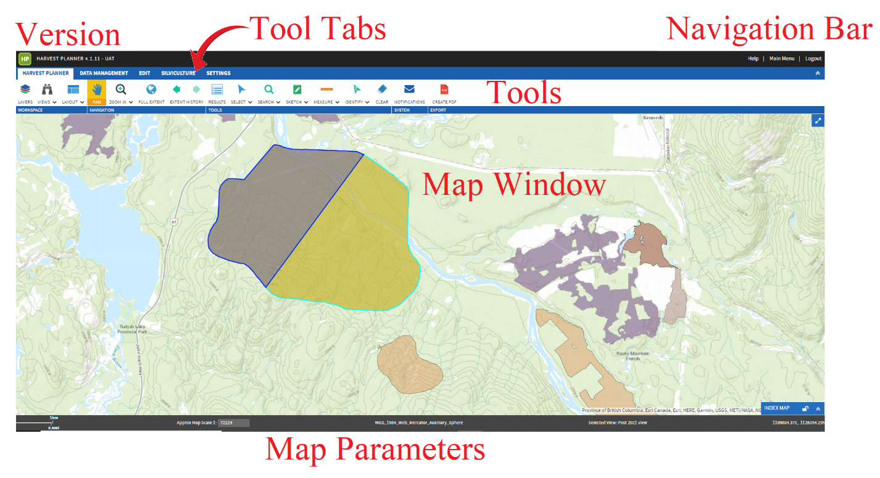
The interface provides the ability to create and edit spatial and this user guide / training document covers some of these features. In reality, most of the spatial will be done outside of FMS and then imported in. Do not get overwhelmed by these edit features.

2.1 Results vs. RESULTS

FMS uses the term results. This is a grid that tabulates the items that have been selected in the map window or have been search for using the search tool. This term may be confused with the Reporting Silviculture Updates and Land Status Tracking System (RESULTS) application.

When you see results written in lower case it refers to the FMS context
When you see RESULTS written in upper case it refers to the RESULTS application.

2.2 Mouse/scroll wheel
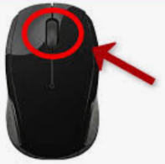
There are specific tools for zoom and pan in FMS.

However, the mouse scroll wheel is configured so that:
- Rolling the wheel will change the zoom
- Pressing the wheel will put you in pan mode

2.3 Pinning tables to the sides

When working in FMS it is sometimes useful to pin common tables such as the results table and layers table to the side of the map window.

This can be done by holding the table with the right mouse pressed down and moving it to the side blue pinning bar that will appear. When it turns tan in colour let go of the mouse button. The table should be pinned to the side.

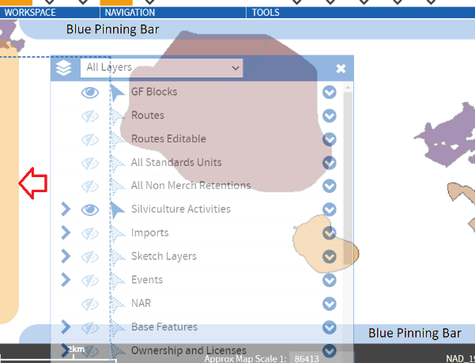

2.4 Using two monitors

Because FMS is a browser application there is no advantage of using two monitors to display the FMS application. However, most reporting will use PowerBI and therefore it may be advantageous to have PowerBI on one screen and FMS on the other.

There have been reports of people sharing their FMS id so that an instance of FMS can be display on each monitor. You should not be sharing your FMS id. When we move to single sign on using your idir then this will no longer be possible (never share your idir).

3.0 Getting Help

Once you are in the application you will see along the top some high-level navigation buttons
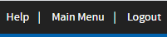
Help takes you to a new web window where you must log in – same ID and password as FMS.
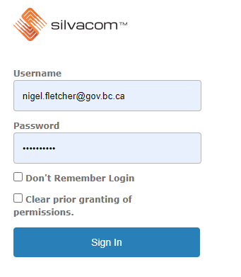
You can search out what you are trying to do. It will provide you with step-by-step instruction. This will become very useful as you learn how to use the application. You can also submit a ticket from this site where you can get direct support from Silvacom.
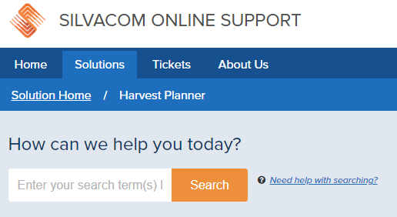

4.0 Screen Freeze / Mouse Shift / Projections / Truncated results grid

Screen Freeze

From time-to-time FMS may freeze, give error messages and then freeze, or give you a service unavailable message.
If this occurs just shut the browser and log on again. If the problem persists, try emptying/clearing your cache.

Clearing cached data in Chrome
- At the top right, click Customize and control Google Chrome
- Mouse over More tools and click Clear browsing data.
- Check off ‘Cached images and files’ (you may wish to leave the other ones uncheck)
- Click Clear data.
With the Developer Tool showing (a box with html markup), click on refresh with your right button. Choose empty cache and hard reload. Now close the Developer Tool.

If you find a bug (something is not working as it should) or you have a feature suggestion (something you would like FMS to do but it currently does not) or you have a calibration suggestion (the look and feel of FMS – names of layers, colours, etc.) then send them to nigel.fletcher@gov.bc.ca

Mouse Shift

From time-to-time you may find that your mouse has shifted. This is when you select an area on the map window with your mouse it will pick an area shifted over a bit. This is caused by cached images/data in google chrome. You will need to clear your cached data which will fix the shift (see 4.1 Clearing cached data in Chrome.

It is recommend clearing cached data on a regular basis to prevent this.

Projections

The earth is a sphere, but we represent the earth as a flat plane on a map. This causes distortions in the area, shape, direction, bearing and distance. Depending on what properties you want preserve (at the expense of others), the plane is constructed (projected) in many ways.

The Esri Basemaps (Esri Street, Esri Imagery, Esri Topo and Esri Shaded Relief) use the Web Mercator projection where as the FMS layers use the BC Albers projection. This causes issues in zooming to blocks and seeing blocks when an Esri Basemap is turned on.

If you are experiencing these types of issues, try turning off the Esri basemap to see if this resolves the issue (use BC Albers basemaps if you need to get your bearings).

We are working to get Esri basemaps with BC Albers projection.

Results grid not showing attributes

If you get a results grid like this 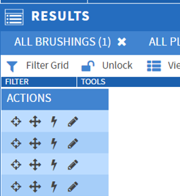instead of like this 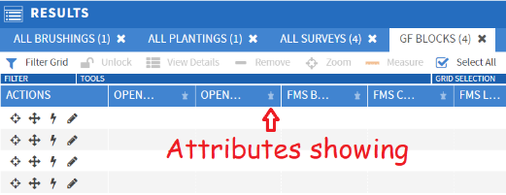

Go to your User Preferences in the Results grid and under Shared dropdown, reset them to ‘Default’.

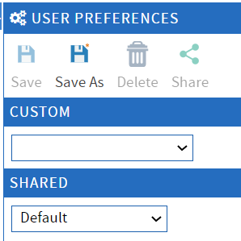

5.0 Showing the right map layers

There are a lot of layers you can turn on or off depending on what you are trying to do.

Good practice is only having the layers you need turned on. There are two modes – being able to see the layer and being able to select the layer. This is very important because if you do not have the selectable turned on then you will not be able to choose it in tools such as search.

Make sure you are on the Harvest Planner tab.
If you are unable to see the tools ribbon there is, on the right hand side of these tabs is the icon or which will open and close the tools. There is also the icon which maximizes the map window.
Click on LAYERS tab if not already highlighted

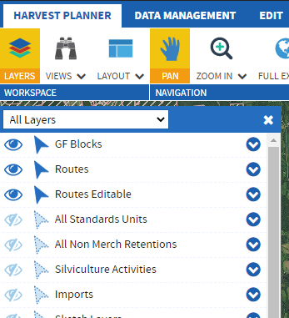
There four symbols on the layer list and each one is very important.
The arrow pointing right which when toggled will point down and will list all the sublayers. Not all layers have sublayers so the symbol may not be showing.
The eye which when toggled will turn on (make visible on the map window) or turn off (disappear from the map window) the layer. If there are sublayers then it may be partly shaded indicating that some of the layers have not been toggled on. Also some layers may only be visible once the map window is zoomed in to a specified extent limit.
The north arrow which when toggled unlocks the layer (makes it selectable) . This must be highlighted or you will not be able to select the object on the map window. If there are sublayers then it may be partly shaded indicating that some of the layers have not been toggled on.
The down arrow which when toggled up will show two special symbols and if available the symbology (legend) of colours and patterns on the map window.

The two symbols are:
The crosshairs just under the eye which when toggled will zoom in so that that layer is visible on the map window if extent limits have been placed on it.
The mortarboard hat just under the north arrow when toggled will make just that layer selectable.

There are a few symbology options when you pull down the menu

It could be how things look and feel on the map window (transparency or cross hatch). Or it could be how the objects are sorted (funding source, year etc.) How things look is part of our calibration so please let us know how you want objects to be shown on the map window.
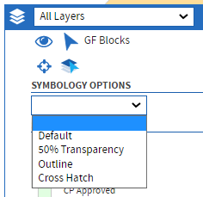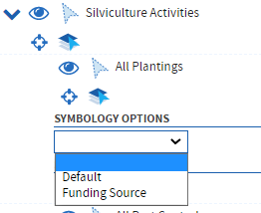
There are more layers than can fit in the layer box , many of which you are not using so to shorten the list you can pull down the menu (currently All layers) and select either Selectable layers or visible layers. This means that the layers that you have made selectable or the layers that you have made visible will only be shown.
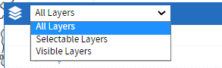
Here I have made GF Blocks, Silviculture Activities, and RESULTS both visible and selectable and made Timber Supply Areas and Blocks visible. With Basemap set to Black Bridge Imagery as visible.

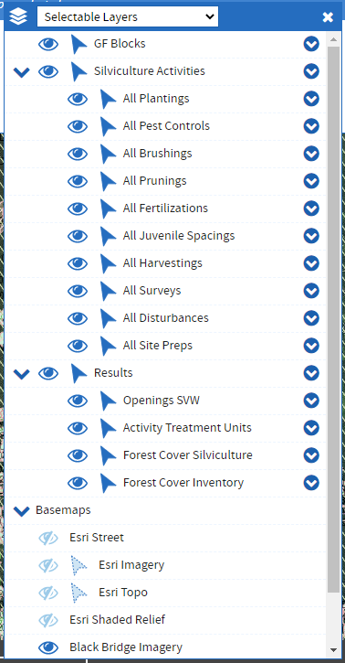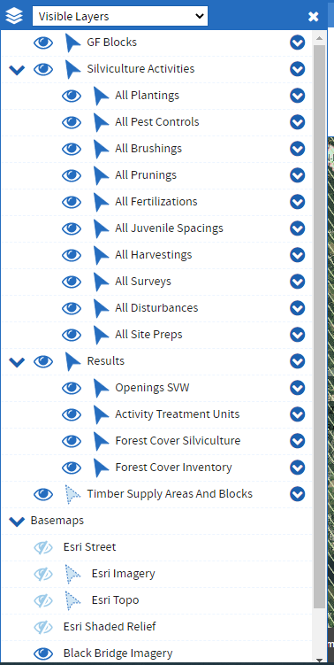
Note: If the list is by selectable layers and you toggle the mortarboard hat then all the layers will disappear except for that one layer.

Basemaps – you can have none (white) or one base layer showing. You can not have more than one basemap showing.

The Black Bridge Imagery is satellite imagery that several programs in FLNR have paid for (FFT being one of them). This imagery is less than 1 year old.

Note: Base maps may have a zoom limit. This means that with this base map on you may not be able to zoom in as far as you would like. You will have to turn off the base map to zoom in further.

6.0 Setting your view

If this is the first time you have logged into Silvacom you should set your view.

Pick all the layers that you want selectable and visible.
Position on the map window where you want to be and the scale (zoom in or out or use in symbology).

Click on the VIEWS tab (Binoculars) 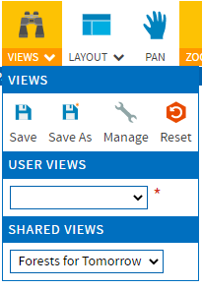
By clicking 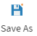, you can save this view as either a USER view or a SHARED view. You will only see your user views and everyone will see your shared views.

If you have pulled up a view and have made some changes, you can resave that view with those changes by clicking on 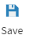.
By clicking on 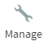you can select one of your views and Edit, Rename, or Delete (close means close the manage views window).
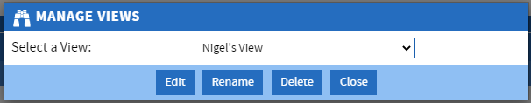
When you click on Edit you can Save the Extent, make it a shared view, make it your default view and add some notes.
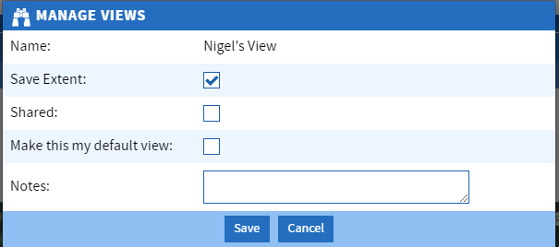

If you have gone to a view then moved around, changed the extent, etc. you can reset it back to the original view by clicking 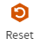

There is no limit on the number of views you can have, so you could have a view for every activity. Note: If you do this DO NOT make them shared views.

7.0 Setting how you want FMS to look (layout)

Once you start using FMS, you will get a feel for the panels (windows) that you would like to have open and their location within the FMS window. You can then save that layout so that when you are working in FMS it will retain that layout. Note: when you save the layout it is only the panels that are saved, the map extents and layer visibility is controlled with the “Views” tool.

There are two layouts (where the tables, lists, etc. are placed on the page) that you can have. The factory default or your own. To set your own, layout the page how you want it and select save. When you click load it will go to that layout. When you click Default it will go to the factory default.
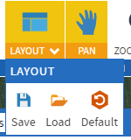
Any panel box (layers, list, Results, etc.) can be moved around the screen by placing the mouse onto the blue part of the title, hold down left button and moving it.

Move some tables around then save this layout. Now toggle between Load and Default to see the two layouts.

8.0 Pan and zoom

When the PAN tab is highlighted (by clicking on it) you can pan around on the map window by holding down the left mouse button.

Zoom In and Zoom Out can be done by toggling the one you want and then holding the left mouse button to build a rectangle around the area to zoom in or out to.

Full extent will zoom and pan the map window to show the default map window extent which is currently set to the world but will be set to BC.

Extent History will go back or forward to previous map window extents. It is session dependent and will reset when FMS is closed.
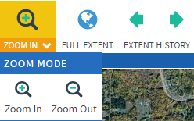

9.0 Selecting objects

The select tool under the Harvest planner lets you select objects on the map window. You can select by layers that are selectable or visible.

or
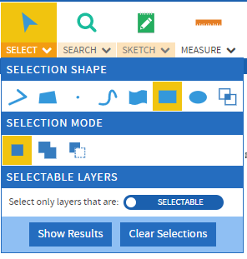
Your mouse can select by shape:

 Polyline – this creates straight lines by clicking left mouse button at each corner – double click to finish. Any selectable object on the line will be selected.
Polygon – This creates straight edge polygons by clicking left mouse button at each corner – double click to finish. Any selectable object in the polygon will be selected.
Point – Any spot that you click on with the left mouse button will be selected.
Free line – This creates a curve line by clicking and holding the left mouse button. Any selectable object on the line will be selected.
Free Polygon – This creates a curve edge polygon by clicking and holding the left mouse. Any selectable object in the polygon will be selected.
Rectangle - This creates a rectangle by clicking and holding the left mouse. Any selectable object in the rectangle will be selected.
Ellipse - This creates an ellipse by clicking and holding the left mouse. Any selectable object in the ellipse will be selected.
Feature – This will bring up a pop-up window where you select a layer or layers and any object in those layers will be selected that intersect with the feature chosen.

You can set the selection mode
Standard Selection – Each time you select objects, the previous objects will be discarded.
Additive Selection – Each time you select objects, they will be added to the previous objects selected.
Remove Selection – The objects you select will be removed from the selected objects.

When you select objects the Results table automatically pops up if it is not already shown, if you do x out of the table the Results button will show it again. The clear sections button clears all of your selections.

10.0 Results table

The FMS Results table (Nothing to do with RESULTS) shows the attributes for objects that have been selected.
The results tool  makes the results table visible and any object or objects that have been selected will have their data shown in this table.

11.0 Being consistent with RESULTS

For FMS to be able to report to RESULTS, the sequence of events for entering activities into FMS should be followed:

- Create a GF Block which will be then assigned an Opening Id that was created in RESULTS.
- Create standards unit(s) when a GF block is created to manage activities such as site prep, planting, brushing and subsequent surveys. If it is a shell opening such as fertilization or landscape level surveying, then standards unit(s) are not required.
- A disturbance is added over the GF Block.
- Activities are then added.

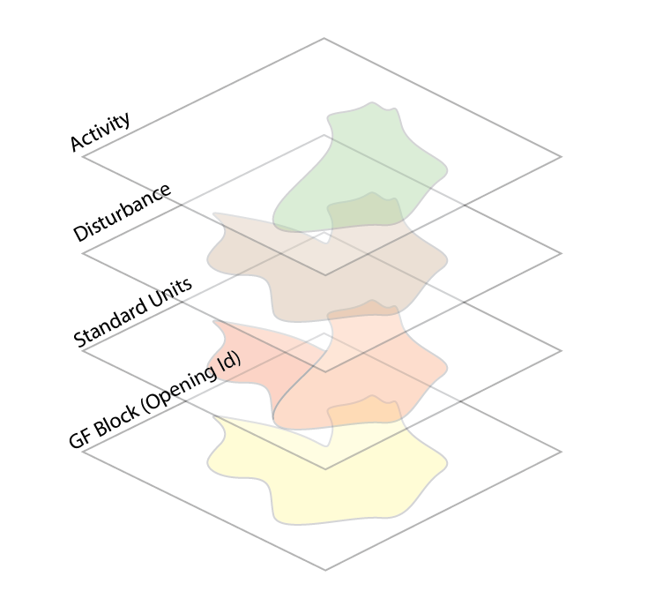

12.0 Creating a block

You must have geometry when creating a block.

There are many ways of getting geometry.
- Use existing geometry from one of the map layers (e.g. Opening SVW 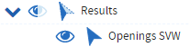)
- Draw a sketch
- Upload a spatial file
- Create your own on the fly when creating a block.
Make sure that that the GF Block Layer is both visible and selectable in the layers table (see 4.0 Showing the right layers)

12.1 Creating a block using existing geometry from the Opening SVW layer

Make sure that that the Opening SVW layer is both visible and selectable in the layers table (see 4.0 Showing the right layers)
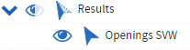
Pan the map window to the location of the block. You should see the opening that you want to take the geometry from.
Click on DATA MANAGEMENT tab , pull down add 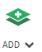, click on block 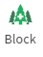
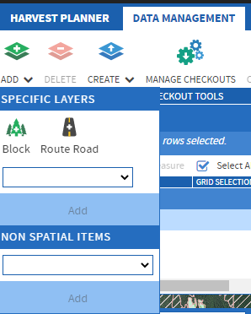

The following pop-up box will appear
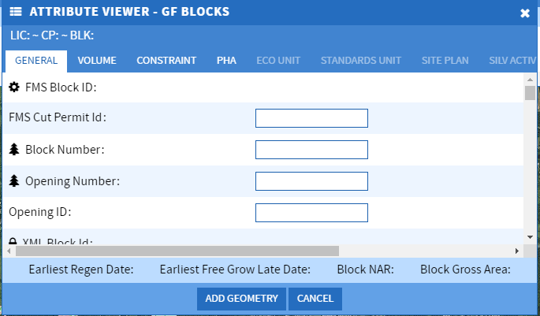

You can fill it in the attributes first or go directly to add geometry.

The attribute that you must put into FMS are:

Opening ID
Common Name

Opening ID may be added later as you must get a new Opening ID from RESULTS (See 6.0 Getting a new Opening ID from RESULTS)

Add geometry by clicking

You will now notice that FMS has now switched to the edit tab giving you tools to add the geometry.

Click pick geometry 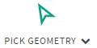, then use your mouse to click on the sketch you just drew in the map window.

Depending on how many layers have been made selectable it will give you a list of items selected. Click the opening svw
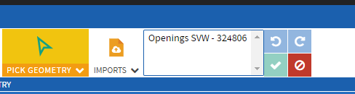
Once highlighted 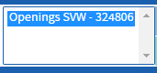 click on 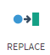 (You are replacing a null value with the opening spatial)
then click the check mark
It will give you the message
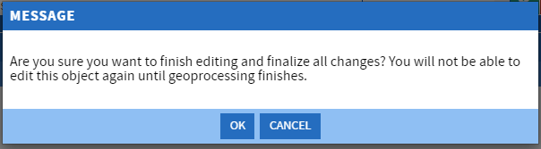
Click OK
Under the tab harvest planner make sure results is highlighted 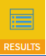.
You should be seeing the results table. Select the block you just created  by clicking on the block. The block should now show as a row in the results table. Note that if you did not put information in before adding geometry it will show as blank row.

You can see that the results table shows both the GF block you created and the original Openings svw. Each layer having their own tab.
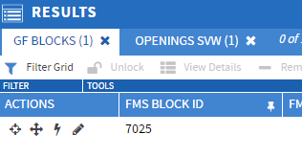
Highlight the GF block in the row and the options in the results table will become available. One of the options is view details.
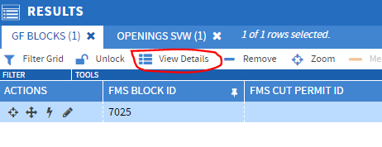
This will bring up another table

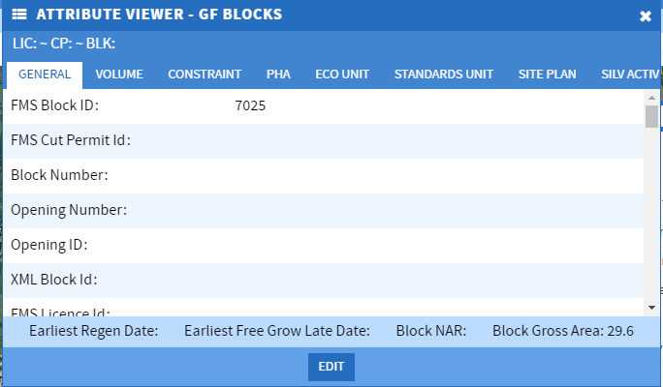

Click edit to edit the block attributes then save changes

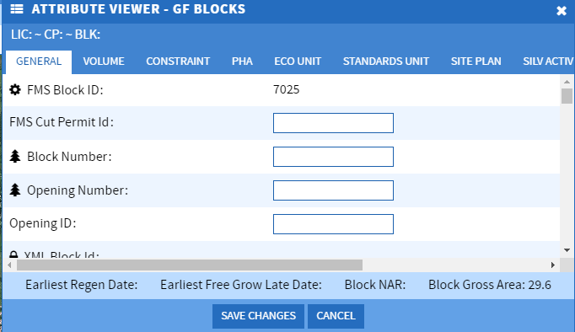
Make sure you save the changes or cancel as leaving this edit box open could cause FMS to freeze or give error messages when doing other tasks that rely on information from the GF block.

12.2 Creating a block by creating geometry on the fly

Creating geometry on the fly is putting a placer block at the location of the GF block so that it can be later replace with correct geometry.

Pan the map window so the location of the block is somewhere in the middle.
Go through the same sequence as you did for the Opening SVW layer.

FMS has now switched to the edit tab giving you tools to add the geometry.

Now click on draw 

You can pick polygon or free polygon
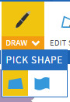

Now click and hold down the left mouse to start drawing on the map window. Double click to finish.
Now click apply, the check mark

It will give you the message:
Click OK
You can manage the block attributes in the same way that you did when you used the Opening SVW layer.

12.21 Creating a spatial file from the GF Block

Spatial is the basis to FMS and that is why it has a GIS (geographic information system) looking interface. Most spatial will not come from drawing on the fly but from other tools such as Esri ArcGIS / Map in the form of a zipped folder.

We will create a spatial file from a GF block so that we can import it in the next section.

To create a zipped spatial folder for demonstrating bring in spatial we will use the GF block just created on the fly to download into a spatial zipped folder.
Make sure the GF blocks are selectable and visible in the layers list
On the harvest planner tab click on select  then select the GF block with the mouse (see 9.0 Selecting objects).
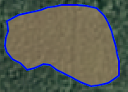 Highlight the block on the results table 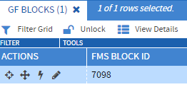
Now click on the tab and then click on 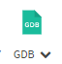 tool.
Don’t include Attributes by leaving it unchecked . 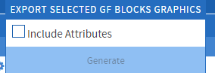 and then click and a zipped file will be downloaded.

Go into windows explorer and change the name to “shape_to_upload” keeping it a zipped file

12.22 Deleting the GF Block

Now delete the GF block so that you can import the shape file you just created in the next section.
Highlight the block on the results table 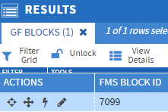 go to and. It will give you a warning message that you are about to delete a feature
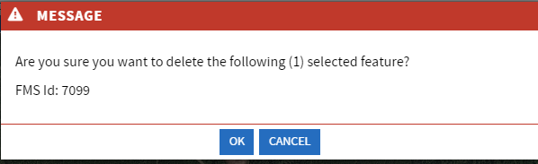
Click . Note: it may still be showing on the map window but a refresh will remove it from the map window.

12.3 Creating a block by uploading a spatial file

Make sure that that you have a spatial file in a zip format (see 30.0 Creating a zip spatial file). The shape file from GDB tool will be in the correct format.
Make sure that the layer Imports is selectable (see 5.0 Turning on the right layers)

Go through the same sequence as you did for the Opening SVW layer.

FMS has now switched to the edit tab giving you tools to add the geometry.

Click 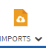

A browse window will pop up. Now navigate to your zipped spatial file and open it
You then get a RESULTS table that shows the polygon imports

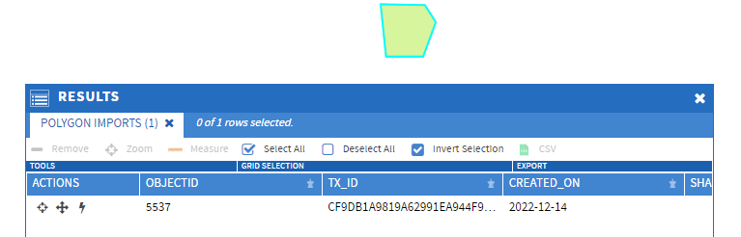
Click on , then use your mouse to select the polygon you just imported in the map window. It will show up in the selected object list.
Highlight the polygon in the list 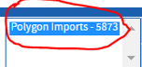 and click on (You are replacing a null value with the import spatial)

then click the check mark

Important – if the polygon is not showing up in the object list, then it is likely that the layer Imports has not been toggled selectable.

It will give you the message
Click OK
You can manage the block attributes in the same way that you did when you used the Opening SVW layer.

You do not need to worry about the shape in the import layer as they are there temporarily. When you exit out of FMS and when you return all of the imports from the last session will be gone. Alternatively you can remove all of the imported shapes. You cannot remove an imported shape individually. To remove all of them click on the down arrow on the Import tool 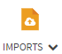and then click 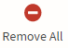.

12.4 Removing overlap of an adjacent SVW opening from a GF block

We will create a GF block that is immediately adjacent to a SVW opening and then remove the portion of the GF block that overlaps the SVW opening.

Make sure both GF Blocks, SVW Opening Layers, and Forest Road Segment Tenure Visible and Selectable , 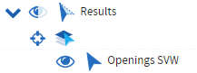and

Create a GF block “on the fly” (refer to 12.3 above) where this GF block overlaps a SVW opening and also has a road within it (needed for buffering in next section).
hold down the left mouse to draw on the map window making sure you overlap a SVW opening. Double click left mouse to finish.

You should have a block similar to

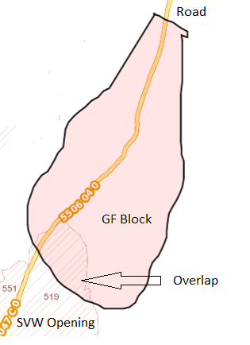

Now we need to remove the overlap before we save the GF block.
Select “Pick Geometry”  and pick with the mouse the SVW Opening that overlaps with the GF Block you are creating.

Click on the text in the box that lists the selected opening (Openings SVW)

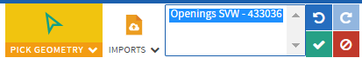

Click on “clip” to remove the portion of the new block that overlaps with the SVW Opening. Make sure it is Clip in the clip options and not

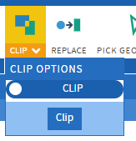

Now click apply

You should now have the portion of the GF block outside of the SVW Opening. The boundary is shared and there are no slivers.

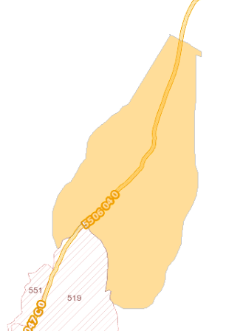

Record the “FMS Block ID” for future use.

13.0 Buffering Roads

We are going to select the roads that are within the block and buffer them. This buffered area will later then be used to create a Standard Unit that represents the Non-Productive Roads.
Make the “Forest Road Segment Tenure” visible and selectable
It should be the only layer that is selectable you can do this by clicking on the mortarboard hat that is just under the selectable arrowhead 
Under the harvest planner tab Use the select tool 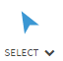to select all the roads in the GF block. They should all turn a dark blue to allow you to confirm that you have them all.

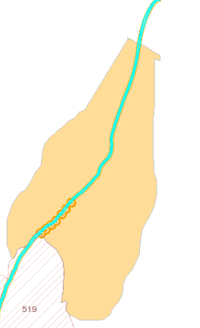
In the Results table, highlight the roads you have selected

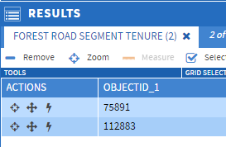

Now go to the Edit tab

Now click on the down arrow of Create Buffer 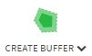

You will get options for the buffer distance and the layer to add the buffer to
The buffer is the distance from the road center. So to have a 10 meter road, set the buffer to 5 metres. The buffer will be placed into the “Harvest Planner Created Buffers” layer. This is the only layer showing. It will temporarily store the buffers for use.

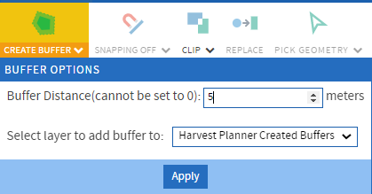

Note: It is possible that you may get 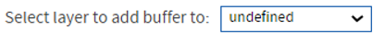 as the layer then the layer is not showing in your view. You will need to change the view to company default.

Now the buffers.

If you zoom in you should see the buffer around the road.

Note: If you are unable to zoom in, it is likely that you have a base layer with a limited zoom in extent and you will have to unselect this base layer. After unselecting the base layer you may still not be able to zoom in. This is because the extent limits are still set and you will have to select a base layer without zoom in limits to reset the extent limits. You can then turn of this base layer.

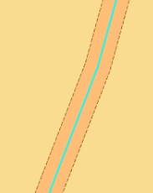

13.0 Creating Standards Units (which include Ecological Units (BEC))

Once you have created a GF block you will need to assign standards unit(s) unless the block is a shell opening. Shell openings are used \ for activities such as fertilization or landscape level surveying. Standards Unit(s) do not need to be assigned to shell openings.

We are going to use the GF block created in 12.5 Removing overlap of an adjacent SVW opening from a GF block

13.1 Create a standards unit for the Non-Productive Roads.

Make the “Harvest Planner Created Buffers” are visible and selectable
On the tab select the down arrow on 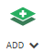 then the down arrow in the text box and choose Standards Unit.

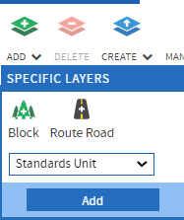

Now click

When the “Attributed Viewer” appears scroll down to “Standards Unit Type” and choose NPUNN Non-Productive Unnatural.
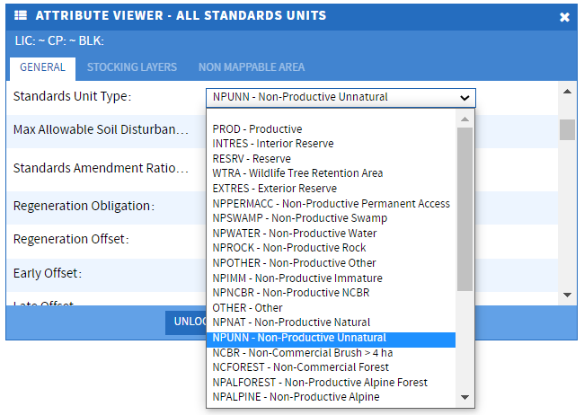

and also fill in the “FMS Block ID” which you recorded in 12.5 Removing overlap of an adjacent SVW opening from a GF block (Note you can enter FMS Block Id for all standards units at the same time once they have been created)

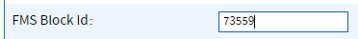

Select Add Geometry .
Use the Pick Geometry to select the “Harvest Planner Created Buffers” polygon that represents the Non-Productive Roads. You may have more than on polygons listed, make sure you select all of the buffers in the GF block.

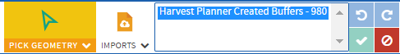
Click “Replace” 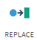

You should now have the outside edges of the buffer turn black


Since some of the standards unit is outside the block so you will need to clip standards unit at the GF block edge.

Make sure GF Blocks is Visible and Selectable ,
Click and select the GF Block
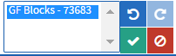

Now use the down arrow  on clip 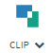 and change to and clip

You will now see that the black outline of the standards unit ends at the GF block edge.
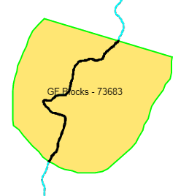
Now apply this as the standard unit. You will get the message.

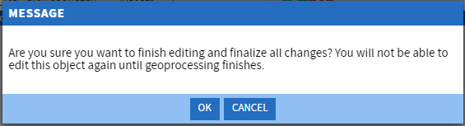

Click 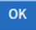

13.2 Create a standards unit for the Non-Productive Natural (swamp, NP, WTP, Rock).
Go through the same sequence to create a standards unit
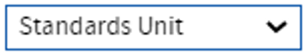

When the “Attributed Viewer” appears scroll down to “Standards Unit Type” and choose PROD -Productive.

and also fill in the “FMS Block ID” which you recorded in 12.5 Removing overlap of an adjacent SVW opening from a GF block (Note you can enter FMS Block Id for all standards units at the same time once they have been created)

Select Add Geometry .

We will draw the polygon on-the-fly but you can also pick geometry or upload a spatial file
Click on on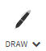and choose the polygon option – polygon or free polygon
Draw the non-productive polygon

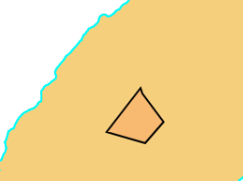

Now apply this as the standard unit. You will get the message.

Click

13.3 Add the Productive Standards Unit

Make sure GF block is selectable

Go through the same sequence to create a standards unit

When the “Attributed Viewer” appears scroll down to “Standards Unit Type” and choose PROD -Productive.

and also fill in the “FMS Block ID” which you recorded in 12.5 Removing overlap of an adjacent SVW opening from a GF block (Note you can enter FMS Block Id for all standards units at the same time once they have been created)
Select Add Geometry .
Use the Pick Geometry to select the GF block
Now select 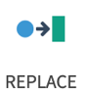
You now need to clip out the other standards units from this polygon
and select the NP unnatural and NP Natural Standards Units.

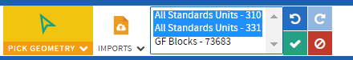
Now use the down arrow on clip and change to and clip

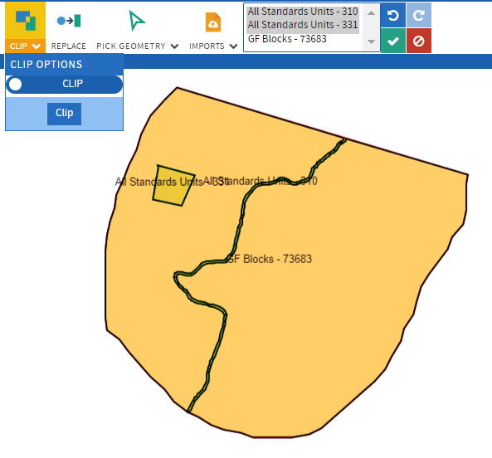
Now apply this as the standard unit. You will get the message.

Click

13.4 Split the Productive Standard Unit into two Standard Units
Make the Standard Units Layer Visible and Selectable
Select the productive Standard Unit
In the “Results” table select the Edit (Pencil) tool. 
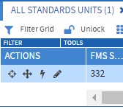
The “Edit” toolbar will then open.
Then use the cut tool  to split the polygon into two productive Standard Units.

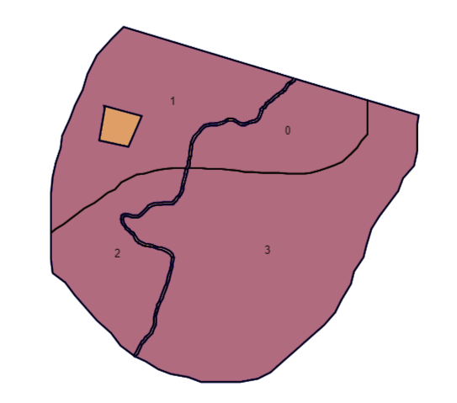
Note that there are actually four separate polygons (0,1,2,3) created with this cut as the NP Road isolated the area on each side.
Now apply

13.4 Checking your standards units

You can check to see all the standards units by having just the Standard Units Layer Visible and Selectable and 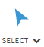the enter block. In the results table you should see all of the standards units.

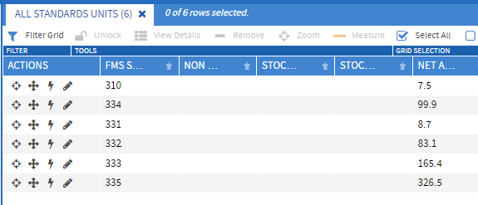

You can flash each one to make these are the standards units are appropriate. You can also highlight them all, view the details and add the FMS Block Id to all standards units at the same time.

Another way of looking at the standard units is to make the GF Blocks Visible and Selectable.

Select the GF Block in the map window.
Select the GF Block in the “Results” table. Select View Details.
Click on the tab 

Ensure that all the applicable Standards Units are shown in here as that will ensure that the “FMS Block ID” field has been filled in for each Standards Unit. If any are missing edit the details associated with the Standards Unit to add the “FMS Block ID”.

The attribute that you must put into FMS are:

Note: Silvacom is in the process of updating the Stocking Standard Legal Id which when entered will auto fill most of the attributes.

FMS Attributes | RESULTS equivalent attributes
Stocking Standard Legal Id | SSID
Max soil disturbance | Max soil disturbance
 | NAR
 | BEC zone
 | BEC subzone
 | BEC site series
Regen offset | Regen offset
 | FG offset
 | Preferred species / Minimal heights
 | Acceptable species / Minimal Heights
 | Target stocking
 | Minimum Preferred and Acceptable Stocking
Minimum Preferred Stocking | Minimum Preferred Stocking
Max Conifers (stems/ha) | Max Conifers (stems/ha)
 | Post Spacing (Min/Max)
 | Minimum Inter-tree Distance
% Height Above Brush | % Height Above Brush
 | Site Plan Exemption
 | Site Plan Amendment

13.5 Combining two standards units together
To combine standards units together one of the standards units that you want to combine.
Note: The Standard Units Layer needs to be Visible and Selectable
In the “Results” table select the Edit (Pencil) tool.
The “Edit” toolbar will then open.
Click and pick the other standards unit that you want combine with this standard unit.
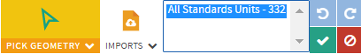


Now 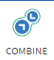 the two standards units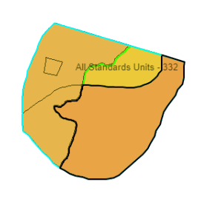 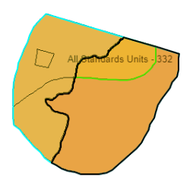
Now apply

14.0 Adding Activities to a GF Block

There are three types of activities:

- Disturbance type
- Silviculture activity
- Block activity
Disturbance and silviculture need spatial and a block activity does not require spatial.

14.1 Adding a disturbance type to a GF block

In order report an activity to RESULTS there must be a disturbance reported. Therefore, all blocks will need to include a disturbance activity.

There is an 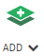 tool under the Data Management tab and there is an tool under Silviculture. These two tools are not the same. The one under Data Management creates blocks, roads, standards units and other non-silviculture objects. The one under Silviculture creates planting, surveys, site prep and other silviculture activities.

A disturbance type is associated with a GF block so you need to have a GF block where the disturbance type is taking place.

Make sure the GF block layer is selectable Select a block or create a new one using the sequence:
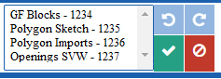

With the block highlighted in the results table:
You can now create a disturbance type for this block.
Under the silviculture tab , click on on the 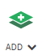 tool.

Choose All Disturbances and click
You will now see the attribute viewer. There will be some attributes that will be required (not yet enforced) which are:

Disturbance Code
Planned Start Date (yyyy-mm-dd)
Completion Date
Number of hectares
System
Variant
Phase

Now .

If nothing happens when you click add geometry, check to make sure that all the manatory fields (those with a star) have been filled in.

Click 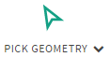 (should be rectangle by default but you can change the pick shape with )

Choose the GF Block that the disturbance is associated with.
The block should show up the pick list 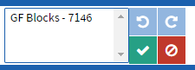.

Highlight in the pick list 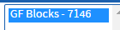 and click 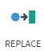 and then to accept the changes.

14.2 Adding a silviculture activity to a GF block

Adding a silviculture activity is the same workflow as disturbances. This is how you would add a survey activity.

Select a GF block and highlight in the results table
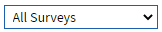

You will now see the attribute viewer. There will be some attributes that will be required and have a red star beside the attribute 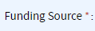 and need to be filled in before you can save the activity.

There are two tabs in the attribute viewer 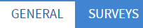. Both tabs have required attributes. The purpose of dividing the attributes is so that you can make batch changes to multiple activities that have common (general) attributes, but you will need to make individual changes to the unique (surveys) attributes. (See 15.0 Making batch changes to multiple activities)
Once the attributes have been entered you can pick the geometry .

If nothing happens when you click add geometry, check to make sure that all the manatory fields (those with a star) have been filled in under both tabs.

Geometry could be the entire GF block or it could be a standards unit or its own unique shape.
Choose the shape that the survey is associated with:

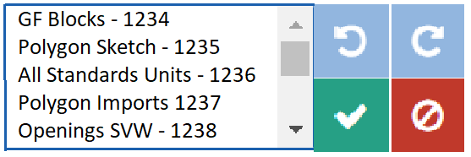

14.3 Adding a block activity

A block activity is an activity that has not spatial such as

Fertilizer Purchase
Future Seed Purchase
Nursery costs
Operational Seed Purchase
Planning
Program Administrator Management Fee
Silviculture Program
Overview Planning

This is usually done by Branch but there may be some non-spatial activities that the district would like to track.

Although the activity itself has no spatial it is place in a GF block that does have spatial. Placing a block over the district, region, or branch office is the most appropriate place to put it.

Create a block over your office (see 12.0 Creating a block).
Select this block that the block activity is to be added to 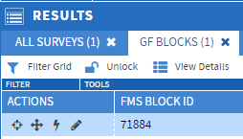
Now click
The attribute viewer will show up. The viewer window will need to be expanded in order to see all the tabs. Mouse over the edge of the box and click left button when you see the double arrow and pull it wider.

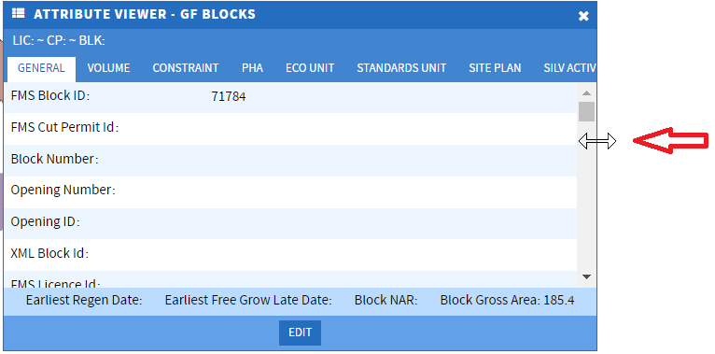

Click on the Block Activity tab (third one from the end)

And then click which will change the options to 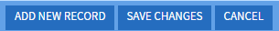 choose

The attribute view – GF blocks should show the form for adding the attributes.

There will be some attributes that will be required (not yet enforced) which are:

Need to add these

Once the attributes are recorded just , geometry is not needed.

14.4 Deleting an Activity

To delete an activity, select or search for the activity so that it is listed in the Results grid and highlight it

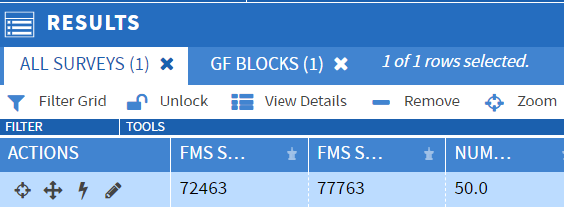
Select 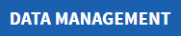 tab and click on 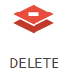

A warning message will appear to make sure that you are sure that you want to delete this activity

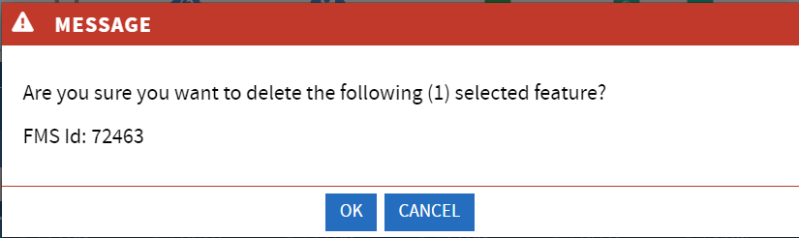

Click to delete.

15.0 Adding the same activity to multiple blocks

The workflow is exactly the same as it is for one GF block only instead of highlighting just one block you highlight all the GF blocks you want to add a survey.

Make a cluster of about five GF Blocks using the techniques in 12.0 Creating a block

You now need to highlight the blocks you just created in the results table. You can find your GF blocks by selecting them on the map window or by using the search tool (see 17.0 Using the search tool).

Here I have selected them on the map window.
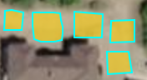

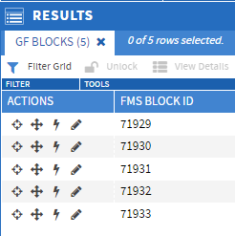 and then highlight them all 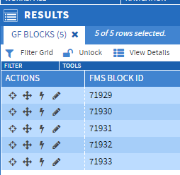

Now add your activity using the techniques in 14.0 Adding Activities to a GF Block.

Fill in all the mandatory attributes in the attribute table.

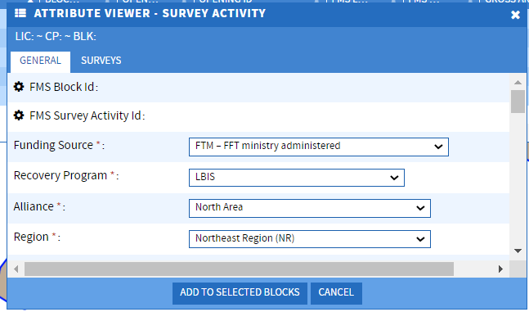

You will notice that there is no button to add geometry but rather just .
Click on

If nothing happens when you click add to selected blocks, check to make sure that all the manatory fields (those with a star) have been filled in.

The same survey will be added to each block and the geometry of the survey will be the same as the GF block.

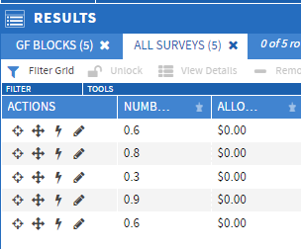

16.0 Making batch changes to multiple activities

You may want to make the same change to multiple activities such as district approval.

Highlight all of the surveys in the results table that you just created.

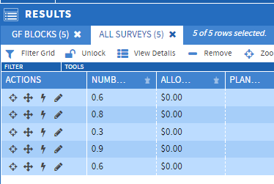

Click on view details 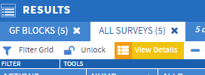

You will get the warning box:

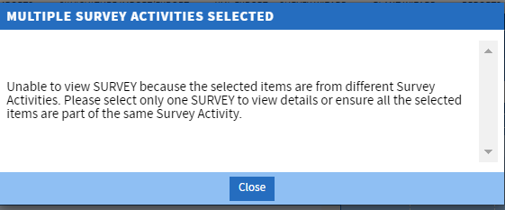

Close this box.

You will now have the attribute view open with only general being available.

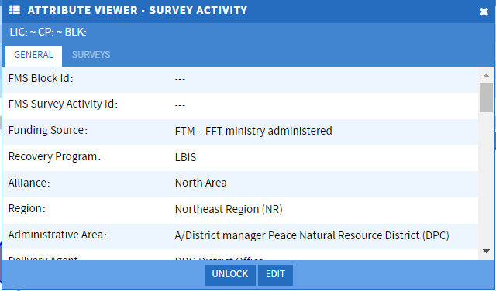

Click on and change the attribute(s) that you want reflected in all of the surveys. For example changing district approval to yes

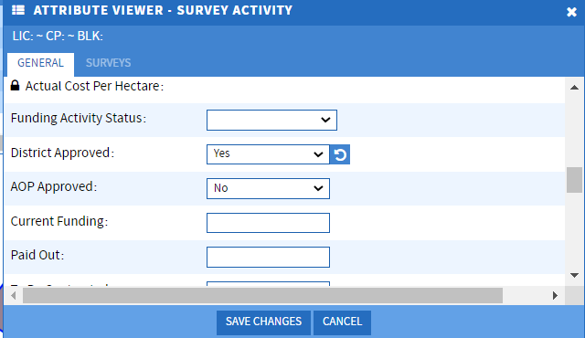
Now save the changes

A warning box will come up.

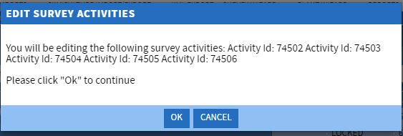

Click OK

The change has now been made to all of the surveys.

17.0 Getting a new Opening ID from RESULTS

An opening must exist in RESULTS before FMS can submit to RESULTS. It is good practice to create an Opening ID in RESULTS which can then be assigned to a GF block in FMS.

There are four attributes you must have to create an Opening ID.
They are:

Org Unit
Opening Category
Opening gross area
Approval date

Now go to the RESULTS application (Note if you are learning – make sure you use the test environment at https://testapps.nrs.gov.bc.ca/ext/results/). If you do not have access to the test environment you can contact scott.akerley@gov.bc.ca.

Click on the openings tab and choose Opening Inquiry

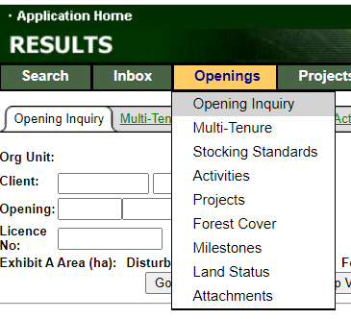
Scroll to the bottom of the page and click Add
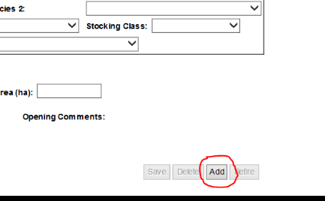
Now fill in the four requirements:

Org unit – make sure it is correct this cannot be changed!!
Opening Category – for fires it will be NDFS.
Opening Gross Area – don’t worry if you don’t know the right ha, this can be changed later.
Approval Date – whatever policy your district uses – could be “today” the date you created the opening or the date of the survey.
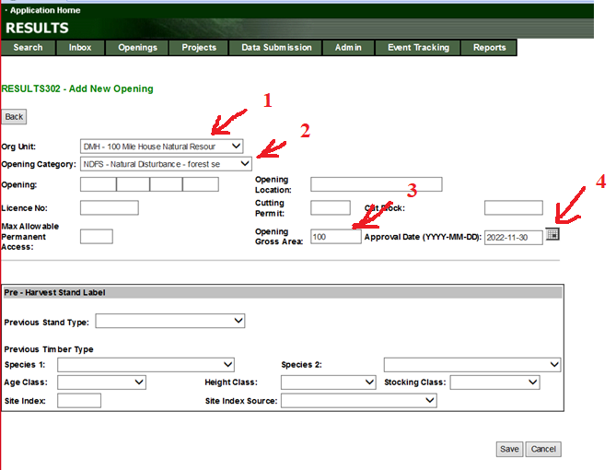
Now click save.

If you are missing any of the mandatories, you will get a message indicating what you have missed.
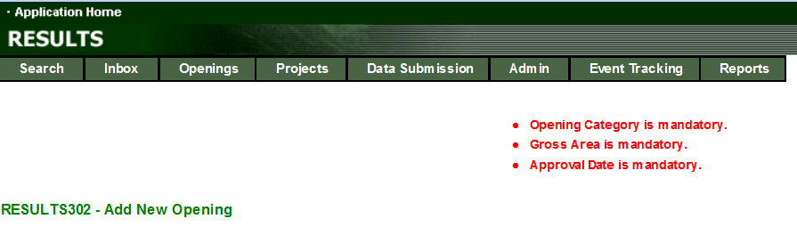

It is very important to make note of the Opening ID as it is really difficult to find it again.

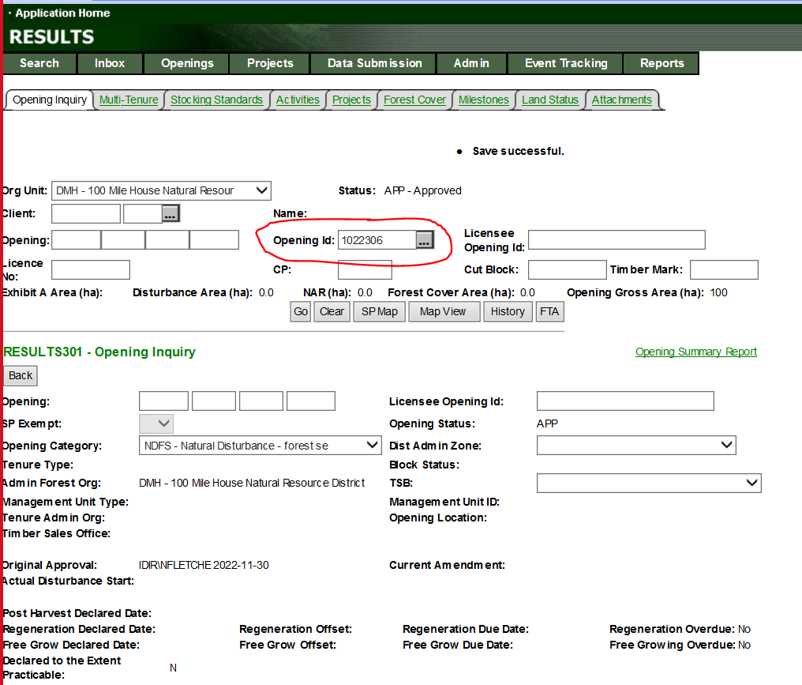

That’s it. Now you have an opening for the FMS GF Block.

18.0 Downloading a georeferenced pdf map

You can create a georeferenced pdf map by clicking 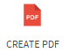. A matte will appear on the map window which stays fixed and you will need to Pan around the map window to place the pdf. You can type in the scale you want (PDF MAP SCALE) or alternatively Zoom in or out. Fill out the other pdf settings and click generate map.

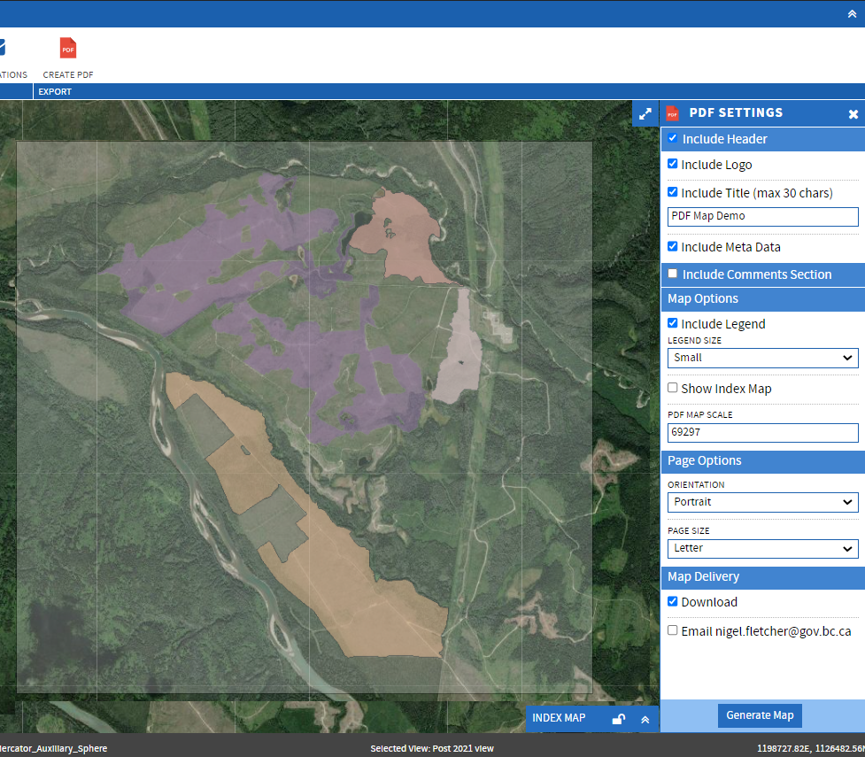

A georeferenced pdf will be created and downloaded to your computer. Alternatively, you can have the map emailed.

19.0 Using the search tool

It is likely that you will want to work on a specific block/activity or group of blocks/activities. The search tool allows the user to find areas of interest quickly.

Under the tab click on the magnifying glass  down arrow and then click on New Search 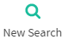 you will get a search table

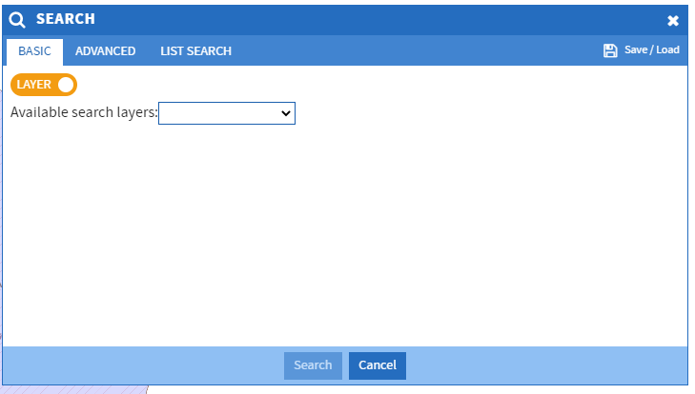

You can choose between Basic, Advanced or List search modes by selecting their respective tabs.
- Basic Search: a query one or more terms that are all match or any of the conditions.
- Advanced: a query were terms can be combined using logic of AND or OR
- List Search: a query of a number or numbers representing list items such as FMS Block ID, etc.
The key to searching is making sure that the layer with the date you wish to search is selectable.
(see 4.0 Showing the right layers)

Here is a simple search – all surveys of the delivery agent DHM – Forsite

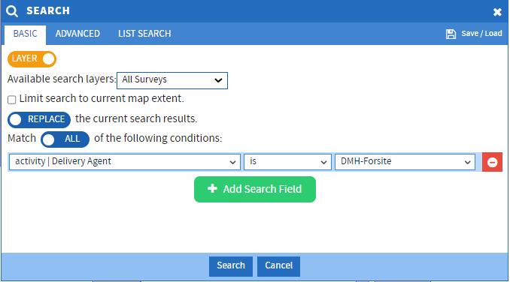

A results box pops up showing the 41 surveys that meet the search criteria

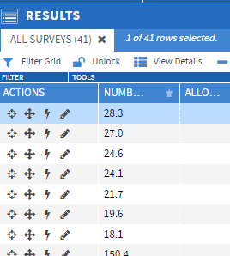

20.0 Making a submission to RESULTS

FMS was originally configured to submit to RESULTS using tenure information. We are in the process of switching this to district information for submission. As soon as this configuration is completed, this training document will detail how to submit to RESULTS.

21.0 Reporting out with PowerBI

21.1 Install Power BI

PowerBI is free to install. Go to Microsoft’s PowerBI web page
https://powerbi.microsoft.com/en-us/downloads/ and choose Advance download options.
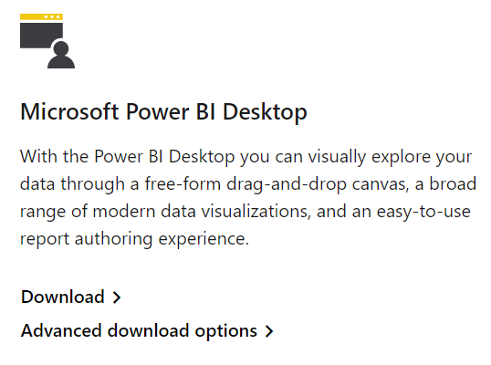
Now click on

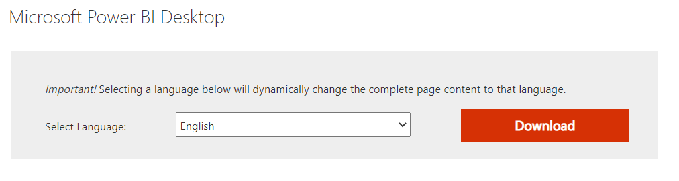
Choose PBIDesktopSetup_x64.exe

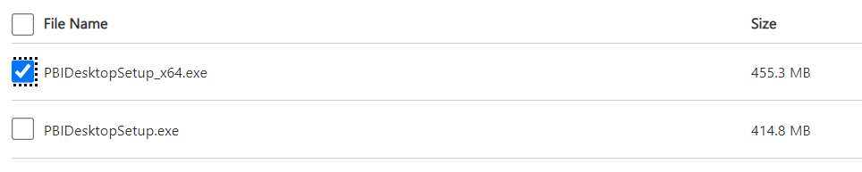
And click 

It should download 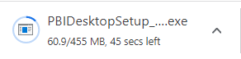

Run the file that was downloaded.

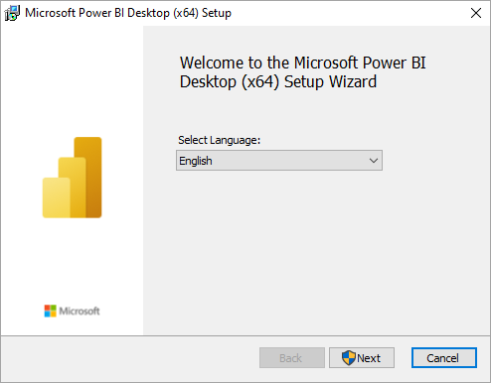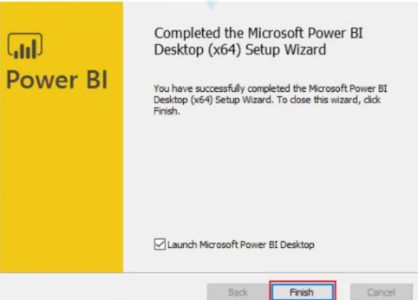

21.2 Open Odata feed

Find PowerBI Application and open it
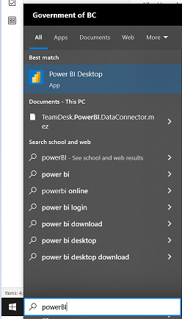
In the window that opens select 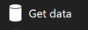 or in the PowerBI workspace click on 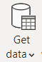
Select OData feed

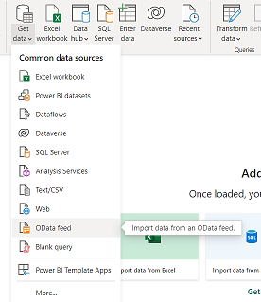

Enter the URL https://online.silvacom.com/fmsmof_bcUAT/odata/
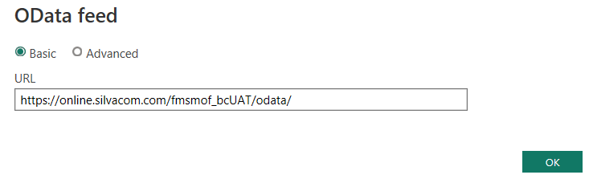
Enter Password – Contact Nigel Fletcher for password

21.3 Open Power BI Report ODataReport.pbix

Go to the ministry FTP site and navigate to F:\HFP\gov_internal\!publish\FMS PowerBI Templates
Save the file ODataReport.pbix to your workspace
Click on (left hand corner)
Select 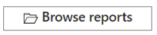

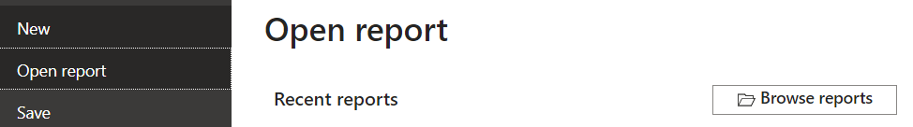

Find ODataReport.pbix that you downloaded to your workspace and 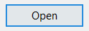

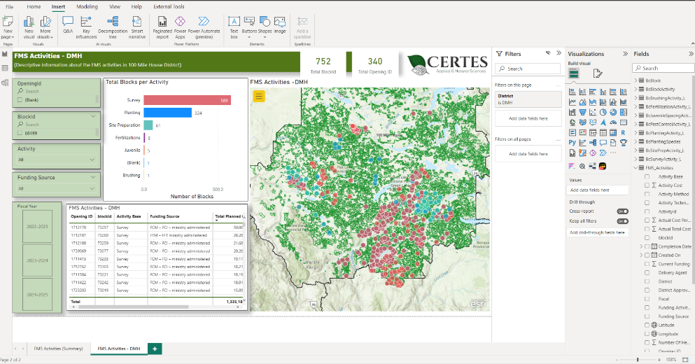
Search for Opening ID
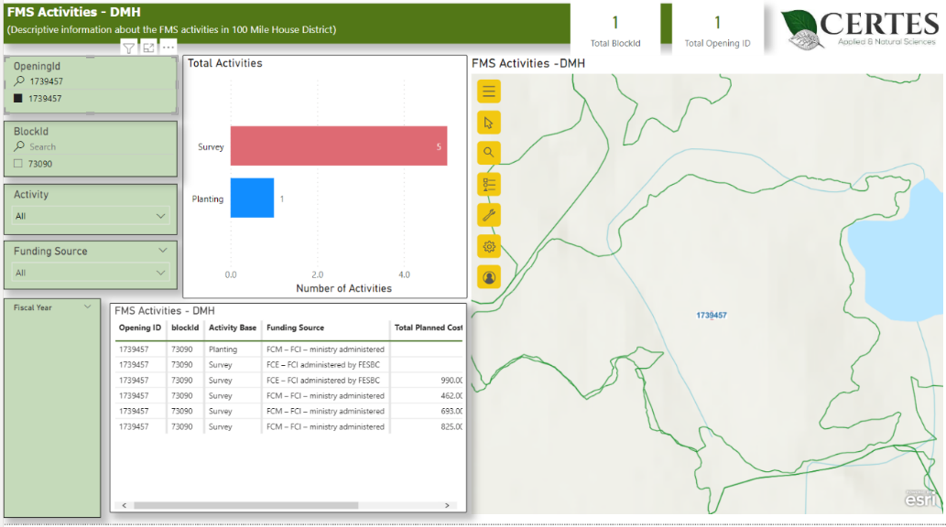
Search for BlockId
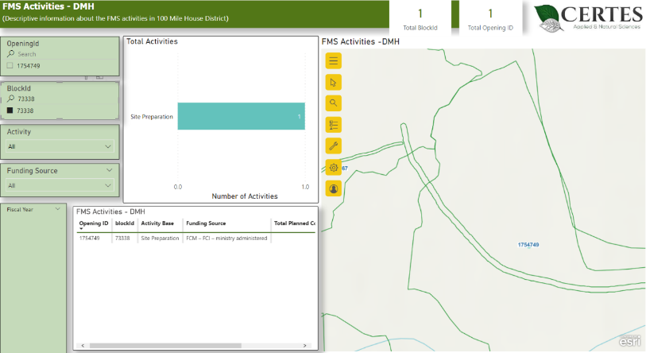
Filter by Activity
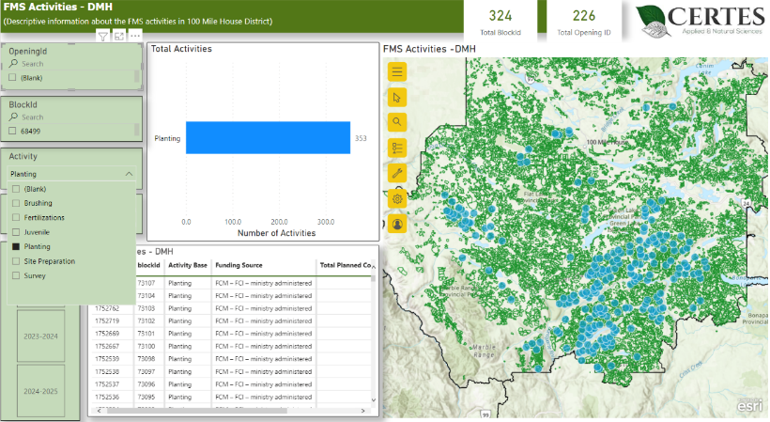
Export a specific table
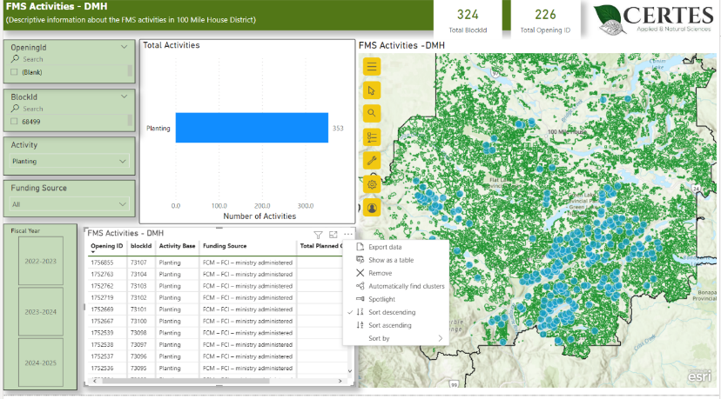
Export to PDF
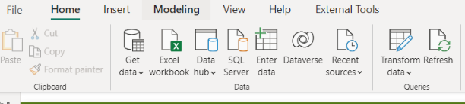
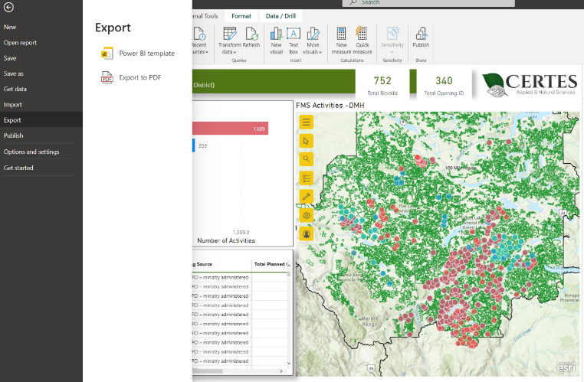
Advanced** Select additional data – Load or transform
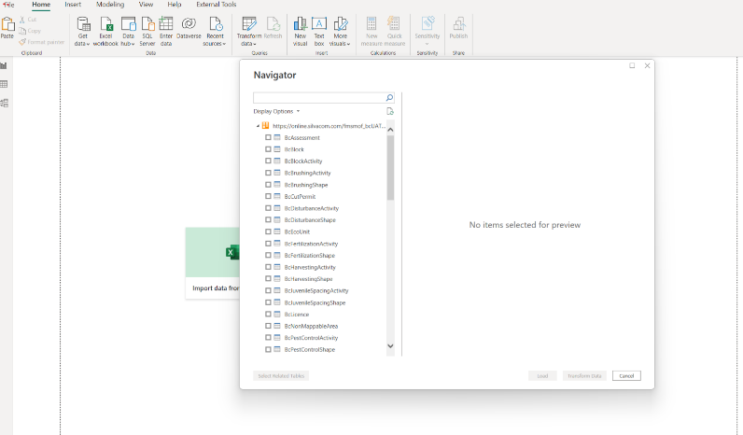

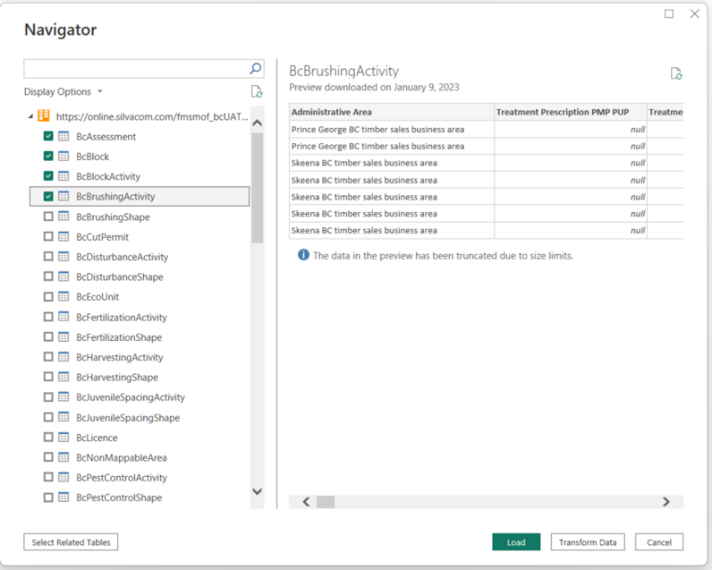

22.0 Taking the FMS skills test (and getting a coffee mug!)

To get access to the production site you must take this FMS skills test. If you receive 80% or better, you will be given access and receive an FMS coffee cup. The test is based on sections 1 – 18 of the Forest Management System (FMS) User Guide and Training Document.

Once you have worked through this guidance and training document, send an email to nigel.fletcher@gov.bc.ca and he will send you an URL link to take an examination.

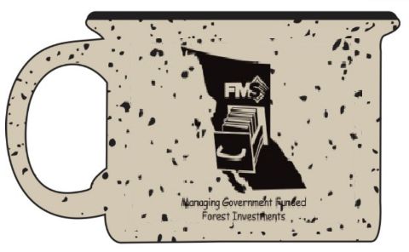

23.0 Using the Silviculture Import/Export Tool (SIET) to add GF Blocks and Activities

Silviculture Import/Export Tool (SIET) was purpose-built for the Ministry to allow Delivery Agents, and Recipients to submit planned and completed activities to Districts without creating data entry or busy work for District staff.

Currently only the Activity template is available, soon there will also be the block template which will be able to create blocks based on spatial provided, opening ID or lat/long coordinates.

23.1 Block template

To be developed once the block template is available.

23.2 Activity template

23.21 Download a blank template

Those with an FMS user id can download the most recent template with or without data from the within the application. We will also put a blank template on the Provincial ftp site (location TBD).

To download the template, click on tab
Use the on 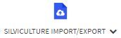and

You will get a message

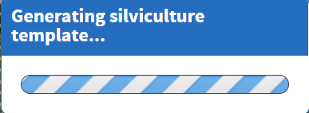
Which will then change to
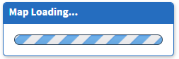
And a zipped folder (template) will be downloaded. The zipped folder contains:

- a file geodatabase which is the spatial container, housing templates (blank layers) for each government-funded block and silviculture activity, and
- An excel workbook with a worksheet for each activity or object in the database.
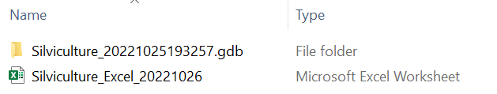

23.22 Download a template that contains current data in FMS

You may select one or many silviculture activities using the select tool or search tool that brings up a results grid.

If you highlight activities under an activity tab then only that only that activity will be exported into the template. In this case I have a results grid with 1 brushings highlighted, 1 plantings highlighted and 2 of the 5 surveys highlighted.

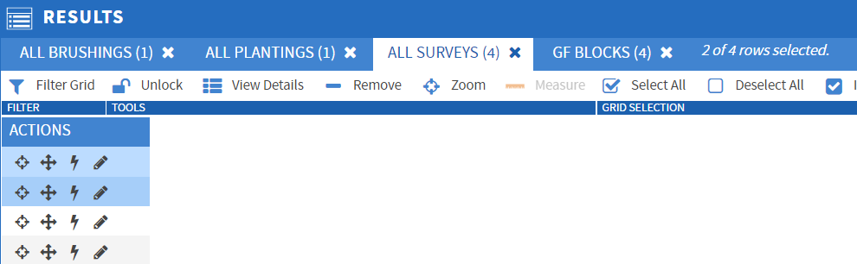

But because I am on the ‘All Surveys’ tab, when I export records to the template by opening the tab, using the on and 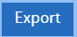

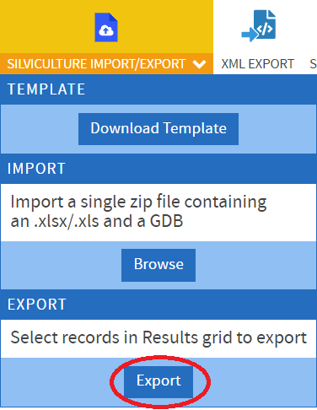

I will only get the two highlighted surveys in a template with only a surveys worksheet.

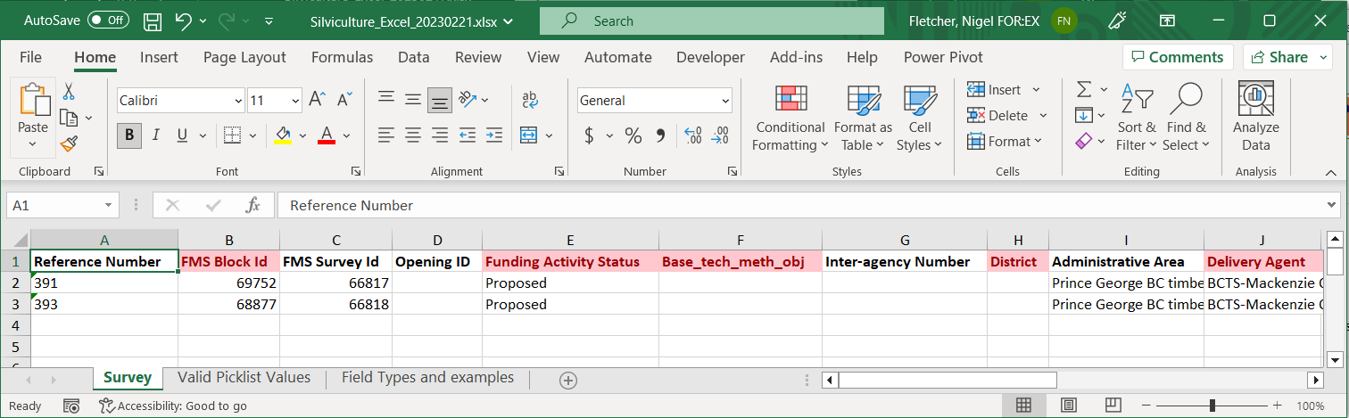

To get all of the activities in a template with all of the activity worksheets you must highlight all of the blocks and have the block tab open.

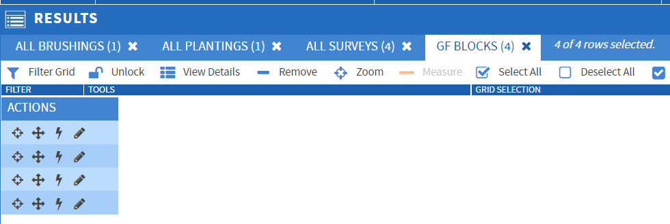

Now when I export the data to the template by opening the tab, using the on and

I get the complete template and all the brushings, plantings and surveys data included.

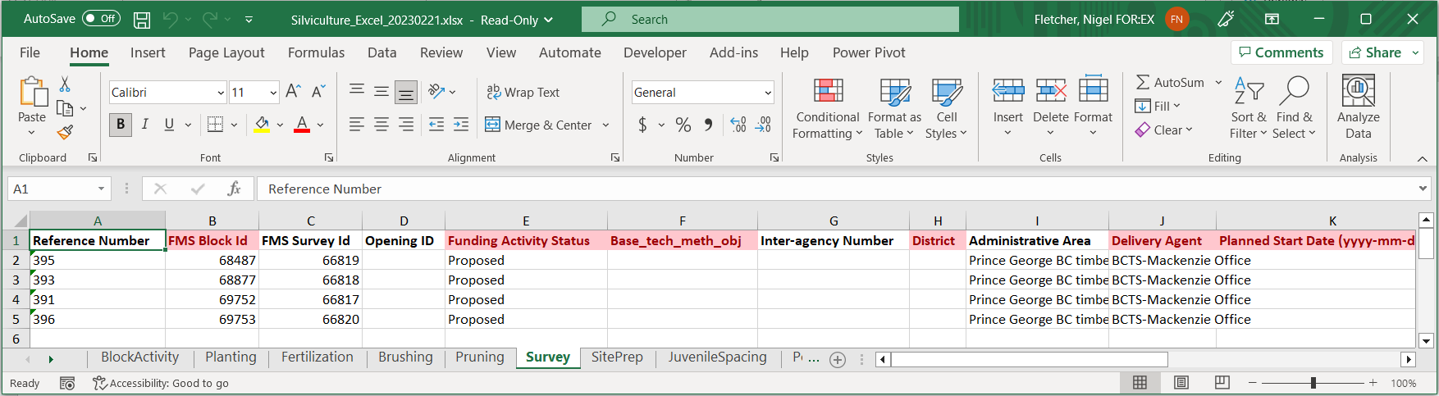

23.22 Filling in the Excel workbook

When you open the Excel workbook you will notice that it has a worksheet for

Block Activity
Planting
Fertilization
Brushing
Pruning
Survey
Site Prep
Juvenile Spacing
Pest Control
Valid Picklist Values
Field Types and Examples

Open the Planting worksheet

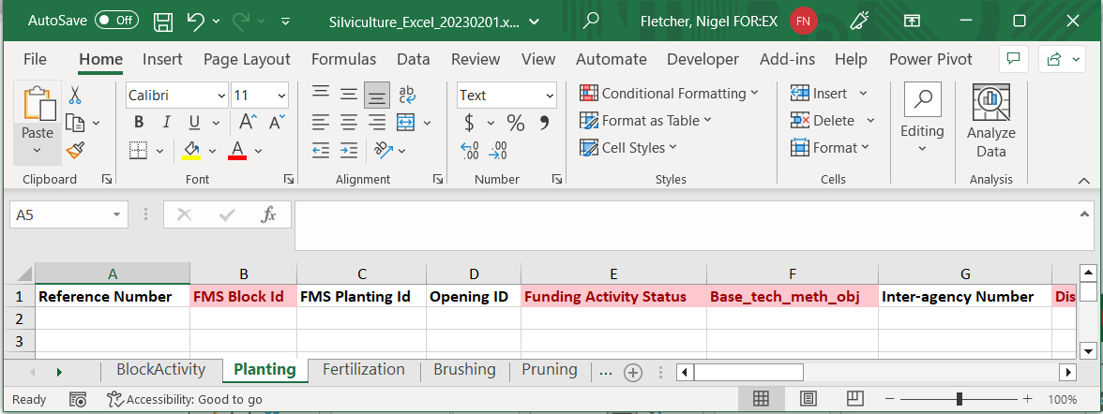

Columns in red are required and columns in white are optional.
You must not change the names, add or reorder the columns or it will fail validation.

Now fill in the mandatory columns putting planting in the Planting worksheet, Brushing in the Brushing worksheet, etc.
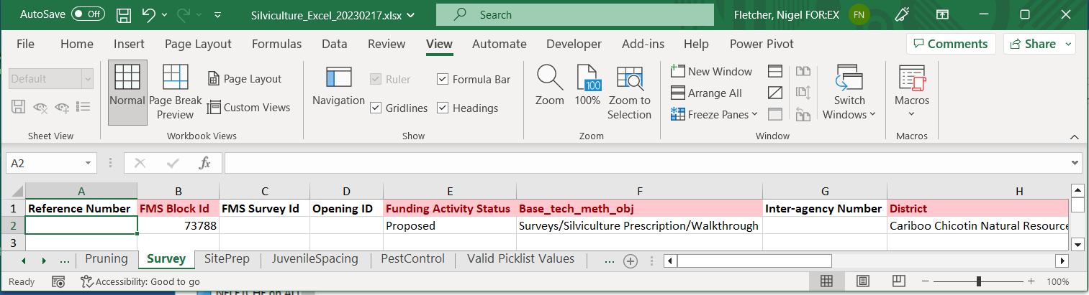

When you fill in the columns they must be in the format as ‘Field Types and Examples’ worksheet and have values listed in the ‘Valid Picklist Values’ worksheet which are case sensitive, or it will fail validation.

23.23 Adding spatial to the SIET geodatabase file

The tabular and spatial components are “linked” to one another by unique IDs and Reference Numbers. This is done in a GIS environment. We will show how this is done in both Esri Arcmap and QGIS.

There are four scenarios that may occur when linking spatial to the tabular data:

- Each activity in the spreadsheet has a separate spatial component;
- Several activities in the spreadsheet has the same spatial component; and
- Each activity has several spatial components.
- The activity is a block activity and does not require a spatial component.
Using ArcMap (see 25.0 Getting into an ArcMap instance using Citrix workspace).

23.231 Scenario 1 each activity has a separate spatial component (ArcMap)
Click on Add data 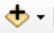

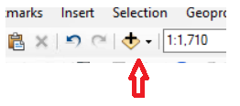

Navigate to the geodatabase folder (e.g. Silviculture_20221025193257.gdb) that came with the template which has the activity layers inside.
Add the activity layer associated with the spatial that you are going to add from ArcMap.

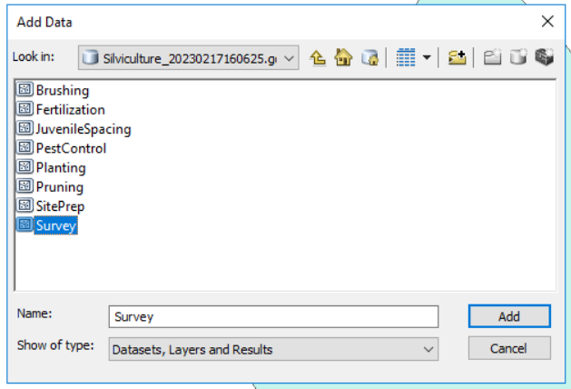

Now you need to put the spatial into this layer (survey layer in this case). Most Delivery Agents will already have all the spatial in ArcMap but in this case, we are going to bring the spatial into ArcMap.

Open ArcMap. Click on Add data

Navigate to the first activity’s spatial data (Blocks inside the gdb spatial folder (unzipped)) and

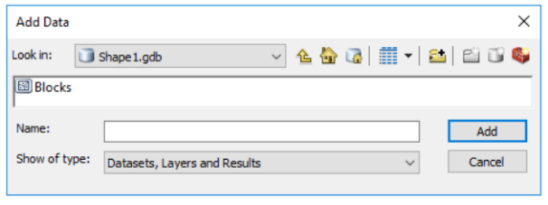

If you don’t see the polygon in the map window hold down the ALT key and click a layer in the table of contents this will place the extent of the layer in the map window.

Since you only want to copy the polygon of the activity from Arc Map you will need to make only the polygon selectable.

Right click on the Blocks layer, open Selection and then ‘Make This The Only Selectable Layer’

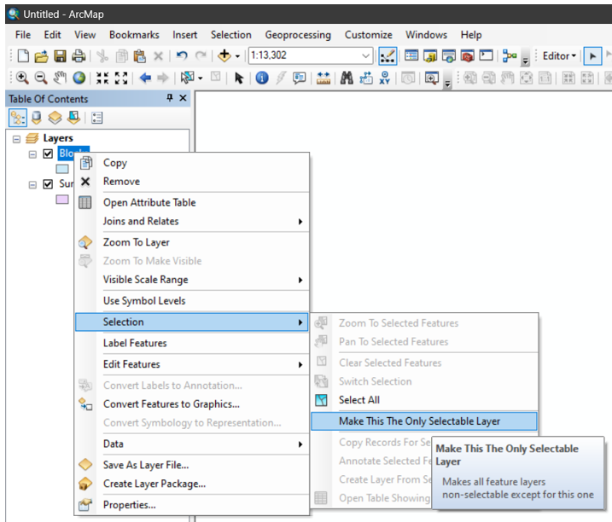

Right click on the Surveys layer, open Edit Features and then ‘Start Editing’

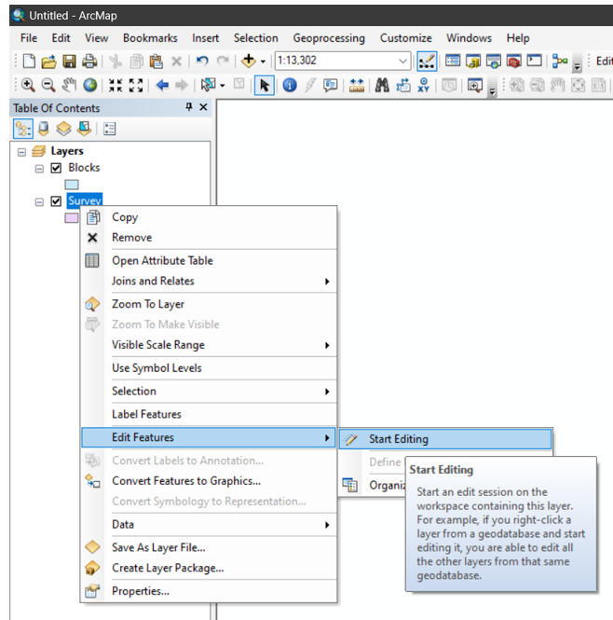
An editor bar will show up in your tools. Click on 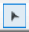 and then click on the block in the map window right click and choose copy or press Ctrl-C or to copy the polygon.

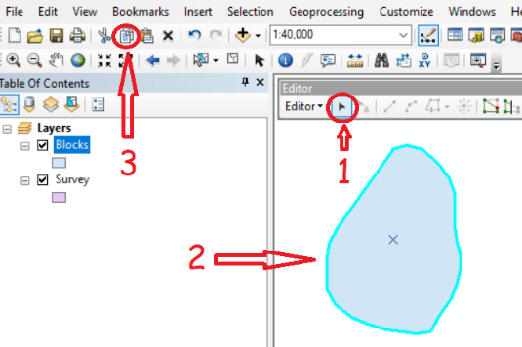

Now paste the copied polygon into Survey layer by using Ctrl-V or or right click and choose paste and then choose Survey in the pop-out window and click 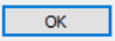.

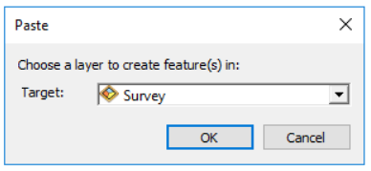

Now save these edits by pulling down Editor and clicking on Save Edits.

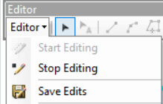

Now open the attributes table by right clicking on the Survey layer and ‘Open Attribute Table’

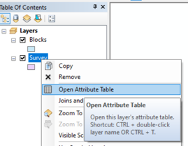

The following attribute table will pop-up with the following attributes.

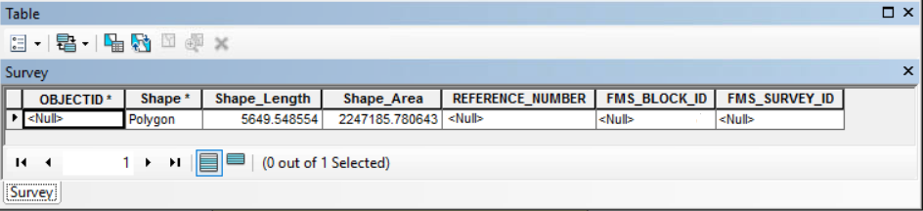

Each Silviculture Activity (Brushing, Fertilization, Planting, Survey, etc.) is a unique Feature Class (or layer) and has the following attributes:
- Shape_Length – system calculated
- Shape_Area – system calculated
- REFERENCE_NUMBER – user entered, optional
- FMS_BLOCK_ID – user entered – must be entered and match a valid FMS_BLOCK_ID. This will be populated if the import file was once previously exported, and users are just updating data – tabular or spatial. It links the spatial record for each Silviculture Activity to each of the corresponding Worksheets for those activities and specifies which Government Funded (GF) Block the activity is linked to.
- FMS_ACTIVITY_ID which will be FMS_PLANTING_ID for Plantings FMS_SURVEY_ID for Surveys and so on – system calculated. This will be populated if the import file was once previously exported, and users are just updating data – tabular or spatial. It links the spatial record for each Silviculture Activity to each of the corresponding Worksheets for those activities. If you are updating an existing activity, the FMS_ACTIVITY_ID needs to be set and should not have changed from the Export file which was originally pulled from FMS. If you are creating a new activity, the FMS_ACTIVITY_ID field should be blank.
Now right click on the title FMS_BLOCK_ID and choose Field Calculator

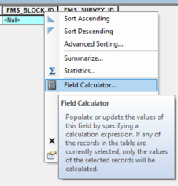

Now enter the FMS Block Id associated with the activity and click 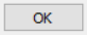.

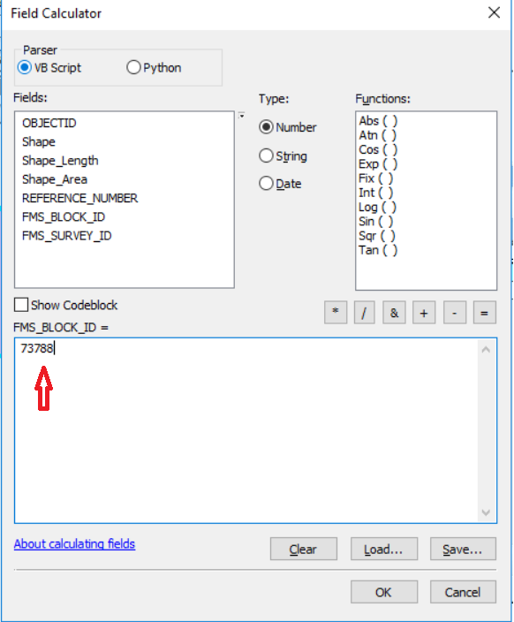

The linkage is now complete. Zip the spatial (file geodatabase) and tabular (excel workbook) together. Then go to 23.24 Importing zipped folder into FMS.

23.232 Scenario 2 several activities has the same spatial component (ArcMap)

Open the file geodatabase in ArcMap

23.233 Scenario 3 each activity has several spatial components (ArcMap)

Open the file geodatabase in ArcMap

Using QGIS

To get QGIS to use the Esri FileGDB you will need to install QGIS with the OGR FileGDB Driver. See 27.1 Loading QGIS onto your computer

23.234 Scenario 1 each activity has a separate spatial component (QGIS)

23.235 Scenario 2 several activities has the same spatial component (QGIS)

Open the file geodatabase in ArcMap

23.236 Scenario 3 each activity has several spatial components (QGIS)

Open the file geodatabase in ArcMap

ArcMap or QGIS not required

23.237 Scenario 4 block activities that do not require a spatial component

Block Activities are non-spatial and do not require a spatial component, only Block Activity Worksheet in the Excel Workbook needs to be populated.

23.24 Importing zipped folder into FMS

Make sure the folder to be imported is a zipped folder containing the File Geodatabase and the Excel Workbook.
Click on tab. Use the on and 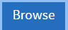
This will open File Explorer, and allow you to specify the zipped folder to import.
A pop up will let you know FMS is importing

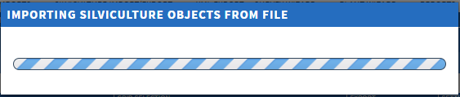

If the import executes successfully, the imported activities/records will present themselves in the Results grid.
If the import fails, you will receive the following notification:
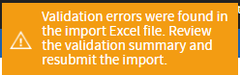
and an excel file titled ‘Silviculture Import Validation Summary’ will automatically download itself. Please open this to review the details of why the import file failed validation and did not successfully import.
NOTE - Users will also receive a validation package that delineates any errors in the data so they can be fixed which is in the format of the original import, with the addition of an ‘Import Errors’ tab in the workbook indicating more detail about each specific error.

23.25 Validation Rules

SIET Validation and business rules are executed upon import to enforce data integrity which is required to facilitate automated business reporting (AOP, etc.) and mapping. The following is a listing of the data validation components that are enforced upon import, so it is worthwhile to consider these when preparing to import data:
  - if there are multiple records within a sheet that have the same activity Id, an error should be shown
  - if there are multiple records within a sheet that have the same FMS Id, an error should be shown
  - if an invalid FMS Id is set an error should be shown if any required fields are missing an error should be shown
  - if any column header names are incorrect an error should be shown
  - if any invalid picklist values are used an error should be shown
  - if a cell's value does not align with the cell's intended data type an error should be shown
  - if a cell's date format is incorrect an error should be shown (yyyy-mm-dd)
  - if a reference number is set in an excel sheet, but not found in the GDB an error should be shown and vice versa
  - if there are any errors in the imported GDB an error should be shown
  - if an excel sheet name does not match one of the sheet names in the template an error should be shown
  - if an activity is locked by another user an error should be shown
  - if any unexpected errors occur the user should be notified
  - if no spatial records are found in the imported GDB an error should be shown (NOTE-we will be updating this to set a placeholder shape based on the District offices location)
  - if there is an error running the silviculture or block business rules an error should be shown

24.0 Submitting data using SNAP and Plant Wizard

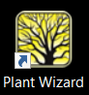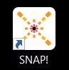

24.1 Data from SNAP (survey wizard)

Survey Wizard is a tool to help upload surveys in a quick and efficient manner.

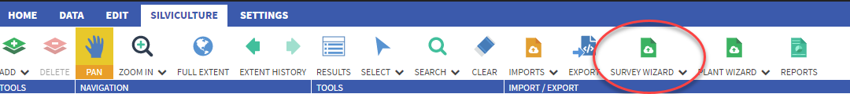
There are 2 import modes you can choose from 1.Create or 2. Update.

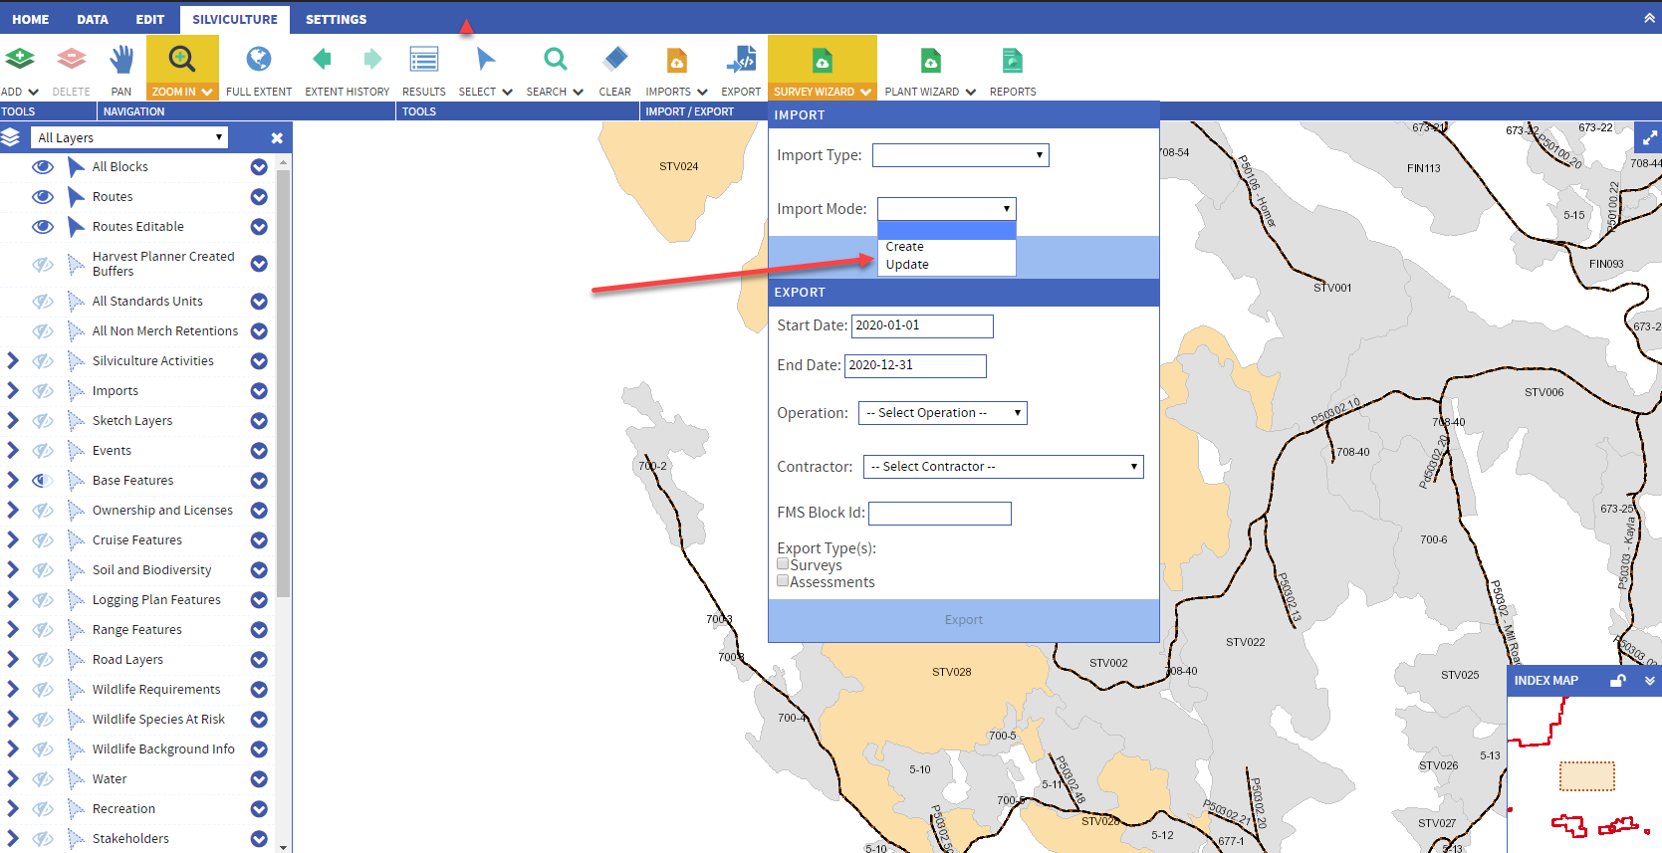

- Create – is for new surveys, that are not in the system yet
- Update – is for existing surveys that need their information updated.

*Please Note – The zip files can not be combined. The “Create” files must only contain new surveys. The “Update” files need the existing information to overwrite. If they are combined you will receive an error message.

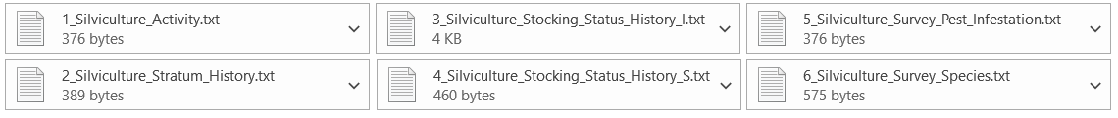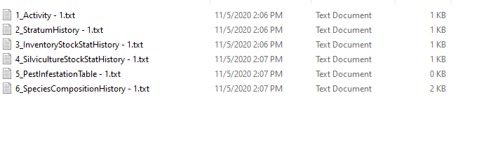

To Upload Files

1. Navigate to the Silviculture Tab
2. Click on the Survey Wizard.
3. Choose an Import Type, there are 2 options.
Create - For new surveys
Update - To amend existing records and update the information.
4. There are 2 ways to upload the files, A .zip file with all 6 tables loaded into 1 file or each table can be completed separately.
The 6 files that are imported via Survey Wizard are;
Table 1. Silviculture Activity which loads the General Survey tab in Harvest Planner.
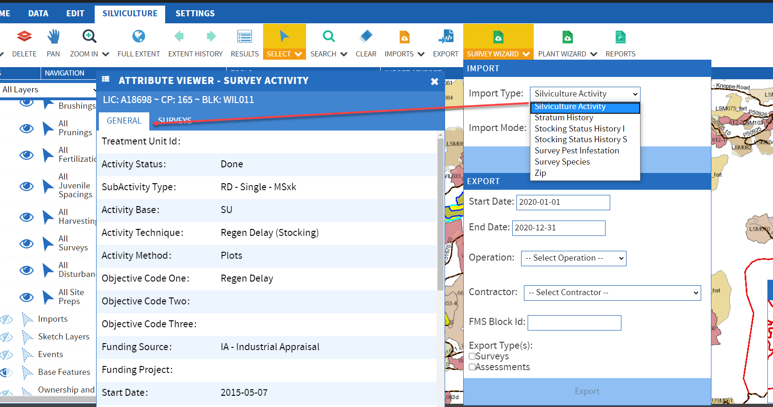
Table 2: Stratum History loads the information for the Surveys tab under the Stratum.
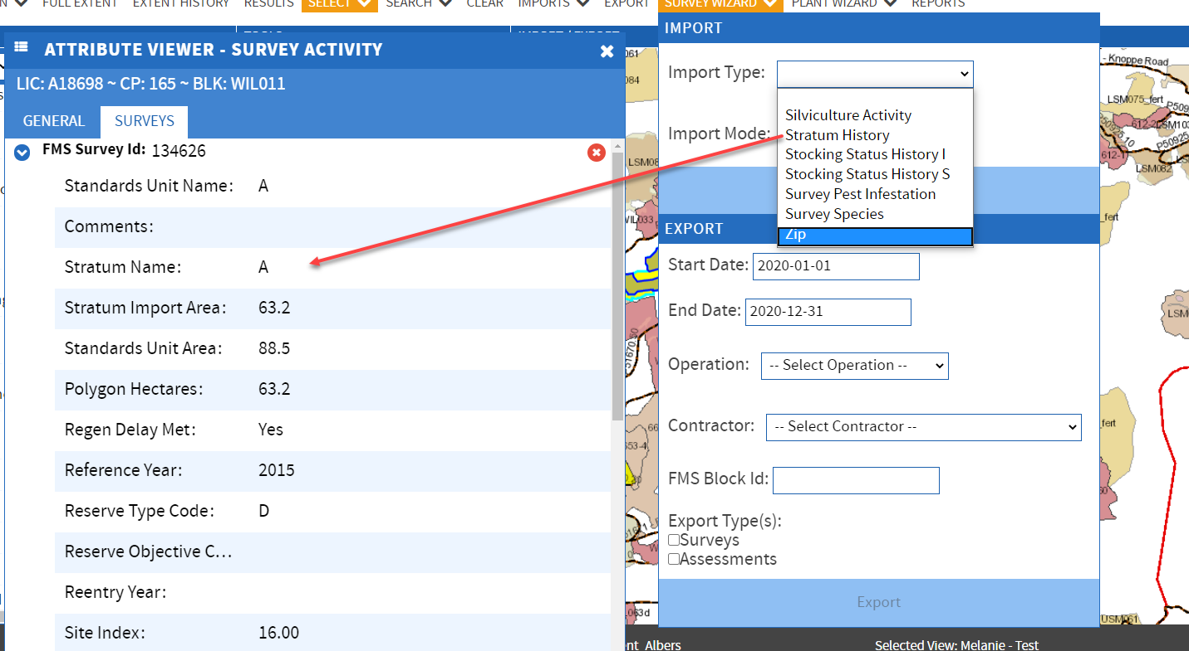
Table 3: Stocking Status I loads the information for the Inventory Part of the Survey
Table 4: Stocking Status S loads the information for the Stocking part of the Survey.
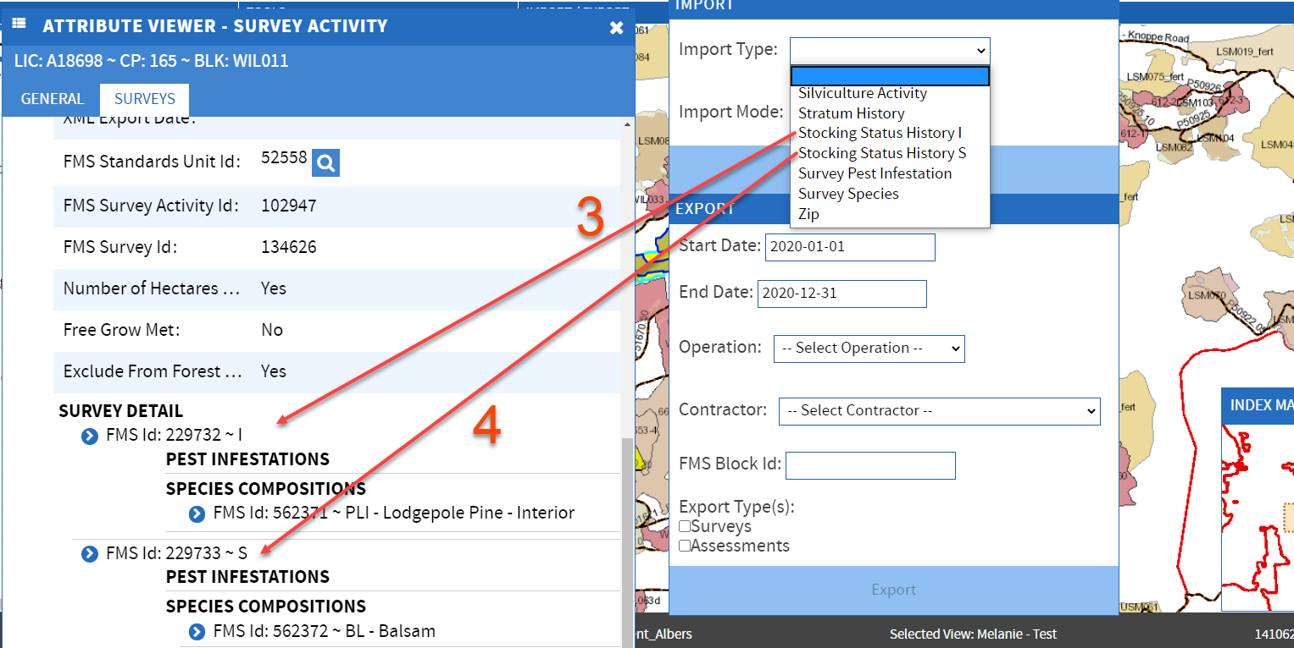Table 5: Survey Pest Infestation, is a child record of the Survey Detail, it holds the information for the Pest Infestations.
Table 6: Survey Species, is a child record of the Survey Detail, it holds the information for the Species Composition.
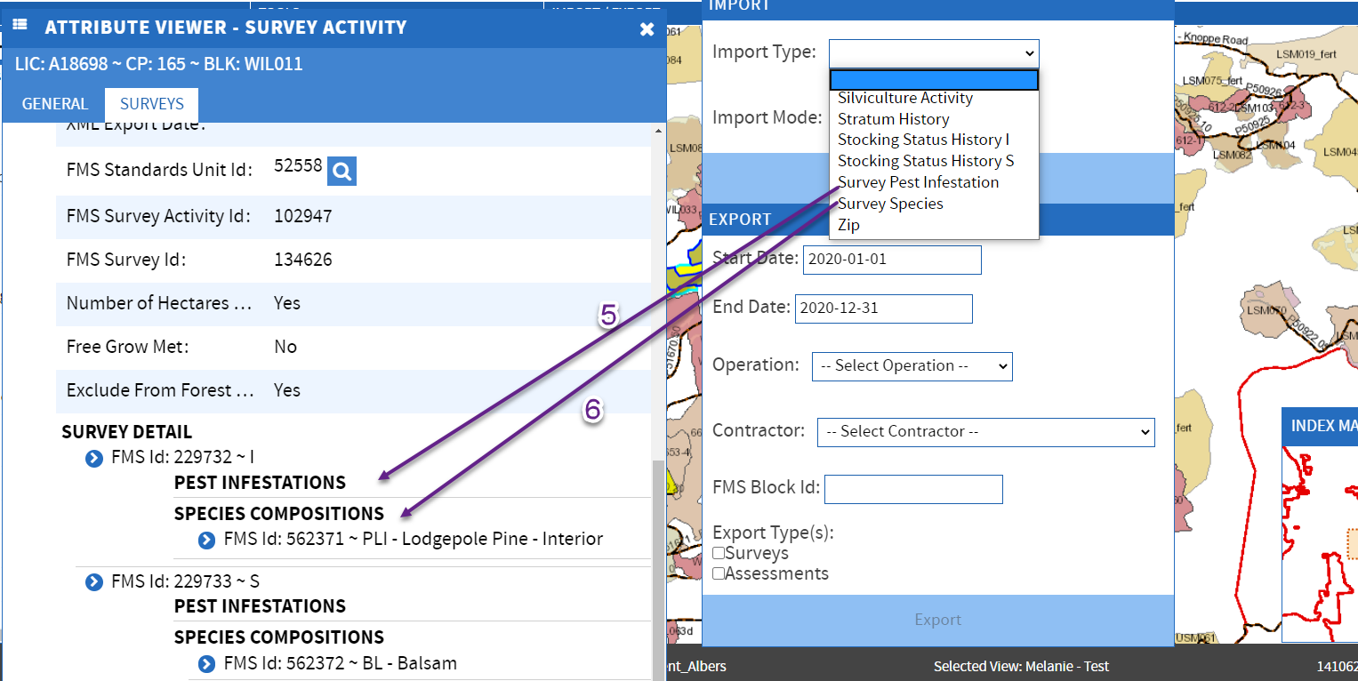
The other import mode available is to add all 6 tables together via .zip file;
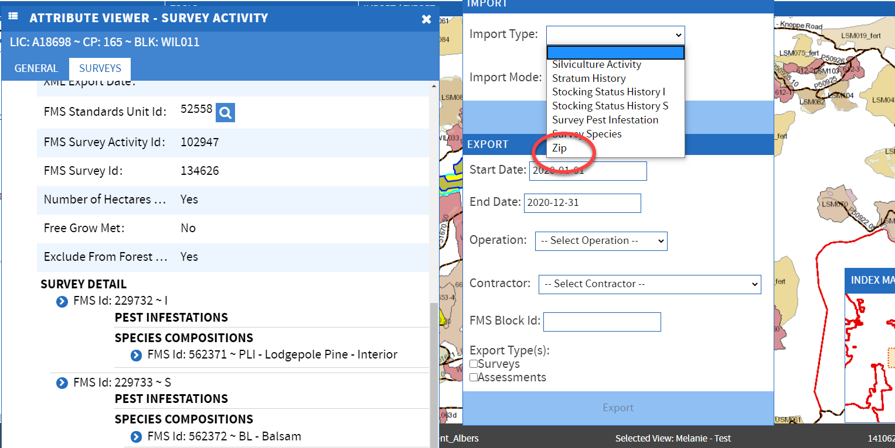
*Important Note*
When uploading to the Survey Wizard, there are 6 file types that are used.
They can be put together and ‘zipped’ into 1 file or loaded separately.

Tables
File 1: Silv Activity

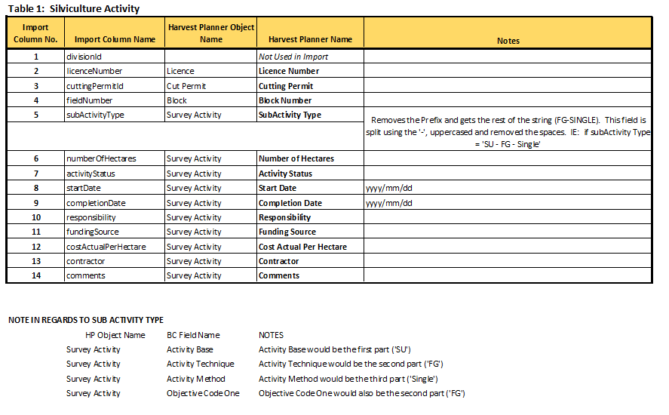

File 2: Stratum History
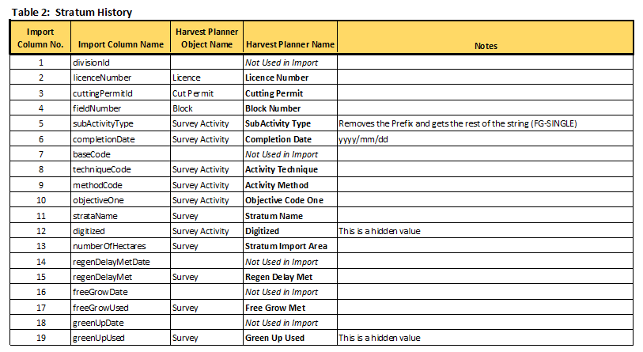
File 3: Stocking Status History 1
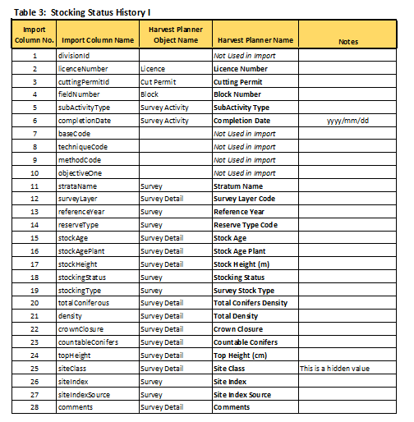

File 4: Stocking Status History 5
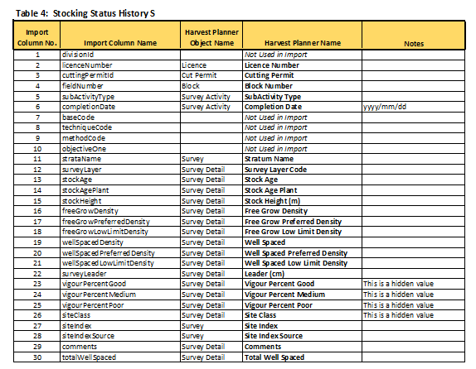

File 5: Survey Pest Infestation
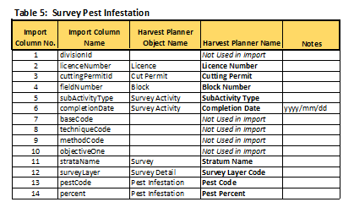
File 6: Survey Species

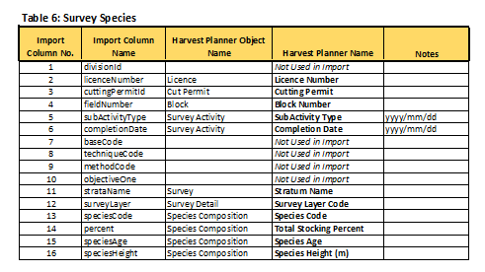

24.2 Data from Plant Wizard

25.0 Hiding, Unhiding and Changing the order of Attributes

In the Results table when an object has been selected you will see on the far right side a heading called Grid Options.

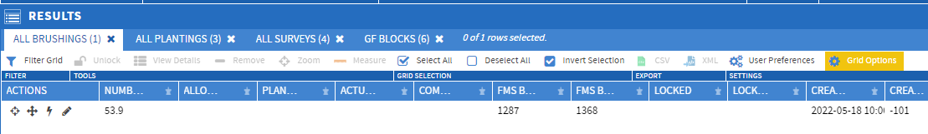

Clicking on this heading will bring up a column of all the activity attributes. You can check them (display) or uncheck them (hide) as well as drag and drop to the order you wish. Actions can not be moved an are always shown first.

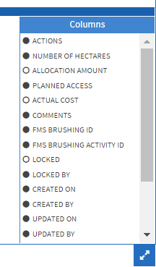

Once you have the order and checking correct, click on User Preferences in order to save this view. You can save it as your own view or a shared view. The order that we will eventually make as the default is called default2 as a shared view.
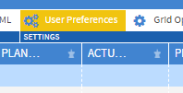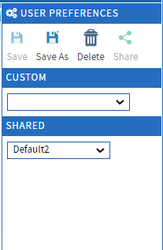

26.0 Getting into an ArcMap instance using citrix workspace

26.1 Loading Citrix workspace onto ministry computer

In order to get onto the Kamloops remote desktop you will need the Citrix workspace application.
Click on the window icon 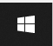 at the bottom left of your screen.
Now start typing ‘software’ until you see ‘software centre’ application appear in the list.

In the search box search for workspace
Click on 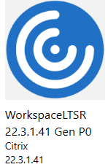 and a description of the software will pop up. Now click on 
Files will be downloaded but eventually it will be installed on your computer.

26.2 Logging into the Kamloops remote desktop and getting into ArcMap

Click on the window icon at the bottom left of your screen.
You should see 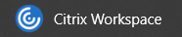 in the list but if not start typing Citrix until it shows up in the list.
If this is the first time you have used Citrix Workspace you will get a welcome pop up window.

Enter the store URL which is dts.gov.bc.ca and 

It should take you to the storefront.
Click on desktops 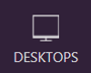 and choose anyone of the Kamloops desktops

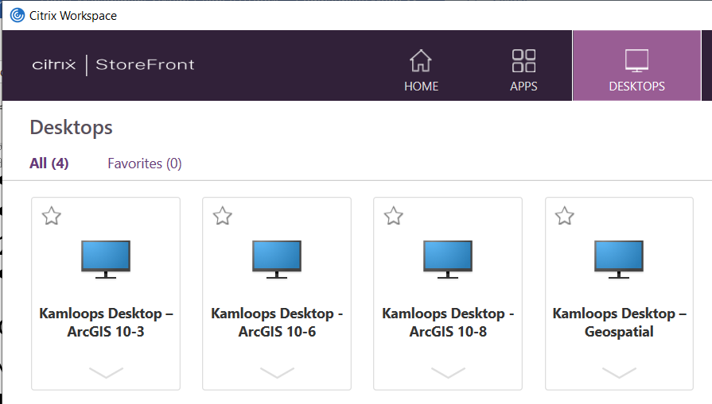

Accept the security check and you should see the Kamloops desktop.

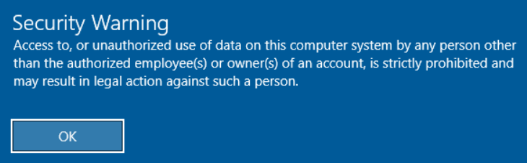
Click on the window icon at the bottom left of your screen
Find the suite of ArcGIS programs 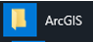. Choose 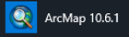

27.0 The QGIS platform

Although all government staff should be able to use the ArcGIS software on the Kamloops Desktop, sometimes it is nice to have software on your computer without having to go through Citrix. There is another free open-source GIS platform that will also perform all of the functions needed for FMS and in some instances easier.

27.1 Loading QGIS onto your computer

To use QGIS with the FMS SIET tool you can not use the OpenFileGDB instead you must use the Esri FileGDB. This requires that you load OSGeo4W-setup.exe (which is different from homepage default version: QGIS-OSGeo4W-3.28.3-1.msi) plus two additional drivers.

If you have a QGIS version installed, you will need to uninstall it first.

- The download can be found at https://www.qgis.org/en/site/forusers/alldownloads.html
- Get the "OSGeo4W installer": https://download.osgeo.org/osgeo4w/v2/osgeo4w-setup.exe
- Run the setup file, choose "Advanced Install" and click Next.
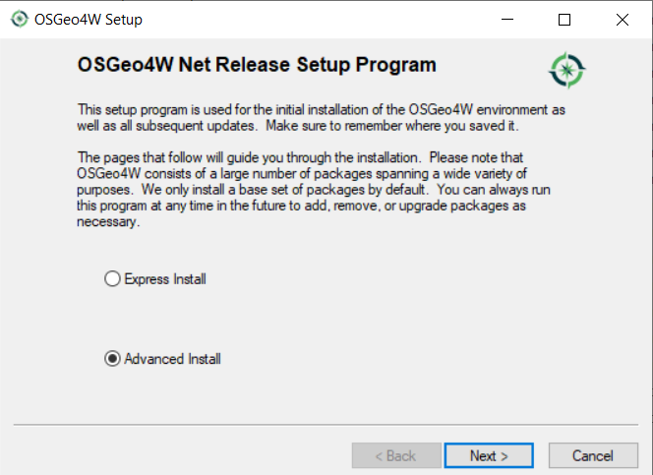
- Choose A Download Source: choose "Install from Internet" and click Next
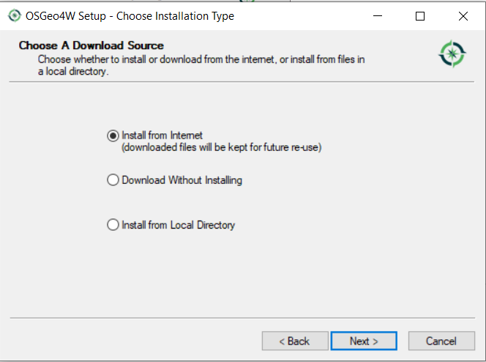
- Select Root Install Directory and click Next.
(On Ministry Computers you will only be able to install for ‘Just Me’)
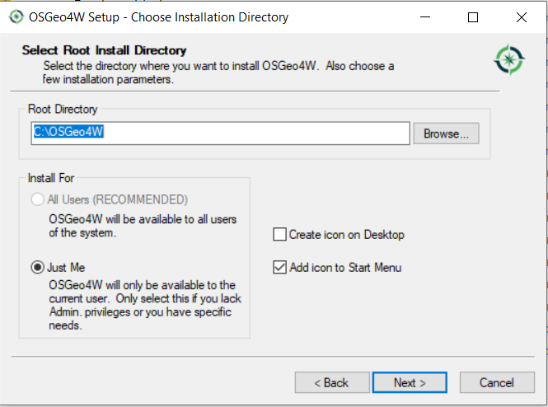
- Select Local Package Directory (use the default) and click Next
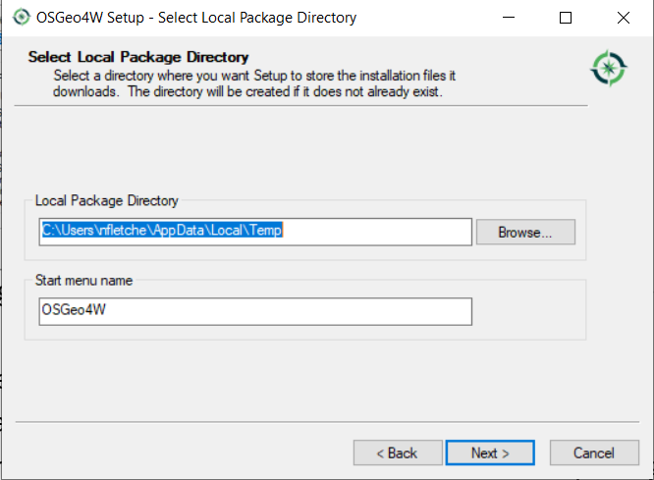
- Select Your Internet Connection - choose "Use System Proxy Settings" and click Next.
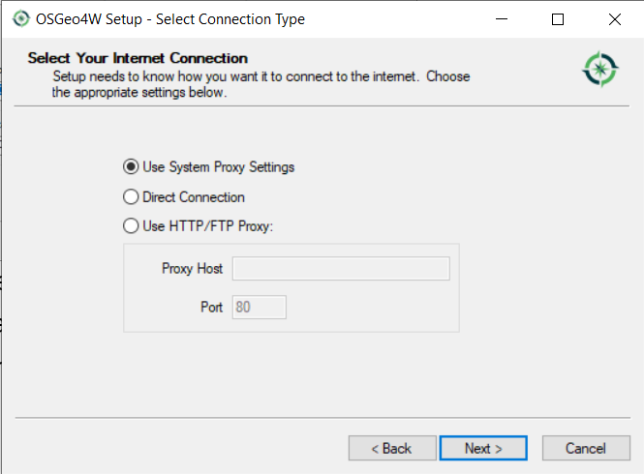
- Choose A Download Site – choose https://download.osgeo.org and click next
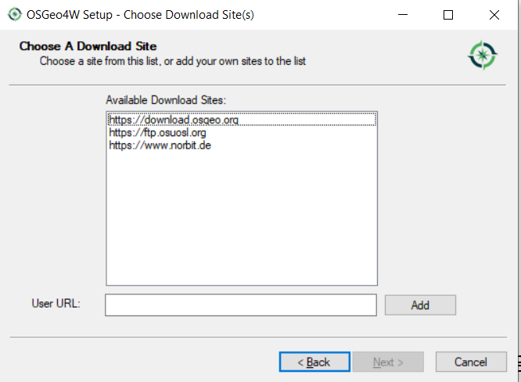

- Select Packages: this is an interface to custom select additional packages to install -the Esri FileGDB.
- In the Search box, type in "gdb" then Expand on the "Libs" category and click "Skip" on the
"gdal-filegdb" package. Skip will turn into 3.6.2-1 and Bins will be checked. Click Next.
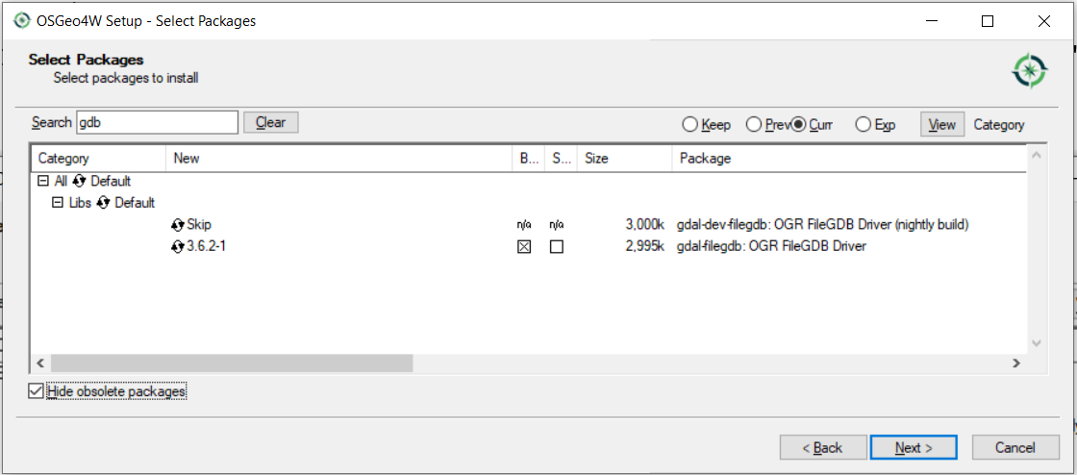

- Install the dependences by leaving “Install these packages to meet dependencies (RECOMMENDED)” checked and click Next

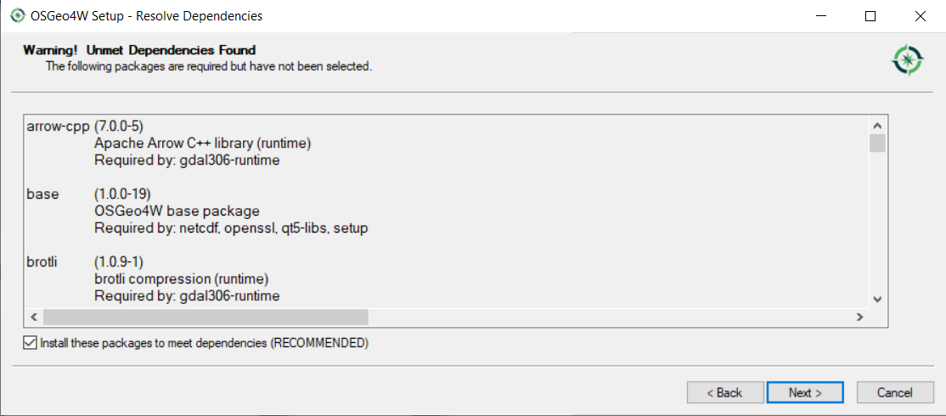

- Agree to the two license terms and clicking Next on both
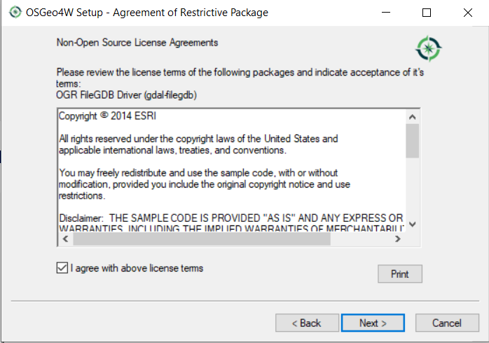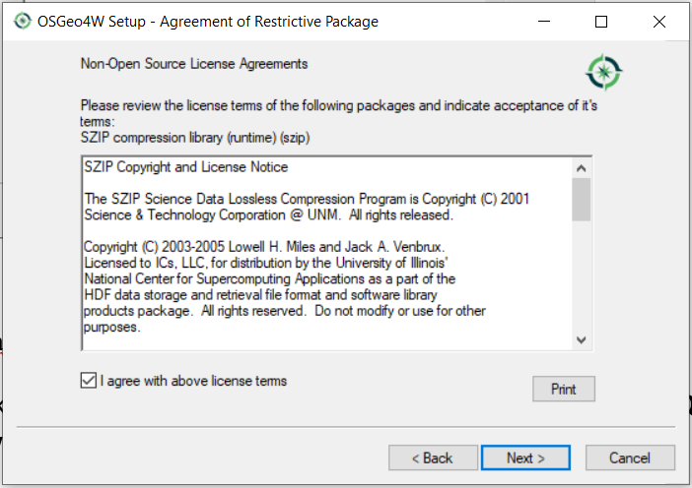

Let the package install (takes about 11 minutes) and click Finish
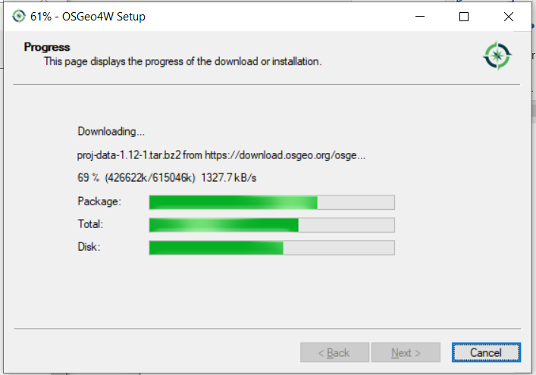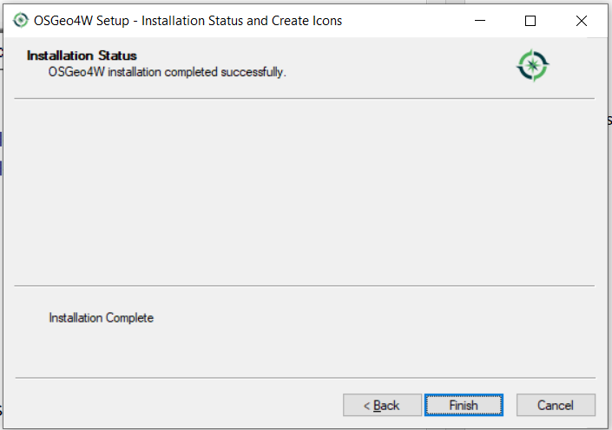

- Now navigate to C:\OSGeo4W\apps\gdal\lib\gdalplugins (root directory for install – step 5) and make sure these two file exist: drivers.ini, ogr_FileGDB.dll

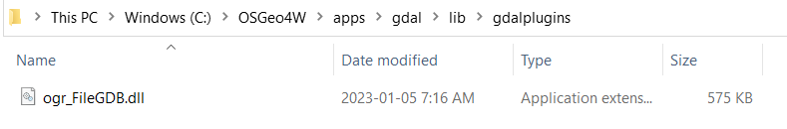
- Open drivers.ini, scroll down to the "OpenFileGDB" entry. There should be "FileGDB" entry below it. Re-order "FileGDB" to be listed above "OpenFileGDB": Save drivers.ini.

28.0 Importing GPX files into FMS

You may want to use your phone, ipad or Garman to record access, boundaries and other spatial items and then load them into FMS. Note that depending on the antenna being used or lack thereof, the accuracy of the GPS data being collected can have a wide range.

The GPS data collect will likely be in the GPX file format which will need to be converted into a ShapeFile. You can use ArcMap or QGIS to make that conversion.

28.1 Using Arc Map to transfer GPX files into GDB format.

Open ArcMap – See 27.0 Getting into an ArcMap instance using Citrix workspace

When you first open ArcMap it takes you to a blank map and a Getting Started dialog box.
Just exit from the dialog box.
If you have an open map then click on File then New 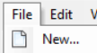
Choose My Templates under New Maps and highlight Blank Map then click 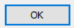

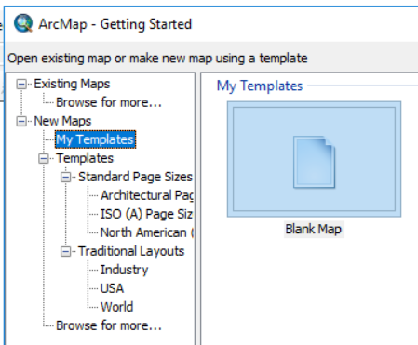 or 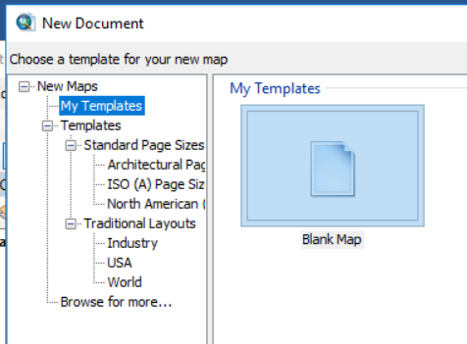

Under Geoprocessing choose Arc Toolbox

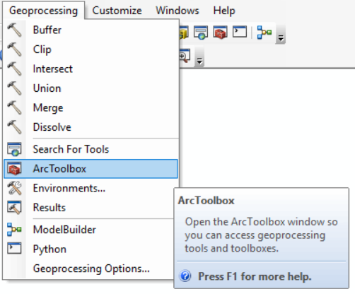

Under Conversion Tools, select the GPX to features.
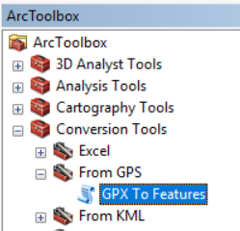

Select the GPX file you would like to import and select an output where you would like to save it.
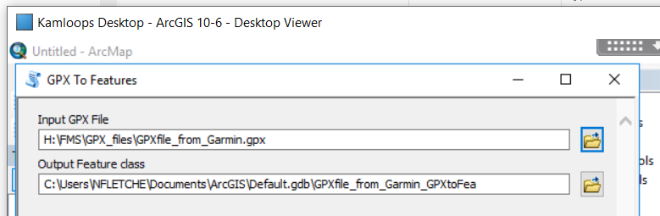
And click 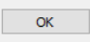

Under Geoprocessing choose Arc Toolbox

You have just created a feature class which you now need to convert to a geodatabase.

Under Conversion Tools, open To Geodatabase and select Feature Class to Geodatabase (multiple)

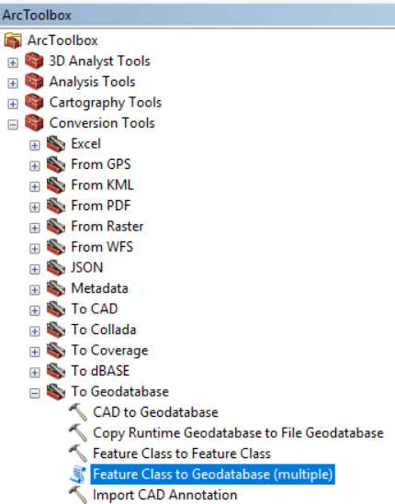

Now find the feature class you just created and add it to the Input Features (should come up right away on the 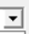 down arrow.

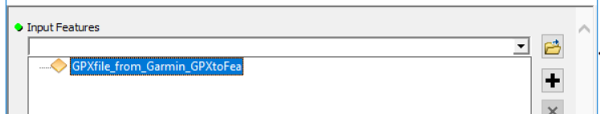

For the outputs you can just place it in the default.gdb. Click on 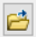 next to the output geodatabase

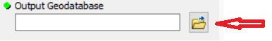
Find default.gdb (may need to go up one level with ) and

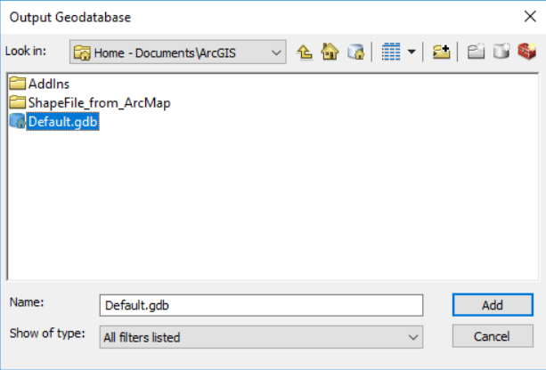

Now click on Environments 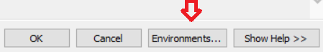

Open Z values. Select “disabled” under the “output has Z values” field.
Open M values. Select “disabled” under the “output has M values” field.
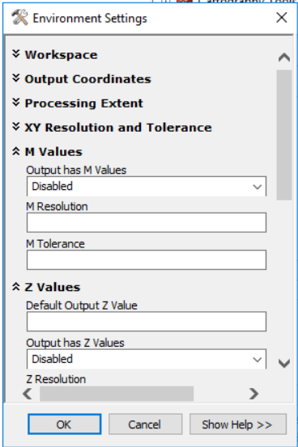
Click .
And again.
Now click on

In your default.gdb you will find another GPXfile_from_Garmin_GPXtoFea_1. Highlight and

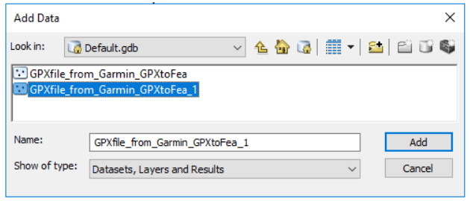

Right click on the new layer, choose Data, then Export Data

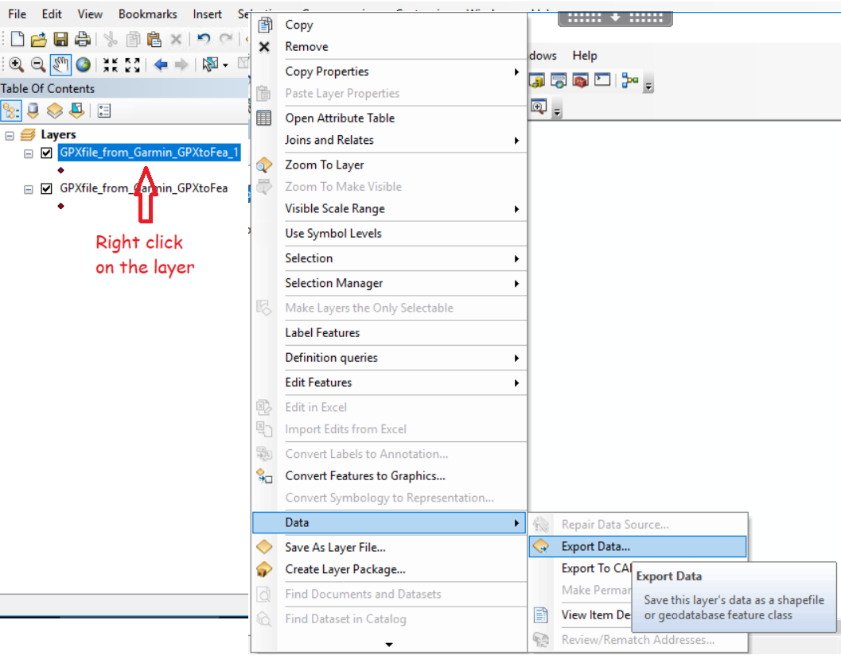
In the pop-up window click on the file folder 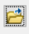

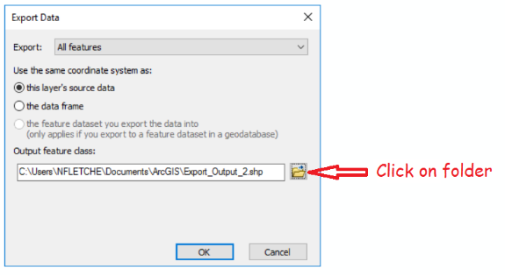
And make sure that the file type is Shapefile

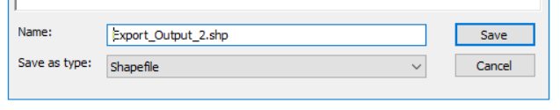
Save and then OK to export data. You will get the pop up asking if you want to save this as a new layer. Select yes or no, it doesn’t matter.

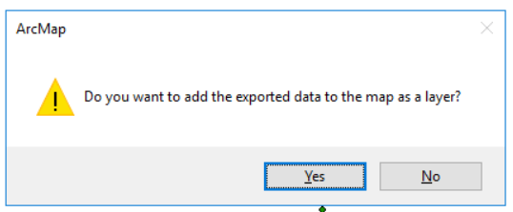

The following files will be exported to your folder

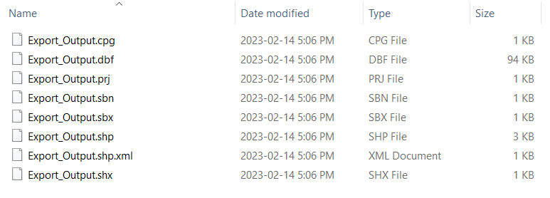
You will need to zip this folder. In File Explorer, right click on the folder and send to Compressed (zipped) Folder.

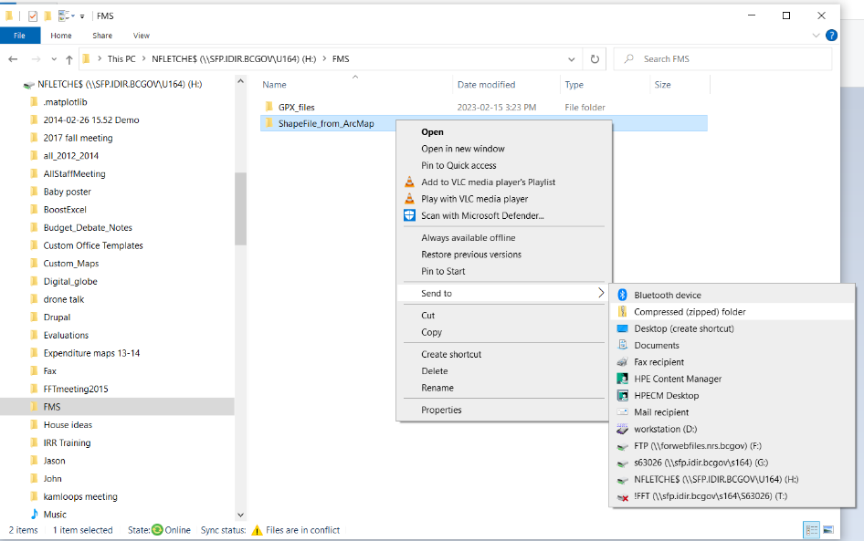

28.1 Using QGIS to transfer GPX files into GDB format.

Open QGIS – See 27.0 Using the OGIS Platform

Drag and drop the gpx file into QGIS from File Explorer

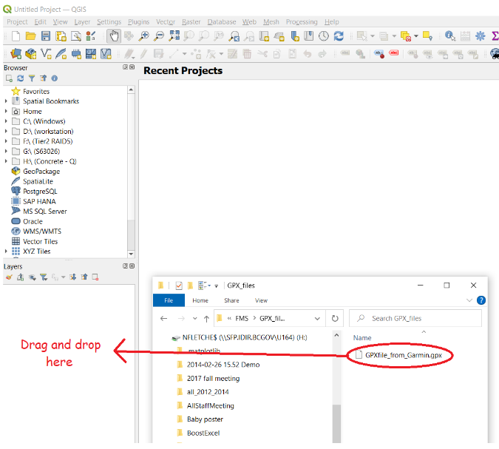

Now choose the layers that you wish to import using ctrl key and left mouse button.
Add these layers

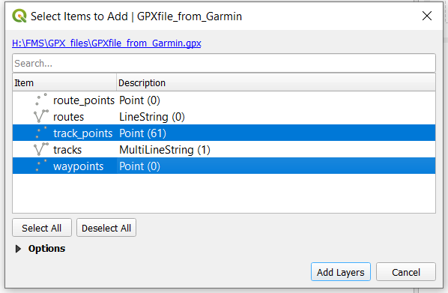

Right Click the Layer and Choose Export – Save Features As…

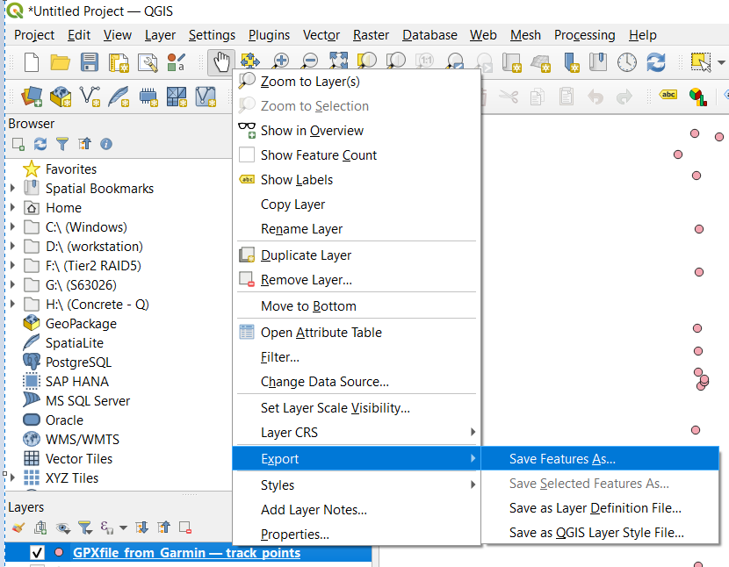

In the dialog box choose the format as Esri shapefile, choose the name and location you want to save the shapefile at, choose the geometry which in this case is point and then uncheck Include z-dimension.

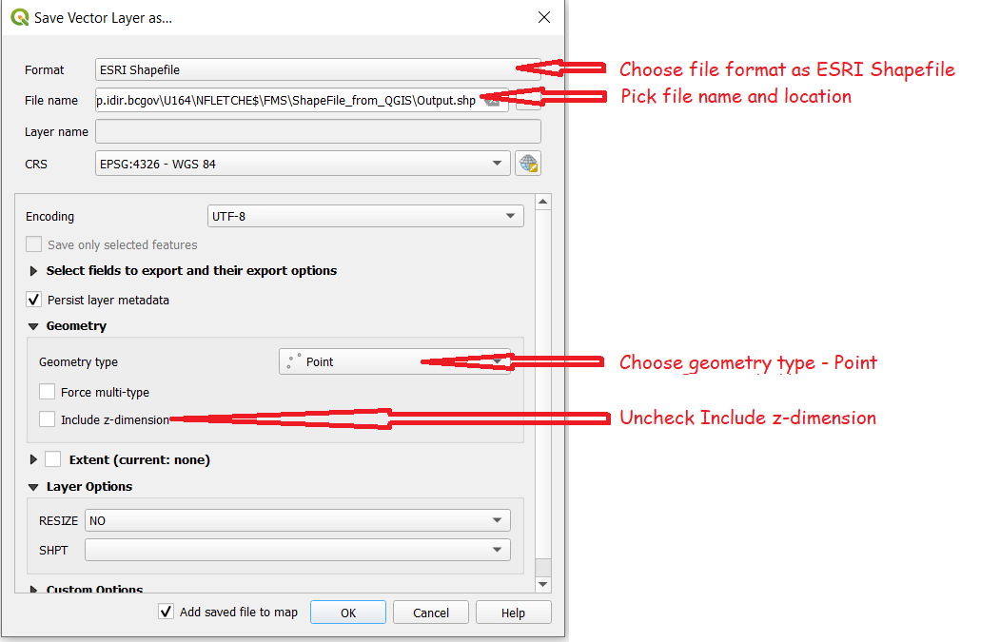

And click
The following files will be exported to your folder

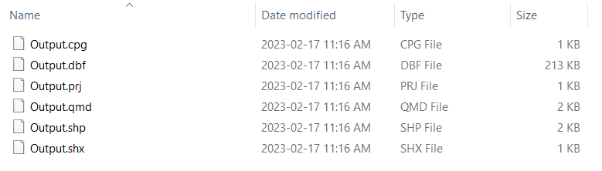

You will need to zip this folder. In File Explorer, right click on the folder and send to Compressed (zipped) Folder.

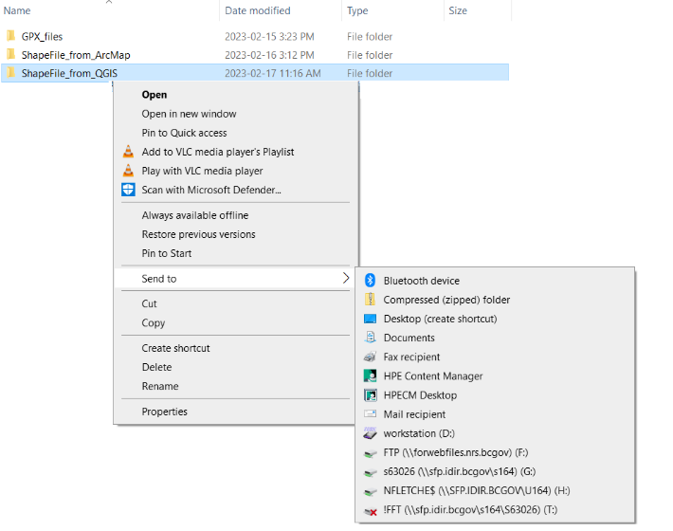

28.3 Importing zipped shapefile
Under the edit tab you will find Imports tool 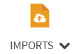

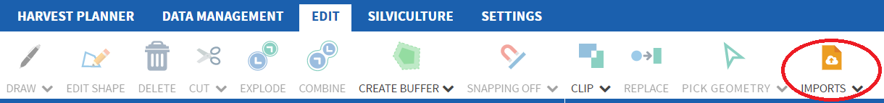
Simply browse for the Compressed (Zipped) folder, double click on it and 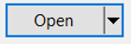

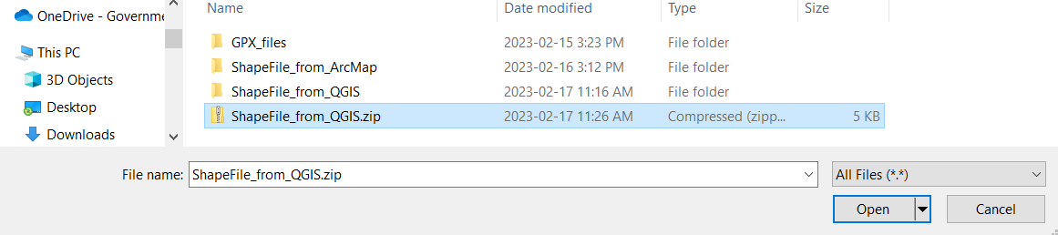

The import is temporary, that is it will be deleted when you end your session. You will need to use Sketch to create a permanent polygon shape. See the next section 29.0 Using the sketch tool

29.0 Using the sketch tool

The sketch tool is to put annotations, arrows, showing a travel route, travel route, polygons, etc. on the map window to assist in providing extra information.

Note: You cannot edit a sketch object with edit shape. You must go to the sketch tool to edit.
Click on on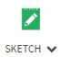and choose one of the eight options for sketching

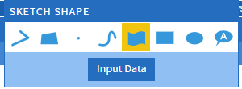
Polyline – this creates straight lines by clicking left mouse button at each corner – double click to finish.
Polygon – This creates straight edge polygons by clicking left mouse button at each corner – double click to finish.
Point – this creates a point when you click the left mouse button.
Free line – This creates a curve line by clicking and holding the left mouse button.
Free Polygon – This creates a curve edge polygon by clicking and holding the left mouse.
Rectangle - This creates a rectangle by clicking and holding the left mouse.
Ellipse - This creates an ellipse by clicking and holding the left mouse.
Annotation – This will bring up the sketch table where you can enter label for that spot.

There is also a button for Input data . This will bring up a window to view and edit both the attribute and shape data.

Putting an annotation
Showing a travel route
Adding a polygon (where to park)

25.1 Putting an annotation

Now click and hold down the left mouse to start drawing on the map window. Double click to finish.

Note the sketch table will automatically pop up after completing a drawing.

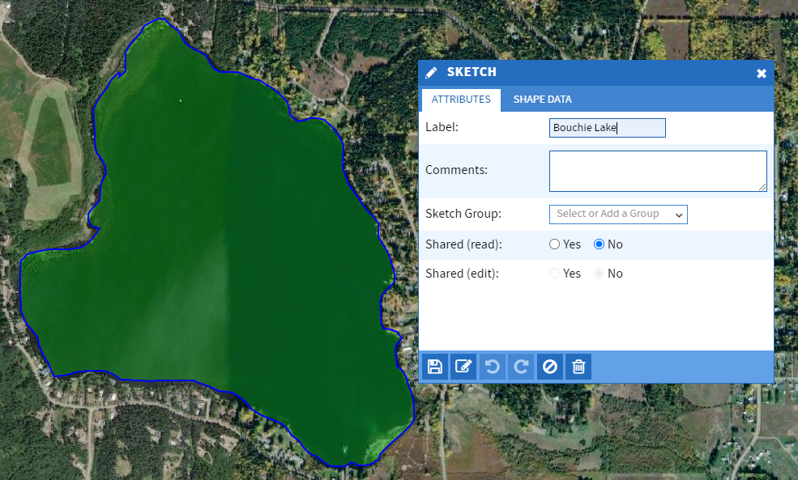
This sketch is not saved until you click on the floppy disc in the sketch table that will pop up.

Give the sketch a name and save it

There are many things you can do with the sketch tool to edit the polygon. The sketch tool is covered in 20.0 Using the sketch tool.

Make sure that that the Polygon Sketch Layer is both visible and selectable in the layers table (see 4.0 Showing the right layers)
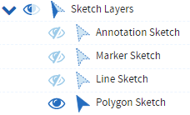

25.2 Deleting the sketch
You can then delete the sketch by having the sketch tool highlighted 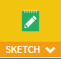 then mouse over the sketch line – it will highlight the outside in red – then click on it to bring up the sketch table. Now click on the garbage can 

30.0 Collecting Spatial Data in the field

Note that when submitting spatial to RESULTS at the 1:20,000 scale, polygon boundaries must be within one millimetre of their true North American Datum of 1983 (NAD83) map location (within 20 m of their true location). One tie point must be established within 10 m of its true NAD83 position for all traversed boundaries. Make sure the handheld unit you are using has this accuracy. Accuracy diminishes in mountainous areas and under heavy canopies.

To import a shape into FMS using the Import tool, the file format must be in a geodatabase file format (GDB). Handhelds like Garmin create a GPX file and to transfer GPX files into GDB format you must use ArcMap or QGIS.

30.1 Using Trimble Data collector to collect spatial for FMS

This is likely the most accurate (but also the most expensive) system to collect data. It is something you would want to use if you are bordering private property.

30.2 Using a smartphone/tablet/ipad to collect spatial for FMS

Smart phones and cellular data tablets /ipads which have internal GPS antennas to communicate with GPS satellites can be used directly for GPS. Note that GPS in tablets is separate from the cell service, so you don’t need to have an active data plan for the GPS to work. There are also External GPS receivers and GNSS receivers for tablets. GPS (Global Positioning System) is the USA positioning system where as GNSS (Global Navigation Satellite System) uses other positioning systems (GPS, GLONASS, Galileo, Beidou) getting better coverage.

The better the antenna the better the accuracy and a GNSS receiver will have better accuracy than GPS only receiver.

30.21 Collecting data with Avenza Maps

You will need to download the app from the app store.

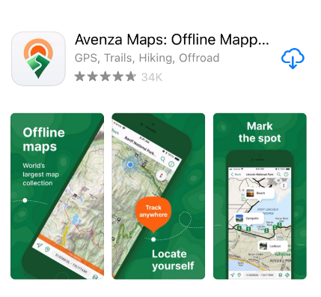

You must have the Professional version of Avenza Maps to have the required functionality.

You will need to register using one of 5 government Registration keys (USER NAME). See https://nrm.sp.gov.bc.ca/sites/flnr/mobile/Shared%20Documents/Avenza%20Maps%20Registration%20Process.pdf to determine which key you should use which is based on your work group.

To register, first select in the lower right corner of the Avenza Maps’ home screen. Then select the which will take you to the Settings screen. (Note: tap on the words not the arrow). Fill in the account details.

EMAIL: Your.Name@gov.bc.ca
USER NAME: Registration Key (select and enter key from list)
PASSWORD: leave blank
NAME: Your Name (John Doe)
ORGANIZATION: Ministry of Forests

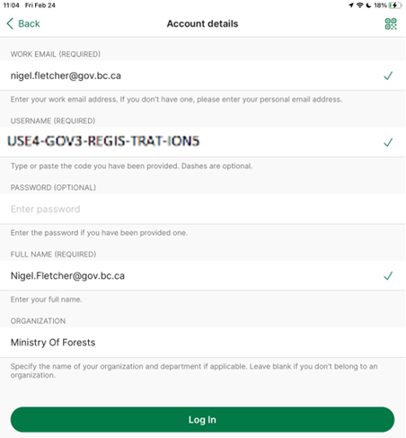

Select “Log In” to submit to your account details to Avenza. You will now have the professional version of Avenza available for use on your mobile device.

Base Map

Avenza Maps uses a GeoPDF Map as a base map when you are offline. Open Street Maps (OSM Basemap) are available within the app provided there is a connection to the internet.
Once you have loaded a GeoPDF in Avenza Maps you can capture Geospatial data as a layer on this map.

You can create a GeoPDF map in FMS, See 18.0 Downloading a georeferenced pdf map, or use other geospatial applications and then load them into Avenza Maps for offline use.

There are many ways of loading a map. You can email the map:

- Send to email. When the email is opened pdf is downloaded but not saved. You now need to save it into Avenza Maps.
- Tab the map in the email, it will open in its own window.
- Tap the export icon  at the bottom of the screen.
- Scroll through the apps and tap Avenza Maps and the map will be loaded in “My Maps”
You can do a direct import:
Press  at the top of the screen to load a map from dropbox or cloud storage.

Recording a GPS Track

To record a GPS Track, perform the following steps:
- Select the tools icon in the lower right corner .
- Select 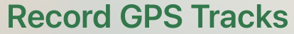
- Select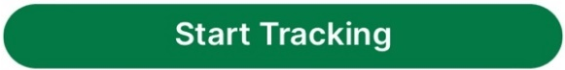
- Select when it is necessary to temporarily stop recording your track.
- Select to stop recording the track and save it.

Drawing polygons or lines

Sometimes when you are in the field you may want to draw lines, polygons and annotations.

Although you can draw polygons and lines in FMS (see 29.0 Using the sketch tool) it is likely that you will have no internet access in the field where as Avenza maps can be used offlne.

- Tap the tools icon in the lower right corner.
- Tap the 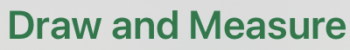 tool.
- Move the map to place the map center indicator  where you would like to start a track or polygon and tap the 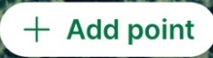 button.
- Use this 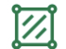button to toggle between a distance (line) and area (polygon).
- Tap to save your line or polygon.

Editing the track / feature

You may be collecting several tracks and would like to name them so that you know what features you are bringing into the GIS environment (ArcGIS /QGIS) to stitch together and export as a shapefile folder.

- Tap on the feature/track. This will highlight the feature and add a label.
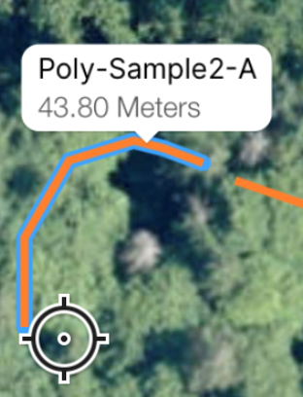

- Tap on the feature label. This will bring up the edit screen where you can change the name, choose the style of the line, add photos, write a description and other elements.
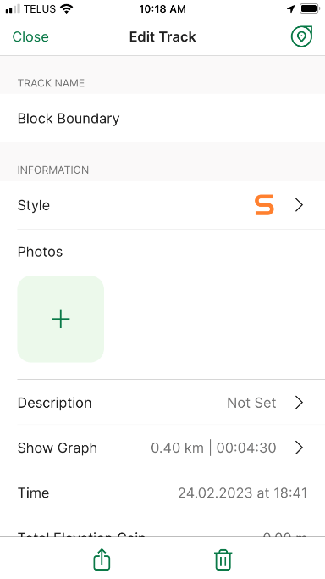

Below are three different features created in different ways.
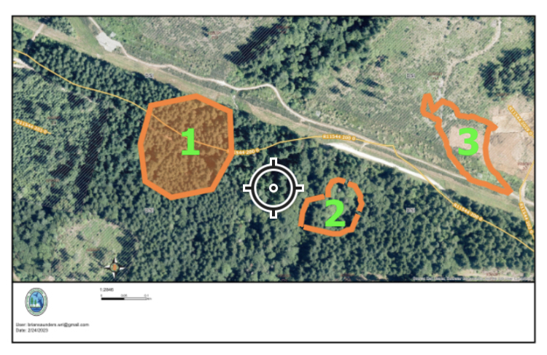
- Created by using the Draw and Measure Tool. Switched from a Line to a Polygon before saving.
- Four separate tracks saved as lines using the Draw and Measure Tool.
- Recorded GPS track.

Exporting Tracks

- Open the base map you used to record the track on in Avenza Maps
- Tap the Layer button 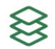
- Tap the export button 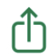.
- Tap 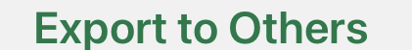

- Name the track and set the Format to GPX.

        - FILENAME – normally this should include the Block ID or other unique identifier
        - FORMAT – set to GPX
        - TRACK EXPORT – as a Line there is less data than as a Track.
        - DATA – if “Custom” is selected you can choose to only export some of the data.
        - IMAGE SIZE – if there are images associated with some of the features you can limit their size.
        - COORDINATE SYSTEM – leave as what the default is.

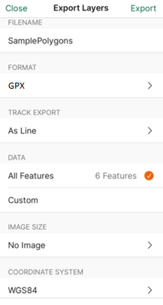
- Tap 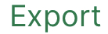 (top right)
- Choose the method of export (airdrop, messages, email, etc.). Generally, if no photos are being exported the file size is small and can be easily emailed.

You will now need to convert the GPX to an Esri ShapeFile to import into FMS. See 28.0 Importing GPX files into FMS.

30.22 Collecting data with ArcGIS collector

ArcGIS collector is now ArcGIS Field Maps.

You will need to download the app from the app store.

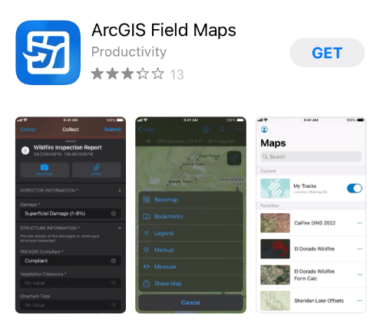

When you open the application, it will ask you if you want to sign into ArcGIS Online, ArcGIS Enterprise or skip sign-in.

30.3 Using a handheld GPS unit (Garmin GPSMAP 60CSx) to collect spatial for FMS

Contractors working for the Ministry may not have subscriptions to Avenza or Esri which is a $200 expense each year and may opt purchase a one-time expense handheld GPS unit to collect spatial data.

These instructions are for Garmin GPSMAP 60CSx which has an accuracy of 8 m in a mountainous heavy coastal canopy. You will have to refer to the user’s manual for other handhelds. The objective is to get a GPX file.

Turning on the unit
- Find a location where you have a clear view of the sky.
- Turn On the GPSMAP 60CSx by pressing, holding, and then releasing the POWER key. When the unit turns on, a tone sounds and the Introduction Page appears, followed by the Satellite Page.
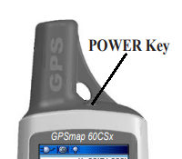

- Hold the unit in front of you with the top tilted upward. While the GPS receiver is searching for the satellite signals, a “Locating Satellites” message is replaced by an “Acquiring Satellites” message until enough signals are acquired to fix its location. When the receiver has signals from at least four satellites, the display at the top of the page changes to indicate position accuracy and location coordinates.
If the GPSMAP 60CSx can’t get past the “Acquiring Satellites” message or you get a “Lost Satellite Signal” message, move to a new location away from objects that may be blocking signals.

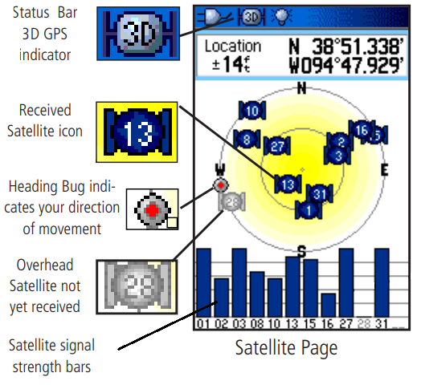
- If this is the first time using the unit Press the Menu key and scroll to “New Location” and Press ENTR key. It will go back to the Satellite Page. This will mark your location and will keep the unit focused on the satellites above this location.
Creating a track (Recording the boundary)

There are two types of points that are collected, waypoints and tracks. Waypoints are quite accurate, so the more waypoints, the more accurate your boundary will be. Use a waypoint each time you change bearings.

- Find a starting location. A tie point (junction/visible ground mark) makes it easier to confirm location of the polygon.
- Press Menu key twice to go to the Main Menu. Curser to Tracks and press ENTR key.
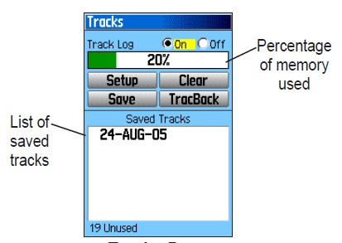
- Clear the track log by scrolling to Clear and pressing the ENTR key. Highlight OK on the confirmation message and press the ENTR key.
- Make sure Track log is on. You are now creating a track. You can name the track and set the interval on when a point is recorded by highlighting Setup.
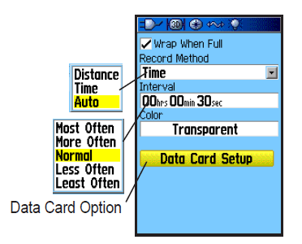
Wrap when full – means that it will start to record over the oldest data when memory is full.
Record Method – can be a set time or a set distance. Auto will give you five options to choose from (Most Often, More Often, Normal, Less Often, Least Often.
Color – you can set the colour.
Data Card Setup –
I set the Record Method to distance with an interval of 0.01m (10 cm)
- Walk the boundary making Waypoints when your bearing changes.

Recording a waypoint

- Press and hold the MARK key until the Mark Waypoint Page appears.
- A default three-digit name and symbol will be assigned to the new waypoint. You can change the name and symbol by scrolling to the name and/or symbol and pressing the ENTR key. An on-screen keypad will allow you to make changes by scrolling through the letters/numbers and markers. Press ENTR key to add the letter and then ‘OK’ on the on screen keypad when finished.
- Scroll to OK and press ENTR on the Mark Waypoint Page to record the waypoint to the waypoint list.
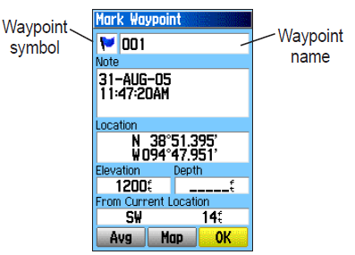

Ending and saving the traverse

Connect to Computer to download GPX file

There are two ways to get the GPX file. You can take out the Micro SD card and put it into your computer as a drive. Or you can use Garman’s Base Camp program.

Micro SD

Base Camp

Make sure the Garman Program Base Camp is installed on the computer.
- Start up Base Camp.
- Plug GPS unit into a USB 2.0 port. Do not use a USB 3.0 or higher port as the unit will not be recognized.
- Power up the GPS unit
- You should see the devise show up with the folder Internal Storage. Click on this folder
To import a shape into FMS using the Import tool, the file format must be GDB. You must transfer GPX files into GDB format using ArcMap or QGIS. See 28.0 Importing GPX files into FMS

Appendix 1 – Two to Three Day Training Agenda

DRAFT AGENDA – FMS District Training
Location: Ministry of Forests District Office,
Tuesday, xxxx xx, 2023, to Thursday, xxxx xx, 2023
Objective: To have district staff familiar with and confident to plan and manage their silviculture program in FMS and have most of their program loaded into FMS.
Trainers: Zach Cole (Silvacom), George Jennings (Certes),Nigel Fletcher (Ministry of Forests)
District Staff: xxx
Delivery Agent: xxxx (attending the morning session on 2nd day )
Tuesday, XXXX XX, 2023
Time | Topic | Lead
9:00 – 9:30 | Welcome:  - Acknowledgement  - Safety Briefing  - Introductions  - Overview: Meeting Purpose and Agenda  - Coffee Cup handout | Nigel Fletcher
9:30 – 10:30 | Walking through FMS  District staff should be in FMS and following along creating their own shapes and data.  - Create GF Block (cutting to boundary)  - Add standards units  - Add disturbance  - Add activities | Nigel Fletcher demo Zach Cole and George Jennings walking around helping district staff if they hit issues.
10:30 – 10:45 | Health Break
10:45 – 11:30 | Finishing up walking through FMS  - Using the search feature in FMS | Nigel Fletcher  Zach Cole  George Jennings
11:30 – 12:00 | Review of Training Guide / Question Answering  District staff should have gone through the training guide on their own.  Question-and-Answer session | Nigel Fletcher  Zach Cole  George Jennings
Noon | Lunch
1:00 – 2:00 | The District Program  - – who, what, where  This will provide and understand for Silvacom to know what is needed now and in the future for FMS to assist districts.  - Wildfire process  Learning about the wildfire program, what is need in FMS to facilitate their program | District Rep  Wildfire Rep
2:00 – 2:30 | Uploading using SNAP and Plant Wizard | Zach Cole
2:30 – 3:00 | Reporting to RESULTS | Zach Cole
3:00 – 3:15 | Health Break
3:15 – 4:30 | Power BI  George to demo and teach how to access reports on the web  Discuss future reports and Citrix workspace | George Jennings
4:30 | Adjourn – assuming this is the end of the day but we can stay as long as needed
Wednesday, XXXX XX, 2023
Time | Topic | Lead
8:30 – 9:00 | Welcome:  - Acknowledgement  - Safety Briefing  - Introduction of Delivery Agent staff and Coffee Cup handout | Nigel Fletcher
9:00 – 10:00 | SIET (Silviculture Input / Export Tool)  - How delivery agents (and districts) will use it | Zach Cole
10:00 – 10:15 | Health Break
10:15 – 12:00 | Reviewing layers and pull downs  - Getting district input on Calibration of FMS | Nigel Fletcher  Zach Cole  George Jennings
Noon | Lunch
1:00 – 2:00 | Introducing Map Management | Zach Cole
2:00 -2:30 | Production Site  Making sure those taking this training have access. | Zach Cole
2:30 – 3:00 | District program load  District staff working with trainers to start loading their silviculture program | Nigel Fletcher  Zach Cole  George Jennings
3:00 – 3:15 | Health Break
3:15 – 4:30 | District program load continued  District staff working with trainers to start loading their silviculture program | Nigel Fletcher  Zach Cole  George Jennings
4:30 | Adjourn – assuming this is the end of the day but we can stay as long as needed

Thursday, XXXX XX, 2023 (Extra Day if needed)
Time | Topic | Lead
8:30 – 8:45 | Welcome:  - Acknowledgement  - Safety Briefing | Nigel Fletcher
8:45 – 10:00 | Continue with district program load / learning FMS | Nigel Fletcher  George Jennings
10:00 – 10:15 | Health Break
10:15 – 12:00 | Continue with district program load / learning FMS | Nigel Fletcher  George Jennings
Noon | Lunch
1:00 – 3:00 | Continue with district program load / learning FMS | Nigel Fletcher  George Jennings
3:00 – 3:15 | Health Break
3:15 – 4:30 | Continue with district program load / learning FMS | Nigel Fletcher  George Jennings
4:30 | Adjourn

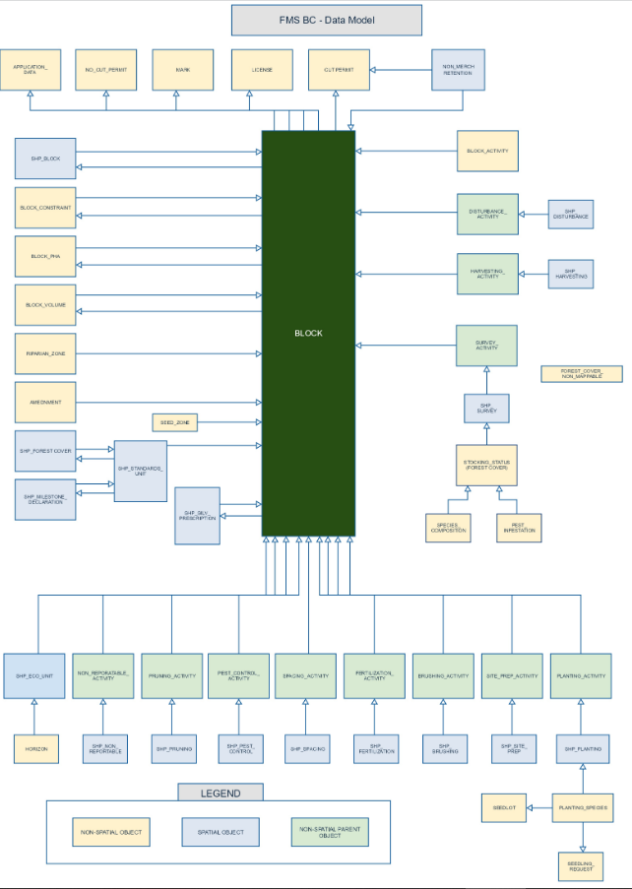
Appendix 2 – FMS Data Model

Appendix 2 – Layer definition

Layer name |  |  | Definition
GF Blocks |  |  | It is the outside boundary of an area being managed and is the container for disturbance, standards units and activities.
All Standards Units
Siliviculture Activities
 | All Harvestings
 | All Disturbances
 | All Surveys
 | All Pest Controls
 | All Site Preps
 | All Plantings
 | All Brushings
 | All Juvenile Spacings
 | All Prunings
 | All Fertilizations
 | All Cone Collections
 | All Research Trials
Imports
 | Polygon Imports
 | Line Imports
 | Point Imports
Sketch Layers
 | Annotation Sketch
 | Marker Sketch
 | Line Sketch
 | Polygon Sketch
RESULTS
 | Openings SVW
 | Opening Status (obligation/non-obligation)
 | Activity Treatment Units
 | Forest Cover Silviculture
 | Forest Cover Inventory
 | Permanent Sample Plots
FTA
 | Forest Cut Blocks ALL FTA
Wild Fire
 | Wildfire Zones (old district boundaries)
 | Current to 2015 wild fire boundaries
 | Historical wild fire boundaries
 | Burn Severity 2021
 | Fires 2010-2021
 | WRR wildfire risk reduction projects
Ownership and Licenses
 | Treaty Selection Lands
 | Tsilhqot'in Decision
 | First Nation Referral Areas
 | Crown Land Reserves and Notations
 | Tree Farm Licences (TFL)
 | Woodlots and Community Forests
 | Defined Forest Area (DFA)
 | Indian Reserves
 | Federal Lands (DND, …)
 | BC Parcel Fabric Fully Attributed
Range Tenures and Range Structures
 | Range Tenures FTEN
 | Grazing Leases
 | Grazing Licenses
 | Grazing Permits
 | Range Infrastructure
Natural Resource Districts
Land Use Plans Contraints
 | whse_land_use_planning.rmp_plan_legal_poly_svw
 | whse_land_use_planning.rmp_plan_legal_line_svw
 | whse_land_use_planning.rmp_plan_nonlegal_poly_svw
 | whse_land_use_planning.rmp_plan_nonlegal_line_svw
 | Legal Points (gosshawk nests etc.)
 | Non-legal Points
 | Landscape Units
 | Old Growth Management Areas
 | Wildlife Species At Risk
 |  | Spotted Bat Sites
 | Wildlife Corridors
FFT
 | OPENING SPATIAL - ALL ACTIVITIES
 | PLANNED ACTIVITIES WITH ACTIVITY SPATIAL
 | COMPLETED ACTIVITIES WITH ACTIVITY SPATIAL
Old Growth Deferral Areas (OGDA) - not legal
Road Layers
 | Forest Road Segment Tenure
 | Road Structures on Unnumbered Roads
 | Roads Un-Numbered
Water
 | Lakes, Rivers, Swamps
 | Community Watersheds
Stakeholders
 | Guide outfitters licenses
 | Guide outfitter infrastructure
 | Guest Ranch trail network
 | Trappers
VRI
BEC Cartographic Zones Subzones Variants
Parks
National Parks
Provincial Parks / EcoReserves
 | Regional Parks
 | FS Recreation Sites
Operating area
 | Operating Area Boundaries
 | Timber Supply areas and blocks
 | Forest Licence and operating areas
 | BCTS Operating Areas
Base Maps
 | Esri Street
 |  | Esri Imagery
 |  | Esri Topo
 | Esri Shaded Relief
 | Black Bridge Imagery
 | BC Albers Base Cache
 | BC Albers Roads Cache
 | 1:20,000 mapsheets
 | Air Photo Index

Appendix 3 – Data Dictionary by Block, Standards Unit, and activity

Categories

Attributes in red are mandatory
Attributes in purple are machine generated
Attributes in orange are calculated
Attributes in blue are calculated but can be manually over written
Attributes with a green (R) next to the attribute are needed for a RESULTS submission. Although some are not mandatory in FMS, they should be entered if known.
Attributes with a red S with a grey background (S) are attributes found in SIET template.

Block
Opening ID (R) – this is assigned by RESULTS

Common Name – This is a name that makes sense to where the block is located. E.g. 23km- Blackwater FSR

Block Activity

FMS Block Id – this is generated by FMS

FMS Block Activity Id – this is generated by FMS

Reference Number – this is delivery agent generated number. This is needed if spatial is provided when uploading using the SIET tool. It provides away to match the attribute record to the spatial.

Type

CAS Project Name

Fiscal – this is generated from the Planned Start Date

Funding source
Funding Activity Status
Recovery Program
Inter-agency number
Alliance
Region
District
Administrative Area
Delivery Agent
Planned Start Date (mm/dd/yyyy)
Completion Date
Planned Total Cost
Allocation Amount
Actual Cost
Comments
District Approved
AOP Approved
Current Funding
Paid Out
Under Contract
To Be Contracted
Other
Not Allocated
Submitter Name
Submitter Email
Created On
Created by
Updated On
Updated by
Locked
Locked by

Number of hectares
Other cost ($)

Disturbance

General Tab

FMS Block Id
FMS Disturbance Activity ID
Disturbance Code
System
Phase
Variant
Planned Start Date (yyyy-mm-dd)
Completion Date
Number of Hectares
xlm Action code
Contractor
District
Comments
Created on
Updated on
Updated by
Locked
Locked by
Submitter Name
Submitter Email

Funding Activity Status
CAS project Name
Planned Cost
Responsibility
Digitized
Inter-agency number
Base_tech_meth_ obj
other cost
recovery program

Disturbances Tab

FMS Desturbances Id
Comments
Measurement Method Code
Capture Method Code
Observation date
xlm export date
Number of hectares
locked
locked by
created on
created by
Updated on
Updated by
FMS Disturbance Id
FMS disturbance Activity
Number of hectares locked

Allocation amount
Planned access
Actural cost
Planned hectares (override)
Planned Implementation ($)

Planting

General Tab

Reference Number (S) | this is delivery agent generated number. This is needed if spatial is provided when uploading using the SIET tool. It provides away to match the attribute record to the spatial.
FMS Block Id (S) | this is generated by FMS – if you are using SIET tool you must provide this Id.
FMS Planting Activity Id | this is generated by FMS
Fiscal | this is generated from the Planned Start Date
Funding source | this is where the funding is coming from, it may be left blank if unknown or needs to be determined
Funding Activity Status (S) | When entering a project for the first time use Proposed otherwise use amended (other options are: completed, N/A, allocated,, and Post-AOP allocation.
Recovery Program | Should be left blank as it will be determined by FIRB and is related to funding source (e.g. 2BT, LBIS, CLEANBC, LCELF)
Base_Tech_Meth_Obj (S) (R) | This is used to determine the Base, Technique, Method, Objective Codes and CAS Project Name
Activity Base | Calculated from Base_Tech_Meth_Obj
Activity Technique | Calculated from Base_Tech_Meth_Obj
Activity Method | Calculated from Base_Tech_Meth_Obj
Objective Code one | Calculated from Base_Tech_Meth_Obj
CAS Project Name | Calculated from Base_Tech_Meth_Obj
Internal rate of return | To be eligible for FFT (Forests for Tomorrow) funding the prescribed regime of treatments must meet the FFT Incremental internal rate of return (Inc-IRR) criteria.
Inter-agency number (S) | This is usually the project # from PricewaterhouseCoopers (PwC) so that PwC activities can be reference to RESULTS and FMS activities
Alliance | This is how the budget is allocated out through allocation letters (North, South, Coast, BCTS, PwC, Branch)
Region | Grouping of districts – calculated from district
District (S) (R) | This is the district in which the spatial resides. GF blocks that cross district boundaries must be represented with two separate GF blocks.
Administrative Area (S) | This allows the user to sort by their own boundaries that may not follow district or regional boundaries (BCTS BA, District, Region, Fire Zone).
Delivery Agent (S) | The agency that is planning / carrying out the activity
Planned Start Date (mm/dd/yyyy) (S) (R) | This is used to determine fiscal, it is the date in which funding will be spent to carry out the activity.
Completion Date (R) | Date the activity has been completed
Planned Cost Per Hectare
Actual Cost Per Hectare
Other cost ($)(S)
District Approved
AOP Approved
Current Funding
Paid Out
Under Contract
To Be Contracted
Other
Not Allocated
Submitter Name (S)
Submitter Email (S)
Created On
Created by
Updated On
Updated by
Locked
Locked by

Plantings Tab

FMS Planting Id (S) | Machine generated
FMS Planting Activity Id | Machine generated
Number of Hectares | Calculated based on the spatial file provided.
Planned Hectares (override) (S) | Enter the number of hectares that will be planted. If true spatial was provided it should be the same as the calculated number of hectares.
Planned # of Trees (S) | Number of trees to be ordered for the block
Density | User Entered
Planned Cost per Tree ($/tree) (S) | Unit cost for putting a tree in the ground. Does not include the cost of the tree.
Planned Cost Per Hectare (S) | User Entered
Actual Cost Per Ha | User Entered
Planned Cost | Locked
Actual Cost | User Entered
Planned Access ($)(S) | User Entered
Planned Implementation ($)(S) | User Entered
Seedling Purchase | User Entered
Planned External Sowing (S) | User Entered
Allocation Amount | Calculated
Comments (S) | User Entered
XLM Export Date | User Input from time calendar

