Interior Silviculture Sub-Committee (ISSC)
“Face to Face” Meeting Minutes, November 15-16, 2017 - Final
Prince George District Office

Attendance:
- Present: Bill Laing, Carolyn Stevens, Eileen Kostian (alternate for Larry Fielding), Grant Glessing, Kerri Howse, Kori Vernier, Miodrag Tkalec, Nina Sigloch, Paul Rehsler, Roger Powell, Todd Schmidt, Ken Zielke, and Mari Schenkeveld
- Regrets/Absent: Catherine Bealle Statland, Darcy Lillico, David Jackson, and Megan Hanacek
Meeting: 1:00 p.m. to 4:35 p.m. on Wednesday, November 15th, and 8:30 a.m. to 4:00 p.m. on Thursday, November 16th.
- Meeting Minutes and Actions:
Paul started the meeting, and introduced Ken Zielke, who will facilitate this meeting. Carolyn introduced the District office building, its amenities, and safety procedures. Introductions were made by everyone around the table.
Kori organized the meeting participants into three groups for the icebreaker to find ten things in common per group.
Ken reviewed the Agenda, the TOR, Meeting Objectives and Format. Paul reviewed the “Issues Prioritization List’. He rechecked with the group as to whether there were any missed issues; there were none. The priority ranking was discussed, as well as the planned order of topics to be discussed at this meeting. It was agreed to cover off the “Stocking Standards as required Forest Stewardship Plan Content” as the first topic before “Max Density”.
Ken reviewed the Terms of Reference. The scope of this Committee is to serve as an advisory to the OIFS. Some concerns were voiced regarding communication breaks with the OIFs. The ISSC members may have already experienced some issues identified by the OIFs at an operational level. The operating principle is to respond in a timely manner on these identified issues. Ken said that the challenge is to identify issues and impacts and then, the options and recommendations will move forward. The history of the ISSC ‘s TOR was discussed. It originated from the Williams Lake Sub-Committee’s TOR, reviewed and updated by the OIFs.
The meeting objectives and format were discussed. The structure of the meeting is to be conducted in a respectful manner and try to understand each other’s perspective. Ken said that disagreements are beneficial if done in a respectful manner, since they will facilitate discussion and concerns.
- Issues Note: “Stocking Standards as Required Forest Stewardship Plan Content”:
Options 1 and 2 were discussed and considered as well as problems. The stocking standards has progressed a fair bit due to working groups in different regions. Perspectives should be looked at in terms of the benefits and importance. When issues and impacts are clarified, then options will flow. The Stocking Standards ensure that all Licencees in the same areas will comply with the same requirements for reforestation. The issues must be clarified by linking SS to objectives for consistent standards. In order to make this issue compelling to the OIFS, the wording must be updated, and the focus on efficiency. A problem with the stocking standards is that they get degraded over time with variations, such as on the minimum Inter-tree distance or stratification ramifications. Stocking standards are lacking clarity. There is less clarity about the results since much history and long-term knowledge are lost with personnel transfers and retirements. There is a huge opportunity to work together collectively and provide input, and be willing to accept the results whether successful or a failure. In meeting only the legal requirements, it becomes a “lowbar” target, which does not meet long-term objectives. In achieving FG status using stocking standards, it provides a linkage to the timber supply at an operational stage. We need to establish targets for a long-term objective, but will contain risks. The stocking standards should be pulled out of the FSP, but Todd was concerned with Option 1 requiring amendment to the regulations. Ken did not think that it was too difficult a process to change regulations as compared to legislation. Nina also mentioned that other parties (i.e. Habitat, Eco-systems, Cumulative Effects, First Nations, Water etc.) are interested in the Stocking Standards as part of the Forest Stewardship Plan. Decisions may possibly be made by District Managers who are not foresters and do not have timber objectives in mind. It may be a good idea to move the Stocking Standards out of the FSP, and have them specifically tie to timber objectives. We need to be aware that standards may be used for various reasons. Regional executives should be made aware that there are costs associated with different values. The other values need to be evaluated together (Government and Licencees), and get back to the forest management process. Instead of the stand level management, we need to go the “forest” level or the TSA level.
Ken mentioned that targeting lowbar is difficult. We have an issue problem, and need a way of evaluating impacts, starting with a small percent of an area. The key is to know where one is going and setting standards. There needs to be other systems used rather than just survey methodology. WSS numbers are used for compliance but do not tie into TSR. Are we wasting time with compliance using Stocking Standards? Are there other ways? Some Licencees are tied to the area tenure, but having volume tenures would be a philosophical change. The key is to improve and clarify these issues, and also clarify the Management Plan purpose. Todd asked what it entails to amend regulations. Amending regulations would take time, but perceived as being relatively easy as compared to amending legislation. Option 1 was preferable, where the FSP could go through approval more quickly without having to wait for the Stocking Standards to be approved, and site specific amendments could be made without requiring FSP amendments. It was suggested that a representative from this meeting do a presentation to the OIFs.
Action: Paul and Nina to revise and refine the Briefing Note and develop a Work Plan on “Stocking Standards as Required Forest Stewardship Plan Content”, and circulate to the ISSC for review, and then forward to OIFs for review and feedback.
Action: Kori to send Nina a list of the OIF members list.
Discussion ensued on one District, Rocky Mountain, which had success with common stocking standards. They also had a small Silviculture Sub-committee. Paul said that the Work Plan would feature TSA working groups, and look at changing regulations. We will need to have endorsement from OIFs to proceed. It will be done at the Landscape level, on a specified area, most likely in the Peace area, and worked on collectively under a shared FSP by BCTS, Canfor and West Fraser,
- Maximum Density:
The ISSC Draft on maximum density was reviewed. Kori mentioned that the first page deals with issues, while the second page is geared towards guidance. The repression density field trip in the Okanagan was discussed. Discussion ensued on the definition of maximum density; whether it should be treated; the potential value and the need for dollars. There are gaps in science and long-term information. There is no 2003 fire data to fall back on, especially since the data collected were on areas not free growing. It is difficult to predict max density due to gaps in data. There were fir trials conducted in the Kootenays but it did not support evaluation.
Should maximum Density be part of Basic Silviculture? Treating maximum density is not something that everyone will do, since it has unrecoverable costs. Long term research needs to be an established. Is there value in spending high dollars, since there is no long-term information on the impacts of fire on maximum density? Timing is important, since to prevent Repression, the area needs to be managed early. Discussion ensued on whether it is worthwhile to spend money to treat stands. There are many unanswered questions. We do not want to create another problem forest type. The gaps are addressed in Kori’s max density paper. We need to deal with gaps and knowledge for a recommendation. Post spacing density was also discussed. What is the differentiation between Interior Appraisal and FFT? If the Province will not invest money into this issue, why do Licencees have to do it?
The group will separate into two groups to go through the ten issues. Ken said that the recommendations could go forward with the following considerations:
- Is there value going forward?
- Remind government regarding gaps in information.
- What is the best Silviculture? Analysis may be required, so OIFs should be kept informed.

He advised on looking at which tasks could move, and recommendations made? What are the gaps, and what needs further group discussions?
Some of the other considerations discussed were:
- Is the Softwood Lumber tariffs affected if funding becomes available?
- How big are other issues such as impacts at climate change?
- How big a problem would it be if maximum density is taken out of Basic Silviculture?
- Do we have mechanisms in place to manage these issues? There are stocking standards, management level identification, and Enhanced Standards.
The ISSC adjourned for the day at 4:35 p.m. The group will be getting together for dinner at Earl’s at 6 p.m.
November 16, 2017 – 8:30 a.m.
Maximum Density (Con’t):
The ISSC members were split into two groups to review the ten issues that Kori had drafted in her “ISSC, Draft” table. The issues need to be sorted into which ones can have recommendations, and others which will need further discussion. Ken also advised on checking for any other gaps that may need to be added.
The first group consisted of Nina, Paul, Carolyn, Eileen, Kori, Miodrag and Mari. The second group consisted of Todd, Greg, Kerri, Roger, Bill and Ken.
GROUP #1: Kori gave a summary of Group 1’s discussion.
Definition: Group 1 discussed the terms “Repression Level” and “Maximum Density”. The document “Maximum Density (legal perspective)” was checked. It was agreed that the two terms should be separated, although the Maximum Density (legal perspective)” paper stated that “the term repression level, as used in early silviculture prescriptions has the same meaning as our current definition of maximum density.” The group agreed that Repression is based on physiology (growth of the tree), while Maximum Density is based on management objectives (including wildlife and other values). Stand density management is dealt in separate entirety but not as repression.
Post Spacing Density: This topic was not discussed.
Countable Conifer Definition: The current definition does not include enough information to make decisions. It is advised that we need to collectively look at the stands.
The Decision Key and FFT: Remove the ROI component of Repression Density Tool to use the tool to define when Repression occurs. The financial portion needs to be taken out of the scope and pushed into a different category to deal with. The tools need to define Repression, and also the upgrades needed for the tool. The species only apply to the fire regenerated stands, pine and larch. The tool does not include fir, which is a gap in knowledge. The larch needs to be reworded to include co-dom and dom. Site index issue is important. Larch is thought to be better on these sites, but is not necessarily the case. It is not on Trena’s list. Kori said that she wants to add larch to reflect dry site conditions, and provide help for Rocky Mountain to get on board.
Survey Procedures: Changes are being introduced and the difficulty of defining and auditing co-dom versus countable conifers. The wording could be potentially changed on the presentation notes for the Repression Tool. It is ambiguous. How do we define it so that we can repeat it in the field and two people can have similar results? Examples can be added to improve the upgrade.
Monitoring: The trials need to be put into place, and then identified as to whether the numbers fully represent the stand. The question is how do we fully evaluate? If there is a threshold number, but the decision key is not used, we are potentially devaluing stands by treating them, which is enforced. In order to identify the gap, take max density stands and put them in a separate analysis unit and evaluate the impact of increased rotation lengths on the TSR. It would be a method of enhancing the Decision Key to be able to come up with identifying the threshold. Instead of using costs to tie to the threshold, the impacts on rotation lengths and volume could represent that threshold. Appraisal will be a bit outside the scope. It would be worthwhile to see how the new system works and improve on it as a special entity. The question is how to get it paid for under the existing systems. Currently, the Decision Key and updates will meet the needs of the FFT. If we develop something that is excluding ROI, then it will be outside of FFT, and becomes a joint project between the Resources Practices Branch and our group. We will then need to put forward changes to achieve both the objectives of identifying stands and removing the ROI.
GROUP # 2- Ken provided a summary of Group 2’s discussions.
He said that there are definitely different personality types between the two groups. Group #1’s discussion was more detailed, while Group #2 dealt with the “big picture”. There are usually three “buckets” in a discussion; policy, strategy and technical.
The policy questions are: “Is Max Density equal to Repression?”, and “Should Max Density be Basic Silviculture?” In Appraisal, the principal landowner pays for Silviculture practices. For high density stands, the government looks at the stand and assesses whether it is worthwhile to invest monies. For high density stands, such as in the case of wildfire, would you space if it was on your own land? Group 2 focused on economics. They felt that it was unfair for Licencees, not covered by Appraisal allowance, but directed to space on fire stands at their own cost. It is not an investment for them, since there are no guarantees that they will be back to re-harvest the stand in the future. The government (people of BC) should take on the risks, since they will benefit if the stand is successful or suffer from failure. The key concern is that Licencees will have to bear costs for the fire originated salvage. Obligation should be possibly limited to the regen stage rather than free growing for these stands, but the regen standards need to be acceptable. It was suggested that these areas could be treated like NRFLS, and have silviculture levies on the salvage areas for both Government and Licencees. The key recommendation from Group 2 was to remove Max Density from Basic Silviculture for fire originated stands. Industry and Government should both do up a plan to identify areas for salvage and reforestation. The Appraisal system could determine reasonable costs, but if the costs are deemed more than reasonable, then FFT could take over. Most of the issues will go away with these key recommendations except for basic knowledge and research questions which can be worked on. Testing could be done on a pilot to test a small area, which was involved in the recent fires. Other high risk blocks with high costs, such as the Mule Deer Range should also be addressed separately like the high risk fire blocks. Discussion ensued over the post fire strategies. The Government and Licencees should work together. Paul had concerns with the amount of funding that FFT is limited to. The Licencees could take on the low risk stands, and manage obligations, including max density, up to Free Growing. The high risk areas including high density blocks should be exempt from Free Growing obligations. Area based tenure is better than volume based tenure, but the areas are not always manageable. The question was asked who should take on the risks for the high risk areas. The Licencees should take on the short term risks but not long-term. The landowner in this scenario would be the government, and the licencees can help somewhat, but they are limited as to how much they can do. It would work like a business arrangement. The Government should be more engaged for the public. There are problems with internal staff (both Government and Licencees) not understanding the risks and liabilities. Basic Silviculture should not be dropped, but the areas need to be treated quickly, which will address Repression. In terms of the FSP, the fire and Lodgepole pine regen stands should be separated from the regular regen areas. In moving forward, the group felt that the post spacing requirements should be removed from the scope. It is not a legal requirement unless included in the FSP. The post spacing density will be separated out of the Issues Note, and Kori and Grant will decide what to do with it. The blocks in the fire areas need to be salvaged for harvesting as soon as possible, but silviculture issues do not necessarily need to be addressed before harvesting. Currently, many Licencees have not started salvage harvest, since they want to figure things out first, such as additional costs. A question was asked about the Enhanced Standards and whether they would be helpful in these fire areas. The Enhanced Standards only covers costs for density management, not for other values.
Action: Kori and Grant to review Ken’s notes, and develop a Briefing Note based on the issues and discussions from the group on Maximum Density.
Action: Kori and Grant will decide what to do with the post density after it is separated out the Issues Note.
- Post Wildfire Reforestation:
Grant mentioned a September 10th Briefing Note on the “Impacts of BC Fires”. There is a section on the “Wildfire Impacts on Reforestation Obligation” on management units in Williams Lake, Quesnel, 100 Mile, Kamloops, etc. There are many issues emerging. There are too many blocks for Section 108 funding to address, plus there are other issues, such as regenerating fir for the Mule Deer Winter Range. One issue may be that there is not enough funding to plant all the burned areas, while other issues may be not enough availability of seedlings and not enough planters for the burned areas. Costs may rise due to the competition resulting from these issues. The areas containing dry fir and dead pine will be problematic since they will be difficult to regenerate. Climate based seed transfers may be considered. There needs to be a measured approach to prioritization, with the focus on habitat issues and problem areas. Carbon issues may emerge as well. Communication has not been well established between Government and Licencees. Currently, Wildlife Strategy and Forest Health Regional teams are attempting to concept a plan to manage all values. Nina mentioned that it will be a complicated process due to all the values being assessed by Government, and there is not much information coming through. With multiple complexity issues to address before salvage, there are delays, and both sides are frustrated. The Province is coordinating a plan for salvage. It was mentioned that reforestation is also a high priority and needs to be coordinated by the Province. Nina said that reforestation is already in the top ten on the priority list. Currently, if an area is salvaged, it will need to be reforested. We are in need of direction and waiting for it.
Recommendation: Joint Licencees and Government working groups are needed to set priorities and evaluate need within the time horizon.
Many people assume that blocks will regenerate on their own as they did in past fires, but it is different this time due to dead pine blocks. The public needs to be informed, and plans developed, such as ten-year plans. A short term emergency plan is needed as well. There are entomology issues, such as the black army cutworm, Rhizina, and spruce budworm to address. The short term emergency plan could help to provide exemption to move salvage quickly. The Crown may need to coordinate all the seeds to distribute due to the seed supply issues. Seed analysis is being done but the Forest Genetic Council (FGC) has not released it. All the key players need to be involved and communication generated. Kori and Todd both agreed that they needed to know if the Seed Analysis will be forthcoming. Nina said that currently it is only being done for FFT (Government) obligations, not for Licencees. Section 108 was discussed and whether we are all going for relief funding, or if we can obtain extra seedlings. Kori said that there is no indication from the Branch on the manner of funding.
Recommendation: A list of questions (key concerns) with realistic timelines need to be drawn up and submitted to the government.
Two levels of planning, short and long-term, are needed. We need to ensure that the window of opportunity will not close for salvage, and we need to have prioritization of areas, and exemptions for delayed reforestation.
The Seedling and Seeding needs analysis will have to generate the availability of seed and needs, which will include the Province, BCTS and Licencees. We will need to outline steps towards getting the Seedling Analysis done by considering the following:
- It will require information on hectares burned, by units, by BEC, and elevation.
- It will track seed.
- It will track legal obligations for Section 108, which will provide relief or funding.
- It will provide Reforestation strategy.
- It will require species information.
- It will require a list of Nurseries.
Keeping to a landscape plan will be cost effective. It may create more ammunition for the USA to use for the Softwood Lumber tariffs. High level decisions will be needed as in the past. There may be limiting factors to achieving the desired outcome.
An Issues Note should not be prolonged, and questions need to be used to go forward. A list of issues needs to be generated. Then, we need to work on identifying and clarifying issues, and then seek guidance.
The group brainstormed a list of key concerns and points, which Ken charted on the whiteboard. The questions are “What is being done?” and “Who is doing it?” Ken said that the worst case scenario is thinking that someone else is working on it, and no one is, or only doing part of it.
Ken drew up diagrams on the board. See Diagram #1, “Target: Reforest in a Timely Manner” (page 8) and Diagram #2, “Issues List” (page 9).

Diagram #1
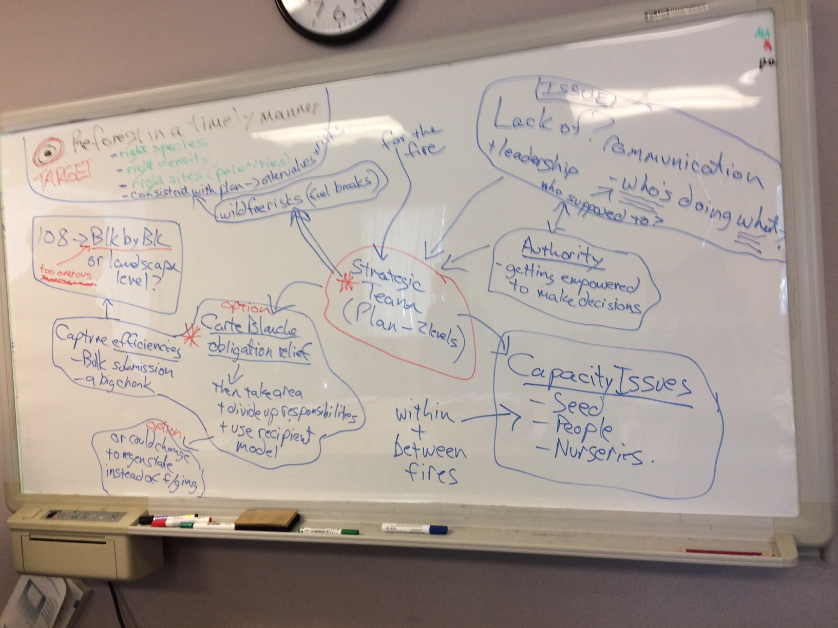
Diagram #2
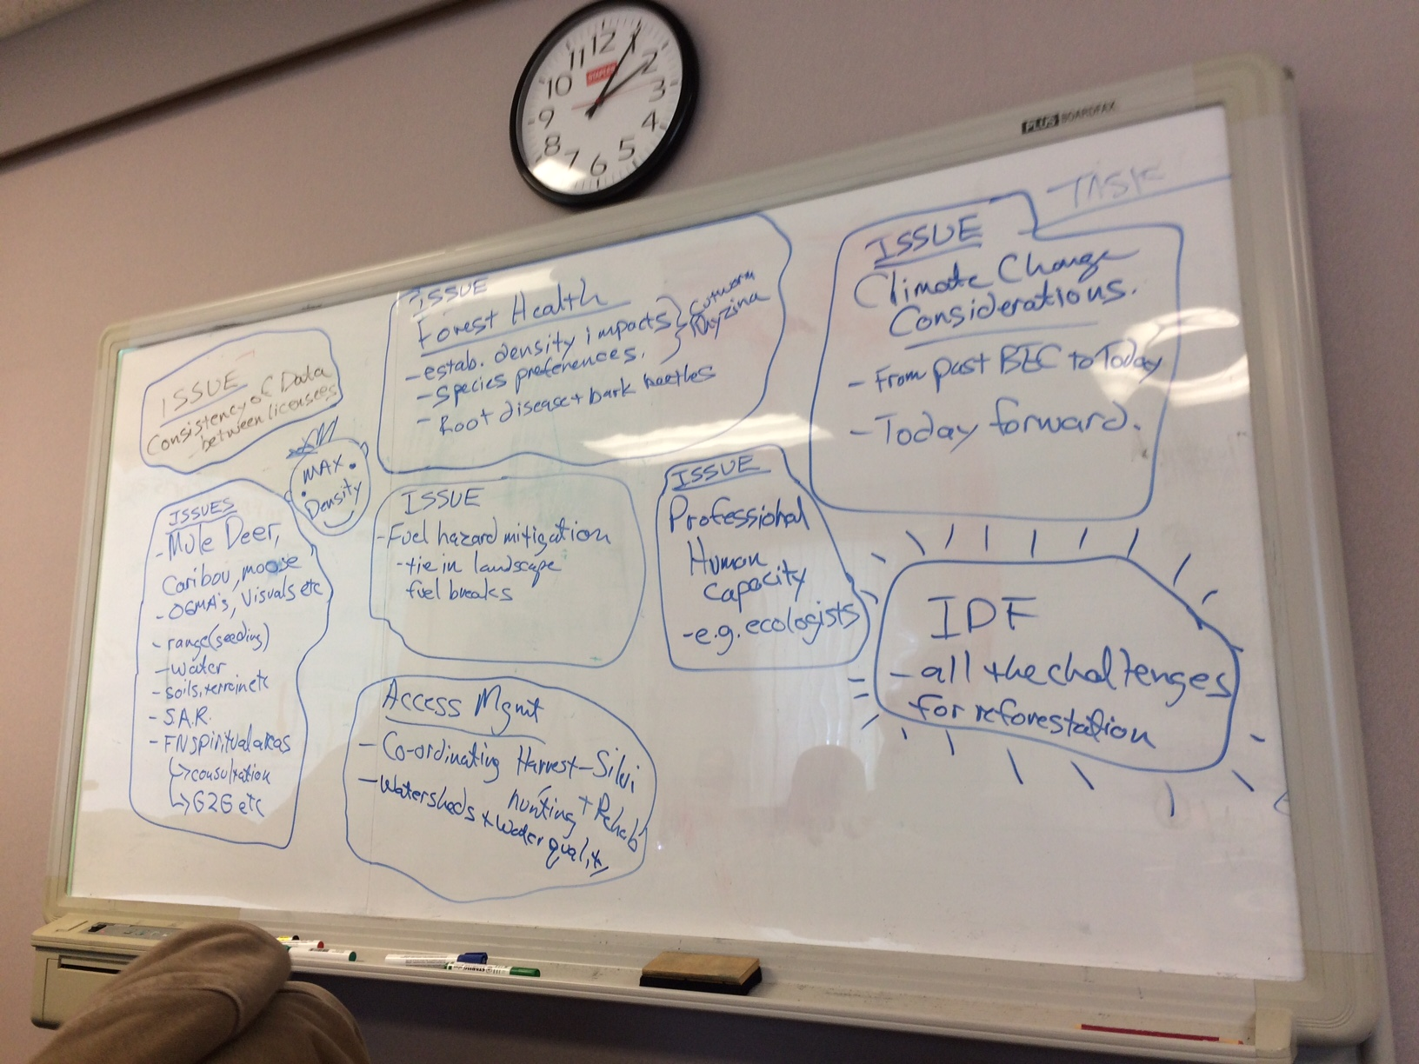

Discussion ensued. The purpose is to put the best seeds on the best sites. There is a need to coordination, and it should be a priority for the person in charge. It is important to have a Management Strategic team at a fire level, and employ a carte blanche method for blocks under Section 108. A Briefing note is needed.
Action: Grant and Kerri/Darcy will compile a Briefing Note on these issues, and present options to make recommendations.
Action: Kori will forward information from the FGC.
In summary, we will need the OIFs to endorse the concept on how to address these issues, and elicit guidance from them as to which issues the ISSC should tackle.
- Enhanced Basic Silviculture:
Historically, it started with the Type 4 Strategy in Quesnel, where a West Fraser TFL was planted at a higher density than the rest of the TSA. There was no mechanism to reimburse Licencee for the additional cost. A process put in place to reimburse costs was the Enhanced Silviculture Regime in the Interior Appraisal, approved in October. A guidance memo came out after the Interior Appraisal approval outlining procedures. The Enhanced Basic Stocking Standards must be added to the Licencees’ FSP Stocking Standards and in order to do it, must be part of Type 4 or other strategic plan, or be part of other strategies, such as Forest Health. It could also be a District process that comes with the District’s agreement on the stocking standards. The Type 4’s and the BEC zones where they had been applied on were the building blocks started in Appraisal. The question is now how do we continue with the implementation and how do we add other BECs, especially existing ones that do not have these standards ? Other parties, such as Carbon, want to increase densities in the stands, and what will be their role? The Committee can serve as a “sounding board” to come up with BECs and how we are going to apply them in the Enhanced Standards in the absence of higher level plans, such as Type 4 or ISS. The new ISS will be part of it.
How do we now implement? Discussion followed. For the first year, the Enhanced Stocking Standards will be reported separately, so we will have to have mechanisms in the Log Cost Survey to capture costs. The mechanism for deliverables is in the Stocking Standards itself, meeting obligation at the point of regeneration. Costs were discussed. The costs are shown with BECs and numbers on the Appraisal side. The costs for higher densities may be recouped using Forest Health, etc. No one in the group has used Enhanced Standards yet. A suggestion was made to let it “sit” until we are exposed to it. If not in compliance, a re-appraisal can be done if the requirements cannot be met and the site is inadequate. IDF can be included in Enhanced Standards for the burned areas, which can change the stand from unevenaged to clearcut. Could using the Enhanced Basic Standards be a mechanism for the difference in costs? The reasons for using the Enhanced Basic Standards would be to address wood quality; midterm; commercial thinning; enhanced allowance for higher densities; white pine with increased mortality and higher density; natural regen areas with lodgepole pine that are not working, complicated issues with fir; and fir with 50% mortality with the judicious use of seed. If the need to plant higher densities is directed, but no way to get enhanced costs, then the Licencees is left with the cost. If the Enhanced Standards are in their FSP and approved, then there will be monies for it.
- Bednesti (Chief Forester Tour) Action Plan:
Paul reviewed the Bednesti Action Plan table.
#1. In collaboration with Industry, the Ministry and the ABCPF were going to clarify the expectations of a Professional in regards to FSPs and Stocking Standards submission, which would be consistent with the assumptions of the TSR. A paper was written up by Al Powelson and Kevin Astridge, and circulated internally several times, and shared with Mike Larock (ABCPF). It has now passed again to Al Powelson and Jeff Mycock to review before forwarding it to the rest of the OIFs. It deals with the Stocking Standards and how the Licencees’ Silviculture Foresters would develop them, and how the Government Foresters would review them. Feedback from ABCPF on a draft of the “Role of the Professional in Silviculture” is close to being released. Paul will share the draft with the ISSC when it is released. It will provide a better understanding of the expectations of the Licencee Forester when he/she is developing the Stocking Standards to ensure that they are consistent with the TSR. It was asked whether this action item is still relevant or outdated since the item is several years old.
#2 Impact models for Gall Rust and Comandra Rust are being worked on. There will be another presentation in December. They are close to being released and will be part of TASS/Tipsy models as add-on for Rust. Kori asked who attended the September 27th presentation in order to obtain information.
Action: Paul to get a list of attendees at the September presentation on the impact models for Gall Rust and Comandra Rust.
#3: The ISSC has started working on the stocking standards issue this weekend. This Bednesti action was to make transformative changes to stocking standards system, and rather than linking it to timber objectives, make them consistent with a forward plan. Kori mentioned that there are some Bednesti action items, which overlap into other issues that ISSC is working on. This is one of them. An action item that ISSC is currently working on is “to explore opportunities and to closely tie Silviculture performance to TSR and AAC” for cost benefits is not addressed in this Bednesti action. It is a gap that is missing, and will be dealt with separately from the Bednesti action point.
#4. We need to look at the data collected to evaluate how obligations are fulfilled. It was suggested to use G&Y monitoring instead of planting or ingress data. It may be a better idea due to the longer term duration than free growing obligations. What are we reporting? The survey system is for regulatory compliance. Currently, we are projecting survey information over time, which is “guess work”. There should be another way to link directly to the timber supply rather than using survey methodology, which does not work well. Greg Jorgenson, who is looking after the survey process, has been tasked with reviewing other options, such as looking into new technology. Kerri asked if there is an opportunity to provide feedback at the “front end” instead of the “back end”. It was suggested that we invite Greg as a guest speaker to one of our meetings and provide feedback. This action point is one that we could do more work on. Paul will add it to the priority list.
Action: Paul to add to the Priority List, “Invite Greg Jorgenson as a guest speaker to an ISSC meeting for an opportunity to provide feedback on alternatives to the current survey methodology”.
#5. This action item was if changes are made to the stocking standards, how are the costs reflected back to those incurring them. If the stocking standards are pulled from the FSP and are more consistent, then everyone can pull it together and collaborate. The Appraisal system will more accurately reflect the costs.
#6. ISSC’s communication strategy for effective communications will be aligned with the OIF’s.
Kori asked how to share information with others, such as other Licencees and Districts, which are not part of the ISSC. Expertise is being lost through people retiring. Working groups consisting of District, Licencee, and BCTS staff, such as the TO working group may be a way to share information and expertise. Communiques were suggested, but there are already too many emails to go through. Another suggestion was to build “regional” people to share knowledge. It is helpful to have programs like SISCO. Communicating regularly with the Silviculture working groups at the District or TSA level would be beneficial. Extra effort should be made to provide information to others that are not at this table. We need approval from the OIFS before communicating with other groups.
#7. This action deals with filling training gaps, which used to be filled in the past by SIBC and other organizations, which are no longer operational.
#8. The critical knowledge and information needs should be identified, and checked as to whether there may be technology and/or other methods that will be helpful to address these needs.
Training and research are very critical. Workshops and networking are very much needed. Kori said that we need to connect with the operational people at a District level. Experts should be brought into committees such as the TSA steering committees. Communication is needed in organizing the structure for training as to who is paying, etc. The OIFs can be approached if ISSC identifies needs. There are constraints for training at a higher level but a training ground is needed for future leaders. Gaps are found in both training and research. There are two training needs. One is training around the immediate emerging science to address specific issues while the other is advanced training, which used to be addressed by programs like SIBC..
- Review of Recommendations and ISSC Work Plan:
Ken summarized the meeting. The Stocking Standards issue has an existing document that Paul and Nina will be working on. For Max Density, Kori and Grant will be drafting a Briefing note to be discussed by the ISSC and moved forward. For Post Wildfire Reforestation, the charts were drafted on the whiteboard. Grant and Kerri/Darcy will do a Briefing note including broad recommendations to the OIFS with a shopping list for a strategic team to take on, such as batching Section 108 in an organized manner. We had a good discussion with Enhanced Basic Silviculture which brought out key implementation questions. The Bednesti Action Points were revisited, with some points seemingly out of date. The action points will be addressed with Briefing notes and other issues can be addressed with some recommendations from the ISSC.
Paul said that since we decided to separate the stocking standards linkage to the TSR item from Bednesti Action Point #3, it would be worthwhile to have Dave Wadell provide us with some preliminary information from the Okanagan pilot. For the survey methodology issue, Paul will get Greg Jorgenson to participate in one of the ISSC meetings to get ideas from us on where the surveys should go in the future. Then we discussed the three way communication linking ISSC to the TSA working groups and the OIFs.
- Wrap Up:
Each person in the group went around the table and summarized what he/she got out of the meeting.
Everyone agreed that the meeting progressed very well, staying on the agenda, and with good involvement in discussions. The ISSC consisted of mixed Ministry and Licencee professionals, but the group melded well. The ISSC meetings should be relooked at. “Face to face” meetings should be more of a priority, since we are able to get more done. Conference call meetings do not entail very much time for discussion. The “face to face” meetings are effective, but many are unable to attend very many due to time constraints. It may be advisable to keep “face to face” meetings to one per year. Another alternative are video conference meetings. The ISSC had a number of issues to review this time, so this “face to face” meeting has been valuable. A significant change in membership in the ISSC has occurred in the last few years. Kerri mentioned that she has enjoyed being on the ISSC, but now will be turning it over to Darcy. It was valuable in having Ken facilitate this meeting. The group had variable perspective and ideas, which contributed to the value of the meeting.
Next meeting: Conference call meeting on December 5, 2017 (note: changed to December 18, 2017). The next years’ meeting schedule will be done soon.
The meeting was adjourned at 4 p.m.

