Adapting Forest Resource Management to a Changing Climate

A field-based workshop, October 7th and 8th 2015

Williams Lake / Alex Fraser Research Forest

You are invited to attend a workshop designed to bring the most recent thinking on how to incorporate a changing climate into operational direction.

If you have been wondering what direction to take, this workshop is for you.

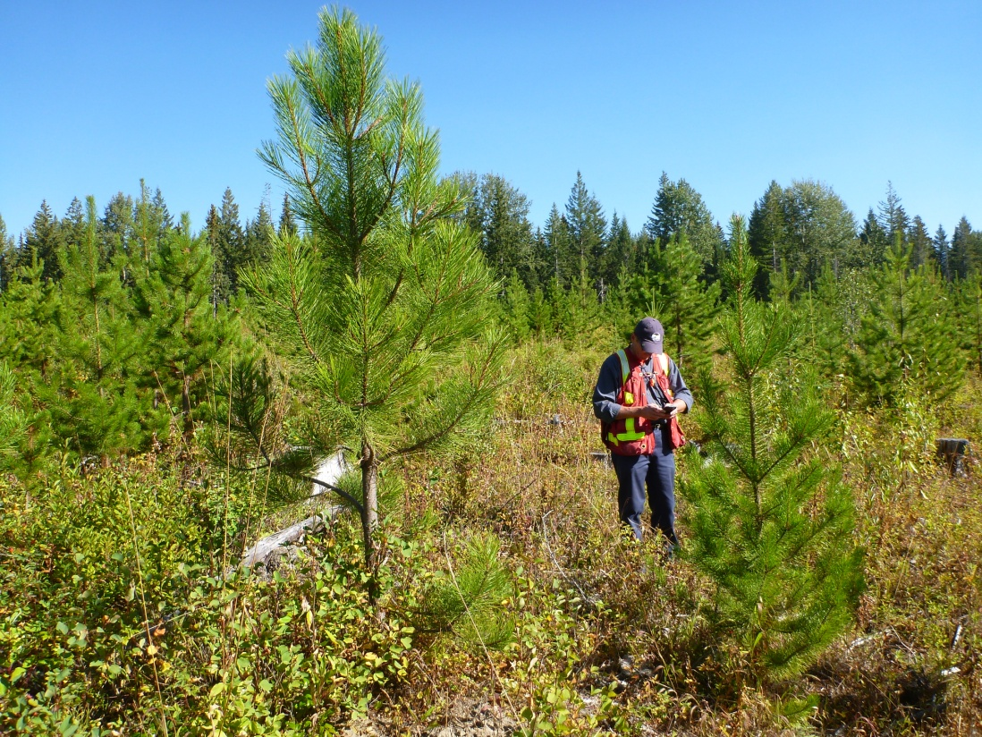

The workshop is field-based with a brief start in Williams Lake for coordination.

It is sponsored by
- BC Ministry of Forests, Lands and Natural Resource Operations – Competitiveness and Innovation Branch

Dates:
- Wednesday, October 7th and Thursday, October 8th 2015

Goal of the Workshop:
For practitioners to learn about the options to address risk and assess trade-offs as they emerge. Learn from experts and your peers through formal and informal discussions in the field where discussion about treatment options and a demonstration of their effects will take place. You will leave feeling empowered to use a climate change lens in your day-to-day operations and future projects.
The workshop provides a field based opportunity to observe climate change adaptation best practices on the ground. It is structured to assist in building relationships with others working to adapt forest management practices, to get a better understanding of the resource values that may be vulnerable within the Dry Fir zone, and to understand what options are available to address the vulnerabilities.

Who would benefit from attending?
All those involved in managing the dry forests of the interior of BC

The workshop will focus on a range of forest management topics including:
- Our changing climate – what we’re seeing, and what to expect in the Cariboo
- How our management can help with the bigger picture – that is carbon mitigation
- Harvesting – timing considerations based on climatic conditions
- Species selection and silvicultural systems
  - News on provenance trials and the most up-to-date information on species selection and nursery practices to address drought
- Risk – how to build it into your planning process
- Fire – where is it an issue and what can be done to address risk?
  - Landscape Fire Management Planning – where are we at?
  - Risk and Resilience – ongoing studies
  - LiDAR inventory and identifying stands at high risk
  - Biomass Harvesting – GHG reduction and risk mitigation

The workshop will be based on the above themes with presentations, exercises and thought provoking discussion looking for solutions and actions moving forwards. The session will be facilitated by Bryce Bancroft of Symmetree Consultants and Ken Day, Manager of UBC’s Alex Fraser Research Forest.

What to Bring:

Field gear, including: good boots, rain gear, hi-viz vest and hard hat for fire sites. Snacks and lunch are provided.

Registration:
Please note registration is limited to the first 30 registrants so please register by September 25th to ensure transportation and logistics can be organized in advance.
Please reply to Kylie Green (kylie.green@ubc.ca) to register (See Page 3).

Registration for

Adapting Forest Resource Management to a Changing Climate

A Field-Based Workshop

October 7th and 8th 2015 – Williams Lake

To register, please fill in this form & email to Kylie Green @ kylie.green@ubc.ca:
Name: Click here to enter text.
Affiliation: Click here to enter text.
Email: Click here to enter text.
Phone Number: Click here to enter text.
Do you have any dietary requests – e.g., gluten-free: Click here to enter text.
Registration fee: $0
NOTE: Please bring any climate/weather based harvesting related issues with you to the session, or email to BryceB@telus.net for discussion and options on site – we are hoping to address issues before they are problems.

Thank you. We are looking forward
to an interesting and informative two days.

