Project B5: Risk Analysis and Decision Support Tool
Final Report
April 17, 2012
Project Leader Craig DeLong
RESEARCH PROCESS
The main objectives of this project were:
1) To develop a tool that assigns the relative risk of forest stands to climate change-induced mortality from drought and related drought-induced biotic agent impacts
2) To develop a tool to predict landscape level risk based on triggers to extreme events such as landslides, floods, wildfire, and pest outbreaks.
3) To establish a method for evaluating risk of frost damage to seedlings.
4) To propose a home for the tools and a required budget for maintenance and upgrading.
5) To test output from the stand level tool against field based assessments of tree stress.
6) To provide a test case for integration of scientific predictions into community planning and governance.
Project Overview
Project activities focused on predicting the relative risk of high levels of tree mortality within forest ecosystems in response to climate change at the landscape and stand level. The intent is to provide managers and practitioners tools they can use to plan activities such as priority harvest, biological agent risk reduction, protection of communities, and tree species conversion in order to reduce the impacts or take advantage of climate change. Our research was comprised of two main components (landscape and stand level) and a field study connected to the stand level component.
The landscape level component, applied to the Northern Interior Forest Region (NIFR) only. The stand level risk assessment and management decision tool was piloted in the Prince George TSA in the NIFR and Cranbrook TSA in the Southern Interior Forest Region (SIFR). Development of a process for assessing frost risk was piloted in a portion of the Cariboo region.
The intent of the stand level tool was to develop a province-wide application for managers in all regions. Our intent was to pilot the tool across a range of geographic and ecological variability, in order to facilitate application to the remainder of the province. The field studies, were also conducted in the above study areas.
Landscape Component
Extreme weather events are predicted to become more common in response to climate change and little is known about the link between extreme weather and natural disturbance events. Therefore, a very extensive analysis of the historical data was conducted including calculations of baseline probabilities of extreme events, searching for known thresholds associated with natural disturbances, and developing thresholds from combining information from existing natural disturbance databases with historic climate data. The spatial analysis shows baseline trends across Ecoregions in extreme weather/climate events, the historical occurrence of natural disturbances, and the susceptibility of natural disturbances based on thresholds being exceeded (“exceedances”).
The first stage of the landscape component was to solicit the advice of regional experts (Marten Geertsema, John Rex, Richard Reich, Robert Hodgkinson, Ken White, Alex Woods, and Dana Hicks) to identify which disturbances the project would focus on. Natural disturbances were limited to known events in northern British Columbia having a significant impact on forestry and included the following disciplines; geomorphology (large landslides), hydrology (floods, droughts, rainstorms), fire (area burned, frequency, seasonal shifts), pathology (disease outbreaks), and entomology (pest outbreaks). Weather- and climate-related thresholds associated with known disturbances in northern BC were provided by discipline experts either through their own research knowledge, literature (e.g. Carroll et al. 2003, Geertsema et al. 2006, Woods et al. 2005), or by searching databases such as the BC Natural Disturbance Database (Canadian Forest Service), Canadian Large Fire Database (http://cwfis.cfs.nrcan.gc.ca/lfdb ), and Geertsema et al. 2006, as well as indices such as the Canadian Fire Weather Index (http://fire.nofc.cfs.nrcan.gc.ca/en/historical/ha_fw_e.php ). Once thresholds were defined, variability and change were measured across the historical climate data by counting exceedances over a high threshold (Karl et al (eds). 2008) or identifying trends. The climate database is comprised of daily precipitation and temperature data from Environment Canada weather stations in northern British Columbia as developed for Egginton (2005) and updated by Vanessa Foord. The following were recommended for analysis from the regional experts.
- Increasing mean annual precipitation: large debris slides, flooding, and fire.
- Increasing mean annual temperature: large rockslides, permafrost melt, drought, alpine permafrost retreat, increasing stream temperatures.
- Spring cooling: delayed snowmelt – rock slides, flooding
- Spring warming: Mountain Pine Beetle, Spruce Beetle (skips larval overwintering), early freshet/flooding
- Summer precipitation: various diseases, drinking water, fire, changes to frequency of
- Warm and dry summers: defoliators, birch and aspen decline, drought
- Warm summers: increased pest survival, fire
- Warm, wet summers: foliar diseases and pine stem rusts
- Warmer minimum temperatures and wet winters: foliar diseases overwintering survival
- Warmer winter minimum temperatures: 2 year cycle budworm
- Winter precipitation trends: delayed snowmelt – landslides, drinking water, permafrost melt, fire season start date
- August minimum temperatures: foliar diseases and pine stem rusts
- Decreasing spring frosts: 2 year cycle budworm
- Decreasing summer frosts: pest/disease success, seedling survival
- Drought: Douglas Fir beetle, Spruce bark beetle, fire
- Extreme cold after extreme warm: pests/disease breaking dormancy
- Extreme warm: drought, fire
- Fall and spring temperatures <-25oC: Mountain Pine Beetle survival
- Pacific Decadal Oscillation (PDO), Arctic Oscillation (AO), El Nino Southern Oscillation (ENSO) and fire trends.
Results of the climate analysis are displayed spatially by regional trends in each of the climate parameters examined. We calculated weighted averages (Bland and Kerry 1998) for each Ecoregion within northern BC as per Egginton (2005). Figure 1 shows the Ecoregions and weather stations used in the analysis. All of the data is available in spreadsheets, figures, and spatial products. Data analysis was conducted using the “R” statistical package. The majority of the data analysis was done by a contract to Hardy Griesbauer.
The pest disturbances that were available to be summarized from the natural disturbance database were: 2 yr cycle spruce budworm, balsam bark beetle, black headed budworm, douglas fir beetle, douglas fir tussock moth, false hemlock looper, forest tent caterpillar, hemlock sawfly, large aspen tortrix, mountain pine beetle, northern tent caterpillar, spruce beetle, eastern spruce budworm, western hemlock lopper, western spruce budworm. The fire variables that we examined from the Canadian Large Fire database and the Fire Weather Index were: number of large fires, start date, area burned, area burned with cold PDO, area burned with warm PDO, correlation between start date and spring AO, correlation between hectares burned and summer AO, correlation between hectares burned and summer ENSO (both all and large fires), correlation between hectares burned and summer PDO (both all and large fires).
Drought analysis was conducted several ways. The first was to calculate a Standardized Precipitation Index (SPI), which is based on the cumulative probability of a given rainfall occurring at a station based on historical rain records (McKee et al. 1993). This is accomplished by fitting historical rainfall to a gamma distribution and transforming the cumulative probability gamma function to a standard normal random variable Z with a mean of 0 and a standard deviation of 1. The methods of moment estimates of gamma parameters were used for the fitting (Magyari-Sáska 2007). A visual analysis of the data indicated that for the most part, this approach yielded reasonable estimates of the gamma parameters for the data. Climate Moisture Index (CMI) was also calculated, following Hogg et al. 1997. CMI measures drought as a ratio of precipitation to potential evapotranspiration (PET). It is calculated using maximum and minimum temperatures, precipitation, and station elevation. The methods of Groisman and Knight (2008) were used to calculate no-rain episodes for the climate stations. Daily precipitation data less than 1.0 mm were considered days with no rain (precipitation) and the length of consecutive no-rain days for each station were tallied. To relate the no-rain data with daily mean temperatures, four other variables were also calculated; total number of no-rain days during warm period, percentage of no-rain days during warm period, longest period of contiguous no-rain days in warm period, and number of X-day consecutive dry spells in the warm period (X=10, 20, 30). The warm period was defined per station as starting when the daily average temperature exceeded 5ºC and ended when the daily average temperature fell below 5ºC.
Changes in precipitation timing were calculated to attempt to detect any seasonal shifts in precipitation amounts. For example, if July is historically the wettest month of the year in Prince George, has there been a trend towards the wettest month more recently occurring in June? In a given year, precipitation timing for a month or a season was defined as a percentage of annual precipitation and a time series of precipitation percentages for a given month or season was created. In order to gauge trends in warm and wet summers, the years in which a station’s summer temperature and precipitation exceeded their 60th percentile were identified.
Baseline extreme climate analysis was done using the daily climate data to calculate 27 indices of extreme climate recommended by the CCl/CLIVAR Expert Team for Climate Change Detection Monitoring and Indices (Zhang and Yang, 2004). The “climate.pcic” package was provided by the Pacific Climate Impacts Consortium. These climate indices included: annual maximum length of dry spell, annual maximum length of wet spell, annual length of growing season, annual sum of precipitation in days where daily precipitation is at least 1mm, annual count of days exceeding 10mm precipitation, annual count of days exceeding 20mm precipitation, annual count of days exceeding 30mm precipitation, annual sum of precipitation where daily precipitation exceeds 95th percentile of daily precipitation, annual sum of precipitation where daily precipitation exceeds 99th percentile of daily precipitation, annual count of precipitation intensity (sum of wet-day precipitation sum/number of wet days), annual count of frost days (minimum temperature <0 °C), annual count of summer days (maximum temperature >25 °C), annual count of icing days (maximum temperature <0 °C), annual count of tropical nights (minimum temperature >20 °C), annual count of warm spells (warm spell = 6+ days where maximum temperature >90th percentile), annual count of cold spells (cold spell = 6+ days where minimum temperature <10th percentile), monthly average diurnal temperature ranges, monthly maximum 5-day consecutive precipitation, monthly maximum 1-day consecutive precipitation, monthly percentage of values below 10th percentile of minimum temperatures, monthly percentage of values below 10th percentile of maximum temperatures, monthly percentage of values above 90th percentile of minimum temperatures, monthly percentage of values above 90th percentile of maximum temperatures, monthly maximum of maximum temperatures, monthly maximum of minimum temperatures, monthly minimum of maximum temperatures, and monthly minimum of minimum temperatures. These climate indices are based on a “climate normal” period, so the ecoregional summary method of data could not be used. A representative weather station was chosen for each of the regions instead.
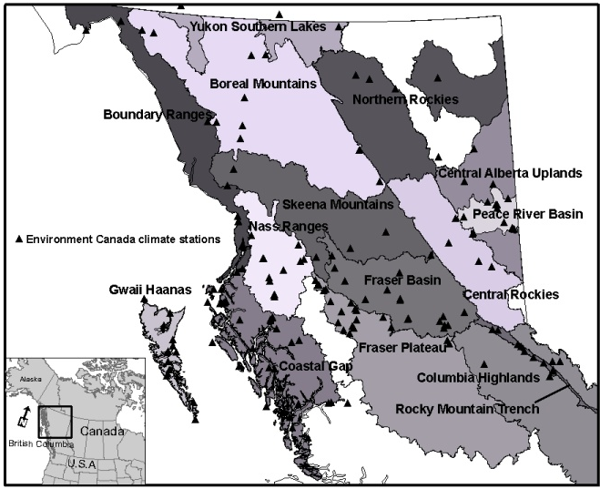
Figure 1: Ecoregions used to summarize trends of climate and natural disturbances. Triangles show Environment Canada weather stations used for climate analysis (Foord et al., submitted).
Stand Level Component
Changes in tree species distributions as a response to climate have been examined at a broad level in BC (e.g., Wang et al. in process), but the varied response of individual tree species at the stand level in response to differing site properties (e.g., soil moisture regime) is needed to inform stand level management. We desired to develop a tool to assess stand level drought risk.
We used a water balance approach first described by Klinka et al. (1989) referred to as Actual Soil Moisture Regime (AMSR). Details of how the approach was used to assess drought stress and assign drought tolerances (i.e., ASMR limits) to tree species are given in Appendix 1.
The climatic component for determining ASMR was derived using long term climate data representing biogeoclimatic units (BGC) while the site component was derived using site and soil conditions representing a relative soil moisture regime (RSMR) (see Appendix 1). A site specific (BGC unit by RSMR) and tree species specific assignment of drought risk class given current climatic conditions was assigned to polygons generated from overlaying Predictive Ecosystem Mapping (PEM) and Vegetation Resources Inventory (VRI) data. This risk rating was based on the PEM site series assignment (most limiting RSMR was used where a site series crosses multiple RSMRs) and leading tree species. Drought risk classes were assigned numbers so that in future it is easy to split, refine, and update the site unit and tree species matrices developed. Risk class was then adjusted based on change in ASMR over next 20 years (see Appendix 1). If the change in ASMR value changed to a new ASMR class based on any of the 3 climate change scenarios, risk was changed accordingly. Following this step, current and future drought risk can be mapped and provided to practitioners. A simple Excel application was also developed to allow entry of a BGC unit, RSMR, and tree species to calculate a drought risk of alternate reforestation species choices.
The site unit/tree species polygon drought risk assignments served as the starting point for drought induced biological agent risk assignment. With the help of entomology and pathology specialists we developed a list of biological agents that were felt to potentially cause stand level mortality and were felt to be exacerbated by drought for each tree species in our study areas. This allowed us to map risk for a particular biological agent. Biological agent risk was assigned by raising the drought risk class up one class if the tree species dominating the polygon is susceptible to mortality from the agent, and is within the stand age range of common susceptibility. The biological agent risk maps only identify risk polygons for that agent, while other polygons have no assignment.
As a pilot study, we also used the frost hazard assessment system developed by Steen et al. (1990) to map frost hazard for a portion of the Cariboo Forest Region. The 2 components required to map frost hazard (BGC unit and slope position) using their system are existing layers with the Cariboo PEM. We included this component in our project since this will be a critical component of any assessment of alternate reforestation species choices in the future. Based on the results of this mapping and the procedures used to develop the mapping we will advise on how frost hazard mapping could be repeated for other portions of the province where frost is considered to be an important limiting factor.
Field Studies
Models are best evaluated where actual field data are available for calibration and comparison of results. As part of our overall assessment of climate-induced mortality risk, we conducted field studies to calibrate drought stress and evaluate anticipated response variables. The field studies determined the response of trees to current and past climate on sites at different levels of predicted relative drought risk. These studies provided: 1) tests of field methods to evaluate tree response to drought; 2) feedback on how responsive trees are to the predicted current level of drought risk; and 3) insight into potential tree response to climate change.
In 2010 during the pilot sampling phase prior to the development of risk maps, sites were selected in Cranbrook based on site condition in order to test the methods used to determine drought stress signals. Douglas-fir (Pseudotsuga meziesii var glauca) was the only species examined on two comparative treatments (sites). The first was an upper slope shedding (Dry) site in the PPdh2 BGC and the second a mid- to lower-slope mesic (Mesic) site in the nearby IDFdm2 BGC. Ten trees at each site were selected and cores for dendrochronology and stable carbon isotope analysis were collected at the start of the field season. Twig water potential was sampled on seven occasions throughout the field season and root tissue samples for total non-structural carbohydrate analysis were collected in late fall. To minimize non-climatic “noise” in samples related to stand dynamics and forest health issues, only healthy, unsuppressed dominant trees were chosen. Soil monitoring and weather stations were also installed at each site. To assess current year tree vigour, sapwood tissue from roots was collected and analyzed to determine total non structural carbohydrate content using methods adapted from Bansel and Germino (2009), Wargo et al. (2003) and Dunn et al. (1997).
Tree cores were taken from 20 trees at each site using standard dendrochronology methods and analyzed to compare to historical climate data. Cores from older trees were also taken from the surrounding area to develop a chronology to determine the frequency of historical disturbance events. To complement the historical dendrochronology and climate data, drought stress history was determined using stable carbon isotope ratio (C¹³/C¹²) following (McDowell et. al. 2002). Based on the relationship between tree growth and historic precipitation trends, locations for time periods within each core representative of these dynamics were extracted and these rings used to examine C¹³/C¹² stable carbon isotope ratio.
Tree level stress response to the current season’s conditions was also examined using water potential. To describe water potential dynamics, five trees in each of the two treatments were randomly chosen and on seven occasions dispersed throughout the growing season sampled by removing twigs (using shotgun) from within the top 5 m of the trees and measuring mid-day twig water potential (terminal shoot moisture status) immediately on-site with a pressure chamber (PMS Instrument®, Corvallis, OR).
In 2011, a dendrochronological assessment was undertaken to validate the stand-level tool estimates of ASMR and risk. The objective of this component was to analyze spruce and subalpine fir tree-rings across a gradient of soil moisture conditions and drought risk defined by ASMR to detect potential risk-related differences. We used GIS to randomly select 30 high-risk polygons each for spruce and subalpine fir in the Prince George TSA. Polygons selected were only rejected if access was difficult (e.g., > 500m from a driveable road) or the polygon is unsuitable based on site visitation (e.g., obviously not in correct risk class, polygon has been harvested, etc.). Where possible, we additionally sampled low-risk sites adjacent to the selected polygons. Where present, we also sampled Douglas-fir trees. Site data were collected at each site to support risk rating and BEC classification. In addition, one representative Dry and Mesic site were chosen within the SBSdw3 (Fort St. James District) and SBSmk1 (Prince George District) biogeoclimatic units for more detailed work as above.
Tree-ring samples were collected from 8-15 trees per species at each site. Cores were prepared and analyzed using standard dendroecological techniques (Fritts 1976) at the University of Northern British Columbia’s Tree-Ring Lab (http://www.unbc.ca/dendrolab/index.html). Growth characteristics (such as mean annual growth and mean annual variation) and growth sensitivity to climate were analyzed and compared across sites with different risk ratings. For the climatic sensitivity analysis, annual growth responses at each sample site were compared to historical variation in key climate variables from both homogenized Environment Canada local climate station data (Mekis and Hogg 1999, Vincent et al. 2002) and the ClimateWNA model (Wang et al. 2006) to quantify growth sensitivity to climate fluctuations within and between tree populations across the study sites. Growth sensitivity to historical drought and El Nino events were also be analyzed and compared across sites with different risk ratings.

COLLABORATION
We hosted a meeting in February of 2010 and invited representatives from other projects to attend to discuss linkages and synergies between projects. Representatives from projects 1 “Reducing vulnerabilities and promoting resilience of BC's natural and human systems through adaptation of post-disturbance land management options”, 3 “Integrating climate change adaptation strategies with sustainability and socioeconomic objectives for the Quesnel timber supply area”, 4 “Climate change vulnerability of old-growth forests in BC's inland temperate rainforest”, 8 “Resilience and climate change: adaptation potential for management and ecological systems in the West Kootenays”, 11 “A multi-scale transdisciplinary vulnerability assessment” and 14 “Integrating FFEI scientific predictions into community planning and governance” attended the meeting. We established that the best way for us to contribute to other projects was to provide climate data and climate scenario worksheets that we were preparing for use in TACA since other people intended on using TACA and we had completed some of the BGC units from other study areas. We provided data for projects 3, 4, 8, and 11.

COMMUNICATION
We held 2 meetings in each of Prince George and Cranbrook. At the first meetings we discussed details of the project and obtained feedback from participants on what outcomes were desirable to meet their needs and in the 2nd meeting we presented results from the projects and described how they could use the information operationally.
We were asked to make a presentation to City of Prince George and have subsequently completed some work for them using the tools developed.
Hardy Griesbauer presented the stand level tool at SISCO in Naramata, BC, in April 2010 and as an outcome of this we were asked to do a presentation at Williams Lake in Sept 2011 which has lead to a request to estimate costs for applying the tool across the old Cariboo Forest Region.
Bruce Rogers presented a poster at the FFESC meeting in Vancouver in early 2011.
Vanessa Foord presented a talk on the preliminary analysis of the landscape component at the Canadian Meteorological and Oceanographic Congress in Victoria, June 2011. She also presented a poster at the same conference on the entire project. Vanessa also made a presentation about the project at the Climate Change and Community Forests conference in Dunster, October 2011.

RESEARCH OUTCOMES
Landscape Component
The following summarizes significant results from the historical climate and natural disturbance analysis, as listed in 1-19 of the Project Overview section. Numbers given here are still under statistical review and may change slightly, and subject to peer review in future publications. Only some results are presented and a thorough interpretation of the results will be left for publications. Data from the natural disturbance databases are subject to the limitations of the data availability and quality. Analysis of the fire data is subject to biases resulting from the level of suppression and management activities of each fire, of which the information is not known to the users. Only natural caused fires; however, were included in the analysis. All of the data below is available in a database, figures, or spatial files and further analysis and quality checking is planned.
- Increasing mean annual precipitation (MAP) and large debris slides, flooding, and fire.
Ecoregions with statistically significant increases in MAP are Gwaii Haanas (1.1% per decade), Nass Ranges (0.8% per decade), Fraser Basin (1.2% per decade), and Columbia Highlands (1.5% per decade) (Foord et al., submitted). Due to the geomorphological make-up of Gwaii Haanas, Nass Ranges, and Columbia Highlands and the documented knowledge of historical large debris slides (Geertsema et al. 2006, Hogan and Schwab 1991), there is an increased risk of future debris slides under increasing MAP. These areas, as well as the Fraser Basin, are also at increased risk of flooding from increasing MAP; however, no attempt was made by the study to quantify historical floods. Increased MAP may decrease forest fire potential, although this is also a function of forest management. The fire trend analysis also showed that Columbia Highlands and Fraser Basin have seen a statistically significant decreasing trend in area burned. The Nass Ranges has a significant trend towards later fire start date, which may also be a function of its significant increase in MAP.
- Increasing mean annual temperature (MAT) and large rockslides, permafrost melt, alpine permafrost retreat, drought, and increasing stream temperatures.
All but one ecoregion in the study had statistically significant increases in MAT. Skeena Mountains and Northern Rockies had 0.2ºC increases per decade, whereas Gwaii Haanas, Boundary Ranges, Coastal Gap, Nass Ranges, Fraser Plateau, Fraser Basin, Rocky Mountain Trench, Peace River Basin, Yukon Southern Lakes, and Boreal Mountains had increases of 0.1ºC/decade (Foord et al., submitted). Geertsema et al. 2006 have shown recent large rockslides in the Northern Rockies, Skeena Mountains, Boundary Ranges, Boreal Mountains, Columbia Highlands, Nass Ranges, and Coastal Gap. MAT may play a role in alpine snow and permafrost retreat, increasing the potential for failure in these regions from increased freeze-thaw processes and debutrussing of slopes (Egginton 2005). The Northern Rockies which has seen the largest per decade increase in MAT is also an area with isolated permafrost. This region is therefore at a larger risk of slope failure both from large rockslides but also permafrost melt. A project is currently underway to monitor permafrost temperatures in the region (by Geertsema and Foord).
Potentially the regions experiencing significant increases in MAT could have a higher drought risk. However, current precipitation trends in these regions have also showed increasing precipitation (discussed in detail further in the report). Increasing MAT may also play a role in increased stream temperatures; however, trends in stream temperatures were not assessed as part of this study. The Upper Fraser basin/ Nechako plateau are currently areas of concern for increasing stream temperatures as they are habitat for temperature sensitive fish species such as salmon, bull trout, and white sturgeon (John Rex, pers. comm.). Areas in the Peace may also be of concern for increasing stream temperatures with increased MAT because of temperature sensitive Arctic grayling and char (http://www.env.gov.bc.ca/wat/wq/BCguidelines/temptech/temperature.html#tab2 ).
- Spring cooling and delayed snowmelt, large rockslides, and flooding.
While several regions showed decreasing trends in spring mean, max, and minimum temperatures, only one region was significant, the Yukon Southern Lakes with a -0.1ºC/decade trend in maximum temperatures (Foord et al., submitted). Given the terrain in the region, an increased risk of delayed snowmelt from cooler spring temperatures causing large rockslides is possible; however, no historical events were recorded from Geertsema et al. 2006. Flooding here should refer to delayed freshet or the potential for a rapid freshet causing flooding, of which the Yukon Southern Lakes may be at risk; however, no attempt was made to analysis historical freshet data.
- Spring warming and Mountain Pine Beetle (MPB), Spruce Beetle, and early freshet/flooding.
Spring warming can impact MPB and Spruce Beetle by potentially allowing the pest to skip larval overwintering. Many regions have statistically significant increases in spring mean temperatures, the largest change of 0.2ºC/decade have occurred in the Northern Rockies (Foord et al., submitted). Gwaii Haanas, Boundary Ranges, Coastal Gap, Nass Ranges, Fraser Basin, Rocky Mountain Trends, Peace River Basin, Yukon Southern Lakes, and Boreal Mountains have increased 0.1ºC/decade (Foord et al., submitted); however, many of these regions are not at risk of these pests. The pest analysis showed there were significant increasing trends in MPB in the Fraser Plateau and the Skeena Mountains. Spruce Beetle had no region with significant increasing trends. With the exception of Gwaii Haanas, and most of the Coastal Gap, Spruce beetle exists in these regions of significant spring warming (http://www.for.gov.bc.ca/tasb/legsregs/fpc/fpcguide/beetle/figure2.htm ). For both MPB and Spruce beetle, a GIS exercise is planned to bring in forest cover maps with the temperature data and create a hazard rating using existing information (http://www.for.gov.bc.ca/tasb/legsregs/fpc/fpcguide/beetle/table11.htm ).
The regions listed above may also be at risk for an early freshet; however, an analysis of freshet data was not part of this study.
- Summer precipitation and various forest diseases, drinking water, fire, and changes to frequency of fire.
Summer precipitation has increased significantly per decade in Gwaii Haanas (1.4%), Nass Ranges (1.3%), Fraser Plateau (1.8%), Fraser Basin (2.3%), Columbia Highlands (1.4%), Rocky Mountain Trench (2.0%), and Boreal Mountains (2.4%) (Foord et al., submitted). Regional pathologists have seen increasing diseases in the Fraser Plateau and the Fraser Basin, and further east any additional increases in precipitation might actually cause a decrease in some rusts. Dothistroma is still a risk; however, in these more eastern regions and has been seen to be on the upswing (Richard Reich, pers. comm). Increased precipitation with warmer temperatures may be a better indicator of increasing disease levels, and this will be discussed further in the report.
Only one region had a significant decrease in summer precipitation, the Central Rockies (-3.1%/decade) (Foord et al., submitted). This area may be at an increased risk for drinking water issues and changes to fire regimes. Our fire analysis did not show any significant trends in the Central Rockies. Decreases in precipitation will be discussed further in the report in the drought section.
- Warm/dry summers and defoliators, birch and aspen decline, and drought
As mentioned above, only one region had a significant decrease of summer precipitation, the Central Rockies, and it did not have a significant summer warming trend. Currently, summers in northern British Columbia are trending towards warmer and wetter than warmer and drier. This will be shown in more detail in the analysis of drought conditions below. Trends for some defoliators were examined using the BC Natural Disturbance database. Both two-year cycle budworm and Western Hemlock looper had a significant decreasing trend in the Fraser Basin. Black-headed budworm had a significant decreasing trend in the Fraser Plateau, Gwaii Haanas, and the Nass Ranges. The Douglas-fir tussock moth had a significant decreasing trend in the Columbia Highlands. False Hemlock looper had a significant decreasing trend in the Rocky Mountain Trench, and Western Spruce budworm had an increasing trend in the Fraser Plateau. Forest tent caterpillar, Eastern Spruce budworm, Northern tent caterpillar, and Hemlock sawfly had either very little data or no regions with significant trends. Examining trends in birch and aspen decline were beyond the scope of this project; however, they could be brought in to the GIS tool if such information exists spatially.
- Warm summers and increased pest survival, fire, increasing stream temperatures.
Many regions had significant increasing summer mean temperatures per decade: Skeena Mountains (0.19ºC); Northern Rockies ((0.12ºC); Fraser Basin (0.09ºC); Boreal Mountains, Rocky Mountain Trench (0.08ºC); Nass Ranges (0.07ºC); Peace River Basin and Fraser Plateau (0.06ºC); and Boundary Ranges, Coastal Gap, and Yukon Southern Lakes (0.05ºC) (Foord et al., submitted). Four regions had significant increases in summer maximum temperatures per decade; Skeena Mountains (0.15ºC), Boreal Mountains (0.10ºC); Nass Ranges (0.08ºC), and Columbia Highlands (0.06ºC) (Foord et al., submitted). Many regions also had significant increases in summer minimum temperatures per decade: Fraser Basin (0.18ºC); Central Alberta Uplands (0.15ºC); Nass Ranges and Skeena Mountains (0.13ºC); Boundary Ranges and Fraser Plateau (0.10ºC); Peace River Basin (0.09ºC); Boreal Mountains and Coastal Gap (0.07ºC); and Gwaii Haanas (0.04ºC) (Foord et al., submitted). Regions with increasing pest trends include Boreal Mountains, Central Rockies, Columbia Highlands, Fraser Basin, Nass Ranges, Skeena Mountains, Fraser Plateau, Gwaii Haanas, and Rocky Mountain Trench. With the exception of the Central Rockies and Rocky Mountain Trench, the regions with increasing pest trends are occurring in conjunction with warmer summer temperatures.
None of the regions listed above with warmer summer temperatures had significant increases in the area burned from fires or in fire season start date. Fire will be discussed in more detail below. Examining stream temperatures was beyond the scope of this paper; however, the Nechako River, part of the Fraser Basin region which has seen large increases in summer mean and minimum temperatures is a river sensitive to increasing temperatures.
- Warm/wet summers and foliar diseases and pine stem rusts.
In a decadal analysis of summers with above the 60th percentile of each stations precipitation and temperature showed the 1990’s to have the highest number of wet/warm summers in the majority of the regions. It was the top 1 or 2 decade in twelve of the regions. The 2000’s ranked high as well, although could not be number one as the dataset only went to 2008. Regions where the most recent decades were the warmest and wettest were Boreal Ranges, Boundary Ranges, Coastal Gap, Fraser Basin, Fraser Plateau, Northern Rockies, Peace River, Skeena Mountains, and Yukon Southern Lakes. The Fraser Basin and the Fraser Plateau are areas in which current research is being conducted on the severity of foliar diseases and pine stem rusts, as they have been seen to be increasing (Richard Reich and others). An analysis of diseases and rust data was not made available to the project; however, there is spatial information for rusts that will be brought into GIS for a more in depth analysis with the climate data. Future analysis will examine foliar diseases and pine stem rusts separately, as they have different mechanisms of development and success.
- Warmer minimum temperatures/wet winters and overwinter survival of foliar diseases.
The largest increase of any temperature trend in northern British Columbia is in winter minimum temperatures. Many regions had significant increasing trends per decade; Skeena Mountains (0.57ºC), Northern Rockies (0.45ºC), Central Alberta Uplands and Rocky Mountain Trench (0.41ºC), Fraser Basin (0.40ºC), Yukon Southern Lakes (0.36ºC), Peace River Basin (0.33ºC), Fraser Plateau (0.26ºC), Coastal Gap (0.17ºC), Boreal Mountains (0.16ºC) (Foord et al, submitted). No regions had increases in winter precipitation. Such large increases in winter minimum temperatures may play a role in allowing for disease overwinter survival; however, foliar disease survival data was not available for the project.
- Warmer winter temperatures and two-year cycle budworm.
Significant increasing mean winter temperatures have occurred in many regions. These are (per decade); Skeena Mountains (0.54ºC), Northern Rockies (0.43ºC), Central Alberta Uplands (0.39ºC), Peace River Basin (0.27ºC), Yukon Southern Lakes (0.27ºC), Boreal Mountains (0.24ºC), Fraser Basin (0.23ºC), Nass Ranges (0.18ºC), Boundary Ranges (0.16ºC), Fraser Plateau (0.15ºC), Coastal Gap (0.13ºC), and Gwaii Haanas (0.10ºC) (Foord et al., submitted). The only region with a significant trend also in two-year cycle budworm was the Fraser Basin, which had a decreasing trend (21 years of data).
- Winter precipitation trends and delayed snowmelt, landslides, drinking water, permafrost melt, fire season start date.
Winter precipitation in most of the regions is decreasing; however, only one region was statistically significant, the Yukon Southern Lakes (-2.6% per decade) (Foord et al., submitted). As mentioned above, no large landslides were identified in this region using Geertsema et al. (2006). Spring temperatures and delayed snowmelt in this region were discussed above as a potential hazard; however, with the decrease in snow this risk is also decreased. An analysis of drinking water was beyond the scope of this project; however, there are known issues with drinking water in the Peace (Kiskatinaw watershed, http://www.dawsoncreek.ca/cityhall/departments/water/watershed/ ) which is experiencing declining winter precipitation.
The Yukon Southern Lakes is a region of sporadic permafrost, but the effect of snow cover on permafrost can work both ways. Snowpack can isolate the permafrost from fall and spring thawing, but can also prevent the transfer of cold air in the winter to the soil (Stieglitz et al. 2003). The fire analysis showed the Yukon Southern Lakes region with no significant trend in fire season start date. Central Alberta Uplands had a significant earlier start to the fire season but has not seen a significant decrease in winter precipitation. The Northern Rockies and Nass Ranges are trending towards a later start date, even under decreasing winter precipitation. Spring conditions and fire start date should also be investigated.
- August minimum temperatures and foliar diseases and pine stem rusts.
Increasing August minimum temperatures have increased significantly in several regions (per decade); Fraser Basin (0.20ºC), Nass Ranges (0.14ºC), Fraser Plateau (0.12ºC), Peace River (0.11ºC), Boreal Ranges (0.07ºC), and Coastal Gap (0.06ºC). Regional pathology experts (Richard Reich and Alex Woods) are seeing an increase of foliar diseases and pine stem rusts in the Fraser Basin, the Fraser Plateau, and Nass Ranges, which may be related to increased August minimum temperatures (and other factors). Analyzing disease levels was not part of this study; however, information could be brought into GIS for additional correlation. Blister rusts could be primarily affected by increasing August minimum temperatures, and future analysis will look at splitting foliar disease and pine stem rusts and late summer minimum temperature as they have different timing of minimum temperature thresholds (Richard Reich, pers. comm).
- Decreasing spring frosts and two-year cycle budworm.
Many regions showed a significant trend towards decreasing number of days with frost (<0ºC) in the spring. These are (in days per decade); Skeena Mountains (-1.23), Nass Ranges (-0.98), Fraser Basin (-0.67), Boundary Ranges (-0.56), Coastal Gap (-0.55), Northern Rockies (-0.53), Gwaii Haanas (-0.51), Peace (0.50), and Boreal Ranges (0.30). Interestingly, there was one region with a significant increase in days with frost, the Central Rockies (1.12 per decade). Only one region also had a significant change in two-year cycle budworm, and that was a significant decreasing trend in area attacked in the Fraser Basin.
- Decreasing summer frosts and pest/disease success, and seedling survival.
Several regions had significant decreasing trends per decade in the number of summer frost days (<0ºC). These were the Skeena Mountains (-0.55), Fraser Basin (-0.50), Boreal Ranges (-0.34), Fraser Plateau (-0.34), and Northern Rockies (-0.16). There have been significant increasing trends in some pests in these regions, such as the Balsam bark beetle in the Fraser Basin and Boreal Ranges, Mountain Pine Beetle in the Fraser Basin and Skeena Mountains, Douglas fir beetle in the Fraser Plateau, and Western Spruce Budworm in the Fraser Plateau. Seedling survival was not assessed as part of this project, but could be part of the GIS analysis if such spatial information exists.
- Drought and Douglas fir beetle, Spruce bark beetle, and fire.
Two regions with significant decreasing trends in the Standardized Precipitation Index (Skeena Mountains and Yukon Southern Lakes) and the Climate Moisture Index (Fraser Plateau and the Yukon Southern Lakes) were found, but these were in the winter. The trend in length of maximum consecutive no-rain days showed many regions with significant decreasing length (i.e. increased daily frequency of precipitation and no trends towards drought). The trend in number of 10-day no rain episodes also showed decreasing trends, indicating less potential for drought as there is an increased frequency of precipitation. Examining the frequency of 10-day no rain events by decade again showed most regions trending towards less drought; however, there were a few exceptions. Yukon Southern Lakes had a decreasing trend but the 1990’s was in the top 3 decades for average number of 10-day no-rain events. In the Peace, the second highest decade in average number of 10-day no rain events occurred in the 1990’s; however, there is no obvious decadal trend. In decadal calculations of 20-day no rain events, the 1990’s was the 3rd highest again for the Yukon Southern Lakes. In decadal calculations of 30-day no rain events, there was no trends towards this as an increasing event, although there may have been a few that occurred during the 1990’s in the Northern Rockies and the Skeena Mountains.
There are no obvious drought trends in northern British Columbia in all of the different precipitation analysis that were conducted. Spruce beetle also had no significant increasing trends and Douglas fir beetle has seen an increase in the Fraser Plateau, which is an area of increasing precipitation trends. Individual drought years may play a role in the success of these pests but that was not part of this analysis. The analysis of fire trends showed no areas that could be associated with increasing drought.
- Extreme cold after extreme warm and pests/disease breaking dormancy
Monthly diurnal temperatures ranges was used to estimate potential trends in extreme cold after extreme warm as more direct methods were difficult and time consuming. The majority of significant trends were in decreasing diurnal temperature ranges, therefore, indicating that the potential for extreme cold after extreme warm is also decreasing. Monthly diurnal temperatures ranges were calculated as part of the Climdex variables which are only done by station, not region, and only for a 30-year average (1961-1990). The following is a summary of stations with increasing trends in monthly diurnal temperature range, i.e. large swings in temperature. January: Barkerville (Columbia Highlands); February: Barkerville (Columbia Highlands); March: Barkerville (Columbia Highlands) and Bonilla Island (Coastal Gap); April: Bonilla Island (Coastal Gap), Ootsa Lake Skins Lake Spillway (Fraser Plateau), Atlin (Boreal Ranges), and Kemano (Coastal Gap); May: Bonilla Island (Coastal Gap); June: Bonilla Island (Coastal Gap) and Ootsa Lake Skins Lake Spillway (Fraser Plateau); July: none; August: Ootsa Lake Skins Lake Spillway (Fraser Plateau), Kitimat Townsite (Coastal Gap), and Bonilla Island (Coastal Gap); September: none; October: Atlin (Boreal Ranges); November: Barkerville (Columbia Highlands), Atlin (Boreal Ranges), and Sandspit A (Gwaii Haanas); December: Barkerville (Columbia Highlands), Atlin (Boreal Ranges), Langara (Coastal Gap), and Fort Nelson (Boreal Ranges).
In summary, a potential trend for cold events following warm events occurred in the Columbia Highlands, especially for the winter months (November to March); the Coastal Gap (March-June, August, and December); Boreal Ranges (April, October-December); Fraser Plateau (April, June, and August); and Gwaii Haanas (November). These may be areas of concern for pests and diseases breaking dormancy, but an analysis of such events was not part of this study.
- Extreme warm and drought, fire.
Two regions had significant increases in extreme maximum temperatures; Boreal Mountains (0.12ºC/per decade) and Columbia Highlands (0.09ºC/decade) (Foord et al., submitted). Neither of these regions had drought trends. Neither of these regions had significant trends in area burned nor fire season start date.
- Fall and spring temperatures below -25ºC and Mountain Pine Beetle survival.
The frequency of days below -25ºC for October, March, and April during the period 1971-2000, showed 3 regions with significant decreasing trends (i.e. less likely to reach this temperature threshold). These are the Yukon Southern Lakes (-0.97 days/decade), Northern Rockies (-0.79 days/decade), and Columbia Highlands (-0.14 days/decade). These areas may be of concern for future mountain pine beetle risk.
- Pacific Decadal Oscillation (PDO), Arctic Oscillation (AO), El Nino Southern Oscillation (ENSO), and fire trends.
Two databases were used to analysis fire trends, the Canadian Large Fire database (LF) and the Fire Weather Index (FWI). There were significant correlations with increasing fire size from the LF database and positive Arctic Oscillation in the spring in the Central Alberta Rockies (r = 0.48) and decreasing hectares burned and negative Arctic Oscillation from the FWI in the fall (Columbia Highlands, r = -0.31), winter (Boreal Mountains, r=-0.31), and summer (Boreal Mountains, r = -0.37). Significant correlations with a later start date of fire and Arctic Oscillation using the LF database occurred in the spring (Northern Rockies, r = 0.42; and Skeena Mountains, r = 0.64) and the summer (Rocky Mountain Trench, r = 0.70; and Coastal Gap, r = 0.76). In the FWI, significant correlations with hectares burned and the Arctic Oscillation occurred in the spring (Skeena Mountains, r = 0.40; Peace River, r = 0.35; and Northern Rockies, r = 0.31) and summer (Skeena Mountains, r = 0.34). The higher the AO index the later the start dates for fires in many regions. A positive AO index means higher pressure at mid-latitudes, driving storms further north and increasing the potential for precipitation in the north and delaying the start to the fire season.
There were significant correlations with a positive ENSO and increasing fire size from the LF database in winter (Fraser Plateau, r = 0.36), and summer (Yukon Southern Lakes, r = 0.64; Central Alberta Uplands, r = 0.38; and Central Rockies, r = 0.48). The same relationship with hectares burned was consistent in the summer and the Yukon Southern Lakes (r = 0.49) using the FWI. Significant correlations were found with a negative ENSO and earlier start date in the Boundary Ranges (r = -0.58) in the fall and the Peace River (r = -0.43) in the summer, using the LF database. With the FWI, every season had a significant correlation between negative ENSO and an earlier fire season start date in the Skeena Mountains (fall, r = -0.39; winter, r = -0.40; spring, r = -0.50; and summer, r = -0.40). A negative ENSO may influence the jet stream to lower latitudes thus potentially leaving more northern or north-western regions (Skeena Mountains and Boundary Ranges) dry in the winter months and susceptible to an earlier start to the fire season.
Using the LF database, there was a significant correlation with a positive PDO in the Nass Ranges in the spring (r = 0.76) and increasing fire size. There were significant correlations with decreasing fire sizes and a negative PDO in the Columbia Highlands (r = -0.38) and Rocky Mountain Trench (r = -0.69) in the summer. The FWI had significant correlations with decreasing hectares burned and a negative PDO in the Peace River in the spring (r = -0.31) and the Columbia Highlands in the summer (r = -0.30). There was one region with a significant correlation using the LF database and that was with a lower PDO value there was an earlier start date to the fire season in the Fraser Plateau (r = -0.38). Using the FWI, several correlations were found with higher PDO values and later start date to the fire season in the Nass Ranges in all seasons (fall, r = 0.43; winter, r = 0.52; spring, r = 0.54; and summer, r = 0.37) and in the Central Rockies in the spring (r = 0.34) and summer (r = 0.37). Correlations with lower PDO and earlier start to the fire season were found in the Rocky Mountain Trench in the winter (r = -0.31). A higher PDO index can result in a higher mean jet stream location over the northern part of the province potentially bring more precipitation in the winter months to the Nass Ranges and Central Rockies, thus delaying the fire season. A lower PDO would lower the jet stream and funnel more precipitation in the winter to more southern regions, potentially resulting in an earlier start date in more northern regions from lack of snow.
Stand Component
ASMR, drought risk, and pest risk mapping were completed for the Prince George Timber Supply and Cranbrook Timber Supply Areas. Frost risk mapping was completed for a small area in the Williams Lake TSA. The maps are available as GIS layers and are currently being checked and documented for inclusion in the BC Government Land and Resource Data Warehouse. Predictions of potential impacts on specific tree species are included in Appendix 1. Examples of maps produced are included in Figures 2 and 3.
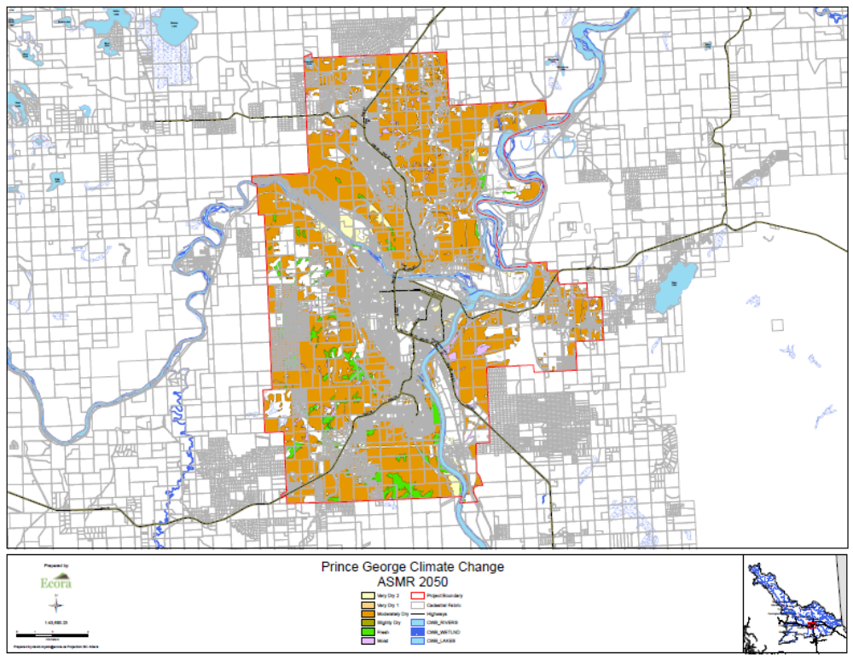
Figure 2. Projected Actual Soil Moisture Regime for the year 2050 with the Prince George city limits.

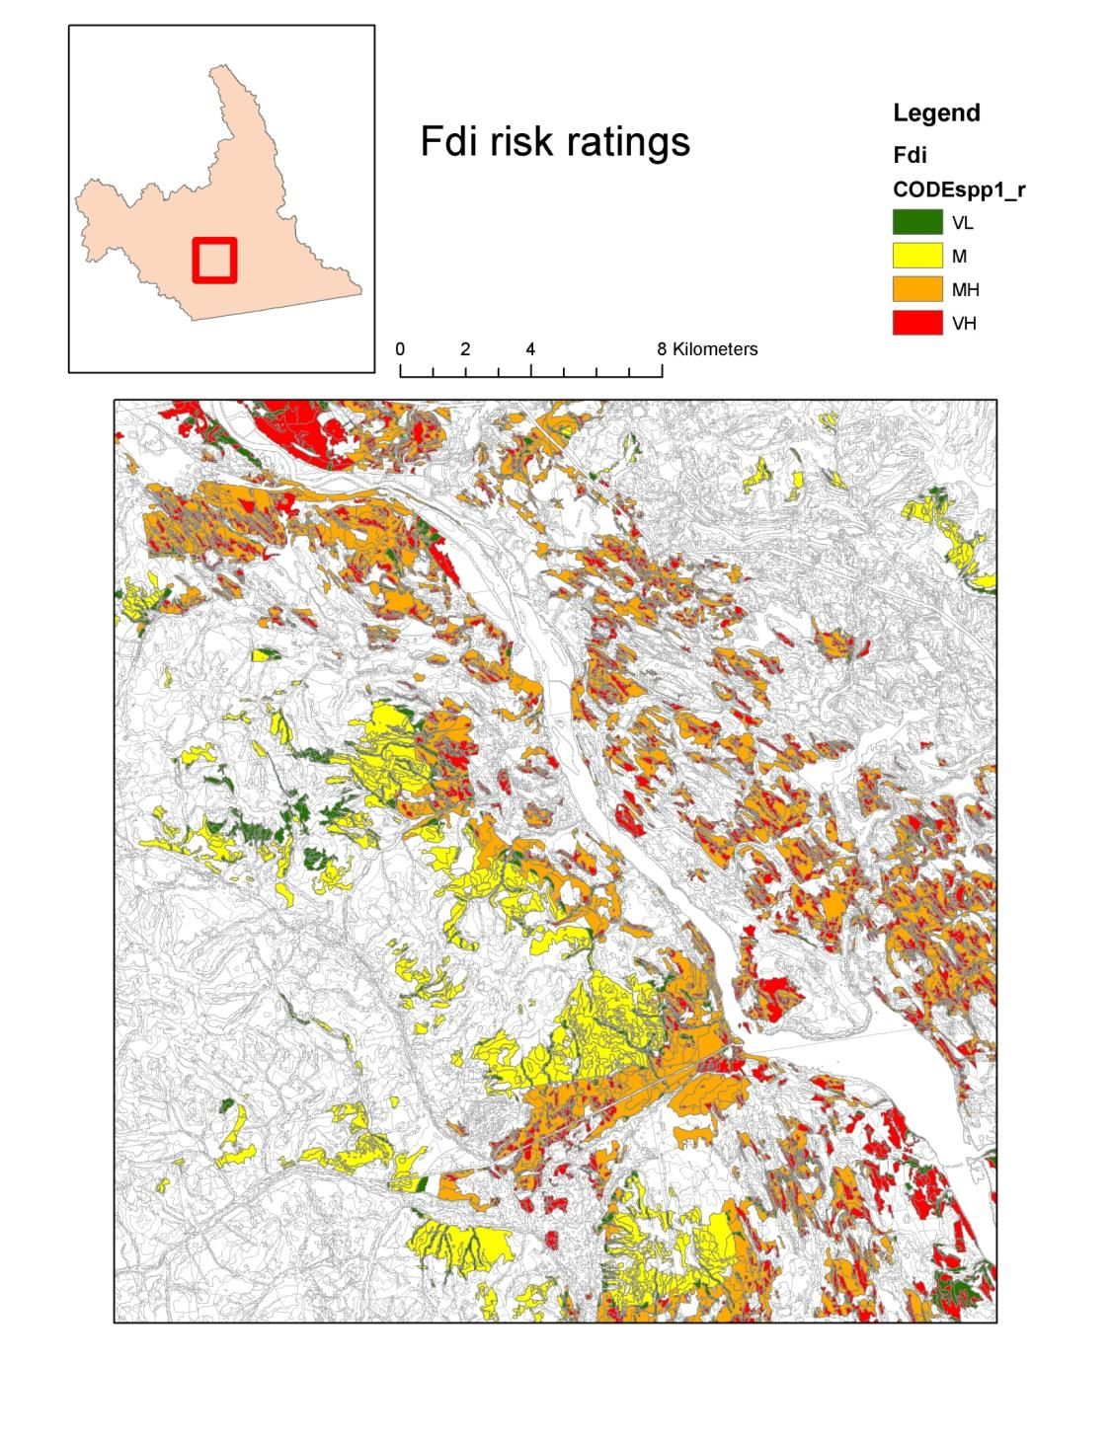
Figure 3. Douglas-fir (Fdi) drought risk ratings for a portion of the Cranbrook TSA. Risk ratings are VL = Very low, M = Moderate, MH = Moderately High, VH = Very High.

Field Studies
Dendrochronology
Data were collected from 60 study sites in total, located within a range of 53.1 to 55°N, and from 122.3 to 125.1°W. Study site elevation ranged from 590 to 1280m above sea level. The study sites were located within nine BGC climatic units, and encompassed 25 different BGC climate unit/site series combinations, representing soil moisture and nutrient regimes ranging from very xeric to hygric, and very poor to rich, respectively. Estimated ASMR ranged from 0.765 to 1.
Chronology development and climatic analysis
We developed chronologies (i.e., time series of average stand growth) for 42 Sx, 19 Bl, and 9 Fd stands over a range of risk ratings for each species. Chronologies were built from 8 to 15 trees and ranged in length from 68 to 375 years. All climatic analysis was limited to the shortest chronology length (68 years, from 1943 to 2010). Analysis of Sx and Bl chronologies was completed in 2011; analysis of Fd chronologies will be completed in 2012 as part of the ongoing isotope and starch analysis. Sx trees collected at two sites could not be cross-dated (likely due to tree- and stand-level disturbance); all trees for these two sites were omitted from further analysis and no chronology was developed for either site. We combined one Sx and four Bl chronologies with adjacent chronologies that had identical ecological characteristics in order to increase the sample size and improve the common signal (EPS). Most chronologies had a strong climate signal in the tree-rings, as measured by EPS. Nine final chronologies (eight Sx and one Bl) had EPS below the recommended minimum of 0.85 (Wigley et al. 1984), however, EPS values were all above 0.8 and we therefore retained these chronologies for further analysis.
Correlation analysis between annual growth (i.e., the chronology) and historical climate indicated that from 1943-2010, June maximum temperatures were primary climatic influences for both species. In both species, all significant correlations with maximum temperatures were negative; in other words, this analysis indicates that future projections of warmer June temperatures will result in lower growth for both species in the Prince George TSA. Warmer temperatures during the previous year (February to October) also reduced spruce growth in most sites. This phenomenon was not observed in the Bl chronologies, and supports other studies that suggest Sx growth shows strong preconditioning associated with previous year climate (e.g., Miyamoto et al. 2010).
Drought was also an important climatic influence for both species from 1943-2010. Most Bl chronologies had positive correlations with May CMI; in other words, growth increased as the precipitation: PET ratio increased. Growth in the Sx chronologies responded to drought over a different time period, from June to August of the previous year. Few chronologies for both species were correlated with any ClimateWNA-derived variables as well as the ENSO, PDO, and AO indices; these variables were omitted from further analyses.
Spruce growth and climatic sensitivity varied significantly with risk rating. Interannual growth fluctuations and standard deviation were significantly higher on higher-risk sites. As well, Sx sensitivity to May maximum temperatures increased with drought risk. Further, climatic sensitivity to previous year temperatures decreased significantly with drought risk rating. These patterns suggest that the primary climatic limitations to Sx growth are different between risk ratings; on droughty (high-risk) sites, growth is limited by May maximum temperatures, whereas on wetter (low-risk) sites, growth is more determined by previous year conditions. These significant patterns also support drought risk ratings approach used in this study.
Subalpine fir growth and climatic sensitivity did not show any significant differences between risk ratings. This may be a function of a) a relatively low sample size (15 chronologies) and/or b) the canopy position of the species. With respect to the former, sensitivity to May temperatures did increase with drought risk rating, however, the trend was not significant. An increased sample size would help elucidate the significance of this potential trend. In most of the high-risk stands, Bl was a seral species that had established under a canopy of other trees. In these types of stands, Bl may be sheltered somewhat from drought or high temperatures, and therefore may have similar climatic sensitivities across a range of soil moisture regimes. This hypothesis could be tested in the future with a more comprehensive Bl study.
Detailed field study
Models are best evaluated where actual field data are available for calibration and comparison of results. As part of our overall assessment of climate-induced mortality risk, we will conduct two related field studies to calibrate drought stress and evaluate anticipated response variables. The field studies will determine the response of trees to current and past climate on sites at different levels of predicted relative drought risk . These studies provided 1) tests of field methods to evaluate tree response to drought; 2) feedback on how responsive trees are to the predicted current level of drought risk; and 3) insight into potential tree response to climate change.
Tree level drought stress signals
2010 Field Work
In 2010 during the pilot sampling phase prior to the development of risk maps, sites were selected in Cranbrook based on site condition in order to test the methods used to determine drought stress signals. Douglas-fir (Pseudotsuga meziesii var glauca) was the only species examined on two comparative treatments (sites), the first upper slope shedding (Dry) site in the PPdh2 BGC and the second a mid to lower slope mesic (Mesic) site in the nearby IDFdm2 BGC. Ten trees at each site were selected, cores for dendrochronology and stable carbon isotope analysis collected at the start of the field season, twig water potential was sampled on seven occasions throughout the field season and root tissue samples for total non-structural carbohydrate analysis were collected in late fall. To minimize non-climatic “noise” in samples related to stand dynamics and forest health issues, only healthy, unsuppressed dominant trees were chosen. Soil monitoring and weather stations were also installed at each site.
Trends seen in the data support hypotheses around higher demand and lower productivity and vigour for trees at the Dry versus Mesic site. However, some differences seen in the current year comparisons were small, likely due to above normal levels of precipitation at both sites minimizing drought impact and response on trees throughout the growing season.

Current Year Tree Vigour
Methods
In 2010 to assess current year tree vigour, sapwood tissue from roots was collected and analyzed to determine total non structural carbohydrate content using methods adapted from Bansel and Germino (2009), Wargo et al. (2003) and Dunn et al. (1997). At The University of Alberta sub samples were then mixed together and ground in a Wiley mill (to pass 40 mesh) as a single sample representing an average per tree. Soluble sugar extraction was then carried out using the hot ethanol method of Chow and Landhäusser (2004). For each tissue sample, five subsamples (50 mg) were extracted three times with 5 ml of 80% ethanol, by boiling the samples in glass tubes capped with glass marbles in a 95 °C water bath for 10 min each. After each extraction, the tubes were centrifuged at 2500 rpm for 5 min, and the supernatants of the three extractions combined for sugar analysis. The residues remaining in the tubes were stored wet at –20 °C for starch analysis.

Preliminary results
As presented in Table 1 below, total non structural carbohydrates stored in roots at the Mesic site were greater than that of the Dry site

Historical Drought Stress
Methods
For dendrochronology, tree cores were taken from 20 trees at each site at 1.3 m above ground (DBH) measured on the uphill side of the tree. Cores were removed perpendicular to slope to avoid compression and tension wood. They were then analyzed used to compare to historical climate data (including 10 sample trees and 10 extra trees). Cores from older trees were also taken from the surrounding area to develop a chronology to determine the frequency of historical disturbance events. To compliment the historical dendrochronolocal and climate data, drought stress history will be determined using stable carbon isotope ratio (C¹³/C¹²) following (McDowell et. al. 2002). All sample trees also had extra cores taken for stable carbon isotope ratio analysis. Based on the relationship between tree growth and historic precipitation trends locations for time periods within each core representative of these dynamics were extracted. Using the same years across all trees for both sites, 5 rings from drought years and 5 rings from high growth years were homogenized into 2 samples for tree and chemically analyze growth rings for C13/C12 stable carbon isotope ratio. Tissue carbon isotope ratios for combined/homogenized annual ring growth corresponding with historic climatic markers were compared within and amongst treatments.
Preliminary results
As presented in Table 1 below (the more positive the value the greater the water stress for that growth period), during combined years of high growth with no water limitation, water stress is lower at both the Mesic and Dry sites comared to that of combined years of low growth associated with drought periods in general. However, during each of the combined low growth and high growth years the Dry site is always under more water stress than the Mesic site.

Current Year Drought Stress
Methods
Tree level stress response to the current season’s conditions were also examined using water potential. To describe water potential dynamics, five trees in each of the two treatments were randomly chosen and on seven occasions dispersed throughout the growing season sampled by removing twigs (using shotgun) from within the top 5 m of the trees and measuring midday twig water potential (terminal shoot moisture status) immediately on site with a pressure chamber (PMS Instrument®, Corvallis, OR).
Preliminary results
As presented in Table 1 below, water potential values (the more negative the more water stress) at both sites were not different on the sample days in early summer (June – July). However, values were more negative indicating greater water stress for the trees at the Dry site during the latter half of the summer (August-September).

Table 1. Mean values and s.e.m. (unpublished) for Stored Root Carbohydrates, daily Twig Water Potential and C13/C12 Isotope Ratio (for separately combined high and low growth year rings).
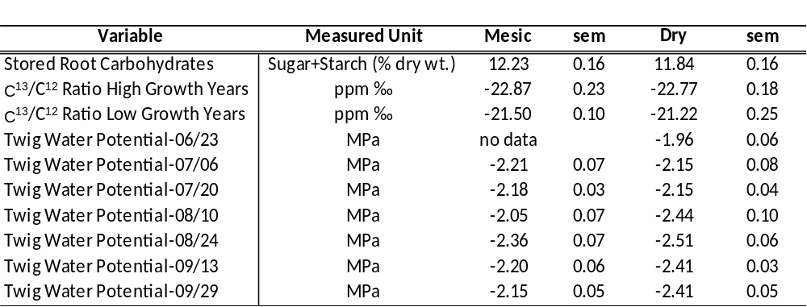

Current Year Weather Conditions
Methods
Onset Hobo ® weather stations were installed adjacent to each site in opening representative of the treatment site conditions. Variables measured were: temperature, relative humidity, wind speed, solar radiation, barometric pressure and growing season precipitation.
Preliminary results
As presented in Table 2 below, vapour pressure deficit (VPD), a major driver in somatic conductance, for the months of July and August (Note: due to damaged sensors these were the only 2 months with comparable data for both sites for ) was on average the same at both sites. However, maximum VPD values and mean and maximum values for radiation loading were higher, thus inducing greater water demand on trees at the Dry site than that of the Mesic site. Growing season precipitation did not differ statistically between the two sites and was well above the climate normal values predicted by ClimateBC.
Table 2. 2010 seasonal weather mean and max values with standard error for vapour pressure deficit (VPD-Mpa), radiation load (Rad-W/m2) and growing season precipitation (PPT-mm) for both the Dry and Mesic sites.
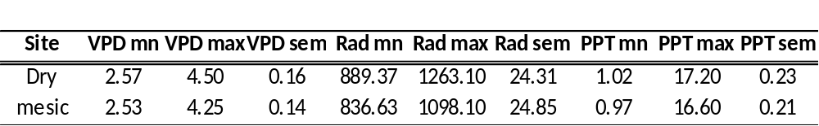
Soil Water
Methods
Changes in hillslope hydrology are anticipated as climate changes potentially redistributing water from upper slope (i.e., depleted water content) to toe slope positions. This redistribution process can be described in terms of variation in soil moisture content at various times throughout the soil profile. Soil water content is measured at each station, one on a shedding site and one on a receiving site. Soil-moisture retention curves are currently developed to determine the amount of water available for plant use within the root layer also referred to the available water storage capacity (AWSC). Field estimation of AWSC will be carried out by determination of repeated volumetric soil water content (θ) measured by capacitance techniques to 60 cm depth (ECH₂O-5 soil moisture probes by Decagon Devices Inc., Pullman, WA), which corresponds to the average depth of the rooting zone. ECH₂O-5 Soil moisture sensors will be installed horizontally at 5, 10, 20, 40 and 60 cm depths at each monitoring location. Soil specific calibration for ECH₂O-5 probes for different soil types are available to increase water content measurement accuracy at each site. Continuous monitoring of soil moisture is possible by connecting the sensors to Em50 data loggers (Decagon Devices Inc.). Field investigation of AWSC also requires complementary information about other soil properties including particle size, organic C content and bulk density. Particle-size distribution is determined from the fine soil fraction having a <2-mm diam. by the hydrometer method (Gee and Bauder 1986). At each sampling area, a soil description will be completed according to the methods outlined in the Field Manual for Describing Terrestrial Ecosystems (BC Ministry of Forests and BC Ministry of Environment, Lands and Parks 1998). Soil orders associated with this study are classified in accordance to the Canadian System of Soil Classification (Soil Classification Working Group 1998). Soil pH in 0.01 M CaCl2 (Kalra and Maynard 1991) and organic carbon content (loss on ignition method, Tiessen and Moir 1993) are to be determined to confirm and supplement field identification and classification.
Preliminary Results
This work has been delayed and data is currently undergoing analysis

2011 Field Work
In 2011 polygon level risk maps generated from the stand level risk mapping were used to randomly select polygons for sampling using GIS. Polygons selected were only rejected if access was difficult (e.g., > 500m from a driveable road) or the polygon is unsuitable based on site visitation (e.g., obviously not in correct risk class, polygon has been harvested, etc.). Rejection rate was <10% based on these criteria. In 2011 10 hybrid spruce (Picea engelmannii × glauca trees and 10 Douglas-fir at each of a High (Dry) and Low risk (Mesic) sites were selected and sampled. A Dry and a Mesic site were chosen in each of two BGC units, one in the SBSdw3 (Ft. St. James District) and the other in the SBSmk1 (Prince George District)

Data for Current Year Tree Vigour and Historical Drought Stress and soil water were collected as per the methods presented for 2010. Due to extremely high levels of seasonal precipitation at both sites total non structural carbohydrate sampling has been postponed until Fall of 2012. Samples are currently being analyzed for C13/C12 ratio at the University of Arizona. Based on the results of the 2010 pilot/methods study, data for total non structural carbohydrate, stable carbon isotope ratios and soil water characteristics are the key focus of the 2011protion of the field validation study.

RECOMMENDATIONS
The clients for the landscape component of the project are primarily those who are responsible for reducing the impacts of natural events including landslides, fire, and biological agents. The research outcomes will help them focus on what areas are of most future concern and what measures might be put in place to minimize the impacts. Harvesting priority decision makers may also find some of the work useful.
The clients for the stand level component are anyone making decisions on harvesting priority and tree species selection following harvest. Polygons that we predict to be at high to extreme risk of drought induced mortality should be given high priority for monitoring so appropriate management decisions can be made promptly. Mountain pine beetle impacted stands with understory species that we predict will have a high risk of mortality should be considered as higher priority harvest areas. Sites that cannot support trees based on our mapping could be considered for conversion to range land which would affect land use policy. Our projected tree species drought and frost risk will be incorporated in to the “Tree Species Selection Tool” currently being developed. Tree species selection relates to Forest Planning and Practices Regulation 16(4), 36(3), and 44. It is recommended that ASMR and associated Drought Risk Mapping be completed in more areas of the province and in particular drier hotter limits of BGC zones (e.g., xh and dh variants of the Interior Douglas-fir zone) where the limits of particular tree species will most likely be exceeded. Frost risk mapping should continue to be developed especially in areas where assisted migration is proposed as summer frosts will be one of the main factors limiting establishment success.

EXTENSION OF RESEARCH OUTCOMES
For the landscape component extension is in process with the clients mentioned above in the Recommendations Section. Further work is planned, as explained in the research outcomes, to increase the level of detail of the results. In the mean time, clients can directly request results in the form of data summaries, analysis spreadsheets, figures, and spatial layers from Vanessa Foord.
For the stand level component we are currently working on adaptation of practices relating to potential tree mortality related to climate change for City of Prince George and the Williams Lake TSA.

REFRENCES
Bansal. S. And M. Germino. 2009. Temporal variation of non-structural carbohydrates in montane conifers: similarities and differences among developing stages, species and environmental conditions. Tree Physiology 29:559-568.

Bland, J.M. and Kerry, M. 1998. Weighted comparison of means. British Medical Journal, 316: 129.

Carroll, A.L., Taylor, S.W., Régnière, J., and Safranyik, L. 2003. Effects of climate change on range expansion by the mountain pine beetle in British Columbia. In Mountain Pine Beetle Symposium: Challenges and Solutions, Shore, T.L., Brooks, J.E., and J.E. Stone (eds.). Natural Resources Canada, Canadian Forest Service, Pacific Forestry Centre, Information Report BC-X-399, pp. 223-232.
Chow P & Landhäusser SM 2004. A simplified method for measuring sugar and starch content in woody-plant tissues. Tree Physiol 24:1129–1136.
Dunn, J.P., T.W. Kimmerer, and D.A Potter. 1987. Winter starch reserves as a predictor of attack by the twolined chestnut borer, Agrilus bilieatus (Eber) (Coleoptera: Buprestidae). Oecologia (Berlin) 74:352-355.

Egginton, V.N. 2005. Historical climate variability from the instrumental record in northern British Columbia and its influence on slope stability. M.Sc. thesis. Simon Fraser University, Burnaby, BC.
Foord, V.N., Clague, J.J., and Jackson, P.L. In Progress. Regional temperature and precipitation trends in northern British Columbia, Canada. Submitted to Atmosphere-Ocean (under review).
Geertsema M, Clague JJ, Schwab JW, and Evans SG. 2006. An overview of recent large catastrophic landslides in northern British Columbia, Engineering Geology 83: 120-143.
Groisman, PY and Knight, RW. 2008. Prolonged Dry Episodes over the Conterminous United States: New Tendencies Emerging during the Last 40 Years. Journal of Climate, 21: 1850-1862.

Hogan, D.L. and Schwab, J.W. 1991. Meteorological conditions associated with hillslope failures on the Queen Charlotte Islands. Land Management Report No. 73, British Columbia Ministry of Forests, Victoria, BC.

Hogg EH. 1997. Temporal scaling of moisture and the forest–grassland boundary in western Canada. Agriculture and Forest Meteorology, 84: 115-122

Kalra, Y.P. and D.G. Maynard. 1991. Methods manual for forest soil and plant analysis. Forestry Canada, Northwest Region, Northern Forestry Centre. Information Report NOR-X-319, 116p.

Karl, T.R, Meehl, G.A, Miller, C.D., Hassol, S.J., Waple, A.M., and Murray, W.L (eds). 2008. Weather and Climate Extremes in a Changing Climate. Synthesis and Assessment Product 3.3, Report by the U.S. Climate Change Science Program and the Subcommittee on Global Change Research. Online at: http://downloads.climatescience.gov/sap/sap3-3/sap3-3-final-all.pdf

Magyari-Saska Zs, (2007), ArcGIS software module for calculating the S.P.I. value, Geographia
Technica, No. 2, Presa Universitară Clujeană, pp. 42-48.

McDowell, N., H. Barnard, B. J. Bond, T. Hinckly, R.M. Hubbard, H. Ishii, B. Kostner, F. Magnani, J.D. Marshal, F.C. Meinzer, N. Phillips, M.G. Ryan and D. Whitehead, 2002a. The relationship between tree height and leaf area:sapwood ratio. Oceologia 132:12 20.

McKee, T.B., Doesken, N.J., and Kleist, J. 1993. The relationship of drought frequency and duration of time scales. Eighth Conference on Applied Climatology, American Meteorological Society, Jan17-23, 1993, Anaheim CA, pp.179-186.

Mekis, E. and Hogg, W.D. 1999. Rehabilitation and analysis of Canadian daily precipitation time series. Atmosphere-Ocean, 37: 53-85.

Soil Classification Working Group. 1998. The Canadian System of Soil Classification. Agric. And Agri-Food Can. Publ. 1646 (Revised). pp187.

Stieglitz, M., Dery, S.J., Romanovsky, V.E., and Osterkamp, T.E. 2003. The role of snow cover in the warming of arctic permafrost. Geophysical Research Letters, 30(13): 54-57.

Tiessen, H. and J.O. Moir, 1993: Total and organic carbon. In: Soil sampling and methods of analysis. Carter, M.R. (ed.). Lewis Publishers, Boca Raton, FL. USA, pp. 187-199.

Vincent, L.A. and Gullet, D.W. 2002. Canadian historical and homogeneous temperature datasets for climate change analysis. International Journal of Climatology, 19: 1375-1388.

Wang, T., Hamann, A., Spittlehouse, D.L., and Aitken, S.N. 2006. Development of scale-free climate data for western Canada for use in resource management. International Journal of Climatology, 26: 383-397.

Wargo, P.M., K. Vogt, D. Vogt, Q. Holifield, J. Tilley, G. Lawrence and M. David. 2003. Vitality and chemistry of roots of red spruce in forest floors of stands with a gradient of soil Al/Ca ratios in the northeast United States. Can. J. For. Res. 33:635-652.

Woods, A., Coates, K.D., and Hamann, A. 2005. Is an unprecedented Dothistroma Needle Blight epidemic related to climate change? BioScience, 55: 761-769.
Zhang, X. And Yang, F. 2004. RClimDex (1.0) User Manual. Climate Research Branch, Environment Canada, Downsview, ON.

Herein defined as the difference between the amount of water in the soil at field capacity and the amount at the permanent wilting point)

