Guidance to Adapt Forest Management for Climate Change in the Southern Interior of BC.
May 7, 2012

Based on:
Validating Impacts, Exploring Vulnerabilities, and Developing Robust Adaptive Strategies under the Kamloops Future Forest Strategy (K2-2011) – Future Forest Ecosystems Scientific Council (FFESC) Interdisciplinary Climate Change Adaptation Research for Forest and Rangeland Ecosystems.
And
Adapting Forest Management in the Kamloops TSA to Address Climate Change – The Kamloops Future Forest Strategy (K1 – 2009)
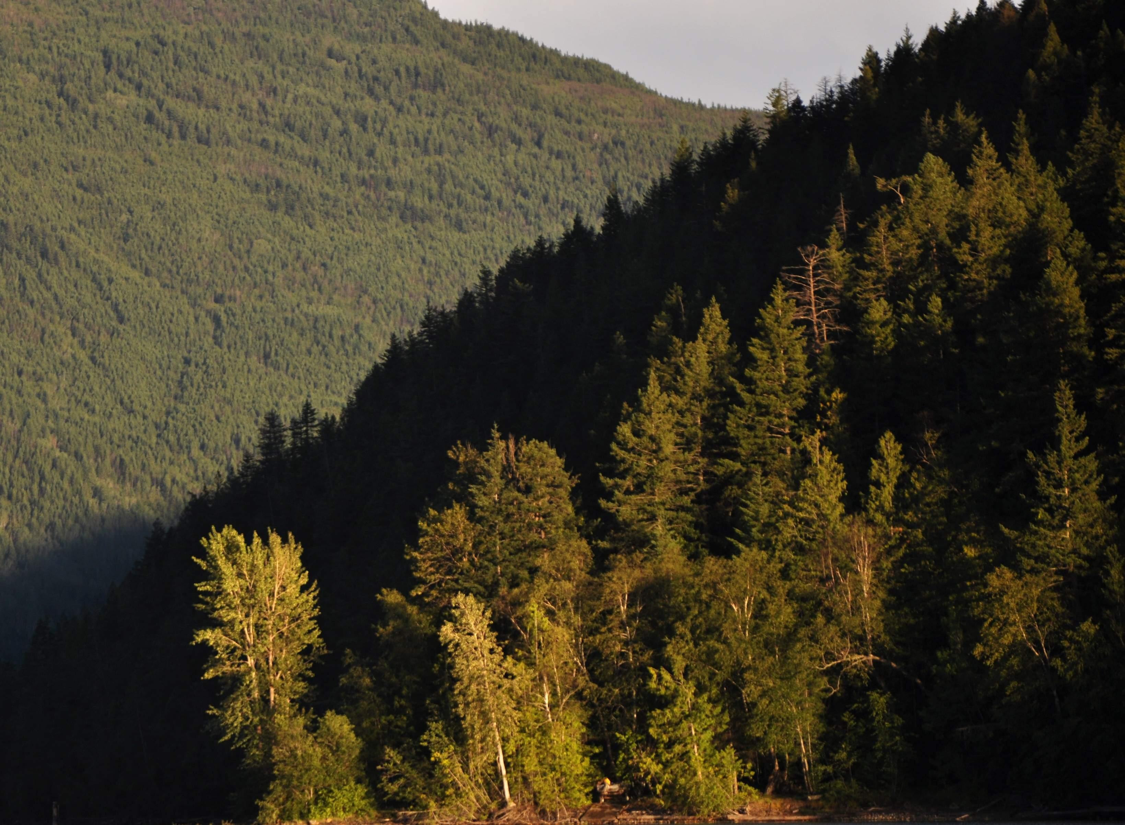
Forest Resources Management
University of British Columbia,
Symmetree Consulting Group Ltd.,
Forsite Consultants Ltd.

Authors:

Ken Zielke RPF – Symmetree Consulting Group, Vancouver BC – kzielke@symmetree.ca
Bryce Bancroft, RPBio - Symmetree Consulting Group, Victoria BC. BryceB@symmetree.ca
Dr Harry Nelson University of British Columbia, Vancouver BC - hnelson@forestryubc.ca
Dr Brad Seely University of British Columbia, Vancouver BC Brad.seely@ubc.ca
Laurie Kremsater RPBio Wildlife Biologist, Abbotsford BC - lkrem@shaw.ca
Cam Brown RPF Forsite Consulting, Salmon Arm BC - cbrown@forsite.ca
Dr Clive Welham University of British Columbia, Vancouver BC - clive.welham@ubc.ca
Michael Gerzon University of British Columbia - mgerzon@gmail.com
Reg Davis Forsite Consulting, Cranbrook BC – rdavis@forsite.ca
Dr Craig Nitschke University of Melbourne and University of BC –
craign@unimelb.edu.au

Special thanks to Ken Day RPF, Manager of the UBC Alex Fraser Research Forest for his review of this guidance.

Table of Contents
Background 4
Broad Forest Management Priorities for Climate Change. 5
Specific Management Recommendations by Ecozone 7
ECOZONE - Dry subzones dominated by Douglas fir and/or Ponderosa pine (e.g. PPxh, IDFxh): 7
ECOZONE - Dry subzones dominated by Lodgepole pine (e.g. IDFdk and MSxk) 11
Dry Transitional subzones (e.g. IDFmw, ICHdw) 16
ECOZONE - Moist transitional subzones (e.g. ICHmw, ICHmk) 20
ECOZONE - Plateau (e.g. MSdm, SBSmm) 24
ECOZONE - Wet Cold Engelmann Spruce / Subalpine Fir (e.g. ESSFwk) 28
APPENDIX 1 - General Description of the Kamloops Climate Change Adaptation Projects, Assumptions and Context 30
Project A – K1 30
Project B – K2 30
The Climate Change Context – K1 vs. K2 32
Other Important General Assumptions: 33
APPENDIX 2 - TRENDS PROJECTED BY K1 & K2 (COMPARED) WITH CLIMATE CHANGE 35
A COMPARISON OF GENERAL TRENDS NOTED BETWEEN K1 AND K2. 35
TRENDS BY ECOZONE 36
ECOZONE - Dry subzones dominated by Douglas fir and Ponderosa pine (e.g. PPxh, IDFxh): 36
ECOZONE - Dry subzones dominated by Lodgepole pine (e.g. IDFdk and MSxk) 38
ECOZONE - Dry Transitional subzones (e.g. IDFmw, ICHdw) 39
ECOZONE - Moist transitional subzones (e.g. ICHmw, ICHmk) 41
ECOZONE - Plateau (e.g. MSdm, SBSmm) 42
ECOZONE - Wet Cold Engelmann Spruce / Subalpine Fir Ecozones (e.g. ESSF) 44

Background
WHO IS THIS DOCUMENT FOR? – Operational Forest Managers developing (and/or approving) strategic and/or operational plans in the Southern Interior of BC.
INTENT – To provide initial guidance for a range of ecological units to assist operational planners with management planning and practices to reduce vulnerability to climate change. Specifically, the guidance provided here should be a starting point to help managers set strategic objectives and targets in the context of climate change for:
- Species preferences and stocking standards for regeneration;
- Strategic harvest planning to replace high risk stands with more resilient stands;
- Incremental silviculture;
- Managing increasing risk of stand replacing wildfires;
- Landscape level retention for biodiversity.
SOURCE - The following recommendations are based on two climate change adaptation projects completed in the Kamloops TSA from 2007 to 2011.
- For background information on the two projects and how they are related see APPENDIX 1.
- See APPENDIX 2 for an explanation of the rationale behind these recommendations. Note they are based on a comparison of projected trends from both projects (K1 and K2) using as a starting point the current business-as-usual strategies and practices.
NOTE REGARDING THE USE OF TERM “ECOZONES” - The following recommendations are suggested by “ecozones”. Biogeoclimatic subzones were amalgamated into ecozones based on their common ecological response to climate change across broad ecological landscapes, providing six ecozones in the Kamloops projects. These ecozones are each described for their broad characteristics so that recommendations can be transferred to other similar ecological units, and modified to fit with slightly different circumstances and conditions. This should be done with input from local ecologists.

Broad Forest Management Priorities for Climate Change.
The two climate change projects in Kamloops underscored the need to adjust forest management in a number of different areas. First and foremost, for many of the southern interior ecological landscapes (ecozones), we need to link species preferences at reforestation to identified vulnerabilities within the varying units. Changing the nature of our forest through reforestation will take a long time. Indeed in K2 we found that after a 100 year simulation period, alternate regeneration strategies had yet to affect sufficient area for a long enough period to significantly impact indicators related to maturing stand types. This highlights the importance of getting started right now.
A simple change that would increase resilience significantly would be to reduce our reliance on lodgepole pine for reforestation. In most subzones we need to stop the conversion of Douglas-fir and other non-pine stand types to lodgepole pine stands. The K2 modeling suggested that lodgepole will be significantly stressed in many of these ecozones (drier ecozones and dry sites in moist ecozones) and much more susceptible to mortality from a range of damaging agents. K2 also dramatically portrayed how much we might change our forested landscapes if we continue with our current pine-biased approach. Note that there are some data to suggest that planting preferences are moving away from pine in the last couple years. Regardless, we feel that it is critical to emphasize the importance of continuing to avoid a lodgepole pine bias for reforestation in a range of ecozones.
Harvesting should be strategically directed toward stand types that will be most vulnerable to impacts from drought, insects, disease and wildfire - allowing for reforestation to more resilient stand conditions. Currently we rarely use harvesting in BC to address these types of forest management issues. We currently target least costs stands with species and log product profiles valued in the marketplace. This strategy would likely require some form of incentive to motivate licensees to adjust their stand selection approach (within reasonable economic limits).
Incremental silviculture options (activities beyond “basic silviculture”) exist to help reduce risk of fires and convert non-resilient stands before they are lost. Depending on the management unit, these activities may also help to address current midterm timber supply challenges, and possibly prevent future timber falldowns.
A variety of silvicultural systems and retention approaches will be important as climate change continues. Partial cutting will be necessary in warm dry subzones to allow for reliable seedling establishment, and may be needed in cool dry subzones to protect seedlings from early or growing season frost damage. Increased retention levels (from stand to landscape) may be necessary to provide refugia and means for species to move as their habitats shift. A diversity of harvesting and regeneration approaches will help diversify stands to protect against extensive insect and disease outbreaks.
Some support work emerged from K2/K1 that will take several years to organize, gain support for, and implement. As a top priority the province needs a functional forest management planning process in every management unit that links desired strategic outcomes with operational practices that need to be implemented to achieve the outcomes. Such a process would: tie local landuse goals to anticipated forest conditions; formulate sound strategies with the best information and tools; link these strategies to clear tactical planning so that we know where, when, and what is going to happen over time; and monitor outcomes to measure progress. Without such planning much of what is suggested in this document will be difficult to implement in an integrated and adaptive fashion and therefore likely less effective over the long term
As part of such strategic planning it would be very helpful to build on the recent BC Fuel Hazard Assessment and Abatement Fire Risk Mapping and other fire risk mapping to: project risks over time with climate change; and to build in considerations of forest level, and not just stand level, consequences. Such mapping should be tied to wildfire management strategies that are linked to landscape and stand level retention strategies for biodiversity. In this way harvesting and other stand interventions can be planned along with retention and reserve networks to best reduce risks for a range of values.
Such strategic planning, in each management unit across the province, would also benefit from some ongoing climate change modeling (as in K2), perhaps in each geographic region (Coast, Southern Interior, Northern Interior) to continuously explore assumptions, uncertainties, and emerging questions for management. Other research questions would emerge from this planning – questions that could help focus research organization on the most pressing issues that might hamper implementation and allow managers to manage for a range of values in a changing climatic context.

Specific Management Recommendations by Ecozone

ECOZONE - Dry subzones dominated by Douglas-fir and/or Ponderosa pine (e.g. PPxh, IDFxh):
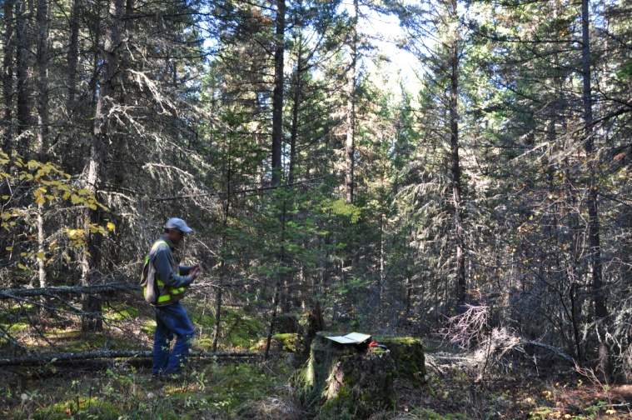 | 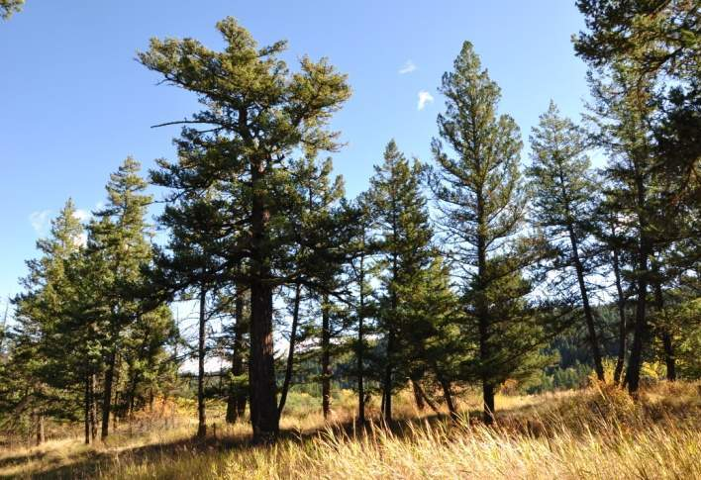
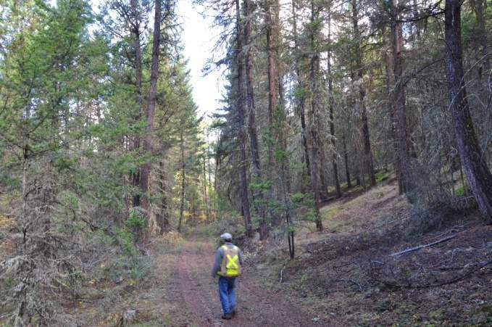 | 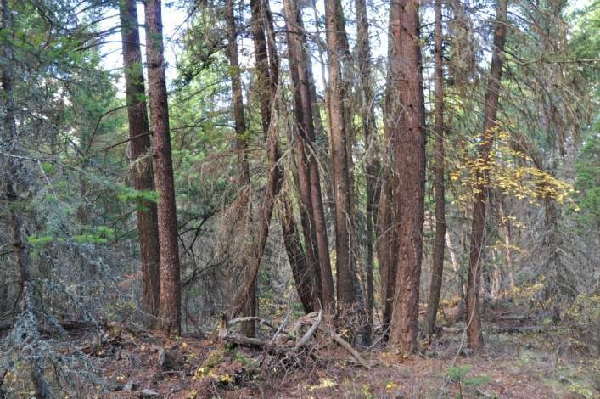

Ecological Notes:
- This ecozone includes subzones where Douglas-fir regenerates in its own understory on mesic sites, and growing season conditions are too dry for lodgepole pine. Ponderosa pine may be found on mesic or drier sites. Note that some trends and recommendations below may be relevant in similar more northerly subzones where ponderosa pine is not found. Work with local ecologists to apply accordingly.

REGENERATION STRATEGIES:

Increase the proportion of stocking in ponderosa pine.
- Include a proportion of ponderosa pine in strategic targets, and/or increase the species status for target stocking from acceptable to preferred as per the standard BC silvicultural survey and stocking methodology.
  - On drier-than-mesic sites - Increase ponderosa pine stocking to encourage ponderosa pine - Douglas-fir mixes – target a 50-50% ponderosa pine/ Douglas-fir mixture as a starting point, and look for appropriate opportunities to occasionally increase it.
  - On mesic sites - Increase ponderosa pine stocking to encourage Douglas-fir ponderosa pine mixed stands – target 25-30% of ponderosa pine as a starting point.

Maintain presence of trembling aspen at the landscape level.
- Avoid removal of aspen through brushing activities and through strategic use of stratification to provide stocking standards that include aspen as a preferred species in situations and circumstances where aspen is concentrated and will freely sprout from root suckers.
  - The intent is to maintain aspen as a source of vegetative reproduction in the future when regeneration from seed will be very challenging.

HARVESTING:
- Reduce fuels with commercial thinning and/or juvenile spacing (under a well designed fire management strategy), to reduce stand level moisture stress and fire risk by maintaining overall stand stocking at low (consider 10-14 m²/ha – on drier and high risk sites) to moderate (consider 14-18 m²/ha - mesic and moderate risk sites) levels.
  - These subzones may become increasing important for timber supply, and productivity is expected to remain reasonable. Yet they are also important for a range of other values and interests. It will therefore become increasingly important to reduce the risk of stand replacing fires to protect timber values, habitat, community safety and property.
  - However, silvicultural systems that maintain overstory cover using open low stocking will increasingly be important to allow for establishment and reduce moisture stress on individual trees over time. Silvicultural systems should be used to encourage an uneven-aged or irregular stand structure to provide ongoing shelter for understory trees, while servicing habitat and other values.
  - Stocking and structural goals suggested here should be discussed with a range of specialists and refined accordingly over time. Consult USA literature for Py/Fd from Montana and Southern Idaho, as these stand/climate combinations could provide examples of our potential future climates. Integrate with other values such as winter range.
  - Note that open overstories may require some repeated underburning at regular intervals to avoid re-establishment of overstocked understories. Work with experienced southern interior ecosystem restoration specialists to design the best approaches.

Over Time:
- Continuously improve and refine the range of partial-cutting options as overhead shade will increasingly become important for establishment.

Incremental Silviculture
- As recommended above (under harvesting), in Douglas-fir stands with high densities of small diameter trees, non economic for timber, reduce fuels and stocking with spacing (combined with commercial thinning where there is sufficient stocking in mid diameter and larger sizes classes available) to reduce fire risk and stand moisture stress.
  - Target high risk stands near communities and private property first.
  - Next target other high risk stands that are a priority for treatment on the timber harvesting landbase (THLB). As these forest types increase in extent, on the management unit, forest level risks for timber and habitat supply increase. Incremental funding may be targeted at reducing stocking in these stands, not just to address the significant fire risk, but also to fill an existing midterm timber supply gap. More importantly, it may help prevent a new timber supply problem further out. At the same time, it may help protect some critical habitats, property, lives, quality of life close to communities and possibly some rare or endangered species.
  - Involve silviculturists and wildlife biologists and ensure climate change context is considered.
  - Explore mechanisms with Branch specialists in Victoria to design special timber sales and other mechanisms to help facilitate the combination of commercial thinning and spacing, which currently seems challenging under our existing tenure and appraisal systems.

Other
- Update and refine recent fire risk mapping to determine the high risk areas within the TSA – now and with climate change.
- Update/design a fire management strategy that considers the climate change trends described in Appendix 2, and the treatments described above. Work with wildfire management Branch specialists and integrate with other objectives.
- Encourage researchers to investigate increased use and range expansion of ponderosa pine in the Southern Interior.
- Use a variety of silvicultural systems and partial cutting intensities to allow for establishment of regeneration across the range of sites over time. Support with appropriate incentives, monitoring, training and other support.
- Track amounts of old forest and make adjustments for OGMAs that may have burned or been affected by severe insect attacks. Consider stand types best suited to persist and recruitment of future OGMAs.
- Encourage researchers to investigate a broad use of lower overall stand stocking levels with partial cutting silvicultural systems to: encourage uneven-aged and irregular stand structures; lower stand level moisture stress; reduce fuels and fire risks in dry Douglas-fir / ponderosa pine stands. The current BC ecosystem restoration program and similar work conducted in the USA may be a helpful starting point.

ECOZONE - Dry subzones dominated by Lodgepole pine (e.g. IDFdk and MSxk)
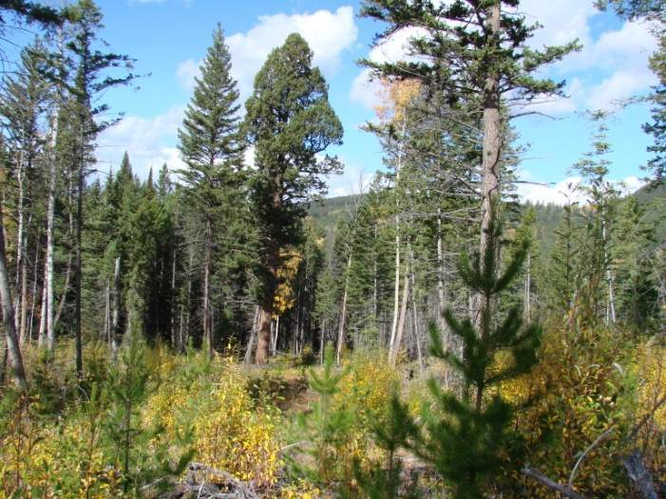 | 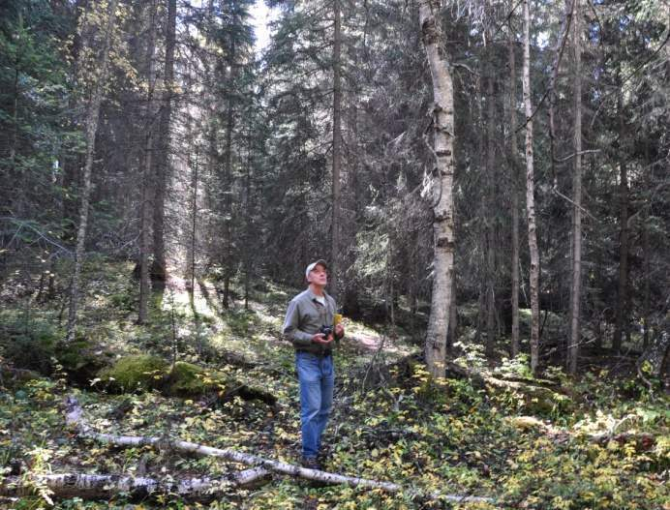
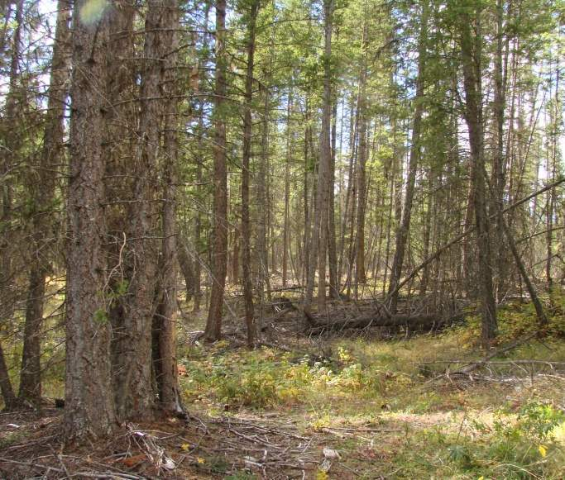 | 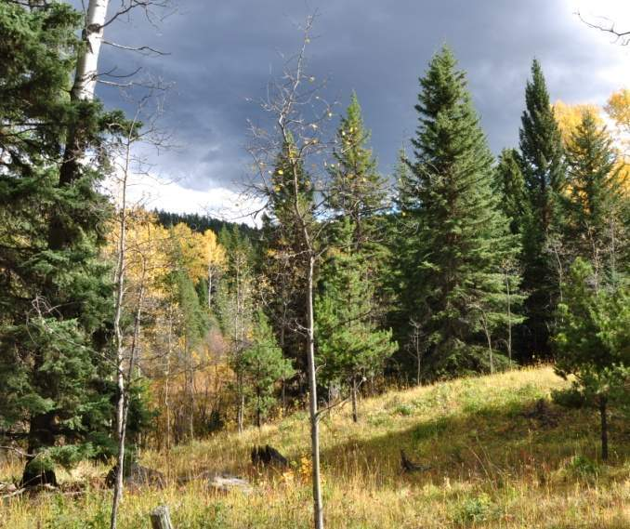

Ecological Notes:
- This ecozone includes subzones that are somewhat moister and/or cooler than the Dry Douglas-fir Ponderosa pine ecozone. Douglas-fir may still regenerate in its own understory on mesic and drier sites, however lodgepole pine also can be found either mixed in with Douglas-fir or in pure stands, although pine beetle has significantly reduced presence in mature stands. Aspen is much more abundant than in the Dry Douglas-fir/ponderosa pine ecozone, and spruce will be found on mesic and moister sites. In Kamloops the IDFdk was most typical of this ecozone.

REGENERATION STRATEGIES:

Avoid conversion of Douglas-fir stands and other non-pine stands to lodgepole pine.
For cutblocks that WERE NOT lodgepole pine leading stand types preharvest:
- Strategically limit lodgepole pine to be a minor stand component, and where possible avoid lodgepole pine altogether:
  - A simple approach, to facilitate this objective at the stand level, is to restrict lodgepole pine to “acceptable” rather than “preferred” status as per the BC silviculture survey methodology and associated approach to stocking standards.
  - Another approach is to restrict lodgepole pine to a maximum of 20-30% of the species composition for regeneration at the stand level and a lesser amount over the landscape. This may be more challenging to implement and control.
  - On sites that could experience growing season frost damage if clearcut, consider partial cutting silvicultural systems to help establish non-pine species.

In cutblocks that were pine-leading prior to harvesting - Avoid establishment of pure lodgepole pine stands, and encourage as much diversity as possible.
Accordingly, in cutblocks that WERE lodgepole pine leading stand types preharvest:
- Increase non-pine stocking to encourage greater stand diversity, as much as is practically possible.
  - First determine which stand/site combinations offer opportunities to increase stocking of other species. On some sites, in some subzones, few options may exist to establish anything other than lodgepole pine, as few other species are suitable and natural regeneration of lodgepole my dominate the site.
  - Set strategic targets for specific sites within these subzones and monitor over time. Where options are available to increase the proportion of non-pine species – a 25-30% stocking of Douglas-fir, ponderosa pine or spruce is a good starting target.
    - Consider Douglas-fir and/or spruce on mesic sites. Monitor spruce carefully for weevils and other insect pests.
    - Consider introduction of ponderosa pine on drier-than-mesic sites, in subzones deemed suitable. Mix in a small amount (e.g., 20%) and consider higher planted stocking when sufficiently comfortable with survival and maintenance of vigor over time.

Maintain presence of trembling aspen at the landscape level.
- Avoid removal of aspen through brushing activities and through strategic use of stratification to provide stocking standards that include aspen as a preferred species in situations and circumstances where aspen is concentrated and will freely sprout from root suckers.
  - As in the dry Douglas-fir/ponderosa pine, the intent is to maintain aspen as a source of vegetative reproduction in the future when regeneration from seed will be very challenging.

HARVESTING:
- Target stands more vulnerable to fire (with climate change) as a priority for harvesting, retaining those stands that are less vulnerable for future passes and other objectives.

Incremental Silviculture
- FERTILIZATION TO PROMOTE SHORT ROTATIONS ON EXISTING YOUNG PINE STANDS - Target young lodgepole pine stands that were too young/small to be damaged by mountain pine beetle in the recent epidemic possibly for multiple treatments over the next 20-40 years to cycle these stands quickly so that they may be harvested and replaced with a more resilient species mixture for the future climate.
  - NOTE – this may be an especially useful strategy in management units facing a midterm timber supply gap from the recent mountain pine beetle infestation.
  - The decision to use this practice will depend on projected forest conditions and the amount of area that presents this opportunity.
- FUEL MANAGEMENT AND DENSITY CONTROL – In appropriate high fire risk stands (for fire with climate change) reduce fuels and stocking with spacing, possibly combined commercial thinning to reduce wildfire risk and stand moisture stress.
  - Target high fire risk stands near communities and private property first.
  - Next target other high fire risk stands that are a priority for treatment on the THLB. As these forest types increase in extent on the management unit, forest level risks for timber and habitat supply increase. Incremental funding may be targeted at reducing stocking in these stands, not just to address the significant fire risk, but also to fill an existing midterm timber supply gap. More importantly, it may help prevent a new timber supply problem at some point in the future. At the same time, it may help protect some critical habitats, property, lives, quality of life close to communities and possibly some rare or endangered species. Involve silviculturists and wildlife biologists and ensure climate change context is considered.
  - Explore mechanisms with Branch specialists in Victoria to design special timber sales and other mechanisms to help facilitate the combination of commercial thinning and spacing, which currently seems challenging under our existing tenure and appraisal systems.

Other
- Update and refine recent fire risk mapping to determine the high risk areas within the TSA – now and with climate change.
- Update/design a fire management strategy that considers the climate change trends described in Appendix 2, and the treatments described above. Work with wildfire management Branch specialists and integrate with other objectives.
- Develop a retention strategy for biodiversity at a number of scales that considers climate change (or refine an existing one) to maintain and recruit acceptable levels of old forest habitats and attributes across this ecological landscape. This strategy must fit with the wildfire management strategy and be integrated into harvest planning over time. This strategy should become an evolving harvest/reserve strategy that frequently is revisited with the involvement of entomologists, habitat biologists and fire management specialists. The intent is to ensure we are reserving and recruiting old and mature stands on the landscape that have a better chance to persist to meet our management intent, while we are harvesting those stands that are more likely to incur high levels of mortality within the short term.

Dry Transitional subzones (e.g. IDFmw, ICHdw)
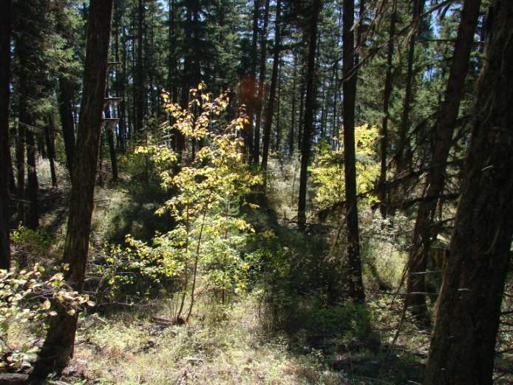 | 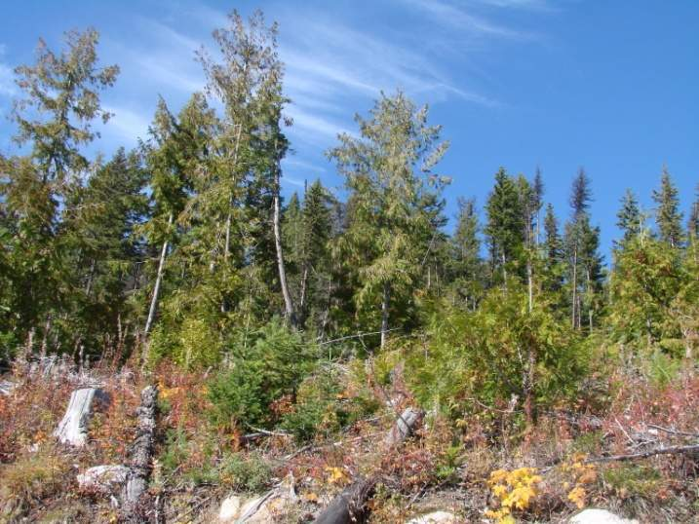
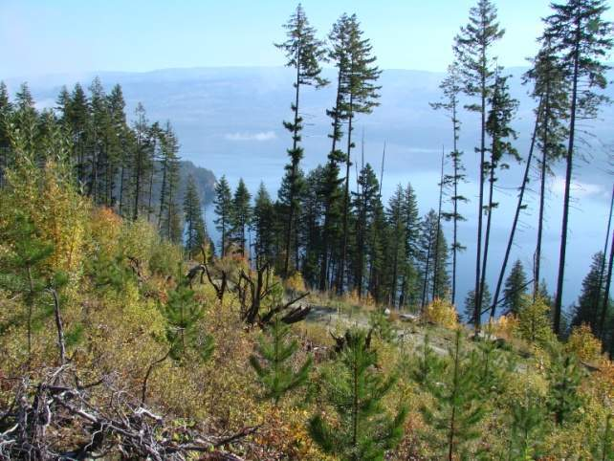 | 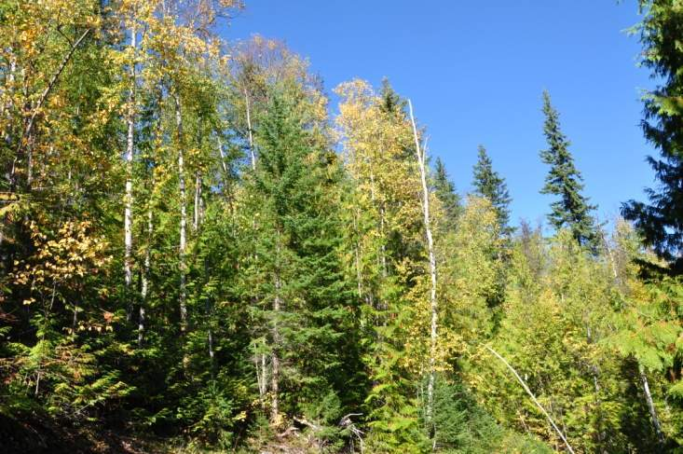

Ecological Notes:
- These are the subzones that are transitional from the Douglas-fir subzones to the western redcedar/western hemlock subzones. Douglas-fir may still regenerate in its own understory on dry sites with warm aspects, however generally there are more broadleaf species, much higher levels of root disease and an emerging presence of western redcedar, spruce and birch on mesic or moister sites.

REGENERATION STRATEGIES:

Avoid conversion of Douglas-fir stands and other non-pine stands to lodgepole pine.
For cutblocks that WERE NOT lodgepole pine leading stand types preharvest:
- Strategically limit lodgepole pine to be a minor stand component (and generally avoid lodgepole on drier-than-mesic sites).
  - A simple approach to facilitate this objective is to restrict lodgepole pine to “acceptable” rather than “preferred” status (BC silvicultural survey methodology and associated approach to stocking standards) in these stand units.
  - Another approach is to restrict lodgepole to a maximum of 20-30% of the species composition for regeneration at the stand level and a lesser amount over the landscape. This may be more challenging to implement and control.
  - On sites that could experience growing season frost damage if they were clearcut, consider partial cutting silvicultural systems.

In cutblocks that were lodgepole pine-leading prior to harvesting - Avoid establishment of pure lodgepole pine stands, and encourage as much diversity as possible.
Accordingly, in cutblocks that WERE lodgepole pine leading stand types preharvest:
- Increase non-pine stocking to encourage greater stand diversity – e.g., target a 25-30% stocking of Douglas-fir, ponderosa pine, western larch and/or white pine at the block level.
  - Set strategic targets for this group of subzones and monitor over time. Look for opportunities now and over time to increase these diversity targets where it makes ecological sense on the landscape. Work with local ecologists.
  - Introduce ponderosa pine (with Douglas-fir) on drier-than-mesic sites (possibly with some western larch). Mix in western larch and blister-rust resistant white pine (with Douglas-fir) on mesic and moister sites.
    - Where introducing a species that are “new” to this subzone, start with a small amount (20-30%) and consider higher planted stocking when sufficiently comfortable with survival and maintenance of vigor over time. See also the Chief Forester’s seed transfer guidelines.

Maintain presence of trembling aspen at the landscape level.
- Maintain concentrated patches of aspen through strategic use of stratification and stocking standards.
  - The intent is to maintain aspen as a source of vegetative reproduction in the future when regeneration from seed will be very challenging.

HARVESTING:
- Identify and target for harvesting in the short term (e.g., over the next 10 years) - mixedwood stands with an older Douglas-fir component that are at high risk of increased mortality (due to a number of factors) and possible transition to a non-economic status over time with climate change.
- Identify and target for harvesting in the midterm (e.g., over the next 20-40 years) – stands that are currently, or will be (with climate change) highly vulnerable to wildfire.
- Test, refine and continuously improve the range of partial-cutting options in drier-than-mesic stand types as overhead shade will increasingly become important for establishment.

Incremental Silviculture
- FERTILIZATION TO PROMOTE SHORT ROTATIONS ON EXISTING YOUNG PINE STANDS - Target young lodgepole pine stands (that were too young/small to be damaged by mountain pine beetle) for fertilization (perhaps multiple treatments) over the next 20-40 years to cycle these stands quickly so that they may be harvested and replaced with a more resilient species mixture for the future climate.
  - NOTE – this may be an especially useful strategy in management units facing a midterm timber supply gap from the recent mountain pine beetle infestation.
  - The decision to use this practice will depend on projected forest conditions and the amount of area that presents this opportunity.
- FUEL MANAGEMENT AND DENSITY CONTROL – In Douglas-fir dominated stands on drier sites where there is a high fire risk (considering climate change) reduce stocking through a combination of spacing and possibly commercial thinning to both reduce fuel loading and stand moisture stress. Explore mechanisms with Branch specialists in Victoria to design special timber sales and other mechanisms to make this possible.
  - Target high risk stands near communities and private property first.
  - Next target other high fire risk stands that are a priority for treatment on the THLB. As these forest types increase in extent on the management unit, forest level risks for timber and habitat supply increase. Incremental funding may be targeted at reducing stocking in these stands, not just to address the significant fire risk, but also to fill an existing midterm timber supply gap. More importantly, it may help prevent a new timber supply problem at some point in the future. At the same time, it may help protect some critical habitats, property, lives, quality of life close to communities and possibly some rare or endangered species. Involve silviculturists and wildlife biologists and ensure climate change context is considered.
  - Explore mechanisms with Branch specialists in Victoria to design special timber sales and other mechanisms to help facilitate the combination of commercial thinning and spacing, which currently seems challenging under our existing tenure and appraisal systems.
  - Note: There may be fewer opportunities for this treatment than in drier ecotypes.

Other
- Update and refine recent fire risk mapping to determine the high risk areas within the TSA – now and with climate change.
- Update/design a fire management strategy that considers the climate change trends described in Appendix 2, and the treatments described above. Work with wildfire management Branch specialists and integrate with other objectives.
- Encourage researchers to investigate increased use and range expansion of ponderosa pine in the Southern Interior.
- Encourage researchers to investigate a range of stand types and stocking levels to reduce fire risks.

Develop a retention strategy for biodiversity at a number of scales (or refine an existing one) to maintain and recruit acceptable levels of old forest habitats and attributes across this ecological landscape. This strategy should become an evolving harvest/reserve strategy that frequently is revisited with the involvement of entomologists, habitat biologists and fire management specialists. The intent is to ensure we are reserving and recruiting old and mature stands on the landscape that have a better chance to persist to meet our management intent, while we are harvesting those stands that are more likely to incur high levels of mortality within the short term.

ECOZONE - Moist transitional subzones (e.g. ICHmw, ICHmk)
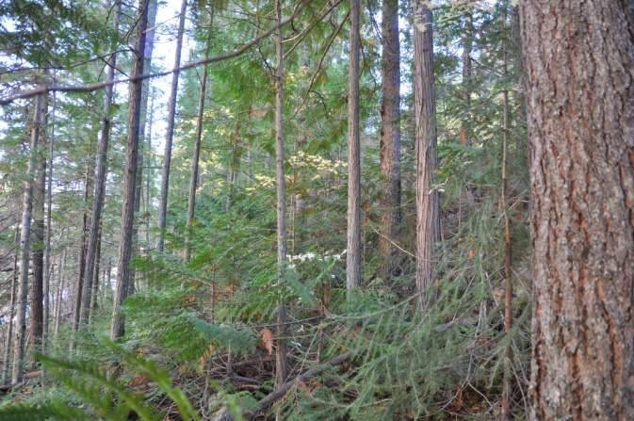 | 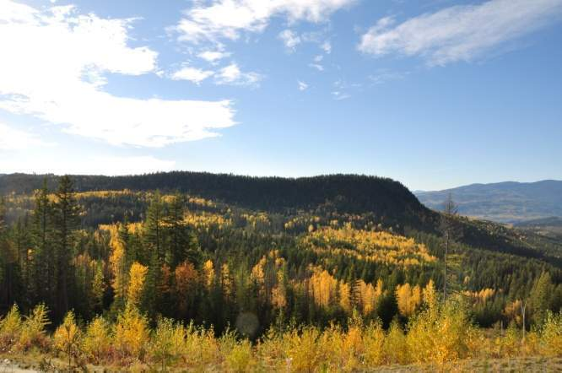
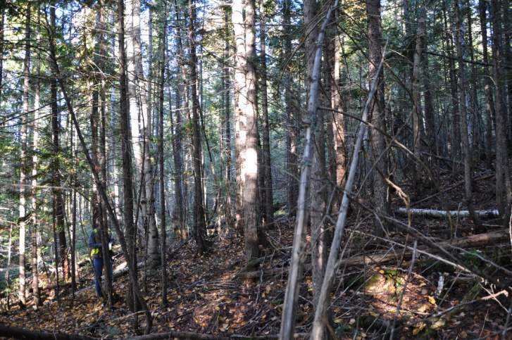 | 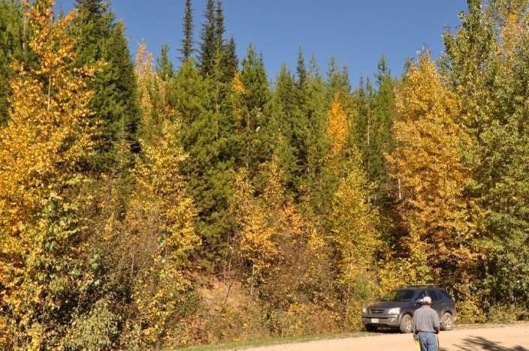

Ecological Notes:
- This ecozone includes moist subzones that tend to be transitional to the wet cool subzones (ICHvk and ICHwk) of the inland temperate rainforest.
- This transitional landscape has western redcedar and western hemlock as climatic climax species (similar to the inland rainforest). However, more widespread and common disturbance and edaphic conditions encourage a wider range of other seral species in this ecological landscape prompting more diversity than is found in the wetter, cooler inland rainforest.
- Moist, yet warm, growing seasons make this a very productive landscape.

REGENERATION STRATEGIES:

Avoid conversion of Douglas-fir and other non-pine stands to lodgepole pine .
For cutblocks that WERE NOT lodgepole pine leading stand types preharvest:
- Strategically limit lodgepole pine to be a minor stand component, and where possible avoid lodgepole pine altogether on submesic and/or other sites where lodgepole pine is currently favoured for regeneration.
  - A simple approach to facilitate this objective, at the stand level, is to restrict lodgepole pine to “acceptable” rather than “preferred” status as per the BC silviculture survey methodology and associated approach to stocking standards.
  - Another approach is to restrict lodgepole to a maximum of 20-30% of the species composition for regeneration at the stand level and a lesser amount over the landscape. This may be more challenging to implement and control.

Avoid creation of spruce leading stands on mesic and subhygric sites,

Mix in western redcedar and/or other species to reduce the proportion of spruce.

Further reduce reforestation with spruce over time (beyond 2025).

Encourage as much species diversity as possible across the landscape.

Encourage species mixtures by planting combinations of Douglas-fir, ponderosa pine, western larch and western white pine and lodgepole pine.
  - Set strategic targets for this group of subzones and monitor over time.
    - Look for opportunities over time to further increase diversity.
  - Target introduction of ponderosa pine on drier-than-mesic sites. Mix in a small amount (e.g., 20-25%) and consider higher planted stocking until sufficiently comfortable with survival and maintenance of vigor over time. Once comfortable with managing ponderosa pine in these subzones, consider increasing stocking in new plantations.
  - Target a broader use of western larch and/or blister rust resistant white pine as a component (25-40%) of stands on mesic sites.

Maintain presence of broadleaf species (trembling aspen and paper birch) at the landscape level.
- Maintain concentrated patches of aspen and birch through strategic use of stratification, and stocking standards (possibly with aspen as a preferred species).
  - The intent is to maintain aspen and birch as a source of vegetative reproduction in the future when regeneration from seed will be very challenging.
- Over time (e.g., over the next 10 years), consider strategic targets for establishment of broadleaf stands at the landscape level to fit with wildfire management and biodiversity landscape strategies while considering the future climate.

HARVESTING:
- Identify and target for harvesting in the short term (e.g., over the next 10 years) - mixedwood stands with an older Douglas-fir component that are at high risk of increasing mortality and possible transition to a non-economic status over time (with climate change).
- Identify and target for harvesting in the midterm (e.g., over the next 20-40 years) – stands that are currently, or will be (with climate change) at a high fire risk.

Incremental Silviculture
- Nothing specific for climate change adaptation.

Other
Over Time:
- Update and refine recent fire risk mapping to determine the high risk areas within the TSA – now and with climate change.
- Update/design a fire management strategy that considers the climate change trends described in Appendix 2, and the treatments described above. Work with wildfire management Branch specialists and integrate with other objectives.

Develop a retention strategy for biodiversity at a number of scales (or refine an existing one) to maintain and recruit acceptable levels of old forest habitats and attributes across this ecological landscape. This strategy should become an evolving harvest/reserve strategy that frequently is revisited with the involvement of entomologists, habitat biologists and fire management specialists. The intent is to ensure we are reserving and recruiting old and mature stands on the landscape that have a better chance to persist to meet our management intent, while we are harvesting those stands that are more likely to incur high levels of mortality within the short term.

ECOZONE - Plateau (e.g. MSdm, SBSmm and ESSFdc)
Note – in the K2 report this ecozone was frequently referred to as the “dry plateau”, which we find is a bit of a misnomer in light of the fact that relatively speaking it is much moister than the other ecozones that have the descriptor of “dry” in them. For this reason we will just refer to it as the plateau ecozone.
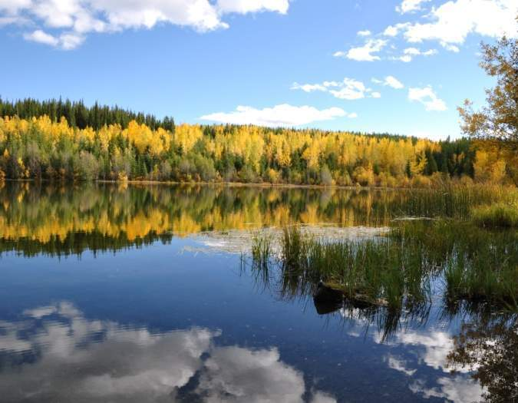 | 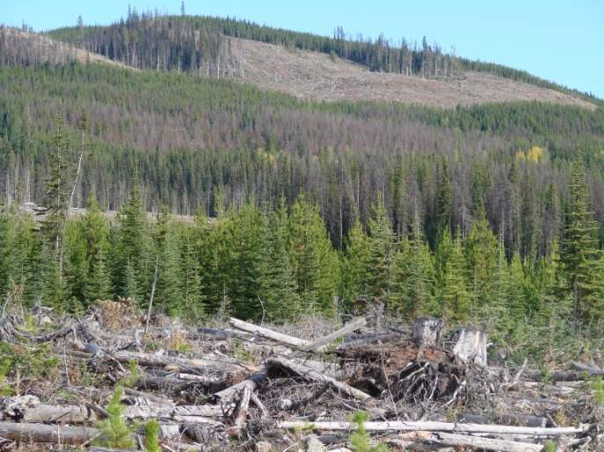
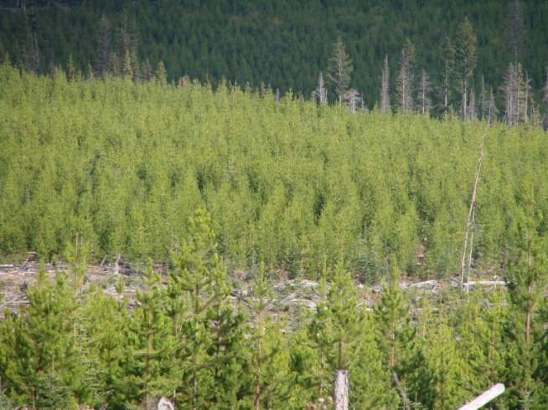 | 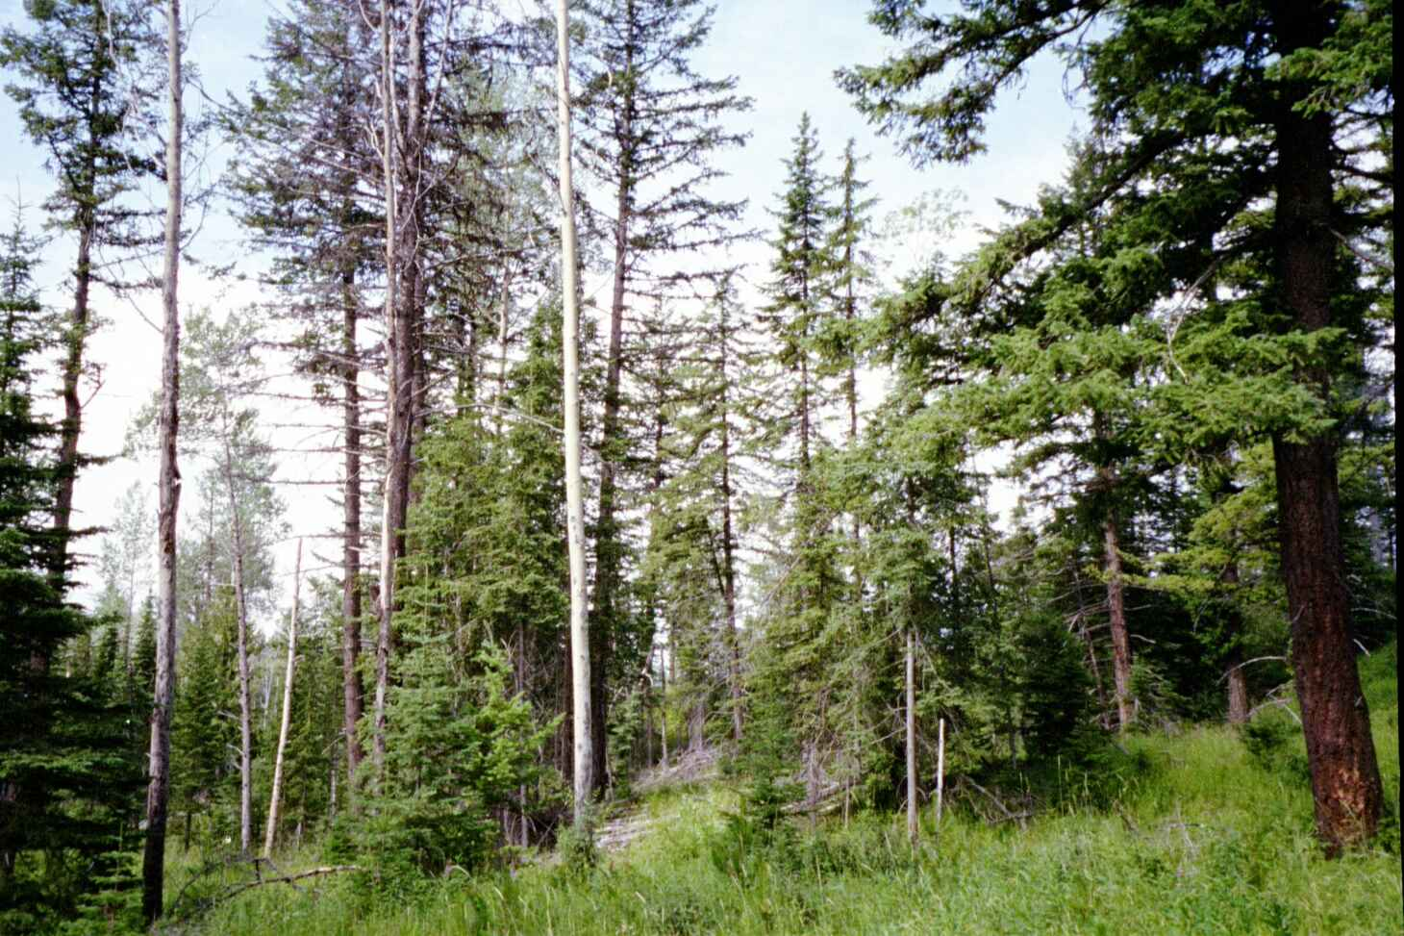

Ecological Notes:
- These are the moist but cool subzones that transition to moist, cold upper elevations.
- This landscape shares characteristics of both upper and lower elevations. Spruce and subalpine fir are common, but Douglas-fir can also be found especially at lower elevations.
- Lodgepole pine has a strong presence and may be more common than in upper, or even lower elevation ecosystems.

REGENERATION STRATEGIES:

Avoid conversion of non-pine stands (e.g., Douglas-fir and Spruce/Balsam stands) to lodgepole pine.
For cutblocks that WERE NOT lodgepole pine leading stand types preharvest:
- Strategically limit lodgepole pine to be a minor stand component, and where possible avoid lodgepole pine altogether:
  - A simple approach to facilitate this objective is to restrict lodgepole pine to “acceptable” rather than “preferred” status (BC silvicultural survey methodology and associated approach to stocking standards) in these stand units.
  - Another approach is to restrict lodgepole to a maximum of 20-30% of the species composition for regeneration at the stand level and a lesser amount over the landscape. This may be more challenging to implement and control.
  - On sites that could experience growing season frost damage if clearcut, consider partial cutting silvicultural systems.

Encourage tree species diversity as much as possible across the landscape.
- This may be accomplished with a diversity of stand types across the landscape and/or by increasing stand level diversity.
  - First determine which stand/site combinations offer opportunities to target for stocking mixtures at the stand level. On some sites options may be limited.
  - Set strategic targets for specific sites within these subzones and monitor over time.
  - Use historic ranges as a starting point. Look for opportunities over time to further increase diversity.
  - Target introduction of more Douglas-fir on suitable sites and stands at the lower end of these subzones where there is some chance for success. Growing season frosts may require use of overhead shelter with partial-cutting. Start with small targeted projects and work up from there.

Maintain presence of trembling aspen at the landscape level.
- Maintain concentrated patches of aspen through strategic use of stratification, and stocking standards (possibly with aspen as a preferred species).
  - The intent is to maintain aspen as a source of vegetative reproduction in the future when regeneration from seed will be very challenging.

HARVESTING:

Monitor old spruce/balsam dominated stands for increased moisture stress. As well, study/monitor climatic effects on bark beetle populations for local threats to older stand types, and the changing risk of fire in these landscapes. Design an evolving harvest/reserve strategy that frequently is revisited with the involvement of entomologists, habitat biologists and fire management specialists. The intent is to ensure we are reserving and recruiting old and mature stands on the landscape that have a better chance to persist to meet our management intent, and we are harvesting those stands that are more likely to incur high levels of mortality within the short term.

Incremental Silviculture
- FERTILIZATION TO PROMOTE SHORT ROTATION ON EXISTING YOUNG PINE STANDS - Target young lodgepole pine stands (that were too young/small to be damaged by mountain pine beetle in the recent epidemic) for fertilization (perhaps multiple treatments) over the next 20-40 years to cycle these stands quickly so that they may be harvested and replaced with a more resilient species mixture for the future climate.
  - NOTE – this may be an especially useful strategy in management units facing a midterm timber supply gap from the recent mountain pine beetle infestation.
  - The decision to use this practice will depend on projected forest conditions and the amount of area that presents this opportunity.

Other
Over Time:
- Update and refine recent fire risk mapping to determine the high risk areas within the TSA – now and with climate change.
- Update/design a fire management strategy that considers the climate change trends described in Appendix 2, and the treatments described above. Work with wildfire management Branch specialists and integrate with other objectives.
- Develop a retention strategy for biodiversity at a number of scales (or refine an existing one) to maintain and recruit acceptable levels of old forest habitats and attributes across this ecological landscape. This strategy must fit with the wildfire management strategy and be integrated into harvest planning over time.

ECOZONE - Wet Cold Engelmann Spruce / Subalpine Fir (e.g. ESSFwk)
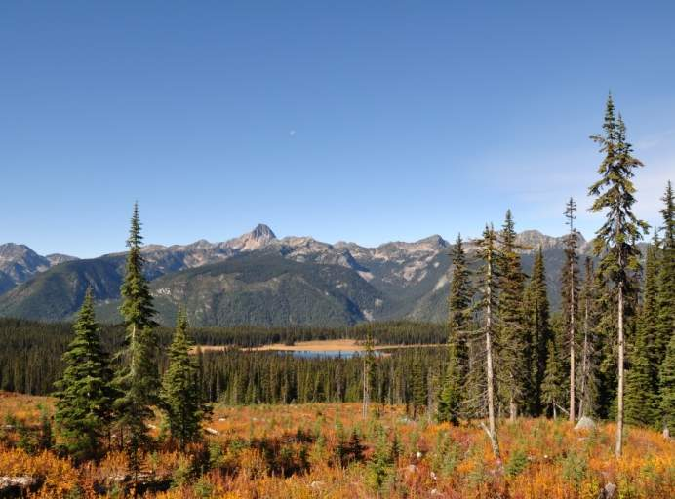 | 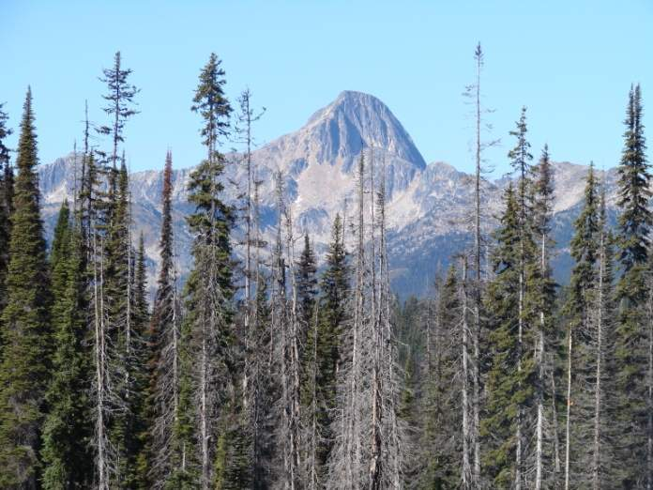
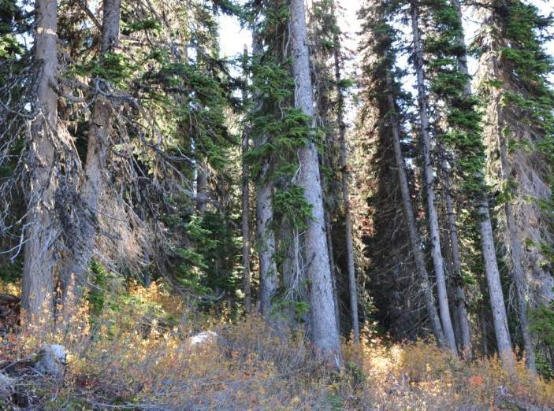 | 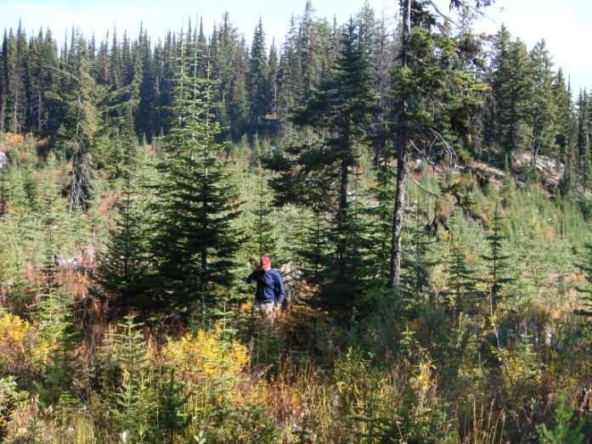

NOTE: K2 DID NOT MODEL THIS ECOZONE – RELIABLE CLIMATE STATION DATA WAS NOT AVAILABLE

Ecological Notes:
- These are the cold, wet subalpine forests in the BC Interior.
- These landscapes are dominated by Engelmann spruce and subalpine fir.
- Lodgepole pine is absent as it is heavily damaged by snow.
- NOTE – K1 INCLUDED THE COOL WET ICH IN THIS ECOZONE (ICHwk and ICHvk)

REGENERATION STRATEGIES:

Encourage tree species diversity as much as possible across the landscape.
- Spruce will continue to be a good choice for regeneration, although weevil problems could become evident over time at the lower elevations in this ecozone.
  - Therefore, look for opportunities to mix in western redcedar at lower elevations.

Conserve incursions of broadleaf species into this ecozone at lower elevations.
  - Over time with climate change, it is likely that aspen and birch will creep into the lower fringes of this ecozone (possibly beyond 2025). Protect and encourage these species as this occurs.

HARVESTING:
- Monitor old spruce and/or balsam stands for increased moisture stress and mortality (especially beyond 2025) – target these for harvesting before a bark beetle infestation. Work with regional entomologists on a strategy. Ensure it fits with a landscape level retention strategy for biodiversity.

Incremental Silviculture
- Nothing specific to climate change.

APPENDIX 1 - General Description of the Kamloops Climate Change Adaptation Projects, Assumptions and Context
Sustainable management of public forest lands requires a vision over time for the mix of structures, stands and landscapes to reasonably fit with multiple objectives and ecosystem processes. Global climate change challenges this vision with tremendous uncertainty. To address this challenge, a team of researchers from the University of British Columbia and consultants working with Symmetree Consulting Group explored forest management vulnerabilities and potential risks associated with future climate uncertainty on a highly diverse case study area, over 370,000 ha in size in the middle of the 2.7 million ha Kamloops TSA management unit in Southern British Columbia.

Project A – K1
The ultimate goal was to increase the understanding of potential climate change impacts on local forests, and design an adaptive strategy to improve resilience and reduce vulnerabilities. The team completed this using a range of global climate projections which informed opinion-based analysis using local experts and practitioners. Narratives of potential future forest conditions were crafted and initial adaptive strategies to improve resilience in key ecosystems were designed. This project has become known as K1.

Project B – K2
In a second project, dubbed K2, sensitivities and vulnerabilities from phase one were tested using scenario forecasting with a suite of computer models operating at a variety of spatial scales. The project is unique in that stand-level growth and development over time is driven by a tree species establishment model (TACA) and a ecosystem process model (FORECAST CLIMATE) that are both tied to a hydrological water balance model making them directly sensitive to changing climate conditions over time. From K2, the team gained valuable insights to enrich their narratives and refine the initial adaptive strategies. The summary of direction and trends reflects these insights as K2 is compared with the original projected trends and direction from K1.
The focus for the K2 modeling was on the implications of continuing throughout the next 100 years with current practices, known as the business-as-usual (BAU) scenario. TSR-type timber harvesting assumptions and silviculture practice, as reflected by recent provincial RESULTS data were modelled forward for this analysis. The intent was to better understand the impacts of BAU on future forest values. One alternate scenario, where planted species mixtures were diversified (with other species mixed in at a reasonable rate) was modelled to test whether species modifications would show improved conditions within the modeling time frame. As an outcome of the project it was noted that many more scenarios and sensitivities could be run, as numerous questions arise when analyzing the modeling outputs.
For more information about the project, see the webpage: http://k2kamloopstsa.com
WARNING ABOUT IMPLIED CERTAINTY, PRECISION AND ACCURACY – Throughout this document terms such as “will” and “will not” are used to indicate trends in forest conditions and processes under a moderate-to-pessimistic view of climate change (moderate to high degree of carbon emissions). These conditions and process changes have considerable uncertainty and could be “better” or even “worse” than described. The description however allows managers one reasonable glimpse of how significant the change in future conditions could be, so that we can start to address the vulnerabilities in our forests today.
The increases and decreases in area impacted, productivity, stress and volumes are reported in this document as precise numbers. This allows for a useful comparison between ecozones. The precision by which these trends are reported should not be assumed to be “accurate” forecasts – see comments related to uncertainty above. This focus on precision over accuracy is a necessary attribute of modeling for climate change with an uncertain future.

The Climate Change Context – K1 vs. K2
It is important to consider that the “worst case” or “high change” carbon emission scenario (A1B) driving the global climate change data in K2 is significantly less “worst case” or less “high change” than other scenarios that could have been chosen. The A1B represents a future where, although economic and population growth is rapid, energy use is balanced across all sources, both fossil and non-fossil fuels (IPCC 2000). The A1FI scenario was used as the “highest change” or “worst case” in K1. It represents a similar rapid growth scenario but with a fossil fuel intensive approach to energy use. Indications are that we are currently on a trajectory with much higher carbon emissions than the A1B scenario and even greater than those projected with the A1FI scenario – which implies greater climate change than was modelled in K2.

Key Points:
- Results from K2 modelling based on the climate inputs used reflect a future that, while it is different than today, many would consider it to be overly “optimistic” compared with K1.
  - It has been shown that if we continue on the climate trajectory we are currently on (in 2011), climate change will be more severe than was modelled in either K1 or K2.

Other Important General Assumptions:
FIRE - the amount of area burned within specific ecogroups was increased proportionally by adjusting fire return intervals from the Biodiversity Guidebook to account for the climate change scenarios used in the K2 project (Nitschke and Innes 2007, 2008b). Past historical fire patterns were used to determine the baseline area and distribution of fires as a baseline. The assumptions for this work were relatively rough and could be significantly improved over time.
HARVESTING – Unlike TSR, harvesting was only modelled over the 100 year simulation period rather than using a much longer timeframe to determine the level where harvest rates and growing stock balance. As growing stock in the K2 modelling is showing a slight decline over the modelling period, it is suspected that the harvest rate is above that which would be sustainable.
INSECT OUTBREAKS – As we know with mountain pine beetle, surprise episodic insect outbreaks can have a large impact on the forest growing stock, composition and structure. Though expected to increase with climate change, K2 could not anticipate and model such surprise events, although some increases in mortality rates were made where it was expected that increased moisture stress would trigger such an increase with insects and disease. The team suspects that the mortality assumed by the model may underestimate what will occur and that more work needs to be done in this area.
REGENERATION – Because the modelling was calibrated locally, based on weather station data, and these stations are in open conditions, regeneration results were based on open clearcut conditions. In many of the drier zones, as regeneration success dropped with the modelled drier summer conditions, presumably a switch to partial-cutting with some overhead shelter would occur allowing for greater regeneration success. This was not modelled.

APPENDIX 2 - TRENDS PROJECTED BY K1 & K2 (COMPARED) WITH CLIMATE CHANGE

A COMPARISON OF GENERAL TRENDS NOTED BETWEEN K1 AND K2.
Much of what was found as broad trends by the K2 modelling, was predicted to a certain extent with K1 expert opinion. However, there were some differences in the output from the two projects that are noteworthy. These differences underline the benefit of following an expert-driven process with a more comprehensive and robust modelling approach.
The most noticeable difference in the two projects is that K2 reported trends with a level of precision not used in K1. K1 generally used broad terms like “significant impact”, “significant increase”, and large decrease. As a modelling exercise, K2 reported trends in precise quantitative terms. This does not imply a greater accuracy (as noted in Appendix 1), but it helps compare ecological units relative to one another in a way that was difficult with expert opinion alone.
As a modelling exercise with ecosystem process models, K2 also was able to report trends that could not be envisioned by expert opinion. For example, K2 used a transpiration deficit index in its stand level modelling to report out on moisture stress in different stand types. This was especially helpful to project increased susceptibility across ecozones to mortality from drought, insects and pathogens.
K2 also was able to project and display the impacts of climate change on stand replacing wildfire disturbance and the resulting forest conditions. K2 showed variable disturbance levels of fire disturbance over time. Some ecozones showed higher levels of fire disturbance than expected from expert opinion in K1. For example, the moist transition ecozone showed much higher levels of disturbance than the dry lodgepole pine (Douglas-fir) ecozone, possibly due to the higher potential fuel loads present in the moist transitional ecozone as it enters a warmer drier climate with a longer, more severe fire season. Overall, K2 found that the high levels of disturbance due to wildfire and harvesting encourage an age class distribution across the case study area that by 2110 is highly concentrated in stands less than 80 years old, setting the stage for a serious timber supply falldown in the 22nd century.
Yet, K2 was more optimistic than K1 regarding the impact of future climates on timber volume production. This may be due in part to the less pessimistic climate scenario. But also the dramatic declines in productivity anticipated by K1 due to a hotter drier growing season were somewhat offset in our K2 modelling by an extended growing season with warmer moister conditions in the spring and fall. While K1 expected a contraction of the Timber Harvesting Landbase (THLB) in the drier subzones with climate change, this was not evident from the K2 output.
Lastly, as a modelling exercise, K2 was able to highlight the problems associated with current regeneration strategies that favour lodgepole pine in many of the ecozones. Under current practice many non-pine stands in the TSA will be converted to lodgepole pine over the next 50-60 years with these strategies. This has dramatic implications for management under climate change in some of these ecozones where pine will be in a less favourable climate than it is adapted to.
Note: We determined “current practice” based on 10-year average rates of establishment from the provincial database for the 21 stand types we used in our project. Recent comparisons between harvest volume billed, previous stand types and area planted in the Kamloops TSA suggests that the trends suggested in this project are starting to change and fewer stand conversions are occurring. We emphasize this issue to underline the importance of minimizing future conversions to lodgepole pine.

TRENDS BY ECOZONE
WARNING – Trends and output are described in the ecozones that follow using precise amounts. This does not mean these are accurate, considering the uncertainty associated with climate change – see the second page of Appendix 1.
The following trends are suggested by “ecozones” for the period beyond 2065 using current practices in the Kamloops TSA under a climate change scenario that many would suggest is “optimistic” (see Appendix 1). Biogeoclimatic subzones were amalgamated (as indicated below) to simplify reporting. The grouping into “ecozones” was done based on a common ecological response to climate change across a broad ecological landscape. This provided us with six ecozones for the Kamloops TSA.
The approach below is to report out on trends emerging from K2 with comparisons back to K1.

ECOZONE - Dry subzones dominated by Douglas-fir and Ponderosa pine (e.g. PPxh, IDFxh):

Regeneration beyond 2065 with climate change:
- K2- Trembling aspen will not regenerate in open conditions and will be confined to partial shade and/or edges of existing stands.
  - Similar to what was projected in K1
- K2- Douglas fir regeneration becomes rare or infrequent in the open and is absent on dry sites over time (except in partial shade and/or edges of existing stands).
  - Similar to what was projected in K1
- K2- Ponderosa pine has fairly frequent regeneration success except on the driest sites, where some shade during the heat of the day may be necessary.
  - An adaptive management scenario with Fd planting reduced from 65% to 35% and replaced with Py showed increased productivity.
  - Similar to what was projected in K1

Stand stress beyond 2065 with climate change
- K2 - There will be high levels of stress in an increasing number of stands.
  - Roughly 9%-10% of the THLB will have stands with high moisture stress throughout (compared to negligible area of high stress stands without climate change).
  - Roughly 25-38% of stands with a Douglas-fir component with have high levels of stress in the Fd.
  - K2 modelling suggested the area in stressed stands would continuously increase for the next 70 years but will taper off somewhat afterwards for two reasons - water-stress induced mortality will open up these stands enough that competition for moisture will lessen, and stands regenerated beyond 2035 will be increasingly more open since the model assumes clearcut conditions for regeneration.
  - With partial-cutting (that will likely occur), regeneration will likely be more successful possibly maintaining higher stocking – without stand density interventions stress levels could remain high.
- K2 - Water-stress induced mortality – about a 25% increase (over normal) in 2060 to 100% increase by 2080.
  - Greater numbers of large snags (> 30 cm) and logs.
- K1 – Generally suggested the same as the above, but with less precision.

Fire and other natural disturbances beyond 2065 with climate change
- K2 - Fire disturbance –area burned between 2065 and 2110 will see a large increase by 167% compared to average area burned with no climate change.
- K1 suggests more mortality from tussock moth and budworm (at least up to 2060).
  - K2 - This was difficult to include in modeling. It may provide more mortality in episodic events which we did not model.

Forest Structure and productivity beyond 2065 with climate change
- K2 - Disturbance will encourage a much greater proportion of area in age classes less than 80 years old (roughly two thirds of the ecozone) by 2110.
- K2 – Ponderosa pine will likely increase as a proportion of species in this ecozone, but Douglas-fir will remain strong.
- Both K2 and K1 suggest - After stand replacing disturbances, hot drier conditions may see much more open and patchy stands with longer regeneration delays.
- K2 – Showed increased productivity in the next 50 years especially from young stands (0-50 years old) mostly due to an expanded growing season.
- K2 -Beyond 2065 (especially) – the impact of climate change is negative on stand productivity (mostly due to summer drought, even though this effect is somewhat buffered by an expanded growing season).
  - However, the K2 modeling is assuming that stands are clearcut and planted contributing to a gradual reduction in densities (poor survival) beyond 2035. This presumably wouldn’t happen if partial-cutting was employed – so the drop may not be as significant.
  - Note that the expanded growing season (favourable shoulder spring/fall conditions) favour increases in younger stands mostly. Such productivity gains declined with stands older than 50.
  - No increase in volume production was noted for stands that are > 80years old in 2012.
- K1 suggested that the THLB would shrink significantly due to a much more pessimistic view of reduced productivity and volume production – this was not supported by K2 modelling – while volume production was declining in the latter part of the next 100 years, it did not contribute to a reduction in THLB.

ECOZONE - Dry subzones dominated by Lodgepole pine (e.g. IDFdk and MSxk)

Regeneration beyond 2065 with climate change:
- K2- Trembling aspen will not regenerate without partial shade and/or the influence of edges of existing stands.
- K2- Douglas-fir and lodgepole pine will regenerate frequently on mesic or moister sites.
- K2- Douglas-fir regeneration success will be reduced and lodgepole pine will be absent on drier sites.
- K1 – Generally suggested the same as the above, but with less precision.

Stand stress beyond 2065 with climate change
- K2 – Moisture stress over time will generally increase by about 30%. Roughly 38%-45% of the THLB will have stands with high moisture stress throughout (compared to relatively little area of high stress stands without climate change). This is projected to lessen considerably by 2080-2100 since the increase in water-stress induced mortality will open up these stands enough that competition for moisture will lessen.
  - Note – lodgepole pine stands may be especially stressed.
  - Also note – that the model is assuming clearcutting with reduced survival.
- K2 - Water-stress induced mortality – about a 50% increase (over normal) in 2060 to 2080.
  - Greater numbers of large snags (> 30 cm) and logs.
- K1 – Generally suggested the same as the above, but with less precision.

Fire and other natural disturbances beyond 2065 with climate change
- K2 - Fire disturbance –area burned between 2065 and 2110 will see a moderate but significant increase by 77% compared to average area burned with no climate change.
  - K1 assumed more fire disturbance than projected by K2.
- K1 suggests gappy mortality from tussock moth, budworm and bark beetles.
  - K2 - episodic events were not modeled in K2 (and it could be significant), however some increased background insect mortality with increased moisture stress was added.

Forest Structure and productivity beyond 2065 with climate change
- K2 - Disturbance will see much higher proportion of younger stands (<80 years old) moving from only 31% (currently) to 64% by 2100.
- K2 – by 2065 the component of Pl-leading stands in the THLB will increase by over 100% to comprise 42% of the THLB in this landscape using the business-as-usual approach which favours lodgepole pine for regeneration. It will decline beyond this point as survival of Pl will decline.
- K2- volume production in stands less than 40 years old at the start of the simulation were positively impacted by climate change after 50 and 100 years of growth.
- K2- Future natural stands dominated by Douglas-fir show an increase in productivity from 30-40% at age 100 despite small drops in density of stands initiated post 2035.
- K2 – managed stands show declining productivity as overall densities drop in Pl stands (to 27% by 2035 and to 0 by 2065) and in Douglas-fir stands (to 68% in 2035 and 63% in 2065)
  - However, the K2 modeling is assuming that stands are clearcut and planted contributing to a gradual reduction in densities (poor survival) beyond 2035. This presumably wouldn’t happen if partial-cutting was employed in Douglas-fir stands and if planting of pine was phased out as survival become poor.
  - Note that the increase in productivity is due to an expanded growing season (favourable shoulder spring/fall conditions) and improved soil fertility.
  - No increase in volume production was noted for stands that are > 80years old in 2012.
- K1 suggested that the THLB would shrink significantly due to a much more pessimistic view of reduced productivity and volume production – this was not supported by K2 modelling – while volume production was declining in the latter part of the next 100 years, it did not contribute to a reduction in THLB.

ECOZONE - Dry Transitional subzones (e.g. IDFmw, ICHdw)

Regeneration beyond 2065 with climate change:
- K2- The regeneration success of trembling aspen, paper birch, and spruce is reduced by 1/3 from the current time period in open conditions.
- K2- Douglas-fir, lodgepole pine, and ponderosa pine regeneration success is slightly lower than the current time period in open conditions – some partial shade will help.
- K2 - In submesic stand types where regeneration was switched from 75/25 (Fd/Pli) to 50/50 Fd/Py, volume production was increased substantially when grown over 50 years due to better survival. Improvements in productivity for such a switch steadily increased for stands established beyond 2035 and closer to 2065.
- K1 – Generally suggested the same as the above, but with less precision.

Stand stress beyond 2065 with climate change
- K2 – Moisture stress over time will generally increase by about 25-50% depending on the year. Roughly 30% of the THLB will have stands with high moisture stress (compared to relatively little area of high stress stands without climate change). This is projected to lessen somewhat by 2080-2100 since the increase in water-stress induced mortality will open up these stands enough that competition for moisture will lessen.
  - Note – lodgepole pine may be especially stressed.
  - Also note – that the model is assuming clearcutting with reduced survival.
- K2 - Water-stress induced mortality – about a 50% increase (over normal) in 2060 to 2080.
  - Greater numbers of large snags (> 30 cm) and logs.
- K1 – Generally suggested the same as the above, but with less precision.

Fire and other natural disturbances beyond 2065 with climate change
- K2 - Fire disturbance –area burned between 2065 and 2110 will see a large increase by 149% compared to average area burned with no climate change.
- K1 suggests significant mortality from a combination of drought, root disease and bark beetles.
  - K2 - incorporated increased background insect/disease mortality with increased moisture stress. It is quite possible that not enough mortality was factored in especially for successive drought years. Also, episodic outbreaks of concentrated mortality were not factored in.

Forest Structure and productivity beyond 2065 with climate change
- K2 - Disturbance will see much higher proportion of younger stands (<80 years old) moving from only 32% (currently) to 80% by 2100.
- K2 – by 2065 the component of Pl-leading stands in the THLB will increase by over 600% to comprise 36% of the THLB in this landscape (compared to 5% currently) using the business-as-usual approach which favours lodgepole pine for regeneration.
- K2- volume production in stands less than 40 years old at the start of the simulation showed modestly positive impacts from climate change over the 100 years.
- K2- volume production in stands more than 80 years old at the start of the simulation showed a slightly negative response to climate change due to increased mortality rates associated with elevated moisture stress and associated other mortality agents.
- K2 – Paper birch suffered higher rates of mortality in stands established pre-2011 than other species and tended to decline in most stand units.
  - Stands establishing after 2011 showed even greater declines due to problems with regeneration survival.
- K2-The submesic stand unit (Fd75/ Pl 25) showed the highest rates of mortality and suffered the greatest decline in productivity (up to a 50% decline) over the simulation.
- K2 -Productivity declines are evident in stands established between 2035 and 2065 (-7%) and beyond 2065 (-18%)
  - However, the K2 modeling is assuming that stands are clearcut and planted contributing to a gradual reduction in densities (poor survival) beyond 2035. This may not happen if partial-cutting was employed in suitable stands (such as Douglas-fir dominated stands) and if planting of pine was phased out as survival become poor.
  - For stands > 80years old in 2012 there may be a small negative impact from climate change. However both background and episodic cumulative impacts from insects and disease may take a greater toll than expected.
- K1 suggested that the THLB would shrink due to a loss of economic timber over time in current mixedwood stands from a combination of drought, insects and disease.
  - K2 modeling was not able to test this hypothesis specifically. The lessons from K2 still support the basis for this concern.

ECOZONE - Moist transitional subzones (e.g. ICHmw, ICHmk)

Regeneration beyond 2065 with climate change:
- K2- Paper birch regeneration success is cut in half and spruce is struggling.
- K2- Douglas-fir and lodgepole pine regeneration success are one third to one half of Period 1 (2011-2035) in mesic –submesic soil types in open conditions. Some shading may help with Douglas-fir on these sites.

Stand stress beyond 2065 with climate change
- K2 – Moisture stress over time will generally increase by about 20-50% depending on the year. Roughly 46-52% of the THLB will have stands with high moisture stress (compared to 1-5% area of high stress stands in the absence of climate change). This is projected to level off a bit by 2080-2100 since the increase in water-stress induced mortality will open up these stands so that competition for moisture may lessen.
  - Both lodgepole pine and Douglas-fir stands components may see an increase in stress by a magnitude of 5-10 times with climate change.
    - Pl will be particularly vulnerable on submesic sites.
  - Spruce may be vulnerable to water stress on both mesic and subhygric sites.
- K2 - Water-stress induced mortality – about a 100% increase (over normal) in 2060 to 2080.
  - Double the numbers of large snags (> 30 cm) and logs.
- K1 – Generally suggested the same as the above, but with less precision.

Fire and other natural disturbances beyond 2065 with climate change
- K2 - Fire disturbance –area burned between 2065 and 2110 will see a large increase by 162% compared to average area burned with no climate change.
  - K1 – expected some increased fire, but not such a large increase.
- K1 assumed that the significant mortality from drought, root disease and bark beetles expected in the dry transition would not be noticeable in the moist transition until after 2050.
  - K2 - incorporated increased background insect/disease mortality with increased moisture stress. It is quite possible that not enough mortality was factored in especially for successive drought years. Also, episodic outbreaks of concentrated mortality were not factored in.

Forest Structure and productivity beyond 2065 with climate change
- K2 - Disturbance will see much higher proportion of younger stands (<80 years old) moving from only 40% (currently) to 85% by 2110.
- K2 – by 2065 the component of Pl-leading stands in the THLB will increase by 260%, using the current business-as-usual - to comprise 68% of the stands in the THLB.
  - NOTE – this is a significant conversion of stand types in this ecozone due to current planting preferences.
- K2- volume production in stands less than 40 years old at the start of the simulation will show positive impacts from climate change throughout the entire simulation period to 2110.
- K2- volume production in stands more than 40 years old at the start of the simulation will show a pronounced negative response (more than the dry transition) to climate change due to increased mortality rates associated with elevated moisture stress and species adapted to a moister climate.
  - K2 – Paper birch, spruce and western redcedar will be particularly vulnerable.
- K2-most future managed stands showed increased volume production with climate change, regardless of the regeneration period.

ECOZONE - Plateau (e.g. MSdm, SBSmm)
Note – in the K2 report this ecozone was frequently referred to as the “dry plateau”, which we find is a bit of a misnomer in light of the fact that relatively speaking it is much moister than the other ecozones that have the descriptor of “dry” in them. For this reason we will just refer to it as the plateau ecozone.

Regeneration beyond 2065 with climate change:
- K2- Subalpine fir regeneration success is almost cut in half in open conditions. As an understory tree regeneration will likely be more successful.
- K2- Lodgepole pine (Pl) and spruce lose about 25% of their regeneration success in open conditions compared to current conditions. Some partial shade for spruce especially may be needed.

Stand stress beyond 2065 with climate change
- K2 – Moisture stress over time may increase slightly for some species like subalpine fir, but even that will vary from 0-25%. Generally the proportion of the THLB that will be under significant stress will actually decline with climate change.
  - Water stress may be a problem in dry years but the frequency of dry years (even with climate change) is low.
  - The weather station for this ecozone is on the north side of Sun Peaks and so may be moister and cooler than it should be to be representative of this landscape.
- K2 - Water-stress induced mortality – about a 40% increase (over normal) in 2060 to 2080.
  - Large snags (> 30 cm) and logs are expected to increase by this amount.

Fire and other natural disturbances beyond 2065 with climate change
- K2 -Fire disturbance –area burned between 2065 and 2110 will see a large increase by 146% compared to average area burned with no climate change.
  - K1 – expected more fire, but not such a large increase.
- K1 assumed that their will be significant episodic mortality events from bark beetles in spruce.
  - K2 - Episodic outbreaks of concentrated mortality were not factored in.

Forest Structure and productivity beyond 2065 with climate change
- K2 - Disturbance will see much higher proportion of younger stands (<80 years old) moving from almost 50% (currently) to 89% by 2110.
- K2 – by 2065 the component of Pl-leading stands in the THLB will increase by 70%, using the current business-as-usual approach favouring pine - to comprise 34% of the stands in the THLB.
- K2- volume production in stands existing in 2011, is expected to substantially increase, particularly in wetter portions of the ecozone. Younger stands will show the greatest increase. This is attributed to a substantial lengthening of the growing season with only minor increases in water stress, and a significant increase in decomposition rates.
  - K1 – underestimated this increase in productivity and likely overestimated the stress compared to K2.
- K2-most future managed stands will show a much increased volume production (sometimes dramatically) with climate change, regardless of stand age or the regeneration period.
  - These increases should be treated with caution as it could be balanced by an increase in bark beetles and other biological agents.

ECOZONE - Wet Cold Engelmann Spruce / Subalpine Fir Ecozones (e.g. ESSF)

Regeneration beyond 2065 with climate change:
- K1- Subalpine fir and spruce regeneration is expected to continue relatively unaffected except in periodic warm dry springs.
- K1 – Douglas-fir and redcedar may become suitable for regeneration at the lower portion of this ecozone past 2065.

Stand stress beyond 2065 with climate change
- K1 – It is expected that water stress in these stands will be even less than is currently projected by K2 in the Plateau Ecozone.
- K1 - Increased mortality will be episodic and related to drier climatic cycles and biotic agents such as spruce or balsam bark beetles.

Fire and other natural disturbances beyond 2065 with climate change
- K1 Fire disturbance –Likely will see an increase in fire, but it will be highly variable (from very small to moderate) and related more to the juxtaposition of this ecozone with ecozones that will have a substantial increase in risk and incidence of fire.

Forest Structure and productivity beyond 2065 with climate change
- K1 - There may be a slight increase in younger age classes over time. Note that much of this area is reserved for mountain caribou. In these old stands, there may be an increase in gaps due to some increased episodic insect activity,
- K1- volume production is expected to increase, perhaps even more so than in the Plateau ecozone.
- K1- most future managed stands will show a much increased volume production (sometimes dramatically) with climate change, regardless of stand age or the regeneration period.
  - These increases should be treated with caution - they could be balanced by an increase in bark beetles and other biological agents.

http://bcwildfire.ca/Industry_Stakeholders/industry/Assessment_Abatement.htm
Was recently completed and released by WMB (April 2012) http://bcwildfire.ca/Industry_Stakeholders/industry/Assessment_Abatement.htm
Was recently completed and released by WMB (April 2012) http://bcwildfire.ca/Industry_Stakeholders/industry/Assessment_Abatement.htm
Was recently completed and released by WMB (April 2012) http://bcwildfire.ca/Industry_Stakeholders/industry/Assessment_Abatement.htm
As described in Stevenson, SK, H.M. Armleder, A. Arenault, D. Coxon, S,C, Delong, and M. Jull. 2011. British Columbia’s inland rainforest. UBC Press. University of BC. www.ubcpress.ca
Was recently completed and released by WMB (April 2012) http://bcwildfire.ca/Industry_Stakeholders/industry/Assessment_Abatement.htm
Was recently completed and released by WMB (April 2012) http://bcwildfire.ca/Industry_Stakeholders/industry/Assessment_Abatement.htm
Nitschke CR, Innes JL (2008). A tree and climate assessment tool for modelling ecosystem response to climate change. Ecological Modelling, 210, 263–272. AND Nitschke CR, Innes JL (2008b). Integrating climate change into forest management in south-central British Columbia: An assessment of landscape vulnerability and development of a climate-smart framework. Forest Ecology and Management, 256, 313–327.
Note the shorter period was chosen due to the high level of uncertainty of climate impacts beyond 100 years.
Note – In reality, a switch in species choice would at least occur at this point as it becomes obvious that Pl regeneration is no longer a viable option. We continue with this approach with the business-as-usual scenario to clearly illustrate the consequences.

