System Requirement to participate:
Computer with audio capability using either speakers and a microphone or a headset.
- Systems Check
If you are First Time User, to perform system check and load Live Meeting client software in advance of your session enable your participation without delays.
First Time Users
To save time before the meeting, check your system by clicking on http://go.microsoft.com/fwlink/?LinkId=90703
- Join Meeting
Find you confirmation email or scheduled meeting time in your calendar with details of your meeting. Select the Join the Meeting link.

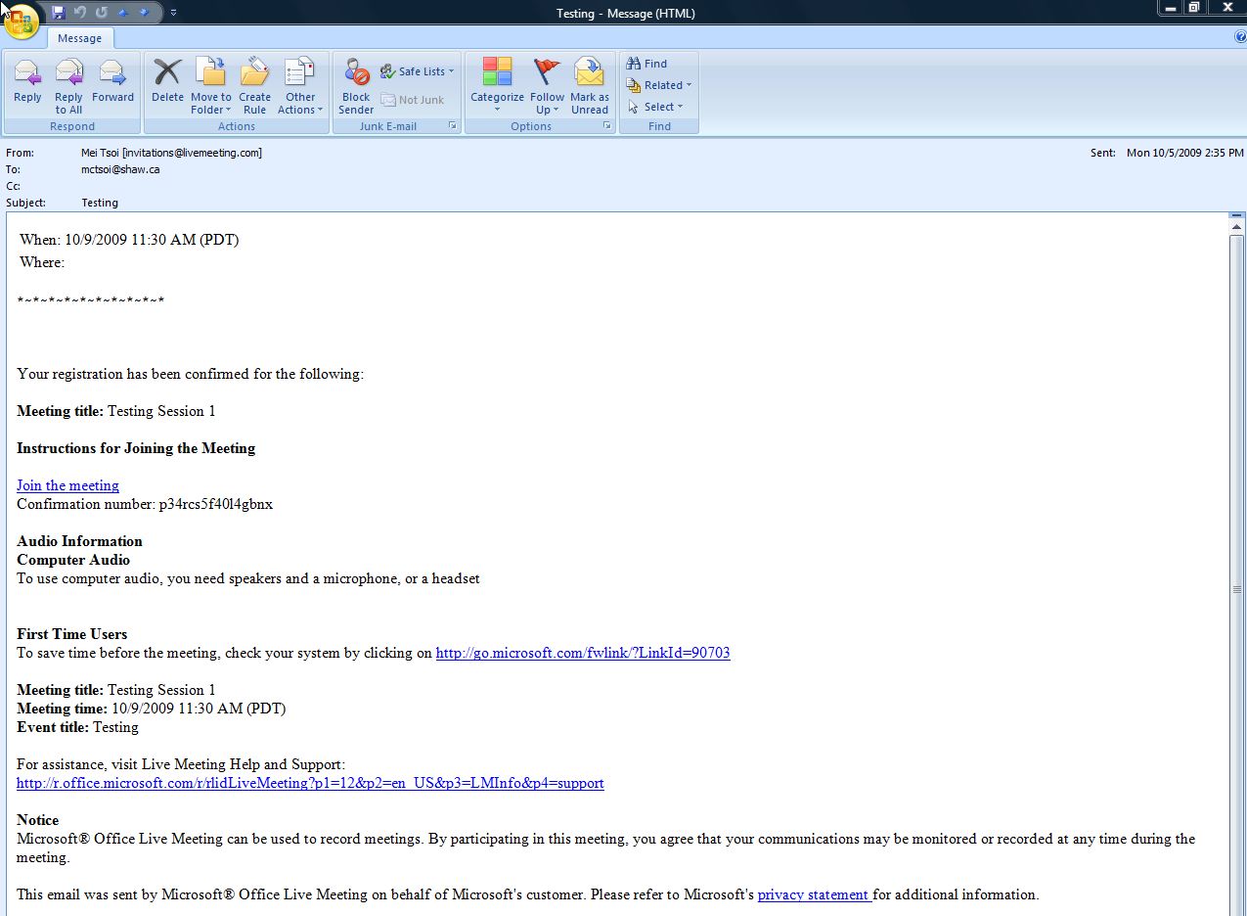
- Perform Sound Check
Use Voice & Video, Options, Set up Audio and Video.
Go through the Wizard with checking headphones/speakers and microphone.
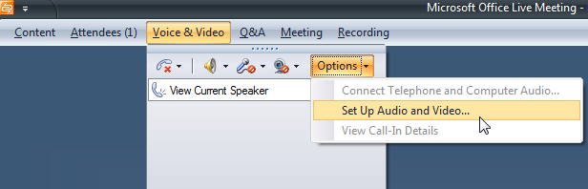

- Unmute Microphone
Go to Voice & Video and ensure that your microphone is un-muted.
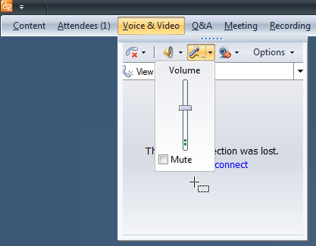

- Give Feedback
Feedback enables you to select from pre-set responses. The responses are set by the instructor.
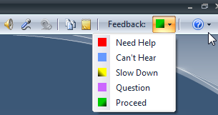

Summary of responses by can be viewed via Attendees.
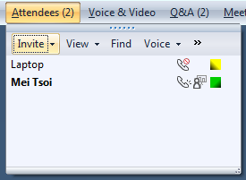
- Questions and Answers
Q/A allows you ask, edit or delete your questions. Just enter your question in the text box and the Ask Button.
Raise your hand to ask a question by microphone
Ask Ask your question
Edit Edit your question
Delete your question
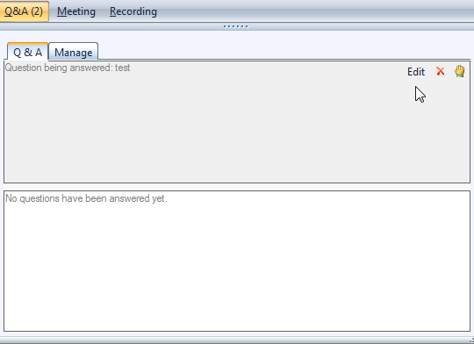
Note that participants will not have “Manage” tab function.

