System Requirement to participate:
Computer with audio capability using either speakers and a microphone or a headset.
- Go to URL posted for Event Registration.
- In Live Meeting, go to Register –Public Events. You DO NOT need to Login.
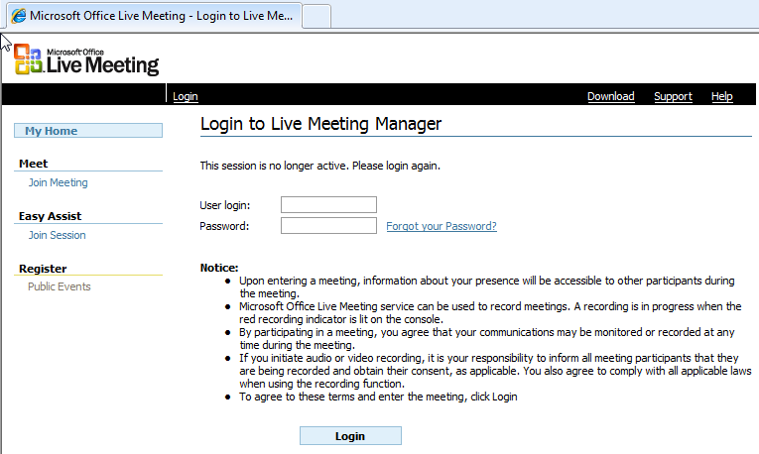
- In Public Events – Select “Upcoming” to filter for Events for scheduled Events/Meetings.
- Select the Event you are interested in.
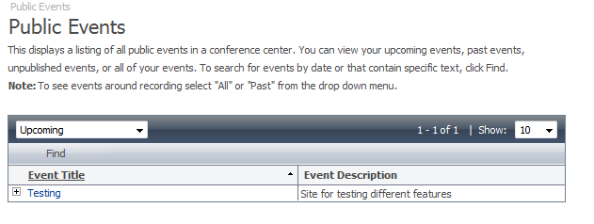
- In the Event Registration, Select the Session(s) and enter minimum required information with red * astrix.
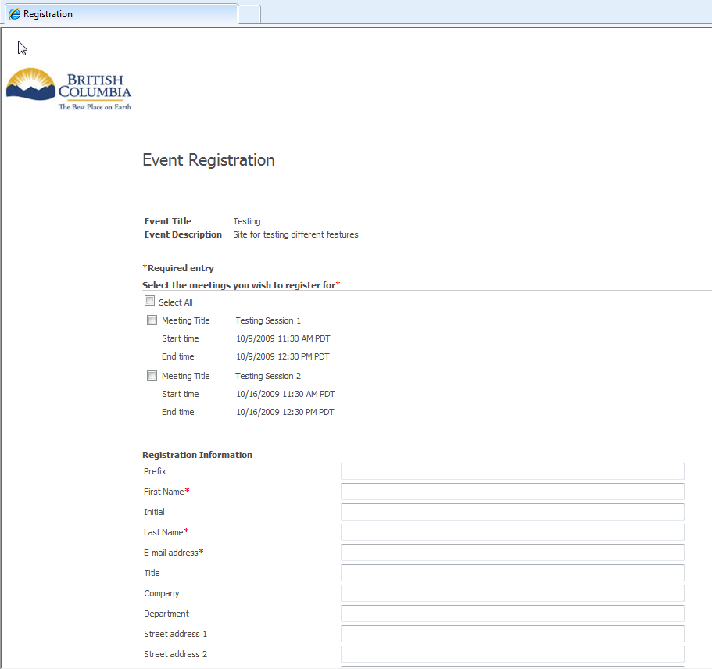

- After registration, you will see web confirmation & receive an email confirmation registration also.
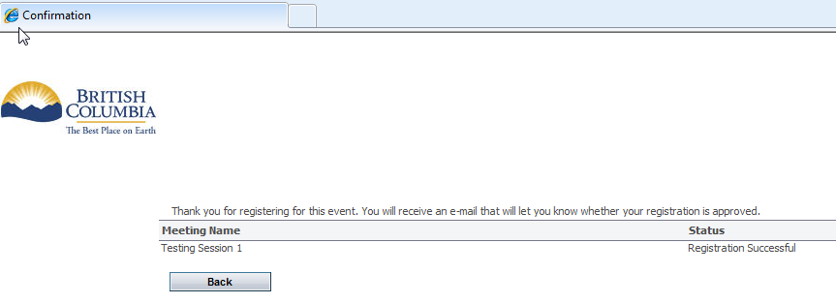

- If you are First Time User, to perform system check and load Live Meeting client software in advance of your session enable your participation without delays.

First Time Users
To save time before the meeting, check your system by clicking on http://go.microsoft.com/fwlink/?LinkId=90703
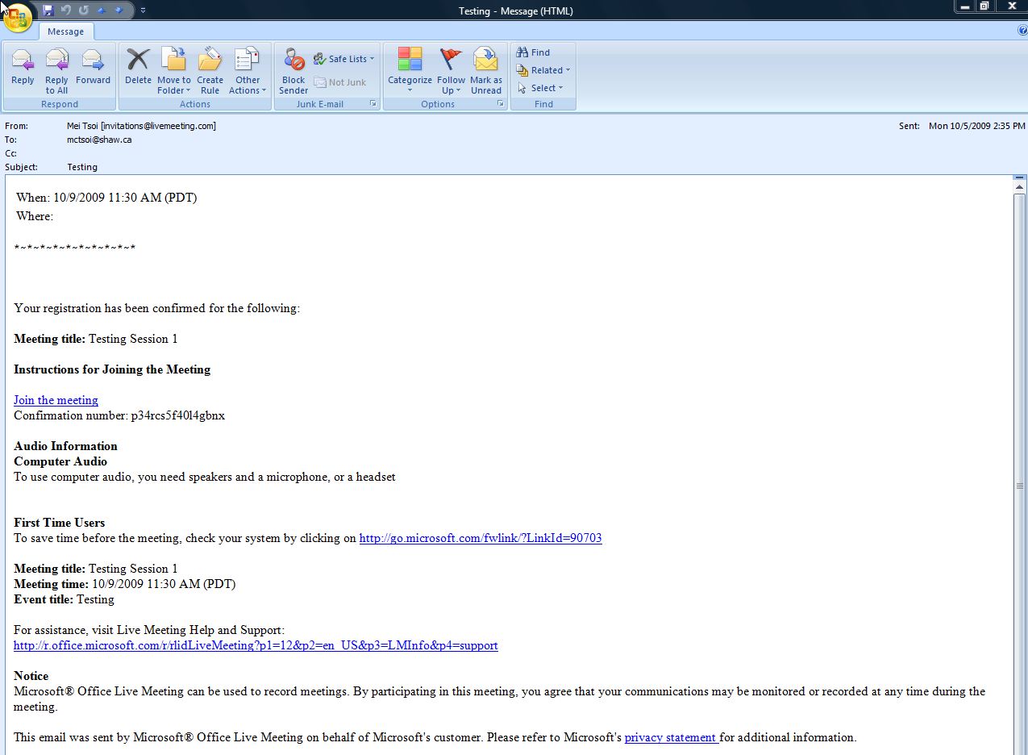
- You may copy and paste the note into your calendar so that you have the meeting time marked with the required hyperlink for Joining the Meeting.

