2-10: Add an 'O' client to an opening (modification to the cut_block_client table)
Opening: DNI 92L 045 0.0 193 (116946) TFL37, 227, NW582H, 37/227
RESULTS:
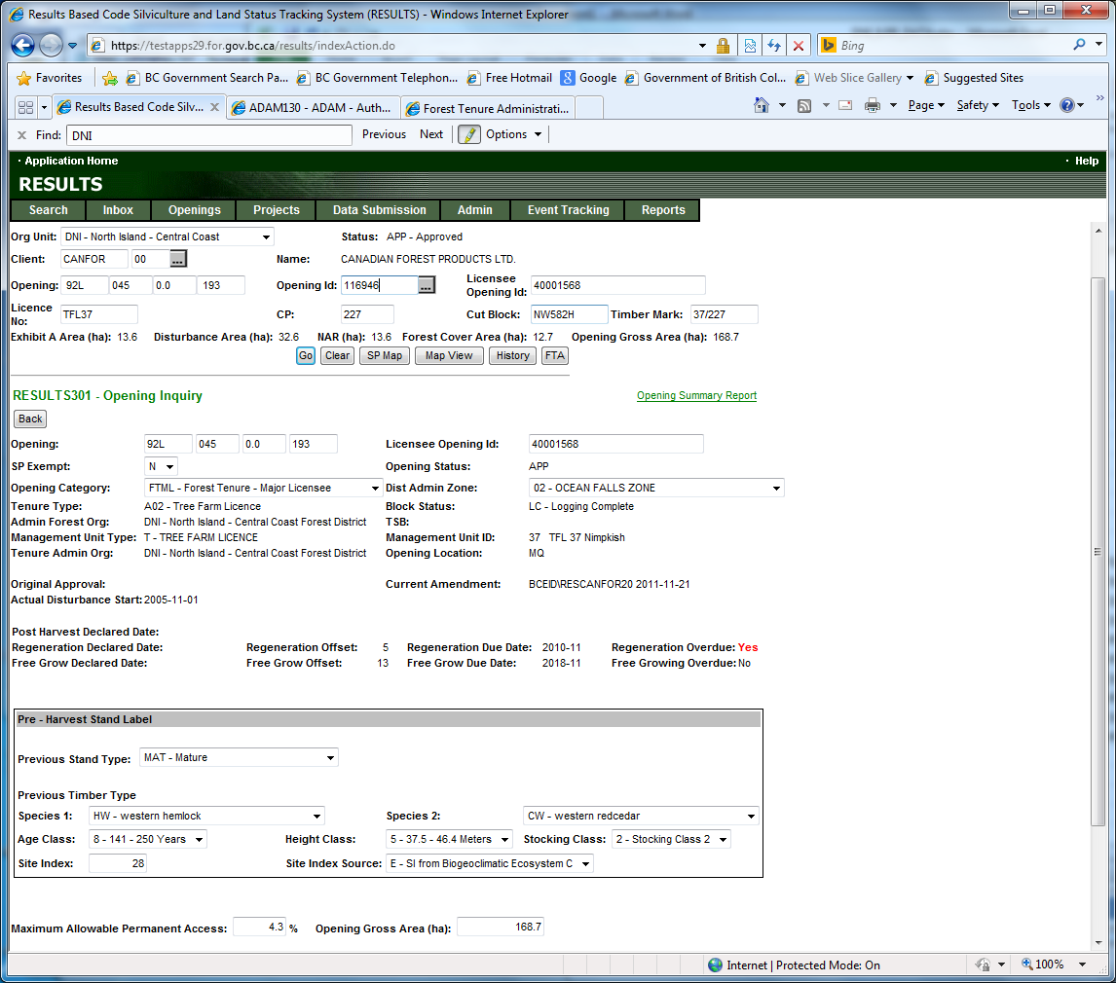
To add the O Client, location the Cut Block in FTA.
- Open the FTA application in test: https://testapps.for.gov.bc.ca/fta
- Ensure that the district FTA is working on is set to the cut block’s district. Select Admin, Org Unit Maintenance from the menu bar and ensure the district is set to the same district as the Opening.
- Click on the Assc. Client tab to go to the “FTA920 - Associated Clients” screen
- Search for the cut block
- File: TFL37
- CP: 227
- Block: NW582H
- Press the Go button

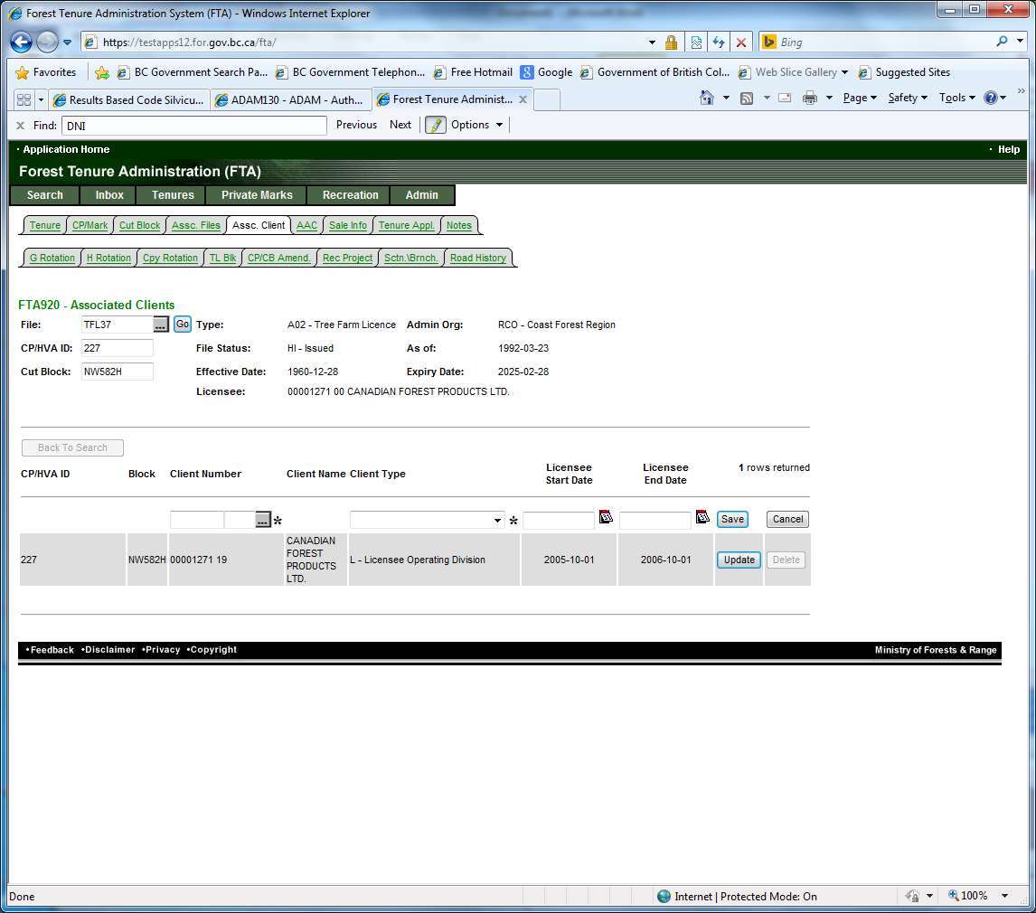
- Enter the O Client Information
- Client: 00002176 00
- Client Type: O
- Licensee Start date: today

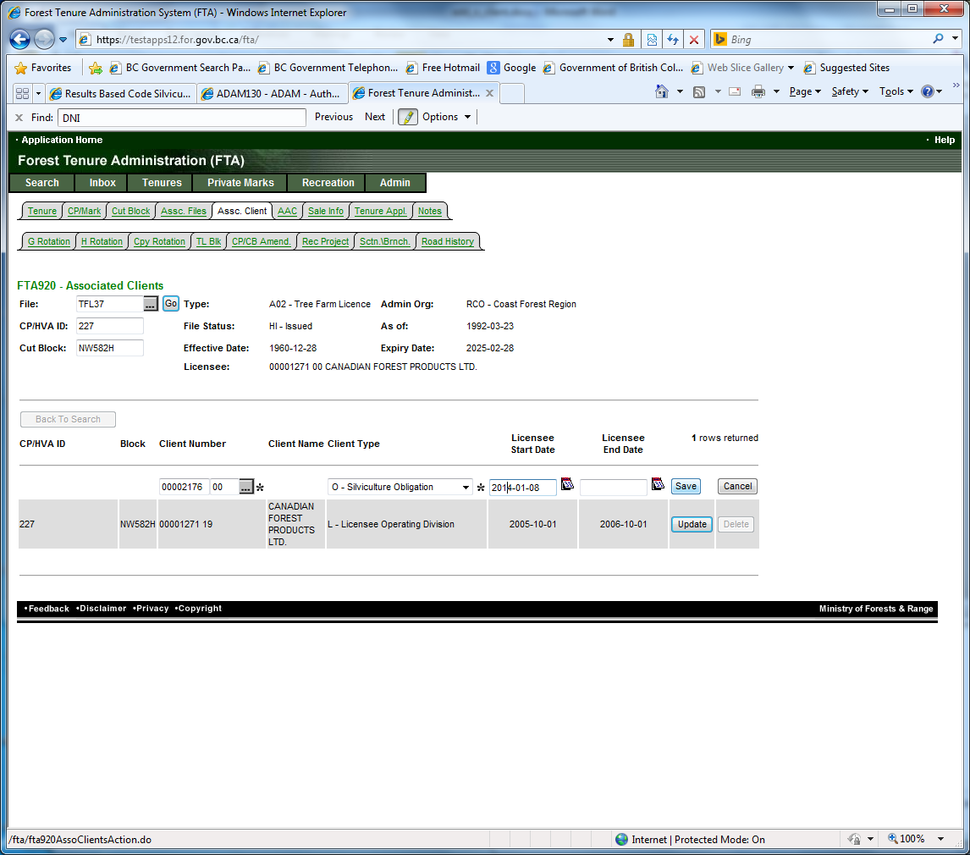

- Press Save
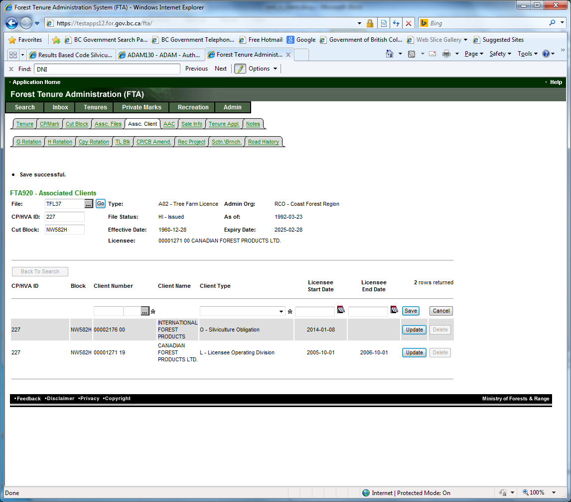

2-11: Change the 'O' client for an opening
To Update the O Client, location the Cut Block in FTA.
- Open the FTA application in test: https://testapps.for.gov.bc.ca/fta
- Ensure that the district FTA is working on is set to the cut block’s district. Select Admin, Org Unit Maintenance from the menu bar and ensure the district is set to the same district as the Opening.
- Click on the Assc. Client tab to go to the “FTA920 - Associated Clients” screen
- Search for the cut block
- File: TFL37
- CP: 227
- Block: NW582H
- Press the Go button

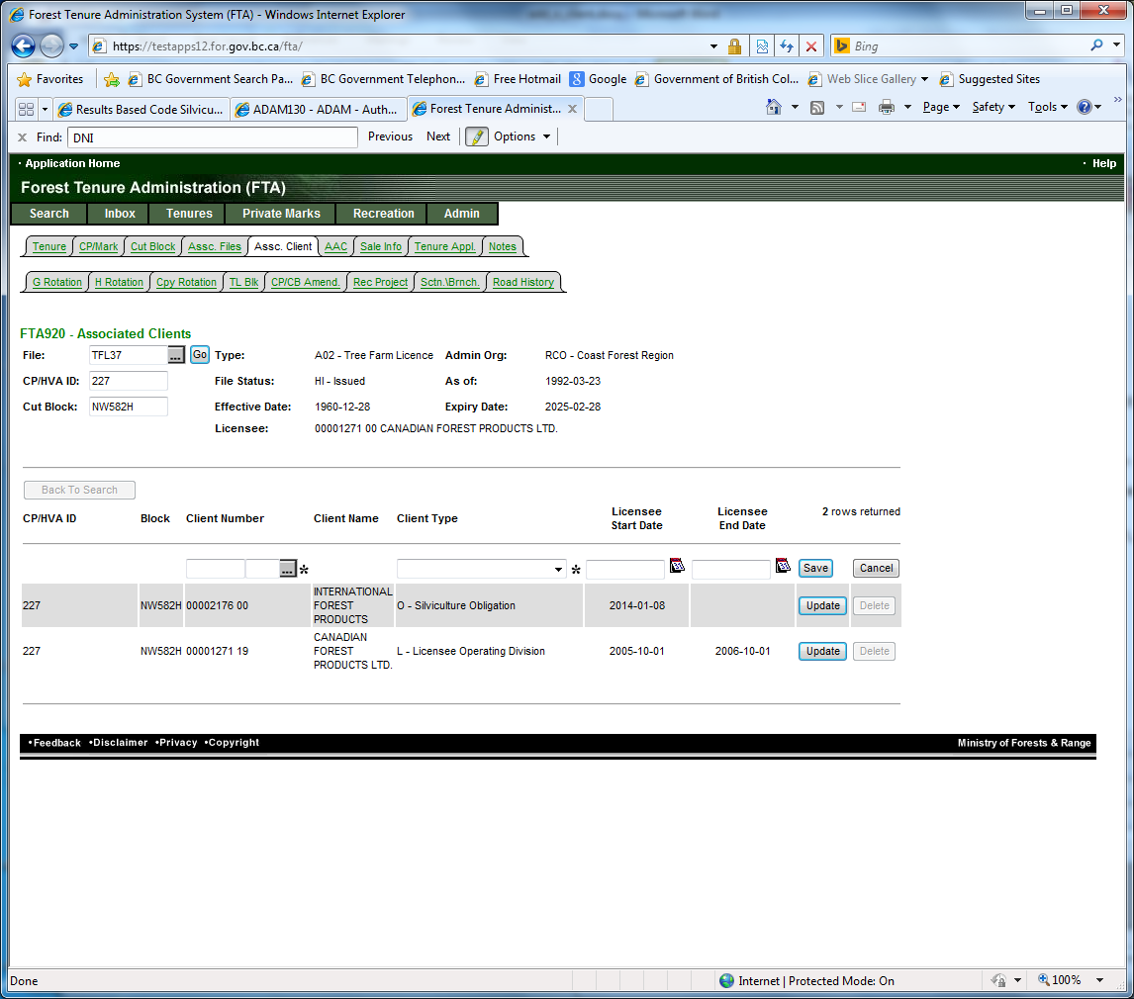
- Press the Update button

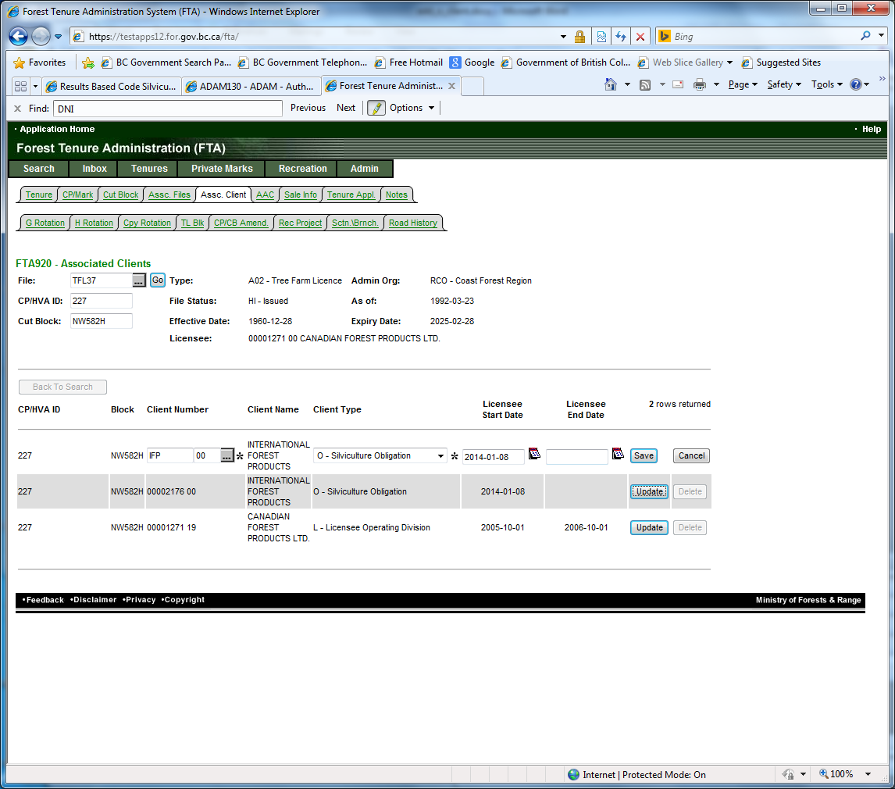

- Update the Client

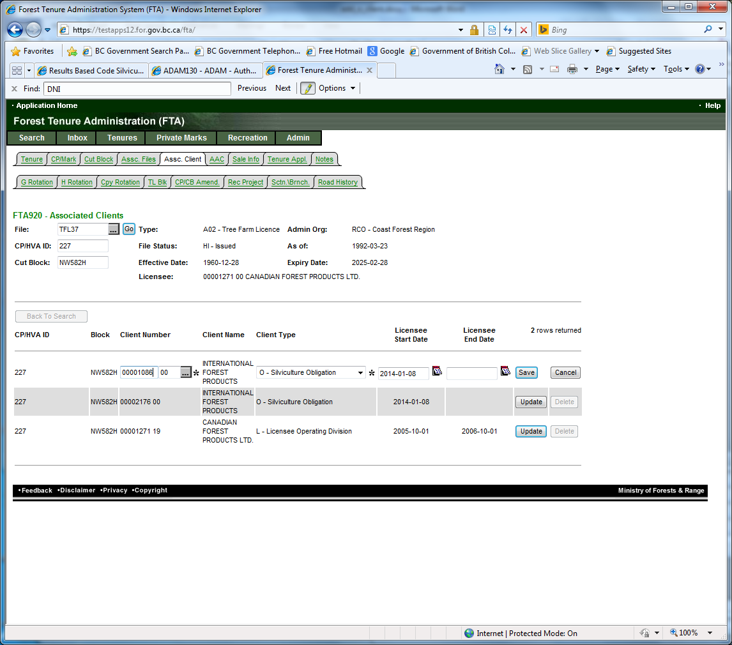

- Press Save

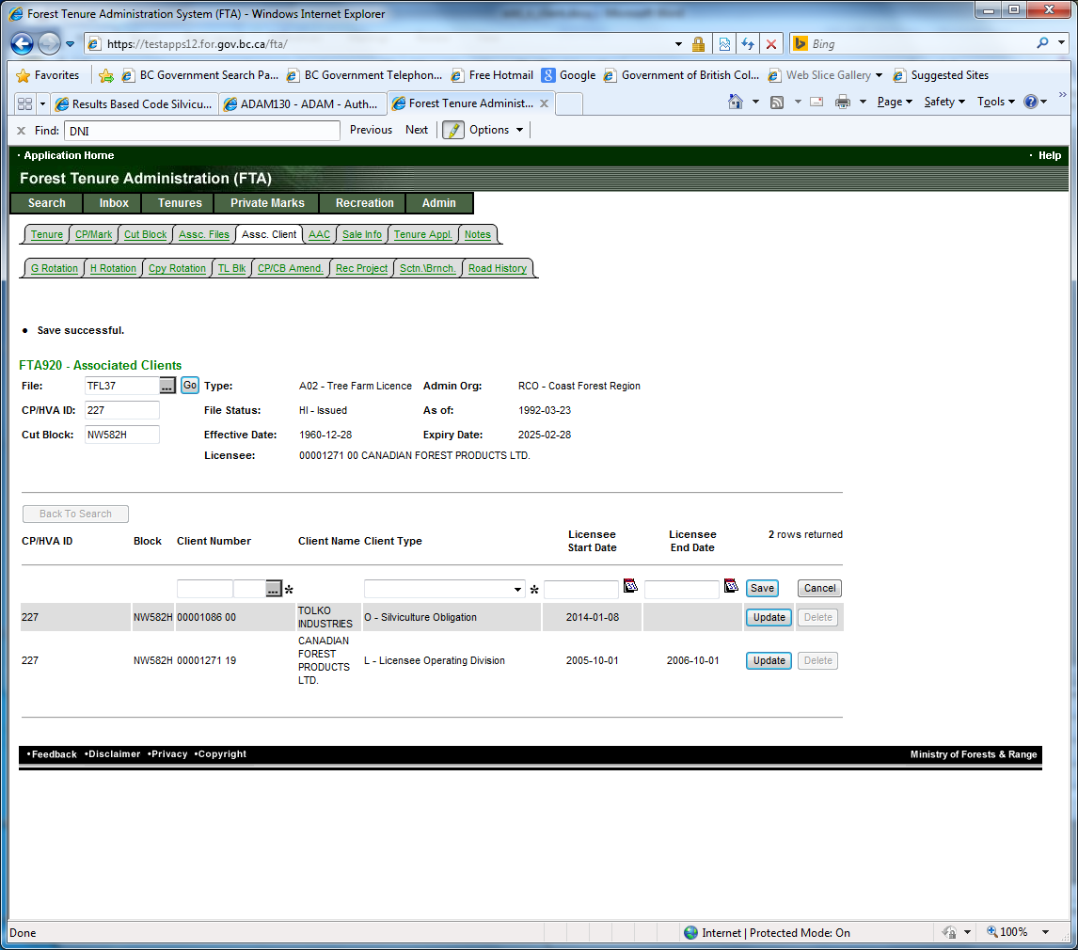

2-12: Remove all clients from a opening (delete all related records in the cut_block_client)
To remove the O Client, location the Cut Block in FTA.
- Open the FTA application in test: https://testapps.for.gov.bc.ca/fta
- Ensure that the district FTA is working on is set to the cut block’s district. Select Admin, Org Unit Maintenance from the menu bar and ensure the district is set to the same district as the Opening.
- Click on the Assc. Client tab to go to the “FTA920 - Associated Clients” screen
- Search for the cut block
- File: TFL37
- CP: 227
- Block: NW582H
- Press the Go button
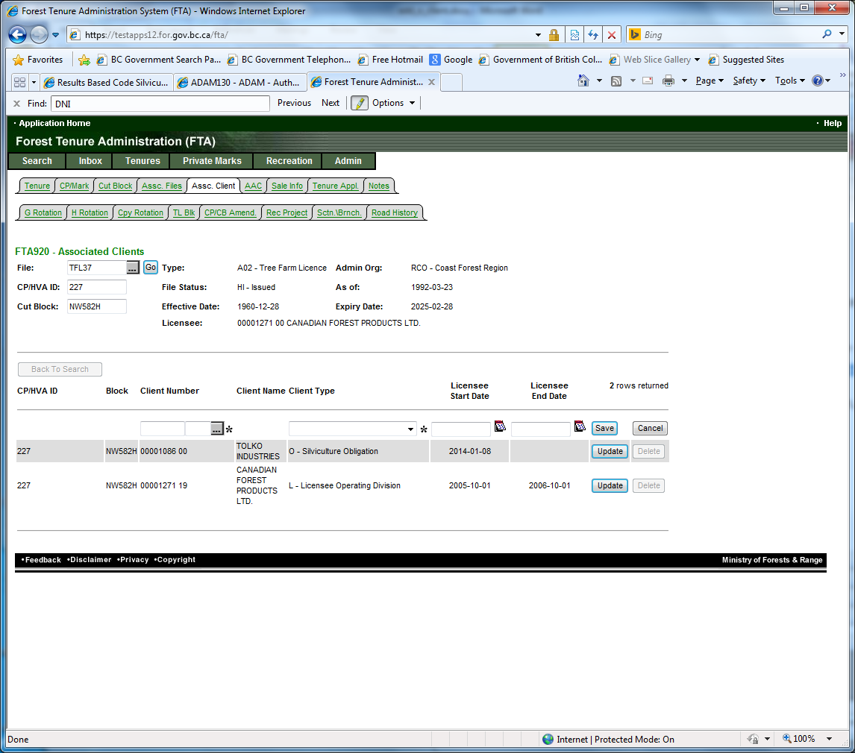
- Repeat the steps above for updating the client, but instead of the client being updated, change the client type from O to S
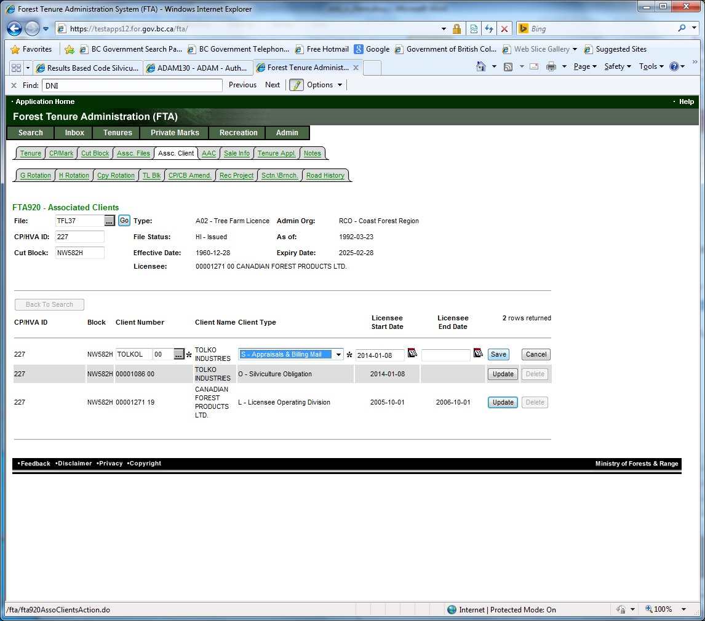
- Press Save

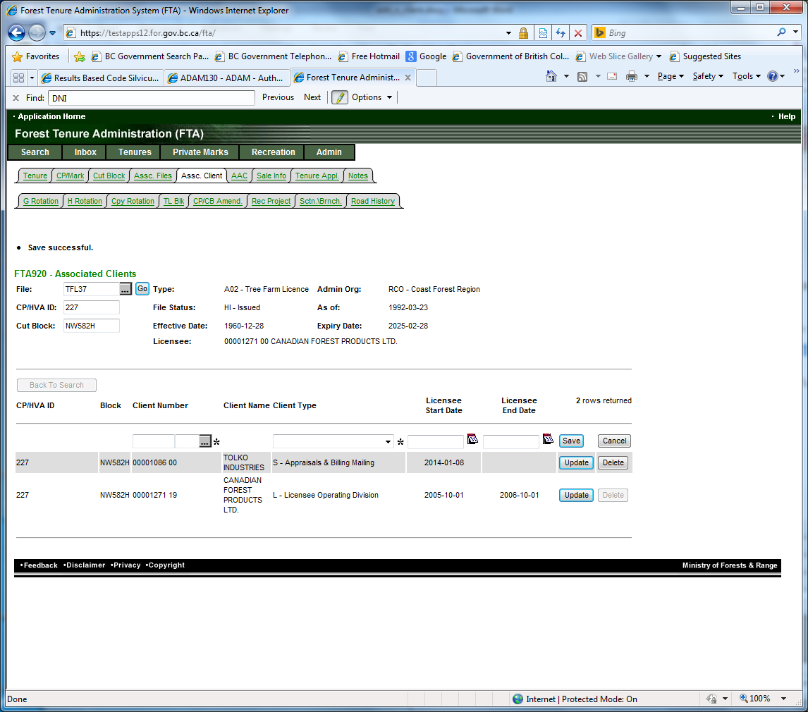

- The delete button should now be enabled.
- Press the delete button and select OK from the pop-up asking if you are sure.

