INSTRUCTIONS: Fuels Management Spatial Data – Pre-Submission QA
The BC Wildfire Service has made an external version of our Quality Assurance (QA) utility available to clients wishing to submit fuels management or CWRP spatial data as part of the Community Resiliency Investment Program (CRI). This utility allows clients to check their spatial data against BC Wildfire Service spatial standards and fix any resulting errors prior to submission. Using this utility will help improve submission success and reduce the amount of time a project spends in the spatial review cycle. For more information on the common problems with spatial submissions, please see the information located here.

*Note this QA tool is not for RESULTS submissions.

If you have any comments or questions on this utility please feel free to send them to BCWildfireGeo@gov.bc.ca.

Important notes about this utility:
- This QA process is only applicable for Fuels Management and CWRP projects submitted under the 2019-2023 and 2024 on CWRPs. The standards for these years require spatial data to be submitted in file geodatabase format. This QA does not check RESULTS submissions.
- There are three parts to this process:
  - The client submits information to be QA’d into a specific folder on our Ministry FTP site.
  - The QA utility picks up the clients submission and runs the QA process, then copies the output information to a separate FTP location that allows the client access to view and download the output files.
  - The client reviews the QA output and downloads the necessary files.
If you would like to view or download the resulting QA’d files please ensure you are using the correct location as stated in the QA e-mail you received.
- This utility requires that the maximum length of your ESRI geodatabase file name (including the .gdb extension) to be 60 characters or less.
- If you are using Internet Explore you can open the FTP site in Windows File Explorer by clicking on View -> Open FTP site in File Explorer.
- If you are having troubles with the FTP site please read the FTP instructions located here: ftp://ftp.for.gov.bc.ca/!HowToUseFTP/!guide.htm. Please note that FTP instructions for Windows File Explorer can change depending on Windows version and Internet Explorer version.

Instructions:
- Copy the template folder called Fuels_Mgmt_GDB_Submission_QA_Template to a location on your local computer. This template folder can be found here:
ftp://ftp.for.gov.bc.ca/HPR/external/!publish/FuelsManagement/GIS_Template/

- Completely fill out the four parameters in the Excel spreadsheet named Fuel_Management_Submission_Template.xlsm within your copied folder:
  - Open the spreadsheet
  - Enable Editing (if required)
  - Enable Content
  - Parameter 1 – Project Year: Click on cell B1, and from the dropdown arrow choose the Project Year (i.e. 2013, 2014, 2015 January, 2015 April+, 2016 etc.). Note that this is the year that your project was approved for funding and not the year in which the project work was completed.
  - Parameter 2 – Project Type: Click on cell B2, and from the dropdown arrow choose the Project Type (i.e. CWPP, Demonstration, Operational, or Prescription). Note that the values you see here will be dependent on which Project Year you chose in the previous step.
  - Parameter 3 – Feature Dataset Name: Click on cell B3, and type in the name of the feature dataset in your submitted geodatabase. You can find this information as shown below in ArcCatalog or in the Layer properties in ArcMap. Note that this parameter is case and spelling sensitive.
ArcCatalog:
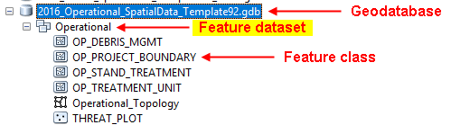
ArcMap:
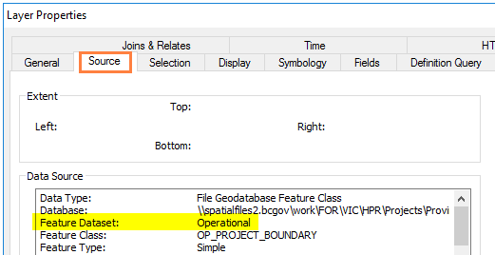

In order for submitters to use this QA process your spatial layers (aka feature classes) must be contained within a feature dataset in the submitted file geodatabase. If you are using one of the BC Wildfire Service GIS templates available here, this structure should already be set up for you.
  - Parameter 4 – E-mail Address: Click on cell B4, and type in one valid email address where the notification email should be sent. If the email address is incorrect, you will not receive notification when your submission has been processed.
  - Save the spread sheet, click OK when the Microsoft Excel warning pops up and then close Excel. You can also save the spreadsheet as an .xls file.
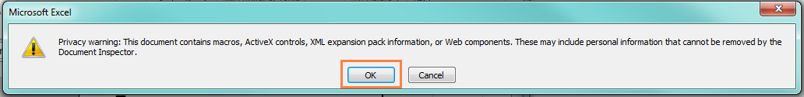

- Using ArcCatalog or ArcMap, copy the fuels management geodatabase associated with this project into the Fuels_Mgmt_GDB_Submission_QA_Template folder you created in Step 1. Note that the geodatabase cannot be zipped or contained within a subfolder.

- Rename the Fuels_Mgmt_GDB_Submission_QA_Template folder to: submission_####, where #### is one number higher than the highest existing sub-folder number on the following FTP site: ftp://ftp.for.gov.bc.ca/HPR/external/incoming/HQ%20Victoria/Wildfire_FuelsMgmt_QA_Incoming/.

So if the existing sub-folders are:
submission_0009
submission_0010
submission_0011
then the next sub-folder should be named: submission_0012

- Copy your newly renamed folder to this location: ftp://ftp.for.gov.bc.ca/HPR/external/incoming/HQ Victoria/Wildfire_FuelsMgmt_QA_Incoming/.

This can be done using either an FTP client, or by navigating to the FTP site in Internet Explorer, opening it in File Explorer as indicated above, and using traditional copy/paste methods.

- The QA process will run as scheduled. Currently the schedule is set up to run once an hour, on the hour (unless it is already running) from 6am to midnight.

- When your submission has finished being processed, an email will be sent to the email address entered in the spreadsheet informing you of whether there were errors with your submission files or whether your submission was successfully processed. Based on these results your submission sub-folder will be renamed with a suffix of either __ERROR__ or __PROCESSED__ and will be copied to the following output location so you can access the output QA’d files: ftp://ftp.for.gov.bc.ca/HPR/external/outgoing/HQ/FuelsManagement/Wildfire_FuelsMgmt_QA_Results/. This output location will also be in the e-mail you receive.

Note that this output folder is in a different location then where you submitted your files. Only this location will allow you to view and download the output files.

Within this folder there will be two versions of the QA’d geodatabase: one contains topology and the other does not. If you have a Basic or ArcView ArcGIS license please download the __NO_TOPOLOGY__ version so that you are able to open it in ArcGIS. This versionhas the topology removed from the geodatabase since it is not supported at this license level.

- If your submission contained errors, please review the e-mail notification, correct the error(s), and create a new QA submission folder with the required information, following the instructions above starting at Step 1.

- If your submission was successfully processed there will be a QA’ed version of the geodatabase and a QA report document in the output folder on the FTP site. The report document contains the following information:
  - QA process specifications (standard year, project type, submission geodatabase name, template geodatabase name)
  - Error Summary – organized by feature class.
  - Hectare Summary – organized by relevant feature classes.
  - The remainder is a detailed summary of the feature class and attribute information checked as part of the QA script. Note that any errors identified here will have already been highlighted in the error section at the top of the report.

- You will need to review the Error Summary and Hectare Summary portions of the report and correct any identified errors. It is also recommended that you review the hectare summaries and compare them to your documents, final reports, and maps. If you correct any errors it is recommended you re-QA your corrected geodatabase by taking a new copy of the template folder identified in Step #1 and following this procedure from the beginning. This will ensure your changes do not contain any further errors.

- Once your geodatabase passes QA it is ready to be submitted via the process outlined in the relevant Community Resiliency Investment (CRI) program and application guide. These can be found on the Union of BC Municipalities (UBCM) website here.

- If you experience any problems with the processing of your submission please contact the BC Wildfire Service Geospatial Staff at BCWildfireGeo@gov.bc.ca.

