Data services commonly used for U.S. wildfire management
Objective: Provide British Columbia Wildfire Service (BCWS) access to publicly available data sets to communicate during transboundary fire incidents.
Contact: Erin Noonan-Wright, U.S. Forest Service R1 Analyst, erin.noonan@usda.gov; 406-241-3993
Contact: Chris Johnson (CJ), U.S. Forest Service Assistant Director Cooperative Fire, christopher.johnson5@usda.gov; 406-329-3409
Contact: Devona Hay, BCWS Fire/Geomatics Team Lead; Devona.Hay@gov.bc.ca – best to use bcwildfiregeo@gov.bc.ca 250-312-6773 or cell 250-320-2821
Common US Data Services (Public)
National IA Frequency Zones (International)
fs-r1 ro faa status board
https://services3.arcgis.com/T4QMspbfLg3qTGWY/arcgis/rest/services/National_InitialAttackFrequencyZoneInternatl_20201215/FeatureServer/0/query?outFields=*&where=1%3D1
Public Fire Data (National Interagency Fire Center(NIFC) - all agencies):
START HERE: https://data-nifc.opendata.arcgis.com/
All Fire Points (historical and current):
https://services3.arcgis.com/T4QMspbfLg3qTGWY/ArcGIS/rest/services/WFIGS_Incident_Locations/FeatureServer/0
**2023 Fire Points: https://services3.arcgis.com/T4QMspbfLg3qTGWY/arcgis/rest/services/WFIGS_Incident_Locations_YearToDate/FeatureServer/0
Fire Perimeters:
All Fire Perimeters (historical)
https://services3.arcgis.com/T4QMspbfLg3qTGWY/arcgis/rest/services/WFIGS_Interagency_Perimeters/FeatureServer
https://services3.arcgis.com/T4QMspbfLg3qTGWY/arcgis/rest/services/InterAgencyFirePerimeterHistory_All_Years_View/FeatureServer/0/
Current Year Fire Perimeters (2023):
https://services3.arcgis.com/T4QMspbfLg3qTGWY/arcgis/rest/services/WFIGS_Interagency_Perimeters_Current/FeatureServer/0/
2023 Fire Locations (Points):
https://services3.arcgis.com/T4QMspbfLg3qTGWY/arcgis/rest/services/WFIGS_Incident_Locations_YearToDate/FeatureServer
Fuels Treatments (2000 to present..)
https://services3.arcgis.com/T4QMspbfLg3qTGWY/arcgis/rest/services/Integrated_Interagency_Fuels_Treatments_View/FeatureServer
Boundaries
Jurisdictional Agencies: https://services3.arcgis.com/T4QMspbfLg3qTGWY/arcgis/rest/services/Jurisdictional_Unit_(Public)/FeatureServer/0
U.S. State boundaries: https://services1.arcgis.com/Hp6G80Pky0om7QvQ/arcgis/rest/services/US_State_Boundaries/FeatureServer/0
U.S. Forest Service Specific Data Layers:
Start HERE: https://usfs.maps.arcgis.com/home/item.html?id=4f29e28b4c0b4a52a512e7106dd1245e
Above is a data portal for all publicly available Forest Service data.
Forest Service developed sites:
https://apps.fs.usda.gov/arcx/rest/services/EDW/EDW_DevelopedSite_01/MapServer/0
Roads:
Forest Service Roads: https://apps.fs.usda.gov/arcx/rest/services/EDW/EDW_RoadBasic_01/MapServer/0
STATE of Idaho Roads: https://data-iplan.opendata.arcgis.com/search?collection=Dataset
Local Idaho Roads: https://gis.itd.idaho.gov/arcgisprod/rest/services/ArcGISOnline/IdahoTransportationLayersForOpenData/MapServer/97
Washington Roads:
State Routes: https://data.wsdot.wa.gov/arcgis/rest/services/Shared/LRSData/MapServer/0
Local Roads: https://data.wsdot.wa.gov/arcgis/rest/services/Shared/LRSData/MapServer/12
STATE of Montana Roads: https://gis-mdt.opendata.arcgis.com/
Local Roads: https://app.mdt.mt.gov/arcgis/rest/services/Standard/ROUTES/FeatureServer/1
Values at Risk
Housing Unit Density: https://apps.fs.usda.gov/fsgisx01/rest/services/RDW_Wildfire/RMRS_WRC_HousingUnitDensity/ImageServer
Powerlines:
https://services2.arcgis.com/FiaPA4ga0iQKduv3/arcgis/rest/services/US_Electric_Power_Transmission_Lines/FeatureServer
Fire Safety:
Suppression Difficulty Index - SDI (90th percentile): we use to assess how hard it is to fight fire in remote locations.
https://apps.fs.usda.gov/fsgisx01/rest/services/RDW_Wildfire/RMRS_Wildfire_Suppression_Difficulty_Index_90thPercentile/ImageServer
Potential Control Location - PCL: used to assess WHERE we can strategically locate control line (with field verification:
https://apps.fs.usda.gov/fsgisx03/rest/services/wo_spf_fam/Potential_Control_Location/ImageServer
SNAGS: Where are locations of dead trees?
https://apps.fs.usda.gov/fsgisx01/rest/services/RDW_ForestEcology/National_Snag_Hazard/ImageServer
REFERENCES:
Alaska Fire Modeling & Weather:
https://www.frames.gov/afsc/resources/fire-modeling-guides
RMA Dashboard: US uses this arc web map experience to assess wildfire risk to responders and to develop strategy with the data provided.
https://experience.arcgis.com/experience/f9d7f7f920494c3db43a23a8dffe4664
Weather & Climate
Remote Automated Weather Stations (RAWS): stations used to inform weather and fuel moisture inputs for spatial fire models like FSPro, FlamMap, etc.)
https://services3.arcgis.com/T4QMspbfLg3qTGWY/arcgis/rest/services/PublicView_RAWS/FeatureServer/1
Key RAWS stations:
https://services3.arcgis.com/T4QMspbfLg3qTGWY/arcgis/rest/services/20220622_Key_RAWS_Station/FeatureServer
Download RAWS data: https://raws.dri.edu/ (most recent 30 days is available without a password).

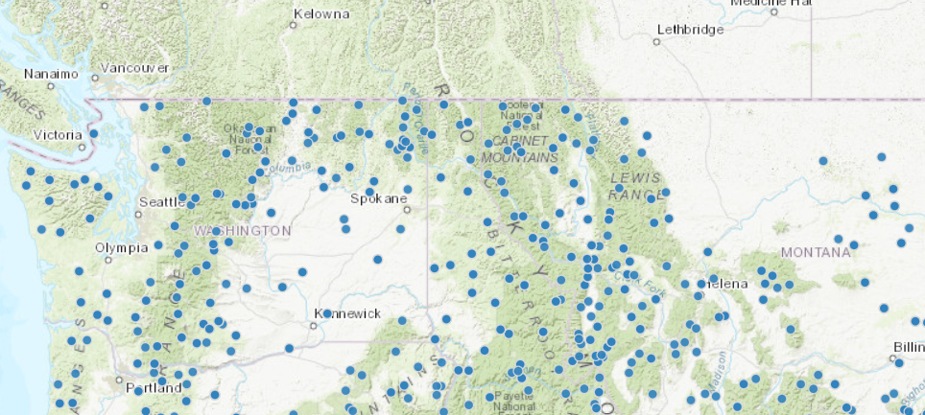
Landfire fuels
CFFDRS Fuel models near Alaska:
https://lfps.usgs.gov/arcgis/rest/services/Landfire_LF220/AK_220CFFDRS/ImageServer
Continental U.S. 40 Fire Behavior Fuel Models also see: https://www.fs.usda.gov/rm/pubs_series/rmrs/gtr/rmrs_gtr153.pdf
https://lfps.usgs.gov/arcgis/rest/services/Landfire_LF220/US_220F40_22/ImageServer
Drought (metadata = https://nifc.maps.arcgis.com/home/item.html?id=7d4cc55ecaef4ceb82c8d05b13e0d049)
https://services9.arcgis.com/RHVPKKiFTONKtxq3/arcgis/rest/services/US_Drought_Intensity_v1/FeatureServer/3
British Colombia Wildfire Services (BCGW) Data Services
Publicly available data, spreadsheet of data (location to be determined) provided along with all details that make up our Fire Management Plans can be found here:
https://catalogue.data.gov.bc.ca/datasets
BC Wildfire Situational Map:
https://wildfiresituation.nrs.gov.bc.ca/map
BC weather station Map:
https://governmentofbc.maps.arcgis.com/apps/webappviewer/index.html?id=c36baf74b74a46978cf517579a9ee332
Historical Weather data: historical weather data for each station
https://www.for.gov.bc.ca/ftp/HPR/external/!publish/BCWS_DATA_MART/
Publicly available data:
Fire Centre: (like a state) https://openmaps.gov.bc.ca/geo/pub/WHSE_LEGAL_ADMIN_BOUNDARIES.DRP_MOF_FIRE_CENTRES_SP/ows?service=WMS&request=GetCapabilities
Fire Zone: (like a county).
https://openmaps.gov.bc.ca/geo/pub/WHSE_LEGAL_ADMIN_BOUNDARIES.DRP_MOF_FIRE_ZONES_SP/ows?service=WMS&request=GetCapabilities
Current Fire Incidents: updated every half hour https://openmaps.gov.bc.ca/geo/pub/WHSE_LAND_AND_NATURAL_RESOURCE.PROT_CURRENT_FIRE_PNTS_SP/ows?service=WMS&request=GetCapabilities
Current Fire Perimeters: updated every half hour. https://openmaps.gov.bc.ca/geo/pub/WHSE_LAND_AND_NATURAL_RESOURCE.PROT_CURRENT_FIRE_POLYS_SP/ows?service=WMS&request=GetCapabilities
Historical Fire Incidents: updated monthly https://openmaps.gov.bc.ca/geo/pub/WHSE_LAND_AND_NATURAL_RESOURCE.PROT_HISTORICAL_INCIDENTS_SP/ows?service=WMS&request=GetCapabilities
Historical Fire Perimeters: updated monthly https://openmaps.gov.bc.ca/geo/pub/WHSE_LAND_AND_NATURAL_RESOURCE.PROT_HISTORICAL_FIRE_POLYS_SP/ows?service=WMS&request=GetCapabilities
Transmission Lines: https://openmaps.gov.bc.ca/geo/pub/WHSE_BASEMAPPING.GBA_TRANSMISSION_LINES_SP/ows?service=WMS&request=GetCapabilities
Fuel type: https://openmaps.gov.bc.ca/geo/pub/WHSE_LAND_AND_NATURAL_RESOURCE.PROT_FUEL_TYPE_SP/ows?service=WFS&request=GetCapabilities
Fuel Type Supporting documentation: https://www2.gov.bc.ca/assets/gov/farming-natural-resources-and-industry/forestry/wildfire-management/fire-fuel-management/bcws_bc_provincial_fuel_type_layer_overview_2015_report.pdf
AGO layers:
Evac Orders and Alerts: https://services6.arcgis.com/ubm4tcTYICKBpist/arcgis/rest/services/test_Emrg_Orders_and_Alerts/FeatureServer
Bans and Prohibitions: https://services6.arcgis.com/ubm4tcTYICKBpist/ArcGIS/rest/services/test_British_Columbia_Bans_and_Prohibition_Areas/FeatureServer
Area Restrictions: https://services6.arcgis.com/ubm4tcTYICKBpist/ArcGIS/rest/services/test_British_Columbia_Area_Restrictions/FeatureServer
Structures:
Publicly available datasets can be found from the spreadsheet provided (location to be determined)
Fuel treatments:
https://catalogue.data.gov.bc.ca/dataset/bc-wildfire-cri-fuel-treatments
https://openmaps.gov.bc.ca/geo/pub/WHSE_LAND_AND_NATURAL_RESOURCE.PROT_FUEL_TREATMENTS_SP/ows?service=WMS&request=GetCapabilities
WUI: 1 km eligible buffer for Fuel Management Funding
https://catalogue.data.gov.bc.ca/dataset/bc-wildfire-wildland-urban-interface-1km-buffer
https://openmaps.gov.bc.ca/geo/pub/WHSE_LAND_AND_NATURAL_RESOURCE.PROT_WUI_ELIGIBLE_BUFFER_SP/ows?service=WMS&request=GetCapabilities
WUI Human interface: a 2km buffer around the structure density class great than 6 structures
https://catalogue.data.gov.bc.ca/dataset/bc-wildfire-wui-human-interface-buffer
https://openmaps.gov.bc.ca/geo/pub/WHSE_LAND_AND_NATURAL_RESOURCE.PROT_WUI_HMN_INTRFCE_BUFFR_SP/ows?service=WMS&request=GetCapabilities
WUI Interface Risk Class: structure density of 25 or more structures per square kilometre – THIS DATASET IS VERY LARGE, make sure you zoom in first
https://catalogue.data.gov.bc.ca/dataset/bc-wildfire-wildland-urban-interface-risk-class
https://openmaps.gov.bc.ca/geo/pub/WHSE_LAND_AND_NATURAL_RESOURCE.PROT_WUI_RISK_CLASS_SP/ows?service=WMS&request=GetCapabilities
OFTS – Open Fire Tracking system (burn registrations)
https://services6.arcgis.com/ubm4tcTYICKBpist/arcgis/rest/services/British_Columbia_OFTS_Registered_Burn_Locations_-_View/FeatureServer
AGOL: (Web Feature Services).
Active Fire Points: updated every half hour
https://services6.arcgis.com/ubm4tcTYICKBpist/arcgis/rest/services/BCWS_ActiveFires_PublicView/FeatureServer
Active Fire Perimeters: updated every half hour
https://services6.arcgis.com/ubm4tcTYICKBpist/arcgis/rest/services/BCWS_FirePerimeters_PublicView/FeatureServer
National Parks:
https://services6.arcgis.com/ubm4tcTYICKBpist/arcgis/rest/services/National_Parks_of_Canada_within_British_Columbia_-_View/FeatureServer
Prohibitions & BANS for burning: Category 1(campfires), Category 2 open fires, Category 3 open fires
https://services6.arcgis.com/ubm4tcTYICKBpist/arcgis/rest/services/British_Columbia_Bans_and_Prohibition_Areas_-_View/FeatureServer
Area Restrictions: directly related to an incident
https://services6.arcgis.com/ubm4tcTYICKBpist/arcgis/rest/services/British_Columbia_Area_Restrictions_-_View/FeatureServer
Danger Rating:
https://catalogue.data.gov.bc.ca/dataset/bc-wildfire-danger-rating
https://openmaps.gov.bc.ca/geo/pub/WHSE_LAND_AND_NATURAL_RESOURCE.PROT_DANGER_RATING_SP/ows?service=WMS&request=GetCapabilities
Drought data:
https://catalogue.data.gov.bc.ca/dataset/bc-drought-levels
https://services6.arcgis.com/ubm4tcTYICKBpist/arcgis/rest/services/British_Columbia_Drought_Levels_View/FeatureServer
Priority Response Areas by RSWAP category: generalized areas by RSWAP category. Areas were buffered by 1 km. corresponds to the values at risk information below.
- RSWAP 1 – red; RSWAP 2 – orange; RSWAP 3 – green; RSWAP 4 – blue
- Values from screencapture below would occur in those areas
KMLs provided, Location to be determined
K5/K6 – Kamloops Fire Centre ( K5_Priority_Response_Areas_Final_SDE.kmz; K6_Priority_Response_Areas_Final_SDE.kmz )
V1/V6 – Coastal Fire Centre ( V1_Priority_Response_Areas_Final_SDE.kmz; V6_Priority_Response_Areas_Final_SDE.kmz )
N1/N5/N6 – Southeast Fire Centre ( N1_Priority_Response_Areas_Final_SDE.kmz; N5_Priority_Response_Areas_Final_SDE.kmz; N6_Priority_Response_Areas_Final_SDE.kmz)
R5/R9 – Northwest Fire Centre ( R5_Priority_Response_Areas_Final_SDE.kmz; R9_Priority_Response_Areas_Final_SDE.kmz )

Fine-scale Values at Risk
Fire Management Plans make up a plethora of detailed information like priority values organized by themes (see symbology below). There are data sets that are internal to BC that will be shared on a fire by fire basis. These sensitive datasets can be provided on the hard copy values maps seen further down.
Theme 1: data sets related to human safety
Theme 2: data sets related to assets like property and critical infrastructure
Theme 3: data sets related to High value natural and cultural resources
Theme 4: Other resource values

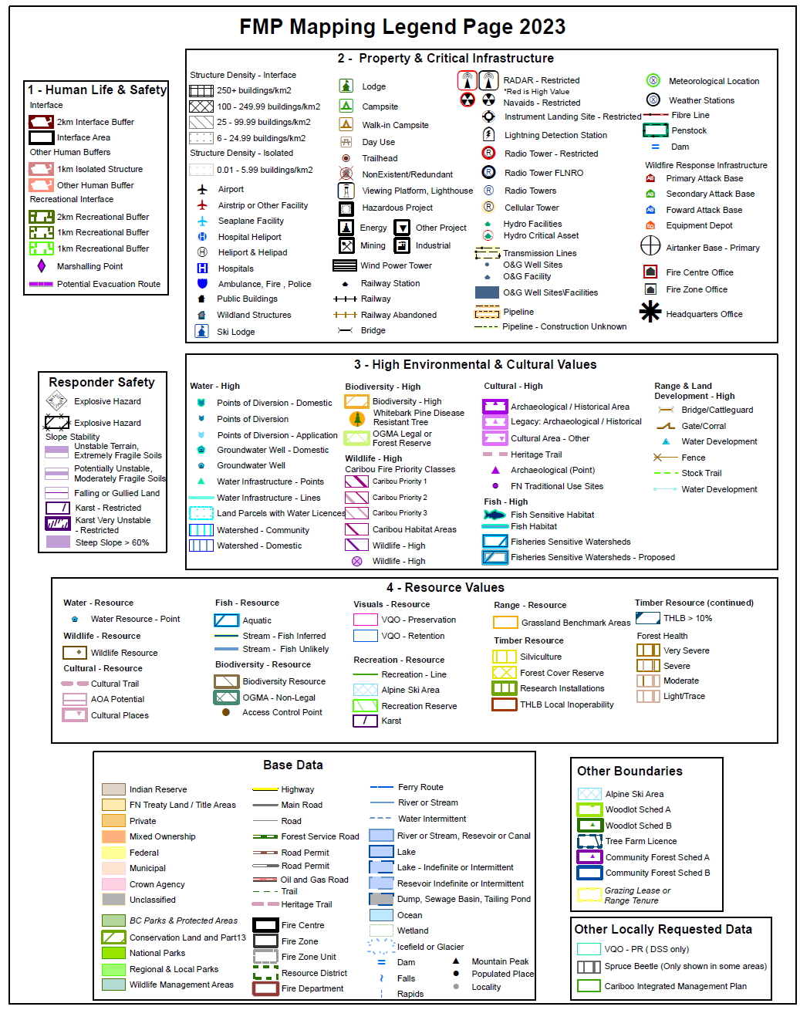
The data are shared by pre-season Theme maps. Users can open in Adobe and select the data layers to make data sets visible using the eye icon. Two sets of maps are created for each area, one with themes 1 and 4 and the other with 123 and priority responder information:
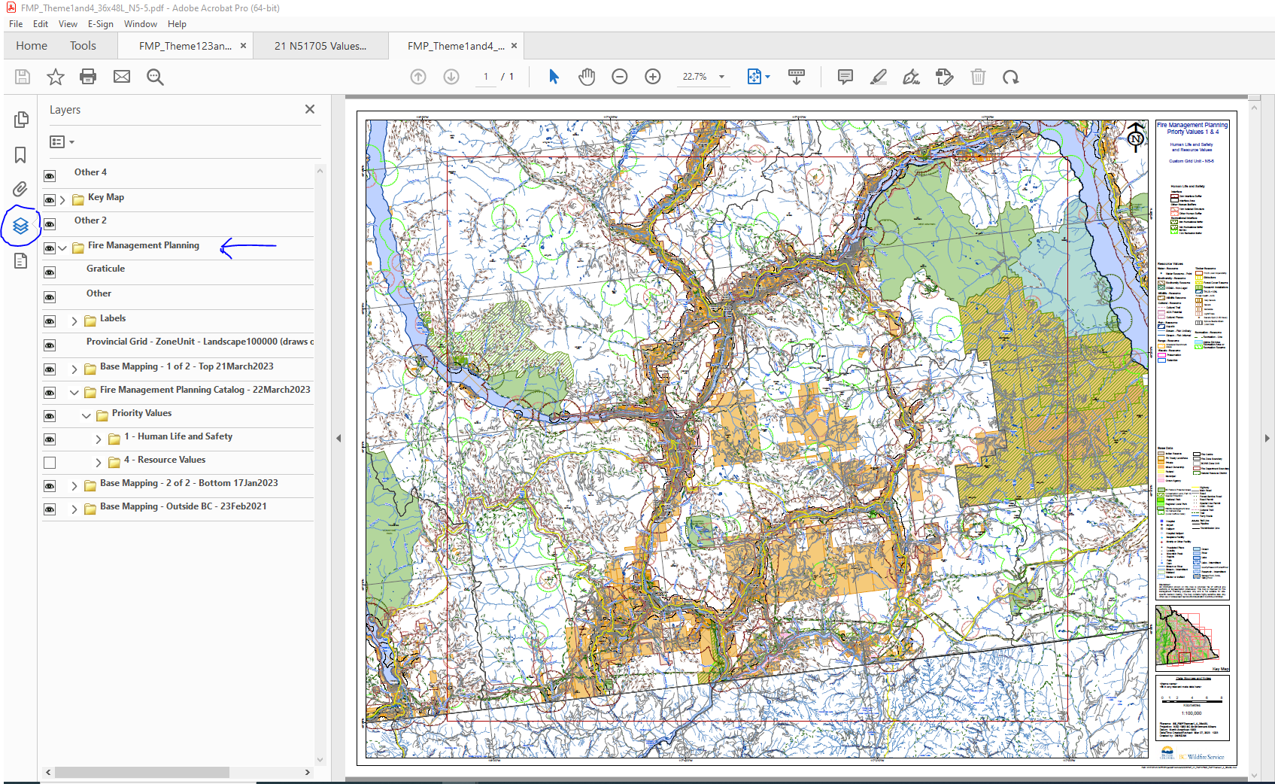

Wildland Fire BC Style Guide for Incidents:
Polygon features:
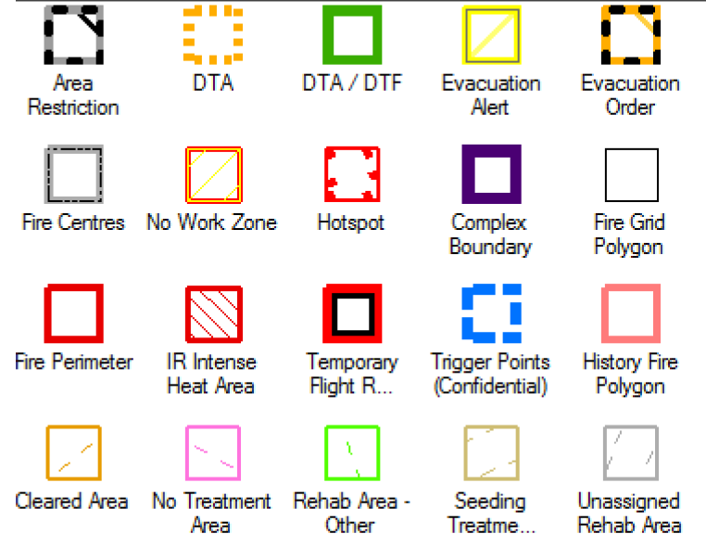
Line features:

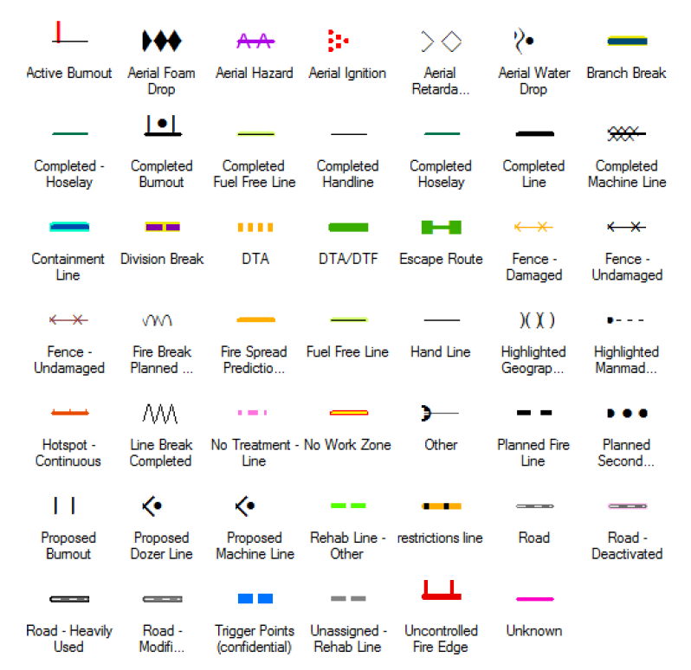

Point features:
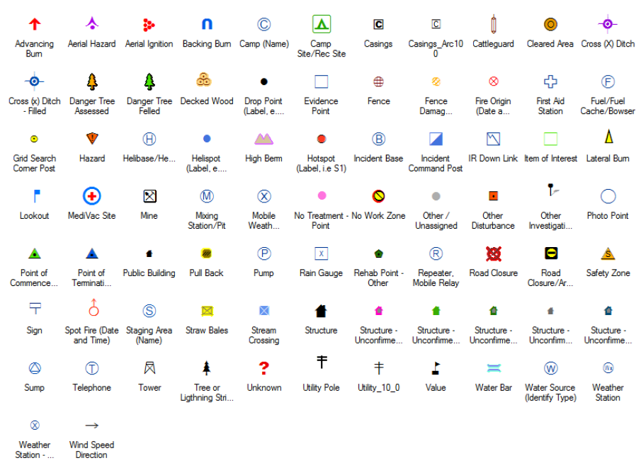

Alberta:
Fire Starts
https://geospatial.alberta.ca/titan/rest/services/wildfire/firemap/MapServer
Weather Stations:
https://geospatial.alberta.ca/titan/rest/services/wildfire/weather_station_reading/MapServer
Active Fires:
https://geospatial.alberta.ca/titan/rest/services/wildfire/firemap/MapServer/0

Border Fire Modeling:
Efforts have been undertaken to provide fire modeling support for border fires. With the advent of Landfire 2020 (v2.2.0) data that includes a 30 mile buffer north of the US border into Canada, fuels and landscape data are available to run models from FlamMap 6.2 and internally for FSPRO.
Products:
- Fire spread probability (FSPRO)
- Short-term/MTT/FlamMap fire spread
- Near-term/Farsite fire spread
Data delivered in geotiff, shapefile and KML formats.
For border fires in:
North Dakota, Montana and Idaho:
Contact: Erin Noonan-Wright, Fire Analyst, Northern Rockies Coordination Center (406-241-3993) erin.noonan@usda.gov; erin_noonan@firenet.gov
Alaska:
Contact: Brian Sorbel, Fire Management Specialist (GIS) (907-644-3413) Brian_Sorbel@nps.gov.
Contact: Chris Moore, Fire Analyst, Northwest Coordination Center (907-482-0161) Christopher_moore@nps.gov
Oregon, Washington:
Contact: Chris Moore, Fire Analyst, Northwest Coordination Center (907-482-0161) Christopher_moore@nps.gov
Kip Van de Water, Fire Analyst, Pacific Northwest Region (530-598-9354) kip.vandewater@usda.gov
Minnesota, New York, Vermont, Maine:
Contact: Allan Hepworth, Fire Analyst, (803-716-5263) allan.hepworth@usda.gov, allan_hepworth@firenet.gov

