CBST Impact and Gap Assessment – Provincial Summary
March, 2019

Western Redcedar (CW)

This document is a summary of the ‘Transitioning to Climate Based Seed Transfer in British Columbia’:
Assessment of Impacts and Gaps under CBST – Provincial Level, by Species, March, 2019 report for Western Redcedar (Cw).
Key Findings

Orchard Seed sources under CBST
Under CBST, orchards that have the same ‘Seed BEC variant’ are deployable to the same set of BEC variants (climate space). For example, orchards 152, 140, 184, 198, 801 (hedge), and 993 share the same ‘Seed BEC variant’ (CWHvm1) and therefore share the same seed deployment area (i.e. CBST Area of Use). Provincially, BC’s eight (including 1 cutting hedge) Cw orchards are assigned to one of 3 ‘Seed BEC variants’. There is considerable overlap among the seed deployment areas in terms of the BEC variants in which they can be deployed.
Table 1: Orchard seed sources by CBST Seed BEC Variant and BECvar Group - CW
Seed BEC Variant (assigned under CBST) | BECvar  Group¹ (link to GBST for transition purposes) | Orchards
CWHvh1 | CWMLOW1 | 128 Lost Lake (WFP), 158 Lost Lake (WFP)
CWHvh3 | CWMLOW2 | 155 Lost Lake (WFP), 190 Haida Gwaii (WFP QCI)
CWHvm1 | CWMLOW3 | 152 Mt. Newton (TWFC), 140 Mt. Newton (TWFC), 184 Saanich (FLNRO), 198 Saanichton (WFP), 801 Cowichan Lake Research Station – cutting hedge (FLNRO), 993 Cowichan Lake (FLNRO)
Orchards marked in “purple” denote retired orchards.

Detailed information on which BEC variants make up the CBST seed deployment area (based on the Seed BEC variant assigned to an orchard) is available in SPAR and the CBST Seedlot Selection Tool. Maps of orchard and natural stand seed deployment areas are available here: CBST Data and Maps.

Impacts under CBST (Genetic Class A)

Seed Deployment relative to GBST

- CBST impacts relative to GBST (not including species suitability): The area of use (AOU) available to coastal Class A Cw orchard seed sources (all Seed BEC Variants) under GBST is reduced overall by 54% in the move to CBST. This loss is balanced by a gain in new area (hectares) of 81% relative to GBST. In addition, 46% of area identified under GBST remains unchanged (overlaps with CBST). Note: Area (hectares) may be over/under estimated due to the inclusion of areas subject to latitude and elevation cut-offs.
- CBST impacts relative to GBST (including species suitability): The total area (hectares) impacted under CBST for Cw Class A seed after factoring in species suitability (i.e. area identified within /without (beyond) the species range projected to 2030) is shown below (Figure 1).

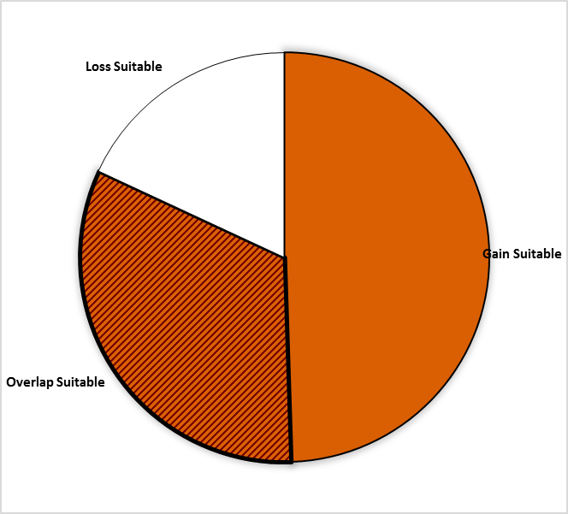
Gain = 49.5%
Area of no change = 32.4%
(Overlap with GBST)
Loss = 18.1%
Figure 1: Total area impacted under CBST for Class A seed including area falling within and without (suitable/non-suitable) the species range projected to 2030 for Western Redcedar

- Losses and gains (relative to GBST) are as follows:

Seed BEC  Variant | BECvar Group | Current  Area of Use  hectares % | Loss  area of contraction  % | Gain  expansion  into new area  % | Overlap  area of no change  % | CBST Area of Use  Gain plus Overlap  hectares % | Overall CBST Impact  Gain plus Overlap
CWHvh1 | CWMLOW1 | 7,356,906 100 | 44 | 79 | 56 | 7,356,906 135 | GAIN
CWHvh3 | CWMLOW2 | 5,488,952 100 | 95 | 53 | 5 | 3,202,260 58 | LOSS
CWHvm1 | CWMLOW3 | 5,528,859 100 | 22 | 110 | 78 | 10,337,257 187 | GAIN
- Provincially, the new CBST Area of Use (gain plus overlap) is 127% for the Class A Cw (all Seed BEC Variants), indicating approximately a one and a third-fold increase in the size of the deployment area previously identified under GBST. However, this new CBST seed deployment area no longer includes eastern and southern Vancouver Island, and the Sunshine Coast. Note: Seed deployment area is overestimated due to transfer cut-offs (north of 52 30) under CBST.

- Management units with new coastal seed sources moving in under CBST (Figure 2, Opportunity = new seed source) include: Kalum and North Coast Timber Supply Areas (TSAs) and TFL 1, 41, 58, 60. Additional CW transfer cut-offs under CBST apply at higher latitudes (e.g. north of 52 30).

- Management units with a moderate reduction (34%-66% loss relative to GBST) in area where Class A coastal seed can be deployed include: Arrowsmith, Strathcona, and Fraser Timber Supply Areas (TSAs); and, Tree Farm Licenses (TFLs) 37, 43, 47 located on northern Vancouver Island and in the Fraser Valley. Additional CW transfer cut-offs under CBST apply to the Fraser TSA (e.g. areas above 800m). Note: CWHvh1 and CWHvh3 were not included in MU analysis.

- It is important to keep in mind that while some seed sources under CBST may be projected to move out of their current ‘Area of Use’ (Current AOU) as defined under GBST, in many cases new seed sources are also projected to move into areas suitable for use under CBST (Figure 2).

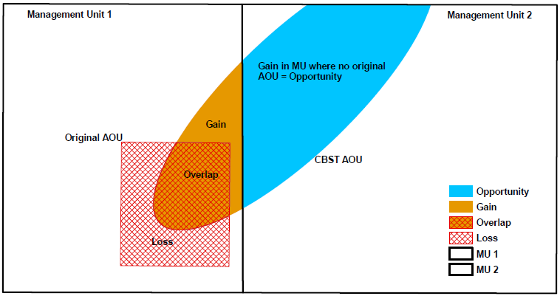

Figure 2: A schematic diagram of seed sources moving in/out of a management unit under CBST

Gaps under CBST (Genetic Class A and B)

Orphans
- Seed sources (seedlots) without seed deployment areas (no area of use) under CBST: NONE
- Plantation (cutblock) BEC variants without seed procurement areas (no access to either Class A or Class B seed) under CBST: 5 (4 interior - BWBSmw, ICHdw1, ICHxw, and PPxh3, and 1 coastal - CWHws1). These CW plantation BEC variant orphans are expected to be addressed through a minor adjustment to the genetic suitability threshold (i.e. all of these BECvars would have at least one BEC variant procurement area).

Table 2: Seed source and plantation orphans identified under CBST

CBST Orphan | BEC variant(s) identified as a CBST orphan | CBST orphan without a
Seed Source (seedlot) | none | seed deployment area
Plantation (cutblock) | BWBSmw, CWHws1, ICHdw1, ICHxw, PPxh3 | seed procurement area

Seed Deficits
- Legacy shortfalls exist (i.e. pre-CBST there was a deficit of Cw Class A seed in BC).
- Analysis of current seed inventories, based on historical planting, indicates that under CBST there is a deficit of approximately 0.35 M seedlings per year (7% of total historic Class A annual Cw planting) that cannot currently be met from orchard Class A seed sources.
- The current deficit in Cw Class A orchard seed cannot be met by existing orchards, since the demand for Cw seed resides entirely (100%) outside the current set of orchard CBST areas of use (deficits, based on Class A Cw recent historical annual demand, in plantation BEC variants not covered by CBST). See full report for CBST suitable/non-suitable breakouts
- The demand for Class B seed, based on historical planting, is for the most part (78%) outside CBST areas of use (deficits, based on historical demand, in plantation BEC variants not covered by CBST). See full report for CBST suitable/non-suitable breakouts
- Overall, the largest Cw seed deficits (after allocation of Class B seed) reside in the CWHds1, ICHmw2, CWHxm2, ICHvk1, and CWHxm1. Natural stand collections from CWHds1 and CWHvh2 would address an estimated 22% of this current deficit.

Table 3: Potential Seed Deficits under CBST based on Historical Planting

Genetic Class | Annual Planting | Seed Deficit | Seed Deficit over Annual Planting | Plantation BEC variants representing the largest seed deficits seed demand not met based on planting history from either suitable or non-suitable seed sources under CBST)
 | Pot’l trees | Pot’l trees | %
Class A | 5,055,000 | -354,376 | 7 | CWHxm2, [CWHxm1]
Class B | 2,433,202 | -822,205 | 34 | CWHds1, CWHvh2, ICHmw2, ICHvk1, CWHws1, ICHdw1
Class A and B | 7,488,202 | -824,156 | 11 | CWHds1, ICHmw2, CWHxm2, ICHvk1, CWHxm1

Seed Surpluses
- Moderate to high [fairly significant] surplus inventories exist of both orchard and natural stand Class B seed sources (legacy issue); however, not all seed demand is met in all BEC variants. An estimated 7 years supply of Class A seed is potentially available after allocation of seed to suitable CBST plantation BEC variants.
- Under CBST the largest surplus Class A seed inventories currently estimated (based on SPAR seedlot extracts) for the following plantation BEC variants, include: CWHvm1 and CWHvm2. This is in part due to CWHvm1 orchard seed no longer suitable for use in some BEC variants (e.g. CWHxm1 and CWHxm2) under CBST.
Table 4: Potential Seed Surpluses under CBST based on Historical Planting

Genetic Class | Annual Planting | Seed Surplus | Seed Surplus over Annual Planting | Plantation BEC variants representing the largest surplus seed inventories (remaining after allocation of seed to suitable CBST BECs [by seed source] across plantation BEC variants with planting history
 | Pot’l trees | Pot’l trees | %
Class A | 5,055,000 | 35,918,999 | 711 | CWHvm1, CWHvm2
Class B | 2,433,202 | 55,993,094 | 2301 | ESSFwk1
Class A and B | 7,488,202 | 91,912,093 | 1227 | CHWvm1, CWHvm2 and ESSFwk1

Species Specific Mitigation Options

Short Term (During Transition Period)
- Continued use of GBST will be required to meet the CWHxm1 and CWHxm2 Class A deficits in the short term.
- Cw is becoming less climatically suitable in some BECs (eg CWHxm1 and xm2) suggesting that an alternate species may be more appropriate for planting.
- Revisions to coastal BEC variants are planned within 2 years (BEC 13 and 14), including splitting larger BEC units. This may allow the additional constraints associated with latitude and elevation to be removed.

Long Term (Orchard Considerations, Forest Health and Ecology)
- Breeders to explore if seed sources from the US could be infused into new/existing Cw orchards; or, procured for use in BC in the CWHxm2 and xm1.
- Coordination and integration with CCISS will be very important for Cw (i.e. species suitability shifts).
- Transfer of coast Cw to the interior and interior Cw to the coast is currently restricted due to cedar leaf blight impacts. More research is needed.

For more information

See Climate Based Seed Transfer - Impact and Gap Analysis. Please check back periodically for updates pertaining to the science, policy (amendments to the Standards), tools, and CBST Area of Use and Orchard (coverage) maps.

Use of Information
This document provides a summary of an assessment of impacts and gaps currently identified under Climate Based Seed Transfer (CBST) relative to geographically based seed transfer (GBST) as regulated under FRPA. Area-based data summaries were generated using CBST Areas of Use, April 5, 2018, based, in part, on the provincial Biogeoclimatic Ecosystem Classification (BEC version 10).
Use of information contained in this document is limited to province-wide species level interpretations as viewed through multiple lenses – seed planner, seed producer, seed owner, and seed user. Further updates to CBST AOU are anticipated (target, April 2020) due to further updates to BEC (BEC 11/12), as well, as other potential changes to science foundation data sets (climate variables, transfer functions). CBST impacts and/or gaps may change/vary at more refined scales. Use this information with caution when informing operational-level strategies, plans, seed selection and use; and, seedling requests.

Further constraints apply to Cw CBST AOUs (latitude and elevation) which are not included in this analysis. NB: New Constraint Statement: “For Climate Based Seed Transfer, limit deployment of Cw seedlots from CWH vm 1 to planting sites below 800 m elevation in CWH mm 2 and CWH vm 2 and limit deployment of Class A Cw seedlots from CWH vm 1 to planting sites south of 52 30 N Latitude in CWH vh 2, CWH vm 2 and CWH vm 1. Class B Cw seedlots from CWHvm1 sourced from north of 52 30 N latitude may be planted in CWHvh2, CWHvm2 and CWHvm1, north of 52 30 N latitude.”
CBST deployment area (area gained plus area of overlap) as compared to Geographically Based Seed Transfer
Source: CBST_Impact_Assessment_v.4.2.1SEPT272018.xlsx
Includes area covered by producing orchards, and retired orchards with seed inventory (active seedlots)
Under different scenarios this deficit can change (e.g increase/decrease due to Annual Allowable cut (AAC) lifts or netdowns).
Recent historic annual planting data (2013-2017) extracted from RESULTS. Five year average updates are planned.
These PLANTATION BEC variants represent approximately 80% or more of the total seed deficit
Under different scenarios this surplus can change (e.g. seed additions and withdrawals)
Recent historic annual planting data (2013-2017) extracted from RESULTS. Five year average updates are planned.
These PLANTATION BEC variants represent approximately 80% or more of the total seed surplus

