CBST Impact and Gap Assessment
March, 2019

Coastal Douglas-fir (FDC)

This document is a summary of the ‘Transitioning to Climate Based Seed Transfer in British Columbia’:
Assessment of Impacts and Gaps under CBST – Provincial Level, by Species, March, 2019 report for Coastal Douglas-fir (Fdc).
Key Findings
Orchard seed sources under CBST
Under CBST, orchards that have the same ‘Seed BEC variant’ are deployable to the same set of BEC variants (climate space). For example, orchards 406 and 181 both have the same ‘Seed BEC variant’ (CWHms2) and therefore share the same seed deployment area (i.e. CBST Area of Use). Provincially, BC BC’s ten producing Fdc orchards are assigned to one of 2 ‘Seed BEC variants’: CWHdm and CWHms2 (Table 1). There is minimal overlap (only in the CWHms2 in the Bella Coola area) between the two CBST Areas of Use.

Table 1: Orchard seed sources by CBST Seed BEC Variant and BECvar Group - FDC
Seed BEC Variant (assigned under CBST) | BECvar Group  (link to GBST for transition purposes) | Orchards
CWHdm | FDCMLOW2 | 134 (TWFC), 149 Bowser (FLNRO), 154 Mt. Newton (TWFC), 162 Bowser (FLNRO), 166 Saanichton (WFP), 183 Mt. Newton (TWFC), 197 Mt. Newton (TWFC),199 Saanich (FLNRO), 405 Saanichton (WFP), 996 Rochester Washington (USA)
CWHms2 | FDCMHIGH2 | 406 Saanichton (WFP)
CWHms2 | FDCSMALL1 | 181 Saanich (FLNRO), 146 Surrey (FLNRO)
 |  | Retired orchards listed below (may have seed available on SPAR)
CDFmm | FDCMLOW1 | 123 Ainscough (MB), 110 Saanichton (WFP)
CWHmm1 | FDCMHIGH1 | 116 Sechelt (CANFOR), 121 Saanichton (WFP)
CWHvm1 | FDCMHIGH3 | 114 Koksilah (FLNRO)
CWHvm2 | FDCSMALL2 | 120 Saanich (FLNRO)
CWHxm1 | FDCMLOW3 | 111 Nootka (WFP)
CWHxm2 | FDCMLOW4 | 101 Quinsam (FLNRO), 124 Ainscough (MB)
Orchards marked in “purple” denote retired orchards. Orchards marked in ‘blue’ denote developing or established orchards (no seed production yet).

Detailed information on which BEC variants make up the CBST seed deployment area (based on the Seed BEC variant assigned to an orchard) is available in SPAR and the CBST Seedlot Selection Tool. Maps of orchard and natural stand seed deployment areas are available here: CBST Data and Maps.

Impacts under CBST (Genetic Class A)

Seed Deployment relative to GBST

- CBST impacts relative to GBST (not including species suitability): The area of use (AOU) available to Fdc Class A orchard seed (all Seed BEC Variants) under GBST is reduced overall by 35% in the move to CBST. This loss is balanced by an overall gain in new area (hectares) of 69% relative to GBST. In addition, 65% of area available for use remains unchanged (overlaps with CBST).

- CBST impacts relative to GBST (including species suitability): The total area (hectares) impacted under CBST for Fdc Class A seed after factoring in species suitability (i.e. area identified within /without [beyond] the species range projected to 2030) is shown below (Figure 1).
Loss = 3.2%
(Non-suitable species)
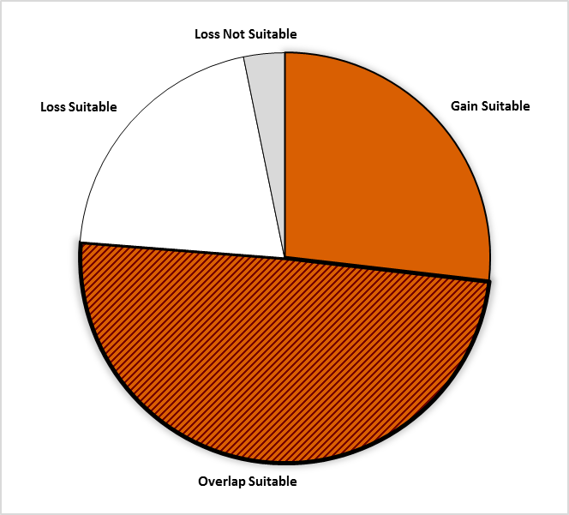
Gain = 26.8%
Area of no change = 49.4%
(Overlap with GBST)
Loss = 20.5%

Figure 1: Total area impacted under CBST for Class A seed including area falling within and without (suitable/non-suitable) the species range projected to 2030 for Coastal Douglas-fir

- Losses and gains vary between the Maritime low, Maritime high and the Submaritime BECvar Group as follows:

Seed BEC  Variant | BECvar Group | Current  Area of Use  hectares % | Loss  area of contraction  % | Gain  expansion  into new area  % | Overlap  area of no change  % | CBST Area of Use  Gain plus Overlap  hectares % | Overall CBST Impact  Gain plus Overlap
CWHdm | FDCMLOW2 | 6,581,344 100 | 27 | 32 | 71 | 6,465,412 98 | LOSS
CWHms2* | FDCMHIGH2 | 2,299,712 100 | 47 | 94 | 53 | 3,362,124 147 | GAIN
CWHms2* | FDCSMALL1 | 759,821 100 | 62 | 40 | 38 | 3,362,124 100 | No change

- Provincially, the new CBST AOU for Fdc is 134% (all Seed BEC Variants), indicating a one and a third-fold increase in the overall size of the deployment area previously identified under GBST.

- Spatially, the areas of use for FDCMHIGH2 and FDCSMALL1 now share the same CBST AOU. In terms of impacts relative to their GBST AOUs the two orchards have switched places [shifted] under CBST.

- For example, the deployment area for the maritime high elevation orchard has retained some high elevation areas in the maritime and also moved into the submaritime (CWHms1). The submaritime orchard, on the other hand, has lost some submaritime areas (river valleys) and gained area in the higher elevation maritime areas (CWHmm2 and CWHvm2). It is important to note that some of the impacts affecting SM BEC variants may be mitigated by use of Fdi seed.

- Impacts include loss of a suitable seed source for the CDFmm, as this BEC variant although suitable under CBST (i.e. supplied by FDCMLOW1), is being met by a limited finite seed source (i.e. retired orchards no longer producing) (Table 1).

- Management units with new orchard seed sources moving in (Figure 2, Opportunity = new seed source) : Arrowsmith, Kalum, Lillooet (submaritime), Merritt (submartime), North Coast, North Island, Pacific, Strathcona, Williams Lake; and, TFL 1, 19, 25, 26, 37, 39, 41, 44, 45 (submaritime), 46, 47, 54, 57, 6, and 61.

  - Management Units moderately or significantly impacted (by reduction of areas where orchard seed can be deployed) include the Lillooet(submaritime BECs) , Arrowsmith, Fraser, GBR South, North Island, Pacific, and Strathcona Timber Supply Areas; and Tree Farm Licenses 45, 19, 26, 37, 39, 44, 45, 46, 47, 54, 57, 6, and 61.

  - It is important to keep in mind that while some seed sources under CBST may be projected to move out of their current ‘Area of Use’ (Current AOU) as defined under GBST, in many cases new seed sources are also projected to move into areas suitable for use under CBST (Figure 2).

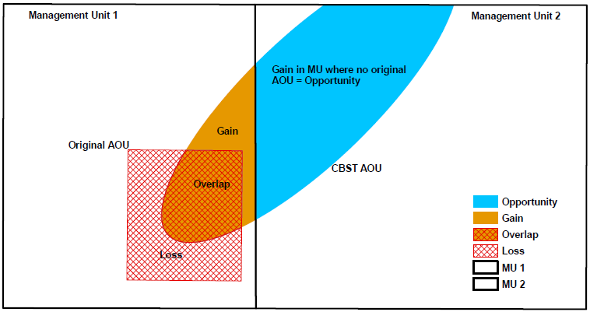

Figure 2: A schematic diagram of seed sources moving in/out of a management unit under CBST

Gaps under CBST (Genetic Class A and B)

Orphans
- Seed source (seedlot) without seed deployment area under CBST (no area of use) under CBST: NONE
- Plantation (cutblock) BEC variants without seed procurement area (no access to either Class A or Class B seed) under CBST: CWHwm, CWHws1, ESSFdk2, ESSFwc3, and MHun (Table 2). Those BEC variants shown in ‘bold’ cannot be mitigated by a slight adjustment to the genetic suitability; however, there is no current harvesting of Fdc in these BEC variants.

Table 2: Seed source and plantation orphans identified under CBST

CBST Orphan | BEC variant(s) identified as a CBST orphan | CBST orphan without a
Seed Source (seedlot) | NONE | seed deployment area
Plantation (cutblock) | CWHwm, CWHws1,ESSFdk2, ESSFwc3, MHun | seed procurement area

Seed Deficits:
- Analysis of current seed inventories indicates that under CBST there is a Class A deficit of approximately 0.5 M seedlings per year (6% of Fdc Class A recent historic annual planting) that cannot currently be met from orchard Class A seed sources. However, it appears that it can be addressed using a different distribution of seed surpluses from the CWHdm (through optimization).
- Class A deficits (all seed sources) for the most part are 80% within non-suitable BEC variants under CBST. Of those 20% deficits falling within suitable BEC variants an estimated (85%) are within one BEC variant (CWHxm2).
- It is important to note that the current analysis of deficits does not take the range of GW for FDc orchards into account. Therefore the deficits could be underestimated (where GW <5 seed is available but GW > 20 was previously selected). This will be looked at in further analysis.
- In addition, deficits are currently being prevented by use of seed inventories from multiple retired orchards. These inventories will eventually be used up leading to a potentially longer term gap if demand remains the same for these areas.

- Class B deficits are minor, focused in the CWHws2, fall entirely in BEC variants that can no longer be planted under CBST. These deficits may have been mitigated by recent Fdc collections made in 2018. If that is not the case, they could easily be mitigated by future collections.

Table 3: Seed Deficits under CBST based on Historical Planting

Genetic Class | Annual Planting | Seed Deficit | Seed Deficit over Annual Planting | PLANTATION BEC variants representing the largest seed deficits (seed demand not met based on planting history from either suitable or non-suitable seed sources under CBST)
 | Pot’l trees | Pot’l trees | %
Class A | 7,887,485 | -506,905 | 6% | CWHxm2, IDFww, ESSFmw, MHmm2
Class B | 511,193 | -26,794 | 5% | CWHws2
Class A and B | 8,398,678 | -48,318 | 0.6% | CWHws2, MHmm2

Seed Surpluses
- Very significant surplus inventories exist of natural stand Class B seed sources. This is largely a legacy issue as a result of large cone collections made prior to Fdc orchards coming into production.
- Similarly, Class A surpluses are a legacy of BC’s progress toward a second and third generation breeding program, where higher GW seed sources are preferred over the lower GW seed from first generation orchards.
- Under CBST the largest surplus Class A seed inventories currently estimated (based on SPAR seedlot extracts) for the following plantation BEC variants, include: CWHds1, CWHms1, CWHvm1, CWHxm2, and CWHvm2.

Table 4: Seed Surpluses under CBST based on Historical Planting
Genetic Class | Annual Planting | Seed Surplus | Seed surplus over Annual Planting | PLANTATION BEC variants representing the largest surplus seed inventories (remaining after allocation of seed to suitable CBST BECs [by seed source] across plantation BEC variants with planting history
 | Pot’l trees | Pot’l trees | %
Class A | 7,887,485 | 29,331,415 | 372 | CWHds1, CWHvm1, CWH vm2, CWHms1, MHmm1
Class B | 511,193 | 47,153,107 | 9224 | CWHms1, CWHds1, CWHxm2, CWHmm1
Class A and B | 8,398,678 | 76,484,522 | 911 | CWHds1, CWHms1, CWHvm1, CWHxm2, CWHvm2
Species Specific Mitigation Options
Short Term (During Transition Period)
- Assessment of potential gaps pertaining to Fdc seed deficits will need ongoing analysis, based on expected changes to seed inventories (large 2018 crop, depletion of seed from retired orchards).
- Further analysis using a Genetic Worth lens is required (i.e. consideration of low gain versus high gain seed) before policy based mitigation options can be considered.

Long Term (Orchard Considerations, Forest Health and Ecology)
- CBST has resulted in a merging of two orchards (181, formerly submaritime; and, 406, formerly high elevation maritime) under CBST. Breeders need to explore realignment of orchards.
- Fdc is an advanced breeding program that already incorporates many US seed sources. Likelihood of opportunities for additional Fdc seed sources from the US is limited. Consider if US seed sources could be effectively infused into orchards or procured for use in BC.
- Transfer of Fdc from maritime BEC variants to the interior is also not acceptable. However, transfer of submaritime Fdc to the interior is acceptable.
- Fdc is a species that appears to have the ability to expand in the province with climate warming, subject to snow press during establishment. Further research is needed.

For more information
See Climate Based Seed Transfer - Impact and Gap Analysis. Please check back periodically for updates pertaining to the science, policy (amendments to the Standards), tools, and CBST Area of Use and Orchard (coverage) maps.

Use of Information
This document provides a summary of an assessment of impacts and gaps currently identified under Climate Based Seed Transfer (CBST) relative to geographically based seed transfer (GBST) as regulated under FRPA. Area-based data summaries were generated using CBST Areas of Use, April 5, 2018, based, in part, on the provincial Biogeoclimatic Ecosystem Classification (BEC version 10).
Use of information contained in this document is limited to province-wide species level interpretations as viewed through multiple lenses – seed planner, seed producer, seed owner, and seed user. Further updates to CBST AOU are anticipated (target, April 2020) due to further updates to BEC (BEC 11/12), as well, as other potential changes to science foundation data sets (climate variables, transfer functions). CBST impacts and/or gaps may change/vary at more refined scales. Use this information with caution when informing operational-level strategies, plans, seed selection and use; and, seedling requests.

CBST deployment area (area gained plus area of overlap) as compared to Geographically Based Seed Transfer
Source: CBST_Impact_Assessment_v.4.2.1SEPT272018.xlsx
Includes area covered by producing orchards, and retired orchards with seed inventory (active seedlots; CWHdm and CWHms2)
Under different scenarios this deficit can change (e.g increase/decrease due to Annual Allowable cut (AAC) lifts or net downs).
Recent historic annual planting data (2013-2017) extracted from RESULTS. Five year average updates are planned.
These PLANTATION BEC variants represent approximately 80% or more of the total seed deficit
Under different scenarios this surplus can change (e.g. seed additions and withdrawals)
Recent historic annual planting data (2013-2017) extracted from RESULTS. Five year average updates are planned.
These PLANTATION BEC variants represent approximately 80% or more of the total seed surplus

