CBST Impact and Gap Assessment – Provincial Summary
March 2019

Interior Douglas-fir (FDI)

This document is a summary of the ‘Transitioning to Climate Based Seed Transfer in British Columbia: Assessment of Impacts and Gaps under CBST – Provincial Level, by Species, March, 2019’ report for Interior Douglas-fir (Fdi).
Key Findings
Orchard seed sources under CBST
Under CBST, orchards that have the same ‘Seed BEC variant’ are deployable to the same set of BEC variants (climate space). For example, orchards 232 and 226 both have the same ‘Seed BEC variant’ (ICHmk3); and, therefore share the same seed deployment area (i.e. CBST Area of Use). Provincially, BC’s ten Fdi orchards are assigned to one of 8 ‘Seed BEC variants’, there is considerable overlap among the seed deployment areas in terms of the BEC variants in which they can be deployed.
Table 1: Orchard seed sources by CBST Seed BEC variant and BECvar Group - FDI
Seed BEC Variant (assigned under CBST) | BECvar  Group (link to GBST for transition purposes) | Orchards
ICHdw1 | FDINELOW1 | 321 Grandview (PRT/SELECTSD)
ICHmk3 | FDIQLLOW1 | 232 Vernon (VSOC/SELECTSD), 226 Vernon (VSOC)
ICHmw1 | FDIEKLOW1 | 336 Bailey (FLNRO)
ICHmw2 | FDINEHIGH1 | 324 Bailey (FLNRO)
ICHmw3 | FDITOHIGH1 | 354 Grandview (PRT/SELECTSD)
IDFmw1 | FDITOLOW1 | 355 Kalamalka (FLNRO)
SBSdh1 | FDIPGLOW1 | 225 Vernon (VSOC), 233 Vernon(VSOC/SELECTSD)
SBSdw1 | FDICTLOW1 | 231 Vernon (VSOC)
Orchards marked in ‘purple’ denote retired orchards. Orchards marked in ‘blue’ denote developing or established orchards (no seed production yet).

Detailed information on which BEC variants make up the CBST seed deployment area (based on the Seed BEC variant assigned to an orchard) is available in SPAR and the CBST Seedlot Selection Tool. Maps (‘pdfs’) of orchard and natural stand seed deployment areas are available here: CBST Data and Maps.

Impacts identified under CBST (Genetic Class A)

Seed Deployment relative to GBST

- CBST impacts relative to GBST (not including species suitability): The area of use (AOU) available to Fdi orchard seed (all Seed BEC Variants) under GBST is reduced overall by 55% in the move to CBST. This loss is balanced by a gain in new area (hectares) of 185% relative to GBST. In addition, 45% of area identified under GBST remains unchanged (overlaps with CBST).
- CBST impacts relative to GBST (including species suitability): The total area (hectares) impacted under CBST for Fdi Class A seed after factoring in species suitability (i.e. area identified within /without [beyond] the species range projected to 2030) is shown below (Figure 1).

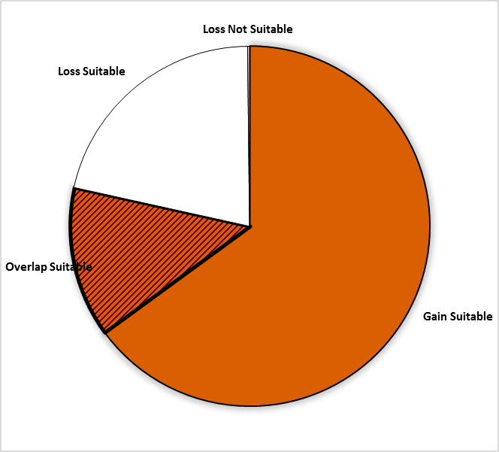
Area of no change = 13.5%
(Overlap with GBST)
Loss = 21.4%
Gain = 65%
Loss = 0.2%
(Non-suitable species)

Figure 1: Total percent area impacted under CBST for Class A seed including area falling both within and without (suitable/non-suitable) the species range projected to 2030 for Interior Douglas-fir

- Provincially, the new Fdi Class A CBST AOU is 229% (all Seed BEC Variants), indicating a two-fold increase of the seed deployment area previously identified under GBST.

- Losses and gains (relative to GBST) vary among seed sources as follows:

Seed BEC Variant | BECvar Group | Current  Area of Use  hectares % | Loss  area of contraction  % | Gain  expansion into new area  % | Overlap  area of no change  % | CBST Area of Use  Gain plus Overlap  hectares % | Overall CBST Impact  Gain plus Overlap
ICHdw1 | FDINELOW1 | 1,908,030 100 | 43 | 202 | 57 | 4,896,102 257 | GAIN
ICHmk3 | FDIQLLOW1 | 2,062,512 100 | 91 | 257 | 9  minimal | 5,461,631 265 | GAIN Shift
ICHmw1 | FDIEKLOW1 | 995,792 100 | 100 | 142 | 0  none | 1,414,612 142 | GAIN Shift
ICHmw2 | FDINEHIGH1 | 3,529,714 100 | 29 | 109 | 71 | 6,323,011 179 | GAIN
ICHmw3 | FDITOHIGH1 | ……………. …. | …. | …. | …. | ………….., …. | ……….
IDFmw1 | FDITOLOW1 | …………… …. | …. | …. | …. | …………… …. | ……….
SBSdh1 | FDIPGLOW1 | 4,500,647 100 | 68 | 157 | 32 | 8,432,809 187 | GAIN
SBSdw1 | FDICTLOW1 | 1,341,000 100 | 7 | 382 | 93 | 6,373,436 475 | GAIN

- Orchards assigned to the ICHmk3 (FDIQLLOW1) and the ICHmw1 (FDIEKLOW1) are the hardest hit by a significant loss (major shift) in deployment area in the move to CBST (See Table 1 for orchards impacted).
- Orchards assigned to the SBSdw1 (FDICTLOW1), ICHmk3 (FDIQLLOW1), and the ICHdw1 (FDINELOW1) have the largest expansion in area of use under CBST (See Table 1 for orchards impacted).

- Management units with new seed sources moving in (Figure 2, Opportunity = new seed source): 23 Timber Supply Areas (TSAs), 18 interior TSAs; 5 coastal TSAs (with sub-maritime BEC variants; and, 6 Tree Farm Licenses (TFLs) - 14, 35, 42, 49, 59, and 8.
- Management units most impacted (by a significant reduction of area where orchard seed can be deployed) include five Timber Supply Areas (Cascadia, Golden, MacKenzie, Revelstoke and Robson Valley) and five Tree Farm Licenses (TFL 30, 52, 53, 55, and 56) located in the north central and southeastern part of BC.

- It is important to keep in mind that while some seed sources under CBST may be projected to move out of their current ‘Area of Use’ (Current AOU) as defined under GBST, in many cases new seed sources are also projected to move into areas suitable for use under CBST (Figure 2).

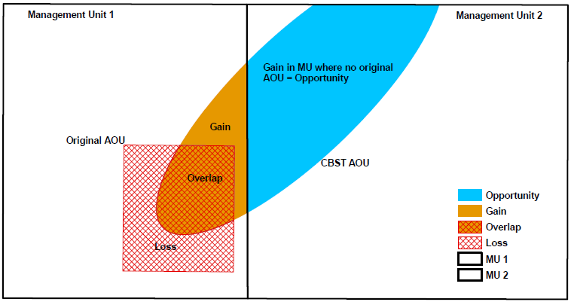

Figure 2: A schematic diagram of seed sources moving in/out of a management unit under CBST
Gaps identified under CBST (Genetic Class A and B)

Orphans
- Seed source (seedlot) without seed deployment area (no area of use) under CBST: 1 (SBSwk3). Plantation (cutblock) BEC variants without seed procurement area (no access to either Class A or Class B seed) under CBST: 14.
- The BEC variant orphans marked in bold will not be addressed through a planned adjustment to the genetic suitability threshold. While this is a substantive list of BECvariants, for the most part, Fdi is currently a minor ecological and silvicultural component of the tree species mix planted in these BEC variants.

Table 2: Seed source and plantation orphans identified under CBST

CBST Orphan | BEC variant(s) identified as a CBST orphan | CBST orphan without a
Seed Source (seedlot) | SBSwk3 | seed deployment area
Plantation (cutblock) | BWBSdk, BWBSmk, BWBSmw, BWBSwk2, ESSFmv4, ESSFun, ICHmc1, ICHvc, ICHvk2, ICHwc, Mhun, SBSmk2, SBSun, SBSvk. | seed procurement area

Seed Deficits
- Legacy shortfalls exist (i.e. pre-CBST there was a large deficit of Fdi Class A seed in BC).
- Analysis of current Fdi seed inventories indicates that under CBST there is a deficit of approximately 2.9 M seedlings per year (66% of total Fdi Class A recent historic annual planting) that cannot currently be met from orchard Class A seed sources.
- Class A seed deficits are split equally between plantation BEC variants supplied by Fdi seed sources that are suitable (51%) and non-suitable (49%) under CBST. The latter being seed that can no longer be planted under CBST. See full report for CBST suitable/non-suitable breakouts
- Overall, the largest Fdi seed deficits (after allocation of Class B seed) reside in the SBSmk1, ICHdw4, and the ICHxw.

Table 3: Seed Deficits under CBST based on Historical Planting

Genetic Class | Annual Planting | Seed Deficit | Seed Deficit over Annual Planting | PLANTATION BEC variants with the largest seed deficits (seed demand not met based on planting history from either suitable or non-suitable seed sources under CBST)
 | Pot’l trees | Pot’l trees | %
Class A | 4,418,537 | -2,935,412 | 66 | SBSdw1, ICHmw2, ICHmw3,ICHdw3, ICHdw1,ICHwk1,ICHmw5, IDFmw2,ICHwk2, ICHmk1
Class B | 5,101,894 | -117,401 | 2 | SBSmk1, SBSmk2, SBSwk3a
Class A and B | 9,520,431 | -337,970 | 3.5 | SBSmk1, ICHdw4, ICHxw

Seed Surpluses
- Provincially, analysis of current Fdi seed inventories indicates there is a one year supply of orchard Class A seed available under CBST based on recent historical annual planting (allocated across all seed sources to suitable plantation BEC variants).
- Very significant surplus inventories exist of natural stand Class B seed (legacy issue). A significant portion of this seed was likely collected prior to the establishment of Fdi orchards or juvenile orchards coming into full production.

Table 4: Seed Surpluses under CBST based on Historical Planting

Genetic Class | Annual Planting³ | Seed Surplus | Seed Surplus over Annual Planting | BEC variants representing the largest surplus seed inventories (remaining after allocation of seed to suitable CBST BECs [by seed source] across plantation BEC variants with planting history
 | Pot’l trees | Pot’l trees | %
Class A | 4,418,537 | 4,166,763 | 94 | SBSdk, SBSmc3, ESSFmv1, SBSmc2
Class B | 5,101,894 | 277,903,406 | 5,447 | SBSmc3, IDFdk1, SBSmc2, SBPSdc, SBPSxc
Class A and B | 9,520,431 | 282,070,169 | 2,963 | SBSmc3, IDFdk1, SBSmc2, SBPSdc, IDFdk3

Species Specific Mitigation Options

Short Term (During Transition Period)
- Increased production from the following orchards could help supply short term gaps: 324 Bailey (FLNRO) and 321 Grandview (PRT/SelectSd). Otherwise, continued use of GBST will be required to meet the Class A deficits in the short term.
- Class B seed deficits are minor and can be absorbed; however, a review of very large surplus legacy inventories is needed
- Alternate species should be considered for planting in the plantation BEC variant orphans, particularly those marked in bold.
- Explore if use of Fdi (from new seed source sunder CBST) might address rehabilitation of stands impacted by BC’s recent rise in catastrophic wildfires in the interior.

Long Term (Orchard Considerations, Forest Health and Ecology)
- Under CBST, Fdi seed cannot be transferred from interior or submaritime BEC variants to maritime BEC variants (Fdc performs much better than Fdi on the coast). Transfer of Fdc from maritime BEC variants to the interior is also not acceptable. However, transfer of submaritime Fdc to the interior is acceptable.
- Ecologist and tree species selection science and policy development is needed. Fdi is a species that appears to have the ability to expand on the coast with climate warming

For more information

See Climate Based Seed Transfer - Impact and Gap Analysis. Please check back periodically for updates pertaining to the science, tools (e.g. CBST Areas of Use maps) and policy (amendments to the Standards).

Use of Information
This document provides a summary of an assessment of impacts and gaps currently identified under Climate Based Seed Transfer (CBST) relative to geographically based seed transfer (GBST) as regulated under FRPA. Area-based data summaries were generated using CBST Areas of Use, April 5, 2018, based, in part, on the provincial Biogeoclimatic Ecosystem Classification (BEC version 10).
Use of information contained in this document is limited to province-wide species level interpretations as viewed through multiple lenses – seed planner, seed producer, seed owner, and seed user. Further updates to CBST AOU are anticipated (target, April 2020) due to further updates to BEC (BEC 11/12), as well, as other potential changes to science foundation data sets (climate variables, transfer functions). CBST impacts and/or gaps may change/vary at more refined scales. Use this information with caution when informing operational-level strategies, plans, seed selection and use; and, seedling requests.

CBST deployment area (area gained plus area of overlap) as compared to Geographically Based Seed Transfer
Source: CBST_Impact_Assessment_v.4.2.1SEPT272018.xlsx
Includes area covered by producing orchards, and retired orchards with seed inventory (active seedlots)
Under different scenarios this deficit can change (e.g increase/decrease due to Annual Allowable cut (AAC) lifts or net downs).
Recent historic annual planting data (2013-2017) extracted from RESULTS. Five year average updates are planned.
These PLANTATION BEC variants represent approximately 80% or more of the total seed deficit
Under different scenarios this surplus can change (e.g. seed additions and withdrawals)
These PLANTATION BEC variants represent approximately 80% or more of the total seed surplus

