CBST Impact and Gap Assessment – Provincial Summary
March, 2019

Western Larch (LW)

This document is a summary of the ‘Transitioning to Climate Based Seed Transfer in British Columbia’:
Assessment of Impacts and Gaps under CBST – Provincial Level, by Species, March, 2019 report for Western Larch (Lw).
Key Findings
Orchard seed sources under CBST
Under CBST, orchards that have the same ‘Seed BEC variant’ are deployable to the same set of BEC variants (climate space). For example, orchards 333 and 353 share the same ‘Seed BEC variant’ (ICHmk1); and, therefore, share the same seed deployment area (i.e. CBST Area of Use). Provincially, BC’s three Lw orchards (producing) are assigned to one of 2 ‘Seed BEC variants’. There is considerable overlap among the seed deployment areas in terms of the BEC variants in which they can be deployed.
Table 1: Orchard seed sources by CBST Seed BEC Variant and BECvar Group - LW
Seed BEC Variant (assigned under CBST) | BECvar Group (link to GBST during transition period) | Orchards
ICHdw1 | LWNELOW/LW2 | 332 FLNRO (Kalamalka)
ICHmk1 | LWEKALL/LW1 | 333 FLNRO (Kalamalka)
ICHmk1 | LWNEHIGH/LW1 | 353 Vernon (Coldwater)

Detailed information on which BEC variants make up the CBST seed deployment area (based on the Seed BEC variant assigned to an orchard) is available in SPAR and the CBST Seedlot Selection Tool. Maps of orchard and natural stand seed deployment areas are available here: CBST Data and Maps.

Impacts identified under CBST (Genetic Class A)

Seed Deployment relative to GBST

- CBST impacts relative to GBST (not including species suitability): The area of use (AOU) available to Lw Class A orchard seed (all Seed BEC Variants) under GBST is reduced overall by 40% in the move to CBST. This loss is balanced in part by a gain in new area (hectares) of 67% relative to GBST. In addition, 60% of deployment area identified under GBST remains unchanged (overlaps with CBST).
- CBST impacts relative to GBST (including species suitability): The total area (hectares) impacted under CBST for Lw Class A seed after factoring in species suitability (i.e. area identified within / without [beyond] the species range projected to 2030) is shown below (Figure 1).

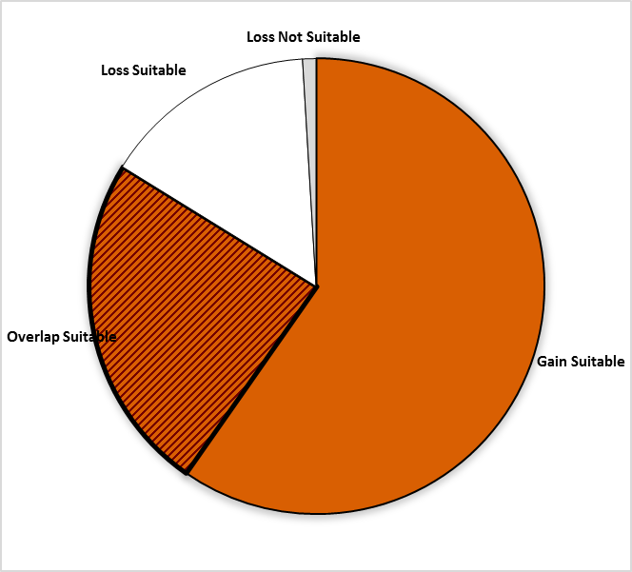
Gain = 59.7%
Area of no change = 24.1%
(Overlap with GBST)
Loss = 0.9%
(Non-suitable species)
Loss = 15.2%

Figure 1: Total area impacted under CBST for Class A seed including area falling within and without (suitable/non-suitable) the species range projected for 2030 for Western larch

- Losses and gains (relative to GBST) vary between seed sources as follows:

Seed BEC Variant | BECvar Group | Current  Area of Use  hectares % | Loss  area of contraction  % | Gain  expansion into new area  % | Overlap  area of no change  % | CBST Area of Use  Gain plus Overlap  hectares % | Overall CBST Impact  Gain plus Overlap
ICHdw1 | LWNELOW  /LW2 | 3,544,520 100 | 36 | 91 | 64 | 5,452,513 155 | GAIN
ICHmk1 | LWEKALL  /LW1 | 10,717,419 100 | 39 | 62 | 61 | 12,752,726 123 | GAIN
ICHmk1 | LWNEHIGH  /LW1 | 618,128 100 | 54 | 2017 | 46 | 12,752,726 2063 | GAIN

- Provincially, the new CBST AOU for Lw is 128% (all Seed BEC Variants), indicates a two-fold increase in the size of the deployment area previously identified under GBST. While two Lw orchards may now share the same deployment area under CBST (orchard 333 and 353), the potential deployment of Lw in BC (on an area basis) has not been reduced in the move to CBST.

- The Lw orchard 353 assigned to the ICHmk1 (LWNEHIGH/LW1) is the hardest hit with the greatest loss at 54%. This same orchard also has the largest expansion (nine fold) in area of use under CBST (See Table 1 for orchards impacted).

- Management units with new orchard seed sources moving in under CBST (Figure 2, Opportunity = new seed source) include: 20 Timber Supply Areas (TSAs), 2 of which are coastal (deployment to submaritime BEC variants only); and, 9 Tree Farm Licenses (TFLs)
- Management units most impacted (by a significant reduction of area where orchard seed can be deployed) include: 16 TSAs, including 4 coastal (deployment to submaritime BEC variants only); and, 5 TFLs, including 1 coastal (deployment to submariitme BEC variants only) (14, 3, 45, 52 and 53).

- It is important to keep in mind that while some seed sources under CBST may be projected to move out of their current ‘Area of Use’ (Current AOU) as defined under GBST, in many cases new seed sources are also projected to move into areas suitable for use under CBST (Figure 2).

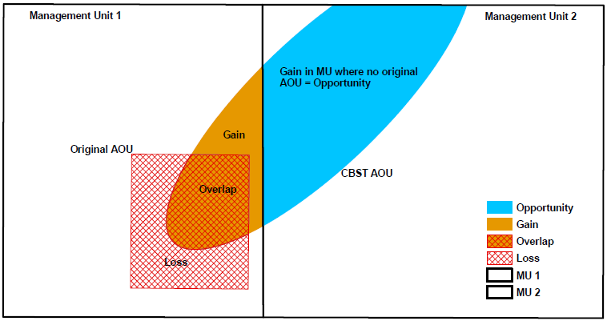

Figure 2: A schematic diagram of seed sources moving in/out of a management unit under CBST

Gaps identified under CBST (Genetic Class A and B)

Orphans
- Seed source (seedlot) without seed deployment area (no area of use) under CBST: NONE (nb. Although, Larch Tamarac (Lt) seedlots collected from the BWBSmw are without deployment area)
- Plantation (cutblock) BEC variants without seed procurement area (no access to either Class A or Class B seed) under CBST: NONE

Table 2: Seed source and plantation orphans identified under CBST

CBST Orphan | BEC variant(s) identified as a CBST orphan | CBST orphan without a
Seed Source (seedlot) | none [LT – BWBSmw] | seed deployment area
Plantation (cutblock) | none | seed procurement area

Seed Deficits
- Analysis of current seed inventories, based on recent historic planting, indicates that under CBST there is a deficit of approximately 0.7M seedlings per year (an estimated 13% of total Lw Class A recent historic annual planting) that cannot currently be met by orchard Class A seed sources.

- However, the deficit in orchard Class A seed can currently only be met by a potential increase in production by 20% of existing orchards (i.e. orchard seed sources with seed deployment areas that are suitable under CBST).

- The Class B deficit is negligible, as is recent historic annual planting (<0.5M annual planting). The demand for Class B seed resides, for the most part (80%) in plantation BEC variants outside CBST areas of use.

- Overall, the largest Lw seed deficits (after allocation of Class B seed) reside in the ICHxw and the ICHmw4. See full report for more detailed analysis of deficits.

Table 2: Seed Deficits under CBST based on Historical Planting

Genetic Class | Annual Planting | Seed Deficit | Seed Deficit over Annual Planting | PLANTATION BEC variants representing the largest seed deficits (seed demand not met based on planting history from either suitable or non-suitable seed sources under CBST)
 | Pot’l trees | Pot’l trees | %
Class A | 5,736,392 | -736,446 | 13% | ESSFdk2, ICHdw1, ICHmw4, ICHxw, IDFdk5, ICHwk1
Class B | 321,122 | -2,189 | 0.6 (<1) | ICHxwa
Class A and B | 6,057,514 | -195,700 | 3% | ICHxw, ICHmw4

Seed Surpluses
- Moderate to high (large) surplus inventories exist of both Class A orchard and Class B natural stand seed (legacy issue). The latter likely due to large collections prior to Lw orchards coming into production. Lw seed inventories continue to be replaced by higher gain seed.

- Analysis of current seed inventories indicates an estimated 7 years supply of orchard Class A based on recent historic annual planting (allocated across all seed sources).

Table 3: Seed Surpluses under CBST based on Historical Planting

Genetic Class | Annual Planting³ | Seed Surplus | Seed Surplus over Annual Planting | PLANTATION BEC variants representing the largest surplus seed inventories (remaining after allocation of seed to suitable CBST BECs [by seed source] across plantation BEC variants with planting history
 | Pot’l trees | Pot’l trees | %
Class A | 5,736,392 | 39,148,208 | 683 | SBSmc2, SBSdk, SBSdw2, SBSmc3, IDFdk3
Class B | 321,122 | 59,870,078 | 18,644 | SBSmc3, SBSdk, ESSFmv1, SBPSmc, SBSdw2, IDFdk3
Class A and B | 6,057,514 | 99,018,286 | 1,635 | SBSmc2, SBSdk, SBSmc3, SBSdw2, ESSFmv1, IDFdk3

Species Specific Mitigation Options

Short Term (During Transition Period)
- Optimization of seed (through re-distribution of surplus seed supplied by an orchard among BEC variants with deficits) could, in the majority of cases, substantially reduce seed deficits.
- Increased production could also help supply demand over the short term.
- Continued use of GBST will be required to meet the Class A deficits in the short term.
- Class B seed deficits are minor and can be absorbed; however, a review of very large surplus legacy inventories is needed.
- Before the Transition Period ends, the LW1 and LW2 zones (introduced in 2014 to provide for early adoption of assisted migration of Lw to address climate change), will need to be rationalized with the new CBST areas of use for Lw. There is a possibility that accepting the new CBST Area of Use will result in some retraction of current Lw1 and Lw2 zones.

Long Term (Orchard Considerations, Forest Health and Ecology)
- Coordination with ecologists on the assisted migration of Lw beyond the current species distribution may include the need for consultation with some First Nations.
- The level of species assisted migration that will be accepted in BC will be an important factor in the planning for new Lw orchards under CBST.

For more information

See Climate Based Seed Transfer - Impact and Gap Analysis. Please check back periodically for updates pertaining to the science, policy (amendments to the Standards), tools, and CBST Area of Use and Orchard (coverage) maps.

Use of Information
This document provides a summary of an assessment of impacts and gaps currently identified under Climate Based Seed Transfer (CBST) relative to geographically based seed transfer (GBST) as regulated under FRPA. Area-based data summaries were generated using CBST Areas of Use, April 5, 2018, based, in part, on the provincial Biogeoclimatic Ecosystem Classification (BEC version 10).
Use of information contained in this document is limited to province-wide species level interpretations as viewed through multiple lenses – seed planner, seed producer, seed owner, and seed user. Further updates to CBST AOU are anticipated (target, April 2020) due to further updates to BEC (BEC 11/12), as well, as other potential changes to science foundation data sets (climate variables, transfer functions). CBST impacts and/or gaps may change/vary at more refined scales. Use this information with caution when informing operational-level strategies, plans, seed selection and use; and, seedling requests.

CBST deployment area (area gained plus area of overlap) as compared to Geographically Based Seed Transfer
Source: CBST_Impact_Assessment_v.4.2.1SEPT272018.xlsx
Includes area covered by producing orchards, and retired orchards with seed inventory (active seedlots)
Under different scenarios this deficit can change (e.g increase/decrease due to Annual Allowable cut (AAC) lifts or net downs).
Recent historic annual planting data (2013-2017) extracted from RESULTS. Five year average updates are planned.
These PLANTATION BEC variants represent approximately 80% or more of the total seed deficit
Under different scenarios this surplus can change (e.g. seed additions and withdrawals)
These PLANTATION BEC variants represent approximately 80% or more of the total seed surpluses

