CBST Impact and Gap Assessment – Provincial Summary
March, 2019

Western White Pine (PW)

This document is a summary of the “Transitioning to a Climate Based Seed Transfer System in British Columbia: Assessment of Impacts and Gaps under CBST – Provincial Level, by Species” report for Western White Pine (Pw).
Key Findings
Orchard Seed Sources under CBST

Under CBST, orchards that have the same ‘Seed BEC variant’ are deployable to the same set of BEC variants (climate space). For example, orchards 175 and 403 (PWMLOW1) both have the same ‘Seed BEC variant’ (CWHxm2); and, therefore share the same seed deployment area (i.e. CBST Area of Use). Provincially, BC’s eight (6 producing, 1 established, and 1 retired) Pw orchards are assigned to one of 2 ‘Seed BEC variants’.
In general, the coastal orchard supplies coastal BEC variants and the interior orchard supplies interior BEC variants (there is a very little overlap in the submaritime BEC variants). In both cases there is a significant shift in seed deployment area away from that previously implemented under geographically based seed transfer. Since Pw seed sources are not generally transferable between the coast and interior (despite some limited transfers to the submartime), there are essentially two distinct analyses required for Pw.
Table 1: Orchard seed sources by Seed BEC Variant and BECvar Group - PW

Seed BEC Variant [assigned under CBST] | BECvar Group (to link to GBST during transition period) | Orchards
CWHxm2 | PWMLOW1 | 174* Sechelt (CANFOR), 175* Saanich FLNRO), 403* Mt Newton (TWFC)), 998 Dorena (USA)
ICHmw2 | PWKQALL1 | 335* (Bailey (FLNRO), 351* (MOF Skimikin), 609 Skimikin (FLNRO), 999 Moscow Idaho (USA)
Orchards marked in “purple” denote retired orchards. *Western White Pine Blister Rust (WPBR) resistant (rust tolerant) orchard

Detailed information on which BEC variants make up the CBST seed deployment area (based on the Seed BEC variant assigned to an orchard) is available in SPAR and the CBST Seedlot Selection Tool. Maps of orchard and natural stand seed deployment areas are available here: CBST Data and Maps.

Impacts identified under CBST (Genetic Class A)

Seed Deployment relative to GBST

- CBST impacts relative to GBST (not including species suitability): The area of use (AOU) available to Pw Class A orchard seed sources (all Seed BEC Variants) under GBST is reduced 53% (coastal) and 73% (interior) in the move to CBST. This loss is balanced by an overall gain in new area of 29% (coastal) and 139% (interior) relative to GBST. In addition, 47% (coastal) and 27% (interior) of area available for seed deployment remains unchanged (overlaps with CBST).

- CBST impacts relative to GBST (including species suitability): The total area (hectares) impacted under CBST for Pw Class A seed after factoring in species suitability (i.e. area identified within /without (beyond) the species range projected to 2030) is shown below (Figure 1).

Loss = 11.8%
(Non-suitable species)
Loss = 2.3%
(Non-suitable species)
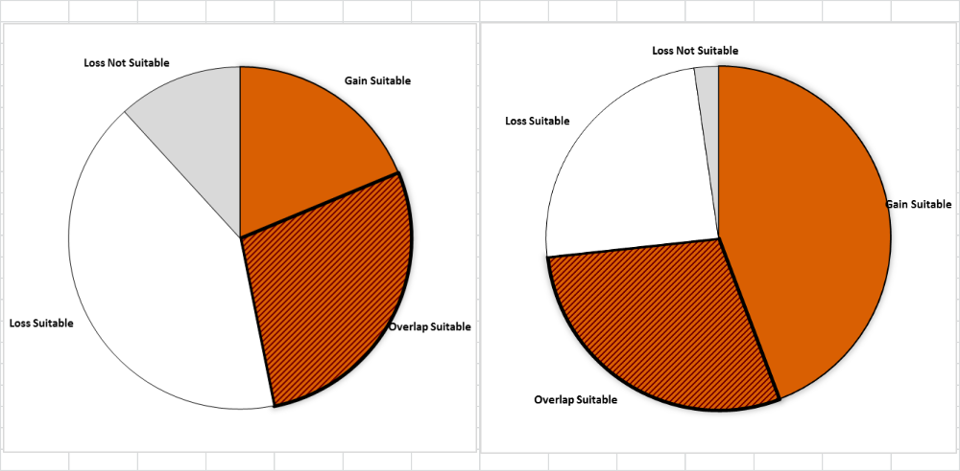
Loss = 22.6%
Area of no change = 31.8%
(Overlap with GBST)
Gain = 43.3%
Area of no change = 28.1%
(Overlap with GBST)
Gain = 18.7%
Loss = 41.4%

Figure 1: Total area impacted under CBST for Class A seed including area falling within and without (suitable/non-suitable) the species range projected to 2030 for coastal (left) and interior (right) Western White Pine

- Losses and gains (relative to GBST) vary between coastal and interior seed sources as follows:

Seed BEC  Variant | BECvar Group | Current  Area of Use  hectares % | Loss  area of contraction  % | Gain  expansion  into new area  % | Overlap  area of no change  % | CBST Area of Use  Gain plus Overlap  hectares % | Overall CBST Impact  Gain plus Overlap
CWHxm2 | PWMLOW1 | 6,006,514 100 | 94 | 35 | 55 | 5,391,867 90 | LOSS Shift
ICHmw2 | PWKQALL1 | 4,046,682 100 | 72 | 70 | 70 | 6,998,877 173 | GAIN Shift

- Provincially, the new Pw Class A CBST AOU (gain plus overlap) for orchard seed sources (all Seed BEC Variants) is 76% (coastal) and 166% (interior) than that previously identified under GBST.

- Coastal orchards assigned to CWHxm2 (PWMLOW1) are hit the hardest by a significant shift northward out of the warm, drier areas on the Sunshine Coast and eastern Vancouver Island into the submaritime coastal interior transition areas in the move to CBST.

- Similarly, interior orchards assigned to the ICHmw2 (PWKQALL1) are also shifting northward out of their current deployment area under GBST; however, overall, they have a greater expansion in seed deployment area under CBST (See Table 1 for orchards impacted).

- Management units with new seed sources moving in (Figure 2, Opportunity = new seed source) include: 17 Timber Supply Areas (TSAs) and 6 Tree Farm Licenses (TFLs).

- Management Units most impacted under CBST (i.e. with significant reduction in area where orchard seed sources can be deployed) include: 10 TSAs (coastal and interior) and 13 TFLs (coastal and interior).

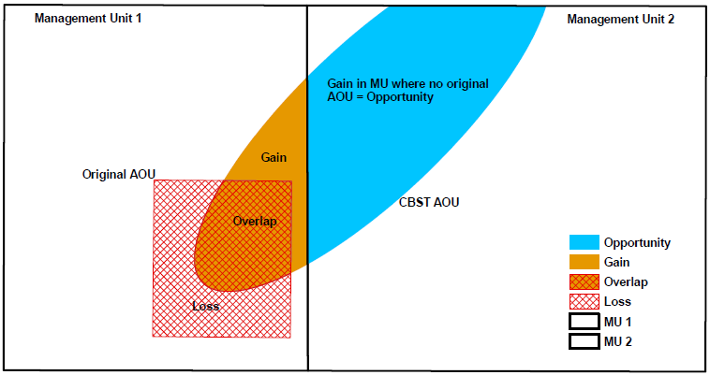

Figure 2: A schematic diagram of seed sources moving in/out of a management unit under CBST
Gaps identified under CBST (Genetic Class A and B)

Orphans
- Plantation (cutblock) BEC variants without seed procurement area (no access to either Class A or Class B seed) under CBST: none
- Seed source (seedlots) without seed deployment area (no area of use) under CBST: none

Table 2: Seed source and plantation orphans identified under CBST

CBST Orphan | BEC variant(s) identified as a CBST orphan | CBST orphan without a
Seed Source (seedlot) | none | seed deployment area
Plantation (cutblock) | none | seed procurement area

Seed Deficits
- Analysis of current seed inventories indicates that under CBST there is a deficit of approximately 0.6M seedlings per year (an estimated 52% of total Pw Class recent historic annual planting) that cannot currently be met by orchard Class A seed sources.
- Class A Pw seed deficits are split between plantation BEC variants supplied by Pw seed sources that are suitable and non-suitable under CBST. The latter being seed that can no longer be planted under CBST.
- Class B seed use is negligible; therefore, seed deficits are not applicable.
- Overall, the largest Pw seed deficits (after allocation of Class B seed) reside in the ICHmw2, ICHdw1, and ICHdw4.
Table 3: Seed Deficits under CBST based on Historical Planting

Genetic Class | Annual Planting | Seed Deficit | Seed Deficit over Annual Planting | Plantation BEC variants representing the largest Seed Deficits (seed demand not met based on planting history from either suitable or non-suitable seed sources under CBST)
 | Pot’l trees | Pot’l trees | %
Class A | 1,162,097 | -601,016 | 52% | ICHmw2, ICHwk1, CWHxm2, ICHmw5, ICHdw1, CWHxm1
Class B | 647 | 0 | 0% | none
Class A and B | 1,162,743 | -155,036 | 13% | ICHmw2, ICHdw1, ICHdw4

Seed Surpluses
- Although it appears that there is a 3 year supply of orchard Class A Pw seed inventory, it is estimated that approximately one quarter of the surplus seed inventory cannot be planted under CBST.
- Very little Class B Pw seedlings have been planted in the past 5 years (the preference being for white pine blister rust resistant Class A seed), resulting in a significant surplus of Class B seed inventory.

Table 4: Seed Surpluses under CBST based on Historical Planting
Genetic Class | Annual Planting³ | Seed Surplus | Seed Surplus over Annual Planting | Plantation BEC variants representing the largest surplus seed inventories (remaining after allocation of seed to suitable CBST BECs [by seed source] across plantation BEC variants with planting history
 | Pot’l trees | Pot’l trees | %
Class A | 1,162,097 | 3,618,203 | 311 | CWHms1, CWHvm1, SBSwk1, ESSFwk1, ESSFmk, SBSvk, CWHds1, ICHwk2, ICHmk3
Class B | 647 | 8,145,453 | …. | ICHwk4, SBswk1, CWHds1, ESSFwk1, CWHxm2, CWHms1, ESSFdc3, ICHwk1, ICHwk2, MSxv, ICHmw3
Class A and B | 1,162,743 | 11,763,657 | 1,012 | ICHwk4, CWHms1, SBSwk1, ESSFwk1, CWHds1, CWHvm1, ICHwk2, ESSFmk, ICHmk3, ESSFdc3, iCHmw3, SBSvk, MSdm2

Species Specific Mitigation Options

Short Term (During Transition Period)
- Since, an estimated 80% of the recent historical demand for Pw seed is sourced from orchards that continue to be deployable under CBST, seed deficits could potentially be mitigated through orchard crop management (e.g. increases to annual production).
- White Pine Blister Rust resistant (rust tolerant) seed will continue to be in the most demand for Pw, regardless of climate change options.
- A review of very large surplus legacy natural stand Class B inventories is needed using a geneti c conservation lens under a range of climate change scenarios (i.e. demand could shift to a greater need for /use of seed).

Long Term (Orchard Considerations, Forest Health and Ecology)
- Published data continues to support that Pw should be restricted in transfer from the coast to the interior and vice versa. Ongoing research and breeding for White Pine Blister Rust resistance are priorities for this species.
- Establishment of a submaritime coastal-interior transition (WPBR resistant) orchard could be considered for use in the interior or on the coast (Submaritime BEC variants), providing maximum flexibility for matching climates. Further research and analysis is needed.

For more information

See Climate Based Seed Transfer - Impact and Gap Analysis. Please check back periodically for updates pertaining to the science, policy (amendments to the Standards), tools, and CBST Area of Use and Orchard (coverage) maps.

Use of Information
This document provides a summary of an assessment of impacts and gaps currently identified under Climate Based Seed Transfer (CBST) relative to geographically based seed transfer (GBST) as regulated under FRPA. Area-based data summaries were generated using CBST Areas of Use, April 5, 2018, based, in part, on the provincial Biogeoclimatic Ecosystem Classification (BEC version 10).
Use of information contained in this document is limited to province-wide species level interpretations as viewed through multiple lenses – seed planner, seed producer, seed owner, and seed user. Further updates to CBST AOU are anticipated (target, April 2020) due to further updates to BEC (BEC 11/12), as well, as other potential changes to science foundation data sets (climate variables, transfer functions). CBST impacts and/or gaps may change/vary at more refined scales. Use this information with caution when informing operational-level strategies, plans, seed selection and use; and, seedling requests.

CBST deployment area (area gained plus area of overlap) as compared to Geographically Based Seed Transfer
Source: CBST_Impact_Assessment_v.4.2.1SEPT272018.xlsx
Includes area covered by producing orchards, and retired orchards with seed inventory (active seedlots)
Under different scenarios this deficit can change (e.g increase/decrease due to Annual Allowable cut (AAC) lifts or net downs).
Recent historic annual planting data (2013-2017) extracted from RESULTS. Five year average updates are planned.
These PLANTATION BEC variants represent approximately 80% or more of the total seed deficit
Under different scenarios this surplus can change (e.g. seed additions and withdrawals)
These PLANTATION BEC variants represent approximately 80% or more of the total seed surplus

