CBST Impact and Gap Assessment – Provincial Summary
March 2019

Ponderosa [Yellow] Pine (PY)

Key Findings
This document is a summary of the ‘Transitioning to Climate Based Seed Transfer in British Columbia’:
Assessment of Impacts and Gaps under CBST – Provincial Level, by Species, March, 2019 report for Ponderosa [Yellow] pine (Py).
Orchard seed sources under CBST
Under CBST, orchards that have the same ‘Seed BEC variant’ are deployable to the same set of BEC variants (climate space). For example, orchards 346 and 345 both have the same ‘Seed BEC variant’ (ICHxw) and therefore share the same seed deployment area (i.e. CBST Area of Use). Provincially, BC’s one producing Py orchard is assigned to the ICHxw Seed BEC Variant.
Table 1: Orchard seed sources by CBST Seed BEC Variant and BECvar Group - PY
Seed BEC Variant (assigned under CBST) | BECvar Group (link to GBST for transition purposes) | Orchards
ICHxw | PYSILOW1 | 346 Bailey (FLNRO), [345 Skimikin (FLNRO)  ]
Orchards marked in purple are retired. Orchards marked in blue are established, but not in production (no crop).
Note: [Orchard 345 Skimikin] is no longer suitable for production and is to be retained for conservation purposes.

Detailed information on which BEC variants make up the CBST seed deployment area (based on Seed BEC variants assigned to an orchard) is available in SPAR, the CBST tool; and, in Appendix 1 of the full report. Maps of orchard and natural stand seed deployment areas are available here: CBST Data and Maps.

Impacts identified under CBST (Genetic Class A)

Seed Deployment relative to GBST

- CBST impacts relative to GBST (not including species suitability): The area of use (AOU) available to Py orchard seed (all Seed BEC Variants) under GBST is reduced overall by 50% in the move to CBST. This loss is balanced by a gain in new area (hectares) of 40% relative to GBST. In addition, 50% of area identified under GBST remains unchanged (overlaps with CBST).

- CBST impacts relative to GBST (including species suitability): The total area (hectares) impacted under CBST for Py Class A seed after factoring in species suitability (i.e. area identified within /without (beyond) the species range projected to 2030) is shown below (Figure 1).
Loss = 1.2%
(Non-suitable species)
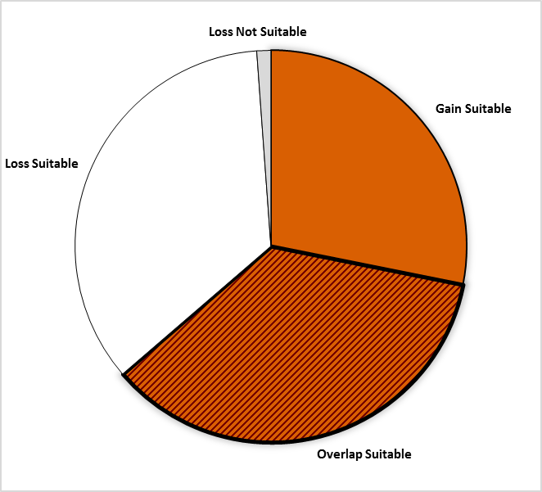
Loss = 35.2%
Area of no change = 35.5%
(Overlap with GBST)

Gain = 28.2%

Figure 1: Total area impacted under CBST for Class A seed including area falling within and without (suitable/non-suitable) the species range projected to 2030 for Ponderosa [Yellow] Pine

- Loss and gain for the PYSILOW1 BECvar Group is as follows:

Seed BEC  Variant | BECvar Group | Current  Area of Use  hectares % | Loss  area of contraction  % | Gain  expansion  into new area  % | Overlap  area of no change  % | CBST Area of Use  Gain plus Overlap  hectares % | Overall CBST Impact  Gain plus Overlap
ICHxw | PYSILOW1 | 3,233,904 100 | 50 | 40 | 50 | 2,866,251 90 | LOSS

- Provincially, the new CBST Area of Use (gain plus overlap) for Py seed sources (all Seed BEC Variants) is 90%, a slight decrease in seed deployment area than that previously identified under GBST.

- Py orchards assigned to the ICHxw (PYSILOW1) are moderately impacted with a shift (loss) in deployment area out of the warmer, drier Cariboo (Williams Lake, 100 Mile House) and Rocky Mountain trench (Revelstoke) regions in the move to CBST (See Table 1 for orchards impacted).
- Management units with new seed sources moving in (Figure 2, Opportunity = new seed source): 5 Timber Supply Areas (TSAs) all located in the submaritime coastal-interior transition region (GBR North, GBR South, Kingcome, Mid Coast and Soo). There are no new seed sources moving into Tree Farm Licenses (TFLs).
- Management Units most impacted under CBST (i.e. with significant reduction in area where orchard seed sources can be deployed) include: 6 TSAs (4 entirely lost – Cascadia, Quesnel, Revelstoke, and Williams Lake; 100 Mile 93%, and Golden 45%) and 2 TFLs (1 entirely lost – TFL 56, TFL 23 80%).

- It is important to keep in mind that while some seed sources under CBST may be projected to move out of their current ‘Area of Use’ (Current AOU) as defined under GBST, in many cases new seed sources are also projected to move into areas suitable for use under CBST (Figure 2).

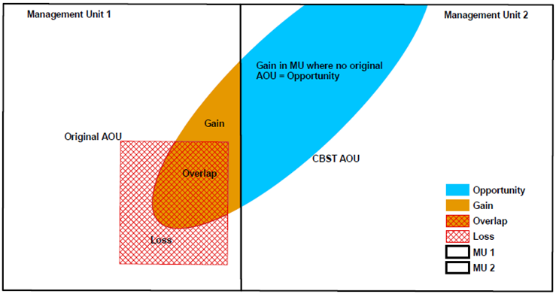

Figure 2: A schematic diagram of seed sources moving in/out of a management unit under CBST

Gaps identified under CBST (Genetic Class A and B)

Orphans
- Seed source (seedlot) without seed deployment area (no area of use) under CBST: NONE
- Plantation (cutblock) BEC variants without seed procurement area (no access to either Class A or Class B seed) under CBST: BGxh1 (cannot be addressed with a minor amendment to genetic suitability; further analysis required to determine appropriate seed sources if needed for this BEC variant (e.g. collections from outside BC).

Table 2: Seed source and plantation orphans identified under CBST

CBST Orphan | BEC variant(s) identified as a CBST orphan | CBST orphan without a
Seed Source (seedlot) | none | seed deployment area
Plantation (cutblock) | BGxh1 | seed procurement area
Seed Deficits
- Analysis of current Py Class A seed inventories indicates that under CBST there is a Class A deficit of 0.07 M seedlings per year (57% of total Py Class A recent historic annual planting) that cannot currently be met from orchard Class A seed sources.

- However, this total deficit could be reduced to 0.01M (9% of recent historic annual planting) through optimization of Class A seed surpluses; whereby, a different distribution of seed (e.g. from IDFww and IDFmw2) is used to meet gaps. This remaining deficit cannot currently be met by Class B inventories. A collection may be needed to supply the ICHmw5.

- Class A Py seed deficits reside for the most part (83%) in plantation BEC variants supplied by seed sources that can no longer be planted under CBST; whereas, Class B deficits reside approximately two thirds (71%) in plantation BEC variants supplied by Py seed sources that can no longer be planted under CBST. See full report for CBST suitable/non-suitable breakouts

- The Class B deficit is negligible comprising 3% of total Py Class B recent historic annual planting.

- Overall, Py seed deficits (after allocation of Class B seed) reside in the CWHds1 (-3,447 trees) and the ICHdm (-1,421 trees). New cone collections will be required to supply seed to these plantation BEC vars.

Table 3: Seed Deficits under CBST based on Historical Planting

Genetic Class | Annual Planting | Seed Deficit | Seed Deficit over Annual Planting | PLANTATION BEC variants representing the largest seed deficits (seed demand not met based on planting history from either suitable or non-suitable seed sources under CBST)
 | Pot’l trees | Pot’l trees | %
Class A | 12,486 | -7,134 | 57 | ICHdw1, ICHmw5
Class B | 167,023 | -5,085 | 3 | CWHds1, ICHdm
Class A and B | 179,509 | -5,085 | 3 | CWHds1, ICHdm

Seed Surpluses
- Class A orchard seed surpluses are minimal.

- Fairly large surplus inventories exist of natural stand Class B seed sources. This is largely a legacy issue as collections were made prior to the Py orchard coming into production.

- Under CBST the largest surplus Class A seed inventories currently estimated (based on SPAR seedlot extracts) for the following plantation BEC variants, include: IDFww, IDFmw2 and IDFxm2.

Table 3: Seed Surpluses under CBST based on Historical Planting

Genetic Class | Annual Planting² | Seed Surplus | Seed Surplus over Annual Planting | PLANTATION BEC variants representing the largest surplus seed inventories (remaining after allocation of seed to suitable CBST BECs [by seed source] across plantation BEC variants with planting history)
 | Pot’l trees | Pot’l trees | %
Class A | 12,486 | 4,114 | 33 | IDFww, IDFmw, IDFxm2
Class B | 167,023 | 18,174,997 | 10882 | IDFxh2, IDFdk3, IDFdk1, BGxw2
Class A and B | 179,509 | 18.179,091 | 10127 | IDFxh2, IDFdk3, IDFdk1, BGxw2

Species Specific Mitigation Options

Short Term (During Transition Period)
- Natural stand seed collections of will address deficits in the short term.

Long Term (Orchard Considerations, Forest Health and Ecology)
- FIRM is currently exploring the potential for an expanded Py breeding program – Py has been shown to be a resilient species with a broader range than currently covered by that of BC’s forest tree improvement program.
- Should harvesting or wildfire increase the need for planting in the IDF zone – the supply of Py Class B seed could become important.

For more information

See Climate Based Seed Transfer - Impact and Gap Analysis. Please check back periodically for updates pertaining to the science, policy (amendments to the Standards), tools, and CBST Area of Use and Orchard (coverage) maps.

Use of Information
This document provides a summary of an assessment of impacts and gaps currently identified under Climate Based Seed Transfer (CBST) relative to geographically based seed transfer (GBST) as regulated under FRPA. Area-based data summaries were generated using CBST Areas of Use, April 5, 2018, based, in part, on the provincial Biogeoclimatic Ecosystem Classification (BEC version 10).
Use of information contained in this document is limited to province-wide species level interpretations as viewed through multiple lenses – seed planner, seed producer, seed owner, and seed user. Further updates to CBST AOU are anticipated (target, April 2020) due to further updates to BEC (BEC 11/12), as well, as other potential changes to science foundation data sets (climate variables, transfer functions). CBST impacts and/or gaps may change/vary at more refined scales. Use this information with caution when informing operational-level strategies, plans, seed selection and use; and, seedling requests.

CBST deployment area (area gained plus area of overlap) as compared to Geographically Based Seed Transfer
Source: CBST_Impact_Assessment_v.4.2.1SEPT272018.xlsx
Includes area covered by producing orchards, and retired orchards with seed inventory (active seedlots; CWHdm and CWHms2)
Under different scenarios this deficit can change (e.g increase/decrease due to Annual Allowable cut (AAC) lifts or net downs).
Recent historic annual planting data (2013-2017) extracted from RESULTS. Five year average updates are planned.
These PLANTATION BEC variants represent approximately 80% or more of the total seed deficit
Under different scenarios this surplus can change (e.g. seed additions and withdrawals)
These PLANTATION BEC variants represent approximately 80% or more of the total seed surplus

