CBST Impact and Gap Assessment – Provincial Summary
March, 2019

Interior Spruce (SX)

This document is a summary of the “Transitioning to a Climate Based Seed Transfer System in British Columbia: Assessment of Impacts and Gaps under CBST – Provincial Level, by Species” report for Interior Spruce (Sx).
Key Findings
Orchard Seed Sources under CBST
Under CBST, orchards that have the same ‘Seed BEC variant’ are deployable to the same set of BEC variants (climate space). For example, orchards 249, 243, and 620 both have the same ‘Seed BEC variant’ (SBSdk); and, therefore share the same seed deployment area (i.e. CBST Area of Use). Provincially, BC’s fifteen (14 producing and 1 established) Sx orchards are assigned to one of 15 (13 producing, 1 established, 2 retired) ‘Seed BEC variants’. There is considerable overlap, in terms of the BEC variants in which they can be deployed, among the 15 seed deployment areas.
Table 1: Orchard seed sources by Seed BEC Variant and BECvar Group - SX
Seed BEC Variant [assigned under CBST] | BECvar  Group (link to GBST for transition purposes) | Orchards
BWBSmk | SXPRLOW1 | 213 Skimikin (FLNRO)
BWBSmw | SXPRMID1 | 212 Skimikin (FLNRO)
ESSFwh2 | SXNEHIGH1 | 306 Kalamalka (FLNRO), 302 Skimikin (FLNRO)
ICHdm | SXNEMID1 | 301 Skimikin (FLNRO)
ICHdw4 | SXNELOW1 | 341 Kalamalka (FLNRO)
ICHmk2 | SXEKALL2 | 356 Kalamalka (FLNRO)
ICHmw5 | SXNEMID2 | 305 Kalamalka (FLNRO)
ICHwk4 | SXPGLOW1 | 209 Kalamalka (FLNRO)
IDFdk2 | SXTOLOW1 | 342 Eagle Rock (TOLKO/SelectSeed)
MSdk2 | SXEKALL1 | 304 Kalamalka (FLNRO)
MSdm1 | SXTOHIGH1 | 303 Eagle Rock(TOLKO), 343 Eagle Rock (TOLKO/SelectSeed)
SBSdh2 | SXPGHIGH2 | 239 Vernon (VSOC)
SBSdk | SXBVLOW1 | 207,208,229,249 Skimikin (FLNRO), 243 Vernon (VSOC), 620 Kalamalka (FLNRO)
SBSmw | SXPGLOW4/LOW2 | 214 Vernon (VSOC), 247 Vernon (VSOC)
SBSwk1 | SXPGLOW5 | 211 Vernon (VSOC)
SBSwk3 | SXPGLOW6 | 206 Skimikin (FLNRO)
Orchards marked in purple are retired. Orchards marked in blue are established, but not in production (no crop).

Detailed information on which BEC variants make up the CBST seed deployment area (based on the Seed BEC variant assigned to an orchard) is available in SPAR and the CBST Seedlot Selection Tool. Maps of orchard and natural stand seed deployment areas are available here: CBST Data and Maps.

Impacts identified under CBST (Genetic Class A)

Seed Deployment relative to GBST

- CBST impacts relative to GBST (not including species suitability): The area of use (AOU) available to Sx Class A orchard seed sources (all Seed BEC Variants) under GBST is reduced overall by 42% in the move to CBST. This loss is balanced by a gain in new area (hectares) of 101% relative to GBST. In addition, 58% of orchard seed deployment area identified under GBST remains unchanged (overlaps with CBST).

- CBST impacts relative to GBST (including species suitability): The total area (hectares) impacted under CBST for Sx Class A seed after factoring in species suitability (i.e. area identified within /without (beyond) the species range projected to 2030) is shown below (Figure 1).

Loss = 0.1%
(Non-suitable species)

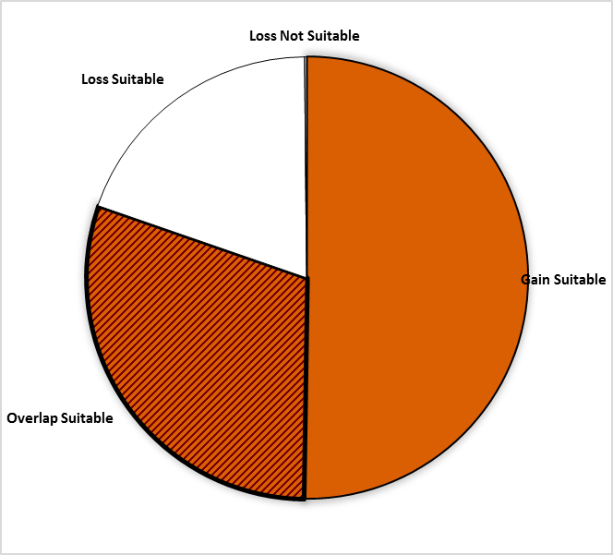
Area of no change = 30.1%
(Overlap with GBST)
Loss = 19.6%
Gain = 50.2%

Figure 1: Total area impacted under CBST for Class A seed including area falling within and without (suitable/non-suitable) the species range projected to 2030 for Interior spruce

- Losses and gains (relative to GBST) vary between seed sources as follows:

Seed BEC  Variant | BECvar Group | Current  Area of Use  hectares % | Loss  area of contraction  % | Gain  expansion  into new area  % | Overlap  area of no change  % | CBST Area of Use  Gain plus Overlap  hectares % | Overall CBST Impact  Gain plus Overlap
BWBSmk | SXPRLOW1 | 3,525,378 100 | 7 | 178 | 93 | 9,567,986 271 | GAIN
BWBSmw | SXPRMID1 | 6,288,053 100 | 54 | 53 | 46 | 6,254,042 99 | LOSS
ESSFwh2 | SXNEHIGH1 | 3,461,981 100 | 8 | 212 | 92 | 10,469,527 302 | GAIN
ICHdm | SXNEMID1 | 4,958,834 100 | 65 | 126 | 35 | 7,995,837 162 | GAIN
ICHdw4 | SXNELOW1 | 3,079,409 100 | 29 | 241 | 71 | 9,554,632 312 | GAIN
ICHmk2 | SXEKALL2 | …………… …… | ….. | ….. | ….. | ……………. …… | ……..
ICHmw5 | SXNEMID2 | 4,958,834 100 | 41 | 142 | 59 | 9,952,729 201 | GAIN
IDFdk2 | SXTOLOW1 | 6,095,783 100 | 23 | 50 | 77 | 7,735,221 127 | GAIN
MSdm1 | SXTOHIGH1 | 3,775,950 100 | 19 | 105 | 81 | 7,019,143 186 | GAIN
SBSdh2 | SXPGHIGH2 | 2,692,348 100 | 75 | 318 | 25 | 9,236,253 343 | GAIN
SBSdk | SXBVLOW1 | 4,391,781 100 | 24 | 128 | 76 | 8,927,401 205 | GAIN
SBSmw* | SXPGLOW2 | 11,090,121 100 | 24 | 54 | 76 | 14,438,115 131 | GAIN
SBSmw* | SXPGLOW4 | 11,961,146 100 | 27 | 52 | 73 | 14,892,119 125 | GAIN
SBSwk1 | SXPGLOW5 | 11,133,735 100 | 45 | 100 | 55 | 17,116,456 154 | GAIN
SBSwk3 | SXPGLOW6 | 11,942,800 100 | 69 | 79 | 31 | 13,166,392 111 | GAIN

- Provincially, the new Sx Class A CBST AOU is an estimated 159% (all Seed BEC Variants), indicating approximately a one and half-fold increase in the overall size of the deployment area previously identified under GBST.

- Orchards assigned to the SBSdh2 (SXPGHIGH2) and SBSwk3 (SXPGLOW6) are the hardest hit by a significant loss (major shift) in deployment area in the move to CBST (See Table 1 for orchards impacted).
- Orchards assigned to the SBSdh2 (SXPGHIGH2), ICHdw4 (SXNELOW1), and ESSFwh2 (SXNEHIGH1) have the largest expansion in area of use under CBST (See Table 1 for orchards impacted).

- Management units with new seed sources moving in (Figure 2, Opportunity = new seed source) include: 32 Timber Supply Areas (TSAs) and 14 Tree Farm Licenses (TFLs).
- Management Units the most impacted under CBST (i.e. with significant reduction in area where orchard seed sources can be deployed) include: 11 TSAs and 12 TFLs.

- It is important to keep in mind that while some seed sources under CBST may be projected to move out of their current ‘Area of Use’ (Current AOU) as defined under GBST, in many cases new seed sources are also projected to move into areas suitable for use under CBST (Figure 2).

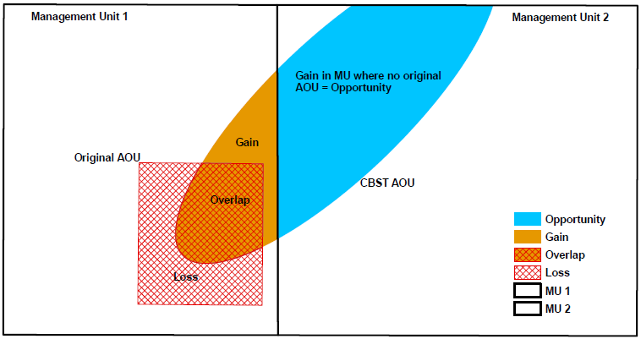

Figure 2: A schematic diagram of seed sources moving in/out of a management unit under CBST

Gaps identified under CBST (Genetic Class A and B)

Orphans
- Seed sources (seedlots) without seed deployment areas (i.e. no area of use) under CBST: ICHmw and SBSdw
- Plantation (cutblock) BEC variants without seed procurement areas (i.e. no Class A or Class B seed sources/cone collection areas) under CBST: None

Table 2: Seed source and plantation orphans identified under CBST

CBST Orphan | BEC variant(s) identified as a CBST orphan | CBST orphan without a
Seed Source (seedlot) | ICHmw, SBSdw | seed deployment area
Plantation (cutblock) | none | seed procurement area

Seed Deficits
- Analysis of current seed inventories indicates that under CBST there is a Class A deficit of approximately 4.5M seedlings per year (an estimated 6% of Sx Class A recent historic annual Sx planting) that cannot currently be met by orchard Class A seed sources.
- Class A Sx seed deficits are split 60/40 between plantation BEC variants supplied by Sx seed sources that are suitable (59%) and non-suitable (41%) under CBST. The latter being seed that can no longer be planted under CBST. See full report for CBST suitable/non-suitable breakouts
- The deficit in Class B and B+ seed (combined), based on recent historic seed planting, is split equally (53%/47%) among planation BEC variants supplied by suitable and non-suitable seed sources.
- Overall, the largest Sx seed deficits (after allocation of Class B seed) reside in the SBSwk3a, ESSFwc2w, ICHmw4, CWHds1, and ICHxw.

Table 3: Seed Deficits under CBST based on Historical Planting

Genetic Class | Annual Planting | Seed Deficit | Seed Deficit over Annual Planting | Plantation BEC variants representing the largest seed deficits (seed demand not met based on planting history from either suitable or non-suitable seed sources under CBST)
 | Pot’l trees | Pot’l trees | %
Class A | 76,223,239 | -4,481,958 | 6% | SBSwk1, SBSvk, SBSwk3a, BWBSwk2, ICHvk1
Class B and B+ | 1,118,680 | -46,625 | 4% | CWHds1, ICHmc2
Class A, B and B+ | 77,341,919 | -568,105 | 1% | SBSwk3a, ESSFwc2w, ICHmw4, CWHds1, ICHxw

Seed Surpluses
- Very significant surplus inventories exist of Class B natural stand seed sources. This is largely a legacy issue as a result of large cone collections made during the eighty’s and ninety’s prior to second generation orchards coming online. SX orchard production continues to replace older seed inventories with higher gain seedlots.
- Surplus Class A seed inventories are high (210%) relative to annual planting (annual planting draws from approximately half of the surplus inventory each year).
- Under CBST, the largest Class A orchard Sx seed inventories currently estimated for the following plantation BEC variants include (in order of largest to smallests): SBSmc2, MSxv, ESSFmv1, ESSFwk1, MSwk2, and BWBSdk.

Table 3: Seed Surpluses under CBST based on Historical Planting

Genetic Class | Annual Planting³ | Seed Surplus | Seed Surplus over Annual Planting | Plantation BEC variants representing the largest surplus seed inventories (remaining after allocation of seed to suitable CBST BECs [by seed source] across plantation BEC variants with planting history
 | Pot’l trees | Pot’l trees | %
Class A | 76,223,239 | 159,852,544 | 210 | SBSmc2, MSxv, ESSFmv1, ESSFwk1, MSxk2, BWBSdk
Class B and B+ | 1,118,680 | 1,149,413,889 | 102,747 | SBSmc2, ESSFmc, SBSmk1, ESSFmv3, BWBSdk, BWBSmk
Class A, B and B+ | 77,341,919 | 1,331,620,686 | 1722 | SBSmc2, BWBSdk, ESSFmc, SBSmk1, ESSFmv3, MSxv

Species Specific Mitigation Options
Short Term (During Transition Period)
- Continued use of GBST will be required to meet the seed demand in plantation BEC variants previously supplied by orchard Class A seed and no longer suitable for orchard seed under CBST.
- Since the SX orchard production continues to replace older seed inventories with higher gain seedlots, Class A surpluses continue to grow.

Long Term (Orchard Considerations, Forest Health and Ecology)
- Given the substantial overlap of areas of use under GBST and CBST, realignment of orchards for CBST is expected to require further spatial analyses to determine the nature and degree (a certain amount of redundancy is needed to address uncertainty under a changing climate and for business contingency planning), of redundancy among seed producers (orchards).
- Breeders to explore opportunities for the incorporation of new weevil-resistant orchard stock into orchards aligned with CBST. Coordination and integration with CCISS will be very important, particularly in areas where large species and/or seed source shifts are anticipated due to novel climates moving in (i.e. procurement of seed sources from south of the border for use in southeastern BC).

For more information

See Climate Based Seed Transfer - Impact and Gap Analysis. Please check back periodically for updates pertaining to the science, policy (amendments to the Standards), tools, and CBST Area of Use and Orchard (coverage) maps.

Use of Information
This document provides a summary of an assessment of impacts and gaps currently identified under Climate Based Seed Transfer (CBST) relative to geographically based seed transfer (GBST) as regulated under FRPA. Area-based data summaries were generated using CBST Areas of Use, April 5, 2018, based, in part, on the provincial Biogeoclimatic Ecosystem Classification (BEC version 10).
Use of information contained in this document is limited to province-wide species level interpretations as viewed through multiple lenses – seed planner, seed producer, seed owner, and seed user. Further updates to CBST AOU are anticipated (target, April 2020) due to further updates to BEC (BEC 11/12), as well, as other potential changes to science foundation data sets (climate variables, transfer functions). CBST impacts and/or gaps may change/vary at more refined scales. Use this information with caution when informing operational-level strategies, plans, seed selection and use; and, seedling requests.

CBST deployment area (area gained plus area of overlap) as compared to Geographically Based Seed Transfer
Source: CBST_Impact_Assessment_v.4.2.1SEPT272018.xlsx
Includes area covered by producing orchards, and retired orchards with seed inventory (active seedlots)
Under different scenarios this deficit can change (e.g increase/decrease due to Annual Allowable cut (AAC) lifts or net downs).
Recent historic annual planting data (2013-2017) extracted from RESULTS. Five year average updates are planned.
These PLANTATION BEC variants represent approximately 80% or more of the total seed deficit
Under different scenarios this surplus can change (e.g. seed additions and withdrawals)
These PLANTATION BEC variants represent approximately 80% or more of the total seed surplus

