The Tree Seed Centre utilizes a MS Access application to perform and manage batch processing performed at the site, which in turn manages some of their business processes.
This document is intended to highlight those batch files, by showing the process flow for each one of these batches that run, as well as providing detail around the database objects touched, and outputs provided by these batches when run.
To note, various other systems exist which comprise the front-end and back-end of the whole system, and these are listed just below:

This document focuses on the Tree Seed Centre (CONSEP) – MS Access Application (Batch – BORA) system while highlighting the following batches:
Batch Name |  | Batch Description | Pg #
Cns_Batch_Cnsb06 |  | Connects and runs Consep Web App Batch (main_proc only)
Cns_Batch_Cnsb08 |  | Connects and runs Consep Web App Batch (main_proc only)
Cns_Batch_Cnsb12 |  | Connects and runs Consep Web App Batch (main_proc only)
Cns_Batch_Cnsb16 |  | Connects and runs Consep Web App Batch (main_proc only)
CNSLB01 |  | Create Request Item Activity | 3
CNSLB02 |  | Schedule Request Item Activities | 4
CNSLB03 |  | Designate CSP Complete with Blending Report | 5
CNSLB05 |  | Update Processing Status for RIA | 6
CNSLB06 |  | Copy manage Seedlot (Handled on CONSEP Backend) | 7
CNSLB12 |  | Copy manage TSC Client Contact (Handled on CONSEP Backend) | 8
CNSLB16 |  | Copy manage Expected Shipment Receipt (Handled on CONSEP Backend) | 9
CNSLB21 |  | Copy Manage Stock Count Results | 10
CNSLB23 |  | Copy Manage Accepted Test Results | 11
CNSLB33 |  | Create Request Item Activity | 12-16
CNSLB47 |  | Collects invoice data and exports to MS Excel | 17
CNSLB48 |  | Quarterly Reporting | 18
CNSLB49 |  | Stock Count Extract | 19
CNSLB52 |  | Process Testing Summary | 20
CNSLB62 |  | Print Client List | 21
CNSLB63 |  | SRQ Little Seed Left Report | 22
CNSLB64 |  | Revenue Projections | 23
CNSLB99 |  | Create a job completion summary file - CNSSYS.TXT to be transferred to the host for reconciliation reporting | 24
CNSLR05 |  | Receipt audit | 25
CNSLR22 |  | Confirmation reports are printed for cone/seed shipments that are have been received over 5 days from the time of printing | 26
 |  | CONSEP Batch Processes Link Tables Refresh | 27
 |  | CONSEP Batch Processes CNSBatch Common | 28
 |  | CONSEP Batch Processes CNSBatch Main | 29
 |  | Life of Seedlot Batches (SPAR and CONSEP) | 30

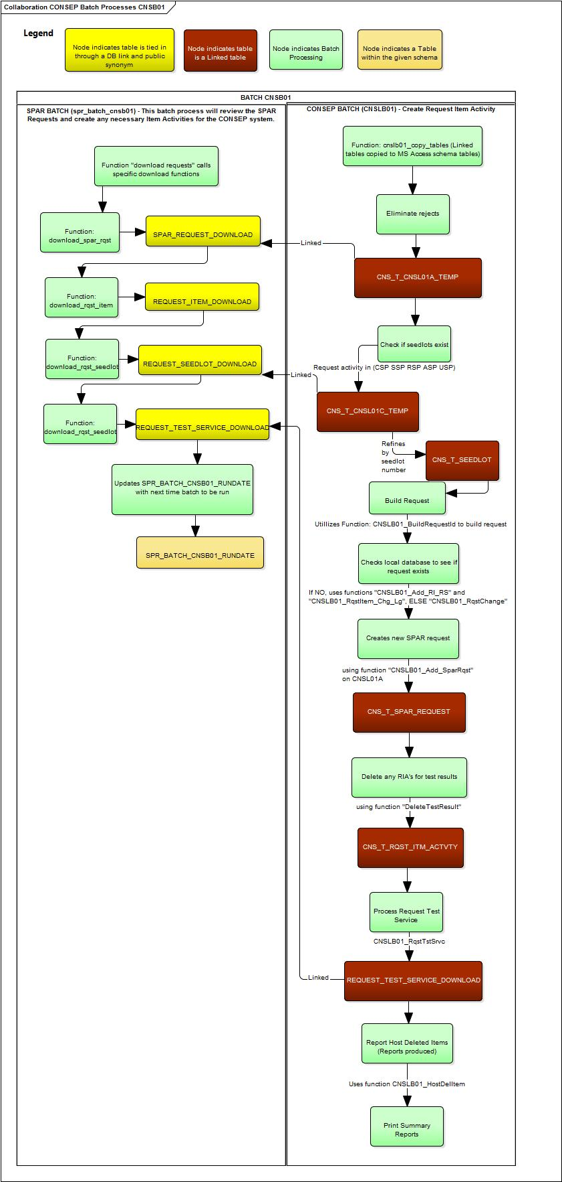
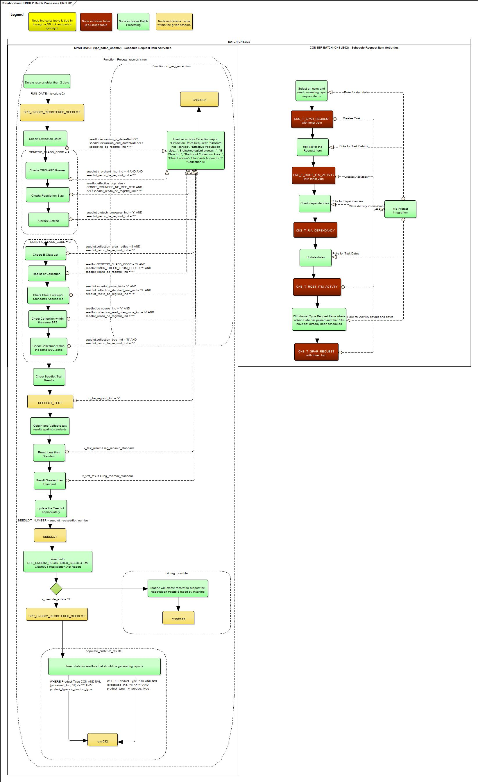
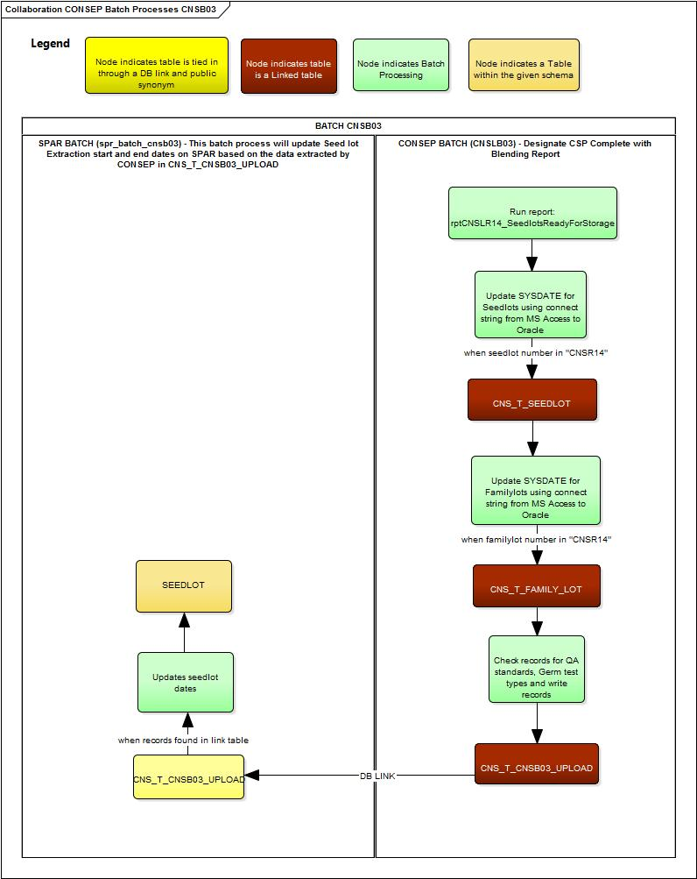

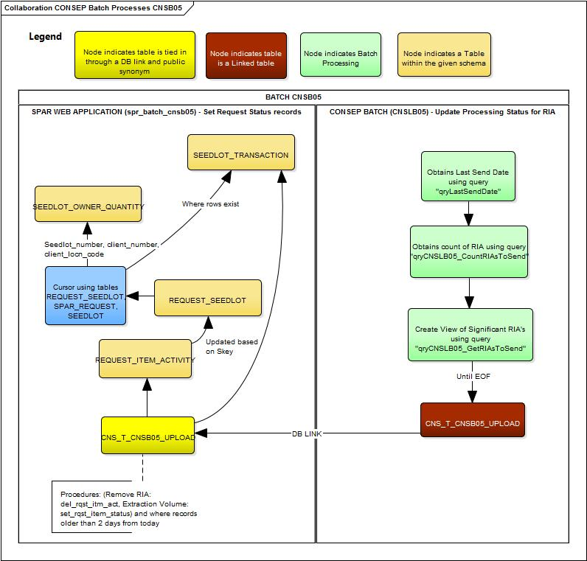

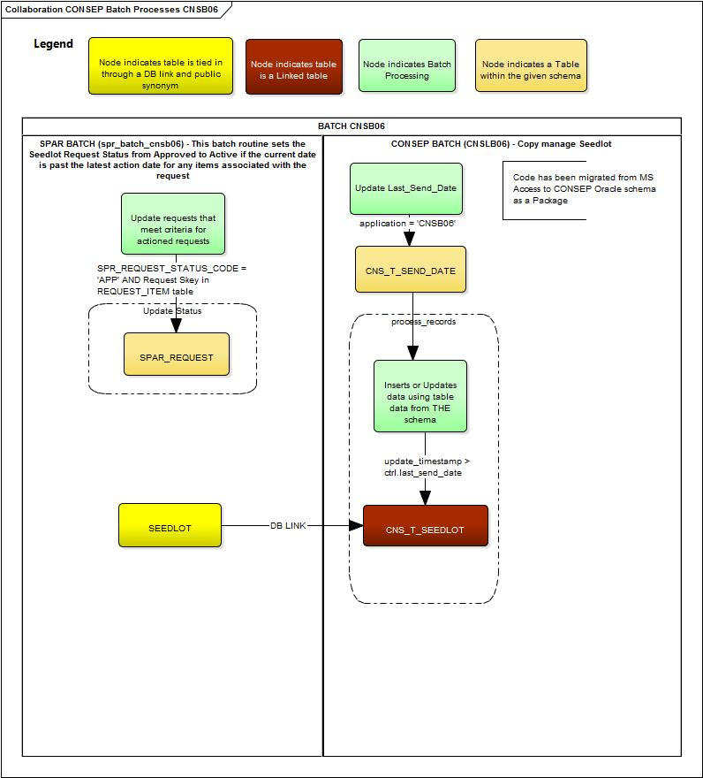

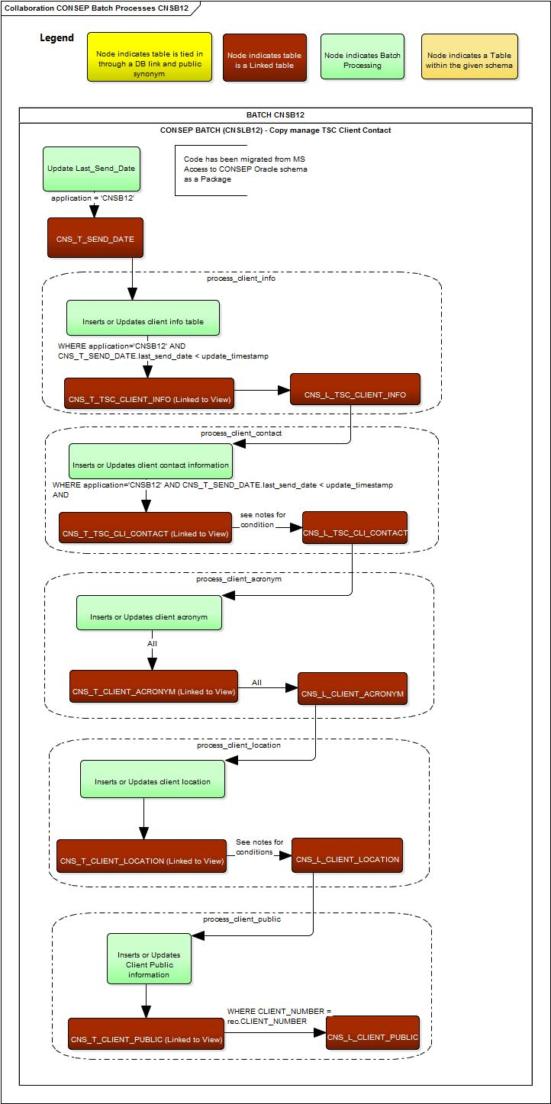
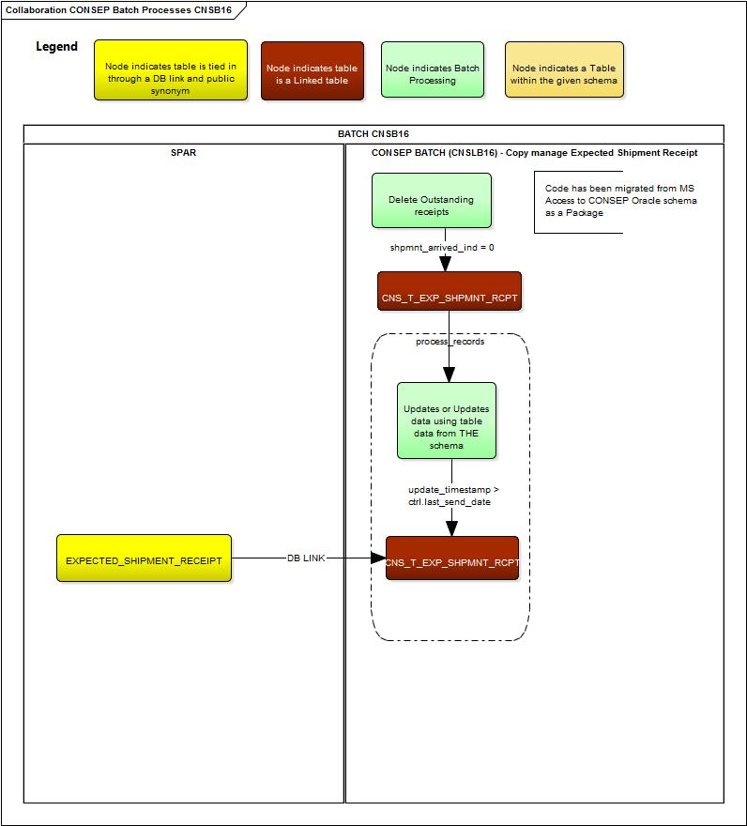

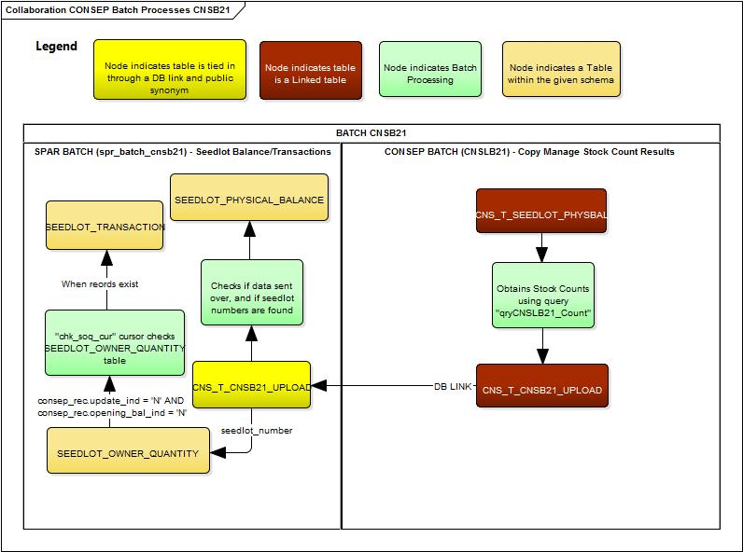

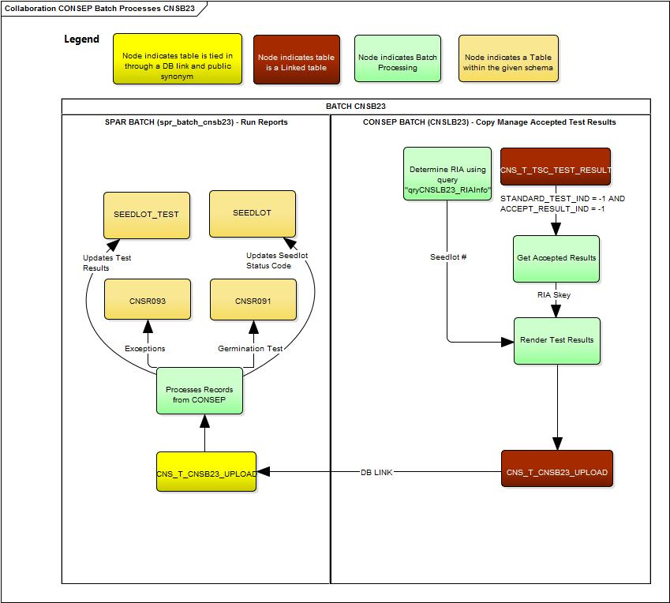

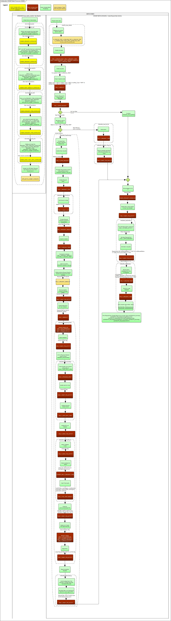
Part 1
Part 2
Part 3

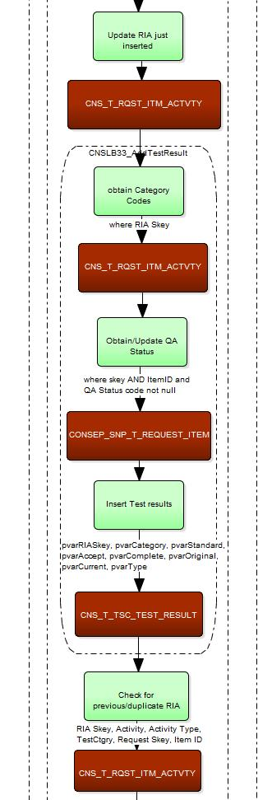
Part 4
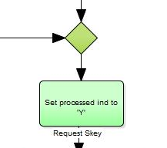
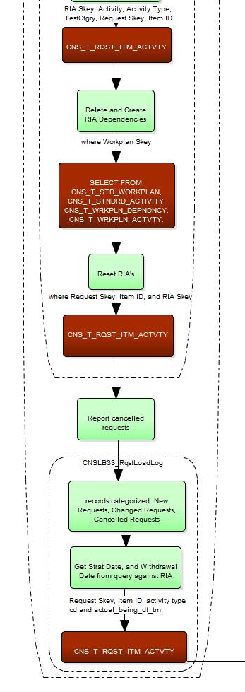
Part 5

