System Overview
The setup of the CONSEP system includes connections to other systems and databases like the Oracle backend for SPAR and CONSEP. As a summary, there are the following systems that integrate as a final CONSEP solution:
Tree Seed Centre (CONSEP)
MS Access Application (Batch - BORA)
Oracle Batch process packages (Backend)
Seed Planning & Registry Application (SPAR)
Web Application (Oracle Backend)

Subject Area: CONSEP Workstation Installation
CONSEP – MS Access Front End, Oracle backend Database via ODBC
Target Audience – IMB BPM or Tech services staff with workstation configuration experience

CONSEP Workstation Setup
When connecting to a database from your workstation, one must setup an ODBC connection to that database which the MS Access database application will then use to populate the data tables.
Given this scenario, the following software must be installed on the desired workstation:
- Oracle client (Obtain online from Oracle website, or within the network share that holds the software for Vivid)
- MS Access
- CONSEP application program files

Oracle Client Setup:
As of writing this document, the latest Oracle client to download is 11g.
It is helpful to first determine the type of system you are setting up the MS Access, and Oracle client on. For example, you will download a specific Oracle client which is dependent on the type of system you are running. Your computer setup could look like the following, where the detail highlighted in red boxes will help you determine the Oracle client needed:
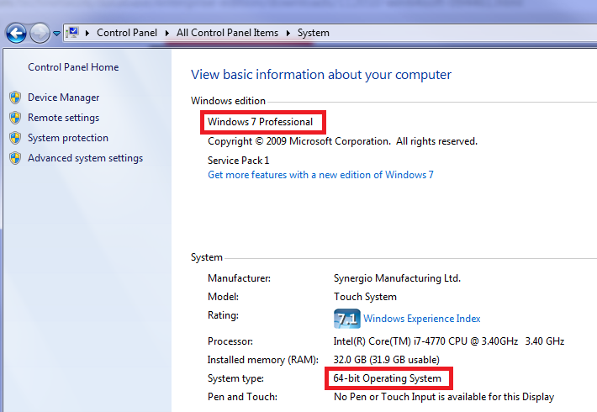
Given this, the appropriate Oracle client download is:

Unpack the downloaded file, and start the installation by selecting “Run as Administrator”
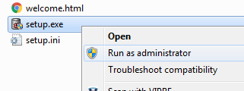

Once the setup is complete, you may proceed with the setup of the connection to the databases. Use the Oracle ODBC connection setup to complete your connection:
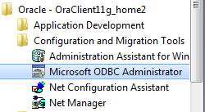

Connection Details within the Vivid Office, in Development environment housed on ORA3
CONSEP:
Username: consep
Pwd: password
Host Name: ora3
Service Name: devpdn
SPAR:
Username: THE
Pwd: password
Host Name: ora3
Service Name: devpdn

Your setup with the Oracle client window may look like the following
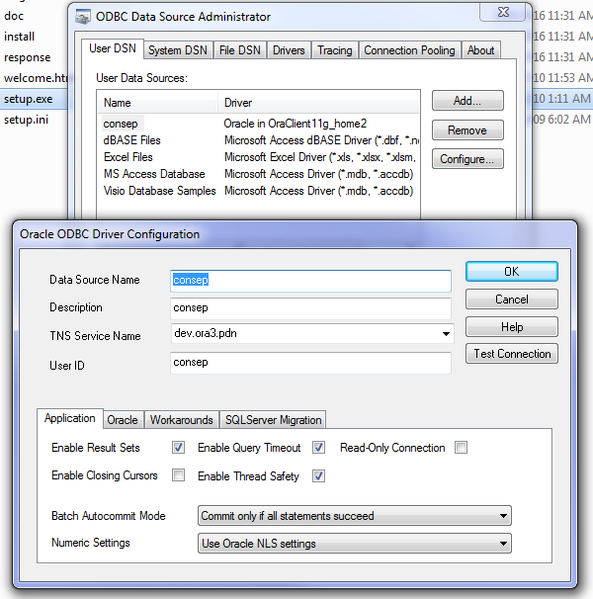

MS Access Setup:
The CONSEP MS Access database is compatible with versions of MS Access up to v. 13
Once MS Access is setup, you may now open the CONSEP MS Access database application locally.
When opening the file, and where you have not relinked the tables within the MS Access database, you will receive errors – These errors are expected until the linking has been performed.

Subject Area: CONSEP Database Relinking
Background: If the ODBC DSN Name has changed then all tables need to be relinked use this process as linked table manager will prompt for each table.
Target Audience: CONSEP maintenance programmer
When opening the CONSEP MS Access database, you will be presented with a form on open. Right-clicking on this form and selecting “Design View” will release the form, and will allow you to relink the database tables within this package.

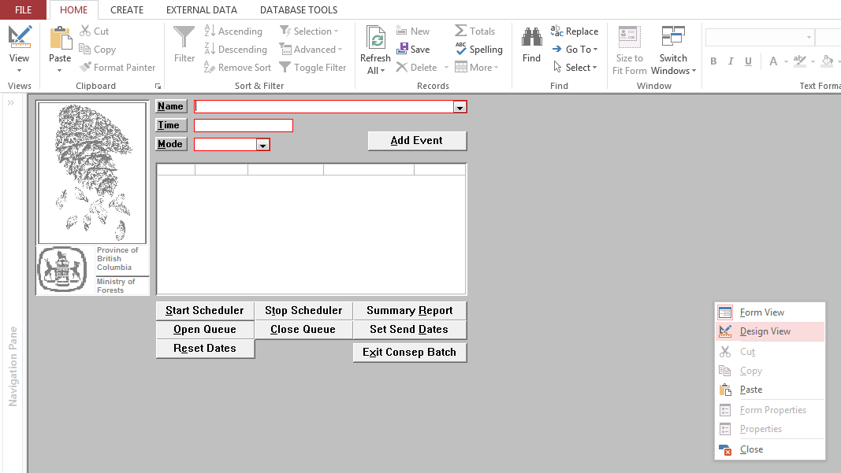
Once the form is released, you are allowed to navigate the MS Access objects, where you will proceed to link the tables:
- A list of existing linked tables is located in local table zztemp-table-list
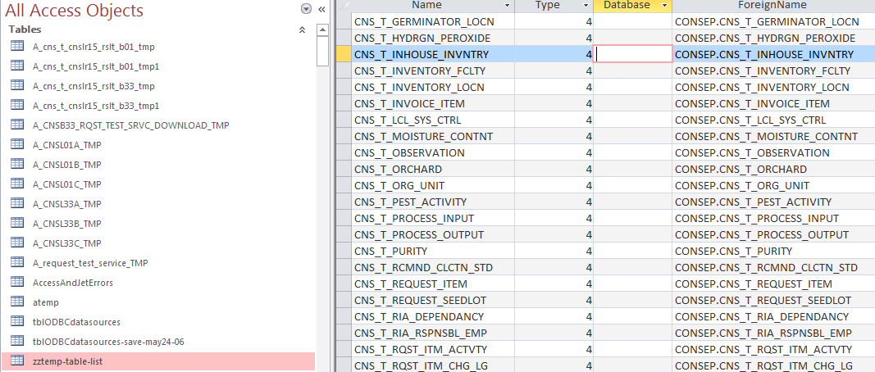
Data held within table
Table data for tables to be relinked
If new tables have been linked to CONSEP then table zztemp-table-list can be reloaded via make table query Zget_current_tables
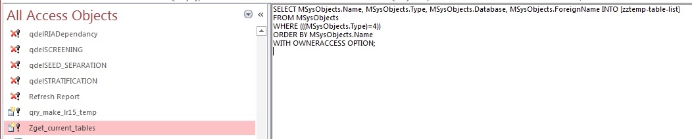
The script comprising the query – Do Not Modify
The query
- Table tblODBCdatasources has the list of table with the ODBC connection information for linked tables. If new tables have been added (step 1) above this table needs to be updated using the following steps:
  - Delete all existing rows
  - Review append query zz-append-data-source and update the “CNSP/CNSD” info with new link table DSN information. (Database, Server, DSN)
  - Update and Run append query zz-append-data-source – adds rows to table tblODBCdatasources
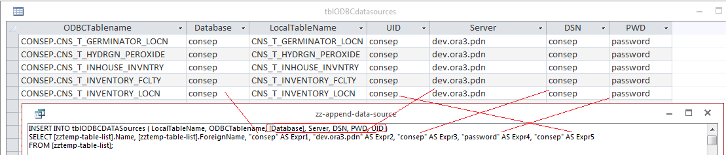
  - Run macro refresh_lnk_tbls – this will relink tables

Note: CNSBORA (Batch) tables without primary keys will need to be linked manually via ODBC data source and renamed:
Note: Select “Save Password” option linking tables manually
Table Name | Primary Key fields
CNS_T_CNSB05_UPLOAD | REQUEST_ID, STANDARD_ACTIVITY_ID, COMMITMENT_IND, ENTRY_TIMESTAMP
CNS_T_CNSB22_UPLOAD | SEEDLOT_NUMBER, CLIENT_NUMBER, CLIENT_LOCN_CODE, ACTUAL_ARRVL_DT_TM
CNS_T_CNSB23_UPLOAD | SEEDLOT_NUMBER, TEST_DATE, SEEDLOT_TEST_CODE, CURRENT_TEST_IND
CNSB33_REQUEST_DOWNLOAD | REQUEST_SKEY
CNSB33_RQST_TEST_SRVC_DOWNLOAD | REQUEST_SKEY, ITEM_ID, SEEDLOT_TEST_CODE
SPAR_REQUEST_DOWNLOAD | REQUEST_SKEY
REQUEST_TEST_SERVICE_DOWNLOAD | REQUEST_SKEY, ITEM_ID, SEEDLOT_TEST_CODE

To Link Manually:
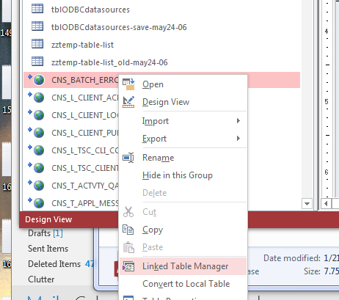
The following icons within the Tables area of MS Access are referred to as Linked Tables. To view the window that helps to link these tables, right-click on one of the linked tables, then select “Linked Table Manager”.

Once selected, you will be presented with a new window where you are now able to visually see the Data Source Connections for the tables (see image below). You are now able to select those tables you wish to update to a new connection.
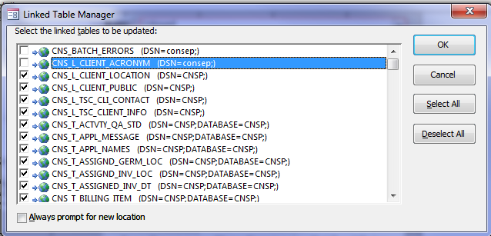
Below is an example of tables selected that have a DSN of CNSP, which are to be updated to point to the “consep” database once the “OK” button is selected:
Once you click “OK”, you will be prompted to enter a data source to use (Select that same data source that was setup during the Oracle client setup:
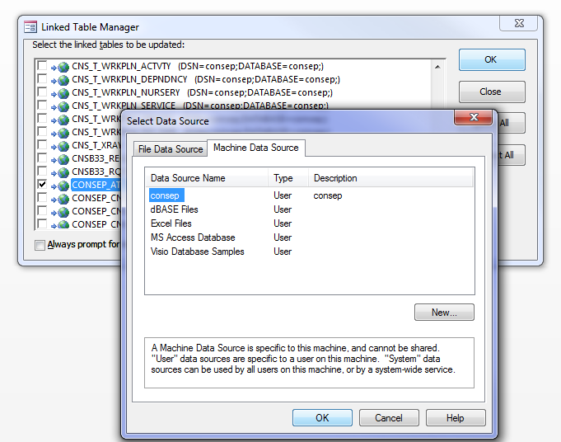
Once you click “OK”, you are presented with a login for the ODBC connection to the new source database:
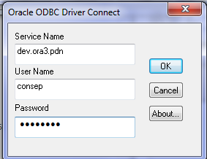
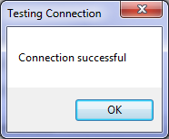
Click ok, and let the process run in linked table manager, do not close the select data source window, so leave the screen showing as the following image, until the process completes:
  - CONSEP Batch only – (CNSBORA), reset the connection string via properties in the following 6 queries:
CNS_Batch_Run_CNSB06
CNS_Batch_Run_CNSB12
CNS_Batch_Run_CNSB16
qdelCNSB05_UPLOAD_Pass_through
qdelCNSB22_UPLOAD_Pass_through
qdelCNSB23_UPLOAD_Pass_through
The above batch files can be found in the same CONSEP MS Access database. The idea is to manually reset the connection for these batch queries by viewing and updating the properties of each batch file. To do this, open the batch:
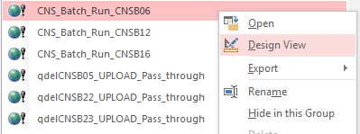
Once the design view opens, you may see the Property sheet on the right:
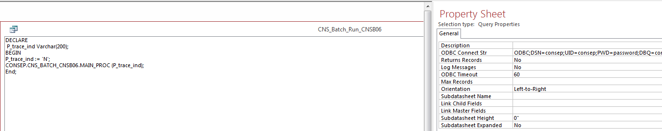
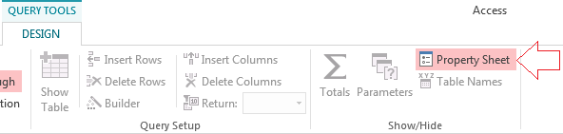
If you do not see the Property sheet, then select Query Tools/Design then select/activate “Property Sheet”.

Updating the connection details for these batches mean you will need to update the property “ODBC Connect Str” to the new appropriate values:
ODBC;DSN=<Data Source Name of Connection Setup>;UID=<User ID>;PWD=<password>;DBQ=<Name of MS Access File>
Here is a completed string for a connection using “consep”, where the above detail is highlighted in yellow:
ODBC;DSN=consep;UID=consep;PWD=password;DBQ=consep;DBA=W;APA=T;EXC=F;FEN=T;QTO=T;FRC=10;FDL=10;LOB=T;RST=T;BTD=F;BAM=IfAllSuccessful;NUM=NLS;DPM=F;MTS=T;MDI=F;CSR=F;FWC=F;FBS=64000;TLO=O;

