Summary Report 2015/2016
LiDAR Enhanced Forest Inventory (LEFI)
Kamloops and Okanagan TSA’s

Forest Analysis and Inventory Branch
Ministry of Forests, Lands and Natural Resource Operations

Revised April 28, 2016
Executive Summary¹

Light Detection and Ranging (LiDAR) data was acquired for an area of 367,000 ha in Kamloops, Okanagan , Merritt, and Williams Lake TSA’s, jointly by a consortium of Tolko Industries Ltd, BC Timber Sales- Kamloops, BC Timber Sales- Okanagan and North Thompson Community Forest Society. The LiDAR point cloud data was offered to FAIB under the Data Sharing Agreements in which FAIB would conduct a LiDAR enhanced forest inventory for public usage.
The project area (about 317,000 ha) was located in both Kamloops and Okanagan TSA’s with about half managed by BC Timber Sales and the other half by Tolko. The FAIB designed a ground sampling campaign followed by field measurements of 226 ground plots with a circular fixed area of 0.04h in the summer of 2015. Both area-based parametric and non-parametric predictions from the normalized LiDAR canopy height and density metrics and ground measurements were made and compared. The first and preliminary results from the parametric predictions are presented in this report, and more spatial extrapolation and evaluation work will be conducted in 2016.

Table of Contents
List of Tables i
List of figures ii
1. Background 3
2. Project Area 3
2.1 Location 3
2.2 LiDAR Data Acquisition 3
3. Methodology 4
3.1 Pre-Inventory Analysis and Stratification 4
3.2 Sampling Design 4
3.3 Ground Data Collection and Compilation 5
3.4 LiDAR Data QA, Canopy Height Model and Height/Density Metrics 7
3.5 Parametric Predictive Modeling 8
3.6 Non-Parametric Predictive Modeling 9
3.7 Summary of Major LEFI Steps and Components 9
4. Results 10
4.1 VRI 2014 and Stratification 10
4.2 LiDAR Data QA and Pre-Processing 11
4.3 Normalized Canopy Height Model (CHM) 14
4.4 LiDAR CHM Metrics and Raster Predictions 16
4.5 Ground Data Collection and Initial Statistical Analysis 16
4.6 Parametric predictions 19
4.7 Nonparametric prediction 24
5. Discussion 29
6. Summary 29
7. References 30
8. Appendix 30

List of Tables
Table 1 Defined strata and initial target number of plots 4
Table 2 Specifications for GPS unit configuration and measurements 6
Table 3 Definitions of predicted variables 6
Table 4 LiDAR predictors derived from the LiDAR canopy 7
Table 5 Total number of laser points in by return class. Statistics derived from the original Okanagan dataset delivered by LiDAR data provider. 12
Table 6 Statistical estimates of selected tree attributes with the change ranges 16
Table 7 The parametric prediction equations associated with all the data and no stratification 19
Table 8 The actual and predicted values are given for basal area and Lorey height using all the data for all strata combined (Combined) and by strata (Strata). 22
Table 9 The actual and predicted values are given for the validation data. Biases that are statistically different from zero (α ≤ 5%) are shaded. 28

List of Figures
Figure 1 The total Lidar area is shown on the left, and the project area (areas 1 and 2) is shown on the right (also shown the ground plot locations). 3
Figure 2 Plot 18 (0.04ha) overlaid on orthophoto (left) and LiDAR canopy (right). 5
Figure 3 Flowchart of LEFI components and processing steps. 10
Figure 4 Area distributions as summarized from the 2014 VRI. 11
Figure 5 Bare earth DEM with the original BCGS 1:2,500 Grid System. 13
Figure 6 Retiled 1000m x 1000m LiDAR dataset (bare earth DEM). 14
Figure 7 Convert each point from an elevation above mean sea level to height above the ground surface. 15
Figure 8 Canopy Height Model 16
Figure 9 Scatter plots of live Lorey height against p90 by strata. 17
Figure 10 Scatter plots of whole stem volume (at the 4cm utilization level) against p90 by strata 18
Figure 11 The live whole stem volumes against p90 without stratification 18
Figure 12 The same data as Figure 6 with the addition that the plots with more than 100 m3/ha of dead whole stem volume are circled. 19
Figure 13 The parametric predictions of Lorey height are plotted against the actual Lorey height by strata. The SUR models were fit using all data (“Combined”) as well as by strata (“Strata”). The 1:1 line is given. 20
Figure 14 The parametric predictions of basal area (m²/ha) are plotted against the actual basal area by strata. The SUR models were fit using all data (“Combined”) as well as by strata (“Strata”). The 1:1 line is given. 21
Figure 15 The parametric predictions of live whole stem volume (m3/ha) are plotted against the actual volume by strata. The SUR models were fit using all data (“Combined”) as well as by strata (“Strata”). The 1:1 line is given. 22
Figure 16 The Basal area predictions and residuals are given by strata. The data are given in Table 8. The standard error bars are given with the residuals. 24
Figure 17 The predictions (a) and residuals (b) are given for the basal area predictions. The standard error is given for the residuals. The data are the validation data set and the sample sizes given in Table 8 25
Figure 18 The predictions (a) and residuals (b) are given for the live whole stem volume predictions. The standard error is given for the residuals. The data are the validation data set and the sample sizes given in Table 8 26
Figure 19 The parametric predictions (100% = 100% of the data used for calibration, 70% = 70% of the data used for calibration, 50% = 50% of the data used for calibration) and nonparametric predictions (RF) are given for the validation data (30%). 27

Background
The Forest Analysis and Inventory Branch (FAIB), BC Ministry of Forests, Lands and Natural Resource Operations (FLNRO), in partnership with BC Timber Sales (BCTS, in Okanagan and Kamloops) and Tolko Industries Ltd.(Tolko), is currently in the process of developing a LiDAR Enhanced Forest Inventory (LEFI) for several spatially disjunctive timberlands of total 367,000 ha located within the Kamloops, Okanagan, Merritt and Cariboo Timber Supply Areas (TSA) as shown in Figure 1 (areas 1-4).
The overall purpose of this project is to establish an operational LEFI model with a set of standards/specifications for future operational Lidar inventory projects. Specific objectives are:
- To design, test, and complete an operational LEFI;
- To develop the standards, specifications, and processes for future operational LEFI;
- To implement/integrate LEFI in the provincial inventory program; and
- To investigate various ways of using LiDAR for improving VRI, in addition to a complete LEFI.
It is scheduled that objectives (a) and (b) will be achieved in the 2015/2016 fiscal and objectives (c) and (d) will be achieved in the 2016/2017 fiscal.

Project Area

Location
It was decided that FAIB will conduct an operational LiDAR enhanced forest inventory (LEFI) for area 1 and area 2 (approximately 317,000 ha in Kamloops and Okanagan TSA’s) in 2015-2016 (for objectives 1 and 3). Areas 3 and 4 (about 50,000 ha), will be used to test methods and procedures for upgrading stand heights only using the LiDAR canopy height model, which will be dealt with in a separate document.
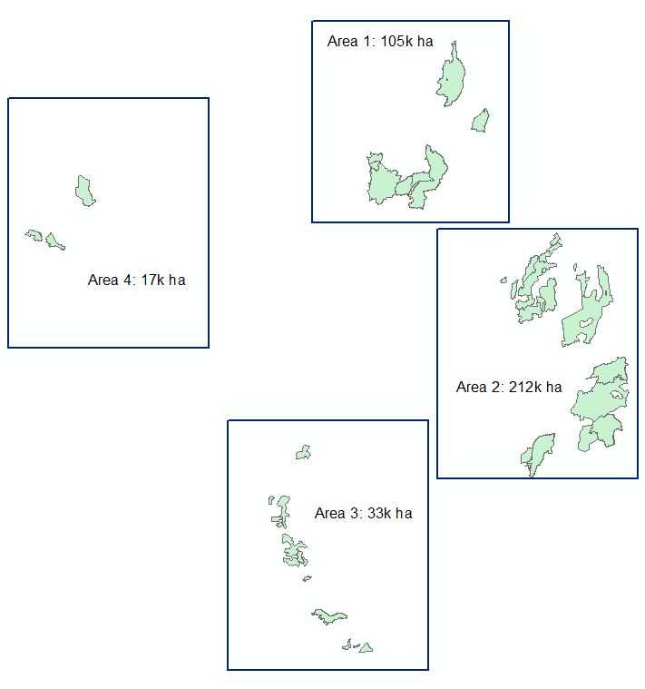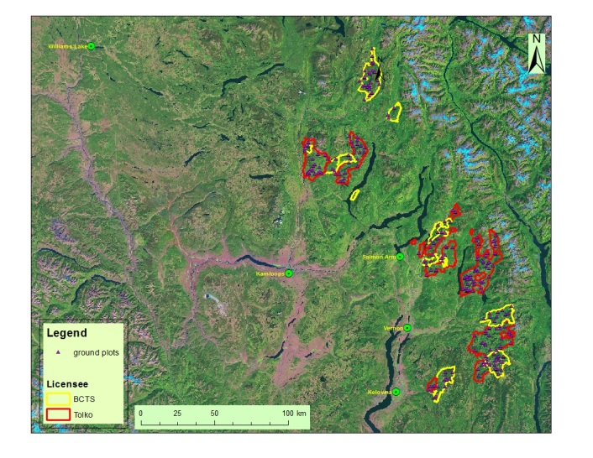
Figure 1 The LiDAR area is shown on the left, and the project area (areas 1 and 2) is shown on the right (also shown the ground plot locations).

LiDAR Data Acquisition
The LiDAR data was acquired by Airborne Imaging Inc. in the summer of 2014 using fixed-wing aircraft and a Leica ALS70 (100 kHz pulse rate) under a contract administrated by Forsite Consultants Ltd. The average point density was about 2-2.7 points/m². The original LiDAR point cloud files classified according to the standard ASPRS v1.2 specifications, Albers projection, and tiled and named according to the BCGS 1:2,500 grid system. Additional products generated by the acquisition vendor (gridded DEM, DSM, CHM files; hill-shade images; contours) were also provided along with the las files but these files were only used for overview and checking purposes and were not used in the data analysis and modeling processes.

Methodology

Pre-Inventory Analysis and Stratification
The 2014 Vegetation Resources Inventory (VRI) for the project area was first analyzed by the Biogeoclimatic Ecosystem Classification (BEC) zones, leading species and stand structure for the initial stratification purpose. The newly acquired LiDAR canopy data was then added to the stratifications for ground sampling selection process.
Based on the pre-inventory analysis, the project area was stratified into four strata with an initial target number of plots of 200 (about 50 in each stratum) based on the limit of the project budget. The target population was all treed polygons with age of 40 years or older in the project area.

Sampling Design
The main goal of ground sampling was to develop predictive models for stand height, basal area, crown closure and density. Thus, the basic requirement was to spread ground plots to cover entire ranges of variations of the above variables.
The 5km grid (created from the NFI 20km grid) was overlaid and all the grid points intercepting VRI stands greater than 40 years old were selected. This resulted in a total of 101 ground points, of which 7 were NFI ground plots.
About 200 additional points were systematically selected from each of height classes (1-6) from the 1km grid.
The LiDAR canopy data was analyzed for height distribution and plots and some over sampled height classes were reduced, while the classes under sampled (particularly in lower and higher ends of height classes) were increased.
The resulting plots were further checked against the orthophotography and recent Landsat. All the plots that were logged or burned were removed. Locations of some plots, except the NFI plots, were modified within selected polygons so that that access distance was less than 2km from access roads.
The strata and final numbers of ground plots are summarized in Table 1.
Out of the 130 plots in strata 1 and 2, 49 were randomly selected as variable radius plots. In addition to the regular measurements on the ground, these plots were measured at the main plot center with one-point prism measurements for the purpose of establishing predictive models as comparison to the fixed area plots method.

Table 1 Defined strata and initial target number of plots
Stratum | BEC Zone | Leading Species | Area % | Target # Plots* | Final # Plots
1 | ICH and IDF | FD | 29 | 57 | 61
2 | ICH and IDF | Others | 27 | 55 | 69
3 | ESSF and MS | BL | 21 | 41 | 43
4 | ESSF and MS | Others | 23 | 47 | 60
Total |  |  | 100 | 200 | 233
*A total of 200 initial ground plots are planned and target numbers of plots are based on area proportions.

An example of ground plots is shown in Figure 2.
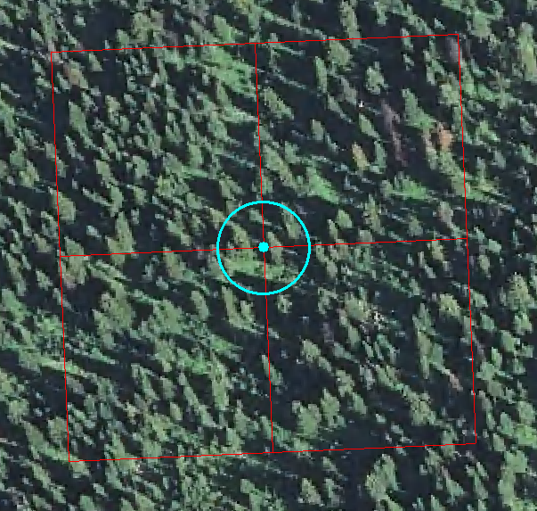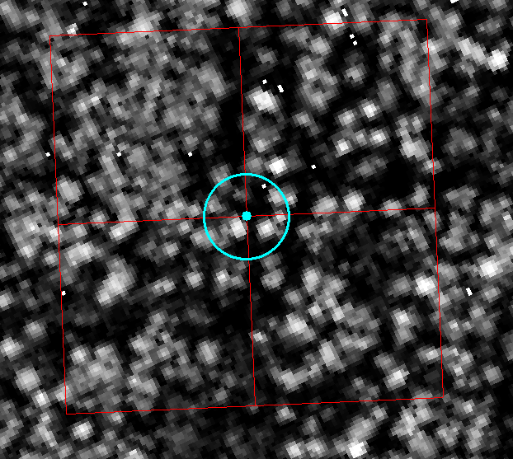

Figure 2 Plot 18 (0.04ha) overlaid on orthophoto (left) and LiDAR canopy (right). The 1ha (100m x 100m) with four quadrats is shown in red.

Ground Data Collection and Compilation
Ground plot design and tree measurements are described in Appendix 2: Field Procedures.
Conventional and real-time uncorrected GPS was used to navigate to the plot centers that were pre-determined and provided by FAIB. Effort was made to locate the plot centers in an unbiased fashion with aid from aerial photos and maps.

It was extremely critical to measure accurately the plot center locations after they were established. The horizontal positional accuracy of the plot center after differential correction was + 2 meters. Once the plot center was determined, the GPS data was recorded twice using survey/mapping grade of GPS receivers such as Trimble GeoExplore, at the beginning and at completion of the field measurements (the minimum time interval is one hour). The minimum of GPS occupation time at the plot center at each measurement was 5 minutes with a total of minimum 100 GPS fixes at 1 sec interval. If it was impossible to obtain GPS data at the plot center, an offset was used. The offset of distance (to nearest centimeter and maximum distance is 20m) and angle (to the nearest degree) from the measurement location to the plot center was recorded. The two raw GPS files per plot center were submitted to the FAIB for post-correction and QA purposes, and crews also conducted their own post processing (if so, both the raw and correct GPS files were submitted). The detail specifications for the GPS parameters are shown in the following Table 2.

Table 2 Specifications for GPS unit configuration and measurements
Parameter | Value | Comment
GDOP | < 10.0 | use only if HDOP or PDOP not available in rover unit
PDOP | < 8.0 | use only if HDOP not available in rover unit
HDOP | < 5.0 | use of HDOP preferred over PDOP
Elevation angle | > 15 | satellite elevation tracking angle (degrees)
Positioning modes | 3D | no 2D positioning acceptable
Logging interval | 1 sec. | maximum allowable is 5 sec under certain onditions
Signal strength | default | minimum threshold to be set at manufacturer’s default value (or higher)
Dynamics | lowest | set to lowest value available
GPS measurement | 2 measurements each at minimum 100 fixes | Two measurements, one at the beginning and one at the completion of field work with minimum one hour interval. The minimum observation time at each measurement is 300 seconds with at least 100 position fixes during that period, or at least 50 position fixes under difficult satellite tracking conditions.
Offset | From GPS to plot center with nearest centimetre for distance and nearest degree for angle | The maximum distance is 20m. Record this on the field cards.

The positions of plot centers were subject to a rigorous QA by FAIB and failure to collect GPS raw data according to the specifications resulted in a complete rejection of the plot data.
Ground plot data were compiled at plot level using a customized procedure developed by the FAIB. Out of all the compiled plot level attributes, the following predicted variables are defined in Table 3.

Table 3 Definitions of predicted variables
Variable name | Units | Utilization | Description
Ba_Ha | m²/ha | 4.0 cm | Basal Area/Ha of live trees
DQ | cm | 4.0 cm | Quadratic mean Dbh of live trees  Calculated as sqrt(BA/TPH/0.00007854).
Vht_Wsv | m²/ha | 4.0 cm | Whole stem volume/ha of live trees
Vha_nwd | m²/ha | 4.0 cm | Whole stem volume/ha of dead trees
Vol_nwb | m²/ha | 12.5 cm | Net merchantable stem volume. Whole stem volume net of stump and top, Cruiser Decay, Waste and Breakage
ht_lor_l | M | 4.0 cm | lorey height live trees  The basal area-weighted average height

LiDAR Data QA, Canopy Height Model and Height/Density Metrics
LiDAR point clouds are geometrically complex, and rarely, if ever, error free due to the multitude of processing steps (e.g., geometric calibration, geo-referencing, noise removal, feature classification, etc.) imposed on the raw LiDAR points prior to delivery. Post-processing workflows developed by LiDAR data analysts and application specialists to extract other derivative products from the point cloud may unknowingly further expand the breadth and severity of data errors and artifacts, especially if these original errors go undetected. LiDAR point clouds often contain billions of three-dimensional (3-D) points, split among several hundreds or thousands of spatially discrete tiles, and therefore are difficult to screen without expensive specialty software and the help of several experienced analysts. There are, however, several ways to rapidly screen these point clouds using a few basic steps.
LiDAR point clouds may consist of several billion three-dimensional (3-D) points, along with other associated attribute data, such as backscatter intensity, scan angle, return number, GPS time, etc. Point clouds are also necessarily partitioned into hundreds or thousands of non-overlapping spatially discrete tiles in an effort to ease data handling, data archive, and post-processing workflows. Unless LiDAR datasets are well screened and well documented by the service provider, point clouds may contain nonstandard point classes and other encoded data flags, classification errors, height outliers, duplicate points, and other unusual or unexpected features. Furthermore, tile boundary shapes may be curvilinear rather rectilinear (e.g., British Columbia Geographic System map sheets), and therefore ill-suited to efficient metric extraction and rasterization when specific point inclusion-exclusion logic is required to avoid point duplication or loss, and when tile buffering is needed to eliminate data processing artifacts along tile edges.
Airborne LiDAR datasets are increasingly delivered by the service provider in a non-proprietary (public) file format, known as LAS, in an effort to standardize and ease the storage and exchange of 3-D point cloud data between users and across platforms. The LAS format is widely supported and open source. Several of the major commercial LiDAR data processing software programs (e.g., ENVI LiDAR, LAStools, MARS, Terrasolid, etc.) support the LAS interchange file format. The LiDAR data processing workflows introduced in the section assume that the 3-D point cloud has been stored in LAS or LAZ (compressed) format. Also, due to the stipulated requirements of the contract, all workflows refer specifically to the use of public and commercial components of LAStools, although these procedural steps and concepts could be easily extended to other software applications.

After a quality check of the LiDAR point cloud data, a normalized tree canopy was created and a number of metrics were generated for an grid cell of size 20m by 20m (0.04ha) using LAStools, R statistical package and ESRI ArcGIS.
The predictors derived from the LiDAR metrics are defined in Table 4. The height cutoff was 2.0 m. The constant term was added to the variable value prior to logarithmic transformation.

Table 4 LiDAR predictors derived from the LiDAR canopy
Variable | Definition | constant
Avg | Mean height (m) | 0.001
Std | Standard Deviation | 100
Qav | Absolute Standard Deviation | 100
Ske | Skewness | 100
Kur | Kurtosis | 100
P10 | 10th percentile LiDAR Height (m) | 0.001
P20 | 20th percentile LiDAR Height (m) | 0.001
P80 | 80th percentile LiDAR Height (m) | 0.001
P90 | 90th percentile LiDAR Height (m) | 0.001
P95 | 95th percentile of LiDAR Height (m) | 0.001
P99 | 99th percentile of LiDAR Height (m) | 0.001
C00 | Count of points ≥ 2m and < 5m | 0.001
C01 | Count of points ≥ 5m and < 10m | 0.001
C02 | Count of points ≥ 10m and < 20m | 0.001
C03 | Count of points ≥ 20m and < 30m | 0.001
C04 | Count of points ≥ 30m and < 40m | 0.001
C05 | Count of points ≥ 40m and < 50m | 0.001
C06 | Count of points ≥ 50m and < 60m | 0.001
C07 | Count of points ≥ 60m and < 70m | 0.001
C08 | Count of points ≥ 70m and < 80m | 0.001
C09 | Count of points ≥ 80m and < 90m | 0.001
C10 | Count of points ≥ 90m and < 100m | 0.001
D00 | C00 divided by total returns, expressed as a percentage | 0.001
D01 | C01 divided by total returns, expressed as a percentage | 0.001
D010 | C10 divided by total returns, expressed as a percentage | 0.001
Cov_gap | Number of first returns above cover cutoff divided by all first returns (%) | 0.001
Dns_gap | Number of all returns above cover cutoff divided by all returns (%) | 0.001

Parametric Predictive Modeling
A logarithmic transformation was applied to all dependent (Y) variables except ratios. Since zero is a permissible value for most attributes but does not have a logarithm, “0.001” was added to Y prior to transformation. The exceptions were measures of spread such as standard deviation, which can take on negative values; “100” was added to these attributes prior to transformation (Table 2). Stepwise, multiple linear regression was used with up to five independent variables:
where is the predicted value of a dependent variable and X₁…X₅ are independent variables (Table 2). For the preliminary models, the dependent variables were fit independently, by forest type and attribute.
In untransformed form, equation (1) becomes the following.
- 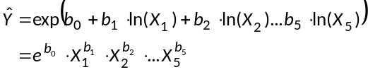
This equation form ensures that the predicted value is always non-negative.
Net merchantable volume at 12.5 cm utilization was estimated as a fraction of whole stem volume at 4.0 cm using the following equation:
- 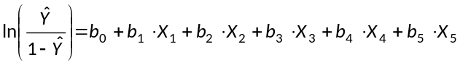
This model form ensures that the predicted fraction falls between zero and 1. In untransformed form, the GMV equation becomes the following:
- 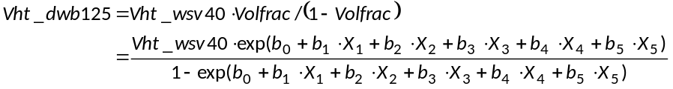
After the preliminary selection of predictor variables, the equation forms (2) and (4) were fit as a nonlinear system of equations (SUR- Seemingly Unrelated Regression, Greene 1993). During this process, some of the original coefficients became statistically insignificant. When this occurred, the least statistically significant predictor was successively removed until all the remaining predictors were considered significant (α ≤ 0.05).
The resulting system of equations for the all strata combined, as an example, is given below:
- 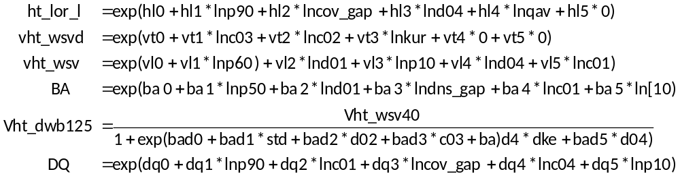
The SUR models were run using all the data (100%) using all the data (Combined) or by strata (Strata). As well, the All models were run using 70% of the data (70%) or 50% of the data (50%). The calibration data were selected by assigning each plot a random number between 0 and 1, by strata, and sorting by random number. The first 70% and the first 50% of the data by strata were used for calibration. The 50% data is a subset of the 70% data

Non-Parametric Predictive Modeling
Random Forest (RF) was run in unsupervised mode with the default of 500 trees. The same LiDAR predictors were used (Table 4). Essentially, RF finds the reference observation that is closest to the target observation in terms of the LiDAR Metrics. This reference observation is then used to impute all the dependent variables (Table 3) to the target observation. This ensures the predictions are plausible (no extrapolation) and compatible with one another. Predictions are not made for reference observations.
The same 70% of the calibration data used for the parametric approach were used for the nonparametric approach and the remaining plots reserved. These are the target observations (also referred to as validation data).

Summary of Major LEFI Steps and Components
The major components and steps with the linkages for the LEFI project is shown in Figure 3.

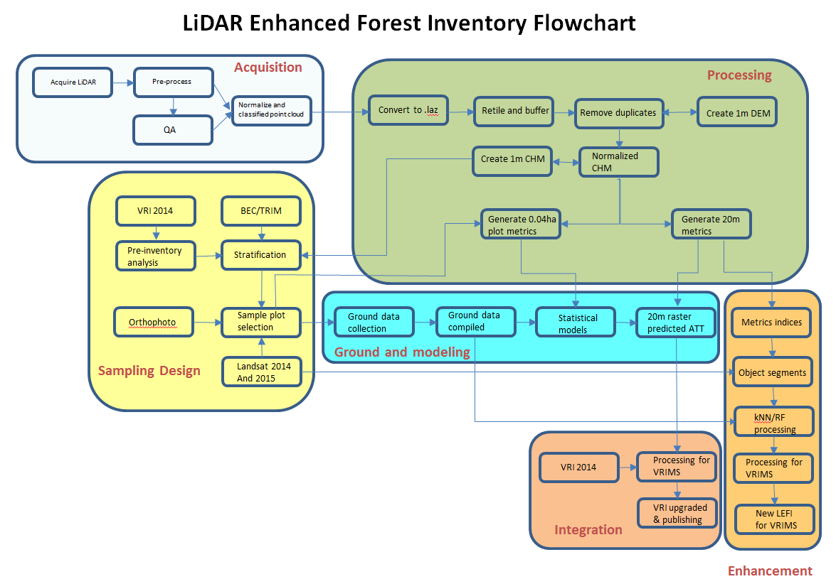
Figure 3 Flowchart of LEFI components and processing steps.

Results

VRI 2014 and Stratification
Figure 4 shows area distributions by several inventory parameters for the entire LiDAR area. It is noted that more than half of the area are inventoried by F (FIP/FC1, inventory methods used prior to year 2000) and about 1/3 of the area by V standard (VRI standard after year 2000). The “I” standard is mostly update of cut blocks. This is consistent with the inventory data age (reference year – the year of photography/inventory was done). Forest in the area is dominated by 2 BEC zones (ICH and ESSF) and 4 species (B, FD, PL, SW) (True/Subalpine Fir, Douglas Fir, Lodgepole Pine, and White/Engelmann Spruce).

- by inventory standards (b) by reference year

(c) by leading species (d) by age class

(e) by height class (f) by BEC zone
Figure 4 Area distributions as summarized from the 2014 VRI.

LiDAR Data QA and Pre-Processing
One of the project areas in Okanagan TSA) was selected for detail quality assurance check of LiDAR data as delivered from the provider.
Table 5 provides a summary of laser points by return class, while Figure 5 shows hill shaded bare earth DEM with the original BCGS 1:2,500 Grid System.
Points with above canopy reflections (due to the presence of atmospheric moisture, particulates, and other airborne obstructions such as birds, insects, etc,) as well other forms of sensor noise were removed or filtered prior to metric extraction. Other non-vegetation classes such as buildings and other anthropogenic structures, withheld, and duplicates were also filtered out.

Table 5 Total number of laser points in by return class. Statistics derived from the original Okanagan dataset delivered by LiDAR data provider.

Return Type | Count | %
First | 2,979,857,828 | 85.94
Second | 390,773,074 | 11.27
Third | 80,394,573 | 2.32
Fourth | 14,838,345 | 0.43
Fifth | 1,605,609 | 0.05
Intermediate | 96,893,631 | 2.79
Last | 2,978,512,598 | 85.90
Single | 2,587,794,628 | 74.63
Ground (2) | 617,618,782 | 17.81
Low Veg (3) | 451,694,586 | 13.03
Med. Veg (4) | 116,075,290 | 3.35
High Veg. (5) | 2,282,075,702 | 65.81
Noise (7) | 5,069 | 0.00
All | 3,467,469,429 | 100.00

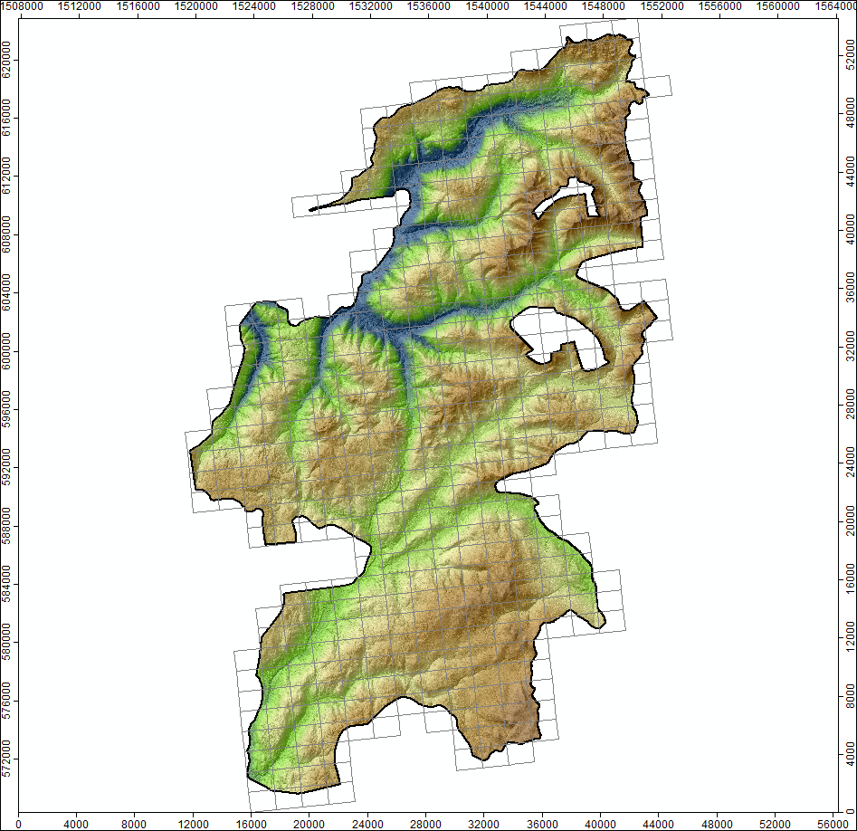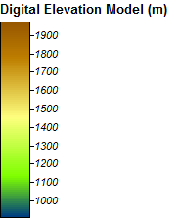
Figure 5 Bare earth DEM with the original BCGS 1:2,500 Grid System.
The original tiled maps from the data provider are useful for view and GIS applications, but difficult for inventory analysis and processing. Therefore, the original LiDAR point cloud data was re-blocked (retitled) to a square shape map of 1000m by 1000m with a 25m buffer between tiled maps. The re-blocking allowed the analyst to eliminate or spot several problems that might arise from processing errors inadvertently created by the data provider, such as inclusion of boundary points, duplicate points, and data corruption. The square tiles allow for fast and efficient tile buffering, data clipping, gridding, and image mosaicking. The outside buffer (25 m) was used to eliminate unwanted boundary artifacts associated with other downstream processes, such as ground finding, DEM extraction, height normalization, etc.
Figure 6 shows the square maps after the re-tiling.

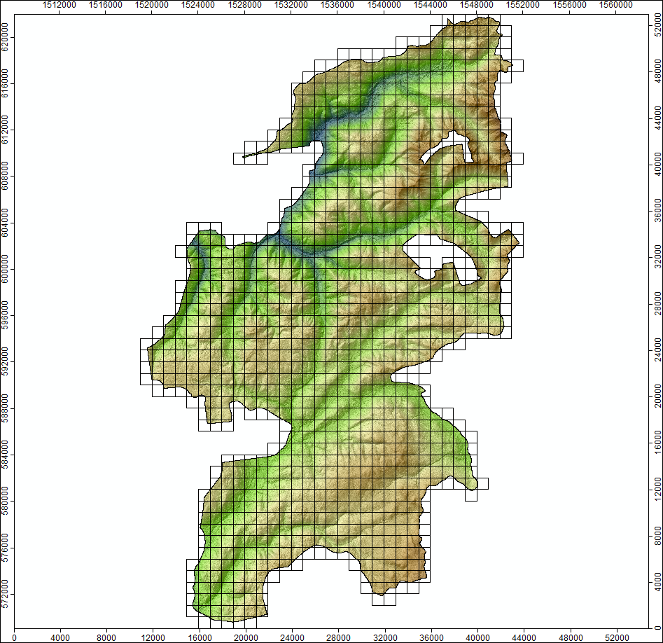
Figure 6 Retiled 1000m x 1000m LiDAR dataset (bare earth DEM).

Normalized Canopy Height Model (CHM)
Each point in the dataset has to be converted from a height above mean sea level (or some other geodetic datum) to a height above the ground surface. Height normalization of the point cloud is required for area-based, vegetation metric extraction. It also makes it easier for an analyst to find and remove low or high vertical outliers, misclassified points, and other spurious laser returns as shown in Figure 7.

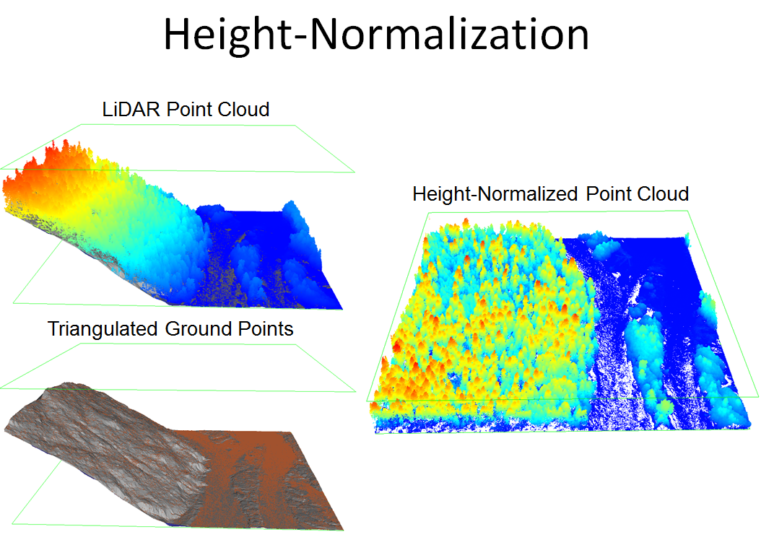

Figure 7 Convert each point from an elevation above mean sea level to height above the ground surface.
Most data providers will construct a CHM by differencing a rasterized DSM (Digital Surface Model) and bare-earth DEM (DTM). This is the least accurate way to create a CHM because height will depend on how the DSM and DEM surfaces were interpolated. Also, the most accurate height maximum is determined by the largest height difference between a non-ground return (1) and its interpolated elevation on the ground surface directly below not by the elevation difference between two pixel centroids. This is especially apparent on steep slopes.
The spatial resolution (i.e., grid cell size) of the CHM should reflect the natural spacing of the laser returns. Too small grid size could result in a preponderance of data voids (pits).
There are a number of ways that data voids or pits can be eliminated: (i) fill each data void with some average measure of height taken from the surrounding neighbourhood of pixel values; (ii) replace each laser point with a small disk that approximates the footprint of the laser pulse (referred to as “splatting”); (iii) implement other more complex algorithms specifically designed for eliminating CHM pits; (iv) choose a grid-cell resolution closer to the natural spacing of the ground returns.
A 1-m CHM raster with 0.5m splatting was created and the resulted image mosaic was used for further review and screening/checking of data quality. The high spatial resolution DEM and CHM will allow the analyst to rapidly find errors related to poor flight-line integration and geometric calibration, point classification, atmospheric noise, sensor timing and filtering errors, etc.
The 1m CHM is shown in Figure 8.

. 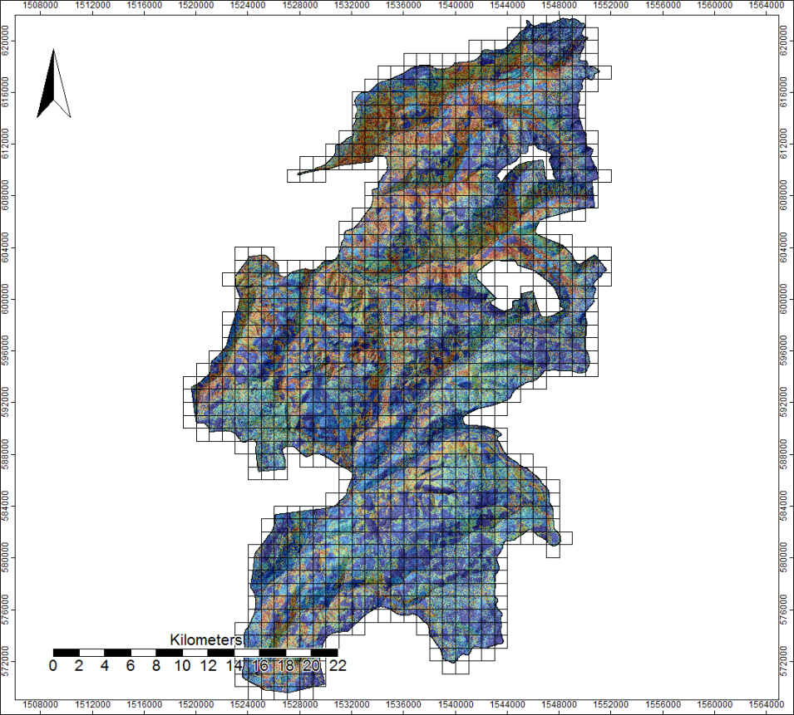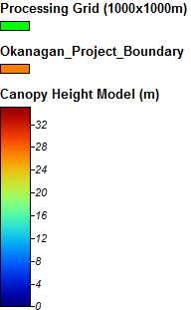
Figure 8 Canopy Height Model

LiDAR CHM Metrics and Raster Predictions
All the LiDAR metrics as defined in Table 4 were generated from the normalized CHM for all the 0.04h circular ground plots. This dataset together with the ground measurements was used for further statistical analysis and modeling.
The normalized CHM was gridded into a 20m by 20m raster and all the predictions were made for every pixel using the predictive models (both parametric and non-parametric approaches).

Ground Data Collection and Initial Statistical Analysis
Out of the total 233 targeted ground plots, two plots were dropped due to the access problem. Plots 80, 104, 147, 270 and 282 were harvested between the time of LiDAR acquisition and field measurement. Plot 170 was outside the LiDAR area. Plot 122 had one live tree. These were dropped from further analysis. Plot 218 fell in a relatively open area in a regenerating block and the LiDAR returns include the crowns of some trees outside the plot. It was also dropped. The final number of ground plots for the further statistical analysis was 223.
Strata 1 and 2 (BEC = ICH/IDF) have higher volumes than strata 3 and 4 (BEC = ESSF/MS). The field plots are summarized in Table 6.

Table 6 Statistical estimates of selected tree attributes with the change ranges
 |  |  | Live |  |  |  | Dead
Strata | N | Basal area  (m²/ha) | Stems/ha | Lorey height  (m) | Whole stem volume (m³/ha) |  | Whole stem volume (m³/ha)
1 | 60 | 43.5 (0.6 - 127.8) | 1175 (25 - 3702) | 22.6 (8.1 - 36) | 393 (2 - 1512) |  | 47 (0 - 177)
2 | 63 | 47.7 (0.9 - 123) | 1039 (100 - 3277) | 22.5 (6 - 40.7) | 417 (2 - 1287) |  | 54 (0 - 295)
3 | 40 | 29.4 (5.8 - 52.4) | 1028 (200 - 3828) | 18.5 (8.7 - 30.7) | 231 (22 - 525) |  | 68 (0 - 297)
4 | 56 | 31.1 (1 - 81.8) | 885 (200 - 1826) | 20 (5.8 - 34.6) | 272 (3 - 835) |  | 53 (0 - 386)

P90 had the highest simple correlation coefficient with live lorey height for all strata (Figure 9). The relationship between lorey height and p90 appears relatively insensitive to strata.

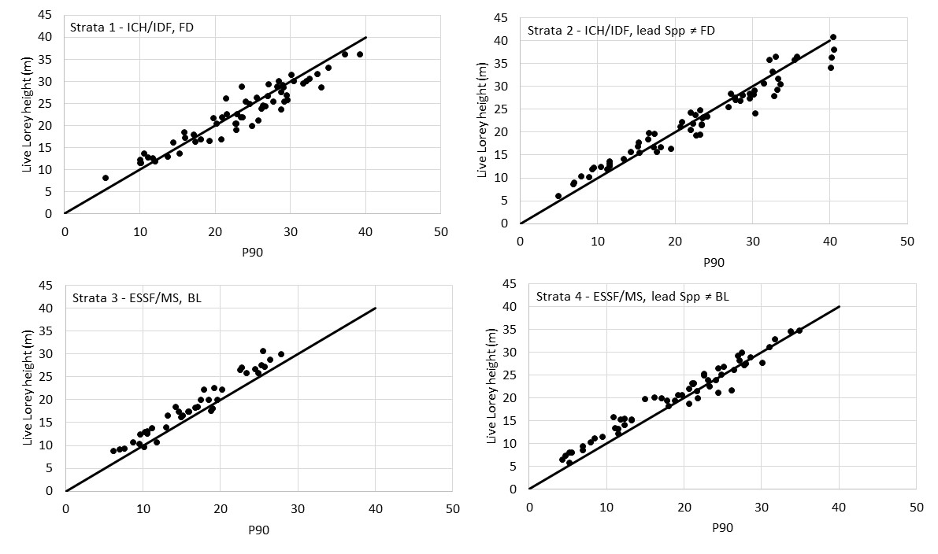
Figure 9 Scatter plots of live Lorey height against p90 by strata.
There is some evidence that the relationship between volume and LiDAR attributes varies with strata (Figure 10). When all the data are plotted on one graph (Figure 11), the curvilinear trend becomes more apparent. There is also some evidence of increasing variability in volume with increasing p90. The ground plot includes all trees whose stem base is within the plot. The LiDAR plot only includes the portion of the tree that is within the plot boundary. And for trees outside the plot, the LIDAR plot includes that portion of the tree crown that falls within the plot boundary. Thus some of the field plot attributes (basal area and volume) are very sensitive to edge trees while the LiDAR plot is relatively insensitive. The larger the tree, the more sensitive the field plot is to edge trees.
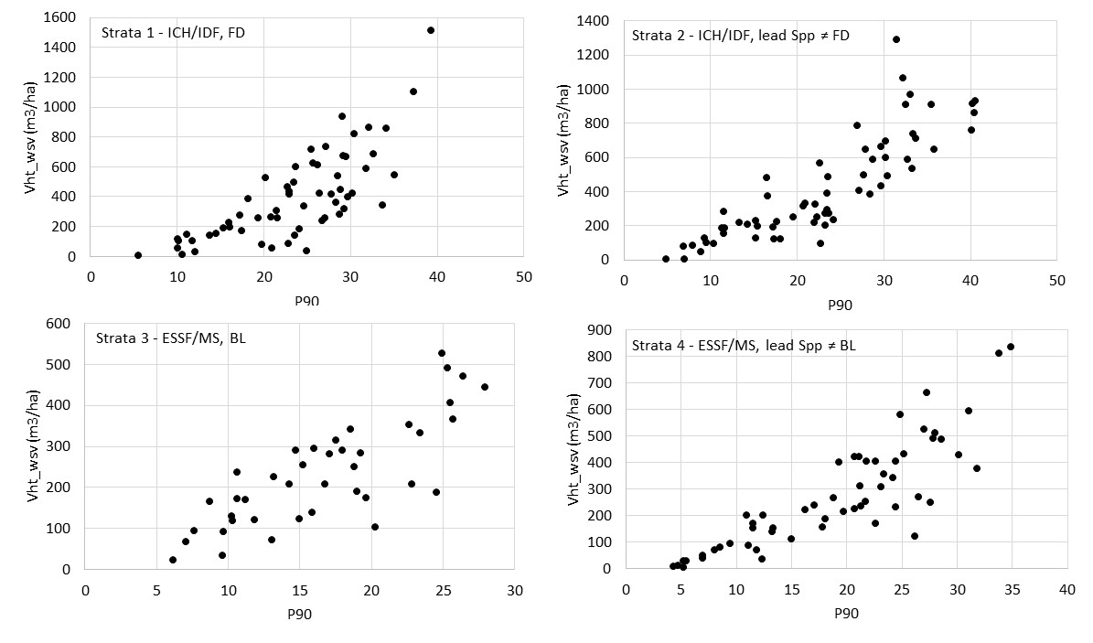
Figure 10 Scatter plots of whole stem volume (at the 4cm utilization level) against p90 by strata

The same data as in Figure 10 but all strata are plotted on one graph (Figure 11).

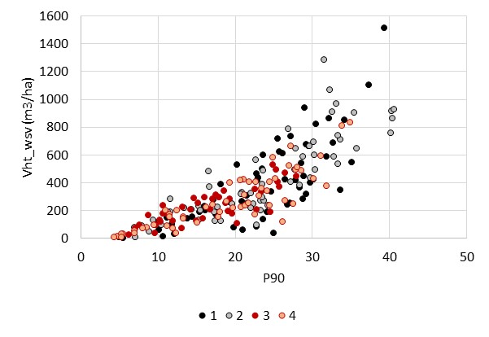
Figure 11 The live whole stem volumes against p90 without stratification
Some plots have a significant amount of dead volume. Most of the interest is in the live volume and there is some concern the dead volume may complicate the predictions. It was expected that in Figure 11, plots with a lot of dead volume would tend to be at the lower part of the data cloud, for a given p90. This trend is not clear (Figure 12). The plots with a lot of dead volume tend to be within the overall data cloud.
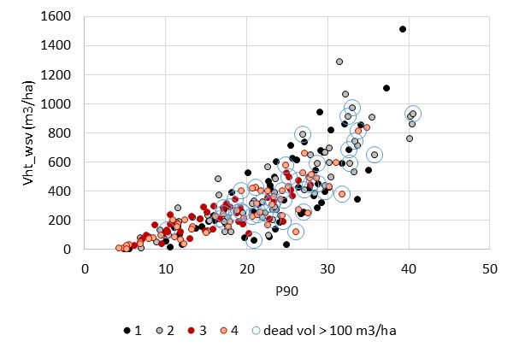
Figure 12 The same data as Figure 6 with the addition that the plots with more than 100 m3/ha of dead whole stem volume are circled.

Parametric predictions
The prediction equations using all the data and no stratification are given in Table 7. The parametric prediction equations associated with all the data and no stratification.

Table 7 The parametric prediction equations associated with all the data and no stratification
Variable | Prediction equation
ht_lor_l | exp(0.564035 + 0.511271*lnp90 + 0.045678*lncov_gap + 0.004767*lnd04 + 0.154872*lnqav);
Vha_nwd | exp(3.877499 + 0.124742*lnd03 );
Vht_Wsv | exp(0.820032 + 1.254242*lnp60 + 0.272216*lnd01 + 0.543549*lnp10 + 0.01024*lnd04);
Ba_Ha | exp(0.790413*lnp50 + 0.287273*lnd01 + -0.05657*lndns_gap + 0.609148*lnp10 + 0.034438*lnd00);
 | 1/(1+exp(-(-0.10978 + -0.03837*kur)));
DQ | exp(0.816127*lnp90 + 0.14983*lncov_gap + 0.191202*lnp10 + 0.014123*lnd05);
HT_top | exp(0.670351+ 0.814821*lnp90 + 0.029218*lnd01);
Vol_nwb | Temp = 1/(1+exp(-(-0.10978 + -0.03837*kur)));  vht_dwb125 = vht_wsv*temp/(1-temp);

The parametric results for Lorey height are given in Figure 13. The predictions for the models calibrated by strata and the models calibrated for all strata combined are similar.
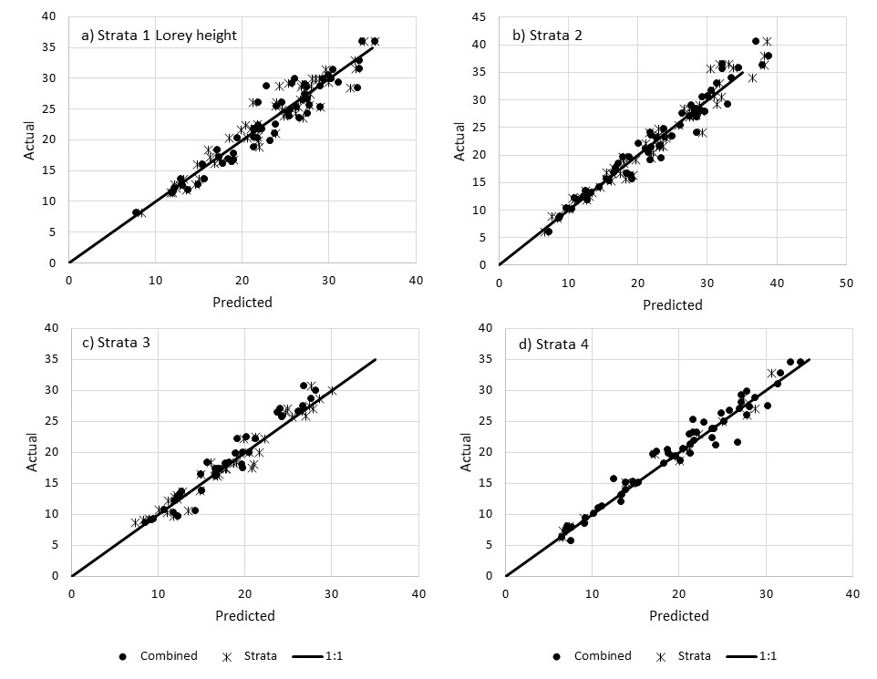
Figure 13 The parametric predictions of Lorey height are plotted against the actual Lorey height by strata. The SUR models were fit using all data (“Combined”) as well as by strata (“Strata”). The 1:1 line is given.

For basal area, the predictions for the combined model generally show more spread than the strata-level models ( Figure 14) particularly for strata 1 and 4.
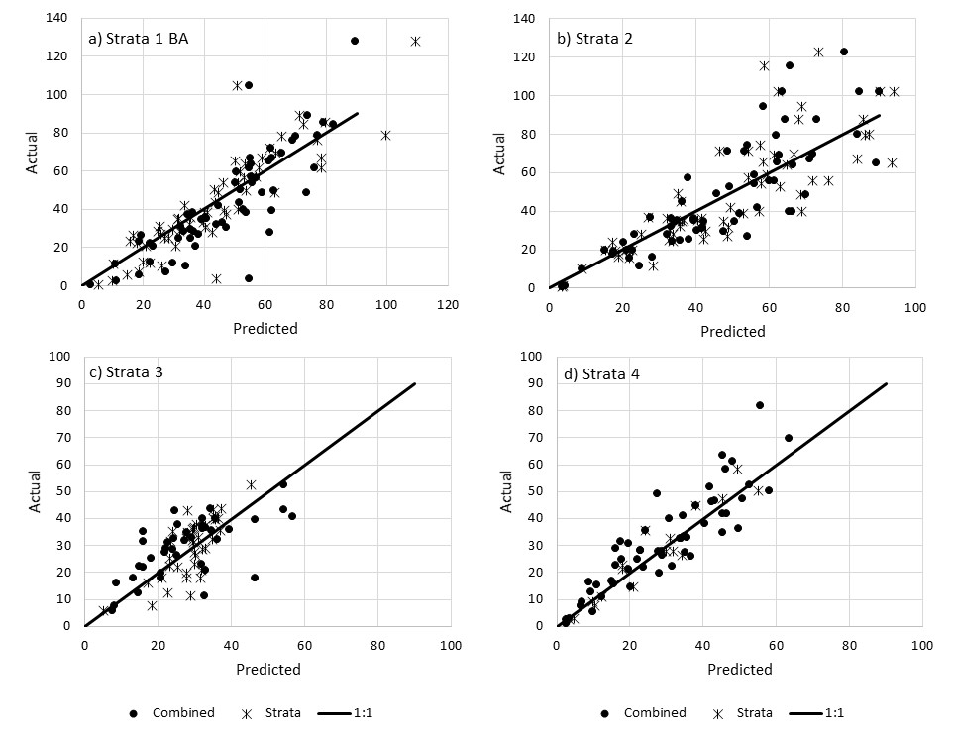
Figure 14 The parametric predictions of basal area (m²/ha) are plotted against the actual basal area by strata. The SUR models were fit using all data (“Combined”) as well as by strata (“Strata”). The 1:1 line is given.

The parametric predictions of volume are given in Figure 15.
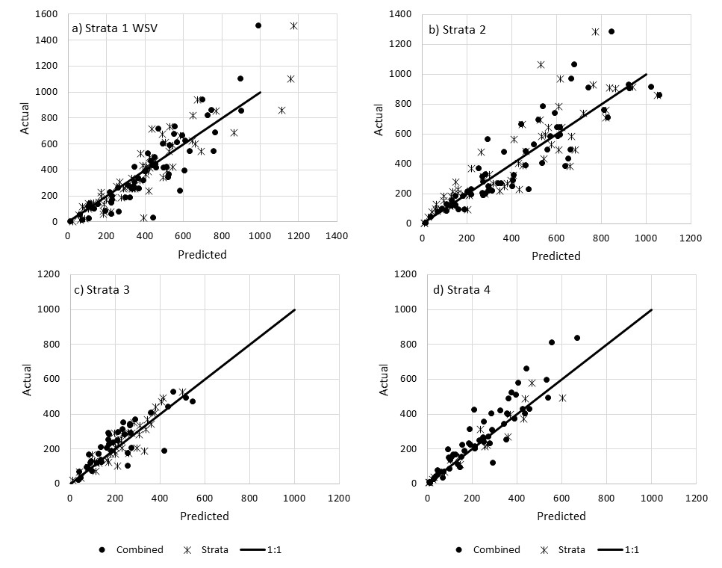
Figure 15 The parametric predictions of live whole stem volume (m3/ha) are plotted against the actual volume by strata. The SUR models were fit using all data (“Combined”) as well as by strata (“Strata”). The 1:1 line is given.

Summary statistics comparing the combined and strata predictions using all the data and parametric prediction are given in Table 8. In general, the strata level models have less bias at the strata level than the combined model. The combined model biases are small for Lorey height (<5%) and up to 10% for BA and volume (strata 1 and 4).

Table 8 The actual and predicted values are given for basal area and Lorey height using all the data for all strata combined (Combined) and by strata (Strata).
 |  |  |  | Mean |  |  | Bias | ± s.e.
Attribute | Strata | N | Actual | Combined | Strata |  | Combined | Strata
BA Live | 1 | 60 | 44 | 47 | 44 |  | -3.7 ± 0.2 | -0.2 ± 0.2
(m²/ha) | 2 | 63 | 48 | 47 | 48 |  | 1 ± 0.2 | -0.4 ± 0.2
 | 3 | 40 | 29 | 28 | 29 |  | 1.6 ± 0.2 | 0.3 ± 0.2
 | 4 | 56 | 31 | 29 | 31 |  | 2.3 ± 0.1 | 0.4 ± 0.1
 | All | 219 | 39 | 39 | 39 |  | 0.1 ± 0.1 | 0 ± 0.1
Lorey height | 1 | 60 | 22.6 | 23 | 22.5 |  | -0.4 ± 0.1 | 0 ± 0.1
(m) | 2 | 63 | 22.5 | 22.6 | 22.5 |  | -0.1 ± 0.1 | 0 ± 0.1
 | 3 | 40 | 18.5 | 18 | 18.4 |  | 0.5 ± 0.1 | 0 ± 0.1
 | 4 | 56 | 20 | 19.8 | 20 |  | 0.2 ± 0.1 | 0 ± 0.1
 | All | 219 | 21.1 | 21.2 | 21.1 |  | 0 ± 0 | 0 ± 0
Whole stem | 1 | 60 | 393 | 417 | 401 |  | -24.3 ± 0.6 | -8 ± 0.5
Volume | 2 | 63 | 417 | 418 | 395 |  | -0.7 ± 0.5 | 21.9 ± 0.5
(m³/ha) | 3 | 40 | 231 | 211 | 228 |  | 20.4 ± 0.5 | 3.3 ± 0.4
Dbh ≥ 7.5 cm | 4 | 56 | 272 | 237 | 267 |  | 34.3 ± 0.4 | 4.3 ± 0.4
live | All | 219 | 339 | 334 | 333 |  | 5.6 ± 0.2 | 5.8 ± 0.2
The basal area data from Table 6 are plotted in Figure 16.
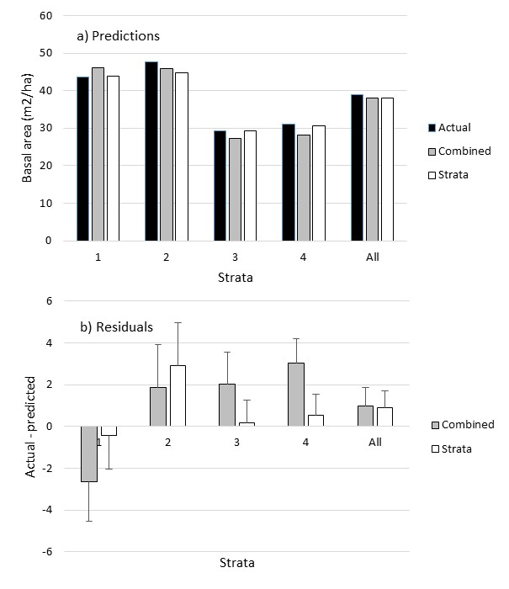
Figure 16 The Basal area predictions and residuals are given by strata. The data are given in Table 8. The standard error bars are given with the residuals.

Nonparametric prediction
The data were not stratified for the nonparametric predictions. Since the RF algorithm looks for a close match, it was felt this eliminates the need to stratify. Approximately 30% of the plots were reserved for validation. The RF predictions are compared to those using the Combined model (no stratification), using all the data, the Combined model using 70% of the data and the Combined model using 50% of the data. Predictions were compared for the 30% of the plots reserved for validation. Note these validation plots were used in the “Combined” model for calibration. The validation plots were not used to calibrate any of the other predictions presented in this section.
The basal are predictions are given in Figure 17 and the live whole stem volume predictions are given in Figure 18. There is less variation among the prediction methods for volume compared to basal area. This may be due to the strong dependent of volume on height, which is estimated very well.

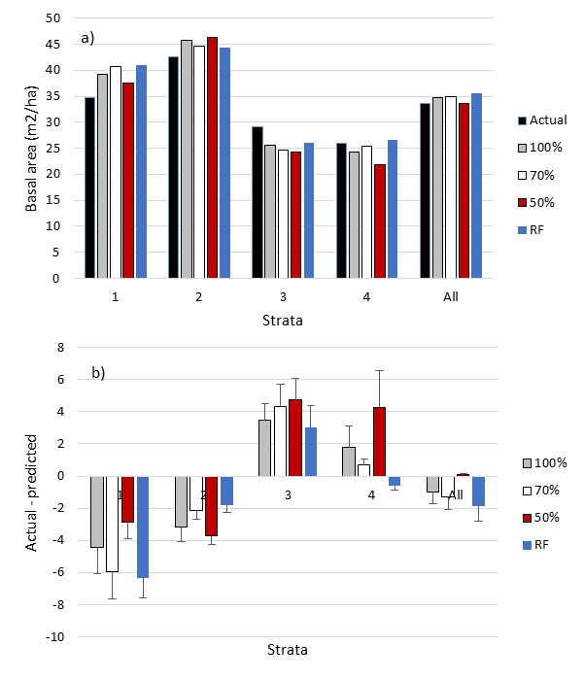
Figure 17 The predictions (a) and residuals (b) are given for the basal area predictions. The standard error is given for the residuals. The data are the validation data set and the sample sizes given in Table 8
.
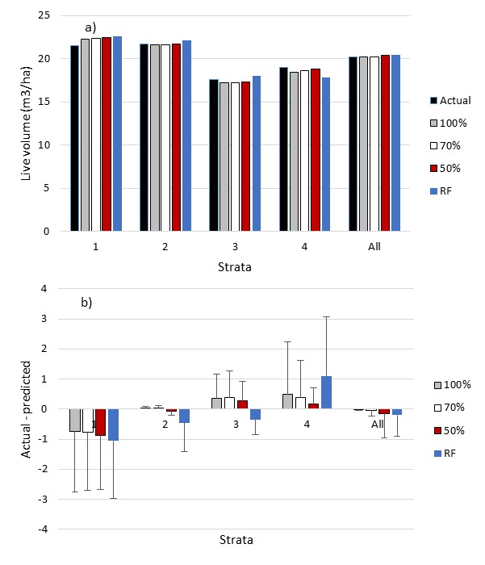
Figure 18 The predictions (a) and residuals (b) are given for the live whole stem volume predictions. The standard error is given for the residuals. The data are the validation data set and the sample sizes given in Table 8

The predictions for Lorey height, basal area, and live whole stem volume are plotted in Figure 19. The predictions for all the dependent variables are given in Table 9. In most cases, the biases are not statistically different from zero. For attributes such as Lorey height and top height, this is because the bias is small. The biases for basal area and volume are larger but are not statistically significant because of the larger standard error.
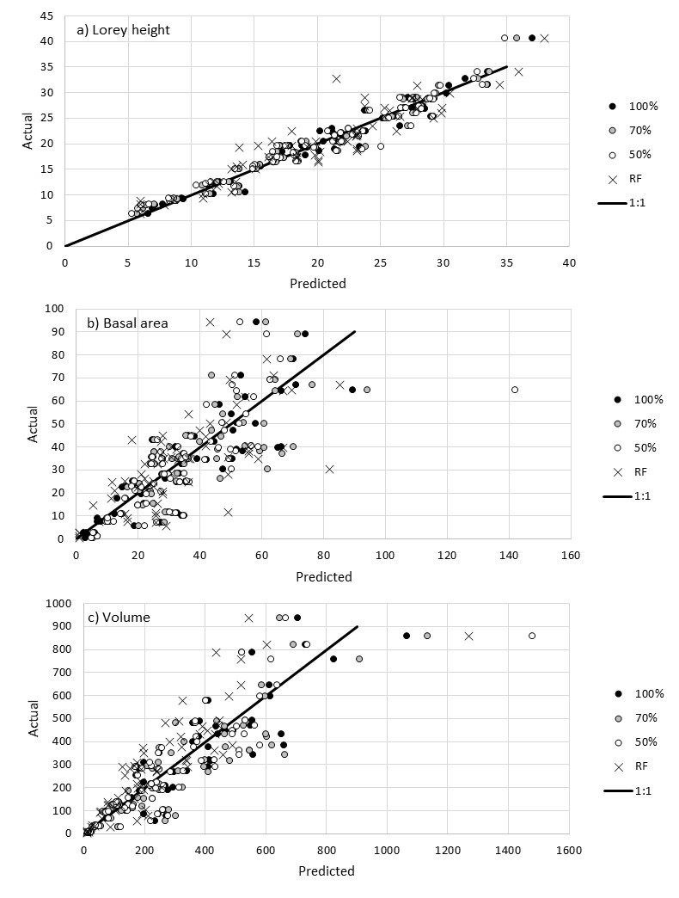
Figure 19 The parametric predictions (100% = 100% of the data used for calibration, 70% = 70% of the data used for calibration, 50% = 50% of the data used for calibration) and nonparametric predictions (RF) are given for the validation data (30%).

Table 9 The actual and predicted values are given for the validation data. Biases that are statistically different from zero (α ≤ 5%) are shaded.

 |  |  |  | Mean |  |  |  |  | Residual | ± s.e.
 | Strata | N | Actual | 100% | 70% | 50% | RF |  | 100% | 70% | 50% | RF
Basal | 1 | 17 | 34.8 | 39.2 | 40.7 | 37.6 | 41.1 |  | -4.4 ± 2.7 | -6 ± 3.5 | -2.9 ± 2.7 | -6.3 ± 5.2
Area | 2 | 18 | 42.5 | 45.7 | 44.7 | 46.2 | 44.3 |  | -3.2 ± 3.5 | -2.1 ± 3.7 | -3.7 ± 6.6 | -1.8 ± 4.1
(m²/ha) | 3 | 11 | 29.1 | 25.6 | 24.8 | 24.3 | 26 |  | 3.5 ± 3.3 | 4.3 ± 3.1 | 4.7 ± 3.5 | 3 ± 2.2
 | 4 | 16 | 26 | 24.2 | 25.4 | 21.8 | 26.7 |  | 1.8 ± 1.3 | 0.7 ± 1.7 | 4.2 ± 1.8 | -0.6 ± 2.5
 | All | 65 | 33.7 | 34.7 | 35 | 33.6 | 35.6 |  | -1 ± 1.4 | -1.3 ± 1.6 | 0.1 ± 2.2 | -1.9 ± 2
DQ | 1 | 17 | 23.9 | 24 | 25.2 | 24.9 | 25 |  | -0.2 ± 0.9 | -1.3 ± 1.4 | -1.1 ± 1.3 | -1.1 ± 1.4
(cm) | 2 | 18 | 23.6 | 22.9 | 23.4 | 23.2 | 23.1 |  | 0.7 ± 1.1 | 0.2 ± 1 | 0.4 ± 1.2 | 0.5 ± 1.3
 | 3 | 11 | 20.4 | 19.6 | 19.1 | 19.3 | 22.1 |  | 0.9 ± 1.2 | 1.4 ± 1.3 | 1.2 ± 1.1 | -1.7 ± 1.5
 | 4 | 16 | 20.6 | 20.5 | 20.7 | 21 | 19.1 |  | 0.1 ± 0.9 | -0.2 ± 1.3 | -0.4 ± 1.2 | 1.5 ± 1.1
 | All | 65 | 22.3 | 22 | 22.4 | 22.4 | 22.4 |  | 0.3 ± 0.5 | -0.1 ± 0.6 | -0.1 ± 0.6 | -0.1 ± 0.7
Lorey | 1 | 17 | 21.5 | 22.3 | 22.3 | 22.4 | 22.6 |  | -0.8 ± 0.4 | -0.8 ± 0.4 | -0.9 ± 0.5 | -1.1 ± 0.6
height | 2 | 18 | 21.7 | 21.6 | 21.6 | 21.7 | 22.1 |  | 0 ± 0.3 | 0 ± 0.4 | -0.1 ± 0.4 | -0.5 ± 0.5
(m) | 3 | 11 | 17.6 | 17.2 | 17.2 | 17.3 | 18 |  | 0.4 ± 0.5 | 0.4 ± 0.4 | 0.3 ± 0.4 | -0.4 ± 0.7
 | 4 | 16 | 18.9 | 18.5 | 18.6 | 18.8 | 17.9 |  | 0.5 ± 0.3 | 0.4 ± 0.3 | 0.2 ± 0.3 | 1.1 ± 0.6
 | All | 65 | 20.2 | 20.2 | 20.2 | 20.4 | 20.4 |  | 0 ± 0.2 | 0 ± 0.2 | -0.2 ± 0.2 | -0.2 ± 0.3
Density | 1 | 17 | 813 | 928 | 1015 | 853 | 877 |  | -115 ± 78 | -202 ± 192 | -40 ± 89 | -64 ± 121
(trees/ha) | 2 | 18 | 1041 | 1253 | 1157 | 1095 | 1182 |  | -212 ± 142 | -116 ± 115 | -54 ± 122 | -141 ± 151
 | 3 | 11 | 1134 | 947 | 957 | 883 | 871 |  | 187 ± 139 | 177 ± 167 | 251 ± 164 | 263 ± 173
 | 4 | 16 | 751 | 796 | 864 | 826 | 812 |  | -45 ± 106 | -113 ± 113 | -76 ± 157 | -62 ± 88
 | All | 65 | 921 | 991 | 1007 | 921 | 947 |  | -70 ± 59 | -85 ± 75 | 0 ± 66 | -26 ± 67
Top | 1 | 13 | 27.2 | 25.7 | 25.8 | 26 | 24.8 |  | -0.6 ± 0.8 | -0.8 ± 0.8 | -1 ± 0.9 | -1.8 ± 1.6
Height | 2 | 18 | 24.6 | 25.5 | 25.6 | 25.8 | 26.2 |  | -0.9 ± 0.8 | -1 ± 0.8 | -1.2 ± 0.9 | -1.6 ± 1.3
(m) | 3 | 9 | 18.9 | 19.9 | 20.1 | 20.4 | 20.7 |  | 0.2 ± 1 | 0 ± 1 | -0.3 ± 1.1 | -0.3 ± 1.3
 | 4 | 12 | 19.4 | 21.3 | 21.4 | 21.7 | 20.1 |  | -0.2 ± 1 | -0.3 ± 1 | -0.6 ± 1 | 1.2 ± 1.6
 | All | 55 | 23 | 23.5 | 23.6 | 23.8 | 23.3 |  | -0.5 ± 0.4 | -0.6 ± 0.5 | -0.8 ± 0.5 | -0.8 ± 0.7
Live | 1 | 17 | 244 | 284 | 254 | 262 | 296 |  | -40.5 ± 20.4 | -9.9 ± 9.3 | -18.8 ± 10.6 | -52.6 ± 31.9
Merch | 2 | 18 | 287 | 332 | 303 | 299 | 332 |  | -45.5 ± 22.4 | -16.1 ± 15 | -12.8 ± 16.1 | -45.2 ± 27.9
Volume | 3 | 11 | 177 | 158 | 178 | 181 | 165 |  | 19.1 ± 19.6 | -1.5 ± 6.1 | -4.5 ± 4.6 | 12.2 ± 11.3
Dbh≥12.5 | 4 | 16 | 187 | 169 | 192 | 197 | 184 |  | 18.1 ± 14.3 | -4.6 ± 4.4 | -9.8 ± 5.8 | 3.1 ± 22.5
(m³/ha | All | 65 | 229 | 245 | 238 | 241 | 254 |  | -16 ± 9.9 | -8.8 ± 5.3 | -12.1 ± 5.7 | -24.3 ± 13.3
Dead | 1 | 17 | 40 | 55 | 56 | 58 | 94 |  | -15.5 ± 11.1 | -16.4 ± 11.4 | -17.9 ± 11.9 | -54.2 ± 29
Volume | 2 | 18 | 49 | 54 | 54 | 55 | 55 |  | -4.9 ± 12.2 | -5.6 ± 12.3 | -6.5 ± 12.6 | -6.4 ± 18.7
Dbh ≥ 7.5 | 3 | 11 | 63 | 43 | 42 | 41 | 48 |  | 19.6 ± 13.4 | 20.2 ± 13.2 | 21.5 ± 13 | 14.1 ± 15.5
(m³/ha) | 4 | 16 | 48 | 47 | 47 | 47 | 50 |  | 0.7 ± 10.2 | 0.7 ± 10.1 | 1 ± 9.8 | -1.7 ± 14
 | All | 65 | 49 | 51 | 51 | 51 | 63 |  | -1.9 ± 5.9 | -2.2 ± 5.9 | -2.6 ± 6 | -14.5 ± 10.6
Live | 1 | 17 | 307 | 350 | 362 | 342 | 373 |  | -43.1 ± 26.9 | -55.5 ± 32.5 | -35.2 ± 24.7 | -66.7 ± 48.2
Volume | 2 | 18 | 373 | 411 | 397 | 419 | 417 |  | -37.6 ± 28.2 | -23.6 ± 31 | -46.3 ± 54.9 | -43.5 ± 37.2
Dbh ≥ 7.5 | 3 | 11 | 223 | 195 | 182 | 180 | 198 |  | 27.9 ± 24.2 | 40.1 ± 24.9 | 42.8 ± 26.9 | 24.8 ± 15
(m³/ha) | 4 | 16 | 229 | 206 | 215 | 188 | 221 |  | 23.6 ± 15.1 | 14.8 ± 15.5 | 41.3 ± 17.7 | 8.3 ± 25.4
 | All | 65 | 291 | 302 | 301 | 295 | 315 |  | -11.4 ± 12.4 | -10.8 ± 14 | -4.5 ± 18.4 | -24.1 ± 18.4

Discussion
Several methodological steps, analytical workflows, and assumptions are needed to generate a reliable, model-based LEFI. First, the LiDAR point cloud, spatial support layers, and ground-reference datasets must be spatially and aspatially complete, and as error free as possible. Second, ground-reference sampling must effectively cover the full range of structural and compositional variability at an intensity that is commensurate with the planned modelling framework. For example, modelling techniques that are incapable of numerical interpolation and extrapolation (e.g., kNN, Random Forests, etc.) must be supported by a larger number of sample points uniformly distributed in multidimensional feature space to ensure the presence of one or more plausible (valid) nearest neighbours. Third, ground-reference data represent the response variable in a model-based LEFI and should be collected and compiled using timber utilization standards and appraisal methods, which are compatible with the planned inventory objectives and forest management needs. Fourth, predictor (explanatory) variables selected for inclusion in any LEFI prediction model must also exist in the out-of-sample target population at the same level of precision, reliability, and spatial scale in order to maintain model integrity. Species composition, for instance, is usually directly measured on the ground at tree and plot levels for in-sample training datasets (i.e., datasets used for model specification and fitting), and derived indirectly by airphoto interpretation at the stand level for the target population. These kinds of data incompatibilities can be the source of unexpected and unknown prediction error when models are applied to new, out-of-sample datasets. Last, critical LEFI models (e.g., height, volume, biomass, etc.) should be validated at plot and stand levels across a range of forest cover types before layers are published for operational use or for appraisal purposes.
There are some advantages to the parametric approach. Some attributes, such as height, are relatively insensitive to strata and it may be possible to develop a relatively general model, applicable over a wide area. This would reduce the amount of calibration data required. With a parametric model it is possible to specify the shape of the relationships and choose whether or not to include an intercept or an asymptote.
There are some advantages to the nonparametric approach. In the implementation here, unsupervised training, the closest match is found in the reference dataset and used to impute all the field attributes. This ensures the attributes are plausible and internally compatible. RF can handle large numbers of predictor variables and collinearity among the predictors is not an issue. There is no need to try and reduce the number of predictors. There is generally no need for stratification since the closest match is found. RF is generally robust to outliers. If additional reference observations are taken, only those target observations that are now closest to the additional observations will have new predictions. Predictions for the other targets will remain unchanged.
TBD: Cost of the ground sampling. Cost and benefit of LEFI, things learned, district/BCTS/Licensees perspective, etc.

Summary
The gains from fitting models by strata were small. Stratification may be more effective if, for instance, the inventory could be stratified accurately and precisely by MPB kill.
The effect of number of ground samples was examined by comparing a parametric model using all the data (100%), 70% of the data and 50% of the data. In terms of basal area, all led to unbiased estimates at the population level. At the strata level, the bias increased slightly at the strata level but was not statistically significant.
Parametric predictions using 70% of the data were compared to RF predictions using 70% of the data. Using the remaining 30% of the data as validation data, overall both methods lead to unbiased estimates. The standard error of the RF estimates was higher than that associated with the parametric predictions.
Parametric models can be used to extrapolate beyond the range of data while RF cannot. In unsupervised mode, RF uses the closest observation in the reference data set to impute all the dependent variable. Thus the predictions for a target pixel are internally compatible (e.g., the relationships between the dependent variables are preserved) since they come from an actual ground measurement.
What has been accomplished in 2015:
- Ground sampling design, ground measurements, and compilation
- LiDAR data QA, pre-processing, CHM/DTM, and LiDAR metrics
- Statistical analysis and model development
- Initial inventory products of predicted Basal Area, Quadratic Diameter, Lorey height, Top Height, Whole Stem Volume at 4cm, Net Volume at 12.5cm, and Dead Volume (gross at 4cm)
- The draft summary report

What is planned to be completed in 2016:
- LEFI integration with VRIMS
- New spatial products with new attribution using the non-parametric approach
- Evaluation and assessment (comparing the existing VRI)
- Implementation (seminar, demo, training workshop, etc.)
- Final summary report

References

Meidinger, D. and Pojar, J. 1991. Ecosystems of British Colombia. B.C. Ministry of Forests, Victoria, B.C.
The American Society for Photogrammetry & Remote Sensing (ASPRS) LASer (LAS) File Format for the interchange of 3-D point cloud data among data users, ASPRS LAS v1.2 Point Classification and Point Classification Flags (source: http://www.asprs.org/a/society/committees/standards/asprs_las_format_v12.pdf).
LAStools is a comprehensive suite of open source (GNU LGPL 2.1) and commercial software tools developed by rapidlasso GmbH (http://rapidlasso.com/lastools/) for manipulating LiDAR data stored in LAS formatted files.
R is a widely used open source (GNU General Public License v2) programming language and environment for statistical computing and graphics (https://www.r-project.org/).
White, J.C., Wulder, M.A., Varhola, A. Vastaranta, M., Coops, N.C., Cook, B.D., Pitt, D., Woods, M., 2013. A best Practices Guide for Generating Forest Inventory Attributes from Airborne Laser Scanning Data Using Area-based Approach. Information Report FI-X-10. Natural Resources Canada, Canadian Forest Service, Canadian Wood Fibre Centre, Pacific Forestry Centre, Victoria, BC, 39 pp.

Appendix

