Spatial Distribution of Soil Class and Soil pH in the Thompson-Okanagan Region, British Columbia
by
Jin Zhang
BSc, Simon Fraser University, 2014
Thesis Submitted in Partial Fulfillment of the
Requirements for the Degree of
Master of Science
in the
Department of Geography
Faculty of Environment

© Jin Zhang 2019
SIMON FRASER UNIVERSITY
Summer 2019

Copyright in this work rests with the author. Please ensure that any reproduction
or re-use is done in accordance with the relevant national copyright legislation.

Approval
Name: | Jin Zhang
Degree: | Master of Science
Title: | The Title: Spatial Distribution of soil class and soil attributes in the Thompson-Okanagan Region,
Examining Committee: | Chair: | [Firstname Lastname]  [Academic Role]
Dr. Margaret G. Schmidt
Senior Supervisor
Associate Professor
Department of Geography
Simon Fraser University
Dr. Chuck Bulmer
Supervisor
Adjunct Professor
Faculty of Land and Food Systems
British Columbia Ministry of Forests, Lands, and Natural Resource Operations
Forest Science Section
Anders Knudby
Supervisor
Associate Professor
Department of Geography, Environment and Geomatics
University of Ottawa
[Firstname Lastname]
Internal Examiner
[Academic Role]
[Department – if different from the home department]
[Firstname Lastname]
External Examiner
[Academic Role or Professional Role]
[Department]
[Institution or Employer]
Date Defended/Approved: | [Month Day, YEAR]
Please review the Approval page instructions on the library’s thesis website before completing this page:
http://www.lib.sfu.ca/help/publish/thesis/format/approval-page
Remember to delete this note before submission.

Ethics Statement

This page must appear as p. iii if your research required ethics approval. Remember to delete this note before submission.
If an ethics exemption was granted, this page must be removed.
If ethics approval was not required, this page must be removed.
Remember to update the Table of Contents after removing this page.

Abstract
Soil Soils are facing great threats from climate change and anthropogenic activities. It is essential to understand the characteristics of soils, such as class and pH, especially when it comes to the issue of evaluating soil quality. In the Thompson–Okanagan region, previous soil surveys covered most parts of the region in polygon data form; however, it would be beneficial if soil data were available at a finer resolution and with uniform soil categories. The digital soil mapping (DSM) approach has shown promising results over various landscapes with limited available data. The main objective of this study was to use an ensemble learning approach to map the spatial distribution of soil classes and soil pH at 25-meter resolution in the Thompson-Okanagan region, BC. Random Forest (RF) was used to map 16 soil subgroups. Overall prediction accuracy was 65.4% with an independent validation dataset. The study of spatial patterns of soil pH was tested with a combination of multiple base learners, which included a Multilinear Regression (GLM) learner, Stepwise Regression (STEP) learner, Lasso and Elastic-Net regularized Generalized Linear Regression (GLMNET) learner, a Kernel-based Support Vector Machine (KSVM) learner, and RF. Base learners with higher prediction accuracy were used to develop a Super Learner (SL). The fitted SL was then used to predict soil pH for three depth intervals (0 – 5cm, 5 – 15cm, and 15 – 30cm) at 25–meter resolution. For all three depth intervals, the SL proved to have the highest MSE value and better prediction accuracy than was obtained from just using one of the base learners.
Keywords: Soil Classification; Soil Properties; Digital Soil Mapping; Ensemble Learning Approach; Super Leaner; Stacked Generalization;

Dedication
This is an optional page. Use your choice of paragraph style for text on this page (1_Para_FlushLeft shown here).
To hide the heading at the top of this page, select the text and change the text colour to white.

Acknowledgements
This is an optional page. Use your choice of paragraph style for text on this page (1_Para shown here).

Table of Contents
Approval iii
Ethics Statement v
Abstract vi
Dedication vii
Acknowledgements viii
Table of Contents ix
List of Tables xii
List of Figures xiv
List of Acronyms xvi
Glossary xvii
Preface/Executive Summary/Image xviii
Chapter 1. Introduction 1
1.1. Context on the study 1
1.2. Conventional soil survey approach 1
1.3. Digital soil mapping approach 2
1.4. Research objectives 4
1.5. Thesis overview 4
References 6
Chapter 2. Background information 7
2.1. Soil mapping and soil survey in Canada 7
2.2. Categorical and continuous soil data 11
2.3. Soil survey sampling design 12
2.4. Mapping system and environmental variables 14
2.5. Statistical models and machine-learning approaches 16
References 20
Chapter 3. Comparison of three sampling designs to map soil classes in the Thompson – Okanagan region 26
3.1. Abstract 26
3.2. Introduction 27
3.3. Material and methods 29
3.3.1. Study area 29
3.3.2. Soil legacy data (soil classes) 31
3.3.3. Field data (field work, sample collection) 34
3.3.4. Environmental variables 37
3.3.5. Lab analysis 38
3.4. Modelling soil classes 39
3.4.1. Development of training data locations (random sampling, balanced-sampling, and cLH-sampling,) 40
3.4.2. Model implementation (RF) 42
3.4.3. Model assessment 43
3.4.4. Map validation 45
3.5. Results and Discussion 46
3.5.1. Parameter optimization 46
3.5.2. Out-of-bag error and the Area proprotion (Ap) (Assessment of variable importance) 48
3.5.3. Assessment of prediction with polygon data 52
3.5.4. Assessment of prediction with point data 53
3.6. Conclusions 54
References 59
Chapter 4. Using soil pH in the Thompson – Okanagan region to examine the ensemble learning approach in digital soil mapping 70
4.1. Abstract 70
4.2. Introduction 71
4.3. Material and methods 73
4.3.1. Study area 74
4.3.2. Field collected data 75
4.3.3. Building training data with environmental variables 75
4.3.4. Description of base learners (GLM, STEP, GLMNET, KSVM, RF) 76
4.3.5. Ensemble learning approach 78
Super learner 79
Parameter optimization 80
Accuracy assessment and validation 80
4.4. Results and discussion 81
4.4.1. Correlation analysis and descriptive statistics of field-collected soil data 81
4.4.2. Parameter optimization 82
4.4.3. Performance of base learners 83
4.4.4. Ensemble learning approach and predicted maps 84
Ensemble learning approach 84
Predicted Soil pH 84
4.5. Conclusion 85
Tables and Figures 87
References 98
Chapter 5. Conclusion 108
5.1. Thesis conclusion and contributions 108
5.2. Research limitations 110
5.3. Future research 111
5.4. Thesis contributions 112
References: 113
Appendix A. Using the field manual for describing terrestrial ecosystems to collect site observation and soil samples for DSM project in the Thompson – Okanagan region 114
Introduction 114
Location selection 114
Field observation and sample collection 115
Tables: 117

List of Tables
Table 3.1. Soil orders, great groups and subgroups used for modeling soil classification in the study area. 33
Table 3.2. Covariates derived from 25 m spatial resolution DEM used for modelling soil classes. 38
Table 3.3. Percentage cover of each soil subgroup in the pure polygon training area and percent of samples of each subgroup for three sampling designs (RS: random sampling; BS: balanced sampling; cLHS = conditioned Latin hypercube sampling). 41
Table 3.4. Out-of-bag (OOB) error for the prediction of individual soil subgroups for three sampling designs (RS: random sampling, BS: balanced sampling; cLHS: conditioned Latin hypercube sampling). 50
Table 4.1. Covariates derived from a 25 m spatial resolution DEM used for modelling soil pH. 87
Table 4.2. Summary of descriptive statistics for the soil pH data at three standard depth intervals. 88
Table 4.3. The overall error rate for soil pH at every depth interval. The external validation procedure was used. 88
Table 4.4. Analysis of variance and analysis of mean results for the difference in pH among vegetation types. The confidence interval is α= 0.5. 89
Table 4.5. Pearson correlation coefficients between soil properties and environmental variables. 90
Table 4.6. Summary of the prediction accuracy of all the base learners and the super learner. 10-fold cross-validation was used to calculate the average value of MSE (MSEavg) and standard deviation of MSE (MSEse). Coefficient (Coef.) was the weighted average, which was used to build the super learner. 91

Use References>Insert Caption to create caption labels and numbers. Right-click on the text above and select Update Field to update this list. See the Thesis Template Instructions for information on creating tables, figures, and captions.
Remember to delete this note before submission.
If there are no tables in the document, remove this page.

List of Figures
Figure 2.1. Recorded soil surveyed areas in Canada to 1975 7
Figure 2.2. Progression of soil surveys in British Columbia from 1930s to 1990s.The figure was composted based on the data from BCSIS. 8
Figure 3.1 Study area in the Thompson-Okanagan region, BC (1:25000 Map grid, composed of map sheets 92I090, 92I010, 92I150, and 92I160). 35
Figure 3.2. The soil map of the study area, which was included in the soil survey report for the Ashcroft area. The zoomed-in area on the right-hand side illustrates the individual map units, which are outlined as individual soil polygons. 37
Figure 3.3. Location of field observations, including mineral sample collections, site descriptions, and pedon descriptions. 290 field sites are labelled with red dots, and the black circle indicates the city of Kamloops. 40
Figure 3.4. Diagram to illustrate the workflow for predicting soil classes from legacy data in the Thompson-Okanagan region. 45
Figure 3.5. Mean 10-fold cross-validation error rate (RMSE and Kappa) for varying number of decision trees during the parameter tuning processes to optimize the model performance in RF . 52
Figure 3.6. Mean 10-fold cross-validation error rate for varying number of predictors tried in parameter tuning processes to optimize the model performance in RF . 53
Figure 3.7. Area ratio of each soil subgroup in the training area with its OOB error in the prediction. The RS_TDATA(%) shows the proportion of each soil subgroup in the training data selected by the random sampling method, and cLH_TDATA(%) shows the proportion of each soil subgroup in the training data selected by the cLH sampling method. RS_OOB (%) and cLH_OOB (%) show the out-of-bag error for each soil subgroup for training data selected by the two sampling methods. 54
Figure 3.8. The sampling proportion of each soil subgroup in the training data selected by the balanced sampling method. 56
Figure 3.9. The evaluation of variable importance in prediction of soil classificiation with RF, and it includes 17 environmental variables. The evlauation was based on the results from the variable importance plots from the RF classifier 57
Figure 3.13. Predicted soil classes at the subgroup level, using the training data developed from random sampling. The map is overlain with a hill shade raster layer. Validation points are from the BCSIS and recently collected field data. 60
Figure 3.14. Modeled soil classes at the subgroup level, using the training data developed from balanced sampling. Validation point are from BCSIS. 61
Figure 3.15. Modeled soil classes at the subgroup level, using the training dataset developed from cLH sampling. Validation points from BCSIS are shown. 62
Figure 3.16. Maps of the distribution of the soil orders at an area near the city of Kamloops. Chernozemic soils, Brunisolic soils and Luvisolic soils were included in this zoomed-in area. Map A is from the soil survey. Map B is from the Random Sampling method. Map C is from the Balanced Sampling method. Map D is from the cLH Sampling method. 63
Figure 4.1. Study area in the Thompson-Okanagan region, BC (1:25000 Map grid, composed of map sheets: 92I090, 92I010, 92I150, and 92I160 with UTM zone of ). 96
Figure 4.2. The simplified workflow of research processes for predicting soil pH (0 – 5cm), pH (5 – 15cm), and pH (15 – 30cm) in the Thompson-Okanagan region. The output map is in 25m raster format. 97
Figure 4.3. Mean 10-fold cross-validation error rate (RMSE) for varying number of decision trees (ntree) during parameter tuning to optimize the model performance in RF learner with 170 scenarios for pH at 3 depth intervals. 98
Figure 4.4. Mean 10-fold cross-validation error rate (RMSE) for varying numbers of predictors (mtry) were used at each split during parameter tuning to optimize the model performance in the RF learner with 170 scenarios for pH at 3 depth intervals. 99
Figure 4.5. Mean 10-fold cross-validation error rate (RMSE) during parameter tuning to optimze the model performance in GLMNET for pH value at three depth intervals. The parameter optimization was tested with several alpha values in 120 scenarios, and non-aggreated overall error rates were summarized as RMSE. 100
Figure 4.6. Predicted soil pH of 3 depth intervals in the study area with the optimized ensemble learning model (SL_T) . 101

Use References>Insert Caption to create caption labels and numbers. Right-click on the text above and select Update Field to update this list. See the Thesis Template Instructions for information on creating tables, figures, and captions.
Remember to delete this note before submission.
If there are no figures in the document, remove this page.

List of Acronyms
BC | British Columbia
BCSIS | British Columbia Soil Information System
BEC | Biogeoclimatic Ecosystem Classification
CART | Classification and Regression Tree
cLH | Conditioned Latin Hypercube sampling
DEM | Digital Elevation Model.
DSM | Digital Soil Mapping
FAO | Food and Agriculture Organisation of the United Nations
GIS | Geography Information System
GLM | Generalized linear regression
GLMNET | Lasso and Elastic-Net regularized generalized linear regression
GLMNET_T | Trained GLMNET
GPS | Global Position System
KSVM | Kernel-based Support Vector Machine
MrRTF | Multi-resolution Ridge Top Flatness
MrVBF | Multi-resolution Valley Bottom Flatness
OOB | Out-of-Bag (error)
RF | Random Forest
RF_T | Trained RF
SAGA | System for Automated Geoscientific
SL | Super Learner
SL_T | Trained SL
STEP | Generalized linear regression stepwise regression

Glossary
Thesis | An extended research paper that is part of the final exam process for a graduate degree. The document may also be classified as a project or collection of extended essays.
Glossary | An alphabetical list of key terms
 | This is an optional page and can be removed if not used.
 | Use one table row for each item to allow sorting using Word’s table tools.
 | Apply the style 1_Para_NoSpace to table rows as shown here.

Preface/Executive Summary/Image
This page can be used for a Preface, Executive Summary, or introductory image. This is an optional page and can be deleted if not used.
To hide the heading at the top of this page – e.g., if using an introductory image – select the text and change the text colour to white.
Do not delete the section break that follows this paragraph. If the section break is not visible, turn on non-printing characters using the Show/Hide icon (¶) on the Home ribbon.

Introduction

Context on the study
Soil provides a medium to grow plants, a habitat for many organisms, a filtration system to purify surface water, and storage for carbon. It is an essential resource, and it is often overlooked. In 2015, the Food and Agriculture Organisation of the United Nations (FAO) estimated that globally 33 percent of all soil is facing degradation due to anthropogenic influences (FAO, 2015). Building and updating soil databases provides crucial information on soil properties and soil classes, which can be used to aid in reversing the trend of soil degradation and ensuring a sustainable future. During the conventional soil mapping period, such soil data were collected in regional soil surveys across Canada, and those surveys provide legacy soil inventory data. Digital soil mapping (DSM) provides a way to improve and update those surveys.
Soil inventory data are the collective result of systematically studying and mapping different soil properties in the field (Day and Coen, 1987). Usually, this includes information on soil classification, morphology, chemical and physical properties, local vegetation, parent material, and soil productivity. In Canada, soil inventory data were collected through soil surveys which focused on the needs of individual provinces. The soil survey process involves collecting soil data at selected field sites, extracting the relationships between soil information and environmental variables, and applying those relationships to map the soil classes and soil properties over space. Canadian soil surveys employed conventional soil mapping approaches over several decades between 1920 and 1990, while more recently the DSM approach is being used in conjunction with conventional approaches.

Conventional soil survey approach
The conventional soil mapping approach provided systematically collected soil information to support economic growth, food security and urban development, but it also had several limitations. Early soil surveys were limited by the level of understanding of landscapes, and a relative lack of technology such as remote sensing, global positioning systems, and advanced computation systems, that are available to modern surveys. As reflected in the early soil survey reports, the environmental factors used to map soils were mostly descriptive characteristics such as slope position, soil surface textural class, and ecological zone. Quantitative environmental factors were collected during field work and interpreted from paper maps and aerial photos. Soil scientists then used their knowledge to make the connections between soil units and environmental factors. The correlation models were described as knowledge-based, and the ability to recognize individual soil units required a significant amount of knowledge and experience (Hudson 1992), was often subjective, and depended on an individual surveyor’s cumulated education and experience. Soil surveyors located boundaries outlining individual map units over the landscape, and then allocated soil type to each unit (Stum et al., 2010). Accessibility to field sites was another limitation of soil mapping during the period of conventional mapping. Most of the field data were collected along roads, railways and near early settlements. As a result, soil surveys tended to cover small areas, soil units often had to be differentiated with insufficient information, and the map resolution was coarse.
The limitations associated with conventional soil mapping make it both time-consuming and expensive to collect enough soil data to fully capture the spatial variation in natural landscapes (McBratney et al., 2003). Developments in computing and modelling have transformed the Canadian soil survey into the era of DSM, where quantitative soil properties can be displayed at uniform resolution and at regional, provincial, or even national scale. In the new era of DSM, rigorous statistical models evaluate additional sources of data to extract relationships among environmental factors, and increased work efficiency results from automated approaches based on the use of digital soil databases and geographic information systems.

Digital soil mapping approach
The models representing the correlations between the environmental factors and map units in the soil mapping system were first systematically described in Jenny’s CLORPT model (Jenny 1941). This model has been widely used and applied in its original form to predict soil classes over space (McBratney et al., 2003). Subsequently, two additional covariates, soil (s) and spatial information (n), were included to produce the SCORPAN model (McBratney el at. 2003), allowing predictions of one spatially referenced soil property from other soil properties using supervised machine-learning algorithms (McBratney el at. 2003). The SCORPAN model has also been used to extend soil information from soil survey maps with limited extent to new areas where detailed information was not available (Bui 2001).
Improvements in computer technology have also helped with the transformation of soil mapping. In DSM, environmental factors such as topographic indices, climate, organisms, parent material, and time are calculated and extracted from a wide range of data sources (McBratney el at, 2003). In most DSMs, a digital elevation model (DEM) is commonly used to calculate the majority of topographic indices. Rapid developments in remote sensing and the widespread availability of the resulting data has also been important to DSM, providing detailed information on vegetation cover, and allowing changes over time to be monitored for large study areas (Minasny and McBratney, 2016; Evrendilek et al., 2007). Also, with the progression of our understanding of soil properties and their relationships with environmental variables, DSM has evolved from relatively simple interpretations to more complex analysis enabled by the new data structures and modelling approaches (Beguin et al., 2017; Hengl et al., 2002). Other major transformations that coincided with the DSM era are increased efficiency and accessibility for soil data collection in the field owing in large part to improved access to areas that previously had no roads. Improving the accessibility to the field expands the coverage and accuracy of the soil data in the survey areas.
With increasing concern about environmental issues related to soil management and land-use, existing soil surveys need to be updated. This is especially true in dry interior forest environments such as those found in the Thompson-Okanagan region, which are vulnerable to climate change. Updated soil maps would typically provide information at a higher resolution, and they would also provide spatially explicit information on many soil properties. Soil properties such as organic matter content, particle size distribution, and pH are essential attributes to better describe soil conditions and they are beneficial in decision-making. Recent developments in DSM and Geographic Information System (GIS) technology provide the possibility of more efficient means of updating existing soil inventory data. The research described in this thesis involves the use of both legacy soil survey data and newly collected field data to map the distribution of soil classes and soil properties in the Thompson-Okanagan region, using field observations, digital soil databases, and machine-learning algorithm.

Research objectives
The goal of this study was to use machine-learning method to map the spatial distribution of soil classes and soil pH for a 4300 km² area in the Thompson – Okanagan region of BC. The main objectives include:
- To extract information on soil classes and attributes from existing soil survey, legacy data, and field data, and use Random Forest to map the spatial distribution of soil classes and soil attributes.
- To compare and evaluate alternative approaches to selecting training data and modelling soil classes and soil attributes.
- To develop a methodology to use five single learners to assemble an ensemble learning method to map the soil pH at three standard depth intervals.

Thesis overview
This thesis includes five chapters, where chapter three and chapter four are two individual papers, which focused on mapping soil categorical data and soil continuous variables.
Chapter one introduces the topic of the thesis and expresses the research objectives. Chapter two explains background information about the history of Canadian soil survey, soil classes, soil properties, environmental attributes, and the machine learners used in my research. Chapter three focuses on a regional scale study, which is mapping soil classes to the level of soil subgroups, and it includes two major components. In the first component, it provides a description of the soil survey method used in the field and describes how the soil legacy data and environmental attributes were prepared for analysis by Random Forest, used in this study. The second component is evaluating three different sampling methods. Chapter four emphasizes using ensemble learning method to predict soil pH at three depth intervals with five single learners being used in the ensemble process. Chapter five summarizes my research and provides suggestions for future studies.

References
Bui, E.N., Moran, C.J., 2001. Disaggregation of polygons of surficial geology and soil maps using spatial modelling and legacy data. Geoderma 103, 79-94
Beguin, J., Fuglstad, G.A., Mansuy, N., Paré, D., 2017. Predicting soil properties in the Canadian boreal forest with limited data: Comparison of spatial and non-spatial statistical approaches. Geoderma 306, 195-205.
Day, J.H., Coen, G.M., 1987. Soil surveys in Canada, in: Coen, G.M. (Eds.), Soil Survey Handbook. Technical Bulletin 1987-9E. Land Resource Research Centre Contribution Number 85-30. Research Branch. Agriculture Canada, pp. 1-7.
Evrendilek, F., Berberoglu, S., Gulbeyaz, O., Ertekin, C., 2007. Modelling potential distribution and carbon dynamics of natural terrestrial ecosystem: a case study of Turkey. Sensors 7, 2273-2296.
FAO, 2015. FAOSTAT. Food and agriculture organization of the United Nations, Rome, Italy. http://faostat.fao.org/default.aspx
Hengl, T., Rossiter, D.G., Husnjak, S., 2002. Mapping soil properties from an existing national soil data set using freely available ancillary data. 17th World Congress of Soil Science, Bangkok, Thailand, August 14-21. Paper no. 1140.
Hudson, B.D., 1992. The soil survey as paradigm-based science. Soil Science Society of American Journal 56, 836-841.
Jenny, H., 1941. Factors of soil formation. A system of quantitative pedology. New York: McGraw Hill.
McBratney, A.B., Mendonça Santos, M. L., Minasny, B., 2003. On digital soil mapping. Geoderma 117, 3-52.
Minasny, B., McBratney, A.B., 2016. Digital soil mapping: A brief history and some lessons, Geoderma 264, 301-311.
Stum, A.K., Boettinger, J.J., White, M.A. Ramsey, R.D., 2010. Random Forests applied as a soil spatial predictive model in arid Utah, In Digital soil mapping: Bridging Research, Environmental Application, and Operation, Springer: 179-189.

Background information
Mapping soils over space is a practice that has been conducted across Canada since the early 1920s, primarily to support agriculture. Therefore, early soil surveys mainly focused on the potentially cultivatable soils close to agricultural communities and railway lines in western Canada, such as the Prairie regions, south coastal and interior BC, and southern Ontario (Anderson and Smith, 2011). The earliest soil mapping projects were completed with a small number of environmental variables to produce soil survey reports, with limited field observations and field-scale studies on soil properties (McKeague and Stobbe, 1978).

Soil mapping and soil survey in Canada
Soil mapping is the identification, description and delineation on a map of different types of soil based on direct field observations or indirect inference (Mapping System Working Group, 1981). Soil surveying in Canada first started in southwestern Ontario in 1914, and its primary purpose was to identify and map the major soil types to provide guidelines for planning for agriculture (McKeague and Stobbe, 1978) (Figure 2.1). In the western provinces of Canada, the earliest soil surveys were carried out between 1919 and 1930 to identify suitable land for agriculture. Map units were differentiated based on the suitability of the land, and mapped areas were clustered near the transcontinental railway.

Figure 2.1. Recorded soil surveyed areas in Canada to 1975

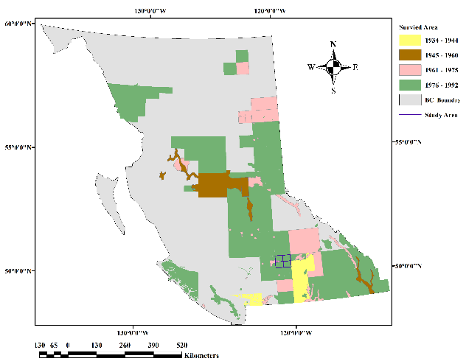
Figure 2.2. Progression of soil surveys in British Columbia from 1930s to 1990s.The figure was composted based on the data from BCSIS.
By the early 1930s, individual soil surveys were beginning to be done in some parts of Canada. As illustrated in Figure 2.2 the first set of systematic soil surveys in BC were completed in the interior (McKeague and Stobbe, 1978). Unlike other soil surveys, which were focused on agriculture in other provinces, BC Forest Services first carried out soil surveys at various areas across BC to establish a permanent forest reserve. The earliest agriculture-related soil survey in BC was done in 1931 to enhance fruit yield in the Okanagan region of BC. Soil surveys have been carried out across BC based on different landscape categories. The reports from those soil surveys have been used to build up the soil inventory of BC, which has limited and segmented coverage over the landscape of BC. Individual maps have different scales, resolutions, soil units, and map contents.
The soil survey of the Ashcroft-Savona Area in the Thompson River Valley of British Columbia (1963) and the Soils of the Ashcroft Map Area (1992) are two reports covering the Thompson and Okanagan region (Sprout and Kelley,1963; Young et al., 1992). These two soil survey reports were written to assist in achieving higher agricultural productivity and timber production in the area. These soil reports have detailed descriptions of soils which are suitable for cultivation and rangeland at lower elevations and flat areas, and there was selective information for soils in the forest regions at higher elevations. Most importantly, previous soil survey reports mainly focused on the qualitative description of the soils with a lack of quantitative measurement of soil properties.
The soil survey reports include traditional soil maps; descriptions of landscapes, soils and soil classification; and suggestions for soil management. On traditional soil maps, a map unit consists of different soil classes, which include soil associations, zones, series, types, and phases (Farstad and Drewry 1978). The soil classification system in Canada has changed as the understanding of soil has increased. In the 1920s, the soil classification system was based on the landscape zonal system. Saskatchewan, Ontario, and BC classified soils as soil “series” or “types” (Anderson et al., 2011). Alberta started with soil zones, and Manitoba classified soils as soil “associations” (Anderson et al., 2011). In 1967, soil surveys started to use soil association as the individual map unit. Soil associations define a group of soil series that are associated with similar landscape units (Sprout 1978). Soil series, soil types and soil associations group soils based on their parent materials, soil properties, climate conditions, and vegetation coverage. The taxonomic system of soil classification was developed in 1955 and focused on pedogenic processes (Canadian System of Soil Classification, 2003). The Canadian Soil Classification System currently has five tiers ranging from general to more specific, which are orders, great groups, subgroups, family classes, and series (Canadian System of Soil Classification, 2003). In the Thompson and Okanagan region, soil series were used in earlier soil maps, later changing to soil associations. Based on the environmental conditions, every association is linked with one or more soil subgroups which are used in the current Canadian Soil Classification System. In total, there are 104 soil associations and 46 soil subgroups in the Thompson and Okanagan regions (Young et al., 1992).
Differences between each map unit are mainly controlled by topographic indices and environmental conditions (MacMillan et al., 2007, Jenny 1941). Also, soil map units are classified by a knowledge-based empirical model including the understanding and identification of the characteristics of landscapes to define local drainage, texture, soil depth, land use, and surficial material (Bui 2004). Soil scientists defined these soil map units based on combinations of existing spatial data, aerial photographs, and field observation (Wysocki et al., 2004). Traditional soil surveying has combined several soil and landscape classification systems to create a map label, which includes but is not limited to the name of the soil, type of land modification, kind of surficial material, and the percentage of the area of the map unit in which the given soil is found (Sondheim and Suttie, 1983)

Categorical and continuous soil data
A soil database includes categorical and continuous data. Soil categorical data includes information on soil taxonomy, soil drainage class, classification of soil parent material, soil fertility class, and soil texture class. McBratney et al. (2003) summarized that 90% of DSM studies included soil taxonomy as part of the predictions. Just like any other classification system, soil classification systems are structured in several hierarchical levels from the most general to most specific. The classification system of soil taxonomy has been developed separately by different countries to meet their specific conditions. As a result, there are several different soil classification systems around the world, including examples such as the Australian Soil Classification system (Isbell and National committee of soil and terrain, 2016), the New Zealand Soil Classification system (Hewitt and Manaaki Whenua-Landcare Research New Zealand Ltd, 2010), the United States Department of Agriculture soil taxonomy system (Soil survey staff, 1999), and the Canadian System of Soil Classification (CSSC, 1998). In 1985, the Food and Agriculture Organization of the United Nations developed a worldwide classification system (Chesworth et al., 2008). The FAO system is a generalization of several national standard soil classification systems.
In addition to the categorical information, the soil is measured by its chemical and physical properties, which includes the quantitative measurement of soil mineral particles, organic matter, air, and water. These attributes include soil bulk density, soil particle size distribution, soil organic matter content, soil pH, cation exchange capacity, soil chemical composition, and available water holding capacity. The process of collecting soil samples and analyzing them in the lab is time-consuming and expensive and thus many areas of BC have limited coverage in terms of soil sample data. For example, the British Columbia Soil Information System (BCSIS) database (Sondheim and Suttie, 1983) contains 129 soil profiles from the Thompson and Okanagan region, and there is limited information available about soil properties in the database. Therefore, the spatial distribution of soil properties in the Thompson-Okanagan region has been fragmented and limited to specific ecosystems of interest (Evan et al., 2012). The previous soil survey reports include estimated values for some soil map units in the region (Young et al., 1992). Although soil polygon maps such as are found in legacy soil surveys can be useful, there is increasing demand for continuous full coverage of various soil properties.

Soil survey sampling design
The design of a soil survey involves many critical steps, and one is the sampling design. The sampling methods include design-based sampling approaches and model-based sampling approaches (de Gruijter and ter Braak, 1990; Brus and de Gruijter, 1997; de Gruijter et al., 2006). A brief description of several sampling methods is presented here. The purpose is to provide a summary of individual approaches and their application in soil mapping and to compare different sampling methods for mapping soil categorical data and numerical data.
The commonly used design-based sampling methods are based on random sampling and include simple random sampling, stratified simple random sampling, two-stage random sampling, cluster random sampling, systematic random sampling, and probabilities-proportion-to-size sampling (de Gruijter et al., 2006). In simple random sampling locations are randomly selected over space and these selected locations are mutually independent of each other. Simple random sampling is straight forward. The only requirement is to decide on the sample size. One disadvantage is the distribution of the sampling points, which are irregularly spaced with clustering and empty regions. Simple random sampling provides unbiased estimates of the mean and variance with continuous soil attributes, but it requires a large sample size to provide proper geographic coverage and reduce error (Brus and Gruijter 1997).
In addition to simple random sampling, stratified simple random sampling divides the sample population into different subgroups, and simple random sampling is applied to each subgroup (Avery and Burkhart, 1994). Stratified simple random sampling requires prior knowledge of the area and a pre-selection of categories to divide the landscape into different sub-regions (de Gruijter et al., 2006). In comparison with simple random sampling, stratified simple random sampling has two advantages including improvement in accuracy for individual subgroups and the overall study area, and providing separate interpretation for individual subgroups (de Gruijter et al., 2006). For example, land cover type and soil series maps have been used to stratify landscapes while mapping soil carbon (Grossman et al., 2001; Thompson and Kolka 2005; Worsham et al., 2012).
Unlike simple random sampling or stratified random sampling, systematic random sampling or regular grid sampling uses a regular grid to cover the entire study area with the same spacing between individual sampling points. The grid spacing is defined as:
$d=\sqrt{A/n }$
Where d represents the distance between each sampled point, A is the size of the area, and n is the sampling size. The regular grid sampling design works well with areas having small spatial variation. The model-based grid sampling uses an additional model to optimize specific spatial variation over the landscape. The model-based grid sampling leads to biased coverage of selected spatial variation (Brus 2019). The optimized spatial coverage also increases the accuracy of the results in comparison to any other random sampling methods.
In addition to sampling spatial variation, the model-based sampling method samples hyperdimensional feature space incorporating the existing ancillary data of the study area (Bolstad and Vose, 2001; Minasny and McBratney 2006). A Latin square is a two-dimensional experimental design to study the responses based on two numerical inputs (McKay et al., 1979). Latin hypercube means there are more than three variables as inputs. Minasny and McBratney (2006) adapted Latin hypercube sampling with a search algorithm to select sampling locations based on the range of each available continuous variable. This adaptation became known as conditioned Latin hypercube (cLH) sampling and is used in observational studies such as studies in soil science (Minasny and McBratney 2006; Worsham et al., 2012). cLH sampling is purposefully designed to capture the mean and extreme values regardless of how frequently or infrequently these values occur (Minasny and McBratney 2007). cLH sampling is commonly used in the field of DSM especially when the mapping methods use classification and decision tree learners (Minasny and McBratney 2007). Worsham, et al. (2012) applied cLH sampling with a landscape type units map, soil series maps, and topographic variables derived from DEMs to estimate soil carbon content using regression kriging. The cLH sampling design was also used to improve the accuracy of mapping soil properties including soil carbon, soil clay content, and Ca concentration at the field and regional scale (Kravchenko and Robertson 2007; Ramirez-Lopez et al., 2014).

Mapping system and environmental variables
Mapping systems have changed significantly since the early soil survey work. In the 1920’s, the mapping system used varied among different surveys, and soil units were primarily defined by soil texture. Then soil scientists started to notice the relationships between soil zones, soil profiles, and characteristics of the landscapes. In 1941, Dr. Hans Jenny published a standard soil forming system called the CLORPT model, which indicates that environmental factors including climate (c), organisms (o), relief (r), parent material (p), and time (t) drive the lateral and vertical distribution of soil genesis in landscapes (Jenny 1941). Although not all of the environmental factors are applied, in general the DSM mapping system uses the SCORPAN model which incorporates two additional factors: soil attributes (s) and a spatial component (n) to the existing Jenny’s CLOPRT model (McBratney et al., 2003).
Relief (r) is the most widely used environmental variable in soil mapping systems (McBratney et al., 2003). In the traditional soil survey system, relief was mainly represented by elevation, which was either extracted from contour maps or measured at points in the field. In the DSM system, elevation is commonly derived from a DEM, with elevation often obtained from space-born Landsat images, airborne radar images, LiDAR, and other remote sensing datasets (McBratney et al., 2003). Based on different parametric equations, the DEM also is used to calculate other primary and secondary terrain parameters, as well as landscape classification including slope, aspect, curvature, compounded terrain indices and landscape units. All these terrain parameters provide a quantitative description of the landscape which can be used in the DSM system (Wilson & Gallant, 2000; Wood, 1996). Previous studies also showed promising results when using DEM data to predict both soil categorical data and continuous data (McBratney et al., 2003).
Another environmental variable is organisms (o) including vegetation coverage and human activities. Vegetation is commonly used to define the ecozones, which correlate with the spatial distribution of organic matter content (Paustian 1997; Evrendilek 2007). Geospatial distribution of soil development is controlled by vegetation and the continental climate in drier regions (Dokuchaev 1883). Vegetation types are influencing factors for root distribution, especially in arid regions (Ma et al., 2008). Below-ground biomass strongly depends on the abundance of above-ground biomass (Wa et al., 2008). For example, on the meadow steppe of the inner Mongolian region, there are significant amounts of aboveground biomass, which leads to relatively higher below-ground biomass than in the desert steppe environment (Wa et al., 2008). Spatial distribution of vegetation coverage can be quantified by airborne or spaceborne remote sensing (Robin et al., 2011). Land cover and land use classification, biomass and yield maps, and vegetation maps can be used to extract either categorical or continuous values to represent the vegetation coverage of the landscape (McBratney et al., 2003).
Parent material has a great amount of influence on soil structure, and mineral composition, and it is often described in two categories: consolidated or unconsolidated material. Consolidated material consists of bedrock and unconsolidated material includes till, glacio-fluvial material, glacio-lacustrine, alluvium, lacustrine, aeolian, and colluvium. Many of these materials are made up with a mixture of different minerals from many origins. In the traditional soil survey, lithology maps and geological maps were used to gather information about the parent materials. In DSM, both digitized maps and mathematical models are commonly used to extract quantitative information about surface mineralogy and texture.
Environmental factors such as climate influence soil genesis and soil properties. For example, limited precipitation in the spring and higher temperatures in the summer cause significant annual water deficits on both grassland and forested region in the Thompson-Okanagan region (Pennock et al., 2011). In addition to topographic indices, climatic influence can be complicated (McConkey et al., 1996). Organic matter accumulation and plant growth should be high where solar radiation is high (Noorbakhsh et al., 2008). In the DSM, remote sensing data has been used to represent both climate data and vegetation coverage (McBratney et al., 2003).

Statistical models and machine-learning approaches
Since 1990, there has been expanded use of advanced data mining algorithms for detecting high-dimensional non-linear relationships over various landscapes units for both categorical data and continuous soil data. During this period, soil mapping increasingly took advantage of computer technology and the development of machine-learning algorithms. Such algorithms include linear and logistic regression, and decision tree learners. These learners have been used to identify the relationships among soil properties observed in the field, soil classification, and environmental variables (McBratney el at. 2003). The linear method, logistic method, and decision tree method with bagging represent three different phases in the evolution of machine-learning approach.
The earliest machine-learning method is the linear method, which includes a regression processes to work with continuous data and a classification processes to work with categorical data. Linear regression uses a linear function to find the best fit between the dependent variable (soil parameters) and independent variables (environmental variables), which are expressed as simple linear regression and multilinear regression processes. The simple linear regression learner uses one predictor variable to predict soil attributes. Such learners have been used to predict properties including the thickness of soil horizons, depth to the presence of mottles in the soil profile, and depth to presence of CaCO₃ (Walker et al., 1968, Pennock et al., 1987; Moore, 1993). Advantages of the linear learner include that construction of the learner is straight forward, and that the learner itself can cover a wide range of values in a dataset. With the extension to the multilinear regression learner, these learners can work with a larger number of environmental variables and are especially useful for including remote sensing and climate data. Hengl et al. (2002) used a multilinear regression learner to predict soil pH and soil organic matter. The linear method uses discriminant analysis to work with categorical data (Hastie et al., 2001). It is a semi-supervised linear learner and has been used with categorical soil data since 1930 (Fisher, 1936). McBratney et al. (2003) found that it was used as a classification learner in 30% of studies.
As database complexity has increased, tree-based learners have been found to outperform linear learners. Instead of using one learner to fit all the parameters, the tree-based method uses a decision algorithm to separate the dataset into several subgroups. The decision at each separation is based on the measurement of the difference of the response of the independent variables (environmental variables), which leads to several subgroups. Tree-based learners can handle both categorical and continuous data. With the decision algorithm, tree-based learners automatically select splitting variables, splitting points and the shape of the tree. Three examples of tree-based learners are CART (Breiman et al., 1984), Cubist (RuleQuest Research, 2000), and randomForest (Breiman, 2001a). Advantages of the tree-based learners include that they can handle linear relationships; the results of the prediction are easy to interpret; and they can process databases with non-repeated patterns (Breiman et al., 1984). One major disadvantage of the tree-based learners is the lack of smoothness in the predictions, which can lead to over-representation of certain predictions if the database has a small number of independent variables. One way to solve this problem is to build multilinear regression learners at each split such as the Cubist. Tree-based learners for continuous data are called regression trees, and are used for the prediction of many soil attributes including soil particle size distribution, water retention, soil total P, and cation exchange capacity (CEC) (Pachepsky et al., 2001; McKenzie and Ryan, 1999; Bishop and McBratney, 2001; Khaledian et al., 2017). Decision trees have been used to model soil classes, soil drainage class, soil texture classes, and soil fertility classes (Dobermann and Oberthur, 1997; Bui et al., 1999; Thomas et al., 1999; Carré and Girard, 2002; Piccinei et al., 2019)
In recent years, researchers have increasingly used aggregated learners to enhance prediction accuracy. These learners have complex algorithms which combine decision tree structure with optimal randomization and bagging (Breiman, 1996; Freund and Schapire, 1996). The ensemble structure creates many advantages over the single linear learner and the single tree-based learner. These advantages include easily processing multi-dimensional non-linear relationships, handling both categorical environmental variables along with continuous environmental variables, providing the variable-importance plot, and providing the out-of-bag (OOB) error plot as an estimation of the generalization error (Grimm et al., 2008). Variable-importance plots provide additional information to help researchers further understand the relationships between soil and its environmental variables. One disadvantage of using ensembled learner is the possibility of overfitting when working with unbalanced datasets or unrepresentative datasets (Segal, 2004). Overfitting is especially prevalent in the area of DSM, and the awareness and acknowledgment of this real concern requires further investigation.
The Ensemble learning approach with stacking is an additional progression in the DSM modeling to improve the prediction accuracy. The stacking structure is training one learning algorithm to evaluate, compare, and select several different type of base learners to produce a stacked prediction. Common practice in DSM is comparing several learners and deciding on one fitted learner to make the prediction (McBratney, 2003; Heung et al., 2016). Every individual learner has its advantages and disadvantages, and there is no one learner that is best for all scenarios. Learner selection in the ensemble learning structure uses the cross-validation process to evaluate the performance of several single learners. Then the error rate of individual learners is used to estimate an optimal weighted average for assembling a stacked prediction. The ensemble learning process has been proven to incorporate all the benefits from the selected learners and minimize the risk of bias and overfitting (Ju, 2016). Recent studies in statistics have demonstrated that an ensembled algorithm with a collection of several single learners can outperform a single learner (van der Laan et al., 2007). The ensemble learning approach with stacking structure has been applied in medical research (Polley and van der Laan, 2010), climate studies (Crosbie et al., 2012), biostatics analysis (van der Laan et al., 2007), and computer information analysis (Divina et al., 2018), and recently it has started to get the attention of soil scientists.
Map validation, and error assessment provides a quantitative measurement of the work produced by DSM. It includes map accuracy and model performance. In the classification processes, the validation dataset is selected independently of the training data. The validation dataset can be used to assess the accuracy and quality of a map (Heung et al., 2016 & 2014). The validation for the results of the continuous variables consists of model fit and model accuracy. The model fit is the examination of predicting the accuracy of the learner within the training data, which involves statistical measures such as R², RMSE, and MSE. The model accuracy is the examination of statistical measures with the validation data. These are also referred to as calibration and validation ((Szatmάri, G and Pάszto, L, 2019).

Summary.. I think a two or three sentence summary of this chapter would be helpful. It just kind of stops without warning. Just refer back to the intro and something like this (you can also do this after the defense…) .. “In summary, soil mapping has evolved over a one hundred year period from a mostly descriptive and field-based activity to one that increasingly relies on computerized data analysis. A wide variety of approaches are currently employed for the design of soil mapping projects, for data analysis and spatial prediction, and for error checking. Even the most sophisticated methods still rely on the fundamental understanding of how environmental variables affect soil properties, as presented in the CLORPT model.”

References
Anderson, D.W., Smith, S.C.A., 2011. A history of soil classification and soil survey in Canada: personal perspective. Canadian Journal of Soil Science 91(5), 675-694.
Bishop, T.F.A., McBratney, A.B., 2001. A comparison of prediction methods for the creation of field-extent soil property maps. Geoderma 130, 149-160.
Bui, E.N., 2004. Soil survey as a knowledge system. Geoderma 120, 17-26.
Breiman, L., 1996. Bagging predictors, Machine Learning 26, 123-140.
Breiman, L., 2001a. Random forests, Machine Learning 45, 5-32.
Breiman,L., Friedman, J.H., Olshen, R.A., Stone, C.J., 1984. Classification and regression. Trees. Wadsworth, Belmont, CA.
Brus, D.J., de Gruijter, J.J., 1997. Random sampling or geostatistical modelling? Choosing between design-based and model-based sampling strategies for soil (with Discussion). Geoderma 80, 1-59.
Brus, D.J., 2019. Sampling for digital soil mapping: A tutorial supported by R scripts. Geoderma 338, 464-480.
Bolstad, P.V., Vose, J.M., 2001. The effects of terrain position and elevation on soil organic carbon in the Southern Appalachians. In: Lai, R.(eds) Assessment methods for soil carbon. CRC/Lewis Publication. Boca Raton, Fla. pp. 4-51.
Bui, E.N., Loughead, A., Corner, R., 1999. Extracting soil-landscape rules from previous soil surveys. Australian Journal of Soil Research 37, 495-508.
Canadian Agricultural Services Coordinating Committee. Soil Classification Working Group. 1998. The Canadian system of soil classification. 3rd ed. Agriculture and Agri-Food Canada. Ottawa. ON. Pub. 1646.
Chesworth W., Arbestain, M.C., Macias, F., Spaargaren, O., Mualem, Y., Morel-Seytoux, H.J., Horwath, W.R., Almendros, G., Chesworth, W., Grossl, P.R., Sparks, D.L., Spaargaren, O., Fairbridge, R.W., Singer, A., Eswaran, H., Micheli, E., 2008. Classification of soils: World Reference Base (WRB) for soil resources. In: Chesworth, W.(eds) Encyclopedia of soil science. Encyclopedia of Earth Science Series. Springer, Dordrecht.
Carré and Girard, 2002. Quantitative mapping of soil types based on regression kirging of taxonomic distances with landform and land cover attributes, Geoderma 110, 241-263.
Crosbie, R.S., Pickett, T., Mpelasoka, F.S., Hodgson, G., Charles, Barron, O.V., 2013. An assessment of the climate change impacts on groundwater recharge at a continental scale using a probabilistic approach with an ensemble of GCMs. Climate Change 117 (1), 41-53.
Divina, F., Gilson, A., Goméz-Vela, F., García-Torres, M., Torres, J.F., 2018. Stacking ensemble learning for short-term electricity consumption forecasting. Energies 11(4), 949.
de Gruijter, J.J., ter Braak, C.J., 1990. Model-free estimation from spatial samples: A reappraisal of classical sampling theory. Math Geo. 22, 407-415.
de Gruijter, J., Brus, D,J., Bierkens, M.F.P., Knotters, M., 2006. Sampling for natural resource monitoring. Springer Berlin Heidelberg, Heidelberg, Berlin.
Dobermann, A., Oberthur, T., 1997. Fuzzy mapping of soil fertility – a case study on irrigated Riceland in the Philippines. Geoderma, 77, 317–339.
Dokuchaev, V.V., 1883. Russian Chernozem. Report to the imperial free economic society, Tipogr. Declerona i Evdokimova, St. Petersburg,
Evans, C. R. W., Krzic, M., Broersma, K., Thompson, D. J., 2012. Long-term grazing effects on grassland soil properties in southern British Columbia. Canadian Journal of Soil Science 92, 685-693.
Evrendilek, F., Berberoglu, S., Gulbeyaz, O., Ertekin, C., 2007. Modelling potential distribution and carbon dynamics of natural terrestrial ecosystem: a case study of Turkey. Sensors 7, 2273-2296.
Farstad, L., Drewry, N.T., 1978. Soil and land utilization surveys prior to 1965. in Valentine, et al. (Ed.) Soils landscapes of British Columbia. BC Ministry of Environment, Resource Analysis Branch pp.197-181.
Fisher, R.A., 1936. The use of multiple measurements in taxonomic problems. Annals of Eugenics 7, 179–188.
Freund, Y., Schapire, R.E., 1996. A short introduction to boosting. Journal of Japanese Society for Artificial Intelligence 14 (5), 771-780.
Grimm, R., Behrens, T., Märker, M., Elsenbeer, H., 2008. Soil organic carbon concentrations and stocks on Barro Colorado Island – digital soil mapping using Random Forests analysis. Geoderma 146, 120-113.
Grossman, R. B., Harms, D. S., Kingsbury, D. F., Shaw, R. K., Jenkins, A. B., 2001. Assessment of soil organic carbon using the U.S. soil survey. In: Lal, R., Kimble, J.M., Follett, R. F., Stewart, B. A., (Eds.) Assessment methods for soil carbon, Lewis Publishers, Boca Raton, FL. pp. 87-104.
Hastie, T.J., Tibshirani, R.J., Friedman, J., 2001. The elements of statistical learning: data mining, inference and prediction. Springer Series in Statistics. Springer – Verlag, New York.
Hengl, T., Rossiter, D.G., Husnjak, S., 2002. Mapping soil properties from an existing national soil data set using freely available ancillary data. 17th World Congress of Soil Science, Bangkok, Thailand, August 14-21. Paper no. 1140.
Heung, B., Bulmer, C.E., Schmidt, M.G., 2014. Predictive soil parent material mapping at a regional-scale: A Random Forest approach. Geoderma 214-215, 141 – 154
Heung, B., Ho, H.C., Zhang, J., Knudby, A., Bulmer, C.E., Schmidt, M.G., 2016. An overview and comparison of machine-learning techniques for classification purposes in digital soil mapping. Geoderma 265, 62-77.
Hewitt, A.E., Manaaki Whenua-Landcare Research New Zealand Ltd. 2010. New Zealand soil classification, Lincoln, N.Z.: Manaaki Whenua Press.
Isbell, R.F., National Committee on Soil and Terrain (Australia) author, 2016. The Australian soil classification. Clayton south, Vic: CSIRO Publishing.
Jenny, H., 1941. Factors of soil formation. A system of quantitative pedology. New York: McGraw Hill.
Ju, C., 2016. A general ensemble learning framework for online and offline machine learning (MA Thesis) University of California, Berkeley, CA, USA.
Khaledian, Y., Brevik, E.C., Pereira, P., Cerdà, A., Fattah, M.A., Tzaikeh, H., 2017. Modelling soil cation exchange capacity in multiple countries. Catena 158. 1994-2000.
Kravchenko, A.N., Robertson, G.P., 2007. Whole-profile soil carbon stocks: the danger of assuming too much from analyses of too little. Soil Sci.Soc.Am.J. 75, 235-240.
Ma, W.H., Yang, Y.H., He, J. S., Zeng, H., Fang, J. Y., 2008. Above – and below ground biomass in relation to environmental factors in temperate grasslands, Inner Mongolia. Science in China Series C: Life Science 51, 263-270.
MacMillan, R.A., Moon,D.E., Coupé, R.A., 2007. Automated predictive ecological mapping in a Forest Region of B.C., Canada, 2001-2005. Geoderma 140, 353-373.
Mapping System Working Group, 1981. A soil mapping system for Canada: Revised. Land Resource Research Institute 94 1981 Ottawa, ON Agriculture Canada 94 Contribution Number 142. Research Branch.
McBratney, A.B., Mendonça Santos, M. L., Minasny, B., 2003. On digital soil mapping. Geoderma 117, 3-52.
McConkey, B.G., Ulrich, D. J., Mellinger, M., 1996. Spatial variability of wheat yield, soil properties and erosion in hummocky terrain. Canadian Journal of Soil Science 74, 219-228.
McKay, M.D., Beckman, R.J., Conover, W.J., 1979. Comparison of three methods for selecting values of input variables in the analysis of output from a computer code. Technometric 21, 239-245.
McKeague, J.A., Stobbe, P.C., 1978. Soil survey and genesis and classification research in Canada. Canadian Journal of Soil Science 75, 3-9.
McKenzie, N., Ryan, P., 1999. Spatial prediction of soil properties using environmental correlation. Geoderma 89, 67-94.
Minasny, B., McBratney, A.B., 2006. A conditioned Latin hypercube method for sampling in the presence of ancillary information. Computers & Geosciences 32, 1378-1388.
Minasny, B., McBratney, A. B., 2007. Latin hypercube sampling as a tool for digital soil mapping. pp 253-163. In: Lagacherie, P., McBratney, A. B., Voltz, M., (eds.). Digital soil mapping: An introductory perspective, Developments in soil science, Vol. 31. Elsevier, Amsterdam, The Netherlands.
Moore, I.D., Gessler, P.E., Nielsen, G.A., Peterson, G.A., 1993. Soil attribute prediction using terrain analysis. Soil Science Society of American Journal 57, 443-452.
Noorbakhsh, S., Schoenau, J., Zeleke, T., Qian, P., 2008. Soil properties, yield, and landscape relationships in south-central Saskatchewan Canada. Journal of Plant Nutrition 31, 539-556.
Pachepsky, Y., Rawls, W.J., Gimenez, D., 2001. Comparison of soil water retetention at field and laboratory scales. Soil Sci. Soc. Am. J. 65, 460-462.
Paustian, K., Levine, E., Post, W., Ryzhova, I.M., 1997. The use of models to integrate information and understanding of soil C at the regional scale. Geoderma 79, 227-260.
Paustian, K., Andrén, O., Janzen, H.H., Lal, R., Smith, P., Tian, G., Tiessen, H., Van Noordwijk, M., Woomer, P.L., 2007. Agricultural soils as sink to mitigate CO₂ emissions. Soil Use and Management 13(s4). 230-244.
Pennock, D.J., Zebarth, B.J., De Jong, E., 1987. Landform classification and soil distribution in hummocky terrain, Saskatchewan, Canada. Geoderma 40, 297-315.
Pennock, D.J, Bedard-Haughn, A., Viaud, V., 2011. Chernozemic soils of Canada: Genesis, distribution, and classification. Canadian Journal of Soil Science 91, 719-747.
Piccinei, C., Marchetti, A., Rivieccio, R., Napoli, R., 2019. Multinomial logistic regression with soil diagnostic features and land surface parameters for soil mapping of Latium (Central Italy). Geoderma 352, 385-394.
Ramirez-Lopez, L., Schmidt, K., Behrens, T., Wesemael, B.V., Dematte, J.A.M., Scholten, T., 2014. Sampling optimal calibration sets in soil infrared spectroscopy. Geoderma 226-227, 140-145.
Robin, M., Chapuis, J.L., Lebouvier, M., 2011. Remote sensing of vegetation cover change in islands of the Kerguelen archipelago. Polar Biology 2011 34, 1689-1700. Available at: https://doi-org.proxy.lib.sfu.ca/10.1007/s00300-011-1069-z
RuleQuest Research, 2000. Cubist. RuleQuest Research, Sydney, Australia.
Segal, M.R., 2004. Machine Learning benchmarks and random forest regression. Technical Report. Center for Bioinformatics & Molecular Biostatistics papers, University of California, San Francisco, CA, USA.
Soil survey staff, 1999. Soil taxonomy: A basic system of soil classification for making and interpreting soil surveys, 2nd edition. Natural Resources Conservation Service. U.S. Department of Agriculture Handbook.
Sondheim, M., Suttie, K., 1983. User manual for the British Columbia Soil Information System, Volume 1, BC Ministry of Forest Publication R28 – 82053, Victoria, BC.
Sprout, P.N., Kelley, C.C., 1963. Soil survey of the Ashcroft-Savona area Thompson river valley British Columbia (No. bc103). British Columbia Department of Agriculture Kelowna, B.C.
Sprout, P.N., 1978. The Canada land inventory period 1965 – 1975. In: Valentine, et al. (ed.) Soils landscapes of British Columbia. BC Ministry of Environment, Resource Analysis Branch. 197p
Szatmάri, G., and Pάsztor, L., 2019. Comparison of various uncertainty modelling approaches based on geostatistics and machine learning algorithms.
Thompson, J. A., Kolka, R. K., 2005. Soil carbon storage estimation in a forested watershed using quantitative soil-landscape modelling. American Soil Science Society 69, 1086-1093.
Thomas, R., Ayarza, M.A., Neufeldt, H., Westerhof, R., Zech W., 1999. General conclusions. In: Thomas, R., Ayarza, M.A., (Eds.), Sustainable Land Management for the Oxisols of the Latin American Savannas. Centro Internacional de Agricultura Tropical (CIAT), Cali, Colombia, pp. 215–227.
Walker, P.H., Hall, G.F., Protz, R., 1968. Relation between landform parameters and soil properties 1. Soil Science Society of America Journal 32 (1) 101-104.
Wilson, J.P., Gallant, J.C., 2000. Secondary topographic attributes. In: Wilson, J.P., Gallant, J.C. (Eds.), Terrain Analysis – Principles and applications. Wiley, New York, pp. 87 – 132.
Wood, J., 1996. The Geomorphological Characterisation of Digital Elevation Models. Ph.D. thesis, University of Leicester, UK. Available at: http://hdl.handle.net/2381/34503
Worsham, L., Markewitz, D., Nibbelink, N.P., West, T., 2012. A comparison of three field sampling methods to estimate soil carbon content. Forest science 58(5), 513–522.
Wysocki, D.A., Schoeneberger, P.J., LaGarry, H.E., 2004. Soil survey: a window to the subsurface. Geoderma 125, 167 – 180.
Polley, E.C., van der Laan, M.J., 2010. Super learner in prediction, U.C. Berkeley division of biostatistics working paper series. Working paper. Paper 266.
Young, G., Fenger, M.A., Luttmerding, H.A., 1992. Soils of the Ashcroft map area: report No. 26. (No. bc26). British Columbia Soil Survey. Integrated Management Branch Victoria, British Columbia.

Comparison of three sampling designs to map soil classes in the Thompson – Okanagan region

Abstract
Soils are facing great threats from climate change and anthropogenic activities. It is essential to understand the characteristics of soil, especially when it comes to the issue of soil management. In the Thompson–Okanagan region, soil requires specific attention as it provides an important ecological function and supports major economic assets in the region; the spatial distribution of soil classes in particular provides helpful information for soil conservation and forest management purposes. Previous soil surveys covered most parts of the region in a polygon data form; however, it would be beneficial if soil data were available at a finer resolution with a uniform soil category as included in the Canadian System of Soil Classification. Conventional soil surveys are the product of expert knowledge, which relies upon intensive ground-based fieldwork. These surveys are costly and time consuming. With advances in computer technology, statistical modeling, and spatial analysis, the digital soil mapping (DSM) approach has been used to update existing soil class maps. In the present study, Random Forest (RF) was used to map 16 soil subgroups in the Thompson-Okanagan region. Training data were extracted from soil legacy data, and environmental variables included 17 topographic indices as independent variables. The RF classification algorithm and three types of sampling designs were tested and compared. Results showed that balanced sampling had the highest prediction accuracy with an out-of-bag (OOB) error of 36.62% . Validation was completed using data from points obtained from legacy soil survey data and currently collected field data. Overall accuracy was 65.4%, where Orthic Dark Brown Chernozems and Orthic Brown Chernozems had the highest accuracies among all the soil subgroups of the region.
Keywords: Digital Soil Mapping; machine-learning; Random Forest classifier; Soil classification; Soil subgroups.

Introduction
Soil mapping is the identification and description of different types of soil, based on direct field observation or indirect inference (Mapping System Working Group, 1981). The soil mapping of Canada first started in southwestern Ontario in 1914, with the primary purpose of providing a guideline for agricultural planning (McKeague and Stobbe, 1978). Unlike other provinces, soil mapping in British Columbia (BC) focused on forest reserves to help with natural resource management. In addition to the economic benefit of forestry, regions like the Thompson–Okanagan region provide important grassland and dry interior forest ecosystems. Grassland covers less than 1% of the total land area of BC, but it contains unique biodiversity and natural heritage. The ecosystem on both the grassed region and the wooded dry forest region are considered highly endangered (Ministry of Sustainable Resource Management, Ministry of Water, Land and Air Protection, 2004). As we face growing challenges from climate change, soil degradation, pine beetle infestation, and increasing anthropogenic activities in the area, soil information is needed to help scientists and policy makers establish a long-term plan to conserve the economic and ecological value of the region.
In general, soil survey reports include traditional soil maps; descriptions of landscapes, soils and soil classification; and suggestions for soil management. In traditional soil maps, a map unit consists of different soil classes, which include soil associations, zones, series, types, and phases (Farstad and Drewry 1978). Soil association was used in the soil survey report of the Thompson–Okanagan region, which is used to define a group of soil series that are associated with similar landscape units (Sprout 1978). Information on soil classes provides insight and knowledge on the spatial patterns of soil properties over the landscape. The soil classification system in Canada has changed with the increasing understanding of soil resources. The Canadian Soil Classification System, like other classification systems is structured from the most general categories to the most specific categories. In Canada, the soil classification system goes from orders, great groups, subgroups, and series (Canadian System of Soil Classification, 2003). In the Thompson–Okanagan region, soil series were used in the earlier soil maps, and later soil associations were mapped. Based on the environmental conditions, every soil association is linked with one or more soil subgroups, which are used in the current Canadian Soil Classification System. In total, there are 104 soil associations and 46 soil subgroups in the Thompson–Okanagan region (Young et al., 1992).
Soil surveys of the Ashcroft–Savona Area were carried out in 1963 and 1992, as the Thompson River Valley of British Colombia and the Soils of the Ashcroft Map Area respectively (Sprout and Kelley, 1963 and Young, et al., 1992). The two reports were written to help achieve higher agricultural productivity and timber production in the area. These soil survey reports provide detailed descriptions of soils that are suitable for cultivation and rangeland at lower elevations and flat areas; they also include selective information about soils in the forest regions at higher elevations. Most importantly, however, these reports mainly focus on the qualitative description of soils as opposed to the quantitative measurements of soil properties.
Until the early 2000’s, soil information was gathered by conventional methods of soil mapping, using knowledge-based correlation models to interpret spatial distribution of soil information based on available environmental variables (Anderson et al., 2011). Extensive ground-based soil surveys can help assess various aspects of soil, but they are time consuming, expensive, and have limited coverage (Yu et al., 2014). A common limitation was lack of coverage in rural regions. Advances in digital soil mapping (DSM) have provided additional sources of data and facilitated the development of computer algorithms that can be used to build sophisticated learners which are superior to knowledge-based mental models used in conventional soil mapping (McBratney et al., 2003). Many studies focus on the relationship between spatial patterns of soil types and environmental variables, using the digital mapping approach. However, most DSM projects look purely at either forested regions or grassland regions (Heung et al., 2016; McBratney et al., 2003, Grunwald, 2009; Florinsky et al., 2002; Wiesmeier et al., 2010; Barthold et al., 2013). There are limited studies focusing on the interaction and dynamics between these two types of landscapes. This research provides an opportunity to investigate the spatial pattern of soil classes and environmental variables at 25 m resolution.
Therefore the objectives of this study are 1) to identify the main environmental factors that control the spatial distribution of soil subgroups at regional scale in the Thompson–Okanagan region, 2) using DSM methods to test three sampling designs and produce soil subgroup maps at 25 m cell size, and 3) to provide an updated soil class map for decision makers in a region that is influenced by climate change and anthropogenic activities.

Material and methods

Study area
The study area (Figure 3-1) is located in the southern interior of BC, on the Thompson Plateau, the Fraser plateau, and Shuswap highlands, at latitudes 50.5º N to 51ºN and longitudes 120º W to 121º W (Holland, 1976). The entire study area lies within map sheet 092 of Canada’s National Topographic System (NTS), and it is about 4,349 km². The elevation ranges from 230 m to 2088 m above sea level and it covers a variety of ecosystems, including the following biogeoclimatic zones: Bunchgrass zone (BG), Interior Douglas-fir zone (IDF), Montane Spruce Zone (MS), Sub-Boreal Spruce Zone (SBS), Interior Cedar-Hemlock Zone (ICH), Engelmann Spruce-subalpine Fir Zone (ESSF), and Alpine Tundra Zone (AT) (Lloyd, et al., 1990).
The study area includes a combination of grassland region, transition region, and dry interior forest region (Brayshaw, 1970; Klenner et al., 2008). The majority of the grasslands in the study area are temperate steppe grasslands that occupy catchment areas near Kamloops Lake and the Thompson River at lower elevations between 230 m to 800 m; they cover 40% of the study area where it is warm and dry with a lower canopy closure than the forest region at higher elevations (Environment Canada. 2003). Chernozem is the dominant soil order on the grassland region. Most of the grassy areas at lower elevations are maintained as pastures that support livestock farming (Wikeem and Wikeem, 2004). At landscape locations away from the water basin, and at elevations above 800 m, the vegetation shifts into dry forests dominated by Ponderosa Pine (Pinus ponderosa), Douglas fir (Pseudotsuga menziesii), lodgepole pine (Pinus contorta), white spruce (Picea glauca), and Engelmann spruce (Picea engelmannii) (Moore, et al., 2010; Lloyd et al., 1990). There, the climate is also colder and wetter (Environment Canada, 2003). The dominant soils in the forested parts of the study area are Brunisols and Luvisols. One major water network in the study area is the North Thompson River that flows from north to south and joins the east-to-west-flowing Thompson River at the city of Kamloops. The Thompson River then enters Kamloops Lake at the western edge of the city. In the grassland region, the mean annual temperature is 7.9 °C, and mean annual precipitation is 285mm. In the forest region, the mean annual temperature is 5.0 °C, and the mean annual rainfall is 476 mm (Lloyd et al., 1990).
The whole area has been impacted by the last glaciation, the Fraser Glaciation, which ended approximately 12,000 to 10,000 years ago (Armstrong et al., 1965; Clague 1981). The glacier’s advance and retreat deposited the most common parent materials, including morainal deposits, glacial fluvial deposits, and glacial lacustrine deposits. The morainal material occurs throughout the area and is intermixed with bedrock outcrops at higher elevations and on small outcrops on ridges and outcrops (Young et al., 1992). Colluvial deposits and fluvial deposits are also commonly seen in the landscape (Young et al., 1992).

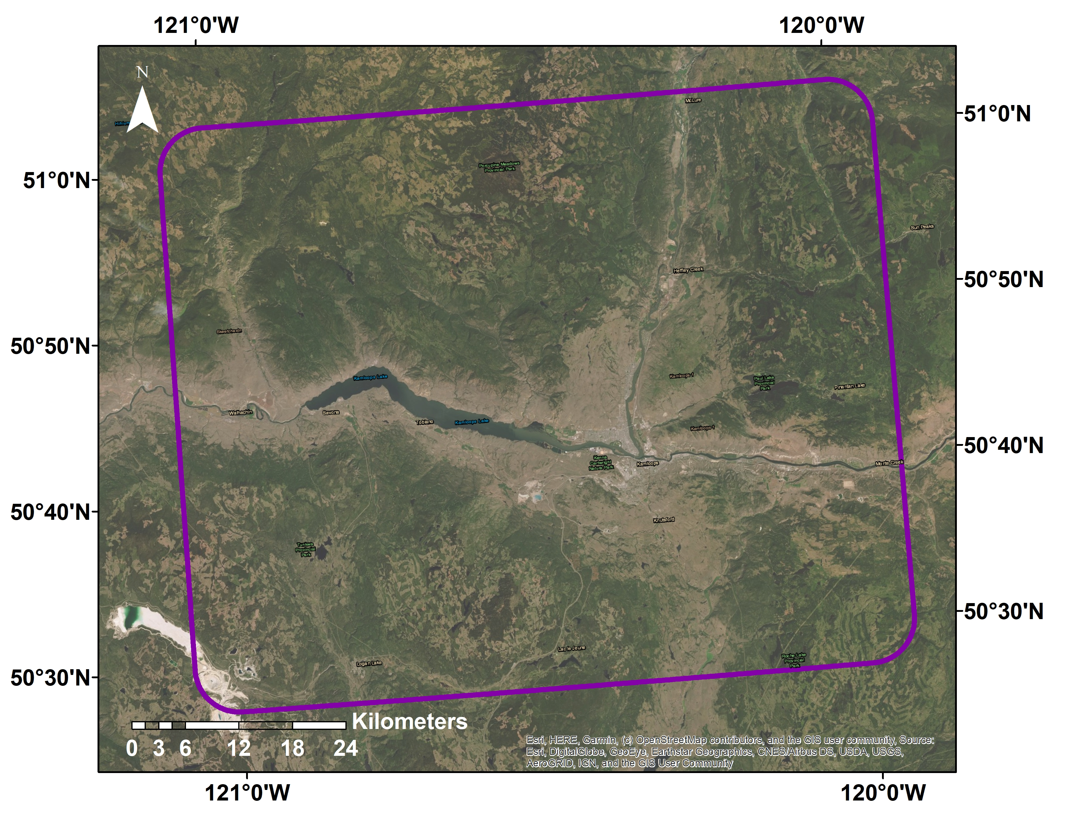
Kamloops
Figure 3.1 Study area in the Thompson-Okanagan region, BC (1:25000 Map grid, composed of map sheets 92I090, 92I010, 92I150, and 92I160).

Soil legacy data (soil classes)
The soil maps for the study area were at a scale of 1:100,000, which created from previous soil surveys. The soil maps included four maps for Soil/Landforms 92I/NE Kamloops, 92I/NW Ashcroft, 92I/SW Lytton, and 92I/SE Merritt (Young et al., 1992). The digitized soil survey’s seamless polygon coverage can be accessed freely through Agriculture and Agri-Food Canada and the BC Ministry of Environment (Kenney and Frank, 2010). Each polygon was labelled with the name of the components and their proportion.
The soil maps of the Thompson-Okanagan region include 99 soil associations for the study area. A soil association is a group of soils that have similar parent material and climatic conditions. Each soil association was linked to one or more soil subgroups from the Canadian System of Soil Classification of which there are 31 in total. As illustrated in Figure 3.2, the soil maps include pure map units (one component) and complex map units (two or more components). For example, $\frac{GD1}{Gh:Ef }$ is a pure map unit used in the soil report from the Ashcroft area (Young et al.,1992). The map symbol indicated in the numerator position, GD1 in this example, represents soil association. In this case GD1 was one of the Godey soils that was most commonly related with Orthic Brown Chernozems (O.BC) and the description of GD1 stated that the landscape was dominated by grass and shrub (Soils of the Ashcroft Map Area, 1992). Map symbols located at the bottom of the line represent the terrain characteristics. For this example, Gh indicates that the soil class is developed from glaciofluvial deposits with hummocky type of land surface; Ef means this polygon has strongly sloping and strongly rolling topography, which indicates the slope gradient is 9% to 30%. Map unit $\frac{{CG}^{6}3-GY^{4}3}{C-Gtv.Gf}$ is an example of a complex map unit. In this polygon, there are two soil associations: Cavanaugh soils (CG ) and Glossey soils (GY). The superscripted numbers indicate the proportion of each soil association in the polygon; in this case 60% of the area is Cavanaugh soils and 40% of the area is Glossey soils. Based on the soil description, the most common soil is Eutric Brunisol.

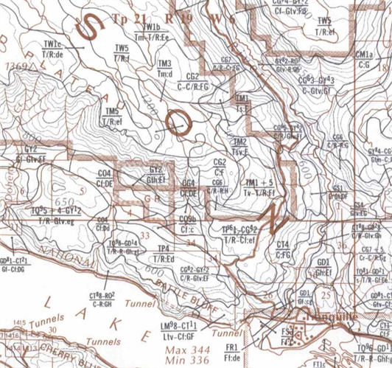
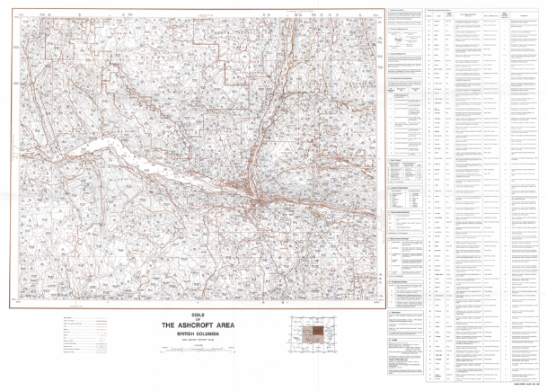
Figure 3.2. The soil map of the study area, which was included in the soil survey report for the Ashcroft area. The zoomed-in area on the right-hand side illustrates the individual map units, which are outlined as individual soil polygons.

Table 3.1. Soil orders, great groups and subgroups used for modeling soil classification in the study area.
Orders | Code | Great Groups | Code | Subgroups | Code | Map Label
Organic | O | Organic Fibrisol | F | Organic | TY.F | O
Organic | O | Organic Mesisol | M | Organic | TY.M | O
Podzol | P | Humo-Ferric Podzol | HFP | Orthic Humo-Ferric Podzol | O.HFP | O.HFP
Chernozem | C | Brown Chernozem | BC | Orthic Brown Chernozem | O.BC | O.BC
Chernozem | C | Dark Brown Chernozem | DBC | Orthic Dark Brown Chernozem | O.DBC | O.DBC
Chernozem | C | Black Chernozem | BLC | Orthic Black Chernozem | O.BLC | O.BLC
Luvisol | L | Gray Luvisol | GL | Podzolic Gray Luvisol | PZ.GL | PZ.GL
 |  |  |  | Brunisolic Gray Luvisol | B.GL | B.GL
 |  |  |  | Orthic Gray Luvisol | O.GL | O.GL
 |  |  |  | Gleyed Gray Luvisol | GL.GL | GL.GL
Brunisol | B | Eutric Brunisol | EB | Eluviated Eutric Brunisol | E.EB | E.EB
 |  |  |  | Orthic Eutric Brunisol | O.EB | O.EB
Brunisol | B | Dystric Brunisol | OB | Eluviated Dystric Brunisol | E.DYB | E.DYB
 |  |  |  | Orthic Dystric Brunisol | O.DYB | O.DYB
Regosol | R | Regosol | R | Orthic Regosol | O.R | O.R
 |  |  |  | Gleyed Cumulic Regosol | GLCU.R | GLCU.R

On the digitized soil survey map, the total area of the seamless soil survey polygon data is 4301.40 km². The majority of the mapped area (86.73%, 3730.49 km²) has soil associations that are individually linked to one soil subgroup with proportions greater than 90%. These areas have 16 soil subgroups, which were used to select the training dataset (Table 3.1). Complex polygons were not used to select the training dataset. These 16 soil subgroups also share some portion of areas in the complex polygons. Combining both areas of single-component polygons and the shared portion of the complex polygons shows that these 16 soil subgroups cover 87.4% (3760.46 km²) of the total map area. The complex polygons have an additional 15 soil subgroups that were not used to select the training dataset, and they cover 0.67% (29.95 km²) of the total map area. In the remaining 12.6% of the map area, 1.50% (64.40 km²) is defined as open water, and 0.92% (39.62 km²) as rock outcrops and undifferentiated bedrock. These areas either had missing information (0.85%, 36.58 km²), or areas with undetermined soil subgroups, as each mapped soil association had more than one soil subgroup (6.88%, 295.82 km²) (The soil survey of the Ashcroft map area: report No.26 1996). This study used single component polygons to describe the soils in the region. The single components defined the training areas (TR) from which to extract the calibration data for modelling soil classes.

Field data (field work, sample collection)
Conditioned Latin Hypercube (cLH) sampling (Minasny and McBratney 2006) was used to select 300 field points based on elevation, slope, aspect, vegetation coverage, and geology. To ensure accessibility of the field points, all the points were selected within 200 m of the road network, which included paved, logging, and gravel roads. The initial request was for 300 locations. Ten of the locations were inaccessible and could not be sampled. Data were thus collected from 290 locations (three exposed bedrock sites, and 287 soil pits) (Figure 3.3).
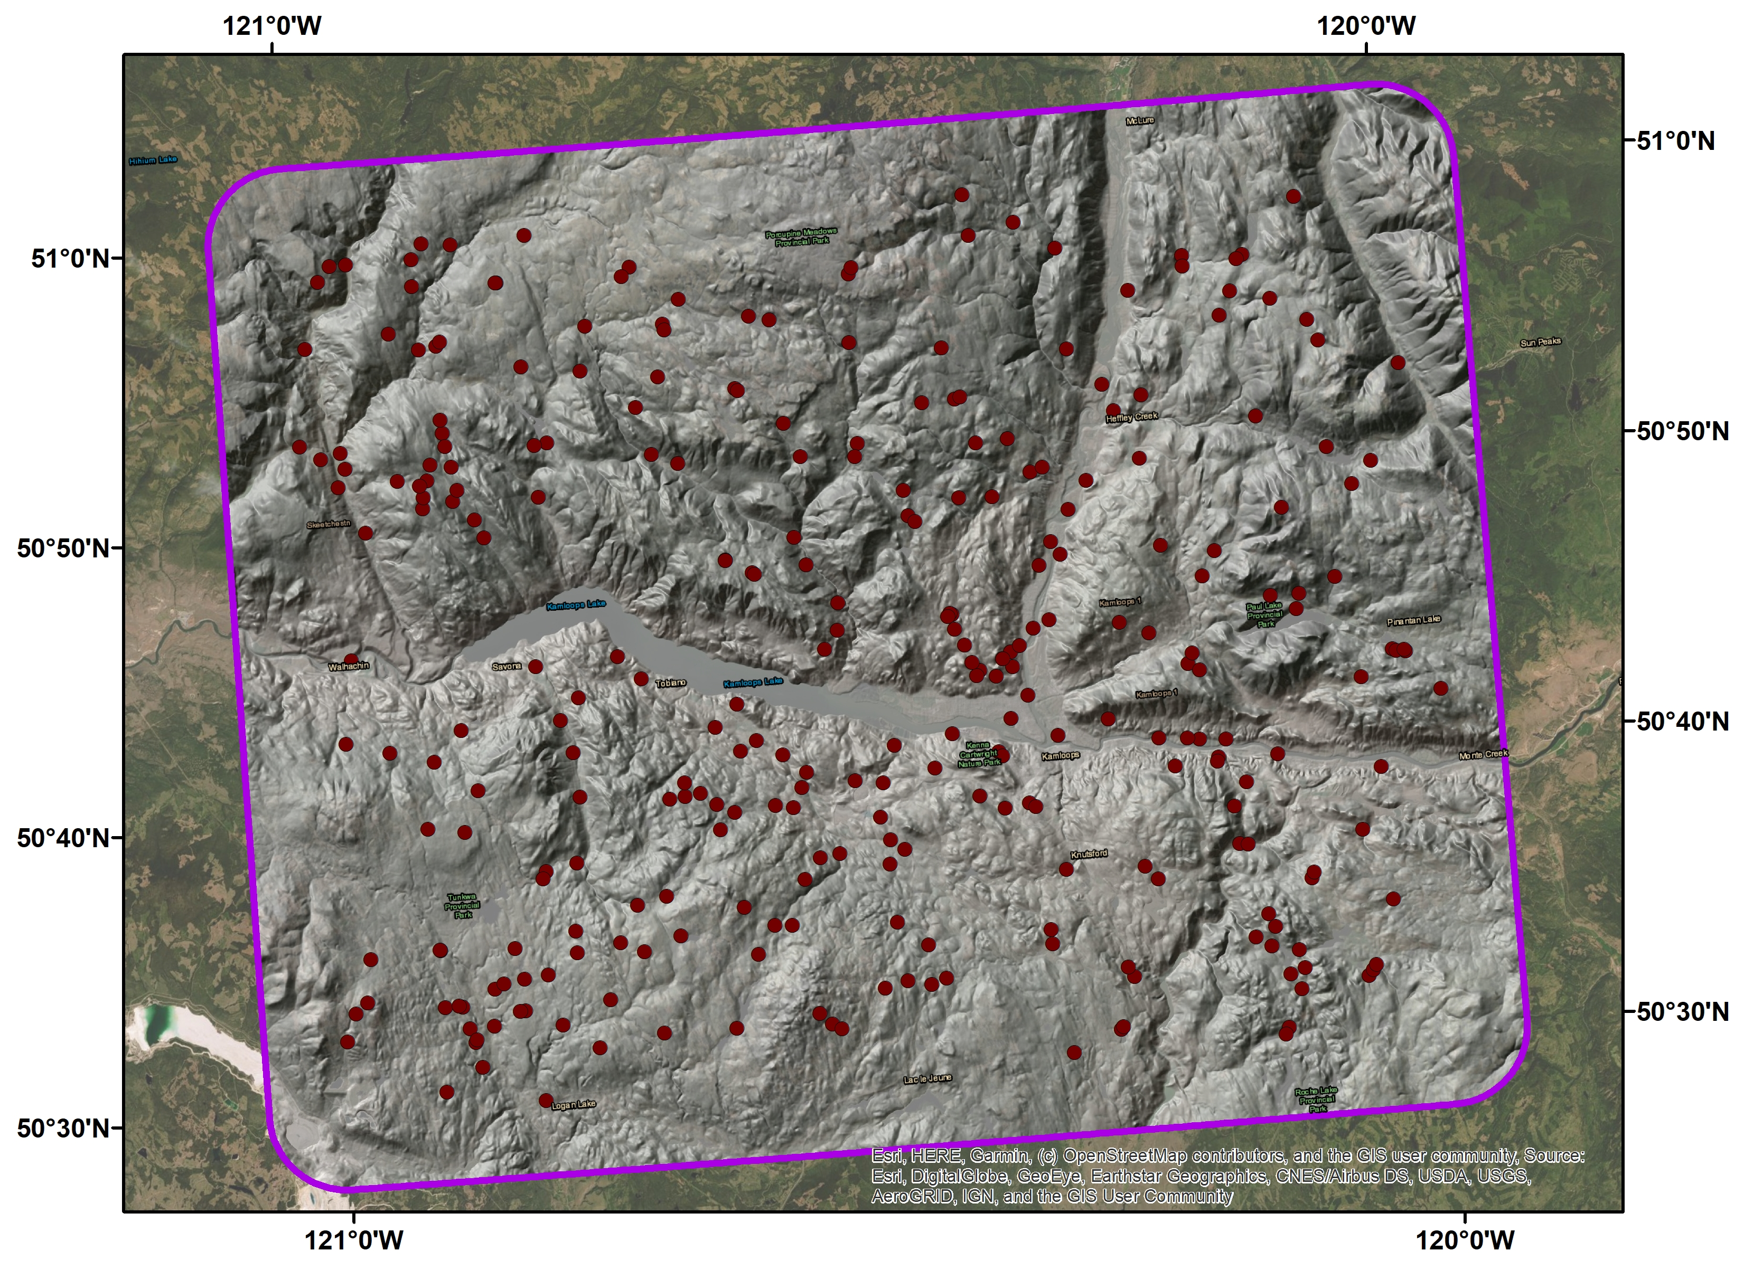
Figure 3.3. Location of field observations, including mineral sample collections, site descriptions, and pedon descriptions. 290 field sites are labelled with red dots, and the black circle indicates the city of Kamloops.
Fieldwork was carried out in the summer of 2015. The field sheet used in the fieldwork (Appendix A) was based on the Field Manual for Describing Terrestrial Ecosystems 2nd edition (2010). The following sections provide a brief description of the fieldwork. A more detailed description was included in Appendix A. At each field location, site conditions were assessed based on readily observable surface conditions. Every field point had to meet two requirements in order to be selected for sampling. The first requirement was that the selected field point was representative of a 25 m by 25 m plot, which means that this point had the same type of vegetation, similar topographical conditions, and the same parent material as found in the plot. The second requirement was that the selected field point had no anthropogenic-related influence (such as harvesting, road construction, or tree planting) affecting the surface soil layers. All 290 locations met these two requirements.
At each selected field point, the precise location was recorded with a GPS and information was collected in the following categories: soil pedon description, topographic description, and surface vegetation description (Luttmerding et al., 1990). The observations of topography included slope position and curvature class. Based on the Field Manual for Describing Terrestrial Ecosystems, 2nd Edition, slope position classes included slope toe, lower slope, mid-slope, upper slope, and crest (Luttmerding et al., 1990). Surface curvature was recorded as concave (CC) or convex (CV). Surface vegetation expression was recorded as grass (G), grass intermixed with forest (GF), or forest (F).
From the mineral soil surface, a soil pit was then excavated to either a depth around 50 cm, a hardpan layer, or bedrock, whichever occurred first. The range of thickness of the individual mineral horizons was between 5 and 20 cm. The range of total depths for the soil pits was 15 to 60 cm. Soil pedon descriptions included designation of soil mineral horizons; field-measured depth interval of mineral horizons from the surface to the bottom of the soil pit; field assessment of gravel content and grain size (coarse, medium, and fine); and depth of the forest floor if it existed. One mineral sample was collected from each soil horizon at every soil pit. A field-based classification was assigned at the Order level based on the Canadian System of Soil Classification. This field classification was refined to the subgroup level based on the results from laboratory analysis (Canadian Agricultural Services Coordinating Committee 1998). By the end of the field season, 896 soil samples were collected from 287 mineral soil pits.
Organic soils only cover a small part of the study area, and the subtle difference between the various subgroups of the Organic soil order are very hard to differentiate in the field. All organic subgroups in the training dataset were merged into one category as organic (O). As the eluviated horizons (Ae) were all very thin, and were blended with either Ah horizons or B horizons. All the eluviated subgroups were merged in with the Orthic subgroups. This approach applied to Chernozems, Luvisols, Gleysols, and Regosols. On the final map, there were three Chernozemic soils: Brown Chernozem, Dark Brown Chernozem, and Black Chernozem. Two Brunisolic soils were Eutric Brunisol and Dystric Brunisol. There were four Luvisolic soils: Podzolic Gray Luvisol, Brunisolic Gray Luvisol, Orthic Gray Luvisol, and Gleyed Gray Luvisol. There were two Regosolic soils: Regosol and Cumulic Regosol; and one Gleysol. The point data collected from fieldwork and from the BCSIS database were used as validation data points for modelling soil classes.

Environmental variables
To predict the soil subgroups and soil attributes in target pixels, we used raster datasets available at 25 m resolution to represent the soil forming factors (Table 3.2). Mean filters with a window size of 3X3, 3X3, and 5X5 cells were applied in sequence to reduce noise and anomalies in the DEM (Heung el al. 2014). We then derived 15 topographic indices from a Digital Elevation Model (DEM) (B.C. Ministry of Sustainable Resource Management, 2002) using the System for Automated Geoscientific Analysis (SAGA) (SAGA Development Team, 2011). These included hillshade, slope, aspect, profile curvature, plan curvature, convergence index, altitude above channel network, and channel network base level. Additional compound terrain variables were multi-resolution valley bottom flatness (MRVBF), multi-resolution ridge top flatness (MRRTF), and wetness index. Two radiation reflection layers (direct solar radiation and diffuse solar radiation reflection) were used to represent climate data. Following the BC Environmental Standard system, all the environmental covariates were projected as Albers Equal Area Conic with NAD83 datum. In total there were 17 environmental variables included in the study (Table 3.2).

Table 3.2. Covariates derived from 25 m spatial resolution DEM used for modelling soil classes.
Covariate Type | Covariate | Data format | Code | Reference
Local-scale topography | Elevation | Raster | ELE
Local-scale topography | Slope | Raster | Transferred Slope | Zevenbergen and Thorne. 1987
Local-scale topography | Aspect (0 - 2π) | Raster | ASP | Zevenbergen and Thorne, 1987
Local-scale topography | Plan curvature | Raster | PLCUR | Zevenbergen and Thorne, 1987
Local-scale topography | Profile curvature | Raster | PRCUR | Zevenbergen and Thorne, 1987
Local-scale topography | Convergence Index | Raster | CONV | Koethe and Lehmeier, 1996
Landscape-scale topography | Multiresolution index of valley bottom flatness | Raster | MRVBF | Gallant and Dowling, 2003
Landscape-scale topography | Multiresolution ridge top flatness | Raster | MRRTF | Gallant and Dowling, 2003
Landscape-scale topography | Total catchment area | Raster | CARE | SAGA Development Team 2011
Landscape-scale topography | Slop length factor | Raster | LSF | Moore et al., 1993
Landscape exposure | Diffused insolation | Raster | CLSDF | Boehner et al., 2009; Oke, 1998; Wilson and Gallant (eds) 2000; Hofierka and Suri, 2002
Landscape exposure | Directed insolation | Raster | CLSDR | Boehner and Antonic, 2009; Oke, 1998; Wilson and Gallant (eds) 2000; Hofierka and Suri, 2002
Landscape exposure | Analytical hillshading | Raster | AHILL | SAGA Development Team 2011
Hydrological characteristics | Channel network base level | Raster | CHBL | SAGA Development Team 2011
Hydrological characteristics | Topographic wetness index | Raster | WET | Beven and Kirkby, 1979
Hydrological characteristics | Altitude above channel network | Raster | ALNE | SAGA Development Team 2011
Hydrological characteristics | Diurnal anisotropic heating | Raster | DAH | Boehner, J. and Conrad, O. 2008

Lab analysis
All mineral soil samples were air dried and then passed through a 2 mm sieve. The fine fraction of each air-dried soil sample was analyzed for pH, organic matter, and particle size distribution (percentage of sand, silt, and clay). Lab analyses were carried out in the provincial soil analytical lab in Victoria, BC. The pH was measured with a pH/ion conductivity meter using a water solution at a ratio of 1:2 (Kalra and Maynard 1991). The organic matter concentration was measured using the loss-on-ignition (LOI) method by heating mineral soil samples at 375°C and measuring weight loss (Kalra and Maynard 1991). Soil particle size distribution was carried out using the Bouyoucos hydrometer method without pretreatment for all samples (Kalra and Maynard 1991). The hydrometer was used to measure the density of a soil suspension. Twenty-five mineral soil samples were high in organic matter (>8%); for these samples, pre-treatment was applied to ensure the complete dispersion of all the soil particles (Kalra and Maynard 1991). The results were later used to further defined the soil classes into the level of great group.

Modelling soil classes
The soil classification study followed five major steps (Figure 3.4). First, training datasets were built using the selected point with assigned soil subgroups from the soil legacy data. Second, training datasets were used to calibrate the machine-learning statistical model. Third, the calibrated model was used to determine the soil class for every cell in the study area. In the end, three different soil subgroup maps were made and evaluated. Internal and external validation was then used to evaluate model fit and prediction accuracy.

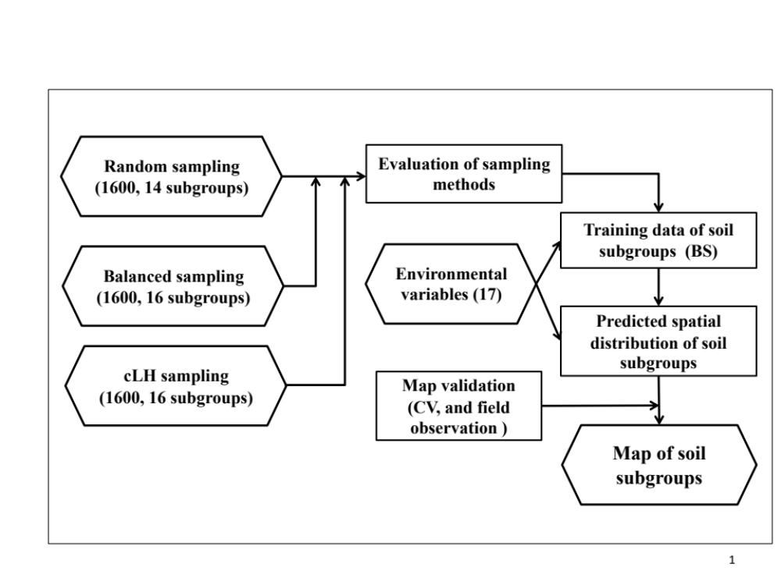
Figure 3.4. Diagram to illustrate the workflow for predicting soil classes from legacy data in the Thompson-Okanagan region.

Development of training data locations (random sampling, balanced-sampling, and cLH-sampling,)
To get a closer look at different sampling designs, we decided to test three sampling methods: random sampling (RS), balanced-sampling (BS), and cLH-sampling (cLHS). These methods were each used to select 1600 training data locations from the single-component polygons. RS is a probability sampling design and it was the simplest among all three methods. The algorithm is straightforward, and it can be applied in both R and ArcGIS. The outcome of RS is random regardless of any spatial correlation with other selected points or the characteristics of the landscape. One disadvantage of RS is that it oversamples the most common and under samples the least common classes. In this study, RS produced unbalanced training data covering 14 soil subgroups (Table 3.3), where Orthic Gray Luvisol and Eluviated Eutric Brunisol were the two classes most represented in the training data. On the other hand, rarer classes such as Gleyed Gray Luvisol, and Orthic Eutric Brunisol had the smallest number of points in the training data, and organic subgroups were entirely missing from the training data.

Table 3.3. Percentage cover of each soil subgroup in the pure polygon training area and percent of samples of each subgroup for three sampling designs (RS: random sampling; BS: balanced sampling; cLHS = conditioned Latin hypercube sampling).
Orders | Great Groups | Subgroups | Area (%) in the training area | RS (%) in training data | RS (%) in predicted pixels | BS (%) in training data | BS (%) in predicted pixels | cLH S (%) in training | cLHS (%) in predicted pixels
Organic | F | TY.F | 0.03 | 0 | 27.90% | 6.25 | 12.75% | 0.25 | 34.65%
 | M | TY.M | 0.03 | 0 | 43.82% | 6.25 | 14.97% | 0.12 | 32.51%
Podzol | HFP | O.HFP | 2.37 | 2.56 | 8.78% | 6.25 | 8.26% | 2.30 | 7.29%
Chernozem | BC | O.BC | 11.09 | 11.69 | 5.08% | 6.25 | 8.05% | 10.40 | 4.42%
 | DBC | O.DBC | 6.76 | 6.75 | 0.99% | 6.25 | 9.25% | 7.50 | 5.02%
 | BLC | O.BLC | 4.49 | 3.75 | 2.59% | 6.25 | 6.36% | 6.30 | 3.97%
Luvisol | GL | PZ.GL | 3.12 | 3.63 | 4.61% | 6.25 | 6.34% | 3.10 | 5.50%
 |  | B.GL | 5.39 | 4.25 | 3.34% | 6.25 | 4.16% | 6.10 | 3.76%
 |  | O.GL | 27.38 | 26.69 | 0.68% | 6.25 | 7.43% | 24.90 | 0.57%
 |  | GL.GL | 0.15 | 0.19 | 1.97% | 6.25 | 2.22% | 0.12 | 2.07%
Brunisol | EB | E.EB | 31.82 | 33.00 | 0.25% | 6.25 | 9.12% | 31.9 | 0.15%
 |  | O.EB | 0.15 | 0.19 | 0.01% | 6.25 | 3.10% | 0.25 | <0.01%
 | DB | E.DYB | 2.32 | 2.25 | 0.01% | 6.25 | 2.30% | 2.10 | <0.01%
 |  | O.DYB | 1.75 | 1.44 | <0.01% | 6.25 | 4.45% | 2.20 | <0.01%
Regosol | R | O.R | 2.14 | 2.81 | N/A | 6.25 | 0.66% | 2.10 | 0.08%
 |  | GLCU.R | 0.45 | 0.81 | N/A | 6.25 | 0.59% | 0.25 | <0.00%
 |  | Total | 100 | 100 |  | 100 |  | 100

BS is a non-probability sampling design purposely designed to cover every class equally regardless of its area proportion (Ap) in the training area. One advantage is that it produces balanced training data, where every class shares an equal number of points, but a disadvantage is that it requires pre-determined categories for the stratification. The cLHS is an adapted experimental sampling design, which can be generated with the clhs package in r (Roudier. 2011). In this study, cLHS also produced unbalanced training data covering all 16 soil subgroups. The sampling proportion (sp%) of every soil subgroup in each training data location is summarized in Table 3.3. All the selected points were intersected with the soil subgroup and environmental variable layers. In the end, three separate training data sets (TRS, TBS, and TcLH,) were built and used separately to calibrate the classification leaners. Similar workflow for developing training data to predict categorical soil data can be found in studies such as Minasny and McBratney (2006), Odgers et al. (2011), Heung et al. (2016) and Taghizadeh-Zeraatpisheh et al. (2017).

Model implementation (RF)
Random Forests (RF) are supervised tree-based learners with classification and regression specifications, which can be used to predict categorical or continuous variables at target locations. Identifying relationships based on the training data and predicting results are two major steps in the process. This part of the soil classification used the randomForest package in the statistical software, R, with the classification specification. The algorithm was first used to identify the relationships between 16 soil subgroups and 17 environmental variables based on the training data (Breiman, 2001; Liaw and Wiener 2002; R Development Core Team, 2012). In this study, the randomForest algorithm used the bootstrap technique to randomly select, with replacement, two thirds of the original training data to systematically build multiple classification trees. When building each individual tree, each split was calculated using a randomly selected environmental variable, with the total number of environmental variables tried designated as mtry (Heung et al., 2014). At each node, a decision was made after a number of random comparisons, and the best variable values were selected to make a split in the sub-training data. Each tree was statistically evaluated based on the accumulated vote of every correct classification. The average vote of every correctly assembled classification tree was used to determine the best relationship to derive each soil subgroup.
The parameter optimization processes were carried out with the caret package in R to test different sets of parameters in random forest. The tuning processes with 10-fold cross-validation were used to optimize the settings on each parameter, and the parameters included the number of trees (ntree) and the number of predictors tried at each node (mtry). Kappa values were used to evaluate the prediction accuracy during the tuning processes. Along with building each decision tree, one third of the samples were set aside to calculate the error estimation, which is called out-of-bag error (OOB). The OOB was calculated for every tree; then it was generalized for every soil subgroup in the classification processes. The result of RF for every soil subgroup was an aggregation of many tree-based learners based on the majority vote. After the relationships were recognized from the training data, they were used to assign one of 16 soil subgroups for every cell based on the values of all environmental variables in the target location.

Model assessment
Based on the outputs from RF, the assessment of the results was carried out in three steps. First, the model fit was evaluated for each sampling method. Second, an assessment of variable importance was determined for each sampling method and individual soil subgroups. Third, the predictions of soil subgroups were validated using the field data for each sampling method.
The model fit of RF was evaluated based on the classification error in the confusion matrix, which was produced as an OOB error during calibration of RF. The confusion matrix showed the classification error (%) in each soil subgroup in the training data and overall classification error (%) for the whole training data. The classification error (%) was estimated as follows (James et al., 2013):
$E_{k}=1-\max_{k}\left({\hat{p}}_{mk}\right)$
$$E_{mean}= \frac{\sum{E_{k}}}{n}$$
Here ${\hat{p}}_{mk }$is the proportion of correct observation in the mth selected sub-dataset for the kth class. The mean value of the classification error for all the classes was then calculated and displayed as overall classification error (%) for the whole training data. Although classification error (%) is useful for evaluating the prediction accuracy, an additional assessment was needed to fully understand the influence of environmental variables.
Two by-products—the variable importance matrix and plots—were used to interpret the relationship between environmental variables with soil classes (Liaw and Wiener, 2002). The variable importance matrix is a summary of the quantitative measurement of importance for an individual class. The estimation of each variable is based on how much prediction error increases or decreases when the OOB error for that variable is increased or decreased. The mean decreases in accuracy calculate the importance of a variable regarding the prediction accuracy before and after removing a variable. The mean decrease of the Gini Index measures the rate of misclassification before and after removing a specific variable from the dataset. Variable importance plots helped rank the environmental variables for each soil subgroup.
Area proportion (Ap) was also calculated using the area of specific soil subgroup over the total area. Sampling proportion (Sp) was calculated using the number of sampled points of a specific soil subgroup over the total number of sampling points. They are expressed in the following formulas:
$$Ap_{(x)}= \frac{A_{x}}{\sum{A}}*100\%$$
$$Sp_{(x)}=\frac{N_{x}}{\sum{N}}*100\%$$
Where Ax is the area of category x, A is the total area, and Nx is the number of points for category x.

Map validation
Map accuracy was evaluated by using field-collected point data to assess the accuracy of prediction of soil subgroups. The validation dataset was collected independently of the training data in separate fieldwork.
Soil classification data collected during my field work (Summer 2015, where n = 290 points) were supplemented with additional (n = 88) points from legacy soil pit data from the British Columbia Soil Information System (BCSIS) (Sondheim and Suttie 1983) to build a validation dataset with n = 379 points. In total, there were n = 119 points on the grass-covered landscape and n = 260 on the forested and intermixed forested with grass understory landscape. Two tiers of validation (r = 0, and r = 1) were applied to consider the uncertainty in the location of the original soil pits. For the first level of validation (r = 0), a prediction was considered correct if the soil subgroup at a validation point matched the predicted soil subgroup at the exact location. On the second level of validation (r = 1), a prediction was considered correct if the soil subgroup at a validation point matched the predicted soil subgroup in the center pixel which contained the validation point and within any one of the eight pixels surrounding the validation point.
Soil classification at the order level was performed twice for each of the 290 field plots—once in the field and once again in the lab. The classification was then refined into the level of subgroups in the lab based on the analytical results. During the classification in the lab, 35 of 291 field plots were reclassified into different soil orders based on the more precise results corresponding to the soil colour, soil particle size distribution, soil organic matter content, and pH value. The field data included 34 soil subgroups, with 14 soil subgroups represented in the training data and predicted soil map; 12 soil subgroups were included in the previous soil survey report but not in the training data, and eight were not identified from the previous soil survey report. I did not find any organic soil during fieldwork.

Results and Discussion

Parameter optimization
The parameters of mtry and ntree in RF were tuned with 10-fold cross-validation, and tested with the training dataset from BS sampling methods and 17 variables. The results are illustrated as the average prediction accuracy and value of Kappa in Figure 3.5 and Figure 3.6. The average prediction accuracy and Kappa reveals the same results: ntree = 4000 and mtry = 6 achieved the best prediction. In comparison to the default setting of these parameters in RF (ntree = 500, mtry = 3), the improvement was less than 2%. The results showed that the tuning process with grid search improved overall prediction accuracy, though the margin was small. Similar results have been shown in other classification studies, such as in Heung et al. (2014) who used RF classifier to predict the spatial distribution of parent materials in Langley–Vancouver, British Columbia. Traditionally, the parameter optimization process in complex models such as RF, were considered extremely time consuming with little intuitive meaning (Brungard et al., 2015; Shawe-Taylor and Cristianini, 2004). With help from the caret package and the development of a grid search algorithm, the parameter optimization process is easily implemented. Although a large amount of computation power is required for a large dataset, the parameter optimization appeared to improve model outputs.

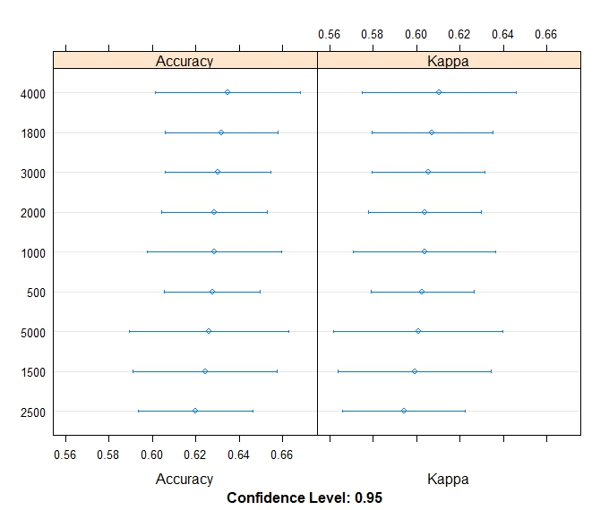
Number of decision trees
Figure 3.5. Mean 10-fold cross-validation error rate (RMSE and Kappa) for varying number of decision trees during the parameter tuning processes to optimize the model performance in RF .

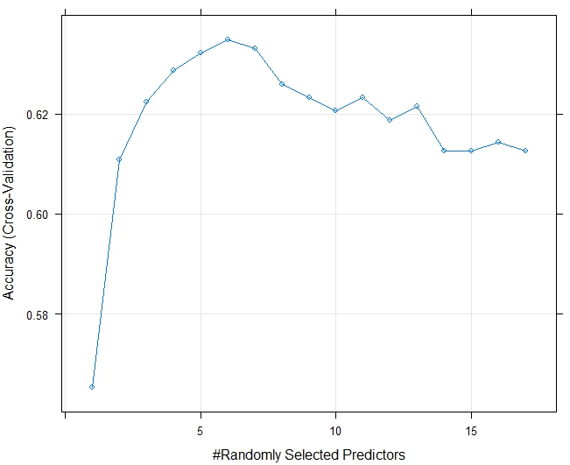
Figure 3.6. Mean 10-fold cross-validation error rate for varying number of predictors tried in parameter tuning processes to optimize the model performance in RF .

Out-of-bag error and the Area proprotion (Ap) (Assessment of variable importance)
A strong correlation was observed between the area proportion (Ap) of the soil subgroups and OOB error in the random sampling method and cLH sampling method (Figure 3.7). Soil subgroups with relatively high area proportion tended to have low OOB error, except for Regosols and organic soils. For example, Eluviated Eutric Brunisol (E.EB) and Orthic Grey Luvisol (O.GL) had a higher area proportion in the training data selected with random sampling method and cLH sampling respectively, and they had the lower OOB error in their predictions. On the other hand, Gleyed Grey Luvisol (GL.GL) and Orthic Eutric Brunisol had a smaller area proportion in the training area, and these had higher OOB errors in the predictions derived from the random sampling and the cLH sampling methods. As mentioned before, Orthic Regosol (O.R) was an exception, and it had low OOB error regardless of sampling design. Another exception is organic soils. Subgroups with a higher proportion of the sampling points in the training data had lower OOB error, decreasing from 99.99% to 1.00% and 2.00% (Table 3.4). By decreasing the sampling proportion of the Eluviated Eutric Brunisol in the training data, the OOB error increased from around 30% to 70% (Table 3.4).

Figure 3.7. Area proportion of each soil subgroup in the training area with its OOB error in the prediction. The RS_TDATA(%) shows the proportion of each soil subgroup in the training data selected by the random sampling method, and cLH_TDATA(%) shows the proportion of each soil subgroup in the training data selected by the cLH sampling method. RS_OOB (%) and cLH_OOB (%) show the out-of-bag error for each soil subgroup for training data selected by the two sampling methods.
Besides the proportion of sampling points (Sp) in the training data, the environmental variables also had a strong influence upon individual soil subgroups. In this study, 17 environmental variables were derived from the Digital Elevation Models (DEMs). When setting up the training data with an equal number of points for the individual soil subgroups, as was applied in the balanced sampling design, Orthic Regosol and organic soils had lowest OOB errors, which indicated a strong correlation with the environmental variables (Figure 3.8).

Table 3.4. Out-of-bag (OOB) error for the prediction of individual soil subgroups for three sampling designs (RS: random sampling, BS: balanced sampling; cLHS: conditioned Latin hypercube sampling).
Soil Subgroups | N of points in RS | OOB error (%) for RS | N of points in TBS | OOB error (%) for BS | N of points in TcLHS | OOB error (%) for cLHS
E.EB |  | 32.77 |  | 70.00 | 534 | 29.62
O.GL |  | 25.53 |  | 48.00 | 429 | 36.95
O.BC |  | 32.09 |  | 35.00 | 167 | 27.06
O.DBC |  | 61.11 |  | 55.00 | 106 | 54.10
BR.GL |  | 89.71 |  | 64.00 | 62 | 66.00
O.BLC |  | 80.00 |  | 40.00 | 95 | 47.06
PZ.GL |  | 82.76 |  | 55.00 | 47 | 68.00
O.HFP |  | 61.00 |  | 48.00 | 51 | 68.42
E.DYB |  | 99.99 |  | 63.00 | 35 | 99.99
O.R |  | 13.33 |  | 9.00 | 30 | 5.88
O.DYB |  | 99.99 |  | 58.00 | 29 | 99.99
GLCU.R |  | 99.99 |  | 15.00 | 13 | 99.99
GL.GL |  | 99.99 |  | 4.00 | 1 | 99.99
O.EB |  | 99.99 |  | 5.00 |  | 99.99
TY.F |  | N/A |  | 1.00 | 1 | 99.99
TY.M |  | N/A |  | 2.00 |  | 99.99

In conclusion, the minor soil subgroups GLCU.R., GL.GL., O.EB., and organic soils had the lowest area proportion (Ap) in the training area, which resulted in low classification accuracy for the random sampling method and the cLH sampling method. When increasing the number of samples for the minor soil subgroups GLCU.R., GL.GL., O.EB., and organic soils, the classification accuracies improved. These results also indicated that these minor soil subgroups could be predicted using topographic variables derived from the digital elevation model. The overall variable importance plots (Figure 3.9 confirmed that three out of four top-rated variables are terrain-related environmental variables.

Figure 3.8. The sampling proportion of each soil subgroup in the training data selected by the balanced sampling method.

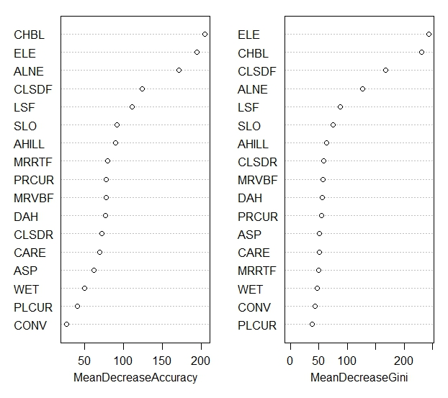
Figure 3.9. The evaluation of variable importance in prediction of soil classificiation with RF, and it includes 17 environmental variables. The evlauation was based on the results from the variable importance plots from the RF classifier

Assessment of prediction with polygon data
This soil classification study produced three soil classification maps for the study area in the Thompson–Okanagan region (Figure 3.10, Figure 3.11, and Figure 3.12). Comparisons of the predicted soil maps and the original soil survey map reveal similar patterns in the distribution of the soil orders. Chernozemic soils were on the grassland region at mid-elevation. When the landscapes changed into the dry interior forest region at the higher elevation, Brunisols became the dominant soil, and the landscapes on the higher elevations were mostly covered with Luvisols (Figure 3.13). With a closer look at three predicted soil maps for the areas near the Kamloops Lake, the cLH sampling method (Figure 13.3 D) produced a similar distribution of soil orders as the simple component polygons in the training area (Figure 13.3 A). The balanced sampling method predicted a higher coverage of Chernozems near the Kamloops Lake. In the same area, the cLH sampling predicted a higher coverage of Brunisols. When looking at the whole study area, the random sampling method and cLH sampling method both predicted a higher coverage of Luvisols at the mid elevation. In the same area (Figure 13.3 D), the balanced sampling method predicted higher coverage of Brunisols (Figure 13.3 C).
The predictions are limited and constrained by the training data. cLH sampling and balanced sampling methods covered all 16 soil subgroups from the training area. Random sampling only covered 14 soil subgroups. Therefore, in the results the predicted soil class map from the training data produced by cLH sampling and balanced sampling had 16 soil subgroups, and the predicted soil map from the random sampling had 14 soil subgroups.

Assessment of prediction with point data
The simple polygons included 16 soil subgroups and represented 51.6% of the variation in soil classes and 87.4% of the land area within the study area. The validation data represent 54.84% of the variation in soil subgroups in the study area, and the validation data represent 93.75% of the variation in the training area with single component polygons. The validation data included 14 soil subgroups and two organic soils. Three soil subgroup maps were produced, and the highest map accuracy was 65.4%, where Eluviated Eutric Brunisol and Orthic Brown Chernozems had the highest accuracies among all the soil subgroups in the region.
In previous studies, the RF was used to predict categorical data such as parent materials in British Columbia, Canada (Heung et al., 2016), soil classes in three semi-arid landscapes in the United States (Brungard et al., 2015), and soil classes in the Alps in Europe (Baruck et al., 2016). The map accuracy rates were all greater than 70%. In comparison, the accuracies of the three predicted soil subgroup maps were lower than 66% in this study, which is slightly lower than other similar studies mentioned above. These results confirmed that overall classification accuracy relies substantially upon the number of categories predicted and the purity of the training data. Increasing the number of predicted classes resulted in lower classification accuracy. Besides using the most accurate models, increasing the number of observations within each class or decreasing the number of classes over the landscape leads to better overall classification accuracy.

Conclusions
Seventeen topographic variables used RF to predict the spatial distribution of soil subgroups over three types of landscape units: grassland region, transition region, and dry interior forest region. All of the environmental variables were derived from a digital elevation model. The most important variable is channel network base level that relates to the hydrological movement, and it indicates the hydrological factors are the main soil formation influencer in the region. The distribution and movement of water not only controls the distribution of the vegetation, they also influence the spatial distribution of soil classes.
Additionally, this study compared three sampling methods: random sampling, balanced sampling, and cLH sampling. The results showed that the sampling method used to build the training data from soil legacy data has great influence on the predicted distributions of soil classes. OOB error was lowest in the balanced sampling method, which had an equal number of sample points in each class unlike the imbalanced sampling methods. Unfortunately, balanced sampling is very difficult to achieve when mapping an unknown region. The parameter optimization is necessary although the implementation can be time consuming for a large dataset.
In digital soil mapping, using an RF classifier with a finer resolution digital elevation model allowed us to produce a soil class map with uniform resolution that provides continuous coverage in the region. The 25 m resolution reveals additional details of the spatial distribution of soil subgroups. Future studies can further focus on including vegetation and climatic variables. One difficulty I encountered is the fuzzy boundaries between different types of landscape units, which made it difficult to differentiate the landscape regions; the application of remote sensing data can further help to reduce the noise along the boundaries. This study only evaluated the predictions from RF classifier; additional comparisons of other types of classifiers should be included in further research.

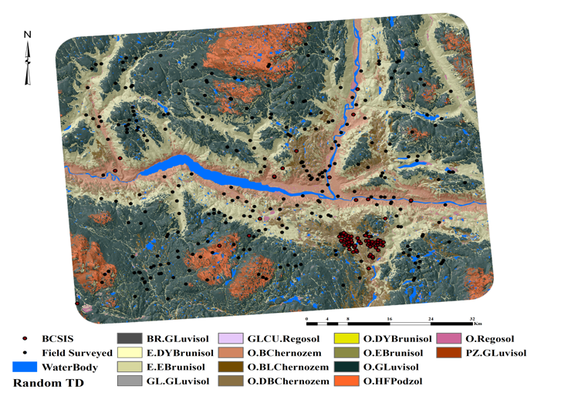
Figure 3.13. Predicted soil classes at the subgroup level, using the training data developed from random sampling. The map is overlain with a hill shade raster layer. Validation points are from the BCSIS and recently collected field data.
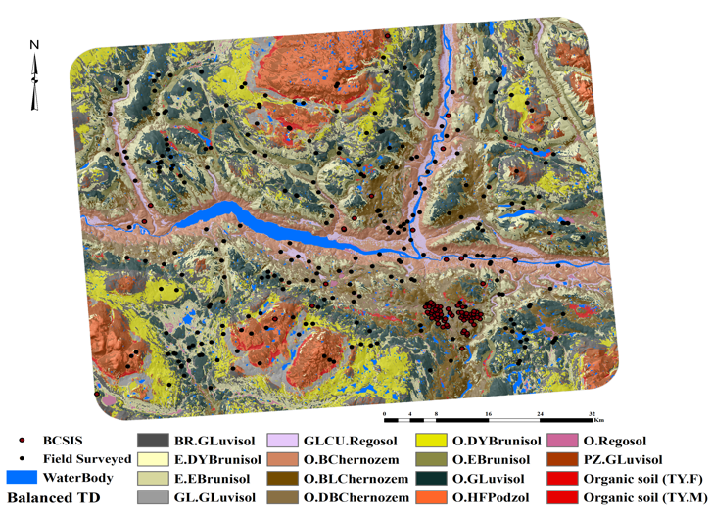
Figure 3.14. Modeled soil classes at the subgroup level, using the training data developed from balanced sampling. Validation point are from BCSIS and recently collected field data.
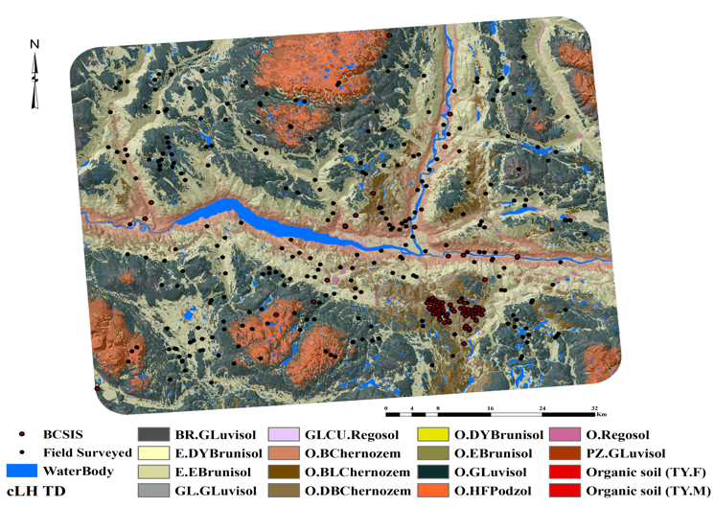
Figure 3.15. Modeled soil classes at the subgroup level, using the training dataset developed from cLH sampling. Validation points from BCSIS and recently collected field data.
Map A: Seamless polygon data | Map B: Random sampling method | 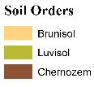
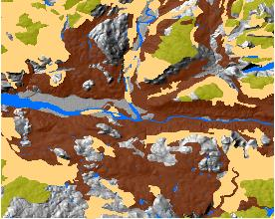 | 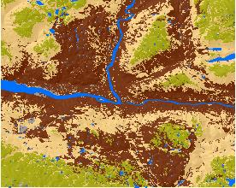 | Other
Map C: Balanced sampling method | Map D: cLH sampling method
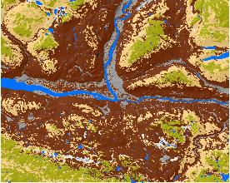 | 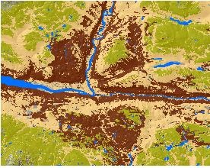
Figure 3.16. Maps of the distribution of the soil orders at an area near the city of Kamloops. Chernozemic soils, Brunisolic soils and Luvisolic soils were included in this zoomed-in area. Map A is from the soil survey. Map B is from the Random Sampling method. Map C is from the Balanced Sampling method. Map D is from the cLH Sampling method. All the soil maps

References
Anderson, D.W., Smith, S.C.A., 2011. A history of soil classification and soil survey in Canada: personal perspective. Canadian Journal of Soil Science 91(5), 675-694.

Addiscott, T.M., 1998. Modelling concepts and their relation to the scale of the problem. Nutrient Cycling in Agroecosystems 50, 239 – 245.
Adhikari, K., Hartemink, A.E., Minasny, B., Kheir, R.B., Greve, M.B., Greve, M.H., 2014. Digital mapping of soil organic carbon contents and stocks in Denmark. PLoS One 9. e105519.
Arrouays D., McKenzie N., Hempel J., Richer de Forges A., McBratney A., (eds) 2014. GlobalSoilMap: basis of the global spatial soil information system. CRC Press, Leiden.
Avery, T. E., Burkhart, H. E., 1994. Sampling designs. In Duffy, A. C., Morriss, J. M., (eds). Forest measurements, 4th ed, McGraw-Hill, Boston, Massachusetts.
Barthold, F.K., Wiesmeier, M., Breuer, L., Frede, H.G., Wu, J., Blank, F.B., 2013. Land use and climate control the spatial distribution of soil types in the grasslands of Inner Mongolia. Journal of Arid Environments 88, 194 – 205.
Beguin, J., Fuglstad, G.A., Mansuy, N., Paré, D., 2017. Predicting soil properties in the Canadian boreal forest with limited data: Comparison of spatial and non-spatial statistical approaches. Geoderma 306, 195 – 205.
Bennett, K.P., Campbell, C., 2000. Support vector machines: Hype or hallelujah? SIGKDD Explorations, 2(2). URL http://www.acm.org/sigs/sigkdd/explorations/issue2-2/bennett.pdf.
Bergstrom, D.W., Monreal, C.M., Jacques, E. St., 2000. Spatial dependence of soil organic carbon mass and its relationship to soil series and topography. Canadian Journal of Soil Science 81, 53 – 62.
Beyer, H.L., 2012. Geospatial Modeling Environment. URL: http://www.spatialecology.com/gme
Boehner, J., Antonic, O., 2009. Land surface parameters specific to Topo-Climatology. In Hengl, T., & Reuter, H.I., (eds). Geomorphometry – concepts, software, applications.
Brady, N.C., Weil, R.R., 2008. The nature and properties of soils. Fourteenth edition, Prentice Hall, Upper Saddle River, New Jersey.
Brayshaw, T.C., 1970. The dry forests of southern British Columbia. Syesis 3, 17 – 43.
Breiman, L., 1996. Bagging predictors, Machine Learning 26, 123-140.
Breiman, L., 1996b. Stacking regressions Machine Learning 24, 49-63.
Breiman, L., 2001a. Random forests, Machine Learning 45, 5 – 32.
Breiman, L., 2001b. Statistical modelling: The two cultures. Statistical Science 16 (3), 199 – 231.
Breiman,L., Friedman, J.H., Olshen, R.A., Stone, C.J., 1984. Classification and regression. Trees. Wadsworth, Belmont, CA.
British Columbia Ministry of Forests and Range and British Columbia Ministry of Environment. 2010. Field manual for describing terrestrial ecosystems, 2nd ed. Forest Science Program, Victoria, B.C. Land management Handbook No.25
Brungard, C.W., Boettinger, J.L., Duniway, M.C., Wills, S.A., Edwards, T.C., 2015. Machine learning for predicting soil classes in three semi-arid landscapes. Geoderma 239 – 240, 68 – 83.
Bui, E.N., 2004. Soil survey as a knowledge system. Geoderma 120, 17 – 26.
Bui, E.N., Moran, C.J., 2001. Disaggregation of polygons of surficial geology and soil maps using spatial modelling and legacy data. Geoderma 103, 79-94
Burrough, P.A., McDonnell, R.A., 1998. Principles of geographical information systems. Oxford University Press.
Canadian Agricultural Services Coordinating Committee. Soil Classification Working Group. 1998. The Canadian system of soil classification. 3rd ed. Agriculture and Agri-Food Canada. Ottawa. ON. Pub. 1646.
Ciampalini, R., Lagacherie, P., Gomez, C., Grünberger, O., Hamrouni, H.M., Mekki, I., Richard, A., 2013. Detecting, correcting and interpreting the biases of measured soil profile data: A case study in the Cap Bon Region (Tunisia). Geoderma 192, 68 – 76.
Crave, A., Gascuel–odoux, C., 1997. The influence of topography on time and space distribution of soil surface water content. Hydrological Processes 11, 203 – 210.
Dorigo, W.A. Zurita-Milla, R., de Wit, A.J.W., Brazile, J., Singh, R., Schaepman, M.E., 2007. A review on reflective remote sensing and data assimilation techniques for enhanced agroecosystem modelling. International Journal of Applied Earth Observation and Geoinformation 9, 165 – 193.
Environment Canada. 2013. Environment Canada, National climate data and information archive. Downsview, Ontario. Available from http://www.climate.weatheroffice.gc.ca [accessed 06 September 2014].
Evans, C. R. W., Krzic, M., Broersma, K., Thompson, D. J., 2012. Long-term grazing effects on grassland soil properties in southern British Columbia. Canadian Journal of Soil Science 92, 685 – 693.
Evrendilek, F., Berberoglu, S., Gulbeyaz, O., Ertekin, C., 2007. Modelling potential distribution and carbon dynamics of natural terrestrial ecosystem: a case study of Turkey. Sensors 7, 2273 – 2296.
Fang, X., Xue, Z., Li, B., An, S., 2012. Soil organic carbon distribution in relation to land use and its storage in a small watershed of the Loess Plateau, China. Catena 88, 6-13.
Farstad, L., Drewry, N.T., 1978. Soil and land utilization surveys prior to 1965. in Valentine, et al. (ed.) Soils landscapes of British Columbia. BC Ministry of Environment, Resource Analysis Branch 197p.
Filippi, P., Cattle, S.R., Bishop, T.F.A., Odeh, I.O.A., Pringle, M.J., 2018. Digital soil monitoring of top-and sub-soil pH with bivariate linear mixed models. Geoderma 322, 149-162.
Fisher, R.A., 1936. The use of multiple measurements in taxonomic problems. Annals of Eugenics 7, 179 – 188.
Florinsky, I.V., Eilers, R.G., Manning, G.R., Fuller, L.G., 2002. Prediction of soil properties by digital terrain modelling. Environ. Modell. Softw. 17. 295 – 311.
Florinsky, I.V., 2012. Digital terrain analysis in soil science and geology. Langford Land: The Boulevard.
Friedman, J., Hastie, T., Tibshirani, R., 2010. Regularization paths for generalized linear models via coordinate descent. Journal of Statistical Software, 33(1). 1-22. URL. http://www.jstatsoft.org/v33/i01/.
Friedman, J., Hastie, T., Tibshirani. R., 2010b. glmnet: Lasso and elastic-net regularized linear models, R package version 1.1-5. URL http://CRAN.R-project.org/package=glmnet.
Gillies, R.R., Carlson, T.N., Cui, J., Kustas, W.P., Humes, K.S., 1997. A verification of the ‘triangle’ method for obtaining surface soil water content and energy fluxes from remote measurements of the Normalized Difference Vegetation Index (NDVI) and surface radiated temperature. International Journal of Remote Sensing 18-15, 3145 – 3166.
Grimm, R., Behrens, T., Märker, M., Elsenbeer, H., 2008. Soil organic carbon concentrations and stocks on Barro Colorado Island – digital soil mapping using Random Forests analysis. Geoderma 146, 120 – 113.
Grunwald, S., 2009. Multi-criteria characterization of recent ditial soil mapping and modeling approaches. Geoderma 152, 195 – 207.
Grossman, R. B., Harms, D. S., Kingsbury, D. F., Shaw, R. K., Jenkins, A. B., 2001. Assessment of soil organic carbon using the U.S. soil survey. in Lal, R., Kimble, J.M., Follett, R. F., Stewart, B. A., (eds.) Assessment methods for soil carbon, Lewis Publishers, Boca Raton, FL. pp. 87 – 104.
Hastie, T.J., Tibshirani, R.J., 1990. Generalized additive models. Chapman and Hall/CRC, London.
Hastie, T.J., Pregibon, D., 1992. Generalized linear models. In Chambers, J.M., Hastie, T.J., (des) Statistical models in S. chapter 6, Wadsworth & Brooks/Cole.
Hastie, T.J., Tibshirani, R.J., Friedman, J., 2001. The elements of statistical learning: data mining, inference and prediction. Springer Series in Statistics. Springer – Verlag, New York.
Hengl, T., Rossiter, D.G., Husnjak, S., 2002. Mapping soil properties from an existing national soil data set using freely available ancillary data. 17th World Congress of Soil Science, Bangkok, Thailand, August 14-21. Paper no. 1140.
Hengl, T., Heuvelink, G.B., Kempen, B., Leenaars, J.G., Walsh, M.G., Shepherd, K.D., Sila, A., MacMillan, R.A., de Jesus, J.M., Tamene, I., Tondoh, J.E., 2015. Mapping soil properties of Africa at 250 m resolution: random frosts significantly improve current predictions. PLoS One 10, 1-26.
Heung, B., Bulmer, C.E., Schmidt, M.G., 2014. Predictive soil parent material mapping at a regional-scale: A Random Forest approach. Geoderma 214-215, 141 – 154
Heung, B., Hodúl, M., Schmidt, M.G., 2016. Comparing the use of training data derived from legacy soil pits and soil survey polygons for mapping soil classes. Geoderma 290, 51 – 68.
Hofierka, J., Suri, M., 2002. The solar radiation model for open source GIS: implementation and applications. International GRASS users conference in Trento, Italy, September 2002. pdf.
Hudson, B.D., 1992. The soil survey as paradigm-based science. Soil Science Society of American Journal 56, 836 – 841.
James, G., 2013. An introduction not statistical learning: with applications in R, ………..
Jenny, H., 1941. Factors of soil formation. A system of quantitative pedology. New York: McGraw Hill.
Joint research centre: GIS solar radiation database for Europe and solar radiation and GIS.
Karatzoglou, A., Smola, A., Hornik, K., Zeileis, A., 2004. Kernlab-An S4 package for Kernel methods in R. Journal of Statistical Software, 11(9).
Kalra, Y.P., Maynard, D.G., 1991. Methods manual for forest soil and plant analysis. Forestry Canada Information Report NOR-S-319. Victoria, BC. (pp31, pp25,pp42)
Kern, J.S., 1995. Evaluation of soil water retention models based on basic soil physical properties. Soil Science Society of American Journal 59, 1134 – 1141.
Kern, J.S. 1995. Geographic patterns of soil water-holding capacity in the contiguous united states. Soil Science Society of American Journal 59, 1126 – 1133.
Khaledian, Y., Brevik, E.C., Pereira, P., Cerdà, A., Fattah, M.A., Tzaikeh, H., 2017. Modelling soil cation exchange capacity in multiple countries. Catena 158. 1994-200.
Klenner, W., Walton, R., Arsenault, A., Kremsater, L., 2008. Dry forests in the southern interior of British Columbia: historic disturbances and implications for restoration and management. Forest Ecology and Management 256 (10) 1711-1722.
Kuhn, M., 2008. Building predictive models in R using the caret package. Journal of Statistical Software 28: 1-26.
Kuhn, M., Weston, S., Keefer, C., Coulter, N., 2016. Cubist models for regression.
Kuhn, M., Johnson, K., 2013. Applied predictive modelling. Springer. New York.
Lan. Q., 1993b. Combining instance-based and model-based learning, Proceedings of the Tenth International Conference on Machine Learning (1993a) 236-243.
Lagacherie, P., Arrouays, D., Bourennane, H., Gomez, C., Martin, M., Saby, N.P.A., 2019. How far can the uncertainty on a Digital Soil Map be known?: A numerical experiment using pseudo values of clay content obtained from Vis-SWIR hyperspectral imagery. Geoderma 337, 1320 – 1328.
Legates, D.R., Mahmood, R., Levia, D.F., Deliberty, T.L., Quiring, S. M., Houser, C., et al. 2011. Soil moisture: A central and unifying theme in physical geography. Progress in Physical Geography 35, 65 – 86.
Levin, S.A., 1992. The problem of pattern and scale in ecology. Ecology. 73, 1943 – 1967.
Liaw, A., Wiener, M., 2002. Classification and regression by Random Forest. R News 2,18 – 22.
Lin, L. I. 1989. A concordance correlation coefficient to evaluate reproducibility. Biometrics 45, 255 – 268.
Lin, Y., Prentice III, S.E., Tran, T., Bingham, N.L., King, J.Y., Chadwick, O.A., 2016. Modelling deep soil properties on California grassland hillslopes using LiDAR digital elevation models. Geoderma Reg. 7(1), 67-75.
Lloyd, D., Angove, K., Hope, G., Thompson, C., 1990. A guide to site identification and interpretation for the Kamloops Forest Region. BC Ministry of Forest, Canadian Cataloguing in Publication Data. Research Branch Ministry of Forests, Victoria, BC.
Luttmerding, H.A., 1981. Soils of the Langley – Vancouver map area. Report No. 15, British Columbia soil survey. BC Ministry of Environment, Kelowna, B.C. Canada.
Luttmerding, H.A., Demarchi, D. A. Lea, E. C., Meidinger, D. V., Vold, T., 1990. Describing ecosystems in the field: second edition: MOE manual 11. Land Resource Research Institute. Canada.
Ma, W.H., Yang, Y.H., He, J. S., Zeng, H., Fang, J. Y., 2008. Above – and below ground biomass in relation to environmental factors in temperate grasslands, Inner Mongolia. Science in China Series C: Life Science 51, 263 – 270.
MacMillan, R.A., Moon,D.E., Coupé, R.A., 2007. Automated predictive ecological mapping in a Forest Region of B.C., Canada, 2001-2005. Geoderma 140, 353 – 373.
Markewitz, D. Nibbelink, N. P., West, L. T., 2012. A comparison of three field sampling methods to estimate soil carbon content.
McBratney, A.B., Mendonça Santos, M. L., Minasny, B., 2003. On digital soil mapping. Geoderma 117, 3 – 52.
McBratney, A.B., Odeh, I.O.A., Bishop, T.F.A., Dunbar, M.S., Shatar, T.M., 2007. An overview of pedometric techniques for use in soil survey. Geoderma 97, 293 – 327.
McConkey, B.G., Ulrich, D. J., Mellinger, M., 1996. Spatial variability of wheat yield, soil properties and erosion in hummocky terrain. Canadian Journal of Soil Science 74, 219 – 228.
Meidinger, D., Pojar, J., 1999. Ecosystems of British Columbia. Special report series No. 6. Ministry of forests research branch, Victoria, B.C. Canada.
Minasny, B., McBratney, A.B., 2006. A conditioned Latin hypercube method for sampling in the presence of ancillary information. Computers & Geosciences 32, 1378 – 1388.
Minasny, B., McBratney, A. B., 2007. Latin hypercube sampling as a tool for digital soil mapping. pp 253-163. in Lagacherie, P., McBratney, A. B., Voltz, M., (eds.). Digital soil mapping: An introductory perspective, Developments in soil science, Vol. 31. Elsevier, Amsterdam, The Netherlands.
Minasny, B., Hartemink, A.E., 2011. Predicting soil properties in the tropics. Earth Sci. Rev. 106, 52-62.
Minasny, B., McBratney, A.B., 2016. Digital soil mapping: A brief history and some lessons, Geoderma 264, 301-311.

Moore, R.D., Spittlehouse, D.L., Whitfield, P.H. Stahl, K., 2010. Weather and climate. p. 47- 84. in Pike, R.G. et al. (ed) Compendium of forest hydrology and geomorphology in British Columbia. B.C. Min. For. Range, For. Sci. Prog., Victoria, B.C. and FORREX forum for Research and Extension in Natural Resources, Kamloops, B.C. Land Management. Handbook. 66.
Moore, I.D., Gessler, P.E., Nielsen, G.A., Peterson, G.A., 1993. Soil attribute prediction using terrain analysis. Soil Science Society of American Journal 57, 443-452.
Moore, I.D., Grayson, R.B., Ladson, A.R., 1991. Digital terrain modelling: a review of hydrological, geomorphological, and biological application. Hydrological Processes 5, 3 – 30.
Mulder, V., De Bruin, S., Schaepman, M., Mayr, T., 2011. The using of remote sensing in soil and terrain mapping-a review. Geoderma 162, 1-19.
Neilsen, R.P., 1991. Climatic constraints and issues of scale controlling regional biomes. p. 31 – 35. In M.M. Holland et al. (ed.) The role of Landscape boundaries in the management and restoration of changing environments. Chapman and Hall, New York.
Noorbakhsh, S., Schoenau, J., Zeleke, T., Qian, P., 2008. Soil properties, yield, and landscape relationships in south-central Saskatchewan Canada. Journal of Plant Nutrition 31, 539 – 556.
Oke, T.R., 1998. Boundary layer climates. London, Taylor & Francis.
Paustian, K., Levine, E., Post, W., Ryzhova, I.M., 1997. The use of models to integrate information and understanding of soil C at the regional scale. Geoderma 79, 227 – 260.
Pennock, D.J, Bedard-Haughn, A., Viaud, V., 2011. Chernozemic soils of Canada: Genesis, distribution, and classification. Canadian Journal of Soil Science 91, 719 – 747.
Pennock, D.J., Zebarth, B.J., De Jong, E., 1987. Landform classification and soil distribution in hummocky terrain, Saskatchewan, Canada. Geoderma 40, 297-315.
Poggio, L., Gimona, A., Brewer, M.J., 2013. Regional scale mapping of soil properties and their uncertainty with large number of satellite-derived covariates. Geoderma 209-210, 1-14
Polley, E.C., LeDell, E., Kennedy, C., Lendle, S., van der Laan, M., 2018. Super Learner Prediction, R package version 2.0-24. URL https://github.com/ecpolley/SuperLearner

Polley, E.C., van der Laan, M.J., 2010. Super learner in prediction. Working Paper Series 266 , Division of Biostatistics, University of California, Berkeley, URL http://biostats.bepress.com/ucbbiostat/paper266.
RuleQuest Research, 2000. Cubist. RuleQuest Research, Sydney, Australia.
SAGA Development Core Team, 2011. System for Automated Geoscientific Analyses (SAGA). Available at http://www.saga-gis.org/en/index.heml (verified 28 October, 2014)
Science Committee, 2015. Specifications tiered GlobalSoilMap products, 7 pp.
Schmidt, K., Behrens, T., Scholten, T., 2008. Instance selection and classification tree analysis for large spatial datasets in digital soil mapping, Geoderma 146, 138-146.
Segal, M.R., 2004. Machine Learning benchmarks and random forest regression. Technical Report. Center for Bioinformatics & Molecular Biostatistics papers, University of California, San Francisco, CA, USA:
Shahbazi, F., Hughes, P., McBratney, A.B., Minasny, B., Malone, B.P., 2019. Evaluating the spatial and vertical distribution of agriculturally important nutrients – nitrogen, phosphorous and boron – in North West Iran, Catena 173, 71 – 82.
Shary, P.A., Sharaya, L.S., Mitusov, A.V., 2002. Fundamental quantitative methods of land surface analysis. Geoderma 107,1 – 32.
Shawe-Taylor, J., Christianini, N., 2004. Kernel methods for pattern analysis. Cambridge University Press, Cambridge, UK.
Sinisi, S.E., Polley, E.C., Rhee, S.Y., van der Laan, M.J., 2007. Super learning: An application to the prediction of HIV-1 drug resistance. Statistical Applications in Genetics and Molecular Biology, 6 (1).
Simon, N., Friedman, J., Hastie, T., Tibshirani, R., 2011. Regularization paths for Cox’s proportional hazards model via coordinate descent. Journal of Statistical Software 39(5). 1-13. URL. http://www.jstatsoft.org/v39/i05/.
Sondheim, M., Suttie, K., 1983. User manual for the British Columbia Soil Information System, Volume 1, BC Ministry of Forest Publication R28 – 82053, Victoria, BC.
Soil Survey Staff. 2015. Illustrated guide to soil taxonomy, Version 2.0. USDA-Nature Resources Conservation Service. National Soil Survey Center. Lincoln. Nebraska. 3-24, 3-25.
Sprout, P.N., 1978. The Canada land inventory period 1965 – 1975. in Valentine, et al. (ed.) Soils landscapes of British Columbia. BC Ministry of Environment, Resource Analysis Branch. 197p.
Stum, A.K., Boettinger, J.J., White, M.A. Ramsey, R.D., 2010. Random Forests applied as a soil spatial predictive model in arid Utah, In Digital soil mapping: Bridging Research, Environmental Application, and Operation, Springer: 179 – 189.
Szatmάri, G., and Pάsztor, L., 2019. Comparison of various uncertainty modelling approaches based on geostatistics and machine learning algorithms.
Taghizadeh-Mehrjardi, R., Nabiollahi, K., Kerry, R., 2016. Digital mapping of soil organic carbon at multiple depths using different data mining techniques in Baneh region, Iran. Geoderma 266, 98-110.
Thompson, J. A., Kolka, R. K., 2005. Soil carbon storage estimation in a forested watershed using quantitative soil-landscape modelling. American Soil Science Society 69, 1086 – 1093.
Tu, C., He, T., Lu, X., Luo, Y., Smith, P., 2018. Extent to which pH and topographic factors control soil organic carbon level in dry farming cropland soils of the mountainous region of Southwest China. Catena 163. 204-209.
Pahlavan-Rad, M.R., Akbarimoghaddam, A., 2018. Spatial variability of soil texture fractions and pH in a flood plain (case study from eastern Iran). Catena 160, 275-281.
Polley, E.C., van der Laan, M.J., 2010. Super learner in prediction, U.C. Berkeley dividison of biostatistics working paper series. Working paper. Paper 266.
Umali, B.P., Oliver, D.P., Forrester, S., Chittleborough, D.J., Hutson, J.L., Kookana, R.S., Ostendorf, B., 2012. The effect of terrain and management on the spatial variability of soil properties in an apple orchard. Catena 93, 38-48.
van der Laan, M.J. and Dudoit, S. 2003. Unified cross-validation methodology for selection among estimators and a general cross-validated adaptive Epsilon-Net Estimator: Finite sample oracle inequalities and examples. Technical report 130, Division of Biostatistics, University of California, Berkeley, URL http://www.bepress.com/ucbbiostat/paper130/.
Vysotsky, G.N., 1906. On oro-climatic bases of soil classification. Pochvovedeni. 8, 3 – 4 (in Russian).
Walker, P.H., Hall, G.F., Protz, R., 1968. Relation between landform parameters and soil properties 1. Soil Science Society of America Journal 32 (1) 101-104.
Warrick, A. W., 1998. Spatial variability. In Hillel, D. (Ed.), Environmental soil physical, Academic press, San Diego, Calif. pp. 655 – 675.
Watson, K., 2007. Soil Illustrated – field descriptions, first edition. International Remote Sensing Surveys Ltd. Kamloops, B. C. Canada.
Wiesmeier, M., Barthold, F., Blank, B., Kögeo-Knabner, I., 2010. Digital mapping of soil organic matter stocks using random forest modelling in a semi-arid steppe ecosystem. Plant Soil 340, 7 – 24
Wikeem, B., Wikeem, S., 2004. The grasslands of British Columbia. Grasslands Conservation Council of British Columbia, 954A Laval Crescent, Kamloops, B.C. http://www.bcgrasslands.org/
Willmott, C. J., Matsuura, K. and Robeson, S.M., 2009. Ambiguities inherent in sums-of-squares-based error statistics. Atoms. Environ. 43, 749 – 752.
Wilson, J.P., Gallant, J.C., 2000. Secondary topographic attributes. In: Wilson, J.P., Gallant, J.C. (Eds.), Terrain Analysis – Principles and applications. Wiley, New York, pp. 87 – 132.
Wolpert, D., 1992. Stacked generalization. Neural Networks 5, 241-59.
Wood, J., 1996. The Geomorphological Characterisation of Digital Elevation Models. Ph.D. thesis, University of Leicester, UK. Available at: http://hdl.handle.net/2381/34503
Wysocki, D.A., Schoeneberger, P.J., LaGarry, H.E., 2004. Soil survey: a window to the subsurface. Geoderma 125, 167 – 180.
Young, G., Fenger, M.A., Luttmerding, H.A., 1996. Soils of the Ashcroft map area: report No. 26. British Columbia Soil Survey. Integrated Management Branch Victoria, British Columbia.
Zeraatpisheh, M., Ayoubi, S., Jafari, A., Tajik, S., Finke, P., 2019. Digital mapping of soil properties using multiple machine learning in a semiarid region, central Iran. Geoderma 338, 445-452
Yu, X., Duffy, C., Baldwin, D.C., Lin, H., 2014. The role of macropores and multi-resolution soil survey datasets for distributed surface-subsurface flow modeling. J. Hydrol. 516, 97 – 106.

Using soil pH in the Thompson – Okanagan region to examine the ensemble learning approach in digital soil mapping

Abstract
Information on the spatial distribution of soil pH is essential for assessing soil quality and soil productivity. Digital soil mapping (DSM) is commonly used to predict soil characteristics over various types of landscapes. In the past decade, machine-learning techniques have made progress in providing reliable predictions with limited data. DSM studies often focus on using a single learning approach, which is constructed with a machine learner that extracts the patterns in a large database systematically, and a fitted model is then used to predict soil information in an unmapped area. The practice of using an ensemble learning approach, especially one with combines several single learners, has rarely been tested in DSM. As a case study, we developed a workflow for using an ensemble learning algorithm to predict soil pH in the Thompson-Okanagan region.
This study tested a variety of base learners (STEP, GLMNET, GLM, KSVM, and RF). Base learners with higher prediction accuracies were used to construct the SuperLearner (SL) in the extraction of the complex relationship between soil pH and environmental variables. The fitted SL was then used to predict soil pH at 25-meter spatial resolution in three depth intervals (0 – 5cm, 5 – 15cm, and 15 – 30cm). 10-fold cross-validation was applied to evaluate the prediction accuracies. The SL, as a combination of multiple base learners, had the best prediction accuracy than just using any of the given base learners. On average the improvement of MSE was 3.7% in the 0 – 5cm depth, 3.8% in the 5 – 15cm depth, and 7.4% in the 15 – 30cm depth. Based on our results, we recommend using a super learner ensemble for predicting soil properties as continuous variables to reduce the structural uncertainties within individual base learners. Using the ensemble learning approach also eliminated the issue of choosing the best single learner.
Keywords: Ensemble learning; machine learning; Super Learner; Stacked Generalization; Soil pH.

Introduction
Soil properties can be used to assess soil quality and site productivity. Soil pH influences site productivity and thus can affect forest management. Forest soil can maintain healthy conditions under a wide range of pH values, but extreme conditions can have short-term and long-term impacts on the forest ecosystem (reference). In the Thompson-Okanagan region of B.C., a soil survey conducted in 1992 included limited information related to soil pH (Young et al., 1996). Accurate pH maps with uncertainties will provide the first full coverage of the region; such maps are beneficial in decision making, as concerns over the impact of climate change on the forest ecosystem, such as soil degradation and migration of plant species, increase over both short and long time scales.
The conventional approach to soil mapping is based on expert knowledge and ground-based surveys (Soil survey of Canada (need Reference here)). Conventional soil surveying is time-consuming, and in British Columbia (BC), the geographic extent of soil surveys is limited. These surveys also provide limited information about the spatial distribution of soil properties at the desired resolution (McBratney et al., 2003). The majority of ground-based surveys were historically clustered near urban areas, while rural areas received limited coverage. For example, in the Thompson-Okanagan region, coverage of soil properties in the forested area was limited and fragmented, and the majority of soil descriptions were confined to specific ecosystems of interest (Evan et al., 2012). Therefore, it is necessary to develop a workflow and models to predict soil properties at the uniform scale and resolution, which can also be applied to map other soil properties in future studies (Khaledian et al., 2017).
The relationship between soil information and environmental variables was earlier described by Jenny’s soil formation model (CLORPT) (1941). In 2003, two more additional covariates, soil (s), and spatial information (n) were added into the model (SCORPAN), allowing predictions of one spatially referenced soil property from other soil properties (McBratney et al., 2003). In combination with a supervised machine-learning algorithm, the SCORPAN model can further be used with existing soil data to cover unmapped areas (Bui and Moran, 2001). Soil properties, such as organic matter concentration (OMC), soil particle size distribution, and soil class were successfully mapped based on environmental variables derived from terrain indices (Minasny and Hartemink, 2011; Taghizadeh-Mehrjardi et al., 2016). In several studies, soil pH had been predicted and mapped at local scales (Zerattpisheh et al., 2019; Pahlavan-Rah and Akbarimoghaddam, 2018). Spatial variability of soil pH is influenced by parent material, topography, climate, vegetation, time and anthropogenic activities (Mulder et al., 2011; Umali et al., 2012; Lin et al., 2016).
Developments in the production of digital elevation models (DEM) and machine-learning approaches have provided more efficient ways to assess the spatial distribution of soil pH in agricultural and other landscapes at several depth intervals (Minasny and Hartemink, 2011; Filippi et al., 2018). The earliest DSM practice used the linear regression learner (LM) to find the best fit between the dependent variable (soil properties) and independent variables (environmental variables). The fitted learner was then used to map the continuous variables over the landscape. LM has shown successful results in predicting continuous data, such as depth to the presence of mottles, and depth to CaCO₃ (Walker et al., 1968; Pennock et al., 1987; Moore, 1993). LM works well with a small set of environmental variables, and it most commonly attached with a range of uncertainties (reference).
With improvements in computer technology and algorithms in the past decade, more powerful learners were designed to process large datasets with a larger number of environmental variables. Some examples include generalized linear regression (GLM) (Hastie and Tibshirani 1990), stepwise regression (STEP) (Hastie and Pregibon 1992), and Lasso and Elastic-Net regularized generalized linear regression (GLMNET) (Friedman et al., 2010), which are capable of processing non-linear relationships in both categorical and continuous data (Simon et al., 2011). Lately, combining tree structure learners (e.g. Random Forest and CART) with bagging (Breiman, 1996), or C5 learners (e.g. Cubist) with boosting has improved prediction accuracy (Lan 1993b). Numerous learning algorithms are thus available, and the general practice in DSM is testing many of these learners and choosing one to use for prediction. One way to assess the performance of the models is based on statistical values, including R², RMSE, MSE, MAE, concordance, and bias.
Instead of using a single type of base learner in prediction, the SuperLeaner uses an ensemble learning algorithm to compile an optimal learner, which is a super learner (SL) with improved prediction accuracy (Polley and van der Laan, 2010). The theory of SL was related to the stacking processes included in neural networks for the categorical data (Wolpert, 1992), and it was later adapted into regression stacking for continuous data (Breiman, 1996b). The algorithm of SL was described and validated by Polley and van der Laan (2010) in the study of the super learner in prediction. The construction of a SL includes two steps. First, the ensemble learning algorithm uses cross-validation to evaluate the performance of multiple base learners. It then creates a stacked prediction from selected based learners (Polly and van der Laan, 2010). Using a SL reduces bias, noise, and uncertainties from individual learners and improves the overall accuracy of the prediction.
The objectives of this study were to 1) evaluate and compare a set of five base learners; 2) test the potential of using the ensemble learning approach to extract the relationships between soil properties and environmental variables derived from DEM and to reduce the prediction error and uncertainty in the spatial distribution of soil properties compared to the use of a single learner; and 3) map the spatial distribution of soil pH at a regional scale. Point data were obtained from fieldwork carried out during the summer of 2015. Five machine learners were used as base learners to generate the ensemble learning approach, and raster datasets were used to express the environmental conditions in the Thompson-Okanagan region in BC. To make an adequate assessment of the prediction accuracy of the ensemble learning algorithm, parameter optimization was applied to improve the prediction accuracy.

Material and methods
This study modelled soil pH by using five base learners: generalized linear regression (GLM), generalized linear regression stepwise regression (STEP), Lasso and Elastic-Net regularized generalized linear regression (GLMNET), Kernel-based Support Vector Machine (KSVM) learner, and random forest (RF) with the ensemble learning approach. In all cases, point data were joined with values from environmental variables composing the training data. The training data were then used to fit the learners. The ensemble learning process was applied to selected single learners which displayed higher prediction accuracy in order to predict soil pH over the landscape. As the goal of this study was to examine the ensemble learning process with continuous soil attributes, we mainly focused on the process of improving the prediction accuracy by using the ensemble learning approach, rather than focusing on the performance of individual single learners. Figure 4.2. displays the general workflow of using an ensemble learning algorithm to map soil pH in the study area.

Study area
The study area for this research is in the Thompson-Okanagan region of BC on map sheet NTS 092INE. (Figure 4.1). The study area is located in the southern interior of BC, on the Thompson Plateau, the Fraser Plateau, and the Shuswap Highlands, at latitude from 50.5º N to 51º N and longitude from 120 º W to 121º W (Young et al., 1996). The area is about 78.59 km from east to west and 55.34 km from north to south. The entire study area lies within the map sheet NTS 092. The elevation ranges from 318 m to 2088 m above sea level, and it includes the following biogeoclimatic zones: Bunchgrass Zone (BG), Interior Douglas-fir Zone (IDF), Montane Spruce Zone (MS), Sub-Boreal Spruce Zone (SBS), Interior Cedar-Hemlock Zone (ICH), Engelmann Spruce-subalpine Fir Zone (ESSF), and Alpine Tundra Zone (AT) (Lloyd et al., 1990). The combination of these biogeoclimatic zones results in a variety of ecosystems.
Due to the climatic conditions and topography, the landscape features in the study area represent a combination of grassland region, transition region, and dry interior forest region (Klenner et al., 2008). The majority of the grassland region occupies catchment areas near Kamloops Lake and the Thompson River at lower elevations. The North Thompson River flows from north to south and joins the east to west flowing Thompson River at the city of Kamloops. Then the Thompson River joins Kamloops Lake at the western edge of the city. Grassland covers 40% of the region and occurs between the elevation of 230 m and 800 m. The grassland region has a lower canopy closure than the dry interior forest region, which is at a higher elevation. The climate is warm and dry on the grassland region; the dominant vegetation consists of grasses and sedges, and the dominant soils are Chernozems. At higher elevations, away from the water basins, the climate is colder and wetter; vegetation transforms into forests dominated by ponderosa pine (Pinus ponderosa), Douglas fir (Pseudotsuga menziesii), lodgepole pine (Pinus contorta), white spruce (Picea glauca), and Engelmann spruce (Picea engelmannii) at increasingly higher elevations above 800 m (Moore et al., 2010; Lloyd et al., 1990). In the grassland region, the mean annual temperature is 7.9°C, and the mean annual precipitation is 285 mm. In the forest region, the mean yearly temperature is 5.0°C, and the mean annual rainfall is 476 mm (Lloyd et al., 1990). Most of the grassed areas at lower elevation are maintained as pasture to support livestock, and forestry is the other primary industry in the area.

Field collected data
Conditioned Latin Hypercube (cLH) sampling (Minasny and McBratney 2006) was used to select 300 field points based on elevation, slope, aspect, vegetation coverage, and geology. To ensure accessibility of the field points, all the points were selected within 200 meters of the road network, which included paved, logging, and gravel roads. The initial request was for 300 locations. Ten of the locations were inaccessible and could not be sampled. Data were thus collected from 290 locations (3 exposed bedrock sites, and 287 soil pits).
Fieldwork was carried out in the summer of 2015. The field sheet used in the fieldwork was based on the Field Manual for Describing Terrestrial Ecosystems, 2nd edition (2010). At each field site, mineral samples were collected from individual horizons. By the end of the field season, 896 soil samples were collected from 290 field sites. All mineral soil samples were air dried and passed through a 2 mm sieve. The fine fraction of each air-dried soil sample was analyzed for pH (water). Lab analyses were carried out in the provincial soil analytical lab in Victoria, BC. The pH was measured with a pH/ion conductivity meter using a water solution at a ratio of 1:2 (Kalra and Maynard 1991).

Building training data with environmental variables
Soil pH data were converted into standard depth intervals (0 – 5 cm, 5 – 15 cm, and 15 – 30 cm) based on the specifications of GlobalSoilMap products (Arrouays et al., 2014). The ea_spline function from the ithir package in R was used. The range for soil pH at all depth intervals was summarized and the descriptive statistics were calculated with field collected data; these included minimum value, maximum value, standard deviation, coefficient of variance (CV), and skewness. Analysis of variance was performed with the JMP 13.0 software package with three standard depth intervals at p < 0.01.
To build the training dataset and predict the soil pH in target pixels, we used 17 raster datasets at 25 m resolution that represent the environmental variables. All the environmental variables were derived from a digital elevation model, including two surface radiation datasets which were used to describe climate data (McBratney et al., 2003). Every field point was intersected with the 17 environmental variable layers to create the observation dataset. This dataset was then split into 70% as training data and the remaining 30% as validation data. The training data was then fed into machine learners to evaluate the relationship between soil pH and environmental variables; this relationship was then used to predict soil pH for all cells in the raster data. The remaining 30% of the training data was used for validation of prediction accuracy.
To predict the soil pH in the target cells, we used raster datasets available at 25 m resolution to represent the environmental variables (Table 4.1). The mean filters with a window size of 3X3, 3X3, and 5X5 cells were applied to reduce the noise and anomalies in the DEM (Heung el al. 2014). BEC zone polygons were used to represent the vegetation coverage in the area. I first derived 14 topographic indices from a Digital Elevation Model (DEM) (B.C. Ministry of Sustainable Resource Management, 2002) using System for Automated Geoscientific Analysis (SAGA) (SAGA Development Team, 2011). Two radiation reflection layers (direct solar radiation and diffuse solar radiation reflection) were used to represent the climate data. Following the BC Environmental Standard system, all the environmental covariates were projected as Albers Equal Area Conic, with the NAD83 datum. In total, there were 17 environmental variables included in the study (Table 4.2).

Description of base learners (GLM, STEP, GLMNET, KSVM, RF)
Five base learners were used to extract the relationship between soil pH and the environmental variables. A diverse set of base learners were chosen to test the prediction performance in ensemble learning. In addition to well-known learners such as GLM, STEP, and RF, I also included GLMNET and KSVM. The use of GLMNET and KSVM with continuous variables is commonly seen in medical studies and biological science, but the use of GLMNET and KSVM to predict continuous variables is less common in DSM. The following sections provide a brief description of these machine learners.
The general linear regression (GLM) learner assumes the regression function is linear in its inputs, which is comprised of independent environmental variables. The learner often has an interpretable description of how the predicting variables influence the target variable (Hastie et al., 2001). A lLinear regression learner takes the following form:
$y=a+ \sum_{i=1}^{n}{b_{i}* x_{i}} ± ϵ_{i}$
Where “y” is the dependent predicted variable (soil attribute), “x” is the independent predicting variable (environmental variable), “n” is the number of environmental variables (n=17 in this study), “a” is the intercept, “b” is the partial regression coefficients for each environmental variable, and “$ϵ$” is the uncertainty of estimation. The regression equation is used to predict the soil attributes for every target pixel. Only continuous variables can be used to fit the linear regression learner.
The stepwise generalized linear regression learner (STEP) is a type of multiple regression learner that can select the best-fitted combination of independent variables to predict the dependent variable. The whole process includes forward adding and backward deleting based on the AIC values. The learner starts by using all the independent variables (n= 17 in this study). The AIC value of individual environmental variables were evaluated at every step. The environmental variables with the lowest AIC values were deleted from the equation, so after several steps of evaluation only the best-fitted environmental variables were used in the trained learner. The step package from the R package was used to develop the stepwise generalized linear regression learner (Venables and Ripley, 2002).
The GLMNET is another type of general linear regression learner with regularization and a variable selection method (Friedman et al., 2010). The regularization path is calculated for lasso or elastic-net penalty, which places a constraint on the least important variables. As such, these least important variables will have the least influence during the prediction. There are two parameters, alpha and lambda, which influence the predication accuracy in the lasso algorithm (Friedman et al., 2010b).
The KSVM is a kernel-based support vector machine learner that can be used with the classification or regression method (Bennett and Campbell, 2000; Karatzoglou et al., 2004; Heung et al., 2014). In the regression method, the support vector machine uses multiple variables to construct a hyperplane, which then can be used to build the regression function between transformed observations and environmental variables (Bennett and Campbell, 2000). In doing so, it achieves an enhanced separation between individual observations. The benefit is that it minimizes the possibility of overlap between the observations, and it decreases prediction error (Bennett and Campbell, 2000). The distance between nearby observations on the hyperplane is also a part of the regression function (reference). The additional application of a kernel function is used to calculate the distance between observations internally, which allows faster computation when dealing with large datasets (Karatzoglou et al., 2004).
This soil pH study also used RF regression (RF), which is an ensemble of many unpruned regression trees. The regression trees are calibrated with bootstrap samples of the training dataset (Breiman 2001). As it is constructed to find the best model fit to minimize the overall error rate with the training dataset, the bootstrap sampling helps RF to reduce the possibility of overfitting in balanced datasets (Breiman, 2001b). On the other hand, RF is very sensitive to overfitting when working with extremely imbalanced training datasets to grow big decision trees (Segal, 2004). One solution is to optimize the parameter setting in RF, and there are two parameter specifications; number of parameters tried at each split (mtry) and number of trees (ntree).

Ensemble learning approach
This section provides a brief overview of the ensemble learning approach and more specifically focuses on the steps to develop the super learner, as one of the objectives of this study is to examine the application of ensemble learning in DSM. This study modelled soil pH by using five base learners: GLM, STEP, GLMNET, KSVM and RF. Learner selection and generalized stacking were applied in predicting soil pH at three depth intervals over the landscape.
Applying the ensemble learning approach to map continuous soil attributes is relatively uncommon in DSM. All the learners are available using the caret package (Kuhn, 2008) and the SuperLearner package (Polley et al., 2018), in the R statistical software (R Development Core Team, 2012). Specifically, the caret package was used to facilitate the parameter optimization of base learners and the stacking process of the prediction through a cross-validation procedure (van der Laan and Dudoit, 2003). The SuperLearner package is particularly useful for the ensemble learning approach, as the package compiles a library of base learners from the existing R packages including the powerful caret package. Most importantly, the SuperLearner package is easily adaptable to the spatial dataset.

Super learner
One advantage of the ensemble learning approach is that it assembles a super-learner that can produce an optimal prediction from all predictions made by a selected set of base learners. In this study, the SuperLearner package was used to assemble a super learner based on the risk assessment of given individual base learners. Sinisi et al. (2007) first advertised and theoretically validated the use of cross-validation to compute a super learner that is outperformed by any given candidate base learner, and the SuperLearner package provides such an ensemble learning algorithm to build a super learner. Another function in the SuperLearner package is that it automatically estimates risk for any given base learner, based on the prediction accuracy and prediction variance. High risk indicates poor prediction accuracy and high error rate.
To explore the functionality of the SuperLearner, diverse types of base learners were chosen to compose the super learner with 10-fold cross-validation procedure, as described in the previous section. The cross-validation procedure in super learners has been proven, evaluated, and tested in biostatistical studies (van der Laan and Dudoit, 2003; van der Laan et al., 2006). In the soil science discipline, the cross-validation procedure has been applied in mapping soil categorical data (Schmidt et al., 2008, Heung et al., 2014), and continuous data (Hengl et al., 2015; Zeraatpisheh et al., 2019). The ensemble learning algorithm was assigned an average weighted coefficient with each base learner based on its estimated risk. The ensemble learning algorithm then used the generalized stacking method to produce the ensembled map. The average weighted coefficient ensures that a base learner with better prediction accuracy holds greater influence on the output.

Parameter optimization
Within all the five leaners used in this study, GLM and STEP have no parameters to optimize, and previous studies concluded that parameter optimization of KSVM is time consuming and has little improvement in the prediction accuracy (Heung et al., 2014; Shawe-Taylor and Cristianini, 2004). Besides, the pre-assessment of the five learners indicated that KSVM had an error rate greater than 50%, and it was dropped from building the super learner. Therefore, two base learners (GLMNET, RF) and the super learner were parameterized using a 10-fold cross-validation procedure, where the dataset was randomly divided into ten subsets of near-equal size. The cross-validation algorithm then used nine subsets (90% of the data) to train the super-learner and left out one subset (10% of the data) to validate the accuracy. The whole procedure was then repeated ten times. For the two base learners, a range of parameter values was tested, which also included the parameter values at the default setting. In RF, mtry and ntree were tested with a different combination. mtry was the number of parameters used at each node; it ranged from 1 to 17 in this study. ntree was the number of regression trees built in the learner; the tested value was between 500 to 5000; in total, there were 170 scenarios. In GLMNET, alpha and lambda were tested with different settings between 0 to 1 for alpha and 0.01 to 0.2 for lambda; in total, there were 120 scenarios. The super learner was built on a combination of parameter values that had the lowest mean square error (MSE) and standard error of mean square error (MSEse), which was measured using the cross-validation risk estimator (RCV_{x}) as follows:
$$RCV_{x}= \frac{CV(x)}{CV_{x}(main term least squares)}$$
A similar procedure was recommended by Polley and van der Laan (2010).

Accuracy assessment and validation
Although R² is a valid statistical value for assessing the model fit, a high R² might not indicate a highly accurate prediction because the decision tree-based learners could systematically overfit the learner with the training dataset along the regression line. The results may lead to an over-fitted learner with high R² in model fit but low accuracy in the model prediction. Therefore, other performance statistics, such as the mean square error (MSE) and standard errors, provide reliable information on model fit and model accuracy. We used 10-fold cross-validation which repeated three times.
The soil pH at each depth interval was evaluated after 30 runs. Three performance statistics were calculated to evaluate the prediction accuracy of both individual base learners and the super learner. These statistics included the average value of all the MSEs (MSEavg), standard error of all the MSEs (MSEse), minimum value of all the MSEs (MSEmin), and maximum value of all the MSEs (MSEmax) —were calculated to evaluate the prediction accuracy of The accuracy of the predicted map was presented with the statistical values of R², RMSE, MSE, concordance, and bias during the process of external validation. Although R² and RMSE are commonly used to indicate the average error or variability of a model, these are dependent on the common errors and variability of the dataset (Willmott et al., 2009). Additionally, the concordance coefficient measured the agreement between paired predicted values with observed values (Lin, 1989).

Results and discussion

Correlation analysis and descriptive statistics of field-collected soil data
Descriptive statistics of field-collected data for pH are summarized in Table 4.2. The mean value of soil pH was highest in the 15 – 30 cm depth, and the mean value of soil pH was the lowest in the 0 – 5cm depth (Table 4.3). The descriptive statistics also showed that the means of these soil pH values were not the same as the medians with the absolute value of median skewness ranging from 0.06 to 0.21 (Table 4.3). The skewness implies soil pH was slightly skewed ($\left|skewness\right|<0.5)$(Warrick, 1998) (Table 4.2). The coefficient of variation (CV) indicated the overall variation in soil pH value at three depth intervals. pH value at the 0 – 5cm depth had the lowest difference (13.60%) (Table 4.2). Based on the CVs suggested by Fang et al. (2012), all the soil pH values had moderate variability (10% < CV <90%) (Table 4.2). The different range of CV in soil pH indicated low degrees of spatial heterogeneity over the landscape. Vegetation type also had a strong influence on pH. Table 4.4 shows the analysis of variance results for pH for three types of vegetation cover: forest (F), forest intermixed with grass (FG), and grass (G). At both the 0 – 5 cm depth and the 5 –15 cm depth, pH was significantly different between each of the vegetation types, with pH being highest for G and lowest for F. At the 15 – 30 cm depth there were no significant differences in pH among the vegetation types. Pearson correlations for pH and environmental variables are summarized in Table 4.5. Results showed that pH values were more significantly correlated to three environmental variables (CHBL, CLSDF, and PRCUR) at all three standard depth intervals (Table 4.5), and the correlations were all negative (Table 4.5).

Parameter optimization
The optimized parameter value and average predicted accuracy with the 10-fold cross-validation, for both RF and GLMNET, are illustrated for the tree depth intervals in Figure 4.3., Figure 4.4, and Figure 4.5. It should be pointed out that the objective was to test the expectation that parameter optimization on base leaners improved the accuracy of prediction in individual base learners. The overall improvement in the super learner is discussed in a later section.
In RF, the parameter optimization decreased overall cross-validation error by roughly 1.5% for all three depth intervals, and the results are displayed in Figure 4.3. The search results showed that using ntree = 1000 in the depth 0 – 5 cm (RMSE =0.65), ntree = 500 in the depth 15 – 30 cm (RMSE = 0.69), and ntree = 500 in depth 15 – 30 cm (RMSE = 0.74) had the best prediction accuracy with the lowest RMSE. On the other hand, R² values suggested using ntree = 2000, ntree = 1000, and ntree = 1000 in three depth intervals (Figure 4.3.). The differences between RMSE and R² were expected because R² is a relative measure of fit and RMSE is the absolute measurement of fit that can be used to interpret as the standard deviation of the unexplained variance. As we were looking for high prediction accuracy, RMSE was a good indicator to use. Based on the RMSE value, we used ntree = 1000 , ntree = 500, and ntree = 500 in the trained RFR (RFR_T) for pH (0 – 5cm), pH (5 – 15cm), and pH (15 – 30cm) respectively.
In general, the error rate of mtry decreased dramatically between mtry = 1 and mtry = 2, and it reached the lowest error rate when mtry was between 4 to 6. The error rate increased again as we increased the number of mtry; this reflects the advantage of using RFR to deal with hyperdimensional data. When using RF to fit a hyperdimensional dataset with a non-linear relationship, the RF tends to overfit with the training data and results in low prediction accuracy. Based on the 10 replicates of 10-fold cross-validation, mtry = 4 was used in fitted RF in pH (0 – 5cm) and pH (5 – 15cm) and mtry = 6 was used in fitted RF in pH (15 – 30cm). Using a small number for mtry also minimized the chance of overfitting with the training dataset. The results of the training processes in GLMNET are illustrated in Figure 4.5; the optimal choice of parameter alpha is one at all three depth intervals, which was the same as the default setting of alpha in GLMNET.

Performance of base learners
The model performance and accuracy assessments for every base learner are summarized in Table 4.6; MSE was used to report the prediction accuracy of all base learners and of the super learner (SL). As we expected, the results showed that, overall, trained GLMNET (GLMNET_T) performed better than other learners and demonstrated an average increased prediction accuracy of 1.9% in pH (0 – 5cm), 3.2% in pH (5 – 15cm), and 8.2 % in pH (15 – 30cm). The superior performance of GLMNET_T results from using a penalized regression method to regularize the coefficient of each variable. The coefficient was close to 0 in variables that were less important in the equation; this is also called the “shrinkage method,” which helps to reduce the number of variables in the linear regression equation. The GLMNET_T and GLMNET showed an improvement in prediction accuracy, that was 4.1% higher than GLM. The parameter reduction also minimized the chance of overfitting, which showed that GLMNET_T and GLMNET had higher prediction accuracy than RF and RF_T. Because the optimization process for GLMNET_T showed that the optimized parameter alpha was the default setting of GLMNET, the improvement of the parameter optimization was less than 1%. The same reason also explained the small increase in prediction accuracy in applying parameter optimization in RF. The results of parameter optimization showed that although parameter optimization is a commonly used step when using machine learners, it might have little impact on the prediction accuracy (Shawe-Taylor and Cristianini, 2004 ). One thing that needs to be pointed out is the inconsistency in the cross-validation error rate of GLM with the same training data, which is because the relationships between soil pH and terrain variables are non-linear. On the other hand, more powerful learners, such as KSVM, GLMNET, and RF, demonstrate greater consistency in prediction accuracy.
Among all three depth intervals, pH (0 – 5cm) and pH (5 – 15cm) had higher prediction accuracy in all base learners than pH (15 – 30cm); this indicates a stronger correlation between soil pH and the environmental variables in the upper section of the soil profiles. A previous study showed that using only topographic indices, as used in this study, can successfully map the spatial distribution of soil properties, including soil pH (reference). Tu et al. (2018) suggested that in local-scale studies, the soil pH in the upper profile has the strongest correlation with topographic indices, which was what we used in this study and soil pH in the subsoil was least influenced by the topographic indices. A similar relationship has also been observed in my research in a forest environment.

Ensemble learning approach and predicted maps

Ensemble learning approach
Table 4.6 summarizes the results of the ensemble learning approach that uses super learners along with other base learners. Two super learners, an untuned super learner (SL) and a tuned super learner (SL_T), were constructed to fit soil pH at every depth interval. As expected, the results showed better prediction accuracy for both super learners. In particular, SL_T had the best prediction accuracy at all three depth intervals. Compared with other base learners, SL_T improved the prediction accuracy on average by 3.7% in pH (0 – 5cm), 3.8% in pH (5 – 15cm), and 7.4% in pH (15 – 30cm). The highest accuracy improvement was in the pH (15 – 30cm), which had the largest variance in its training data. The results confirmed that the ensemble learning method could better assess the non-linear correlation in the training data than any given base learner, especially when the training data had greater variation.
Risk analysis was used to estimate the optimal weighted average as a coefficient for each base learner. The results are summarized in Table 4.6. The coefficient ranged from 0.00 to 0.61, and the coefficient of 0.00 indicated that the base learner performed poorly, so it was dropped during the prediction. One particular example is learner GLM and KSVM, which had a higher error rate in all three depth intervals and was not included in the prediction. On the other hand, STEP was only used in predicting the soil pH (0 – 5cm). The selection results confirmed that various base learners should be used to fit the ensemble learning algorithm instead of just using all of the similar base learners or only testing one or two base learners.

Predicted Soil pH
The training data was split into 70%, which was used to fit the learners, and 30%, which was used to externally validate the maps. The overall accuracy was evaluated based on MSE and RMSE. The external validation showed the following error rates in the predicted soil pH map: MSE of 50.4% in ( 0 – 5 cm) depth; MSE of 27.7% in (5 – 15 cm); and MSE of 47.7% in (15 – 30 cm) depth (Table 4.2.). We used SL_T to predict the spatial distribution of soil pH at three depth intervals over the Thompson-Okanagan region (Figure 4.6). The most significant variation was at the 5 – 15cm depth (Figure 4.6c), and it also revealed two distinct patterns. The first pattern showed that soil pH was highest near Thompson River and Kamloops Lake, and soil pH was lowest at the boundary of the mountain regions of the study area. A similar spatial pattern was also observed at the 0 – 5cm depth and 15 – 30cm depth (Figure 4.6). This pattern can be explained in the following way: soil pH decreases with increasing elevation and with distance from the stream network. This explanation is confirmed by field collected data (Table 4.3). The correlation coefficient analysis showed that soil pH had a significantly negative relationship with elevation, and the predicted map of soil pH also revealed that soil has lower pH in the forest, which also agrees with results from field collected data (Table 4.5). The low pH in the forest region could be the result of high organic matter content in the forest floor. The second pattern shows that soil pH is lower at the 0 – 5cm depth and higher at the 15 – 30cm depth. This could be the effect of accumulated basic cations from the parent material.
The challenge in estimating pH values in the study area using environmental variables remains. Other studies have shown that increasing sample size and using additional environmental variables derived from hyperspectral images could improve the accuracy in prediction (Lagacherie et al., 2019).

Conclusion
This paper presents the use of an ensemble learning algorithm to map the spatial distribution of soil pH at three depth intervals. The ensemble learning algorithm was applied to examine the workflow of using topographic indices to map the spatial distribution of soil pH in the dry forest ecosystem in the Thompson-Okanagan region, BC. The extended coverage of soil pH at three depth intervals provides the first full-coverage in the area, and the workflow can be further applied to map the spatial distribution of other soil properties in the area. Elevation and surface vegetation types demonstrate a strong influence on the distribution of soil pH. Soil pH was around 7.5 near the valley basin on the grassland and around 5.5 near the mountain top in the forested area. Soil pH was also higher in the 15 – 30cm depth as compared to the shallower depth intervals, which was likely the result of leaching, seasonal fluctuation of the water table, and sodium-rich parent material. Vegetation indices such as categorical vegetation layer from the remote sensing data, should be considered for future studies.
This study also demonstrated how to use an ensemble learning algorithm to improve prediction accuracy. When using a machine-learning approach in data analysis and prediction, model selection has been a challenge. This is especially difficult when there are more than two models showing promising results in the preliminary study. The ensemble learning approach provides an option to combine the results from multiple learners to achieve better prediction accuracy. The process of manually combining several results requires experience and extensive computing power. The SuperLearner package provided a solution that allowed us to test many learners at the same time and to help us to select the learners. In the process of optimization of RFR parameters and GLMNET parameters, this study found that parameter optimization had little effect in improving the overall prediction accuracy of SL; moreover, it was a time-consuming process. Also, GLMNET had the best prediction accuracy, and it is unlikely to overfit with unbalanced training data. The ensemble learning algorithm has improved prediction accuracy significantly compared to only using single learners.

Tables and Figures
Table 4.1. Covariates derived from a 25 m spatial resolution DEM used for modelling soil pH.
Covariate Type | Covariate | Data format | Code | Reference
Local-scale topography | Elevation | Raster | ELE
Local-scale topography | Slope | Raster | Transferred Slope | Zevenbergen and Thorne. 1987
Local-scale topography | Aspect (0 - 2π) | Raster | ASP | Zevenbergen and Thorne, 1987
Local-scale topography | Plan curvature | Raster | PLCUR | Zevenbergen and Thorne, 1987
Local-scale topography | Profile curvature | Raster | PRCUR | Zevenbergen and Thorne, 1987
Local-scale topography | Convergence Index | Raster | CONV | Koethe and Lehmeier, 1996
Landscape-scale topography | Multiresolution index of valley bottom flatness | Raster | MRVBF | Gallant and Dowling, 2003
Landscape-scale topography | Multiresolution ridge top flatness | Raster | MRRTF | Gallant and Dowling, 2003
Landscape-scale topography | Total catchment area | Raster | CARE | SAGA Development Team 2011
Landscape-scale topography | Slop length factor | Raster | LSF | Moore et al., 1993
Landscape exposure | Diffused insolation | Raster | CLSDF | Boehner et al., 2009; Oke, 1998; Wilson and Gallant (eds) 2000; Hofierka and Suri, 2002
Landscape exposure | Directed insolation | Raster | CLSDR | Boehner and Antonic, 2009; Oke, 1998; Wilson and Gallant (eds) 2000; Hofierka and Suri, 2002
Landscape exposure | Analytical hillshading | Raster | AHILL | SAGA Development Team 2011
Hydrological characteristics | Channel network base level | Raster | CHBL | SAGA Development Team 2011
Hydrological characteristics | Topographic wetness index | Raster | WET | Beven and Kirkby, 1979
Hydrological characteristics | Altitude above channel network | Raster | ALNE | SAGA Development Team 2011
Hydrological characteristics | Diurnal anisotropic heating | Raster | DAH | Boehner, J. and Conrad, O. 2008

Table 4.2. Summary of descriptive statistics for the soil pH data at three standard depth intervals.
Soil properties (Layers) | N | Min | Max | Mean | Std. Dev | Q25 | Q50 | Q75 | CV | Skewness
pH (0 – 5cm) | 285 | 4.75 | 8.60 | 6.73 a | 0.91 | 6.13 | 6.78 | 7.44 | 13.60 | -0.21
pH (5 – 15cm) | 278 | 4.83 | 8.55 | 6.78 ab | 0.93 | 6.12 | 6.77 | 7.55 | 13.66 | -0.09
pH (15 – 30cm) | 269 | 4.83 | 9.63 | 6.92 b | 1.01 | 6.13 | 6.77 | 7.77 | 14.62 | 0.06
pH: soil pH (log (H⁺/OH⁺) Min: minimum; Max: maximum; Std. Dev: standard deviation; CV: coefficient of variation (%) is defined as the ratio of the standard deviation to the mean; Q25, Q50, and Q75 refer to the 25% quartile, median, and 75% quartile.

Depth intervals | R² | Concordance | MSE | RMSE
pH (0 – 5cm) | 0.38 | 0.58 | 0.50 | 0.71
pH (5 – 15cm) | 0.69 | 0.76 | 0.28 | 0.53
pH (15 – 30cm) | 0.53 | 0.64 | 0.48 | 0.69
Table 4.3. The overall error rate for soil pH at every depth interval. The external validation procedure was used.

Table 4.4. Analysis of variance and analysis of mean results for the difference in pH among vegetation types. The confidence interval is α= 0.5.
 | pH Value
pH (0 – 5cm) | Mean | p-value comparison with total mean | p-value comparison with F | p-value comparison with FG | p-value comparison with G
F | 6.4 | < 0.0001 | 1 | <0.0001 | <0.0001
FG | 7.0 | 0.0279 | <0.0001 | 1 | 0.0018
G | 7.5 | <0.0001 | <0.0001 | 0.0018 | 1
pH (5-15cm) | Mean | p-value comparison with mean | p-value comparison with F | p-value comparison with FG | p-value comparison with G
F | 6.4 | < 0.0001 | 1 | <0.0001 | <0.0001
FG | 7.1 | 0.0093 | < 0.0001 | 1 | 0.0005
G | 7.6 | <0.0001 | <0.0001 | 0.0005 | 1
pH (15 – 30 cm) | Mean | p-value comparison with mean | p-value comparison with F | p-value comparison with FG | p-value comparison with G
F | 6.5 | 0.69 | 1 | 0.72 | 0.73
FG | 7.3 | 0.87 | 0.76 | 1 | 1
G | 8.0 | 0.87 | 0.77 | 1 | 1
F: a forest-dominated landscape; FG: forest and grass mixed landscape; G: grass-covered landscape. BEC database and field observation were used to define the classification of surface vegetation units. The points located in the Bunchgrass zone (BG) were classified as G. The p-value: comparison with the average value in that depth interval. (also known as an analysis of the mean test, ANOM).

Table 4.5. Pearson correlation coefficients between soil properties and environmental variables.
Environmental variables | pH (0 – 5cm) | pH (5 – 15cm) | pH (15 – 30cm)
AHILL | 0.09 | 0.09 | 0.08
ALNE | -0.15* | -0.14* | -0.14*
ASP | 0.77 | 0.004 | -0.02
CARE | -0.01 | -0.01 | -0.02
CHBL | -0.67*** | -0.69*** | -0.69***
CONV | -0.005 | 0.001 | 0.02
DAH | 0.13* | 0.12* | 0.10
ELE | -0.68*** | -0.71*** | -0.70***
LSF | 0.11 | 0.11 | 0.10
MRRTF | 0.02 | 0.006 | -0.009
MRVBF | 0.001 | -0.010 | -0.01
PLCUR | 0.01 | 0.01 | 0.02
PRCUR | -0.20** | -0.21** | -0.20**
SLO | 0.10 | 0.11 | 0.10
WET | 0.03 | 0.02 | 0.01
CLSDR | -0.02 | -0.03 | -0.04
CLSDF | -0.67*** | -0.69*** | -0.68***
AHILL: analytical Hillshading; ALNE: altitude above channel network; ASP: aspect; CARE: total catchment area; CHBL: channel network base level; CONV: convergence index; DAH: diurnal anisotropic heating; ELE: elevation; LSF: LS – factor; MRRTF: multiresolution ridge top flatness; MRVBF: multiresolution index of valley bottom; PLCUR: plan curvature; PRCUR: profile curvature; SLO: slope; WET: topographic wetness index; CLSDR: directed solar radiation; CLSDF: diffused solar radiation.
* Correlation is significant at p<0.05.
** Correlation is significant at p<0.005
*** Correlation is significant at p<0.0001.

Table 4.6. Summary of the prediction accuracy of all the base learners and the super learner. 10-fold cross-validation was used to calculate the average value of MSE (MSEavg) and standard deviation of MSE (MSEse). Coefficient (Coef.) was the weighted average, which was used to build the super learner.
Soil Properties | Base learners with the default setting |  |  |  | Base learners with optimization of parameters
Soil Properties | Models | Coef. | MSEavg | MSEse | Models | Coef. | MSEave | MSEse
pH | GLM | 0.00 | 0.434 | 0.038 | GLM | 0.00 | 0.472 | 0.042
(0 – 5cm) | STEP | 0.31 | 0.440 | 0.039 | STEP | 0.25 | 0.440 | 0.039
 | GLMNET | 0.17 | 0.434 | 0.038 | GLMNET | 0.17 | 0.435 | 0.038
 | GLMNET_T¹ | - | - | - | GLMNET_T¹ | 0.06 | 0.431 | 0.038
 | KSVM | 0.00 | 0.492 | 0.040 | KSVM | 0.00 | 0.493 | 0.041
 | RFR | 0.53 | 0.428 | 0.036 | RFR | 0.45 | 0.431 | 0.037
 | RFR_T¹ | - | - | - | RFR_T¹ | 0.07 | 0.430 | 0.037
 | SL | - | 0.426 | 0.036 | SL_T | - | 0.411 | 0.036
pH | GLM | 0.00 | 0.997 | 0.477 | GLM | 0.00 | 0.473 | 0.043
(5 – 15cm) | STEP | 0.07 | 0.491 | 0.043 | STEP | 0.00 | 0.456 | 0.042
 | GLMNET | 0.55 | 0.465 | 0.040 | GLMNET | 0.00 | 0.426 | 0.037
 | GLMNET_T² | - | - | - | GLMNET_T² | 0.56 | 0.424 | 0.037
 | KSVM | 0.00 | 0.530 | 0.047 | KSVM | 0.00 | 0.515 | 0.042
 | RFR | 0.38 | 0.478 | 0.044 | RFR | 0.44 | 0.432 | 0.036
 | RFR_T² | - | - | - | RFR_T² | 0.00 | 0.435 | 0.036
 | SL | - | 0.434 | 0.032 | SL_T | - | 0.414 | 0.036
pH | GLM | 0.00 | 0.834 | 0.057 | GLM | 0.00 | 0.835 | 0.187
(15 – 30cm) | STEP | 0.01 | 0.601 | 0.061 | STEP | 0.00 | 0.601 | 0.061
 | GLMNET | 0.54 | 0.579 | 0.057 | GLMNET | 0.61 | 0.580 | 0.057
 | GLMNET_T³ | - | - | - | GLMNET_T³ | 0.00 | 0.574 | 0.056
 | KSVM | 0.00 | 0.747 | 0.070 | KSVM | 0.00 | 0.746 | 0.070
 | RFR | 0.45 | 0.583 | 0.057 | RFR | 0.00 | 0.583 | 0.057
 | RFR_T³ | - | - | - | RFR_T³ | 0.39 | 0.590 | 0.058
 | SL | - | 0.573 | 0.057 | SL_T | - | 0.570 | 0.56
GLMNET_T¹, GLMNET_T², and GLMNET_T³: were trained GLMNET with alpha = 1; RFR_T¹: is trained RFR with ntree = 1000 and mtry = 4; RFR_T²: is trained RFR with ntree = 500 and mtry = 4; RFR_T³: is trained RFR with ntree = 500 and mtry = 6.

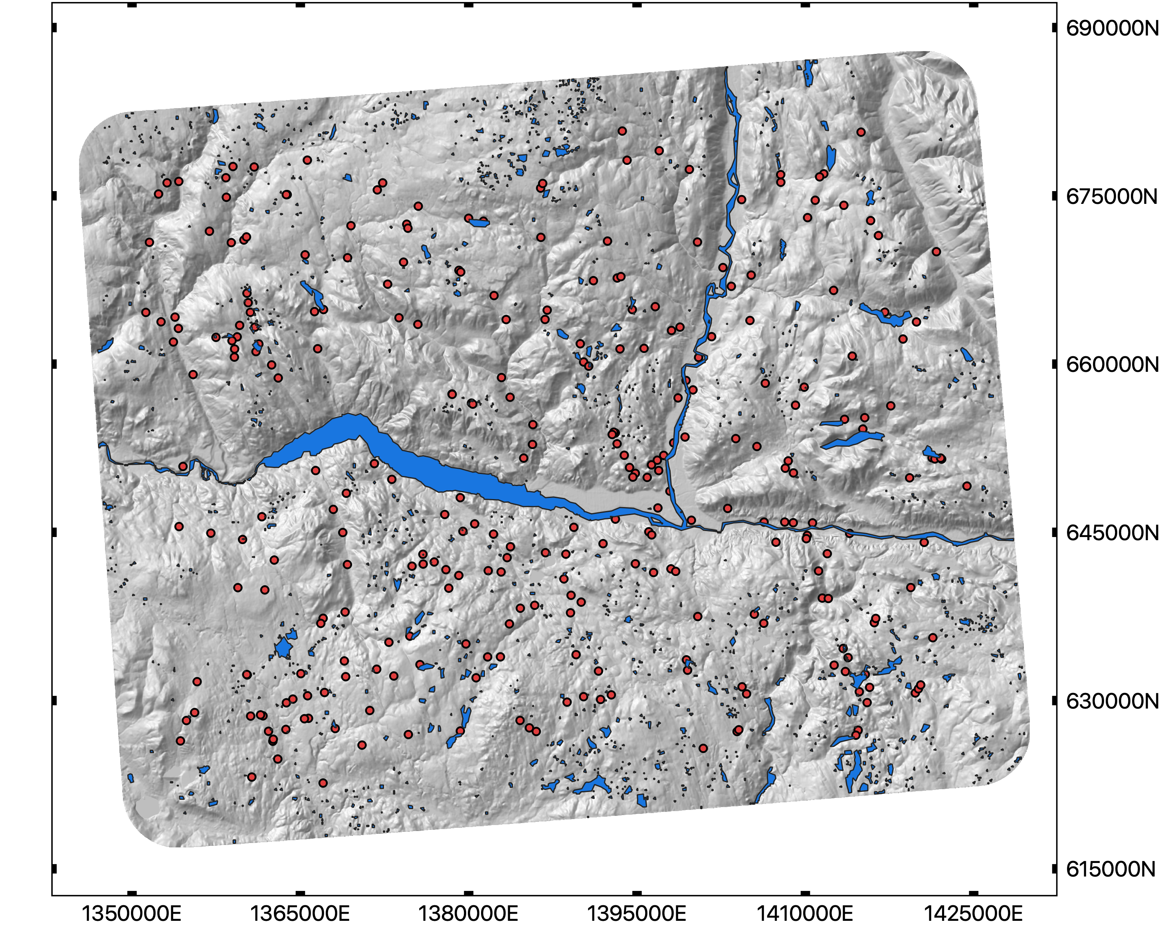
Kamloops
Figure 4.1. Study area in the Thompson-Okanagan region, BC (1:25000 Map grid, composed of map sheets: 92I090, 92I010, 92I150, and 92I160). The UTM coordinats are cooresponding with UTM zone 2 ).

r

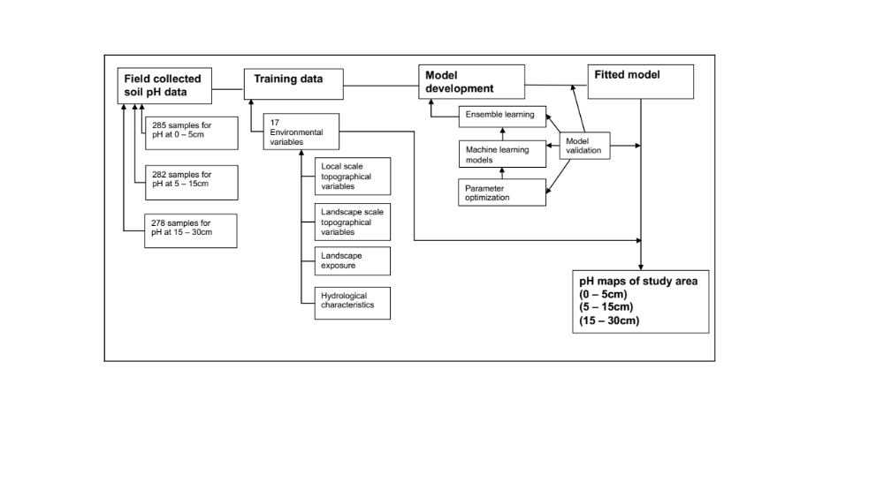
Figure 4.2. The simplified workflow of research processes for predicting soil pH (0 – 5cm), pH (5 – 15cm), and pH (15 – 30cm) in the Thompson-Okanagan region. The output map is in 25m raster format.

Figure 4.3. Mean 10-fold cross-validation error rate (RMSE) for varying number of decision trees (ntree) during parameter tuning to optimize the model performance in RF learner with 170 scenarios for pH at 3 depth intervals.

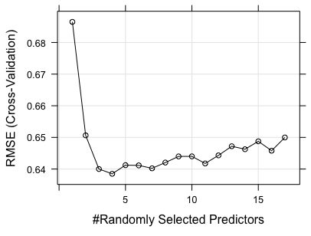  - pH(0 – 5cm) | 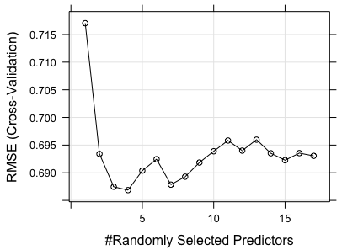  b) pH(5 – 15cm)
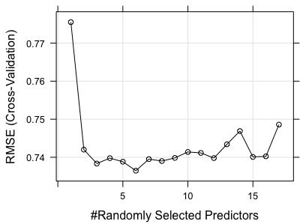
c) pH(15 – 30cm)
Figure 4.4. Mean 10-fold cross-validation error rate (RMSE) for varying numbers of predictors (mtry) were used at each split during parameter tuning to optimize the model performance in the RF learner with 170 scenarios for pH at 3 depth intervals.

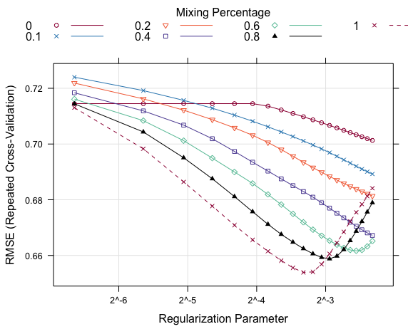  - pH(0 – 5cm) | 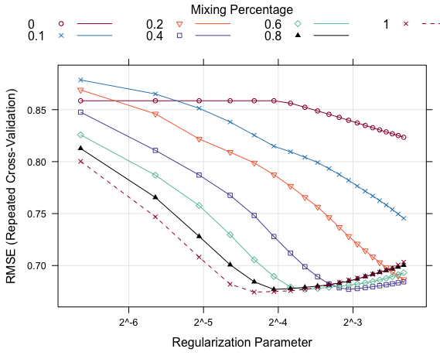  - pH (5 – 15cm)
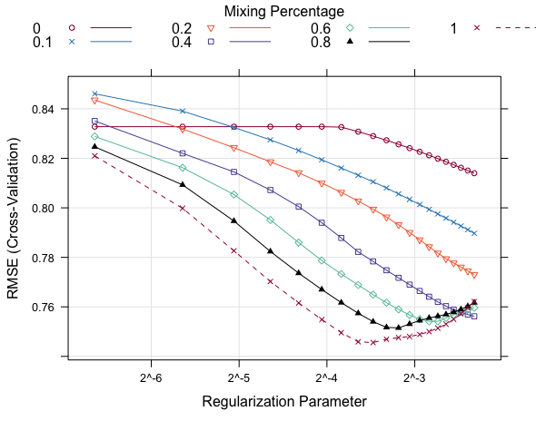
- pH(15 – 30cm)
Figure 4.5. Mean 10-fold cross-validation error rate (RMSE) during parameter tuning to optimze the model performance in GLMNET for pH value at three depth intervals. The parameter optimization was tested with several alpha values in 120 scenarios, and non-aggreated overall error rates were summarized as RMSE.

- pH value at (0 – 5cm) with SL_T | - pH value at (5 – 15cm) with SL_T
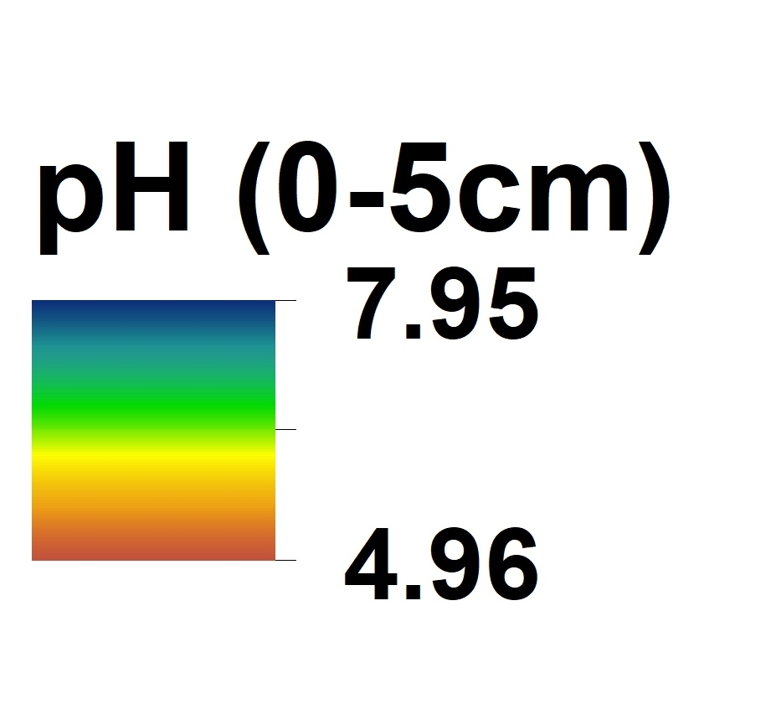  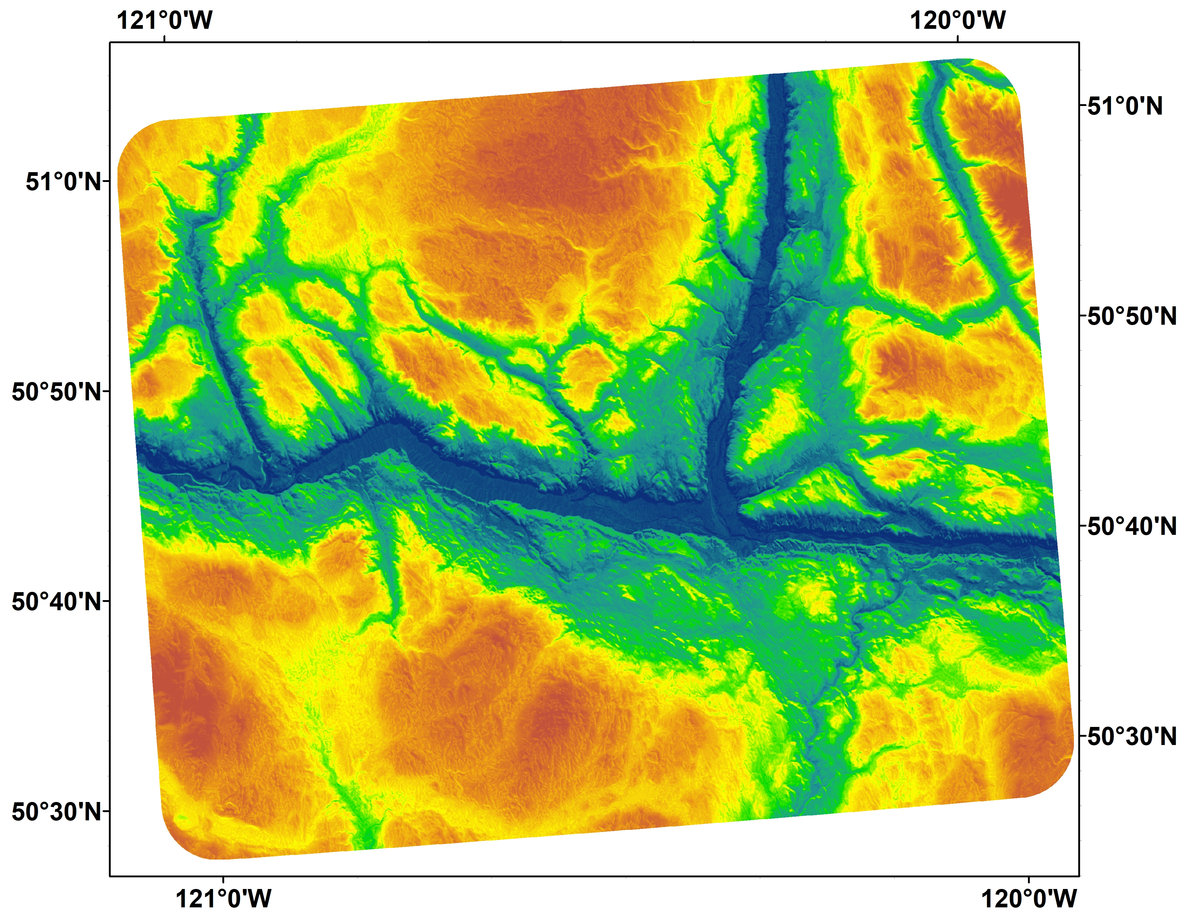 | 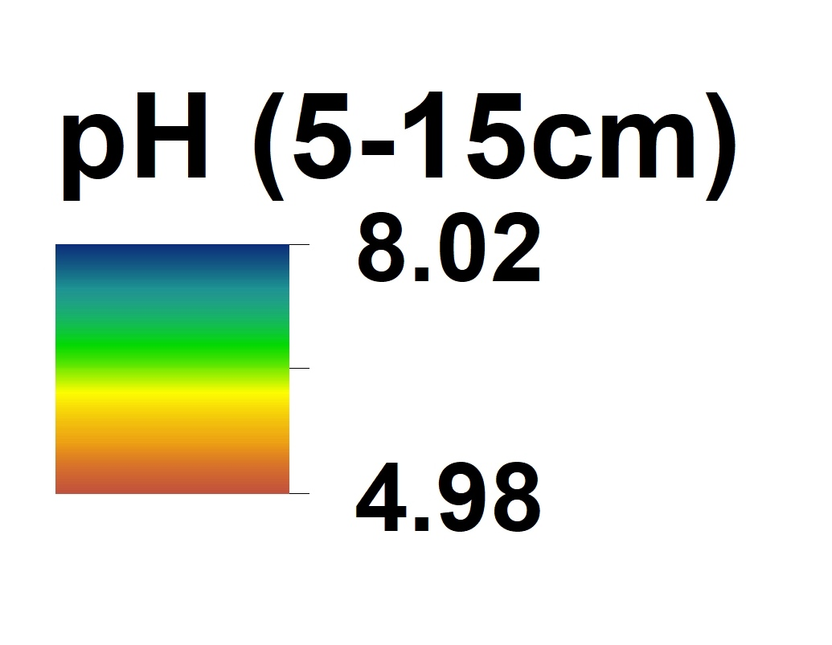  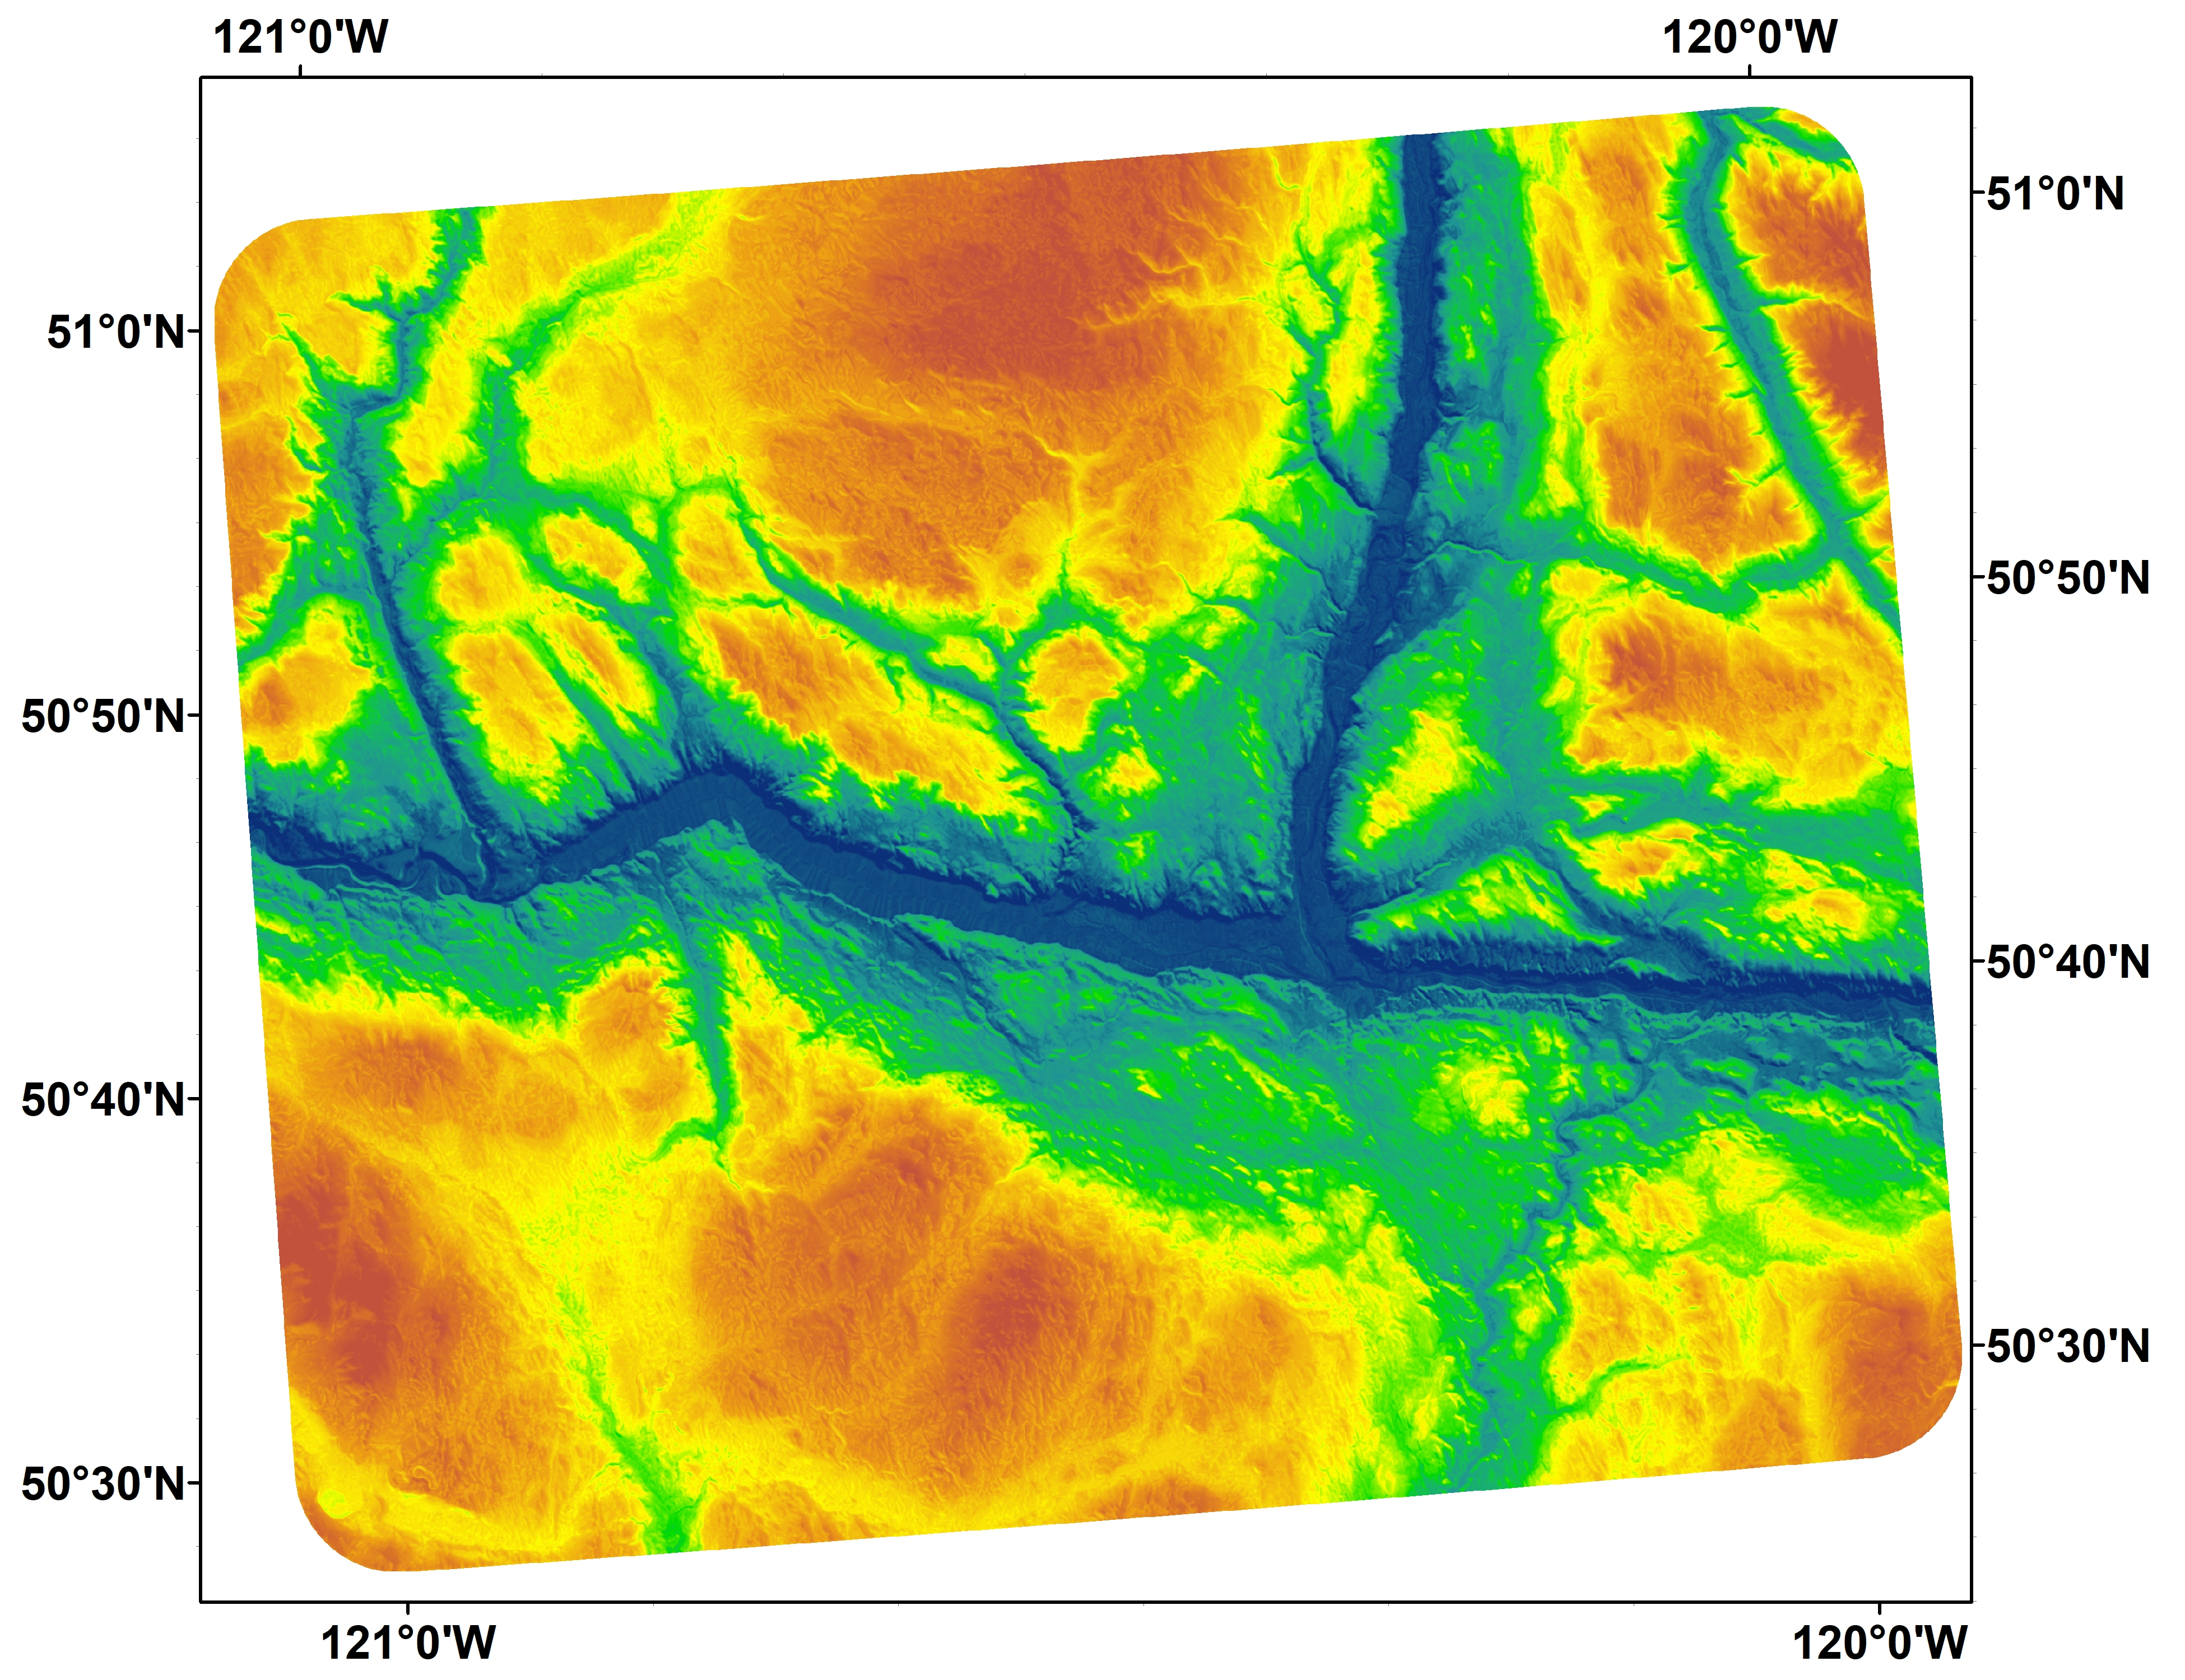
- pH value at (15 – 30cm)
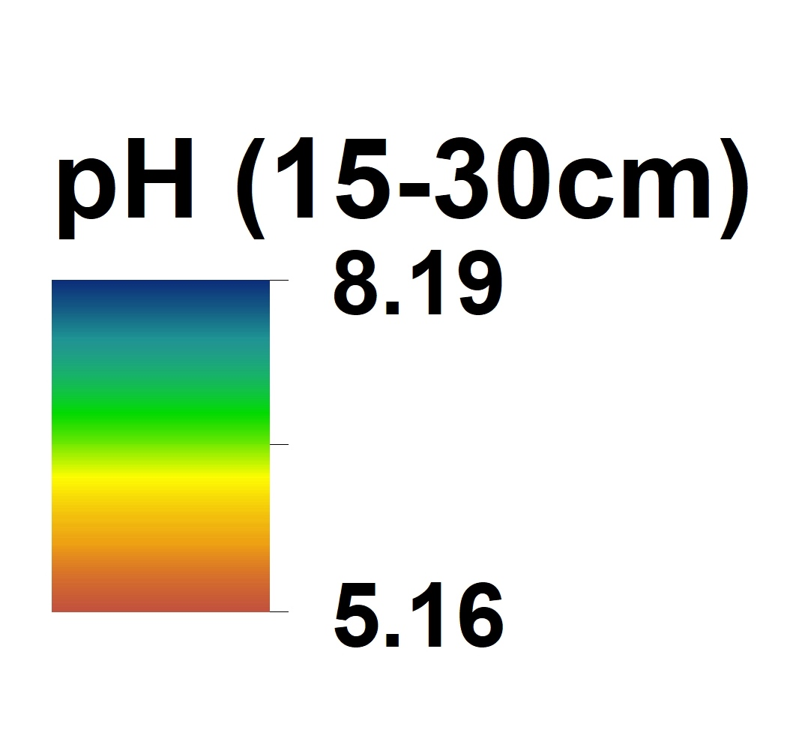
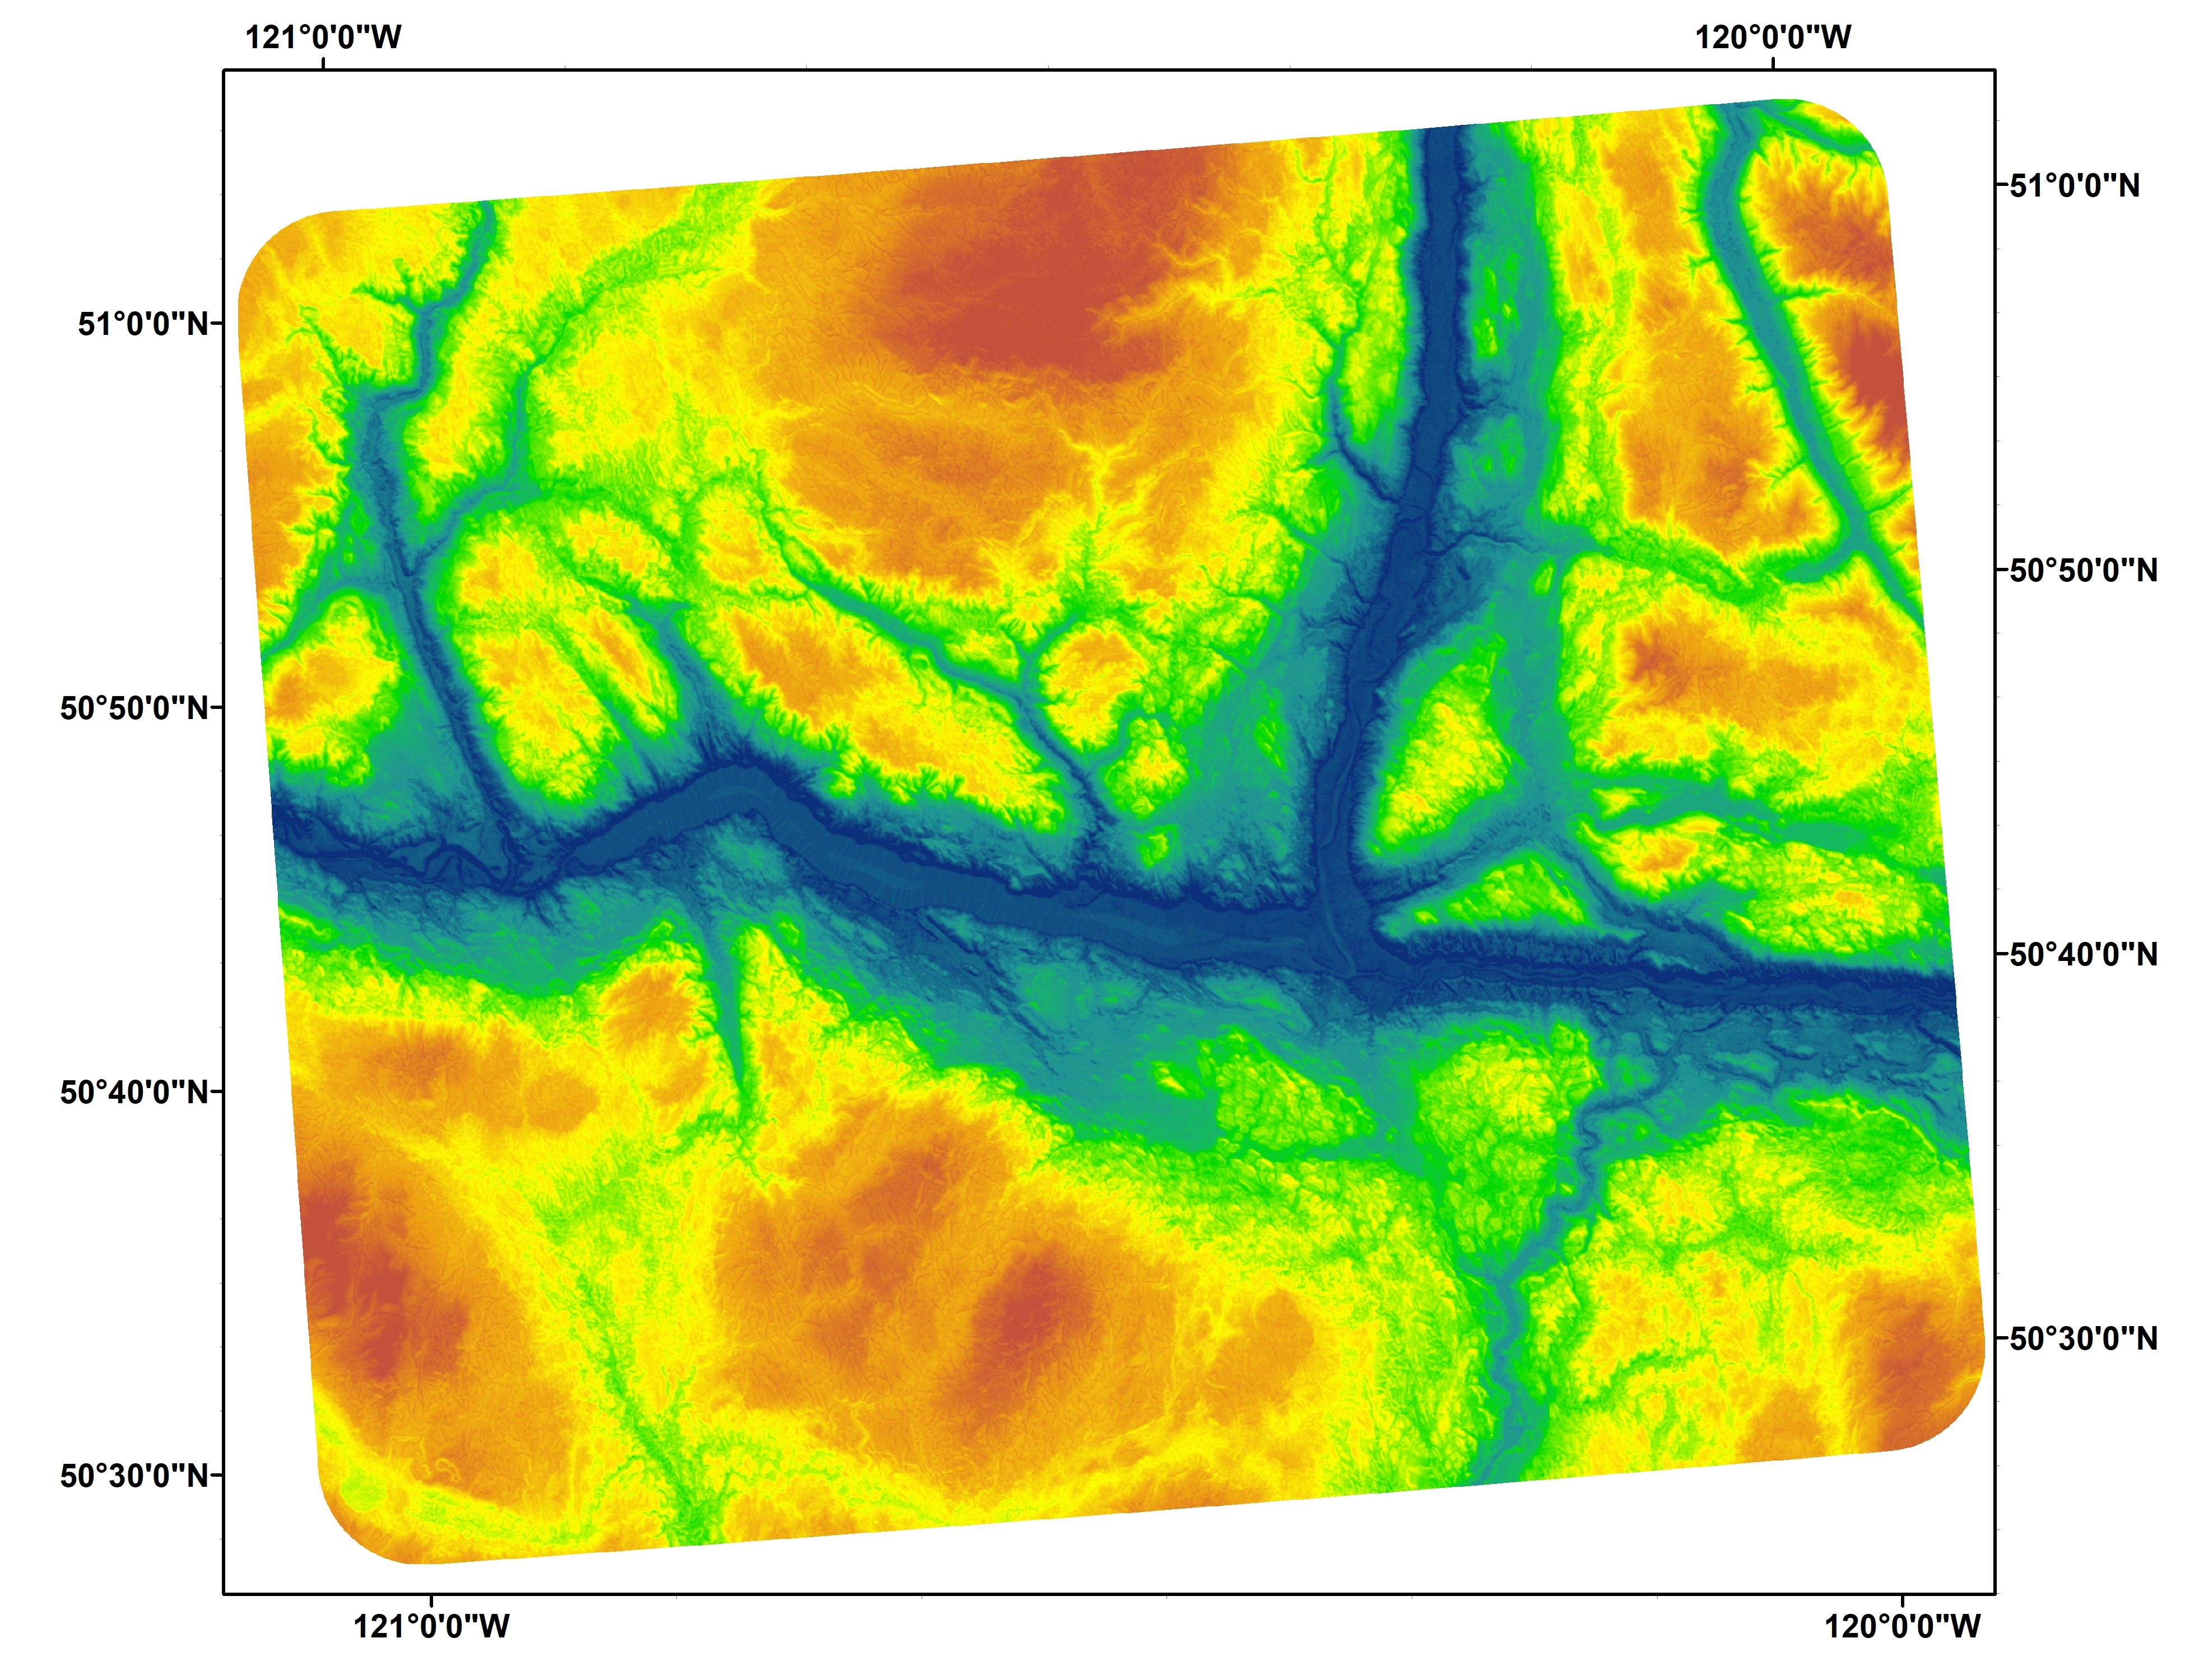
Figure 4.6. Predicted soil pH of 3 depth intervals in the study area with the optimized ensemble learning model (SL_T) .

References
Addiscott, T.M., 1998. Modelling concepts and their relation to the scale of the problem. Nutrient Cycling in Agroecosystems 50, 239 – 245.
Adhikari, K., Hartemink, A.E., Minasny, B., Kheir, R.B., Greve, M.B., Greve, M.H., 2014. Digital mapping of soil organic carbon contents and stocks in Denmark. PLoS One 9. e105519.
Arrouays D., McKenzie N., Hempel J., Richer de Forges A., McBratney A., (eds) 2014. GlobalSoilMap: basis of the global spatial soil information system. CRC Press, Leiden.
Avery, T. E., Burkhart, H. E., 1994. Sampling designs. In Duffy, A. C., Morriss, J. M., (eds). Forest measurements, 4th ed, McGraw-Hill, Boston, Massachusetts.
Beguin, J., Fuglstad, G.A., Mansuy, N., Paré, D., 2017. Predicting soil properties in the Canadian boreal forest with limited data: Comparison of spatial and non-spatial statistical approaches. Geoderma 306, 195 – 205.
Bennett, K.P., Campbell, C., 2000. Support vector machines: Hype or hallelujah? SIGKDD Explorations, 2(2). URL http://www.acm.org/sigs/sigkdd/explorations/issue2-2/bennett.pdf.
Bergstrom, D.W., Monreal, C.M., Jacques, E. St., 2000. Spatial dependence of soil organic carbon mass and its relationship to soil series and topography. Canadian Journal of Soil Science 81, 53 – 62.
Beyer, H.L., 2012. Geospatial Modeling Environment. URL: http://www.spatialecology.com/gme
Boehner, J., Antonic, O., 2009. Land surface parameters specific to Topo-Climatology. In Hengl, T., & Reuter, H.I., (eds). Geomorphometry – concepts, software, applications.
Brady, N.C., Weil, R.R., 2008. The nature and properties of soils. Fourteenth edition, Prentice Hall, Upper Saddle River, New Jersey.
Breiman, L., 1996. Bagging predictors, Machine Learning 26, 123-140.
Breiman, L., 1996b. Stacking regressions Machine Learning 24, 49-63.
Breiman, L., 2001a. Random forests, Machine Learning 45, 5 – 32.
Breiman, L., 2001b. Statistical modelling: The two cultures. Statistical Science 16 (3), 199 – 231.
Breiman,L., Friedman, J.H., Olshen, R.A., Stone, C.J., 1984. Classification and regression. Trees. Wadsworth, Belmont, CA.
British Columbia Ministry of Forests and Range and British Columbia Ministry of Environment. 2010. Field manual for describing terrestrial ecosystems, 2nd ed. Forest Science Program, Victoria, B.C. Land management Handbook No.25
Bui, E.N., 2004. Soil survey as a knowledge system. Geoderma 120, 17 – 26.
Bui, E.N., Moran, C.J., 2001. Disaggregation of polygons of surficial geology and soil maps using spatial modelling and legacy data. Geoderma 103, 79-94
Burrough, P.A., McDonnell, R.A., 1998. Principles of geographical information systems. Oxford University Press.
Canadian Agricultural Services Coordinating Committee. Soil Classification Working Group. 1998. The Canadian system of soil classification. 3rd ed. Agriculture and Agri-Food Canada. Ottawa. ON. Pub. 1646.
Ciampalini, R., Lagacherie, P., Gomez, C., Grünberger, O., Hamrouni, H.M., Mekki, I., Richard, A., 2013. Detecting, correcting and interpreting the biases of measured soil profile data: A case study in the Cap Bon Region (Tunisia). Geoderma 192, 68 – 76.
Crave, A., Gascuel–odoux, C., 1997. The influence of topography on time and space distribution of soil surface water content. Hydrological Processes 11, 203 – 210.
Dorigo, W.A. Zurita-Milla, R., de Wit, A.J.W., Brazile, J., Singh, R., Schaepman, M.E., 2007. A review on reflective remote sensing and data assimilation techniques for enhanced agroecosystem modelling. International Journal of Applied Earth Observation and Geoinformation 9, 165 – 193.
Evans, C. R. W., Krzic, M., Broersma, K., Thompson, D. J., 2012. Long-term grazing effects on grassland soil properties in southern British Columbia. Canadian Journal of Soil Science 92, 685 – 693.
Evrendilek, F., Berberoglu, S., Gulbeyaz, O., Ertekin, C., 2007. Modelling potential distribution and carbon dynamics of natural terrestrial ecosystem: a case study of Turkey. Sensors 7, 2273 – 2296.
Fang, X., Xue, Z., Li, B., An, S., 2012. Soil organic carbon distribution in relation to land use and its storage in a small watershed of the Loess Plateau, China. Catena 88, 6-13.
Farstad, L., Drewry, N.T., 1978. Soil and land utilization surveys prior to 1965. in Valentine, et al. (ed.) Soils landscapes of British Columbia. BC Ministry of Environment, Resource Analysis Branch 197p.
Filippi, P., Cattle, S.R., Bishop, T.F.A., Odeh, I.O.A., Pringle, M.J., 2018. Digital soil monitoring of top-and sub-soil pH with bivariate linear mixed models. Geoderma 322, 149-162.
Fisher, R.A., 1936. The use of multiple measurements in taxonomic problems. Annals of Eugenics 7, 179 – 188.
Florinsky, I.V., 2012. Digital terrain analysis in soil science and geology. Langford Land: The Boulevard.
Friedman, J., Hastie, T., Tibshirani, R., 2010. Regularization paths for generalized linear models via coordinate descent. Journal of Statistical Software, 33(1). 1-22. URL. http://www.jstatsoft.org/v33/i01/.
Friedman, J., Hastie, T., Tibshirani. R., 2010b. glmnet: Lasso and elastic-net regularized linear models, R package version 1.1-5. URL http://CRAN.R-project.org/package=glmnet.
Gillies, R.R., Carlson, T.N., Cui, J., Kustas, W.P., Humes, K.S., 1997. A verification of the ‘triangle’ method for obtaining surface soil water content and energy fluxes from remote measurements of the Normalized Difference Vegetation Index (NDVI) and surface radiated temperature. International Journal of Remote Sensing 18-15, 3145 – 3166.
Grimm, R., Behrens, T., Märker, M., Elsenbeer, H., 2008. Soil organic carbon concentrations and stocks on Barro Colorado Island – digital soil mapping using Random Forests analysis. Geoderma 146, 120 – 113.
Grossman, R. B., Harms, D. S., Kingsbury, D. F., Shaw, R. K., Jenkins, A. B., 2001. Assessment of soil organic carbon using the U.S. soil survey. in Lal, R., Kimble, J.M., Follett, R. F., Stewart, B. A., (eds.) Assessment methods for soil carbon, Lewis Publishers, Boca Raton, FL. pp. 87 – 104.
Hastie, T.J., Tibshirani, R.J., 1990. Generalized additive models. Chapman and Hall/CRC, London.
Hastie, T.J., Pregibon, D., 1992. Generalized linear models. In Chambers, J.M., Hastie, T.J., (des) Statistical models in S. chapter 6, Wadsworth & Brooks/Cole.
Hastie, T.J., Tibshirani, R.J., Friedman, J., 2001. The elements of statistical learning: data mining, inference and prediction. Springer Series in Statistics. Springer – Verlag, New York.
Hengl, T., Rossiter, D.G., Husnjak, S., 2002. Mapping soil properties from an existing national soil data set using freely available ancillary data. 17th World Congress of Soil Science, Bangkok, Thailand, August 14-21. Paper no. 1140.
Hengl, T., Heuvelink, G.B., Kempen, B., Leenaars, J.G., Walsh, M.G., Shepherd, K.D., Sila, A., MacMillan, R.A., de Jesus, J.M., Tamene, I., Tondoh, J.E., 2015. Mapping soil properties of Africa at 250 m resolution: random frosts significantly improve current predictions. PLoS One 10, 1-26.
Heung, B., Bulmer, C.E., Schmidt, M.G., 2014. Predictive soil parent material mapping at a regional-scale: A Random Forest approach. Geoderma 214-215, 141 - 154
Hofierka, J., Suri, M., 2002. The solar radiation model for open source GIS: implementation and applications. International GRASS users conference in Trento, Italy, September 2002. pdf.
Hudson, B.D., 1992. The soil survey as paradigm-based science. Soil Science Society of American Journal 56, 836 – 841.
James, G., 2013. An introduction not statistical learning: with applications in R, ………..
Jenny, H., 1941. Factors of soil formation. A system of quantitative pedology. New York: McGraw Hill.
Joint research centre: GIS solar radiation database for Europe and solar radiation and GIS.
Karatzoglou, A., Smola, A., Hornik, K., Zeileis, A., 2004. Kernlab-An S4 package for Kernel methods in R. Journal of Statistical Software, 11(9).
Kalra, Y.P., Maynard, D.G., 1991. Methods manual for forest soil and plant analysis. Forestry Canada Information Report NOR-S-319. Victoria, BC. (pp31, pp25,pp42)
Kern, J.S., 1995. Evaluation of soil water retention models based on basic soil physical properties. Soil Science Society of American Journal 59, 1134 – 1141.
Kern, J.S. 1995. Geographic patterns of soil water-holding capacity in the contiguous united states. Soil Science Society of American Journal 59, 1126 – 1133.
Khaledian, Y., Brevik, E.C., Pereira, P., Cerdà, A., Fattah, M.A., Tzaikeh, H., 2017. Modelling soil cation exchange capacity in multiple countries. Catena 158. 1994-200.
Klenner, W., Walton, R., Arsenault, A., Kremsater, L., 2008. Dry forests in the southern interior of British Columbia: historic disturbances and implications for restoration and management. Forest Ecology and Management 256 (10) 1711-1722.
Kuhn, M., 2008. Building predictive models in R using the caret package. Journal of Statistical Software 28: 1-26.
Kuhn, M., Weston, S., Keefer, C., Coulter, N., 2016. Cubist models for regression.
Kuhn, M., Johnson, K., 2013. Applied predictive modelling. Springer. New York.
Lan. Q., 1993b. Combining instance-based and model-based learning, Proceedings of the Tenth International Conference on Machine Learning (1993a) 236-243.
Lagacherie, P., Arrouays, D., Bourennane, H., Gomez, C., Martin, M., Saby, N.P.A., 2019. How far can the uncertainty on a Digital Soil Map be known?: A numerical experiment using pseudo values of clay content obtained from Vis-SWIR hyperspectral imagery. Geoderma 337, 1320 – 1328.
Legates, D.R., Mahmood, R., Levia, D.F., Deliberty, T.L., Quiring, S. M., Houser, C., et al. 2011. Soil moisture: A central and unifying theme in physical geography. Progress in Physical Geography 35, 65 – 86.
Levin, S.A., 1992. The problem of pattern and scale in ecology. Ecology. 73, 1943 – 1967.
Liaw, A., Wiener, M., 2002. Classification and regression by Random Forest. R News 2,18 – 22.
Lin, L. I. 1989. A concordance correlation coefficient to evaluate reproducibility. Biometrics 45, 255 – 268.
Lin, Y., Prentice III, S.E., Tran, T., Bingham, N.L., King, J.Y., Chadwick, O.A., 2016. Modelling deep soil properties on California grassland hillslopes using LiDAR digital elevation models. Geoderma Reg. 7(1), 67-75.
Lloyd, D., Angove, K., Hope, G., Thompson, C., 1990. A guide to site identification and interpretation for the Kamloops Forest Region. BC Ministry of Forest, Canadian Cataloguing in Publication Data. Research Branch Ministry of Forests, Victoria, BC.
Luttmerding, H.A., 1981. Soils of the Langley – Vancouver map area. Report No. 15, British Columbia soil survey. BC Ministry of Environment, Kelowna, B.C. Canada.
Luttmerding, H.A., Demarchi, D. A. Lea, E. C., Meidinger, D. V., Vold, T., 1990. Describing ecosystems in the field: second edition: MOE manual 11. Land Resource Research Institute. Canada.
Ma, W.H., Yang, Y.H., He, J. S., Zeng, H., Fang, J. Y., 2008. Above – and below ground biomass in relation to environmental factors in temperate grasslands, Inner Mongolia. Science in China Series C: Life Science 51, 263 – 270.
MacMillan, R.A., Moon,D.E., Coupé, R.A., 2007. Automated predictive ecological mapping in a Forest Region of B.C., Canada, 2001-2005. Geoderma 140, 353 – 373.
Markewitz, D. Nibbelink, N. P., West, L. T., 2012. A comparison of three field sampling methods to estimate soil carbon content.
McBratney, A.B., Mendonça Santos, M. L., Minasny, B., 2003. On digital soil mapping. Geoderma 117, 3 – 52.
McBratney, A.B., Odeh, I.O.A., Bishop, T.F.A., Dunbar, M.S., Shatar, T.M., 2007. An overview of pedometric techniques for use in soil survey. Geoderma 97, 293 – 327.
McConkey, B.G., Ulrich, D. J., Mellinger, M., 1996. Spatial variability of wheat yield, soil properties and erosion in hummocky terrain. Canadian Journal of Soil Science 74, 219 – 228.
Meidinger, D., Pojar, J., 1999. Ecosystems of British Columbia. Special report series No. 6. Ministry of forests research branch, Victoria, B.C. Canada.
Minasny, B., McBratney, A.B., 2006. A conditioned Latin hypercube method for sampling in the presence of ancillary information. Computers & Geosciences 32, 1378 – 1388.
Minasny, B., McBratney, A. B., 2007. Latin hypercube sampling as a tool for digital soil mapping. pp 253-163. in Lagacherie, P., McBratney, A. B., Voltz, M., (eds.). Digital soil mapping: An introductory perspective, Developments in soil science, Vol. 31. Elsevier, Amsterdam, The Netherlands.
Minasny, B., Hartemink, A.E., 2011. Predicting soil properties in the tropics. Earth Sci. Rev. 106, 52-62.
Minasny, B., McBratney, A.B., 2016. Digital soil mapping: A brief history and some lessons, Geoderma 264, 301-311.

Moore, R.D., Spittlehouse, D.L., Whitfield, P.H. Stahl, K., 2010. Weather and climate. p. 47- 84. in Pike, R.G. et al. (ed) Compendium of forest hydrology and geomorphology in British Columbia. B.C. Min. For. Range, For. Sci. Prog., Victoria, B.C. and FORREX forum for Research and Extension in Natural Resources, Kamloops, B.C. Land Management. Handbook. 66.
Moore, I.D., Gessler, P.E., Nielsen, G.A., Peterson, G.A., 1993. Soil attribute prediction using terrain analysis. Soil Science Society of American Journal 57, 443-452.
Moore, I.D., Grayson, R.B., Ladson, A.R., 1991. Digital terrain modelling: a review of hydrological, geomorphological, and biological application. Hydrological Processes 5, 3 – 30.
Mulder, V., De Bruin, S., Schaepman, M., Mayr, T., 2011. The using of remote sensing in soil and terrain mapping-a review. Geoderma 162, 1-19.
Neilsen, R.P., 1991. Climatic constraints and issues of scale controlling regional biomes. p. 31 – 35. In M.M. Holland et al. (ed.) The role of Landscape boundaries in the management and restoration of changing environments. Chapman and Hall, New York.
Noorbakhsh, S., Schoenau, J., Zeleke, T., Qian, P., 2008. Soil properties, yield, and landscape relationships in south-central Saskatchewan Canada. Journal of Plant Nutrition 31, 539 – 556.
Oke, T.R., 1998. Boundary layer climates. London, Taylor & Francis.
Paustian, K., Levine, E., Post, W., Ryzhova, I.M., 1997. The use of models to integrate information and understanding of soil C at the regional scale. Geoderma 79, 227 – 260.
Pennock, D.J, Bedard-Haughn, A., Viaud, V., 2011. Chernozemic soils of Canada: Genesis, distribution, and classification. Canadian Journal of Soil Science 91, 719 – 747.
Pennock, D.J., Zebarth, B.J., De Jong, E., 1987. Landform classification and soil distribution in hummocky terrain, Saskatchewan, Canada. Geoderma 40, 297-315.
Poggio, L., Gimona, A., Brewer, M.J., 2013. Regional scale mapping of soil properties and their uncertainty with large number of satellite-derived covariates. Geoderma 209-210, 1-14
Polley, E.C., LeDell, E., Kennedy, C., Lendle, S., van der Laan, M., 2018. Super Learner Prediction, R package version 2.0-24. URL https://github.com/ecpolley/SuperLearner

Polley, E.C., van der Laan, M.J., 2010. Super learner in prediction. Working Paper Series 266 , Division of Biostatistics, University of California, Berkeley, URL http://biostats.bepress.com/ucbbiostat/paper266.
RuleQuest Research, 2000. Cubist. RuleQuest Research, Sydney, Australia.
SAGA Development Core Team, 2011. System for Automated Geoscientific Analyses (SAGA). Available at http://www.saga-gis.org/en/index.heml (verified 28 October, 2014)
Science Committee, 2015. Specifications tiered GlobalSoilMap products, 7 pp.
Schmidt, K., Behrens, T., Scholten, T., 2008. Instance selection and classification tree analysis for large spatial datasets in digital soil mapping, Geoderma 146, 138-146.
Segal, M.R., 2004. Machine Learning benchmarks and random forest regression. Technical Report. Center for Bioinformatics & Molecular Biostatistics papers, University of California, San Francisco, CA, USA:
Shahbazi, F., Hughes, P., McBratney, A.B., Minasny, B., Malone, B.P., 2019. Evaluating the spatial and vertical distribution of agriculturally important nutrients – nitrogen, phosphorous and boron – in North West Iran, Catena 173, 71 – 82.
Shary, P.A., Sharaya, L.S., Mitusov, A.V., 2002. Fundamental quantitative methods of land surface analysis. Geoderma 107,1 – 32.
Shawe-Taylor, J., Christianini, N., 2004. Kernel methods for pattern analysis. Cambridge University Press, Cambridge, UK.
Sinisi, S.E., Polley, E.C., Rhee, S.Y., van der Laan, M.J., 2007. Super learning: An application to the prediction of HIV-1 drug resistance. Statistical Applications in Genetics and Molecular Biology, 6 (1).
Simon, N., Friedman, J., Hastie, T., Tibshirani, R., 2011. Regularization paths for Cox’s proportional hazards model via coordinate descent. Journal of Statistical Software 39(5). 1-13. URL. http://www.jstatsoft.org/v39/i05/.
Sondheim, M., Suttie, K., 1983. User manual for the British Columbia Soil Information System, Volume 1, BC Ministry of Forest Publication R28 – 82053, Victoria, BC.
Soil Survey Staff. 2015. Illustrated guide to soil taxonomy, Version 2.0. USDA-Nature Resources Conservation Service. National Soil Survey Center. Lincoln. Nebraska. 3-24, 3-25.
Sprout, P.N., 1978. The Canada land inventory period 1965 – 1975. in Valentine, et al. (ed.) Soils landscapes of British Columbia. BC Ministry of Environment, Resource Analysis Branch. 197p.
Stum, A.K., Boettinger, J.J., White, M.A. Ramsey, R.D., 2010. Random Forests applied as a soil spatial predictive model in arid Utah, In Digital soil mapping: Bridging Research, Environmental Application, and Operation, Springer: 179 – 189.
Szatmάri, G., and Pάsztor, L., 2019. Comparison of various uncertainty modelling approaches based on geostatistics and machine learning algorithms.
Taghizadeh-Mehrjardi, R., Nabiollahi, K., Kerry, R., 2016. Digital mapping of soil organic carbon at multiple depths using different data mining techniques in Baneh region, Iran. Geoderma 266, 98-110.
Thompson, J. A., Kolka, R. K., 2005. Soil carbon storage estimation in a forested watershed using quantitative soil-landscape modelling. American Soil Science Society 69, 1086 – 1093.
Tu, C., He, T., Lu, X., Luo, Y., Smith, P., 2018. Extent to which pH and topographic factors control soil organic carbon level in dry farming cropland soils of the mountainous region of Southwest China. Catena 163. 204-209.
Pahlavan-Rad, M.R., Akbarimoghaddam, A., 2018. Spatial variability of soil texture fractions and pH in a flood plain (case study from eastern Iran). Catena 160, 275-281.
Polley, E.C., van der Laan, M.J., 2010. Super learner in prediction, U.C. Berkeley dividison of biostatistics working paper series. Working paper. Paper 266.
Umali, B.P., Oliver, D.P., Forrester, S., Chittleborough, D.J., Hutson, J.L., Kookana, R.S., Ostendorf, B., 2012. The effect of terrain and management on the spatial variability of soil properties in an apple orchard. Catena 93, 38-48.
van der Laan, M.J. and Dudoit, S. 2003. Unified cross-validation methodology for selection among estimators and a general cross-validated adaptive Epsilon-Net Estimator: Finite sample oracle inequalities and examples. Technical report 130, Division of Biostatistics, University of California, Berkeley, URL http://www.bepress.com/ucbbiostat/paper130/.
Vysotsky, G.N., 1906. On oro-climatic bases of soil classification. Pochvovedeni. 8, 3 – 4 (in Russian).
Walker, P.H., Hall, G.F., Protz, R., 1968. Relation between landform parameters and soil properties 1. Soil Science Society of America Journal 32 (1) 101-104.
Warrick, A. W., 1998. Spatial variability. In Hillel, D. (Ed.), Environmental soil physical, Academic press, San Diego, Calif. pp. 655 – 675.
Watson, K., 2007. Soil Illustrated – field descriptions, first edition. International Remote Sensing Surveys Ltd. Kamloops, B. C. Canada.
Wiesmeier, M., Barthold, F., Blank, B., Kögeo-Knabner, I., 2010. Digital mapping of soil organic matter stocks using random forest modelling in a semi-arid steppe ecosystem. Plant Soil 340, 7 – 24
Willmott, C. J., Matsuura, K. and Robeson, S.M., 2009. Ambiguities inherent in sums-of-squares-based error statistics. Atoms. Environ. 43, 749 – 752.
Wilson, J.P., Gallant, J.C., 2000. Secondary topographic attributes. In: Wilson, J.P., Gallant, J.C. (Eds.), Terrain Analysis – Principles and applications. Wiley, New York, pp. 87 – 132.
Wolpert, D., 1992. Stacked generalization. Neural Networks 5, 241-59.
Wood, J., 1996. The Geomorphological Characterisation of Digital Elevation Models. Ph.D. thesis, University of Leicester, UK. Available at: http://hdl.handle.net/2381/34503
Wysocki, D.A., Schoeneberger, P.J., LaGarry, H.E., 2004. Soil survey: a window to the subsurface. Geoderma 125, 167 – 180.
Young, G., Fenger, M.A., Luttmerding, H.A., 1996. Soils of the Ashcroft map area: report No. 26. British Columbia Soil Survey. Integrated Management Branch Victoria, British Columbia.
Zeraatpisheh, M., Ayoubi, S., Jafari, A., Tajik, S., Finke, P., 2019. Digital mapping of soil properties using multiple machine learning in a semiarid region, central Iran. Geoderma 338, 445-452
.
.

Conclusion

Thesis conclusion and contributions
This research focused on using a digital soil mapping approach to update the existing soil information in the Thompson-Okanagan region, which includes both categorical data and continuous data. Several aspects of soil mapping were discussed in various sections of this thesis. The outcome of the research included an updated framework to map categorical soil data from the existing soil polygon data, and an indication for the use of an ensemble learning approach to describe the spatial distribution of soil pH value. The extension of the research included the comparison of balanced sampling and imbalanced sampling when predicting categorical data and comparison of five machine learners when predicting continuous variables. In addition to the mapping processes, this research also established a soil survey plan to collect adequate field data within a limited time frame to accompany the growing need of the data mining processes in digital soil mapping.
In the first part of this study, 17 topographic variables were used with RF to map the spatial distribution of soil subgroups over three types of landscape units: grassland regions, transition regions, and dry interior forest regions. Random sampling, balanced sampling, and cLH sampling were applied to build three separate training datasets from the polygon data (part of objective 1). Three soil subgroup maps were produced and compared (objective 2). The results showed that the balanced sampling method, which selected an equal number of observations at each predicted category, out- performed the other two imbalanced sampling methods. Unfortunately, it is impossible to apply the total balanced sampling method in the unmapped area where there is considerable variation in topography. Two imbalanced sampling methods, such as random sampling and cLH sampling, were tested; cLH sampling had better performance than the random sampling method.
The application of digital soil mapping approach by using an RF classifier with a finer resolution digital elevation model (25 X 25 meters) allowed us to produce a soil class map with uniform resolution, that provided continuous coverage in the region. Parameter optimization is necessary although the implementation can be time-consuming for large datasets. Using an RF classifier also helps us to gain insightful knowledge of the relationship between soil classes and topographic variables. In drier climates and ecosystems, availability of water is the constraining factor for plant growth and eventually soil formation (Reference). The results confirmed that the most important environmental variable was channel network base level - a hydrological characteristic - which indicated that the hydrological factors were the primary soil formation influences in the region. The distribution and movement of water not only controls the distribution of vegetation, it also influences the spatial distribution of soil classes. The research provided an opportunity to investigate the different sampling designs further, and to take a closer look at the influence of the water component on the spatial distribution of soil classes.
The second part of this study presented the use of an ensemble learning algorithm to map the spatial distribution of soil pH at three depth intervals. The ensemble learning algorithm has been tested and examined within the field of medical research (Reference medical) and biochemical studies (Reference biochemical), with limited testing within the digital soil mapping field (Reference Hengl). This study examined the use of topographic indices to map the spatial distribution of soil pH, in the dry forest ecosystem of the Thompson-Okanagan region, BC. The soil data were collected during fieldwork in the summer of 2015, when 892 samples were collected from 290 soil pits. The pH values were tested by horizon and then converted into three depth intervals using the spline tool. The extended coverage of soil pH at three depth intervals provided the first full-coverage of soil pH in the area, and the workflow that was used can be further applied to map the spatial distribution of other soil properties in the area. As shown in the evaluation of variable importance, elevation and surface vegetation types had a strong influence upon the spatial distribution of soil pH value.
The research also demonstrated that using an ensemble learning algorithm with five base learners improved prediction accuracy by ??% at three depth intervals H1 (0-5cm), H2 (5-15cm), and H3 (15-30cm) (objective 3). The ensemble learning approach has shown considerable improvement of prediction accuracy when the prediction accuracy was poor from the single base learner approach, such as the study of spatial distribution of pH value in the depth 15 – 30cm. Additionally, when using a machine-learning approach in data analysis and prediction, model selection has been a challenge. This is especially difficult when more than two models show promising results in the preliminary study. The ensemble learning approach provided an option to combine the results from multiple learners to achieve better prediction accuracy. The process of manually combining several results requires experience and extensive computing power. The ensemble learning package in R provided a solution that allowed us to test many learners at the same time and to help us to select the learners. In the process of optimization of RF parameters and GLMNET parameters, this study found that parameter optimization had little effect in improving the overall prediction accuracy of SL; moreover, it was a time-consuming process. Also, GLMNET had the best prediction accuracy, and it is unlikely to overfit with unbalanced training data. The ensemble learning algorithm has improved prediction accuracy significantly compared to only using single learners.

Research limitations
While conducting the research, I experienced several challenges and limitations with regards to mapping practice and ground-based fieldwork. During the mapping practice, the limitations were mostly related to the different map scales from the soil legacy data, available sources of data to represent the environmental variables, lack of point data in the rural areas from previous soil surveys, and computational limitations of the modeling processes.
Soil legacy data from past soil surveys were used to build the training dataset with the result that soil information included in the polygon maps had significant influence on the predicted soil subgroup maps. The polygon maps defined the number of soil subgroups and the general spatial distribution of soil subgroups in the predictions. The previous soil surveys were conducted to collect information about soil productivity. They had intensive coverage near urban areas and major railways, at lower elevation, with smaller, more detailed polygons. The correlation between soil subgroups and environmental variables was better captured by the RF classifier in these regions, which resulted in more detailed predictions for these areas. On the other hand, the polygon map had coarse coverage in the higher elevation forest region, where the terrain changed drastically over a short distance, which was captured by the finer resolution DEM. As a result, the RF classifier had a higher error rate when it tried to capture the correlation between soil subgroups and environmental variables in the higher elevation forest region. Similar limitations also occurred for the polygons near the local streams and smaller water channels, where the localized topographic variation and micro ecosystem might not be captured in the training data because of the generalization of the soil polygon data.
In addition to the limitations derived from the polygon data, the environmental variables which were used for this study also had their own challenges and limitations. Seventeen environmental variables were used and all of them were derived from a 25-meter DEM. Although these 17 environmental variables were able to represent local scale characteristics, landscape characteristics, landscape exposure and hydrological characters, the representation of organisms, climatic variables, and parent materials were missing from both studies. Previous studies had shown successful results mapping soil pH and soil classes using topographic variables (Florinsky 2016); however, my study was focused on an area with Grassland and Dry forest ecosystems. In these drier climates, water availability is the main influence and can be described by the hydrological process related topographic variables, such as CHBL. In further studies, using vegetation variables such as the normalized difference vegetation index (NDVI) and enhanced vegetation index (EVI) would be suitable for measuring the ground vegetation coverage (reference), which would provide adequate measurement of surface biomass in both local scale and regional scale studies.

Future research
This research evaluated both balanced and imbalanced sampling methods that used soil legacy data and field collected observations to map soil classes at the regional scale. Secondly, this research developed a new workflow that used a well-developed R package to carry out a stacked ensemble learning approach to mapping continuous soil data at a regional scale. Studies were conducted in a transition landscape which varied from steppe grassland to dry forest. The area had been glaciated in the last 15,000 years, and it has heterogeneous topography. Especially in the dry forest region, there were various types of soil subgroups and variation in the soil pH values. The study on spatial distribution of soil pH showed that soil pH was around 7.5 near the valley basin in the grassland and around 5.5 near the mountain top in the forested area. Soil pH was also higher in 15 – 30cm depth, which was the result of leaching, seasonal fluctuation of the water table, and sodium-rich parent material. Vegetation indices should be considered for future studies. Mapping of surface vegetation and total biomass has shown promising results (Reference), and above ground vegetation can be refined and more precisely calculated with radar data at higher resolution, such as 1 meter. The detailed DEM shall be applied and further explored for areas with high terrain heterogeneity, such as areas near steep slopes.
The possibility of using a combination of several classifiers, additional environmental variables, and processes to reduce noise should be included in future studies of soil classification. In this soil classification study, the use of 25 m resolution helped us to gain understanding of the spatial distribution of soil subgroups, but this study only evaluated the predictions from an RF classifier. Therefore, additional comparison of other types of classifiers should be included in further research. Future studies could also be focussed on including vegetation variables and climate variables. Fuzzy boundaries between different types of landscape units made it hard to differentiate the landscape regions, creating some noise along the boundary regions. The application of remote sensing data can further help to reduce the noise along the boundaries.
Lastly, the next application of this dataset would be to focus on soil properties, such as cation exchange capacity, water holding capacity, and soil organic carbon stock, which are difficult and expensive to directly measure. However, these soil properties can be directly calculated with pedotransfer functions. Empowered with machine learners and an ensemble learning approach, the pedotransfer functions can be extended to evaluate the non-linear relationship with massive multiple variables at different scales and various resolutions.

Thesis contributions
The research conducted for this thesis was the first to use an ensemble learning approach in order to map a continuous soil property (soil pH) on the regional scale in Thompson-Okanagan region, British Columbia, Canada. This study is unique in using only topographic variables, which can be easily obtained by using open source software such as SAGA with DEM. Legacy data from BCSIS were used to develop inputs to map the soil subgroups in uniform map units at 25-meter resolution. The use of this data source illustrates an example of extended usage of previous collected data, which reduced the amount of fieldwork required for such an area, and therefore I suggest that further studies in British Columbia should take advantage of BCSIS as much as possible.
Using an ensemble learning approach proved to be a powerful tool for mapping both categorical data and continuous data. Previously in DSM, choosing and selecting the best model had always been a challenging and stressful process. Manually composing an ensemble approach required extensive experience in computation and statistical analysis, whereas using the well-developed R package has allowed for a reduction in the extensive manual computations that typically would have been required for such selection of base learners. Additionally, current standards and practices can be expanded to other areas in DSM at various resolutions and scales. My approach of using soil legacy data from BCSIS and topographic variables drawn from DSM provides an avenue to extend the usage of soil surveys and practices that are available to improve the current standards in fieldwork and DSM methodologies.

References:
Florinsky, I.V., 2016. Predictive soil mapping. Digital terrain analysis in soil science and geology (second edition), Florinsky, I.V. (ed.) Academic Press, pg 287 – 311.
Bishop, T.F.A., McBratney, A.B., Laslett. G.M., 1999. Modeling soil attribute depth functions with equal-area quadratic smoothing splines. Geoderma 91, 27 -45.

Appendix A.
Using the field manual for describing terrestrial ecosystems to collect site observation and soil samples for DSM project in the Thompson – Okanagan region

Introduction
Fieldwork is a crucial step for collecting soil information in the process of soil mapping and soil surveying. Site observation and sample collection are the two major components. In previous soil surveys, the standard tally sheet and describing ecosystem sheet were used to collect site observations and soil pedon data in the Thompson – Okanagan region. Currently, soil mapping practice has shifted into the digital soil mapping phase, and the type of soil information collected and the tools to collect them in the field also have changed. Descriptions of the fieldwork need to be changed to meet the data requirements of the digital soil mapping approaches. With the use of new technology, handheld devices, and computer generated DEMs, the current fieldwork also includes using computers to generate the locations of the fieldwork, using handheld devices to find the location in the field, collecting a set of site observations which are carefully decided for this specific project, and collecting soil samples from individual designated horizons.

Location selection
Conditioned Latin Hypercube (cLH) sampling (Minasny and McBratney 2006) was used to select 300 field points based on the uniqueness of elevation, slope, aspect, vegetation coverage, and geology. To ensure accessibility of the field points, all the points were selected within 200 meters of the road network, which included paved, logging, and gravel roads. The initial request was for 300 locations. Ten of the locations were inaccessible and could not be sampled. Data were thus collected from 290 locations (3 exposed bedrock sites, and 287 soil pits).

Field observation and sample collection
Fieldwork was carried out in the summer of 2015. The fieldsheet used in the fieldwork (Table 3.3) was based on the Field Manual for Describing Terrestrial Ecosystems 2nd edition (2010). At each field site, site conditions were assessed based on readily observable surface conditions. Every field point had to meet two requirements to be selected for sampling. The first requirement was that each field point was representative of a 25 by 25-meter plot, which means the selected field point had the same type of vegetation, similar topographical conditions, and the same parent material as found in the plot. The second requirement was that the selected field point had no anthropogenic-related influence (such as harvesting, road construction, or tree planting) at the surface and within 0.5 meters from the mineral soil surface.
At each field point, the precise location was recorded with a GPS and information was collected in the following categories: soil pedon description, topographic description, and vegetation description (Luttmerding et al., 1990). The observation of topography included slope position, curvature class, and surface vegetation expression. Based on the Field Manual for Describing Terrestrial Ecosystems, 2nd Edition, slope position classes included slope toe, lower slope, mid-slope, upper slope, and crest (Luttmerding et al., 1990). Surface curvature was recorded as concave (CC) or convex (CV). Surface vegetation expression was recorded as grass (G), grass intermixed with forest (GF), or forest (F).
A soil pit was then excavated to a depth of approximately 50 cm from the mineral soil surface, to either a hardpan layer or bedrock, whichever occurred first. The range of thickness of the mineral horizons was between 5 and 20 cm. The range of total depths for the soil pits was 15 to 60 cm. Soil pedon description included designation of soil mineral horizons; field measured depth interval of every mineral horizon from the surface to the bottom of the soil pit, field assessment of gravel content, grain size (coarse, medium, and fine), and depth of the forest floor if it existed. One mineral sample was collected from each soil horizon in each soil pit. A field-based classification was assigned at the level of Orders based on the Canadian System of Soil Classification, and this field classification was refined to the level of subgroups based on the results from laboratory analysis (Canadian Agricultural Services Coordinating Committee 1998). By the end of the field season, 896 soil samples were collected from 290 field sites.
Since the organic soils only cover a small part of the study area, and the subtle difference between the various subgroups are very hard to differentiate in the field, all organic subgroups were merged into one category as organic (O). The eluviated horizons (Ae) were all very thin and thus were blended in with either Ah horizons or B horizons. All the Eluviated subgroups were thus merged in with the Orthic subgroups. The same principle applied to Chernozems, Luvisols, Gleysols, and Regosol. On the final map, there were three Chernozemic soils: Brown Chernozem, Dark Brown Chernozem, and Black Chernozem. Two Brunisolic soils were Eutric Brunisol and Dystric Brunisol. There were four Luvisolic soils: Podzolic Gray Luvisol, Brunisolic Gray Luvisol, Orthic Gray Luvisol, and Gleyed Gray Luvisol. There were two Regosolic soils: Regosol and Cumulic Regosol, and one Gleysol.
The point data collected from fieldwork were used as validation data points for modelling soil classes, and as training and validation data for modelling soil attributes. The soil samples were air dried, sieved, and tested for pH, OMC, and particle size distribution. The information recorded on the field sheet was summarized into a excel sheet.

Tables:
Location: |  |  | Sample NO. |  | Date
Site observation (1) | Elevation | Slope | Aspect | Vegetation
Site observation (2) | Terrain Type (PM) | Soil Drainage/Moisture Subclass | BEC moisture regime | BEC nutrient regime | Soil classification
Site observation (3) | Slope position | Curvature class | Surface expression | Rooting depth | Soil condition
Horizons | Designation | Depth interval (cm) | Coarse Frags % | Samples | Field texture
LFH
H1
H2
H3
Depth to BR
Note:
Pictures:

