TCC 2021 LANDSCAPE STEWARDSHIP CHECKLIST
(To identify potential issues of a proposed development with the BCTS TCC Area FSP and other consultative commitments)

Prepared by | Nona Phillips Forestry Consulting | Date | July 27, 2021
TSL Block/Road Name¹ | UBI / URI Number² | Planning Recce # ³ | Est. Gross Area (ha)⁴ | Est. Gross Volume (m³)⁵ | Road length  (m)⁶ | “Green” Stand Harvest⁷  (Y/N) | Stand Salvage Harvest⁸
TA1918_CAR-153 | Not assigned |  | 95.6 | 47,776 |  | Y | N
TA1918_CAR-155 | Not assigned |  | 42.2 | 21,127 |  | Y | N
TA1918_CAR-160 | Not assigned |  | 16.4 | 4,000 |  | Y | N
TA1918_CAR-162 | Not assigned |  | 62.5 | 17,184 |  | Y | N
TA1918_CAR-176 | Not assigned |  | 25.5 | 6,365 |  | Y | N
TA1918_CAR-177 | Not assigned |  | 14.1 | 3,886 |  | Y | N
TA1918_CAR-178 | Not assigned |  | 47.6 | 13,084 |  | Y | N
TA1918_CAR-180 | Not assigned |  | 29.5 | 9,506 |  | Y | N
Note: each individual block or road that is included in the landscape level check should be included as row item in the landscape checklist
1 TSL Block: if current multiphase eg. TA640/Blk 1 / Road naming convention follows Table 26: Acceptable Road Naming Convention from BCTS GIS Data Standard. www.for.gov.bc.ca - /ftp/TCC/external/!publish/Data_Standards/ArcGIS/Multiphase/Standard/
2 If available for blocks currently under multiphase
3 If available eg. (QU-105a)
4 BAI = Best available info not required for roads
5 BAI = Best available info not required for roads
6 Only for the access road sections to the block boundaries
7“Green” Stand is a stand that has less than 35% dead trees (due to insect, fire or windthrow. Conifer trees with green and/or red needles are considered live trees and will be classified based on pathological indicators. Standing or windfall trees with grey or no needles will be considered dead trees; except for mountain pine beetle attacked lodgepole pine where a tree with less that 5.0% of “red” needles will be considered dead.
8 e.g.: burn, windthrow, Pine beetle, etc.

Shape File Location: R:\General_User_Workspace\TCC PLANNING\!Referrals_shapes\Quesnel (Williams Lake)> new naming convention, PDF map for checklist (template – block shapes/roads), need to make sure it is linked to planned access, buffer shapes: roads 50m and blocks 100m buffer for shapes
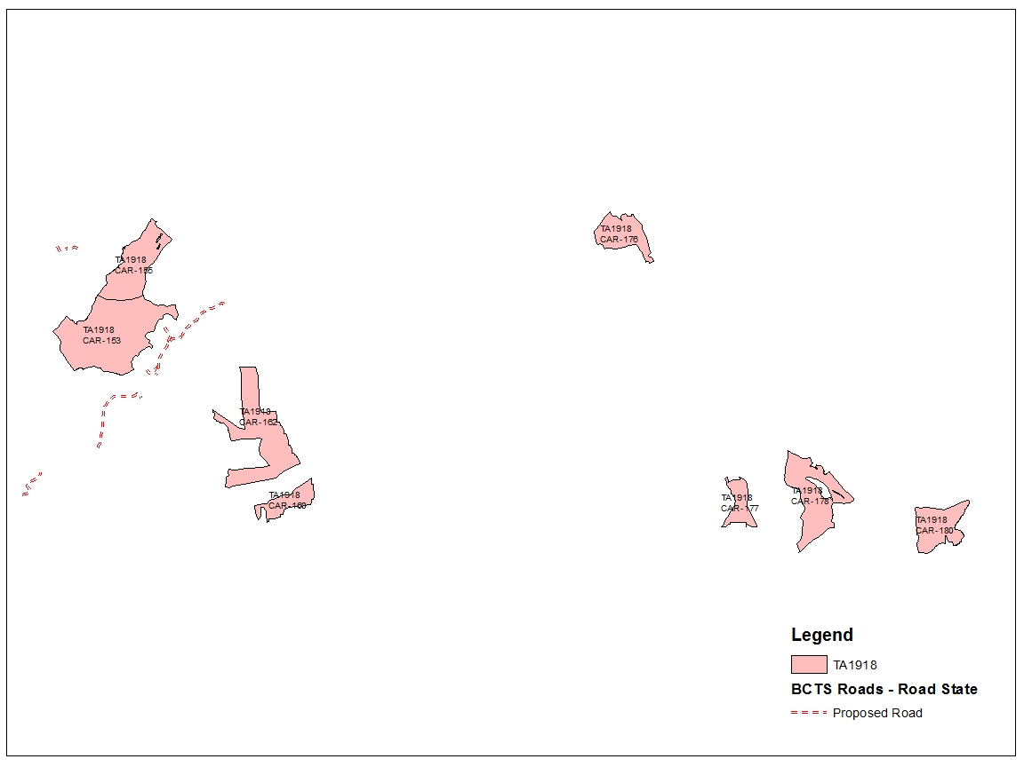

2020 FSP Objectives

Sec. 5.1 Soils
Permanent Access Structure Limits (FPPR, Sec. 36) and Key Road Issues¹ | APPLIES | DOES NOT APPLY
Additional permanent access structures necessary to provide access beyond the cutblock or key road issues |  | X
Comments:
¹adjacent to private land or requires access to private land show the lot#, show rd. status for rd. tributary to new road (wilderness road, road permit etc.)

Sec.5.2 - Timber
FPPR section 43.1 – Secondary Stand Structure | APPLIES | DOES NOT APPLY
Applies to “Targeted Pine leading Stands” within SBPS BEC Zone or FDU 1 West of the Nazko River & FDU 2 West of the Fraser River¹ |  | X
Comments:

Sec.5.3 Wildlife
Wildlife (General) (FSP, Sec.: 5.3.1 through 5.3.19) | APPLIES | DOES NOT APPLY
Proposed development adjacent to or overlapping with any “Wildlife Habitat Areas” Notices or habitat for the species listed in the FSP Table 4 | X
GIS Analysis Identified & listed in the FSP Table 4 Species at Risk (SAR) & “Red Listed” species
Mountain Caribou
Grizzly bear
Fisher
Click or tap here to enter text.
Note:
- For the above listed species identified through GIS data analysis and from the FSP Table 4 (e.g.: American Badger, White Pelican, etc.), FSP Strategies 3b / field observation and 3.d. will apply and a QRP assessment.¹
- For the above list of species record: if seen, or species used (i.e. dens, nests) or key habitat within the block or road, or the surrounding 25m of the boundary for a block or road a QRP field assessment is required.
- When an observation of wildlife species or wildlife use, or key habitat needs for species are not observed in the field, a record that it was not observed must be provided and kept on the proposed development records.
- GAR Order – Wildlife Habitat Areas link: https://www.env.gov.bc.ca/cgi-bin/apps/faw/wharesult.cgi?search=wlap_region&wlap=Cariboo
Comments:
See sections 5.3.14 Grizzly Bear and 5.3.17 Fisher.

The Route card identified that;
- all blocks overlap CDC Non Sensitive Area -Mountain Cariboo and Internal Use Wildlife Sensitive Incident Observations -Mountain Caribou.
- blocks 160, 162, 177, 178 and 180 are adjacent to (do not overlap) a Mountain Caribou WHA (no harvest) 5-106.
- block 180 overlap Cariboo Telemetry (species unknow)
- block 180 overlaps Internal Use Sensitive Survey Observation (species unknown)

Sec. 5.3.2 Moose
High Value Moose Wetland Management Zone (HVMWMZ) |  |  |  |  |  | APPLIES | DOES NOT APPLY
Proposed development adjacent to a key wetland. |  |  |  |  |  |  | X
Block # | Within 200m ^{*)} | Within 500m ^{*)} | Within 1km ^{*)} of HVMW | Road Density within 1km ^{*)} | Wetland is < 6ha | Initial Thermal % | Initial Security %
Comments:

Moose Management Unit (MMU)  (it’s different than HVMWMZ) |  |  |  | APPLIES | DOES NOT APPLY
Proposed development adjacent to a key wetland. |  |  |  |  | X
Block # | Within 100m^{*)} | Wetland < 6ha | Initial Thermal % | Initial Security %
Comments:

Check wetland layer spatial for accuracy with the VRI. Provide documentation for thermal and security cover calculation.
^{*)} Slope distance

Sec. 5.3.3 Mule Deer
Mule Deer (within FDU 1 - Ungulate Winter Range U-5-001 & FDU 2 - Ungulate Winter Range U-5-002.) | APPLIES | DOES NOT APPLY
Proposed development within or adjacent to Ungulate Winter Range  (location of winter range objectives and wildlife measures http://www.env.gov.bc.ca/wld/frpa/uwr/approved_uwr.html) |  | X
Mule Deer Winter Range snowpack zone:
Choose an item.
Mule Deer Winter Range habitat management zone:
Choose an item.
Overlap with Mule Deer Winter Range topographical buffer:
Choose an item.
Comments:

Sec. 5.3.4 Furbearers
Furbearers (General) | APPLIES | DOES NOT APPLY
Where harvesting removes > 50% of stand basal area in contiguous areas > 5 ha and within 100m of riparian area | X
Comments:
The wetland associated with block 1C was compared to the ortho photos and they are similar.

Block | Riparian Feature
153 | May be within 100m of an S4 stream (from the TCC Stream Class layer). The stream layer may not be accurate so the stream existence/location/class must be confirmed on the ground.
155 | May overlap the RMZ of an S4 stream (from the TCC Stream Class layer). The stream layer may not be accurate so the stream existence/location/class must be confirmed on the ground.
160 | May overlap the RMZ of an S4 and five S6 streams (from the TCC Stream Class layer). The stream layer may not be accurate so the stream existence/location/class must be confirmed on the ground.
162 | May overlap the RMZ of an S4 and S6 stream (from the TCC Stream Class layer). The stream layer may not be accurate so the stream existence/location/class must be confirmed on the ground.
176 | May overlap the RMZ and RRZ of an S3 stream (from the TCC Stream Class layer). The stream layer may not be accurate so the stream existence/location/class must be confirmed on the ground. (Also see section 5.3.14 Grizzly Bear Below)
177 | No riparian features within 100m.
178 | May overlap the RMZ and RRZ of an S3 and two S4 streams (from the TCC Stream Class layer). The stream layer may not be accurate so the stream existence/location/class must be confirmed on the ground. (Also see section 5.3.14 Grizzly Bear Below)
180 | May overlap the RMZ of an S4 stream, the RMZ of two S6 streams and within 100m of an S3 stream. (from the TCC Stream Class layer). The stream layer may not be accurate so the stream existence/location/class must be confirmed on the ground. (Also see section 5.3.14 Grizzly Bear Below)

A field assessment / verification needed. Fisher habitat additional piles may be required.

Sec. 5.3.14 – Grizzly Bear
Grizzly Bear Habitat | APPLIES | DOES NOT APPLY
Proposed development within or adjacent to grizzly bear habitat | X
Grizzly bear habitat capability areas:
Moderate
High
Very High

Comments: All blocks overlap high grizzly bear capability
Grizzly bear habitat feature adjacent to:
Stream S1, S2 and S3 Fish spawning reach
Grizzly bear habitat feature adjacent to critical fish habitat:
Yes
Comments:
Blocks 176, 178 and 180 are probably adjacent to an S3 stream but it is not known if the sections are spawning reaches.

Block 180 is adjacent to critical fish habitat (salmon/bull trout).

Blocks 155, 176 and 178 overlap critical fish habitat (salmon/bull trout).

Sec. 5.3.17 – Fisher
Fisher Habitat | APPLIES | DOES NOT APPLY
Proposed development adjacent to or overlapping known Fisher habitat | X
Blocks are located within Dry Forest Fisher Habitat Sub Boreal Moist Sub Boreal Dry
List which types apply in table
Comments:
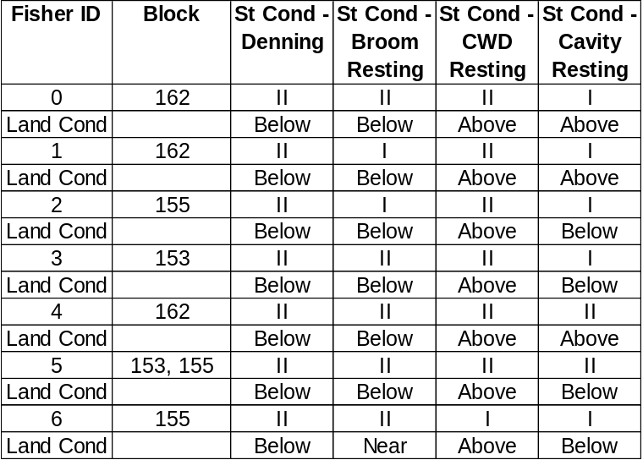
A field assessment / verification needed.

Sec. 5.3.18 and Sec. 5.3.19 Additional Species at Risk (SAR)
Additional SAR under GAR (Listed in Table 7 of FSP) | APPLIES | DOES NOT APPLY
Proposed development adjacent to or overlapping known species at risk. |  | X
GIS Analysis Identified & listed in the FSP Table 7 SAR & “Red Listed” species:
Click or tap here to enter text.
Click or tap here to enter text.
Click or tap here to enter text.
Click or tap here to enter text.
Comments:
See section 5.3 Wildlife

5.4 Riparian Areas

5.4.2 Streams, Wetlands and Lake Riparian Areas
Riparian classification, Riparian Reserve Zone and Riparian Management Area | APPLIES | DOES NOT APPLY
Proposed development is within or adjacent to the RRZ or RMA of lake or wetland. |  | X
The Lake Class from GIS analysis is identified as:
NA

The Wetland Class from GIS analysis is identified as:
NA

Comments:

Lakes with Lake Management Class (FSP Tables 8 and 9) | APPLIES | DOES NOT APPLY
Proposed development is within or adjacent to the management zone of a “Classified Lake”. |  | X
The Lake Class is:
N/A
Calculate the amount of forest disturbed area within the lakeshore management zone.
Comments: N/A
Proposed development is within 2000 metres of a wilderness fisheries lake |  | X
Comments: N/A

Sec. 5.5 Watershed Hydrology
Watershed Hydrology | APPLIES | DOES NOT APPLY
Proposed development is within the Key Watersheds. | X
Choose the Key Watershed identified:
Cariboo River
Identify the Key Watershed Sub-basin:
Blocks 176, 177, 178 and 180 are in the Seller Creek Sub-Basin.
Blocks 153, 155, 160 and 162 are in the Quesnel River Residual area.

The hydrological assessment for the Key Watershed sub-basin is

From the June 2021 Forsite ECA report:

Quesnel River Residual
0-10%
Seller Creek
0-10%
Provide supporting LBR report date.
G:\BCTS\Planning\Land Base Reporting - LBR
Comments (what is ECA %?): See above

Sec. 5.6 Critical Fish Habitat
Critical Fish Habitat | APPLIES | DOES NOT APPLY
Proposed development is within 500m or adjacent to Critical Fish Habitat. | X
Comments:
Block 180 is within 500 m of critical fish habitat (salmon/bull trout).

Blocks 153, 155, 176 and 178 overlap critical fish habitat (salmon/bull trout).

Note: If Grizzly habitat see FSP Sec. 5.3.14, strategy 3(c)

Sec. 5.7 Blackwater Quality Fisheries Resource
Blackwater Quality Fisheries Resource | APPLIES | DOES NOT APPLY
Proposed development is within or adjacent to one or more of the Blackwater Quality Fisheries Resource |  | X
Comments:

Sec. 5.8 Salmon Watersheds
Salmon Watersheds | APPLIES | DOES NOT APPLY
Proposed development is within or adjacent to one or more of the following Salmon Watersheds:  Cariboo River | X
Proposed development is within 500m of the Fraser River or Chilcotin River
No
Proposed development overlaps with terrain class:

The following shows block overlaps with unstable and potentially unstable terrain:
Block | Terrain Category
153 | Potentially Unstable
155 | Potentially Unstable & Unstable
160 | NA
162 | NA
176 | Potentially Unstable
177 | Potentially Unstable
178 | Potentially Unstable
180 | Unstable

Requires terrain stability assessment:
Yes
Comments:

All blocks in this TSL overlap the Cariboo River Salmon Watershed.

Sec. 5.9 Fisheries Sensitive Watersheds
Fisheries Sensitive Watershed (FSW) | APPLIES | DOES NOT APPLY
Proposed development is within or adjacent to one or more of the Horsefly River Fisheries Sensitive Watershed. |  | X
Proposed development requires a Fisheries Sensitive Watersheds assessment
Choose an item.
Active Fluvial Unit (AFU) along fish-bearing stream and direct tributaries to fish bearing streams (based on an aerial overview or a field assessment needed) |  | X
Comments

5.10 Water in Community Watersheds & Licensed Waterworks
Community Watersheds | APPLIES | DOES NOT APPLY
Proposed development is within a Community Watershed:  N/A |  | X
Proposed development requires a Community Watersheds assessment
NA
Licensed Waterworks:
Comments:

5.11 Biodiversity

5.11.1 Seral Stage
Proposed Development Area Seral Stage Targets
Block # | Landscape Unit | Reporting Unit | Surplus MO (ha) | LBR Source Date: mm/yy
153 | Lower Cariboo | ICHwk4 | 1,113 | June 2021
155 | Lower Cariboo | ICHwk4 | 1,113 | June 2021
160 | Lower Cariboo | ESSFwk1 | 7,410 | June 2021
162 | Lower Cariboo | ESSFwk1 (90%) | 7,410 | June 2021
162 | Lower Cariboo | ICHwk4 (10%) | 1,113 | June 2021
176 | Lower Cariboo | ESSFwk1 | 7,410 | June 2021
177 | Lower Cariboo | ESSFwk1 | 7,410 | June 2021
178 | Lower Cariboo | ESSFwk1 | 7,410 | June 2021
180 | Lower Cariboo | ESSFwk1 | 7,410 | June 2021
Comments:
Seral Drawdown / Criteria for a harvest to be met: |  |  |  | APPLIES | DOES NOT APPLY
Proposed development is consistent with the most recent Seral Stage Analysis for this Landscape Unit and Reporting Unit. (FSP Table 13 Mature + Old Seral Targets apply) |  |  |  | X
Does the proposed development have the MO seral availability (not applicable to Roads):
Yes
Initial proposed criterion for Seral Drawdown:
Choose an item.
Proposed development is within Criterion A:
Choose an item.
If yes, provide recruitment area to offset Seral Drawdown, ensure its consistent with the recruitment area strategy in FSP section 5.11.1 Seral Stage. Provide recruitment area, VRI label, map, and shapefile, consult with Planning Forester:

Comments:
All blocks are in units with surplus Mature+Old area.

5.11.2 Spatial Distribution of Cutblocks, Landscape Connectivity and Species Composition
Block | Adjacent other Openings (Y/N) | Patch Size
153 & 155 | Y | Very Large
160 and 162 | Y | Very Large
176 | Y | Very Large
177, 178 & 180 | Y | Very Large

Patch Size
Landscape Unit | NDT |  | Small Patches HO¹ |  | Medium Patches HO | Large Patches HO | Recommendations from LBR report
Lower Cariboo | 1 |  | 0 |  | 0 | 818 | Group small and medium into large patches
Comments:
All blocks are adjacent to other openings creating ones that are in the very large category. There is still room in the largest category.

¹HO is Harvest Opportunity.
Proposed development is consistent with or trend towards the “Patch Size Target Ranges” outlined in FSP Table 15?
Yes
Comments:
Reference: Patch Size target ranges by NDT types, G:\BCTS\Planning\Land Base Reporting - LBR\LBR 2021June\Tables\20210622_Cariboo_LBA_Tables\Cariboo_Patch_and_Seral_Distribution_HarvestOpp_20210618.xlsx
NDT |  | Small |  | Medium |  | Large |  | Very Large
1,2,3b,4 |  | <40 |  | 40-80 |  | 80-250 |  | 250+
3a |  | <40 |  | 40-250 |  | 250-1000 |  | 1000+

Landscape Connectivity
Is there an established Connectivity Corridor?
Yes
All blocks are adjacent to (do not overlap) a connectivity corridor mapped in the Total Chance Plan.
Is the existing Connectivity Corridor consistent with the Natural Connectivity Characteristics Frequency in FSP Table 16?
Yes

If Connectivity Corridor does not exist or meet the objectives of FSP Table 16; establish Connectivity Corridor that maintains the natural connectivity characteristics in the area(s) of the proposed harvest:
NDT: 1 BEC Unit: ESSFwk1
NDT: 1 BEC Unit: ICHwk2, ICHwk4
Comments:
Species Composition
Key leading spruce stand located in one of the following CCLUP sub-unit management zones: Taseko Lake, Kluskus, Anahim Lake, Chezacut, Kleene Kleene, Eagle or Palmer Lake?
No
Comments:
Key leading deciduous stands located in the Quesnel or Beaver Valley CCLUP sub-unit management zones?
No
Comments:
Key leading aspen stands located in the Lower Blackwater CCLUP sub-unit management zone and Chilcotin Plateau (Taseko Lake, Kluskus, Anahim Lake, Chezacut, Kleene Kleene, Eagle or Palmer Lake CCLUP sub-unit management zones)?
No
Comments:
 | APPLIES | DOES NOT APPLY
Areas of “key leading spruce” or “key leading deciduous” or “key leading aspen” stands, should demonstrate in the Site Plan how these stands were considered in the design of “Wildlife Tree Retention Areas” (WTRA) for the proposed development. (FSP Sec. 5.11.2 Result/Strategy 4) |  | X

5.11.3 Old Growth Management Areas (OGMA)
OGMA | APPLIES | DOES NOT APPLY
Proposed development overlaps or is adjacent to:  Permanent OGMA-Static  Permanent OGMA-Rotating  Transitional OGMA | X
Primary forest activities can be authorised if one or more of the following criteria are met (refer to the FSP Sec. 5.11.3 Results / Strategies):
- Permanent OGMA-Static:
Choose an item
- Permanent OGMA-Rotating:
Choose an item
- Transitional OGMA
Choose an item
Choose an item
Comments:
Blocks 153 and 155 are adjacent (do not overlap) permanent OGMAs on their west boundaries.
Block 176 is adjacent (does not overlap) a permanent OGMA on its east boundary.
Blocks 177 is adjacent (does not overlap) a permanent OGMA on its north boundary.
Block 178 is adjacent (does not overlap) permanent OGMAs on its north and transitional OGMA on its south boundaries
5.11.4 Cariboo-Chilcotin Grassland Benchmark Area
Grassland Benchmark | APPLIES | DOES NOT APPLY
Proposed development within or adjacent to the “Grassland Benchmark Area”. |  | X
Comments:
The existing “Grassland Benchmark Area” spatial dataset is consistent with the ortho photography location of the actual grassland location?
No
Comments:

5.11.5 Mature Birch Retention
Mature Birch Retention | APPLIES | DOES NOT APPLY
Proposed development within or adjacent to the “Mature Birch Retention” within following landscape units:  Lower Cariboo | X
Comments:
Blocks 153 and 155 overlap mature birch stands. The VRI was checked to confirm the species composition (see birch map provided). Two of the stands that are in Mature Birch polygon CAR_27_4380 do not have birch according to VRI.

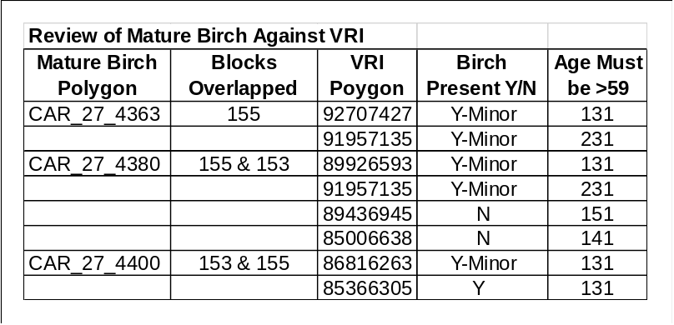

5.11.6 Wildlife and Biodiversity – Stand Level
Wildlife Tree Retention (WTR) Targets (FSP Appendix D or FSP Table 17) | WTR % | APPLIES | DOES NOT APPLY
Where harvesting removes > 50 percent of the pre-harvest merchantable stand basal area or where the harvest is part of a shelterwood silvicultural system, the minimum areas for WTR expressed targets set out in the FSP Appendix D or if FSP Results/Strategy 5 applies Table 17 targets will apply. | 10% for both units | X
Where harvesting removes < 50 percent of the merchantable pre-harvest basal area, ensure, to the extent practicable, that high value wildlife trees are retained up to the targets specified in the FSP Appendix D or if FSP Results/Strategy 5 applies Table 17 targets will apply. |  |  | X
Comments: N/A

5.12 Visual Quality
Scenic Areas | APPLIES | DOES NOT APPLY
Proposed development or access roads are within a scenic area with a Visual Quality Objective (VQO) polygon in a known scenic area. The visual quality objectives are  Preservation  Retention  Partial Retention  Modification  Maximum Modification | X
Scenic Corridors or High Elevation Viewpoints |  | X
Known significant public viewpoint from
Lake surfaces for a scenic area associated with a lake
River channel for a scenic area associated with a river
Existing tourism facilities and key tourist use areas
Existing tourism operations as defined in Section 5.13.1 Tourism
Points for highways deemed significant by a QRP
Points for parks and backcountry areas deemed significant by a QRP
Other viewpoints that are deemed significant by a QRP

Comments: Blocks 153, 155, 160 and 162 overlap a modification VQO polygon. A Viewshed Analysis in ArcGIS must be completed including map and spatial data. Planning forester will propose significant public viewpoints that will require validation in the field.

5.13 Recreation

5.13.1 Tourism
Commercial / Private Recreation Tenures | APPLIES | DOES NOT APPLY
Overlapping licensed commercial / private recreation tenure holders within 2 km of the planned development. | X
Comments:
All blocks in this TSL overlap two commercial recreation licences.
- Crown Land 5406691-Guided Nature Viewing
- Crown Land 5406975 -Multiple Use

5.13.2 Recreation Sites and Trails
Interpretive Forest Sites, Recreation Sites and Recreation Trails | APPLIES | DOES NOT APPLY
Recreation sites and trails within 100 m of the planned development.  (BCGW layer and appendix E) |  | X
What type
NA
Comments:
5.13.3 Backcountry
Backcountry | APPLIES | DOES NOT APPLY
Proposed development is within a backcountry polygon. | X
Known clubs, & tourism operations in the proposed development area | X
Blocks 153 and 155 overlap a backcountry polygon, associated with the Cariboo River, along their west boundaries.

5.13.4 Land Act Order Trails
Buffered Trails | APPLIES | DOES NOT APPLY
Proposed development contains or is adjacent to a buffered trail.  (maintain 50 metre management zones on either side and minimum basal area retention of 85%, except insect control, maintenance of recreational values and fire control…) | X
Yes
Comments:
A snowmobile trail pass just inside the west boundaries of blocks 153 and 155. The trail parallels the Cariboo River. The mapped trail follows what seems to be a trail opening on the ortho photo (see map attached to the landscape checklist)

5.13.5 Alexander MacKenzie Heritage Trail / Nuxalk-Carrier Grease Trail
Alexander Mackenzie Heritage Trail | APPLIES | DOES NOT APPLY
Proposed development is within the 100m buffer zone of the trail. |  | X
Within the “viewscape” of the Alexander Mackenzie Heritage Trail. |  | X
Proposed development is consistent with the Trail Management Plan. |  | X
Comments:
5.13.6 Wildcraft
Wildcraft | APPLIES | DOES NOT APPLY
Does known Access Management Plan apply? |  | X
Comments:
There is no known Government Access Management Plan for this area.

Quesnel Lake SRDZ – 30% roaded access
5.14 Cultural Heritage
5.14.1 Pine Mushrooms
Pine Mushrooms Area | APPLIES | DOES NOT APPLY
Proposed development is within or adjacent to a known pine mushroom area. (Anahim Lake Integrated Resource Management Zone) |  | X
Comments:

5.14.2 Community Areas of Special Concern (CASC)
CASC (no-harvest areas) | APPLIES | DOES NOT APPLY
Proposed development is adjacent or within to CASC.  (see exceptions in the FSP Sec. 5.14.2 Results / Strategies: insect control and interface fuel breaks) |  | X
Comments:

5.14.3 Cultural Heritage Resources (CHR)
Comments: If required, a CHR mitigation strategy will be provided to the timber team following the referral period.
5.15 Grazing – Maintenance of Animal Unit Months
Maintenance of Animal Unit Months
Comments:

6.0 Measures

6.1 Natural Range Barriers
Natural Range Barriers | APPLIES | DOES NOT APPLY
Proposed development overlaps or is adjacent within 200m of a natural range barrier. |  | X
Comments (after consultation with the District Range Agrologist):
6.2 Invasive Plants
Invasive Alien Plant Program | APPLIES | DOES NOT APPLY
Proposed development overlaps or is adjacent to an area identified by the “Invasive Alien Plant Program” (IAPP) or identified during primary field activities. |  | X
Comments
Landscape Level Constraints Outside of the Forest Stewardship Plan
Archeology and TUS
Archeological Potential | APPLIES | DOES NOT APPLY
Proposed development overlaps with high arch potential polygons. | X
Comments: As per the Provincial data (RAAD), all blocks except 160 and177 overlap with a “high archaeological” value polygon.
Traditional Use Data | APPLIES | DOES NOT APPLY
Proposed development overlaps or is adjacent to traditional use sites.
Comments (type of site, proximity):
Remote Access to Archaeological Data (RAAD) | APPLIES | DOES NOT APPLY
Proposed development overlaps or is adjacent to known arch sites in the RAAD database. |  | X
Comments (type of site, proximity):
As per the Provincial data (RAAD), the proposed development blocks do not overlap or are adjacent to the known traditional use sites (TUS).
Tsilhqot’in National Government letter dated October 2, 2013^{*)}
Tsilhqot’in National Government  (Request for questions to be addressed within future TNG referrals.) | APPLIES | DOES NOT APPLY
Proposed development is referred to Tsilhqot’in National Government or Yunesit’in Government.
Management of thermal cover for moose.
Management of moose vulnerability through security cover.
Management of moose vulnerability through access control.
Comments: TNG Zone A Consultative Area
^{*)}Link to TNG letter: G:\BCTS\Planning\!Referral - First Nations & Stakeholders\FN Consultation General\TNG

Migratory Birds Convention Act (1994)
Migratory Bird Nesting Habitat | APPLIES | DOES NOT APPLY
Proposed development adjacent to or overlapping a stand with the following migratory bird nesting habitat ranking of: | X
Comments:
Block | Rank
153 | 4&5
155 | 5
160 | 4
162 | 4
176 | 4
177 | 4
178 | 4&5
180 | 4

A field assessment needed.

Conservation Legacy Area^{*)}
Conservation Legacy Area | APPLIES | DOES NOT APPLY
Conservation Priority Rating and FSP 5.11.6 Results and Strategies: 6 |  | X
Comments: N/A
^{*)} “Quesnel Forest District Enhance Retention Strategy – for Large Scale Salvage of Mountain Pine Beetle Impacted Stands”,
Released 10, February 2006.
Link: https: //www.for.gov.bc.ca/ftp/dqu/external/!publish/matrix/PDF/DQU%20Enhanced%20Conservation%20Strategy-%20Release%201.pdf

TCC Landscape Connectivity Corridor
TCC Landscape Connectivity Corridor | APPLIES | DOES NOT APPLY
Proposed development within or adjacent to a landscape connectivity corridor. | X
Comments: See Section 5.11.2

Terrain Stability Class
Terrain Stability Class | APPLIES | DOES NOT APPLY
Review terrain stability overview data. Does the proposed block overlap terrain stability class 3, 4 or 5? | X
Comments: See Section 5.8

Baker Creek Watershed & Other of Interest Watersheds^{*)}
Baker Creek Watershed | APPLIES | DOES NOT APPLY
Proposed development is within Baker Creek watershed |  | X
Comments (describe sub-basin, aspect, elevation, above or below H60 line, conservation priority): N/A
*) Link to the 2010 Report Recommendations: G:\BCTS\Planning\Baker Creek Watershed\QU district final report Feb 2011\Baker Creek report recommendations follow up 2010[1].pdf
Permanent Sample Plots and Government Forest Research Installations
Permanent Sample Plots and Government Forest Research Installations * | APPLIES | DOES NOT APPLY
Proposed development adjacent to or overlapping known permanent sample plot or known forest research installation location. |  | X
Comments: N/A
Spatial location of known permanent sample plots and forest research installations can be found on the peaches drive at the following location: tcc_root\General_User_Workspace\TCC PLANNING\ResearchPlots
Guidance documents for overlap with permanent sample plot locations can be found on the G drive at the following location: G:\BCTS\Planning\Permanent Sample Plot Guidance

Stakeholders Status Check
Status Check to be Reviewed
Guide:
All blocks overlap guide tenure Iverson, Brian; 500954.
Trapper:
All blocks overlap trapper tenure TR0515T020.
Range:
No overlaps
Grazing Lease:
No overlaps
Recreation Clubs:
No overlaps
Tourism Operations:
All blocks overlap two commercial recreation licences.
- Crown Land 5406691-Guided Nature Viewing
- Crown Land 5406975 -Multiple Use
Licenced Waterworks:
No overlaps
Mineral:
Company | Tenure no. | Block | Type
SLUCHINSKI, EVAN REX | 508428 | 155 | Placer Cell Title Submission
ASHTON, THOMAS ANDREW | 1056797 | 155 | Placer Cell Title Submission
BZ MINERAL RESOURCES LTD. | 596986 | 155 | Placer Cell Title Submission
TITOSKY, DOUGLAS BRENT | 1023111 | 155 | Placer Cell Title Submission
SLUCHINSKI, EVAN REX | 1013880 | 155 | Placer Cell Title Submission
BELL, JOHN MALCOLM | 1077875 | 153&155 | Mineral Cell Title Submission
SLAUTIN, OLEKSANDR | 1028929 | 153&155 | Placer Cell Title Submission
KARUS GOLD CORP. | 519042 | 153 | Mineral Cell Title Submission
MANKE, DONALD GERALD | 1076540 | 153 | Placer Cell Title Submission
BREWER, JAMES DALE | 516594 | 153 | Placer Cell Title Submission
ZION MINERALS LTD | 1064689 | 153 | Mineral Cell Title Submission
MANKE, DONALD GERALD | 1083110 | 153 | Placer Cell Title Submission
ZION MINERALS LTD | 1065027 | 153 | Mineral Cell Title Submission
MANKE, DONALD GERALD | 1083112 | 153 | Placer Cell Title Submission
BARKER MINERALS LTD | 1070173 | 160, 162, 177, 178, 180 | Mineral Cell Title Submission

Private Land:
No overlaps
Road and Blocks:
Block | Tenure Type
 | FTEN Cutblock Poly
 | Forest Road Section R02156 24
 | Forest Cut Permits A20017 556

The Planning Forester and Practices Forester have reviewed and are aware of all information in this document:

Planning Forester: Date:
Print Name & Sign, RPF

Practices Forester: Date:
Print Name & Sign, RPF

Map Attachments:
☐ Moose Thermal
☐ Moose Security
☐ Moose Wetland Shape Comparison
☒ Fisher
☐ Furbearers Riparian Shape Comparison
☐ Riparian Shape Comparison
☐ LMZ Disturbance
☐ Grassland Benchmark Shape Comparison
☒ Mature Birch
☐ Viewshed
☒ Buffered Trails
☐ Pine Mushroom
☐ CASC
☐ Invasive Plants

