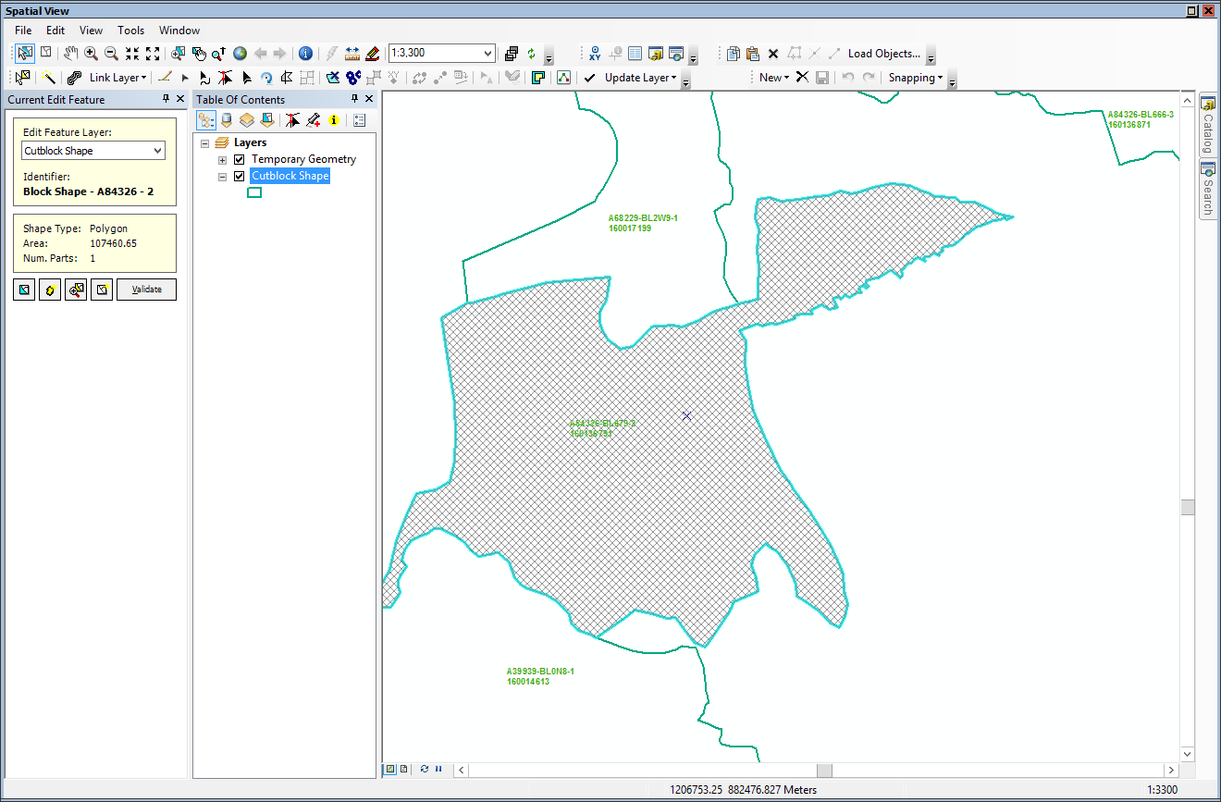
Select your block, send to Map View and Start Editing:

Shared Edit Tool is available in your Editing Commands (Land Resources Manager) toolbar as shown below in top red circle or in your Table of Contents as shown in blue circle below:
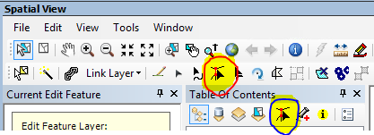

When you select Shared Edit Tool, the Table of Contents will switch from List by Drawing Order (red circle) to Shared Edit (blue circle) as shown below. You can read the instruction here on ‘shared editing’ (which didn’t work for me ).
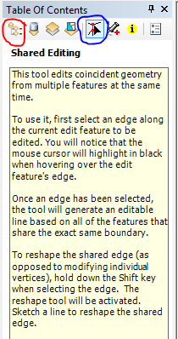

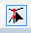
Make sure that have clicked on Shared Edit Tool
If not then click it again for goodness sake!

Click Shift and then select the edge of the block (edge/part of the block line that you want to edit).
As soon as you would do the above, Map View/LRM will start searching for all the layers that are associated with this block and share the common boundary/edge.

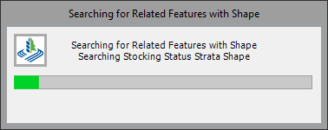

And you will see that it will list those layers in your table of contents’ Shared Edit window as shown below:
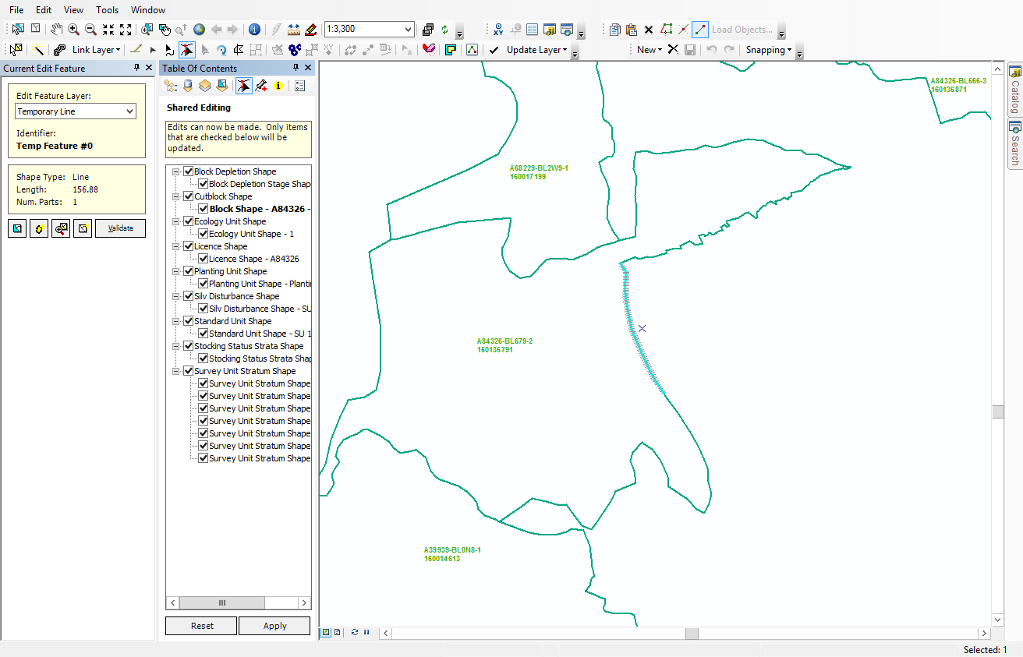

You will also notice that the edge that you selected earlier, will have a hatch line.
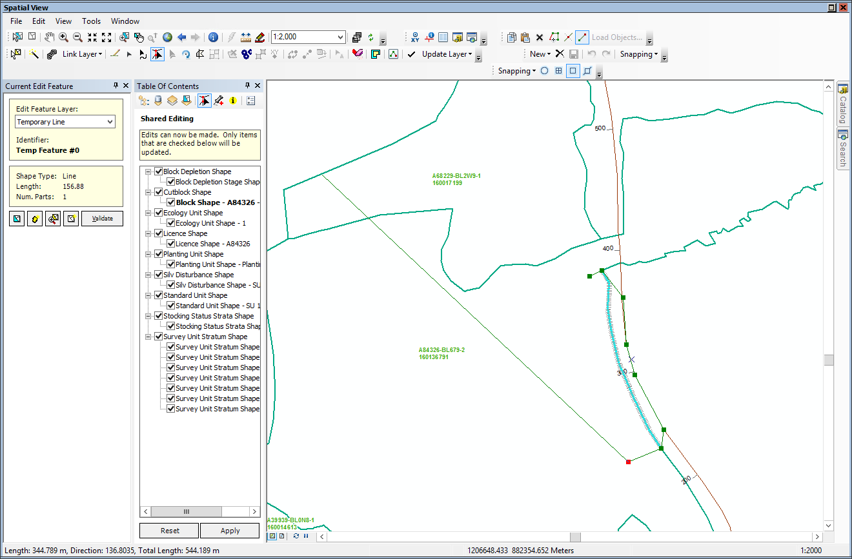
At this point, you can edit the edge as you wish. I added a Road feature and tried to follow it:

Then I double-clicked to finish drawing the line.
Click Apply as shown below in red circle
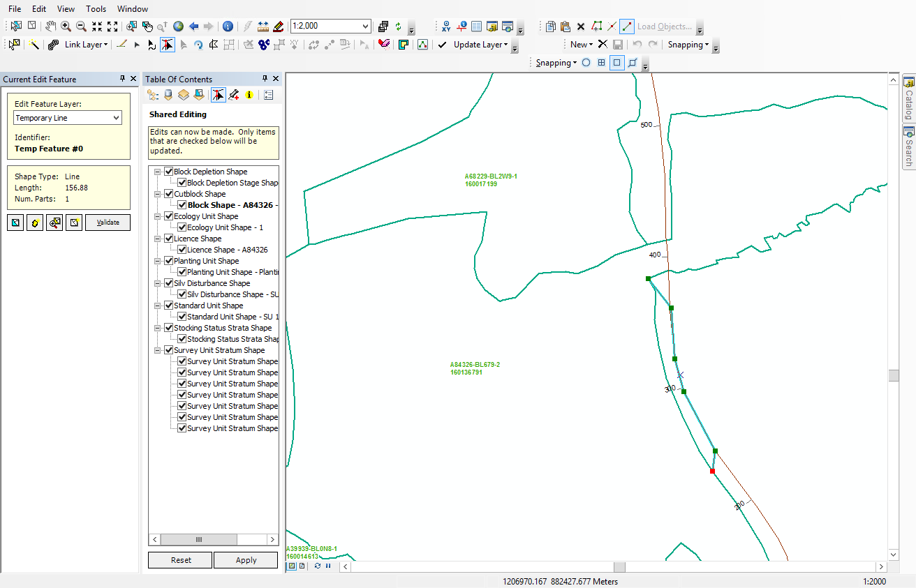


You will get a warning:
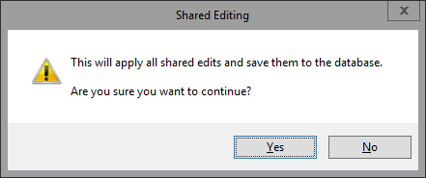

Click Yes because that’s what you wanted to do…right?
The Map View window will flash many messages; I was able to copy only one

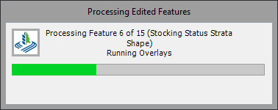

After several messages/quivering/shivering, your shared editing will be done. You can see in the image below that the block boundary as well as SU boundary (orange line) have been edited together.

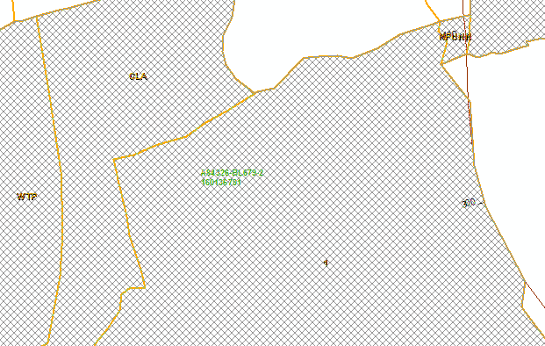

And it will update the area of all associated layer (I tested this in LRM TEST).

