Objective: To remove burnt area from TSL A94253 Block 4, and link modified shapes to tabular records:
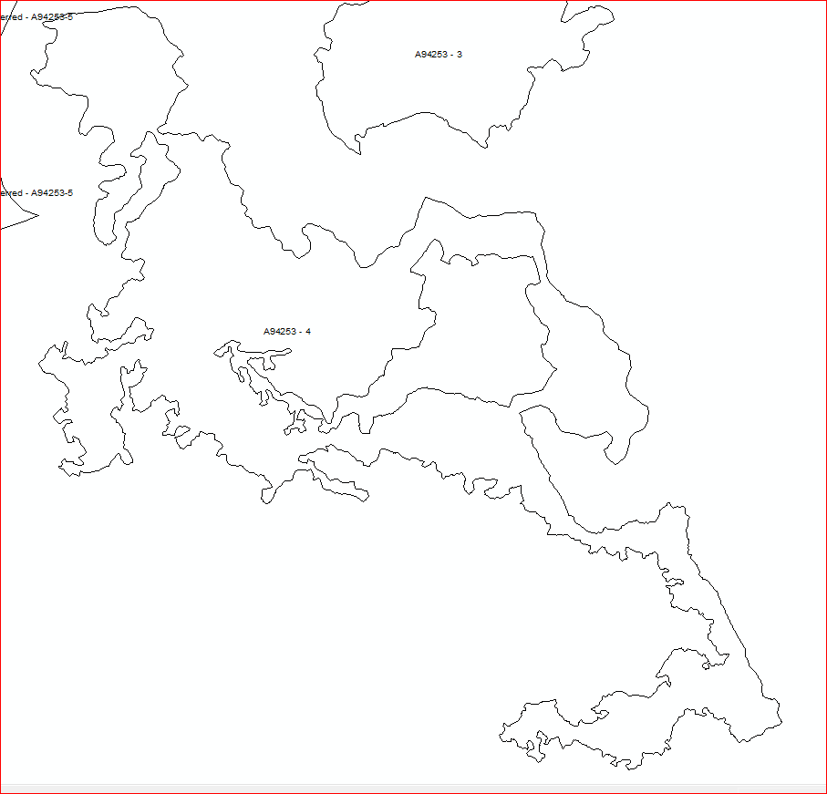
- Digitized a line along the burnt part to use it with ‘flatten tool’ for removing burnt area.
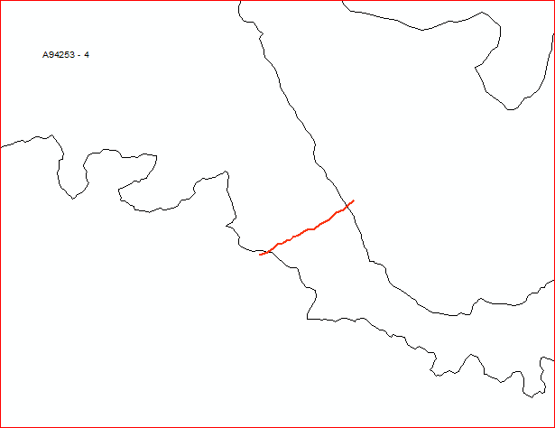

- On attempting to link shapes, a spatial validation error was thrown up, similar to the screenshot below (the error seen below is from a different block)
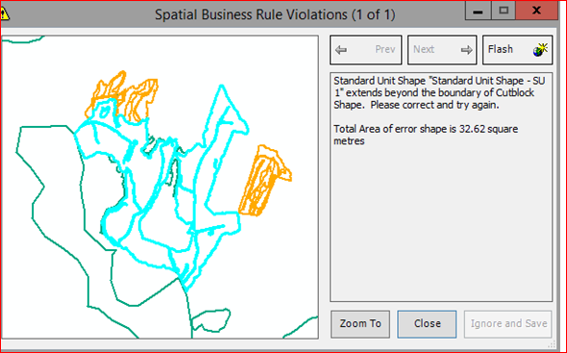
- This block did not have any topological errors in the Cengea Resources system. Topology checks had been previously run before data was migrated to LRM.
- To double-check this, I used ‘Erase’ tool to find the difference between Block and Standard Unit, and the output did not have any slivers or overlaps.
- Deleted all the linked shapes, and modified all the shapes in ArcMap (not in spatial view).
- Linked the modified block shape to ‘Cut Block shape’.
- Clipped the other shapes to this new block boundary and tried to link the remaining shapes (Standard unit, ecology etc), but the Spatial business rule violation error was seen again.
- Under Tools > Options > Spatial View > Tolerance, I changed the Sliver polygon size from the default of 10 square metres to just above the error value, which was around 21 square metres after the block shape was modified.
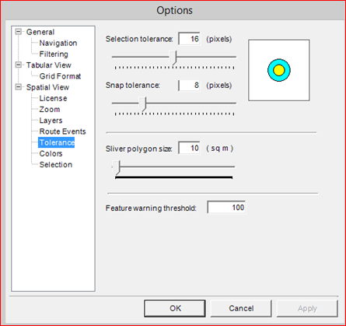
- After this I was able to link all the shapes of this block to tabular records.
- Final block shape:
