TA0904 Pre-Work Notes
This is an FPOC sale, thus a Conformance Certificate, signed by a RPF or RFT that confirms all primary forest activities conducted under this license are consistent with the FSP R&S applicable to this license.
- A copy of the certificate is provided on the last page of the TSL document.

301- RGM SAFE certification expires December 4th, 2022

304/312 Safety issues associated with the timber sale license:
- Harvest areas in blocks 1 & 2 slopes >35%.
- During the Covid-19 outbreak, forestry industry employers are reminded of Work Safe BC and BC Forest Safety Councils guidance to prevent exposure in the workplace. Refer to the TSL Highlights documents for links to the websites.
- This TSL has been damaged by wildfire of varying severity. In areas of greater burn severity, tree roots have been burnt out rendering trees highly unstable. There is a high hazard of sudden tree fall. Workers are to stay in machinery when working in such areas. Do not take breaks out of equipment in highly damaged areas. Monitor winds as risk of tree fall increases with increasing wind speeds.
- Large boulders may present a rolling hazard to workers on steeper terrain.
- Areas of heavy windthrow occur in the TSL as result of fire damage. An area of concern is noted on the harvest plan map indicating an area of severe blowdown, Machinery must work carefully in this area as there may be unknown watercourses underneath.
402/ 1205 The blocks have the following reserve stems: REFER TO HARVEST PLAN FOR MORE INFO

Block 1

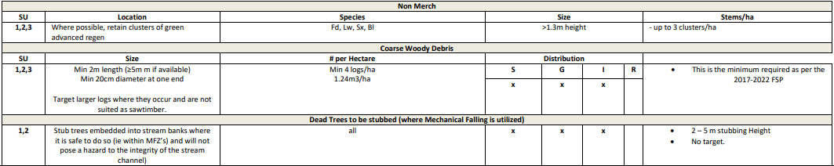
Block 2
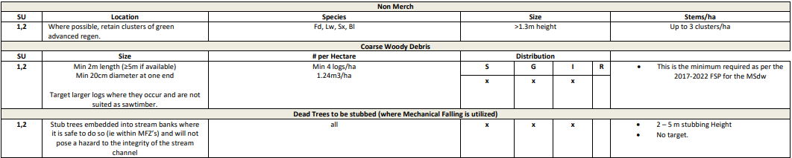
Block 3
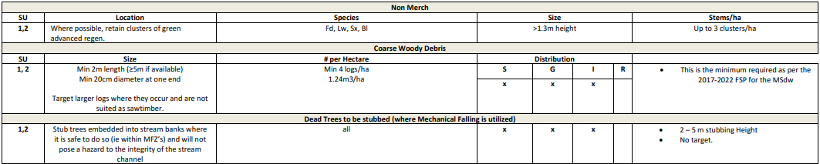

403 Soil Disturbance Levels: Block 1- max allowable disturbance is 10% for all SU.
Block 2- max allowable disturbance is 10% for SU 1 and 5% for SU 2.
Block 3- max allowable disturbance is 10 % for all SU.
601 Permanent access limits
-PAS block 1 = 6.6ha
-PAS block 2 = 3.8ha
-PAS block 3 = 1.2ha

605/ 606/ 609/ 1212
See Road Use Permit and Road SP for more info regarding road sections and culvert crossings
- Approximate new road construction: 6.059 km
- Road Permit 8.578 km
- Approximate total road reactivation/reconstruction: 2.519 km
- Approximate total road deactivation: 4.161 km
- Approximate total road rehabilitation: 4.417 km
- Approximate total forwarding trail construction out of block: 0.202 km
- Approximate total forwarding trail rehabilitation: 0.202 km
- Other: Reactivation of FSR’s CR0108.10 – Mule (366m) and CR0108.12 –
- Hornet (1069m) required. Remove berm and tank trap. Requires light to
- moderate brushing. This will be a permanent road with deactivation required
- post harvest.

Roads Other
- Several watercourses will be crossed by road sections within this TSL. All crossed watercourses have been determined as non-fish bearing either as result of previous fish inventories or due to slope gradient barriers to upstream fish passage identified through field survey of identified reaches.
- Culverts are required at locations noted above in this site plan and on the road overview map. Additional cross drain culverts may be required and are to be installed where deemed necessary following guidelines provided in the FLNRO Engineering manual.
- For road sections prescribed for deactivation, ensure that all prescribed culverts or other installed cross drains are removed upon deactivation and that water bars installed at a suitable depth to ensure that drainage patterns are maintained.
- Ensure that ditchlines do not deposit runoff directly into streams.
- Ensure that falling of trees during road construction is away from streams and that debris entering any stream is quickly removed.
- Machinery are to respect all flagged machine-free zones and are only to enter them where necessary to install prescribed drainage structures.
- Ensure that natural drainage patterns are maintained and monitor that sediment does not enter streams.
- Revised grass seeding requirements for new roads, trails, landings, and deactivated areas (FSP Section 5.8.3 - Revegetation following Road Construction and Deactivation and FSP Section 6.1 - Measures to Prevent the Introduction or Spread of Invasive Plants)
410 Wildlife Tree retention areas:
- Block 1: 23.1ha WTRA
- Block 2: 4.4ha WTRA
- Block 3: 18.9ha WTRA
Please see HP/SP map as well as SP document for further details
501 Riparian areas:
Block 1:

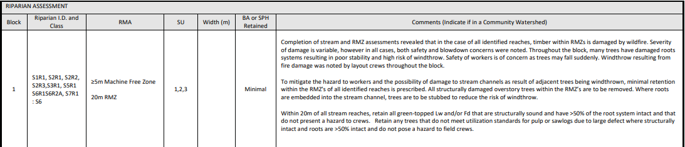
Block 2:
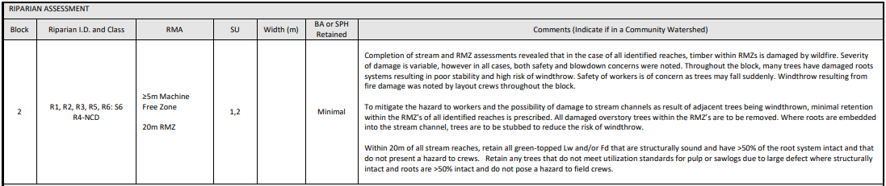
Block 3:
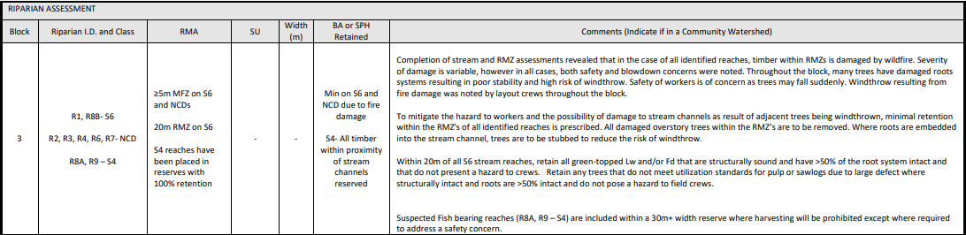

801/ 802/ 804/ 901/ 903/ 904- The emergency response plan (ERP) must be on site at all times and in the same location as the project binder if they will be separate.
- All staff on site are required to know their role and where to find the ERP and project binder
- Training records for all staff working on site must be completed and located in the project binder
- An Emergency Response test must be completed by all personnel on site within 2 weeks of start-up. This test will include a spill response and a fire response.

906- All mobile equipment must have a spill kit in accordance to the BCTS requirements. Additionally, all pickups which are carrying auxiliary fuel tanks must have the appropriate level of spill kit required.
** Fuelling of equipment must not take place within 50 meters of any riparian feature or water course. Refer to the Fuel Handling section of the Supervisor Field Handbook in the TSL binder for more info.

901/ 1204- Licensee to conduct a prework with all staff onsite and have each individual sign off on the prework confirming it being reviewed. Any subsequent new staff must go through a prework and sign off prior to conducting operations

1211- Licensee is responsible to place a sign with contact information (including name and radio frequency) prior to entering active harvesting operations. BCTS to supply signage.

806/ 807- Licensee to provide SE fire center with contact and work location information. As well, required to check fire danger rating for the area on a daily basis. Fax# 250-365-9925

416 Smoke venting index. Prior to disposing of debris piles, licensee must obtain a burn reference number, ensure it is safe to dispose of the debris piles and ensure that there is the appropriate venting index as required under regulations.

808- A fire hazard assessment must be completed on each block in the timber sale post-harvest and submitted to BCTS

1302- The licensee may cut a tree that is located outside of the cutting authority area if a person authorized by the licensee reasonably believes that the tree represents a safety hazard and a “no work zone” does not need to be established.
- The licensee must not buck or remove that tree unless authorized by the TSM.

1304/ 9009- As per section 4.00, Schedule A of the TSL document:
  - Licensee must pile and dispose of all roadside and landing debris
  - Licensee must rip (decompact) all landings and grass seed those landings
  - Must not pile harvesting debris within a minimum of 10m of standing timber and that will not cause damage to or negatively impact adjacent resources
  - If a tree is knocked over/pushed down/leans, that tree must be cut. If not removing the tree, buck it into lengths and lop and scatter the branches.

1308- Must ensure there is a minimum of 1200 plantable spots per hectare post-harvest
1310- Licensee must cut all live trees 3 meters and over in height within the cutting authority area.

419- Licensee is required to notify the District Manager of harvest and road construction start. This can be done by contacting Brent Lucas @ Brent.Lucas@gov.bc.ca or 250-420-6296.

1209/ 1301- Timber Sale Manager (TSM) to be notified if there is intent to deviate from the harvest plan
Designated TSM to be notified if going to shut down operations for more than 14 consecutive days
  - Within 5 days of shutting down.
  - Notify TSM a minimum of 2 days prior to re-commencement of operations.

1306- The licensee is responsible to contact the registered trapper for trapline TR0426T012, the Guide Outfitter 400900 and the Range Tenure Holders RAN073763, RAN077979 & RAN074601 prior to commencement of harvesting.

