Monitoring Inspection
EN21TFD005 – Kokanee 8500
Inspector: Gary Shannon |  | Date: October 1, 2020
Contract #: EN21TFD005 |  | Contractor Name: Bad Ventures Contracting Ltd.
Weather: +12 C; overcast |  | Persons on site: Don Cook, Mike ?
Active Construction Phases |  | Active Equipment
Kokanee 8500 | R/W Felling  Stripping | Kokanee 8500 | Excavator, processor

R/W ( active processing only)
- pilot trail to Hub 53.
- pushover falling complete to Hub 53 all with R/W.
- stakes, ticks and r/w ribbons remain in place.
- self loader is hauling 1-2 loads.

GRUBBING and STRIPPING
- approximately 150 m of stripping partially complete

DEBRIS DISPOSAL
- none to date

SUBGRADE
- Hub 15-25 ( approx 100 m) to rough grade.

DRAINAGE
- temp culvert has been installed at Hub 30 to control water at 1200 mm xing.
- no other water issues.

DRILL and BLASTING
- none to date
- larger boulders encountered so far on pilot will require measuring prior to blasting.

ENDHAUL
- none to date

Discussions
- discussed removal and piling of debris along lower side of r/w.
- discussed sloping over burden along fill slope.

EMS and Safety
- Mike will be meeting with Don this weekend to complete all EMS paperwork as per
prework requirements, training summary update etc.
-Photos below of info provided to date
- signage posted, all safety practices being implemented.

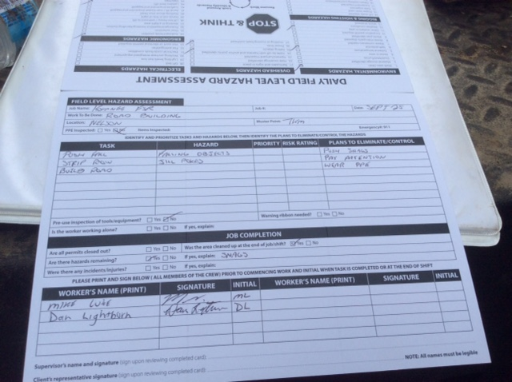

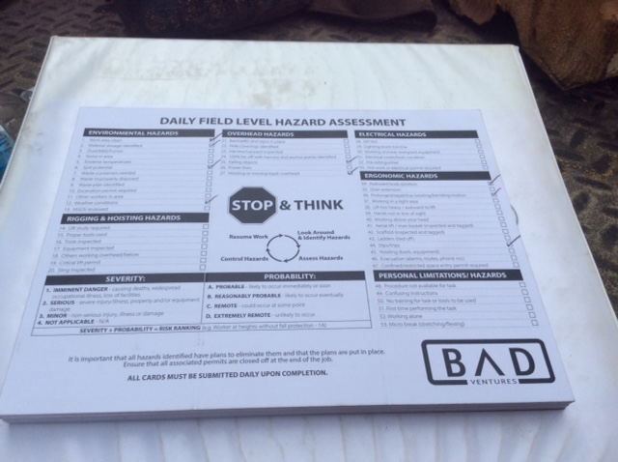

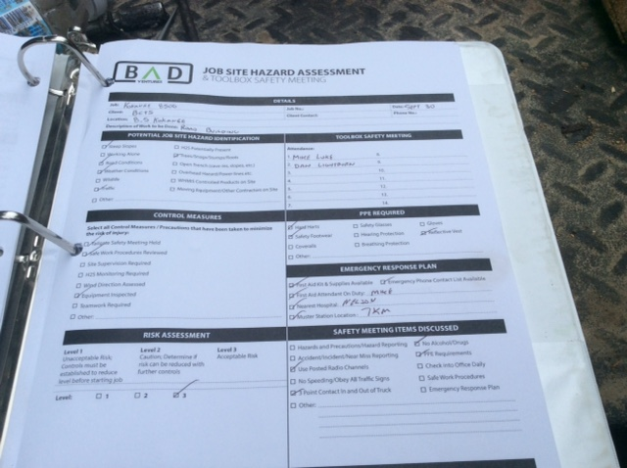

Photos

