Business Area: Kootenay Lake |  | Field Team: KL |  | ORCS/ARCS File(s): 19620-20 | Date of Inspection: 2021-06-10
Timber Sale Licence: TA0915 |  | Road Tenure: N/A |  | Log Dump Permit: N/A | Inspection Type: Final
Licensee: Kootenay Innovative Wood Ltd. (rep Tyler Hodgkinson, RPF) |  | Agent: A.F Timber Co. Ltd. |  | On-site Supervisor: Al Fitchett, Jake Valesik | Geographic Location: Smallwood - Garrity
TSL Completion Status  Block(s)# 1,2,3 - LC |  |  | Active during Inspection  Falling Road Activities (maintenance, deactivation, rehabilitation)  Yarding or Forwarding Loading & Hauling  Equip. Mob or Demob Structure Works (installation, removal)  Helicopter Logging Other (Specify): 1 Machine finishing piling, then walked out on Garrity
Access % 100 | Falling% 100
Yarding % 100 | Loading% 100

INSPECTION Requirement ID # Section
Yes: Inspector’s opinion requirement is being met. Where applicable details provided in comment section to support ID requirement.
No: Inspector’s opinion of non-conformance requiring Corrective Actions to be documented in comment and corrective action section below.
NI: Not inspected.
NA: Not applicable.
Note: Inspectors should also refer to Inspection Guidance Document for requirement detail.
Where identified issues meet EMS Incident definitions, incident reporting and root cause investigation is required including entry into Cengea Issue Tracking System (ITS). ITS required for significant or repeat non-conformance, potential non-compliance, or ER Incidents (refer to EOP-06).
ID # | 03: TSL – Safety Requirements | Status  Y N NI NA | ID # | 05: Legislative - Stream and Riparian Requirements | Status  Y N NI NA
0301 | SAFE Company Status |  | 0501 | Road outside RMA, Cutting in RRZ, RMZ Retention as authorized
0302 | No Safety concerns reported |  | 0502 | RMA Retention on Temperature Sensitive Streams followed
0303 | No Unsafe conditions / acts reported (3.10) |  | 0503 | Stream Crossing to protect channels/mitigate disturbance followed
ID # | 04: Legislative - Area and General Requirements | Status  Y N NI NA | 0504 | Fish Passage and Fish Habitat protection followed
0401 | Damage to the environment prevented |  | 0505 | Stream Sediment in Community Watersheds prevented
0402 | Authorized Timber Harvesting specifications followed |  | 0506 | Drinking Water Quality & Licensed Waterworks followed
0403  0601 | Soil Disturbance Levels (Area & Roadside), Permanent Access Limits as per Site Plan followed |  | ID # | 06: Legislative - Road, Trail and Structure Requirements | Status  Y N NI NA
0412, 13 | General Wildlife Measures, Resource Features, Wildlife Habitat features followed |  | 0602 | Re-vegetate Roads within 2 years followed
0416 | Smoke Venting Index checked for air quality/burning in a prescribed manner |  | 0607 | Build, Repair and/or Install Bridges & Culverts as designed
0417 | FSP Results, Strategies & Measures followed |  | 0608 | Road Clearing Widths Appropriate for Conditions including Safety
0419 | DM Notified of start or re-start of Harvesting & Road Construction |  | 0609 | Road Deactivation Requirements followed
0421 | First Nations Requirements met |  | 0610 | Road Maintenance Requirements followed
ID # | 09: EMS Documents, Records & General Requirements | Status  Y N NI NA | 0611 | 48 Hour Notification for Road Works in Community Watersheds provided
0901 | Pre-work meetings done & documented |  | ID # | 08: Environmental Emergency Response Requirements | Status  Y N NI NA
0902 | Self Inspections & Corrective Actions complete, documented & followed up |  | 0801, 05 | Env Emergency Response Plan and equipment maintained onsite, location known
0903  0904 | Documents/Records on site Project Plans, Training, Pre-works, inspections, EFPs, ERP. |  | 0802 | Awareness of roles, responsibilities and procedures confirmed
0905 | Industrial Waste contained and timely removal |  | 0803 | Incident Reporting documented and reported
0906 | Conformance to BCTS Fuel Handling (EFP 06) requirements |  | 0804 | Test and Drills scheduled and completed
0907 | Other Environmental Field Procedures followed |  | 0806 | 24 hour contact # provided to local Fire Centre
 |  |  | 0807 | Fire Danger Class discussed
 |  |  | 0808 | Fire Hazard Assessments and Abatement conducted, as required

ID # | 12: General Contractual Conditions of Licence | Status  Y N NI NA | ID # | 13: Specific Conditions TSL Schedule “A” | Status  Y N NI NA
1201 | Designated Supervisor directing workers |  | 1301 | TSM Notification requirements followed (start-up, shutdown)
1202 | Timber Marking Practices followed |  | 1302 | Dangerous trees clauses followed
1204 | Pre-work meeting held |  | 1303 | Environmental clauses followed
1205, 0410 | Reserved Timber Requirements and Wildlife Tree Retention followed |  | 1304,08,10 | Harvesting, Silviculture, Slashing, clauses followed
1208, 0411 | Waste Determination Completion per Manual and CWD followed. |  | 1305, 1306 | Forest Health, Other Utilities and Occupiers clauses followed
1209 | TSM notification of Intent / Deviation from Harvest Plan followed |  | 1307, 1309 | Road and Skid Trail clauses followed
1210 | Survey for Monetary Billing completion prior to Waste Disposal |  | ID# | Specific Business Area Requirements
1211 | Onsite Signage: Timber Mark & Radio frequency |  | 9001 | Project Binder, discuss contents including forms, Supervisors field book, Species of Management Concerns, Invasive Plants and other handouts
1212 | Licence / Road Permit Road Specifications followed |  | 9002 | SFI Awareness Document. (see page 2 Supervisor Field Handbook) discuss principles of SFI program i.e protection of water resources.
1213, 1214 | Obtain approvals to cross land or join to a Forest Service Road, Access Controls Installed to be safe for other road users |  | 9003 | Water Management BMP. Review applicable water management, sediment contract best practices documents i.e. wet weather operating guide, deactivation guide, EFPs 2,4 and 5, Harvest Plan and Site Plan, Skid trail BMP.
 |  |  | 9004 | FSP Invasive Plant (IP) measures discussed. Refer to applicable IP EFP.
 |  |  | 9005 | FSP SAR, UWR and WHA information discussed.
 |  |  | 9006 | FSP Fall and yard away, all streams, wetlands and lakes, Clean introduced debris concurrent with harvesting. 5 m machine-free zones on all non-fish bearing streams discussed.
 |  |  | 9007 | FSP 48 hr notification to water licence holders prior to any construction or deactivation discussed.
 |  |  | 9008 | FSP Road maintenance requirements discussed
 |  |  | 9009 | FSP Grass seeding requirements and seed mixes discussed (to minimize soil disturbance and spread of invasive plants)

GENERAL INSPECTION COMMENTS and CORRECTIVE ACTION PLAN
(Reference Requirement ID # where appropriate, add extra sheets for more comments). Where applicable comments recommended supporting inspection status.

WHERE NECESSARY INCLUDE CORRECTIVE ACTION, REPONSIBILITY AND DUE DATE FOR COMPLETION
Progress Inspection this day by Karli Ferrell. Observed the following:
- TSL is now LC (Logging Complete). This is the final inspection.
- Some of the categories above checked as N/A since operations have been completed and no workers can been interviewed.
- 0610: Identified blocked culverts in all 3 blocks of TSL (see attached map for exact location and notes) See Corrective Action below (CA).
- 0808: Fire hazard assessments and abatement will need to be completed now that the TSL is complete. See CA below.
- Licensee is required to submit the FPOC certificate prior to final deposit release. See CA below.
- 0902: This inspection may serve as a licensee self-inspection.
- 0905: Site appears clean and tidy and free of industrial waste
- 1208/0411/1210: A waste assessment is required now that the TSL is complete. See CA Below
- 1212: TSL schedule “C” road rehab requirements were followed. Temp roads within block 1 and 3 have been rehabbed.
- 0610: Road Maintenance requirements for FSR’s included in schedule “A” of the Road Use Permit (RUP) have not been met. Blocked and damaged culverts were identified in all 3 blocks of the TSL.
- FSP requirement 5.8.1 as described in the original prework is required (refer to item 9008 in the prework notes). Water barring, as a minimum, is required on Garrity, Garrity 1800, Garrity 3100, Smallwood 2000 (Grader bar style is preferred). Given the high public and other industrial use on Smallwood FSR, this FSP requirement will not apply for this section.
- Leave trees appear to align with plan, with some unmarked trees retained in place of marked trees that have been cut.
- 1304: appears 3-metre knockdown has been achieved.

Corrective Actions all to be completed by Kootenay Innovative Wood.
- 0610/1212: ensure functional drainage (culvert and ditches) on all sections covered by the RUP. A culvert map is attached that identifies problem areas however this is not a full account of all maintenance required. A FULL INSPECTION OF ALL CULVERTS AND DITCHES IS REQUIRED. To be completed by October 1^{st,} 2021. Complete as of October 6^{th,} 2021
- 0808: Submit Fire Hazard Assessments by August 1st, 2021. Complete as of July 20th, 2021
- 1304: Burn landing piles by December 1st, 2021 and/or as per timing outlined in the Wildfire Regulation.
- 1210: Complete Waste assessment as per current Waste and Residue Regulations. Complete as of summer 2021
- FPOC: Submit Forest Professional Oversite Certification prior to final deposit release.
- FSP Road Maintenance 5.8.1: Water/grader bars are required on Garrity, Garrity 1800, Garrity 3100, Smallwood 2000 by October 1st 2021. Complete as of October 6th, 2021
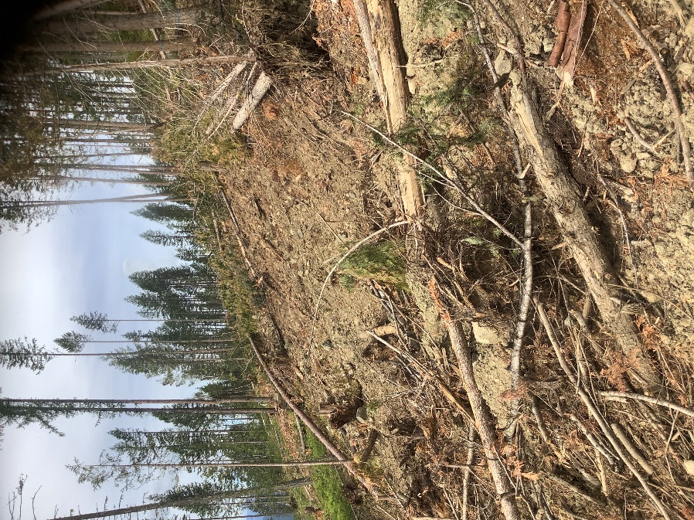 |  | 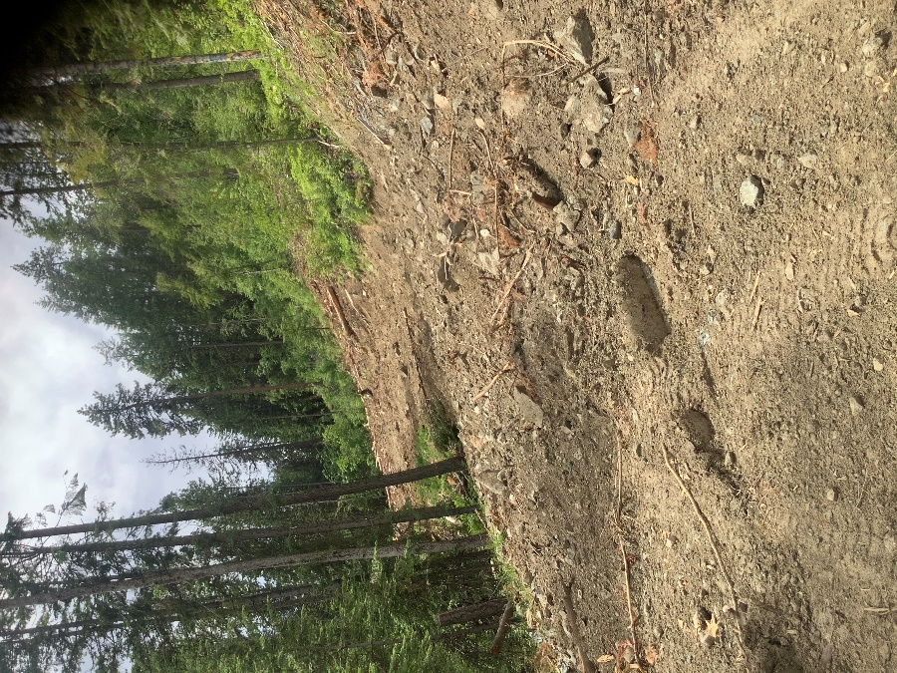
Photo 1: Rehab of Garrity 3110. Maintaining channel for NCD 20 noted good practice. Drainage was also observed to be maintained at the skid crossing at S6-1 within the streamside and riparian management zones. |  | Photo 2: Rehab of existing temp section of Smallwood 2000. Channel established for NCD. Noted good practice.
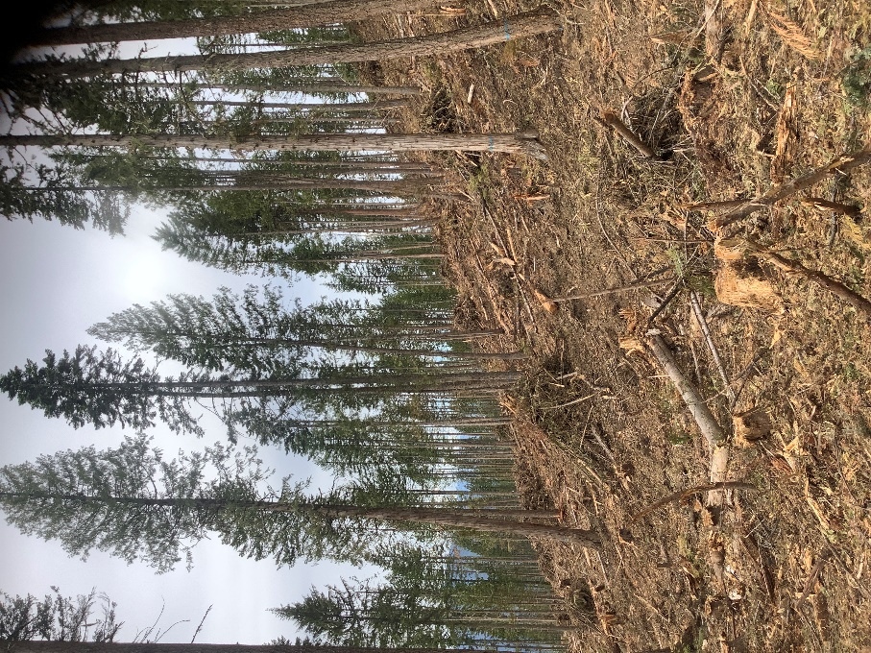 |  | 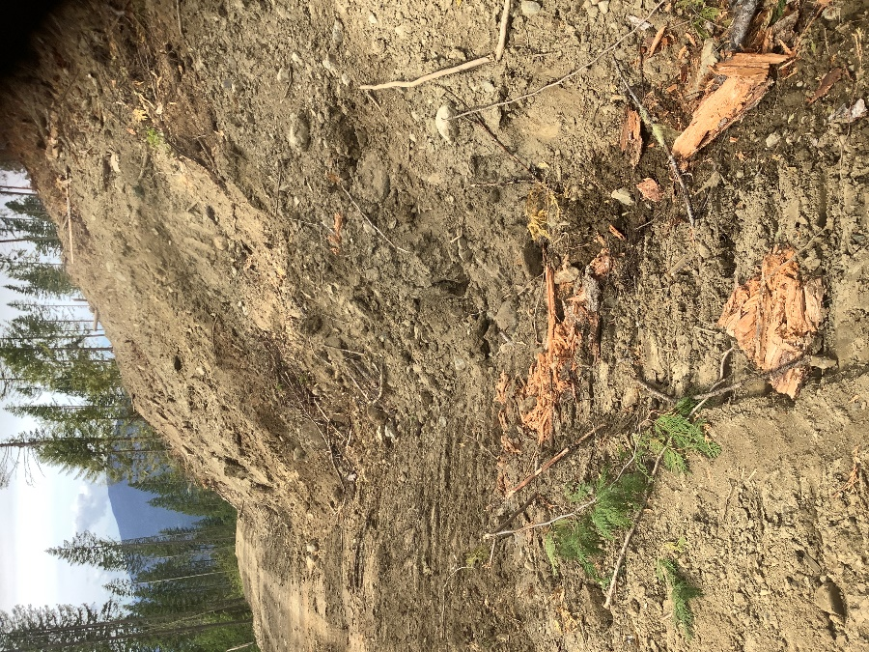
Photo 3: Retention and piling in Block 3 North of Garrity 3110 |  | Photo 4: Garrity 3110 Rehab, blocking inlet and outlet of culvert at this location
Inspected by: Karli Ferrell TFT, Reviewed by Warren Picton RFT  Signature X: |  |  | Received by: Tyler Hodgkinson, RPF and Al Fitchett  Signature X:  I accept receipt of this inspection and am in agreement with the stated actions.
Attachment:  Additional Pages Photos Maps  Correspondence Incident Report Other | Date of Delivery to Licensee or Agent:  Next Planned Inspection Date: TBD |  |  | Delivery Method:  On-site Email , Fax , Mail ,  Hand Delivered

