Business Area:  KL | Field Team:  KL |  | ORCS/ARCS File(s):  19620-20 | Date of Inspection:  2021-03-03
Timber Sale Licence:  TA0915 | Road Tenure:  N/A |  | Log Dump Permit:  N/A | Inspection Type:  Progress
Licensee:  Kootenay Innovative Wood Ltd. | Agent:  A.F Timber Co. Ltd. |  | On-site Supervisor:  Al Fitchett, Jake Valesik | Geographic Location:  Smallwood-Garrity
TSL Completion Status  Block 1 not started  Block 2 not started  Block 3 90% |  | Active during Inspection  Falling Road Activities (maintenance, deactivation, rehabilitation)  Yarding or Forwarding Loading & Hauling  Equip. Mob or Demob Structure Works (installation, removal)  Helicopter Logging Other (Specify):

INSPECTION Requirement ID # Section
Yes: Inspector’s opinion requirement is being met. Where applicable details provided in comment section to support ID requirement.
No: Inspector’s opinion of non-conformance requiring Corrective Actions to be documented in comment and corrective action section below.
NI: Not inspected.
NA: Not applicable.
Note: Inspectors should also refer to Inspection Guidance Document for requirement detail.
Where identified issues meet EMS Incident definitions, incident reporting and root cause investigation is required including entry into Cengea Issue Tracking System (ITS). ITS required for significant or repeat non-conformance, potential non-compliance, or ER Incidents (refer to EOP-06).
ID # | 03: TSL – Safety Requirements | Status  Y N NI NA | ID # | 05: Legislative - Stream and Riparian Requirements | Status  Y N NI NA
0301 | SAFE Company Status |  | 0501 | Road outside RMA, Cutting in RRZ, RMZ Retention as authorized
0302 | No Safety concerns reported |  | 0502 | RMA Retention on Temperature Sensitive Streams followed
0303 | No Unsafe conditions / acts reported (3.10) |  | 0503 | Stream Crossing to protect channels/mitigate disturbance followed
ID # | 04: Legislative - Area and General Requirements | Status  Y N NI NA | 0504 | Fish Passage and Fish Habitat protection followed
0401 | Damage to the environment prevented |  | 0505 | Stream Sediment in Community Watersheds prevented
0402 | Authorized Timber Harvesting specifications followed |  | 0506 | Drinking Water Quality & Licensed Waterworks followed
0403  0601 | Soil Disturbance Levels (Area & Roadside), Permanent Access Limits as per Site Plan followed |  | ID # | 06: Legislative - Road, Trail and Structure Requirements | Status  Y N NI NA
0412, 13 | General Wildlife Measures, Resource Features, Wildlife Habitat features followed |  | 0602 | Re-vegetate Roads within 2 years followed
0416 | Smoke Venting Index checked for air quality/burning in a prescribed manner |  | 0607 | Build, Repair and/or Install Bridges & Culverts as designed
0417 | FSP Results, Strategies & Measures followed |  | 0608 | Road Clearing Widths Appropriate for Conditions including Safety
0419 | DM Notified of start or re-start of Harvesting & Road Construction |  | 0609 | Road Deactivation Requirements followed
0421 | First Nations Requirements met |  | 0610 | Road Maintenance Requirements followed
ID # | 09: EMS Documents, Records & General Requirements | Status  Y N NI NA | 0611 | 48 Hour Notification for Road Works in Community Watersheds provided
0901 | Pre-work meetings done & documented |  | ID # | 08: Environmental Emergency Response Requirements | Status  Y N NI NA
0902 | Self-Inspections & Corrective Actions complete, documented & followed up |  | 0801, 05 | Env Emergency Response Plan and equipment maintained onsite, location known
0903  0904 | Documents/Records on site Project Plans, Training, Pre-works, inspections, EFPs, ERP. |  | 0802 | Awareness of roles, responsibilities and procedures confirmed
0905 | Industrial Waste contained and timely removal |  | 0803 | Incident Reporting documented and reported
0906 | Conformance to BCTS Fuel Handling (EFP 06) requirements |  | 0804 | Test and Drills scheduled and completed
0907 | Other Environmental Field Procedures followed |  | 0806 | 24 hour contact # provided to local Fire Centre
 |  |  | 0807 | Fire Danger Class discussed
 |  |  | 0808 | Fire Hazard Assessments and Abatement conducted, as required

ID # | 12: General Contractual Conditions of Licence | Status  Y N NI NA | ID # | 13: Specific Conditions TSL Schedule “A” | Status  Y N NI NA
1201 | Designated Supervisor directing workers |  | 1301 | TSM Notification requirements followed (start-up, shutdown)
1202 | Timber Marking Practices followed |  | 1302 | Dangerous trees clauses followed
1204 | Pre-work meeting held |  | 1303 | Environmental clauses followed
1205, 0410 | Reserved Timber Requirements and Wildlife Tree Retention followed |  | 1304,08,10 | Harvesting, Silviculture, Slashing, clauses followed
1208, 0411 | Waste Determination Completion per Manual and CWD followed. |  | 1305, 1306 | Forest Health, Other Utilities and Occupiers clauses followed
1209 | TSM notification of Intent / Deviation from Harvest Plan followed |  | 1307, 1309 | Road and Skid Trail clauses followed
1210 | Survey for Monetary Billing completion prior to Waste Disposal |  | ID# | Specific Business Area Requirements
1211 | Onsite Signage: Timber Mark & Radio frequency |  | 9001 | Project Binder, discuss contents including forms, Supervisors field book, Species of Management Concerns, Invasive Plants and other handouts
1212 | Licence / Road Permit Road Specifications followed |  | 9002 | SFI Awareness Document. (see page 2 Supervisor Field Handbook) discuss principles of SFI program i.e protection of water resources.
1213, 1214 | Obtain approvals to cross land or join to a Forest Service Road, Access Controls Installed to be safe for other road users |  | 9003 | Water Management BMP. Review applicable water management, sediment contract best practices documents i.e. wet weather operating guide, deactivation guide, EFPs 2,4 and 5, Harvest Plan and Site Plan, Skid trail BMP.
 |  |  | 9004 | FSP Invasive Plant (IP) measures discussed. Refer to applicable IP EFP.
 |  |  | 9005 | FSP SAR, UWR and WHA information discussed.
 |  |  | 9006 | FSP Fall and yard away, all streams, wetlands and lakes, Clean introduced debris concurrent with harvesting. 5 m machine-free zones on all non-fish bearing streams discussed.
 |  |  | 9007 | FSP 48 hr notification to water licence holders prior to any construction or deactivation discussed.
 |  |  | 9008 | FSP Road maintenance requirements discussed
 |  |  | 9009 | FSP Grass seeding requirements and seed mixes discussed (to minimize soil disturbance and spread of invasive plants)

GENERAL INSPECTION COMMENTS and CORRECTIVE ACTION PLAN
(Reference Requirement ID # where appropriate, add extra sheets for more comments). Where applicable comments recommended supporting inspection status.

WHERE NECESSARY INCLUDE CORRECTIVE ACTION, REPONSIBILITY AND DUE DATE FOR COMPLETION
Progress Inspection this day with Della Peterson (BCTS). Met with Al Fitchett. Discussed/Observed the following:
- Block 3 is currently active and nearing completion. No other blocks have started. Operations within H2 accessed by private land is complete. Piling is still required on this landing.
- This inspection may serve as a Licensee Self Inspection.
- 0417/0610: Operating conditions this day are favourable for skidding. Hauling is now restricted to 70% loads. Water is now starting to run on the Garrity road since daily temperatures are gradually increasing. Al will install some water-bars as needed. Recommended breaching areas of the snow berm on the full length of Garrity before leaving the site.
- Fire Hazard Assessment on Block 3 is not feasible currently due to snow.
- Appears retention targets have been met in the areas viewed this day. Viewed and walked several areas of HU2 Block 3 below Garrity 3100 including the unit to the West of WTRA 7.
- 0412/0413: Wildlife Tree 407 located in WTRA 7 is no longer standing and was not caused by logging activity. See email to Megan K. dated 2021-03-04.
- BCTS Active Works Sign is clear and visible.
- The worksite is generally neat and tidy with no sign of industrial waste.
- Al will confirm with his crew whether the grouping of beetle kill fire marked with pink and block dotted ribbon on the edges of Reserve 5 and 6 have been removed as noted on the last inspection.
- The amended TSL operational restrictions have been emailed to Al.
- 0513: Discussed the Crossing on NCD 2 in HU2 of Block 3. Did not view during this inspection but Al indicated there was very little impact to this feature. Operations in HU2 were completed during extreme cold weather (well below freezing).
- All of Block 3 trap trees have been removed but trap trees still exist on Block 2. Al will remove these trees prior to this month’s end.

0806: Please confirm if Notice to Fire Centre has been completed.

Overall good inspection.

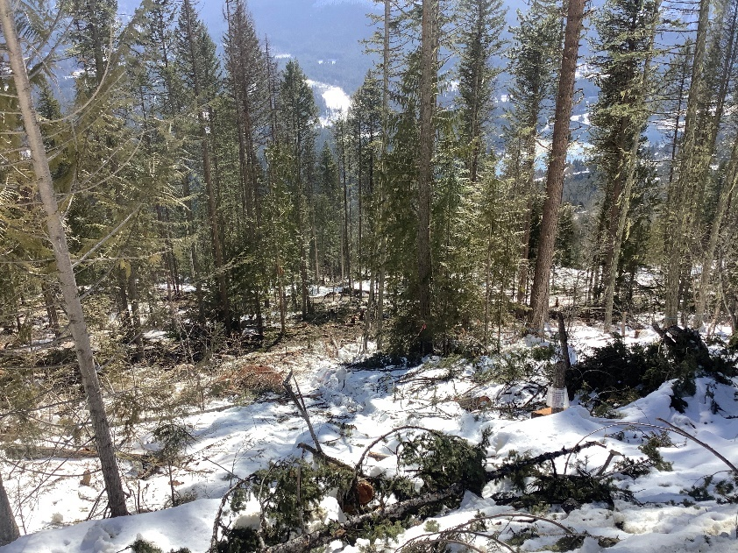 |  | 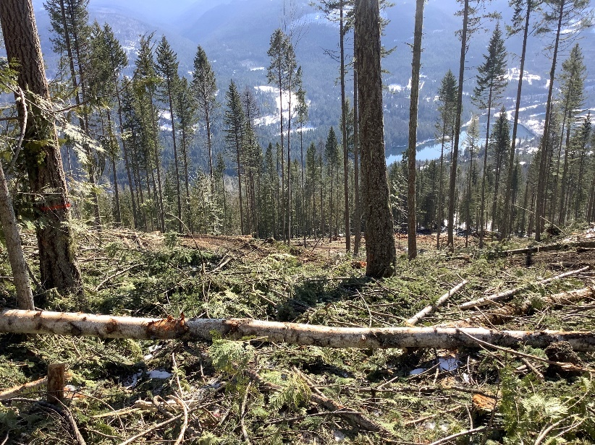
Photo 1: Reserve timber below Garrity 3100 West of Reserve 6 Block 3. |  | Photo 2: Reserve timber within HU2 Block 3.
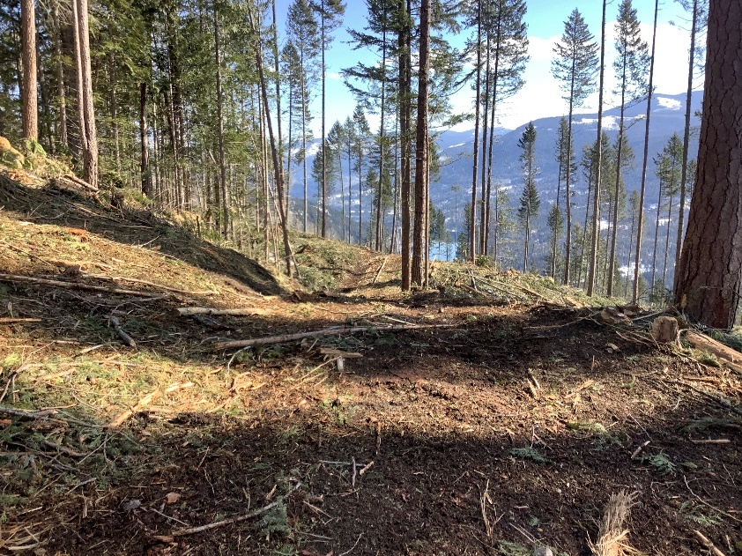 |  | 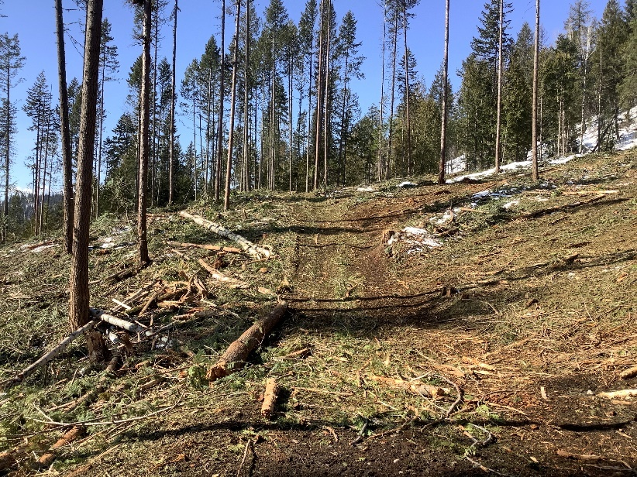
Photo 3: Corridor between WTRA 7 and WTRA 8 in Block 3 HU2. |  | Photo 4: Reserve timber below Garrity 3100 FSR within HU2 Block 3.
Inspected by: Warren Picton, RFT  Signature X: |  | Received by: Al Fitchett and Tyler Hodgkinson  Signature X:  I accept receipt of this inspection and am in agreement with the stated actions.
Attachment:  Additional Pages Photos Maps  Correspondence Incident Report Other | Date of Delivery to Licensee or Agent:  2021-03-04  Next Planned Inspection Date:  2021-04-03 if still active. |  | Delivery Method:  On-site Email , Fax , Mail ,  Hand Delivered

