Business Area:  KL | Field Team:  KL |  | ORCS/ARCS File(s):  19620-20 | Date of Inspection:  2021-05-12
Timber Sale Licence:  TA0915 | Road Tenure:  N/A |  | Log Dump Permit:  N/A | Inspection Type:  Progress
Licensee:  Kootenay Innovative Wood Ltd. | Agent:  A.F Timber Co. Ltd. |  | On-site Supervisor:  Al Fitchett, Jake Valesik | Geographic Location:  Smallwood-Garrity
TSL Completion Status  Block 1 not started  Block 2 60%  Block 3 90% |  | Active during Inspection  Falling Road Activities (maintenance, deactivation, rehabilitation)  Yarding or Forwarding Loading & Hauling  Equip. Mob or Demob Structure Works (installation, removal)  Helicopter Logging Other (Specify):

INSPECTION Requirement ID # Section
Yes: Inspector’s opinion requirement is being met. Where applicable details provided in comment section to support ID requirement.
No: Inspector’s opinion of non-conformance requiring Corrective Actions to be documented in comment and corrective action section below.
NI: Not inspected.
NA: Not applicable.
Note: Inspectors should also refer to Inspection Guidance Document for requirement detail.
Where identified issues meet EMS Incident definitions, incident reporting and root cause investigation is required including entry into Cengea Issue Tracking System (ITS). ITS required for significant or repeat non-conformance, potential non-compliance, or ER Incidents (refer to EOP-06).
ID # | 03: TSL – Safety Requirements | Status  Y N NI NA | ID # | 05: Legislative - Stream and Riparian Requirements | Status  Y N NI NA
0301 | SAFE Company Status |  | 0501 | Road outside RMA, Cutting in RRZ, RMZ Retention as authorized
0302 | No Safety concerns reported |  | 0502 | RMA Retention on Temperature Sensitive Streams followed
0303 | No Unsafe conditions / acts reported (3.10) |  | 0503 | Stream Crossing to protect channels/mitigate disturbance followed
ID # | 04: Legislative - Area and General Requirements | Status  Y N NI NA | 0504 | Fish Passage and Fish Habitat protection followed
0401 | Damage to the environment prevented |  | 0505 | Stream Sediment in Community Watersheds prevented
0402 | Authorized Timber Harvesting specifications followed |  | 0506 | Drinking Water Quality & Licensed Waterworks followed
0403  0601 | Soil Disturbance Levels (Area & Roadside), Permanent Access Limits as per Site Plan followed |  | ID # | 06: Legislative - Road, Trail and Structure Requirements | Status  Y N NI NA
0412, 13 | General Wildlife Measures, Resource Features, Wildlife Habitat features followed |  | 0602 | Re-vegetate Roads within 2 years followed
0416 | Smoke Venting Index checked for air quality/burning in a prescribed manner |  | 0607 | Build, Repair and/or Install Bridges & Culverts as designed
0417 | FSP Results, Strategies & Measures followed |  | 0608 | Road Clearing Widths Appropriate for Conditions including Safety
0419 | DM Notified of start or re-start of Harvesting & Road Construction |  | 0609 | Road Deactivation Requirements followed
0421 | First Nations Requirements met |  | 0610 | Road Maintenance Requirements followed
ID # | 09: EMS Documents, Records & General Requirements | Status  Y N NI NA | 0611 | 48 Hour Notification for Road Works in Community Watersheds provided
0901 | Pre-work meetings done & documented |  | ID # | 08: Environmental Emergency Response Requirements | Status  Y N NI NA
0902 | Self-Inspections & Corrective Actions complete, documented & followed up |  | 0801, 05 | Env Emergency Response Plan and equipment maintained onsite, location known
0903  0904 | Documents/Records on site Project Plans, Training, Pre-works, inspections, EFPs, ERP. |  | 0802 | Awareness of roles, responsibilities and procedures confirmed
0905 | Industrial Waste contained and timely removal |  | 0803 | Incident Reporting documented and reported
0906 | Conformance to BCTS Fuel Handling (EFP 06) requirements |  | 0804 | Test and Drills scheduled and completed
0907 | Other Environmental Field Procedures followed |  | 0806 | 24 hour contact # provided to local Fire Centre
 |  |  | 0807 | Fire Danger Class discussed
 |  |  | 0808 | Fire Hazard Assessments and Abatement conducted, as required

ID # | 12: General Contractual Conditions of Licence | Status  Y N NI NA | ID # | 13: Specific Conditions TSL Schedule “A” | Status  Y N NI NA
1201 | Designated Supervisor directing workers |  | 1301 | TSM Notification requirements followed (start-up, shutdown)
1202 | Timber Marking Practices followed |  | 1302 | Dangerous trees clauses followed
1204 | Pre-work meeting held |  | 1303 | Environmental clauses followed
1205, 0410 | Reserved Timber Requirements and Wildlife Tree Retention followed |  | 1304,08,10 | Harvesting, Silviculture, Slashing, clauses followed
1208, 0411 | Waste Determination Completion per Manual and CWD followed. |  | 1305, 1306 | Forest Health, Other Utilities and Occupiers clauses followed
1209 | TSM notification of Intent / Deviation from Harvest Plan followed |  | 1307, 1309 | Road and Skid Trail clauses followed
1210 | Survey for Monetary Billing completion prior to Waste Disposal |  | ID# | Specific Business Area Requirements
1211 | Onsite Signage: Timber Mark & Radio frequency |  | 9001 | Project Binder, discuss contents including forms, Supervisors field book, Species of Management Concerns, Invasive Plants and other handouts
1212 | Licence / Road Permit Road Specifications followed |  | 9002 | SFI Awareness Document. (see page 2 Supervisor Field Handbook) discuss principles of SFI program i.e protection of water resources.
1213, 1214 | Obtain approvals to cross land or join to a Forest Service Road, Access Controls Installed to be safe for other road users |  | 9003 | Water Management BMP. Review applicable water management, sediment contract best practices documents i.e. wet weather operating guide, deactivation guide, EFPs 2,4 and 5, Harvest Plan and Site Plan, Skid trail BMP.
 |  |  | 9004 | FSP Invasive Plant (IP) measures discussed. Refer to applicable IP EFP.
 |  |  | 9005 | FSP SAR, UWR and WHA information discussed.
 |  |  | 9006 | FSP Fall and yard away, all streams, wetlands and lakes, Clean introduced debris concurrent with harvesting. 5 m machine-free zones on all non-fish bearing streams discussed.
 |  |  | 9007 | FSP 48 hr notification to water licence holders prior to any construction or deactivation discussed.
 |  |  | 9008 | FSP Road maintenance requirements discussed
 |  |  | 9009 | FSP Grass seeding requirements and seed mixes discussed (to minimize soil disturbance and spread of invasive plants)

GENERAL INSPECTION COMMENTS and CORRECTIVE ACTION PLAN
(Reference Requirement ID # where appropriate, add extra sheets for more comments). Where applicable comments recommended supporting inspection status.

WHERE NECESSARY INCLUDE CORRECTIVE ACTION, REPONSIBILITY AND DUE DATE FOR COMPLETION
Progress Inspection this day. Discussed/Observed the following:
- Operations have resumed in the first week of May 2021 after a brief shutdown (<90 days).
- Block 2 is currently active. A Copy of the amended TSL timing restrictions were sent to Tyler in the previous week. Appears Block 2 will be complete before these restrictions come into effect.
- This inspection may serve as a Licensee Self Inspection.
- Ditch/culvert cleaning and road maintenance appear to be completed concurrent with operations. Debris is neatly piled on the section of Garrity FSR that is adjacent to the Block 2.
- The culvert inlet on NCD-3 appears damaged but may be repairable by opening the inlet. Warren sent a text message to Al to address and to also confirm whether this was damaged from operations or previously existed. Some debris is blocking the inlet.
- 0417/0610: Operating conditions this day are favourable for skidding and hauling.
- Viewed the conventional unit above FC 11 to FC13 and the cable unit above FC 1 and FC 17 up to the Garrity 1800 road. Appears leave trees align with the plan. Some Py retained that do not have the blue reserve paint. Jake confirmed that these may be substitutes for leave trees that may have been removed for operational purposes.
- BCTS Active Works Sign is clear and visible at the start of the block. A “trail closure” sign is posted on the far end of the block. I suggested that a BCTS sign at this location may be more appropriate. Al to pick-up an additional sign at the 4-Mile office.
- The worksite is generally neat and tidy with no sign of industrial waste.
- A Portable water tank is in place very close to the active operations.
Overall good inspection.

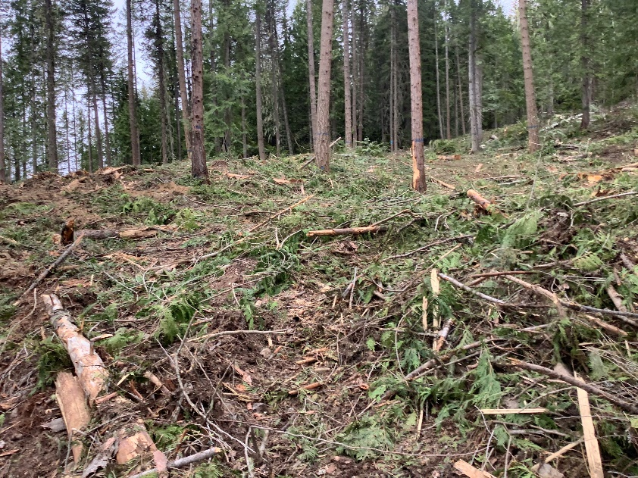 |  | 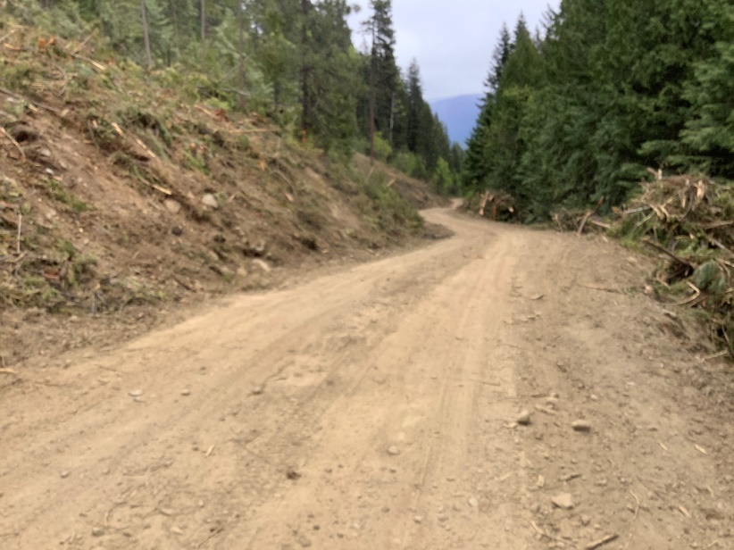
Photo 1: Conventional unit above FC 11 to FC 13 showing leave trees. Trail rehab appears concurrent with operations. |  | Photo 2: Section of Garrity FSR adjacent to Block 2 showing maintained ditches, road surface, and neat slash piles.
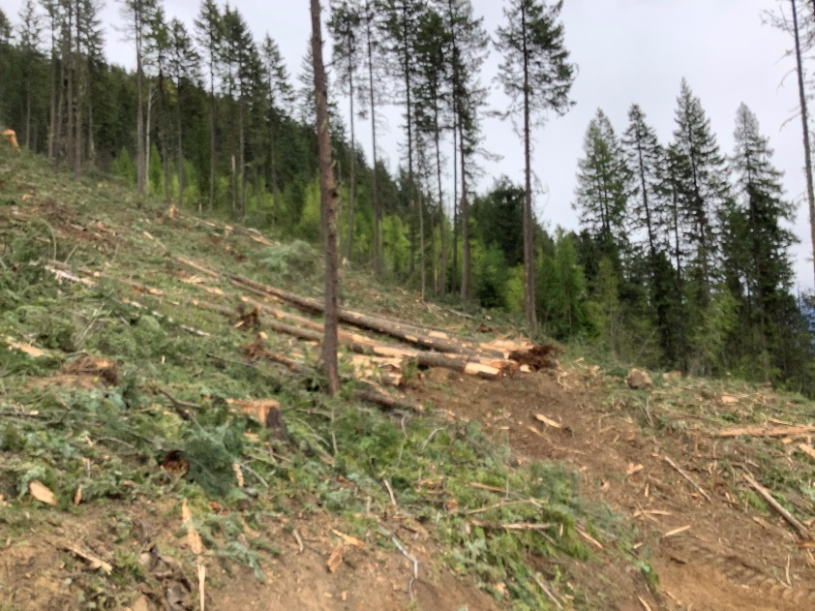 |  | 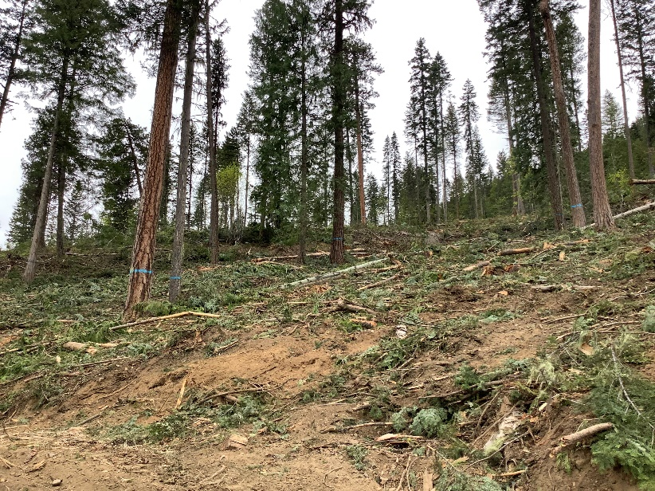
Photo 3: Conventional unit directly above cable unit showing leave trees. |  | Photo 4: Conventional unit below Garrity 1800 to the west of the cable unit showing leave trees.
Inspected by: Warren Picton, RFT  Signature X: |  | Received by: Al Fitchett and Tyler Hodgkinson  Signature X:  I accept receipt of this inspection and am in agreement with the stated actions.
Attachment:  Additional Pages Photos Maps  Correspondence Incident Report Other | Date of Delivery to Licensee or Agent:  2021-05-13  Next Planned Inspection Date:  TBD (depends or timing restrictions vs progress on Block 1 when Block 1 becomes active) |  | Delivery Method:  On-site Email , Fax , Mail ,  Hand Delivered

